High School and Beyond 2020 (HS&B:20)
Base-Year Field Test Sampling and Recruitment

OMB# 1850-new v.1

Supporting Statement Appendix A

Submitted by
National Center for Education Statistics
U.S. Department of Education

September 2018

Table of Contents
Contents

Appendix A1. Endorsement Request Letter 2
Appendix A2. State Letter and Sample Endorsement Letter 3
Appendix A3. District Notification and Recruitment Letter 5
Appendix A4a. School Recruitment Letter 6
Appendix A4b. School Coordinator Role Overview 7
Appendix A4c. School Thank You Letter 10
Appendix A5a. Parent Notification Letter 11
Appendix A5b. Parent Permission Letter – Implicit 12
Appendix A5c. Parent Permission Letter – Implicit – Spanish Translation 14
Appendix A5d. Parent Permission Letter – Explicit 15
Appendix A5e. Parent Permission Letter – Explicit – Spanish Translation 17
Appendix A6a. Study Information Sheet 18
Appendix A6b. Frequently Asked Questions 19
Appendix A6c. Brochure Text 21
Appendix A6d. HS&B:20 Newsletter 22
Appendix A6e. Video Storyboard 26
Appendix A7a. Recruitment Website Text 30
Appendix A8a. Out-of-School Data Collection – Parent Letter 35
Appendix A8b. Out-of-school Data Collection – Student Letter 36
Appendix A8c. Hybrid Out-of-School Data Collection – Student Postcard 37
Appendix A8d. Hybrid Out-of-School Data Collection – Parent Letter 38
Appendix A8e. Hybrid Out-of-school Data Collection – Student Letter 39
Appendix A9a. Summary of Mathematics Assessment 40
Appendix A9b. Summary of Reading Assessment 41
Appendix A9c. Summary of Student Survey 42
Appendix A9d. Summary of Parent Survey 43
Appendix A9e. Summary of Mathematics Teacher Survey 44
Appendix A9f. Summary of School Counselor Survey 45
Appendix A9g. Summary of School Administrator Survey 46
Appendix A10. Student Rostering Materials 47
Appendix A11. Parent Data Collection Letter 49
Appendix A12a. Staff Data Collection Letters – Math Teacher 50
Appendix A12b. Staff Data Collection Letters – Guidance Counselor 51
Appendix A12c. Staff Data Collection Letters – School Administrator 52

Appendix A1. Endorsement Request Letter

[Director’s name] [Date]
[Consortium/Network/Diocese name]
[Address]
[City, State Zip]

Dear [Name]:
Education success is crucial to individual and societal outcomes. Understanding what factors propel some students to successful completion of high school and entry into work or college while leaving others behind is a critical function of the National Center for Education Statistics’ High School and Beyond 2020 study.
How a student does in 9th grade is more predictive of their odds of graduating high school than all other factors, including race, gender, socioeconomic status, and prior academic achievement, combined. https://toandthrough.uchicago.edu/mythbusters
HS&B:20 will give policymakers and educators information they need to improve the high-school experience for ALL students. It will offer the opportunity to explore students transitions into and out of high-school and create a big picture view of K-12 education and trends by rounding out the elementary and middle grades longitudinal studies.
We are hoping you will partner with us by learning more about HS&B:20 and encouraging participation of schools that are selected to represent the U.S. Educational experience in this study. Your support, and a letter of endorsement can show how important this study is and increase participation and success of the study. Without school participation, the validity of national estimates is at risk.
If the 1.3 million dropouts from the Class of 2010 had graduated, the nation would have seen $337 billion more in earnings over the course of the students’ lifetimes.
Campaign for CHSE High School Equity. "Plan for Success: Communities of Color Define Policy Priorities for High School Reform." Campaign for CHSE High School Equity. Accessed February 18, 2015.

Next step: Support this research by signing up to endorse the study at <recruitment website URL>
Learn more about the study by reviewing enclosed brochure and FAQs, watch the study video at [web address] and visit the study website xxxxxxx.org.
You may contact RTI International with questions at xxx-xxx-xxxx or HS&B@rti.org. You may also contact Elise Christopher at NCES at (202) 245-7098. We are confident that you will see the value and importance of this research and will want to partner with us to advance the quality of education for our country’s high school students.
Sincerely,

James L. Woodworth
NCES Commissioner

NCES is authorized to conduct the High School and Beyond 2020 (HS&B:20) by the Education Sciences Reform Act of 2002 (ESRA 2002, 20 U.S.C. §9543) and to collect students’ education records from education agencies or institutions for the purposes of evaluating federally supported education programs under the Family Educational Rights and Privacy Act (FERPA, 34 CFR §§ 99.31(a)(3)(iii) and 99.35). The data are being collected for NCES by RTI International, a U.S.-based nonprofit research organization. All of the information students, parents, and staff provide may be used only for statistical purposes and may not be disclosed, or used, in identifiable form for any other purpose except as required by law (20 U.S.C. §9573 and 6 U.S.C. §151). The collected information will be combined across respondents to produce statistical reports.

Enclosures: HS&B:20 Brochure & Frequently Asked Questions (FAQ) Sheet

Appendix A2. State Letter and Sample Endorsement Letter
[Title First Name Last Name] [Date]
[State Department of Education Official’s Title]
[State Department of Education]
[Address]
[City, State Zip]

Dear [Name]:
Education success is crucial to individual and societal outcomes. Understanding what factors propel some students to successful completion of high school and entry into work or college while leaving others behind is a critical function of the National Center for Education Statistics’ High School and Beyond 2020 (HS&B:20) study.
HS&B:20 will give policymakers and educators information they need to improve the high-school experience for ALL students. It will offer the opportunity to explore students transitions into and out of high-school and create a big picture view of K-12 education and trends by rounding out the elementary and middle grades longitudinal studies.
How a student does in 9th grade is more predictive of their odds of graduating high school than all other factors, including race, gender, socioeconomic status, and prior academic achievement, combined. https://toandthrough.uchicago.edu/mythbusters
To encourage districts, schools and parents to participate, we are asking state departments of education provide a letter of endorsement for the study. Although participation is discretional, it is extremely important to have the participation of all the sampled schools because they were selected to represent the broad diversity of schools across the nation. Without their participation, the validity of the national estimates will be impaired. Your endorsement may positively impact school district and school participation, therefore greatly affecting the success of the study.
If the 1.3 million dropouts from the Class of 2010 had graduated, the nation would have seen $337 billion more in earnings over the course of the students’ lifetimes.
Campaign for CHSE High School Equity. "Plan for Success: Communities of Color Define Policy Priorities for High School Reform." Campaign for CHSE High School Equity. Accessed February 18, 2015.

Next steps: Support your state’s participation in this research by providing a letter of endorsement. A representative of RTI International will contact you to discuss the possibility of receiving such a letter.
You may contact RTI International with questions at xxx-xxx-xxxx or HS&B@rti.org. You may also contact Elise Christopher at NCES at (202) 245-7098. We are confident that you will see the value and importance of this research and will want to partner with us to advance the quality of education for our country’s high school students.
Sincerely,

James L. Woodworth
NCES Commissioner

Cc: <STATE> Testing Coordinator
NCES is authorized to conduct the High School and Beyond 2020 (HS&B:20) by the Education Sciences Reform Act of 2002 (ESRA 2002, 20 U.S.C. §9543) and to collect students’ education records from education agencies or institutions for the purposes of evaluating federally supported education programs under the Family Educational Rights and Privacy Act (FERPA, 34 CFR §§ 99.31(a)(3)(iii) and 99.35). The data are being collected for NCES by RTI International, a U.S.-based nonprofit research organization. All of the information students, parents, and staff provide may be used only for statistical purposes and may not be disclosed, or used, in identifiable form for any other purpose except as required by law (20 U.S.C. §9573 and 6 U.S.C. §151). The collected information will be combined across respondents to produce statistical reports.

Enclosures: HS&B:20 Brochure & Frequently Asked Questions (FAQ) Sheet
Sample Letter of Support

[Date]
[Superintendent or Principal’s Name]
[Title]
[School]
[Address]
[City, State Zip]

Dear School District and School Administrators:

The [INSERT STATE EDUCATION AGENCY NAME] is pleased to support the High School and Beyond 2020 (HS&B:20), conducted by the National Center for Education Statistics (NCES) within the U.S. Department of Education. HS&B:20 will follow a nationally representative sample of high school students and collect data in their 9th grade and 12th grade year. The study is the sixth in a series of high school longitudinal studies since the 1970’s to explore students’ transitions into and out of high school, and into postsecondary education and the workforce.
The data your school, students, staff, and parents provide to NCES and its contractor, RTI International, will help policymakers and educators understands the factors associated with successful transitions to high school and allow for examination of trends over time. These data are critical for making decisions related to policy and practice and the collection of these data is not possible without the participation of selected school districts and schools. By participating in the study, you are providing much needed information to help understand what factors propel some students to successful completion of high school and entry into work or postsecondary education and identify key risk factors during this critical stage of education.
We strongly encourage your participation in HS&B:20. We are confident that schools in our state will understand the importance of this national study and will accept the invitation to participate.
Should you have any questions, please call the HS&B:20 information number, (xxx) xxx-xxxx, or send an email to HS&B@rti.org. You may also contact Elise Christopher at NCES at (202) 245-7098 for more information.
Thank you for dedication to education research and your help in making HS&B:20 a success.
Sincerely,

<Name>
Chief State School Officer

Appendix A3. District Notification and Recruitment Letter
[Superintendent’s Name], Superintendent [Date]
[District]
https://surveys.nces.ed.gov/hsb/
Study ID:
Password:

[Address]
[City, State Zip]

Dear [Name]:
Education success is crucial to individual and societal outcomes. Understanding what factors propel some students to successful completion of high school and entry into work or college while leaving others behind is a critical function of the High School and Beyond 2020 study (HS&B:20). One or more school in your district has been selected to represent the U.S. high school experience in this important research study being conducted by the National Center for Education Statistics, part of the U.S. Department of Education.
How a student does in 9th grade is more predictive of their odds of graduating high school than all other factors, including race, gender, socioeconomic status, and prior academic achievement, combined. https://toandthrough.uchicago.edu/mythbusters
HS&B:20 is an opportunity for schools, students, parents, and school staff to share their experiences and opinions which can shape the future of education. The study will give policymakers and educators information they need to improve the high-school experience for ALL students. Complimenting the elementary and middle grades longitudinal studies, it will offer the opportunity to explore students transitions into and out of high-school and create a big picture view of K-12 education and trends.
Benefits associated with your district’s participation:
- Schools may select from a menu of incentive options for schools, school coordinators, teachers, and students.
- Yearly data sets that can be used for grant writing and school improvement efforts
- Receive school-level reports to compare school-level measures to the national averages and similar schools.
- Participating students receive a two-hour service certificate from the U.S. Department of Education. Participating staff receive continuing education credit.
Next step:
- Support your school(s) participation in this research study. Login to our secure portal to access the school name(s) using the login credentials that are provided in the top right corner of this letter. Contact the school principal and express your support. If the district would like to assist the school(s) further, you may provide the roster needed to select the sample of students to participate.
If the 1.3 million dropouts from the Class of 2010 had graduated, the nation would have seen $337 billion more in earnings over the course of the students’ lifetimes. Campaign for CHSE High School Equity. "Plan for Success: Communities of Color Define Policy Priorities for High School Reform." Campaign for CHSE High School Equity. Accessed February 18, 2015.

It is extremely important to have the participation of all the sampled schools in this research because each represents the broad diversity of schools across the nation. Without their participation, the validity of the national estimates will be impaired. Your endorsement will have an immense impact on the success of this study. Learn more about the study by reviewing enclosed brochure and FAQs, watch the study video at [web address] and visit the study website xxxxxxx.org.
Within a few days, the study materials will be sent to the selected school(s) in your district and our contractor, RTI International, will contact them to participate. Please contact us with questions at (xxx)xxx-xxxx or HS&B@rti.org. School and student participation are discretional, and we are confident that you will see the value and importance of this research to advance the quality of education for our country’s high school students.
Sincerely,
James L. Woodworth
NCES Commissioner

NCES is authorized to conduct the High School and Beyond 2020 (HS&B:20) by the Education Sciences Reform Act of 2002 (ESRA 2002, 20 U.S.C. §9543) and to collect students’ education records from education agencies or institutions for the purposes of evaluating federally supported education programs under the Family Educational Rights and Privacy Act (FERPA, 34 CFR §§ 99.31(a)(3)(iii) and 99.35). The data are being collected for NCES by RTI International, a U.S.-based nonprofit research organization. All of the information students, parents, and staff provide may be used only for statistical purposes and may not be disclosed, or used, in identifiable form for any other purpose except as required by law (20 U.S.C. §9573 and 6 U.S.C. §151). The collected information will be combined across respondents to produce statistical reports.
Enclosures: HS&B:20 study information sheet, Brochure & Frequently Asked Questions (FAQs)

Appendix A4a. School Recruitment Letter
[Principal’s Name] [Date]
[Title]
[School]
[Address]
[City, State Zip]

Education success is crucial to individual and societal outcomes. Understanding what factors propel some students to successful completion of high school and entry into work or college while leaving others behind is a critical function of the High School and Beyond 2020 study (HS&B:20). The National Center for Education Statistics (NCES), part of the U.S. Department of Education, proudly invites your school to participate in the study.
How a student does in 9th grade is more predictive of their odds of graduating high school than all other factors, including race, gender, socioeconomic status, and prior academic achievement, combined. https://toandthrough.uchicago.edu/mythbusters
This is not just a research study. HS&B:20 presents an opportunity for your students, parents, and school staff to provide their experiences and opinions which can shape the future of education. HS&B:20 research data will give educators an in-depth understanding of factors that influence successful graduates. The innumerable benefits of participation include:
- Turn research into practice with yearly national data sets used for grant writing and school improvements
- School level reports on student performance
- Schools may select from a menu of incentive options for schools, school coordinators, teachers, and students. Participating students receive a two-hour service certificate from the U.S. Department of Education and participating staff receive continuing education credit.
Your school is one of a limited number of schools around the country selected to represent the high school experience. NCES has partnered with RTI International to conduct data collection in your school. The RTI field staff team includes your local educators and administrators who are seasoned professionals in the educational arena. HS&B:20 is NOT a test and all responses are aggregated with other participants across the country. All participation is discretionary and is greatly treasured by NCES.
<The district has been notified of the research> <The study has been given the support of Superintendent (insert name)> and we are counting on your participation. As a thank you, your school will receive a [incentive] check or non-monetary equivalent. The designated school coordinator receives [incentive] as a thank you for their help, and each teacher completing an online questionnaire will receive a small token of appreciation. Participating school counselors, school administrators, and teachers receive continuing education credits. Watch this brief video to learn more <insert URL>.
Reserve your school’s participation NOW by calling the HS&B:20 information line at (xxx) xxx-xxxx or by visiting us online at http://inserstudyURL. Our contractor, RTI International, will contact you to discuss your school’s participation. We look forward to partnering with your school to improve educational opportunities for this high school generation and beyond.
If the 1.3 million dropouts from the Class of 2010 had graduated, the nation would have seen $337 billion more in earnings over the course of the students’ lifetimes. Campaign for CHSE High School Equity. "Plan for Success: Communities of Color Define Policy Priorities for High School Reform." Campaign for CHSE High School Equity. Accessed February 18, 2015.

Sincerely,

James L. Woodworth
NCES Commissioner
NCES is authorized to conduct the High School and Beyond 2020 (HS&B:20) by the Education Sciences Reform Act of 2002 (ESRA 2002, 20 U.S.C. §9543) and to collect students’ education records from education agencies or institutions for the purposes of evaluating federally supported education programs under the Family Educational Rights and Privacy Act (FERPA, 34 CFR §§ 99.31(a)(3)(iii) and 99.35). The data are being collected for NCES by RTI International, a U.S.-based nonprofit research organization. All of the information students, parents, and staff provide may be used only for statistical purposes and may not be disclosed, or used, in identifiable form for any other purpose except as required by law (20 U.S.C. §9573 and 6 U.S.C. §151). The collected information will be combined across respondents to produce statistical reports.

Enclosures: HS&B:20 Brochure, Frequently Asked Questions (FAQs) sheet, State Letter of Endorsement (if provided)

Appendix A4b. School Coordinator Role Overview
Welcome colleague to the exciting role of School Coordinator (SC) for the High School and Beyond 2020 (HS&B:20) study conducted by the National Center for Education Statistics (NCES). By helping with HS&B:20, you are contributing to the success of a study that will help educators, parents, and researchers learn how to best support student socioemotional and academic growth and learning during these extremely important years. We need your help and we thank you in advance.

Study Activities
Student Session- About 35 students in grade 9 and 35 students in grade 12 will be invited to participate in an online survey about their life in high school: courses, academics, and social topics. It will be conducted at your school and project staff will bring a mobile Chromebook lab. Students will also complete a vision and hearing screening as part of the student session. Participants will receive an incentive selected by the school and receive a service certificate from the U.S. Department of Education.

Counselor and Administrator Survey- The principal and counselor will complete a survey about school characteristics, staffing, the student population, and the academic environment. The surveys are completed online, and login credentials will be sent to each participant. Counselors and administrators may receive continuing education credits for their participation.

Teacher Survey- Teachers in grade 9 and 12 will complete a survey about their professional background. Some teachers will receive a two-part survey and respond to questions about students participating in HS&B:20. If allowed, teachers will receive [incentive] per student questionnaire completed.

Parent Survey- The parent survey will ask about students’ education experiences, parents’ involvement in and expectations for their children’s academic attainment, and family characteristics. Their survey is online or via telephone interview.

Permission Forms: Determine which type of form to use for your school. RTI will mail forms to you several weeks before the session. Please send home when they arrive.

Roster- Provide a roster of your 9th and 12th grade classes so that we can select the students. If your school is small, we may select all your 9th and 12th students to participate.
- Upload the roster to the secure High School and Beyond website.
- Receive list of selected students and submit parent and teacher information for each student.
Logistics-
- Select date, time, and location for the student session.
- Send home the permission forms and reminders if needed. You may be asked to call parents for outstanding forms.
- Work with your SF to identify any students with special needs who may need accommodations.
- Notify teachers, parents, and students and explain activities coming up.
Session Day- High School and Beyond staff will arrive about 1.5 hours before the session to set up and will bring the mobile Chromebook lab including internet connectivity. Please be available before the session to locate and bring any students that did not arrive on time. If you are unable to be there, designate another staff member to fill in for you that day.

Token of Appreciation- As a token of our appreciation for your time and effort with High School & Beyond, you will receive [incentive] and the list provider [incentive] after the student session has been completed. Your school will receive [incentive] and students a 2-hour service certificate from the U.S. Department of Education.

THANK YOU for doing your part to improve the excellence of High School education for this generation and beyond!

School Coordinator Checklist

Task | Activity | Timeline | Completed
1 | Upload 9th and 12th grade rosters to <insert URL> | Aug-Oct.
2 | After students are selected, log back into <insert URL> and provide teacher and parent info. | Aug-Sept.
3 | Select day and time for student session | Sept.
4 | Reserve the media center or empty classroom for the student session | Sept.
5 | Determine parental consent type (notified, implicit, explicit) | Sept.
6 | Communicate to parents, teachers, and students about upcoming activities | 6 weeks prior to student session
7 | Send home parental permission forms | As soon as they arrive from RTI
8 | Remind parents to sign and return forms as needed | Weekly after forms are sent home
9 | Communicate to your HS&B:20 facilitator when permission forms are returned and be willing to call parents to encourage participation. | Weekly after forms are sent home
10 | Determine if any students need accommodation | 1-2 weeks prior to student session
11 | Meet in person with your SF for a pre-session visit | 1 week prior to student session
12 | Receive Chromebook Shipment | 1-2 days prior to student session
13 | Meet the HS&B staff at school | 1.5 hours before the session begins
14 | Assist as needed to set-up and locate any students who did not arrive for the session | During the session day
15 | Return all permission forms to the facilitator and allow them to use the school fax machine | During the session day
16 | If needed, schedule a make-up session for students unable to attend | After the session day

Appendix A4c. School Thank You Letter

[DATE]

[School name]
[Address 1]
[Address 2}
[City, state, zip]

Dear [Principal]:

We are writing to thank you and your school for participating in the High School and Beyond Study of 2020 (HS&B:20) this spring. The contribution of schools like yours provides vital feedback of the current high school experience and our team expresses gratitude for our partnership. We particularly would like to thank [you/School Coordinator name] for working with us to coordinate the student sessions and ensure the study’s success at your school. [if applicable: We have enclosed [incentive] as a token of our appreciation for the school’s participation.]

We will contact you again in the summer or fall of 2023 to plan for the spring semester 2023 data collection. If you have any questions, please call us at (xxx) xxx-xxxx or email us at hsb@rti.org.

Thank you supporting HS&B:20 to make the study a success.

Sincerely,

Dan Pratt
Project Director, HS&B:20

Appendix A5a. Parent Notification Letter
Dear Parent or Guardian,

Your school is participating in the High School and Beyond 2020 (HS&B:20), conducted by the National Center for Education Statistics in the U.S. Department of Education. HS&B:20 gives you and your child the rare opportunity to share your experiences and opinions to help improve education for your child and children in the future. We are writing now about your child’s participation, and you will receive a separate invitation for you to participate as well.
WHO: About 35 ninth grade and 35 twelfth grade students from your child’s school will be asked to participate. About 75 schools across the country will be participating.
WHAT: Students will complete a survey about themselves and their experiences and answer some math and reading questions. They will also complete a hearing and vision assessment for which you will receive the results. The student session will be conducted on Chromebooks supplied by the study, and participation is voluntary. Your child will receive a certificate for 2 hours of community service from the U.S. Department of Education, and a small gift as a “thank you” for participating.
WHEN: Your student’s school will choose a convenient day and time in the fall for students to spend just [FILL] minutes in the HS&B:20 student session. <If 9th grade> We will contact you one more time in the future to ask permission for your child to participate again in winter/spring 2023 and then high school transcripts will be collected in the fall of 2023.
WHERE: The school will choose the best location for the session, typically a classroom or media center.
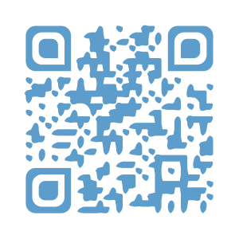
WHY: The study will help us learn more about students’ growth during high school and ways we can support them. Together, this information helps us learn how to give all high schoolers the experience and skills they need to thrive in high school, and beyond.
To learn more: Watch a short video to see what participation will look like [LINK], visit the study website at https://surveys.nces.ed.gov/HSB/ or scan the QR code. If you have questions, please call us at (xxx) xxx-xxxx or send email to hsb@rti.org.

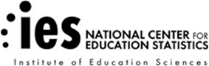

IMPORTANT: This is not a test, and it is not graded. There is little risk to your child in participating. We follow very strict laws to protect personal information and any data collected. All information collected is securely maintained, and your student’s name will never be stored with responses. All reports will use aggregate information for all students who participate, and your child or school will never be identified in any reports.
NCES is authorized to conduct the High School and Beyond 2020 (HS&B:20) by the Education Sciences Reform Act of 2002 (ESRA 2002, 20 U.S.C. §9543) and to collect students’ education records from education agencies or institutions for the purposes of evaluating federally supported education programs under the Family Educational Rights and Privacy Act (FERPA, 34 CFR §§ 99.31(a)(3)(iii) and 99.35). The data are being collected for NCES by RTI International, a U.S.-based nonprofit research organization. All of the information students, parents, and staff provide may be used only for statistical purposes and may not be disclosed, or used, in identifiable form for any other purpose except as required by law (20 U.S.C. §9573 and 6 U.S.C. §151). The collected information will be combined across respondents to produce statistical reports.

Appendix A5b. Parent Permission Letter – Implicit

HS&B Child Permission Form - Implicit Permission – Field Test

Dear Parent or Guardian,

Your school is participating in the High School and Beyond 2020 (HS&B:20), conducted by the National Center for Education Statistics in the U.S. Department of Education. HS&B:20 gives you and your child the rare opportunity to share your experiences and opinions to help improve education for your child and children in the future. We are writing now about your child’s participation, and you will receive a separate invitation for you to participate as well.
WHO: About 35 ninth grade and 35 twelfth grade students from your child’s school will be asked to participate. About 75 schools across the country will be participating.
WHAT: Students will complete a survey about themselves and their experiences and answer some math and reading questions. They will also complete a hearing and vision assessment for which you will receive the results. The student session will be conducted on Chromebooks computers supplied by the study, and participation is voluntary. Your child will receive a certificate for 2 hours of community service from the U.S. Department of Education, and a small gift as a “thank you” for participating.
WHEN: Your student’s school will choose a convenient day and time in the fall for students to spend just [FILL] minutes in the HS&B:20 student session. <If 9th grade> We will contact you one more time in the future to ask permission for your child to participate again in winter/spring 2022-23 and then high school transcripts will be collected in the fall of 2023.
WHERE: The school will choose the best location for the session, typically a classroom or media center.
WHY: The study will help us learn more about students’ growth during high school and ways we can support them. Together, this information helps us learn how to give all high schoolers the experience and skills they need to thrive in high school, and beyond.
To learn more: Watch a short video to see what participation will look like [LINK], visit the study website at https://surveys.nces.ed.gov/HSB/, or scan the QR code. If you have questions, please call us at (XXX) XXX-XXXX or send email to hsb@rti.org.
Thank you for taking the time to learn about this important study and how you can help.
You only need to return the attached form if you do not want for your child to participate.

IMPORTANT: This is not a test, and it is not graded. There is little risk to your child in participating. We follow very strict laws to protect personal information and any data collected. All information collected is securely maintained, and your student’s name will never be stored with responses. All reports will use aggregate information for all students who participate, and your child or school will never be identified in any reports.
NCES is authorized to conduct the High School and Beyond 2020 (HS&B:20) by the Education Sciences Reform Act of 2002 (ESRA 2002, 20 U.S.C. §9543) and to collect students’ education records from education agencies or institutions for the purposes of evaluating federally supported education programs under the Family Educational Rights and Privacy Act (FERPA, 34 CFR §§ 99.31(a)(3)(iii) and 99.35). The data are being collected for NCES by RTI International, a U.S.-based nonprofit research organization. All of the information students, parents, and staff provide may be used only for statistical purposes and may not be disclosed, or used, in identifiable form for any other purpose except as required by law (20 U.S.C. §9573 and 6 U.S.C. §151). The collected information will be combined across respondents to produce statistical reports.

Your child has been asked to participate in a study of student learning called High School and Beyond 2020 (HS&B:20). Student data will be collected in a [FILL]-minute session during the school day. The student session will be led by a team of researchers from RTI International, on behalf of the National Center for Education Statistics (NCES).

If you give permission for your child to participate in HS&B:20 YOU DO NOT NEED TO RETURN THIS FORM. Please keep this copy for your records.

If you do not give permission for your child to participate in HS&B:20, please check the box below, and sign and return this form to your child’s school as soon as possible.

No, I do not give permission for my child to participate in High School and Beyond 2020.

____________________________________________Date of signature: _____/_____/______
(Signature of parent or guardian)

Please Print:

Student Name: _________________________

Parent Name: __________________________

Parent telephone: _________________________________________
Parent email: ______________________________________________

Appendix A5c. Parent Permission Letter – Implicit – Spanish Translation

Appendix A5d. Parent Permission Letter – Explicit
HS&B Child Permission Form - Explicit Permission – Field Test

Please read, sign, and return the attached form to your child’s school or visit the website/scan the QR code to submit an online signature after reading.
https://surveys.nces.ed.gov/HSB/
Dear Parent or Guardian,

Your school is participating in the High School and Beyond 2020 (HS&B:20), conducted by the National Center for Education Statistics in the U.S. Department of Education. HS&B:20 gives you and your child the rare opportunity to share your experiences and opinions to help improve education for your child and children in the future. We are writing now about your child’s participation, and you will receive a separate invitation for you to participate as well.
WHO: About 35 ninth grade and 35 twelfth grade students from your child’s school will be asked to participate. About 75 schools across the country will be participating.
WHAT: Students will complete a survey about themselves and their experiences and answer some math and reading questions. They will also complete a hearing and vision assessment for which you will receive the results. The student session will be conducted on Chromebooks computers supplied by the study, and participation is voluntary. Your child will receive a certificate for 2 hours of community service from the U.S. Department of Education, and a small gift as a “thank you” for participating.
WHEN: Your student’s school will choose a convenient day and time in the fall for students to spend just [FILL] minutes in the HS&B:20 student session. <If 9th grade> We will contact you one more time in the future to ask permission for your child to participate again in winter/spring 2022-23 and then high school transcripts will be collected in the fall of 2023.
WHERE: The school will choose the best location for the session, typically a classroom or media center.
WHY: The study will help us learn more about students’ growth during high school and ways we can support them. Together, this information helps us learn how to give all high schoolers the experience and skills they need to thrive in high school, and beyond.
To learn more & provide permission online: Watch a short video to see what participation will look like [LINK], visit the study website at https://surveys.nces.ed.gov/HSB/, or scan the QR code. If you have questions and would like to talk to us, please call us at (XXX) XXX-XXXX or send email to hsb@rti.org.
Thank you for taking the time to learn about this important study and how you can help. Please sign and return the attached form OR submit an online signature for your child to participate by scanning the QR code above or visiting the study website.

IMPORTANT: This is not a test, and it is not graded. There is little risk to your child in participating. We follow very strict laws to protect personal information and any data collected. All information collected is securely maintained, and your student’s name will never be stored with responses. All reports will use aggregate information for all students who participate, and your child or school will never be identified in any reports.
NCES is authorized to conduct the High School and Beyond 2020 (HS&B:20) by the Education Sciences Reform Act of 2002 (ESRA 2002, 20 U.S.C. §9543) and to collect students’ education records from education agencies or institutions for the purposes of evaluating federally supported education programs under the Family Educational Rights and Privacy Act (FERPA, 34 CFR §§ 99.31(a)(3)(iii) and 99.35). The data are being collected for NCES by RTI International, a U.S.-based nonprofit research organization. All of the information students, parents, and staff provide may be used only for statistical purposes and may not be disclosed, or used, in identifiable form for any other purpose except as required by law (20 U.S.C. §9573 and 6 U.S.C. §151). The collected information will be combined across respondents to produce statistical reports.

;

Parent/Guardian Explicit Permission Form – HS&B:20

Your child has been asked to participate in a study of student learning called High School and Beyond 2020 (HS&B:20). Student data will be collected in a [FILL]-minute session during the school day. The student session will be led by a team of researchers from RTI International, on behalf of the National Center for Education Statistics (NCES).

PLEASE CHECK ONE:

Yes, I give permission for my child to participate in HS&B:20.

No, I do not give permission for my child to participate in HS&B:20.

PLEASE SIGN YOUR NAME BELOW:

_____________________________________________________ Date of signature: _____/_______/_______
(Signature of parent or guardian)

PLEASE PRINT:
Student name: _____________________________________________
School name: ______________________________________________
Parent name: ______________________________________________
Parent telephone: _________________________________________
Parent email: ______________________________________________

FOR OFFICE USE ONLY:
Student ID: ________________________________________________

Appendix A5e. Parent Permission Letter – Explicit – Spanish Translation

Appendix A6a. Study Information Sheet
HS&B:20 Study Information Sheet
HS&B:20 data collection takes place between September 15, 2019 – February 28, 2020.

Appendix A6b. Frequently Asked Questions
Frequently Asked Questions (FAQs)

What is HS&B:20?
The High School and Beyond Study of 2020 (HS&B:20) is a national longitudinal study facilitated by the National Center for Education Statistics (NCES) within the U.S. Department of Education. Study participants include 9th and 12th grade students, teachers, administrator, guidance counselors, and families. All information will be used to improve the excellence of high school for this generation and beyond. RTI International, a U.S.-based nonprofit research organization, will conduct the data collection activities in partnership with NCES.

Why is HS&B:20 important?
HS&B:20 will help educators understand the diversifying environment of how students, parents, and school staff are responding to the challenges of educating youth. Many cutting-edge topics can be addressed including academic skills developed in an era of rapid technological change; gaps in achievement, access to advanced courses, and home supports in the context of growing social and economic inequality.

When is the study being conducted?
The HS&B:20 field test takes place in the fall of 2019 and the spring semester of 2023. The national study years are the fall of 2020 and spring semester of 2024.

Why participate in HS&B:20?
Participating in HS&B:20 is important and we need your help. The voices of your students, teachers, and families will come together to give feedback on the current climate of high school education. Your school was selected to represent schools like yours and cannot be replaced.

How will my school benefit from participating in HS&B:20?
Schools that participate will have a unique opportunity to contribute to national research and use the data to improve high school education. You will receive a report that shows how your students compare to students nationwide and to schools like yours. If permitted, schools receive [incentive] for participating this year and [incentive] to the school coordinator. Students will be presented with a 2-hour service certificate from the U.S. Department of Education.

How will HS&B:20 data be used?
HS&B:20 data will allow researchers to examine family and schooling factors leading to postsecondary education, military, or the workforce. The study will capture unique experiences in high school and may provide insight to:
- Course selections and academic progress over time;
- Transitions from middle school and preparations for transitions to postsecondary education and/or work plans;
- School attributes associated with reduced achievement gaps and equal access to educational opportunities;
- Career and technical education opportunities available to students and characteristics of students who utilize them; and
- Use of technology for innovations such as online learning and effects on student outcomes.

How Many Schools?
HS&B:20 field test in 2019 will involve approximately 75 schools with about 2,000 ninth graders and 2,000 twelfth graders participating. Schools invited include public, Catholic, and other private schools located across the country.

What is involved for students?
Students in 9th and 12th grade will participate in a computer-based session with questions about their high school experiences, and some math and reading questions. Students will also complete a brief hearing and vision assessment. The session takes [fill] minutes or less, and we will randomly select up to 35 students in each grade. If your school is small, we may select all your 9th and 12th graders for HS&B:20.
Participating students receive a token of appreciation and a certificate for 2 hours of community service from the U.S. Department of Education.

What is involved for school staff and parents?
Teachers are invited to complete a two-part survey: (1) professional background and (2) student specific questions. If permitted, they will receive a [incentive] for part one and [incentive] for part two. Counselors and administrators are invited to complete a simple one-part online survey. Participating school staff will receive continuing education credit. Parents are asked to complete a survey online or via telephone.

Who will be responsible for the student data collection?
Trained HS&B:20 staff will facilitate the student session at your school and will bring a mobile Chromebook lab with internet connectivity. Schools will only be asked to designate a school coordinator to assist HS&B:20 staff with pre-planning and session day logistics.

What happens if a student or staff member refuses to participate?
Inevitably, there will be students or staff that do not want to participate. All participation is voluntary, and respondents may skip any question during the session.

Will the names of participants and their responses be kept confidential?
All of the information students, parents, and staff provide may be used only for statistical purposes and may not be disclosed, or used, in identifiable form for any other purpose except as required by law (20 U.S.C. §9573 and 6 U.S.C. §151). The collected information will be combined across respondents to produce statistical reports. Students, schools, and families are not identified in any of the reports.

Who do I contact for further information about HS&B:20?
For additional information, call the HS&B:20 information number, (xxx) xxx-xxxx, or send an email to hsb@rti.org. You may also learn more about the study and education research focused on students in high school by visiting the HS&B:20 website at https://surveys.nces.ed.gov/HSB/. Check out the HS&B:20 video to see what participation looks like at your school. [video link]

Appendix A6c. Brochure Text
High School and Beyond 2020 (HS&B:20) Study Brochure

What is HS&B:20?
The High School and Beyond 2020 (HS&B:20) is a research study that will build on decades of research (since 1972) to understand what makes students successful as they enter high school and progress to postsecondary education, the military, and the workforce.

Why participate in HS&B:20?
You have been given an opportunity to share your experiences and opinions. While your name will never be used in any reports, your input will be used to improve education for our children and those in the future. We want to hear from you!

What does participation look like?
Watch this short video to learn more about participation in HS&B:20 [link]
Students will respond to a survey and answer math and reading questions, and complete a brief hearing and vision assessment. Questionnaires will also be requested from school administrators about the school and its environment; math teachers on their background, teaching approaches, and student engagement in class; counselors on counseling practices at the school; and parents about the home environment and their experiences with their child’s school.

Who is conducting the study?
HS&B:20 is conducted by the National Center for Education Statistics (NCES). NCES collects, analyzes, and reports statistics on the condition of American education. Our mission is to provide scientific evidence on which to ground education practice and policy and to share this information in formats that are useful and accessible to educators, parents, policymakers, researchers, and the public. NCES has contracted RTI International, an independent, not-for-profit research institute, to collect the data for HS&B:20.

Did you know?
- How a student does in 9th grade is more predictive of their odds of graduating high school than all other factors, including race, gender, socioeconomic status, and prior academic achievement, combined. https://toandthrough.uchicago.edu/mythbusters
- Attendance contributes more than any other factor to course failure and low grades.
- Nearly half of students who begin college do not graduate within six years. https://www.ed.gov/news/press-releases/fact-sheet-focusing-higher-education-student-success
- America is ranked 36th in the world in quantity and quality of high school diplomas. https://www.dosomething.org/us/facts/11-facts-about-education-america
- If the 1.3 million dropouts from the Class of 2010 had graduated, the nation would have seen $337 billion more in earnings over the course of the students’ lifetimes. Campaign for CHSE High School Equity. "Plan for Success: Communities of Color Define Policy Priorities for High School Reform." Campaign for CHSE High School Equity. Accessed February 18, 2015

Contact Us
Schools & school staff: (xxx) xxx-xxxx or hsb@rti.org
Parents: (xxx) xxx-xxxx or hsbsurvey@rti.org
https://surveys.nces.ed.gov/hsb

Appendix A6d. HS&B:20 Newsletter
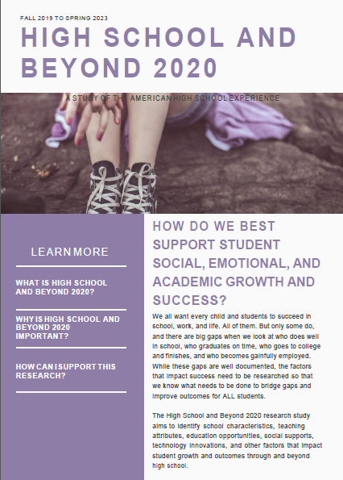
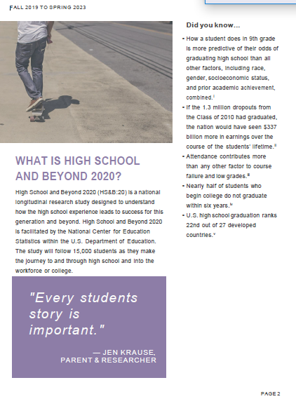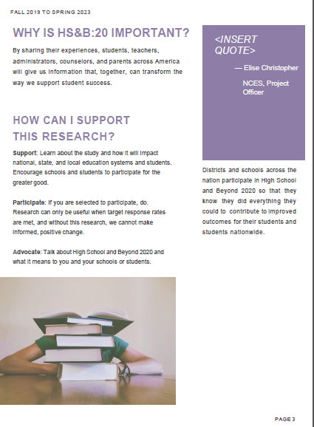
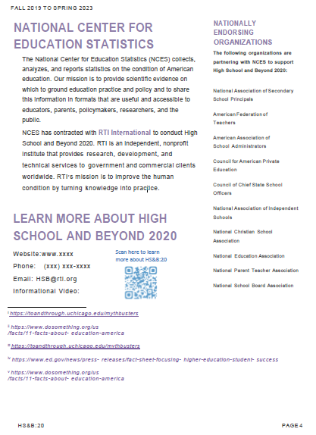

Appendix A6e. Video Storyboard
Stand up and be counted
AUDIO VIDEO
REAGAN: “Mr. Gorbachev, tear down this wall.”  https://www.gettyimages.com/license/450000382 (3:18)  MLK JR.: “I have a dream”  https://www.gettyimages.com/license/665468049 (:04)  Bill Gates: Nelson Mandela was concerned about the future. He believed that people could make the future better than the past.  VO: What if you had the power to change the future?  To open up new possibilities once considered impossible?  You can.  But you have to stand up and be counted.  You have a voice and now is the time to let it be heard.  (AOL dial-up sound)  The National Center for Education Statistics is gathering data for our High School and Beyond study. We’re asking for input from high school students, along with their parents, teachers, counselors, and principals, too.  We want to know what you think about your high school experience.  What works? What doesn’t?  What does it mean to you and your future?  VO: Amelia Earhart news announcer:  “The first group of women flyers who made headlines were composed of a group of daredevil ladies who risked their lives in the still baby science of aerodynamics”  We want to know because we want to make the world a better place too.  The future is depending on you  MALALA YOUSAFZAI: “This award is not just for me. It is for all those children who are voiceless, whose voices need to be heard.”  Stand up and be counted | Footage of ordinary people destroying the Berlin wall.  https://www.gettyimages.com/license/98116047  Footage of peaceful civil rights protest  https://www.gettyimages.com/license/mr_00020775  https://www.gettyimages.com/license/577747772  Unidentified protest video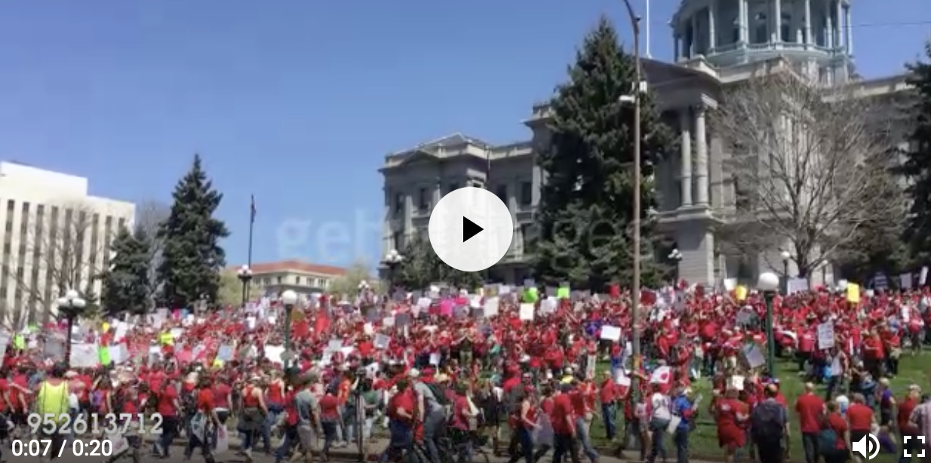  https://www.gettyimages.com/license/952613712  Photo of school desegregation  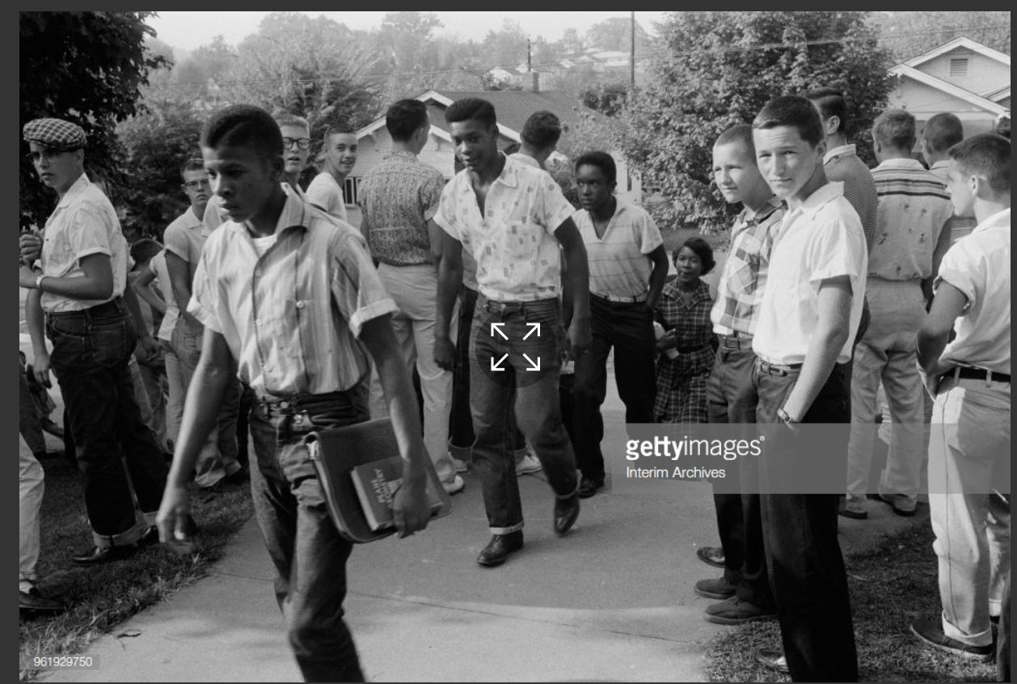  https://www.gettyimages.com/license/961929750  Tianenman square man standing in front of moving tanks  https://www.gettyimages.com/license/450068672  Close up of a mouth opening up, push into darkness. 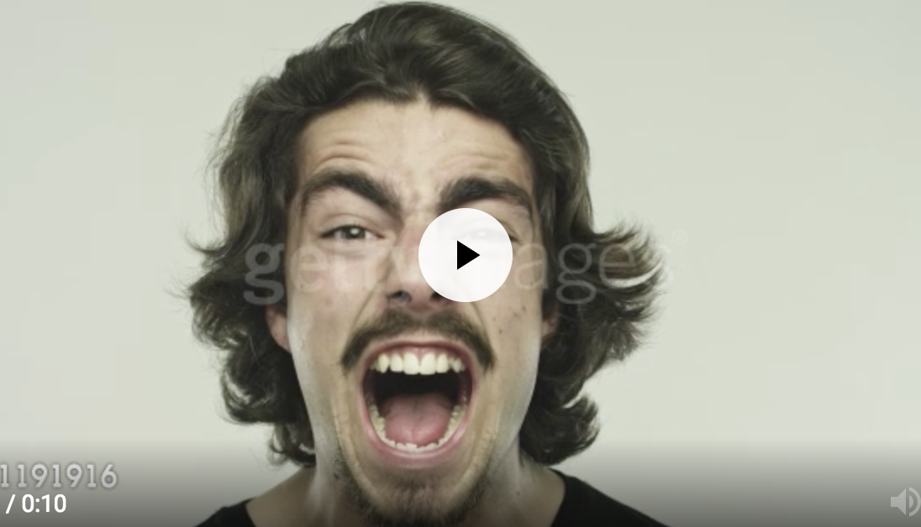  https://www.gettyimages.com/license/681191916  SUPER: Let your voice be heard  Wide shot of classroom full of students and a teacher  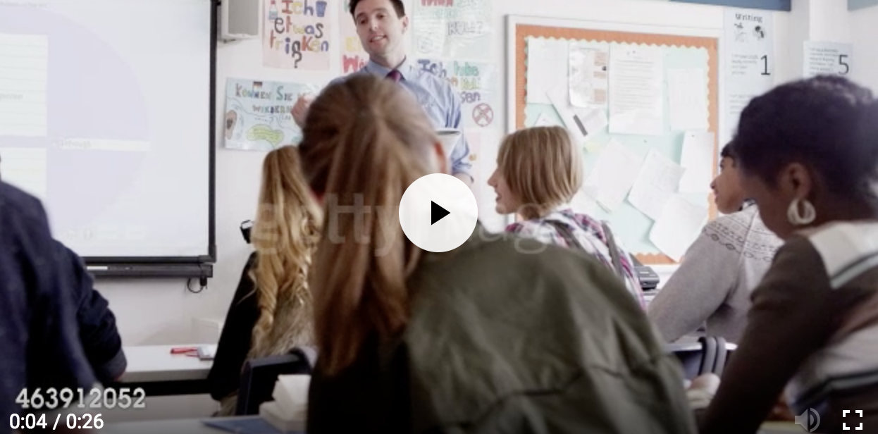  https://www.gettyimages.com/license/463912052  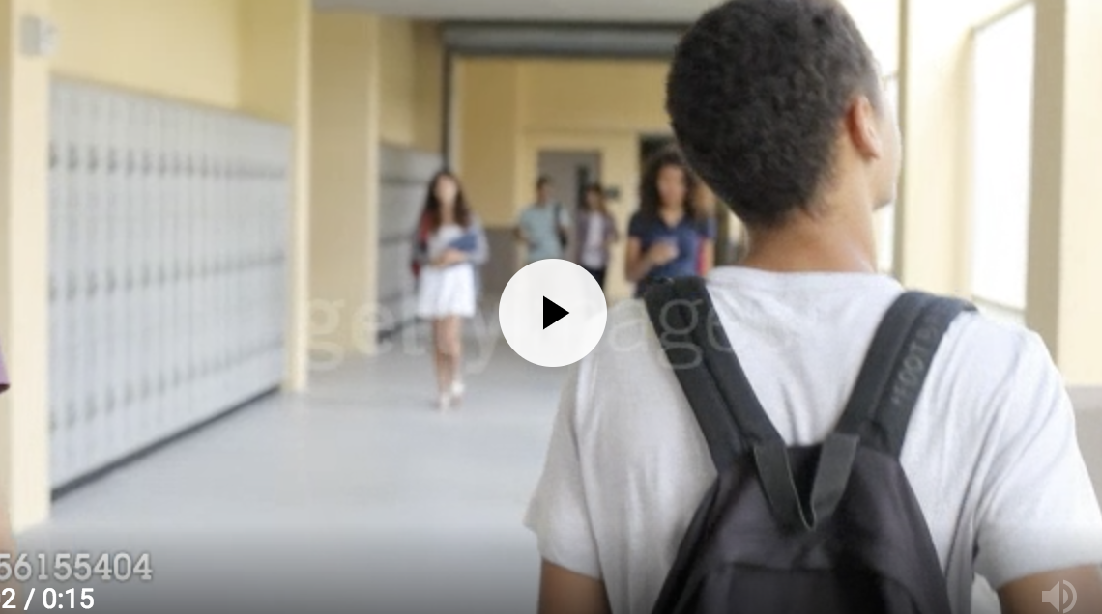  https://www.gettyimages.com/license/456155404  Young person taking survey on computer (animated graphic overlay of dataset being collected, calculated)  SUPER: You Have the Power to Change the Future  Amelia Earhart video  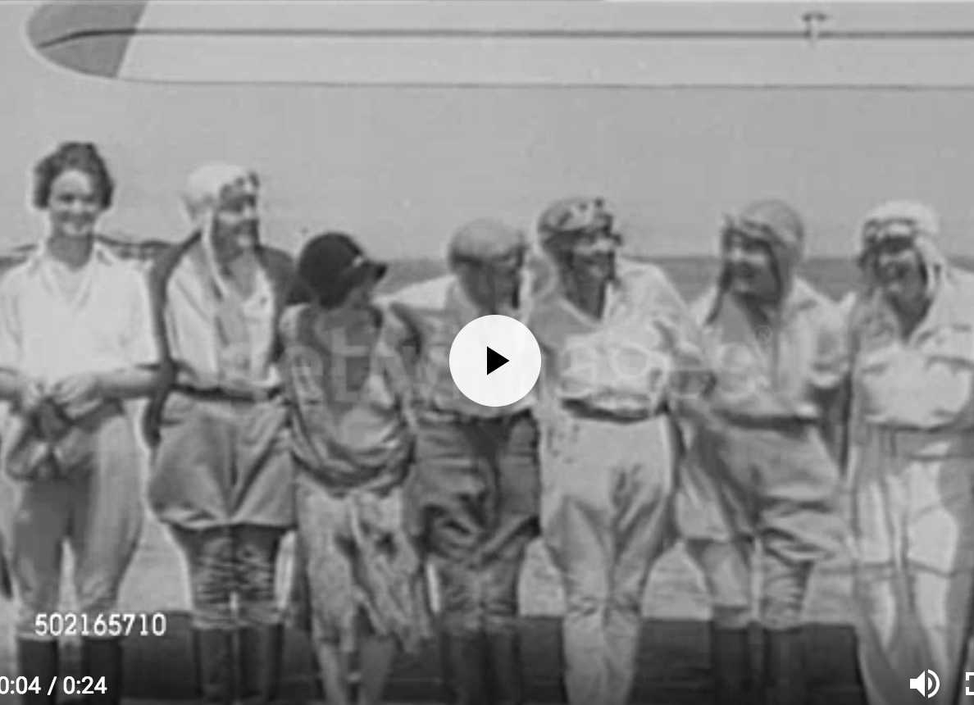  https://www.gettyimages.com/license/502165710  Eye transitions into the world  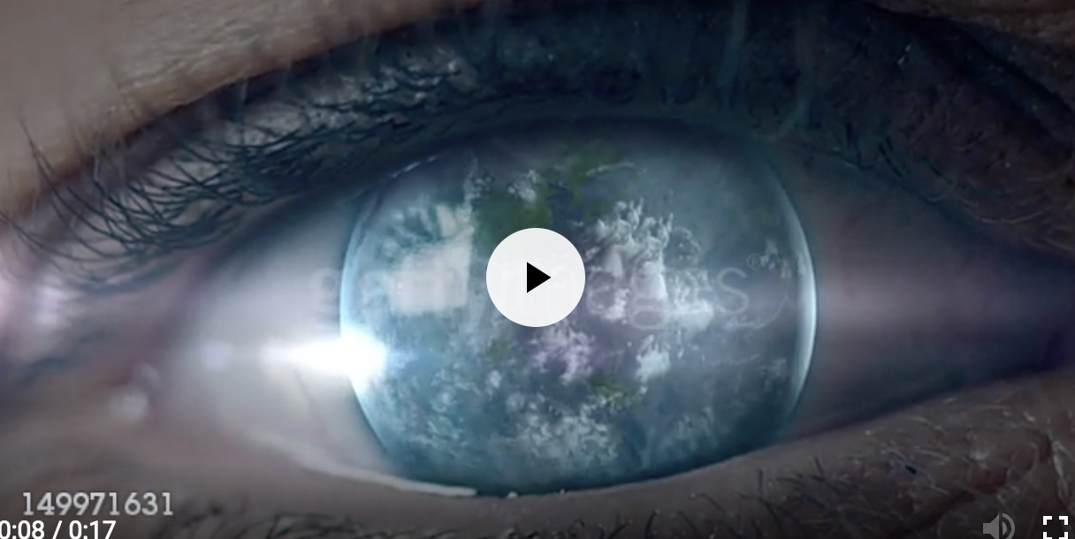https://www.gettyimages.com/license/1499 71631  https://www.gettyimages.com/license/647997930  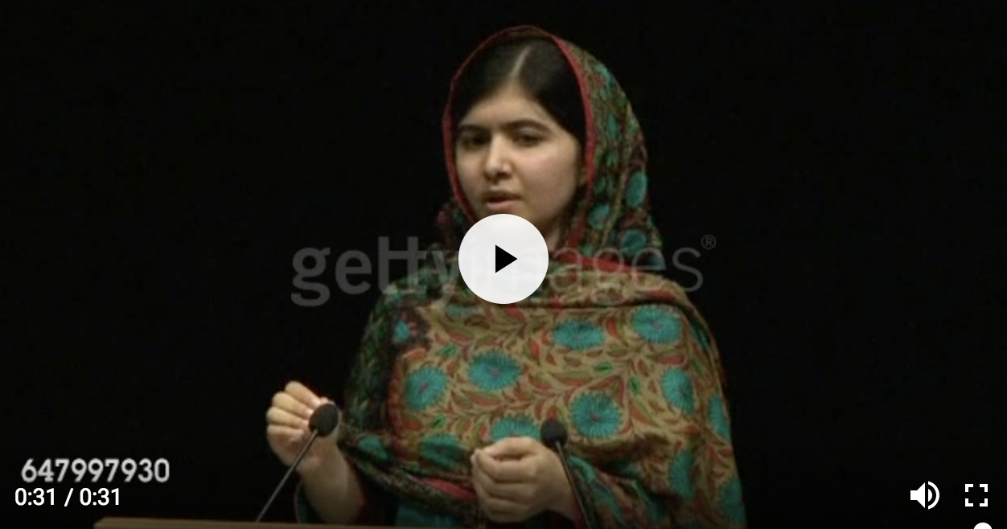  https://www.gettyimages.com/license/689413224  SUPER: Stand up. Be counted.  CTA: Be a change agent at www.xxx.com  LOGO: NCES logo

Appendix A7a. Recruitment Website Text

The recruitment website is used to provide information to school staff and parents about the study. The website also serves as a portal to securely upload student list information and complete the parent and school staff questionnaires.

HS&B:20 Website Content
Landing Page
- Sign-In
NCES is authorized to conduct the High School and Beyond 2020 (HS&B:20) by the Education Sciences Reform Act of 2002 (ESRA 2002, 20 U.S.C. §9543) and to collect students’ education records from education agencies or institutions for the purposes of evaluating federally supported education programs under the Family Educational Rights and Privacy Act (FERPA, 34 CFR §§ 99.31(a)(3)(iii) and 99.35). The data are being collected for NCES by RTI International, a U.S.-based nonprofit research organization. All of the information [respondent type] provide may be used only for statistical purposes and may not be disclosed, or used, in identifiable form for any other purpose except as required by law (20 U.S.C. §9573 and 6 U.S.C. §151). The collected information will be combined across respondents to produce statistical reports.
- Contact info: website, phone, email
- About HS&B:20: The High School and Beyond Study of 2020 (HS&B:20) will help educators, parents, researchers, and policymakers understand the factors that contribute to student success.
Many cutting-edge topics can be addressed including academic skills developed in an era of rapid technological change; gaps in achievement, access to advanced courses, and home supports in the context of growing social and economic inequality.
- NCES Info: The National Center for Education Statistics (NCES) collects, analyzes, and report statistics on the condition of American education. Our mission is to provide scientific evidence on which to ground education practice and policy and to share this information in formats that are useful and accessible to educators, parents, policymakers, researchers, and the public.
  - Longitudinal Series info: Have timeline with links to information about each study
- RTI Info: RTI is an independent, nonprofit institute that provides research, development, and technical services to government and commercial clients worldwide. Our mission is to improve the human condition by turning knowledge into practice.
- Links to Webinar & Video
Why Participate
- Benefits: This is a unique opportunity for schools and educators to contribute in a way that will impact student outcomes for generations to come. Schools that participate in High School and Beyond 2020 will join national research that will be used to improve the high school experience for all students. Schools will receive a report that shows how their students compare to students nationwide and to schools like theirs. Schools will also receive [incentive] for participating. HS&B:20 will give [incentive] to the school coordinator and [incentive] to the list provider. Students will receive a token of appreciation and will be presented with a 2-hour service certificate from the U.S. Department of Education.
- Impact: (include bullets of predecessor study impact on education)
- National Data trends that show need for change:
  - How a student does in 9th grade is more predictive of their odds of graduating high school than all other factors, including race, gender, socioeconomic status, and prior academic achievement, combined. https://toandthrough.uchicago.edu/mythbusters
  - Attendance contributes more than any other factor to course failure and low grades.
  - Nearly half of students who begin college do not graduate within six years. https://www.ed.gov/news/press-releases/fact-sheet-focusing-higher-education-student-success
  - America is ranked 36th in the world in quantity and quality of high school diplomas. https://www.dosomething.org/us/facts/11-facts-about-education-america
  - If the 1.3 million dropouts from the Class of 2010 had graduated, the nation would have seen $337 billion more in earnings over the course of the students’ lifetimes.
  - U.S. high school graduation ranks 22nd out of 27 developed countries.
- “Make a difference” Theme: How can you make a difference by participating in HS&B:20?
  - Districts can learn about HS&B:2020 and how the collected data can be used to improve policies that support student success. They can support participation among peers and educators.
  - Schools
    - Counselors can share information about supports they offer to students in their schools.
    - Teachers can share information about their unique learning environments, background, and individual student’s classroom experience.
    - Principals can provide valuable information about their school’s unique structure and environment.
  - Parents can encourage their children to participate and to tell researchers about their transition to high school, their social and academic experiences, and how their school environment and culture impact their growth.
  - Students can join with peers across the U.S. to participate in student sessions where they will have the opportunity to share information about their high school experiences.
- Video links (HS Student video- why participation is important)
- Research
- Why study is important: Understanding what factors propel some students to successful completion of high school and entry into work or postsecondary education while leaving others behind is a critical function of high school longitudinal studies such as HS&B:20. Research has long shown that increases in education attainment are associated with a wide range of important civic and life outcomes, including stronger employment prospects and earning potential, lower incarceration rates, higher voting rates, and better health and life expectancy (Cutler & Lleras-Muney, 2006; Julian & Kominski, 2011; Milligan, Moretti, & Oreopoulos, 2004; Oreopoulos & Petronijevic, 2013; Sum, Khatiwada, & McLaughlin, 2009).
Data from HS&B:20 can also contribute to improved education experience by documenting opportunity and achievement gaps and how well school address inequity. Finally, HS&B:20 and its predecessors offer an extraordinary opportunity to study trends in students’ high school experiences and education outcomes. By maintaining linkages with NCES’s previous high school longitudinal studies, HS&B:20 data can be used to examine changes over time and shed light on the effects of various policies, demographic shifts, and school practices on student achievement, growth, and education attainment.

Instrument Content
Student | Parent | Administrator | Counselor | Teacher
Background Information | Background Information | School characteristics | Counseling program characteristics | Teacher characteristics
Family structure | Family Structure | School calendar | Discipline and safety | Teacher communication
Neighborhood | Neighborhood | Coursework | School characteristics | Class-level characteristics
Native Language | Native Language | Graduation requirements | Transitions | Coursework
Academic Expectations | Parental Academic Expectations | School performance | Coursework | Student-level characteristics
Parental Academic Expectations | Guidance | Parent engagement | Graduation requirements | Programs and services
Guidance | Attendance Information | Programs and services | Evaluation of staff | School climate
Attendance Information | Academic Experiences | Special education services | Programs and services - offered | School policies
Academic Experiences | Math and Science Experiences | Technology | Programs and services - participation | Teacher attitudes
Math and Science Experiences | School Safety and Climate | Transition to high school | School performance | Evaluation of staff
School Library | Parent Attitudes | Student characteristics | Counselor-level characteristics | Technology usage
School Safety and Climate | Student Behavior | Personnel
Student Attitudes about School | Out-of-School Activities | Interdisciplinary teaching
Student Attitudes about Self | Home life | School climate
Student Behavior | Student Health | Discipline and safety
Student Employment | Student's Peers | Admissions
Out-of-school Activities | Technology Usage | Principal characteristics
Home life | Postsecondary
Student Health | Parent Employment
Student's Peers | Parent Education
Technology Usage | Parent Income/wealth
Postsecondary | Parental Involvement
Parent Employment | High school educational expenses
Parent Education | Locating Information
Parental Involvement
Hearing/Vision
Locating Information

HS&B Student Roster Instructions

Not all students in your school will be asked to participate. We will be selecting a sample. In order to select the sample, we are requesting a complete roster of all students currently enrolled in ninth and twelfth grade at your school.
The roster should include key characteristics about each student for sampling purposes. The HS&B:20 roster data request conforms fully to the requirements of the Family Educational Rights and Privacy Act of 1974 (FERPA) (20 U.S.C. §1232g; 34 CFR Part 99). For the purposes of this collection of data, FERPA permits education agencies and institutions to disclose personally identifiable information from students’ education records, without consent, to authorized representatives of the Secretary of Education in connection with an evaluation of federally supported education programs (34 CFR §§ 99.31(a)(3)(iii) and 99.35). Student data are subject to strict protections that are adhered to by NCES and its contractor organizations. Roster information will be securely destroyed when no longer needed for the purposes specified in 34 CFR §99.35.
NCES is authorized to conduct the High School and Beyond 2020 (HS&B:20) by the Education Sciences Reform Act of 2002 (ESRA 2002, 20 U.S.C. §9543). The data are being collected for NCES by RTI International, a U.S.-based nonprofit research organization. All of the information you provide may be used only for statistical purposes and may not be disclosed, or used, in identifiable form for any other purpose except as required by law (20 U.S.C. §9573 and 6 U.S.C. §151).
According to the Paperwork Reduction Act of 1995, no persons are required to respond to a collection of information unless it displays a valid OMB control number. The valid OMB control number for this voluntary information collection is 1850-XXXX. Approval expires XX/XX/20XX. The time required to complete this information collection is estimated to average approximately [x] minutes per response, including the time to review instructions, gather the data needed, and complete and review the information collection. If you have any comments concerning the accuracy of the time estimate, suggestions for improving this information collection, or any comments or concerns regarding the status of your individual submission, please write directly to: The High School and Beyond 2020 (HS&B:20), National Center for Education Statistics, PCP, 550 12th St., SW, 4th floor, Washington, DC 20202.
Below are instructions for preparing and uploading your student roster. The upload process is similar to attaching a file to an e-mail.

Website Upload Instructions
- Go to https://surveys.nces.ed.gov/hsb
- Enter the study ID and password provided in the cover letter.
- If this is your first time entering your login credentials, you will be prompted to change your password to something that you can remember.
- Click “Provide Your Student Roster.”
- Fill out the required contact information.
- Prepare your document containing the requested information. You have two options for preparing a data file:
  - Click on the link provided (Download Student Roster Template) to download an Excel spreadsheet or;
  - Upload a pre-prepared file from your data system
- If you used our excel file template, once you have filled in the requested data fields, please save this file to your desktop, or some other location on your computer.
- If you have a file already prepared, please save your file to your desktop, or some other location on your computer.
- Go back to the HS&B:20 website (https://surveys.nces.ed.gov/hsb) and click the “Upload” button.
- Click the "Browse" button and navigate to the completed data file stored on your computer and select that file.
- Click the "Upload" button. You will receive a message alerting you to the status of your upload.

Data Files Requested
Please note that just the student information can be submitted initially. Once the sample is drawn, you can submit the parent and teacher information for those sampled students separately.

Data Elements Requested (*denotes element required for sampling)
- Name
- District/School Student identification number
- Date of birth*
- Grade level * (9, 12, or U=ungraded)
- Sex
- Race/ethnicity*
- ELL status
- Parent contact information
  - Name (last, first)
  - Parent Street address, City, State, Zip
  - Home phone number
  - Cell phone number
  - E-mail address
- Student’s Math Teacher Name (last, first)
- Student’s Math Teacher Email Address
- Student’s Math Course Name
- Student’s Math Course Period/Section
If you need assistance, please call the HS&B:20 Help Desk at 1-XXX-XXX-XXXX.
Endorsements
- Blurb about Endorsements page: The following organizations have partnered with NCES to support High School and Beyond 2020. When you see the following symbol, you can view their letter of support and endorsement.
- Include symbol to show when there is a letter of support to view:
- Support letters from universities/colleges
- Include regional endorsement letters (maybe map of U.S. and links to letters?)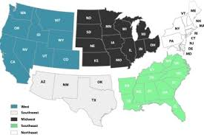

Resources
- Link to video
- Materials
  - Brochure, FAQ, Survey Information Sheet, newsletter
- Link to usable data from ED (ECLS-K, HSLS:09, etc.)
- Parent Permission Forms
- Publications related to study

Appendix A8a. Out-of-School Data Collection – Parent Letter
<PARENT NAME> [DATE]
<ADDR1>
<ADDR2>
<CITY STATE ZIP>
How a student does in 9th grade is more predictive of their odds of graduating high school than all other factors, including race, gender, socioeconomic status, and prior academic achievement, combined. https://toandthrough.uchicago.edu/mythbusters
Dear <Parent or Guardian Name>:
Your child can share his/her high school experiences and opinions and help improve education for them and other students in the future.
The U.S. Department of Education’s National Center for Education Statistics (NCES) is conducting the High School and Beyond 2020 (HS&B:20) study. Students will be asked to spend about [FILL] minutes taking a survey and answering math and reading questions on the computer. In return, we will send them a certificate for 2 hours of community service from the U.S. Department of Education and a check for [incentive]. We will then ask them to participate again in Spring 2023 to see how things change during high school and then we will collect their high school transcripts in 2023.
Please give your child the enclosed envelope so that he/she can participate. The envelope contains the information that needs to be entered into the computer to log in and complete the session.
You will also be asked to complete a survey and will receive a separate letter about your participation.
If the 1.3 million dropouts from the Class of 2010 had graduated, the nation would have seen $337 billion more in earnings over the course of the students’ lifetimes.

The enclosed brochure provides more information about the study. If you have questions, please call 1-xxx-xxx-xxxx or email us at hsb@rti.org. You can also get more information on our website <URL> and by watching this short video <URL>.

We thank you in advance for your cooperation in this important research.
Sincerely,

James L. Woodworth
NCES Commissioner

IMPORTANT: This is not a test, and it is not graded. There is little risk to participating. We follow very strict laws to protect personal information and any data collected. All information collected is securely maintained, and your name will never be stored with responses. All reports will use aggregate information for all students who participate, and you will never be identified in any reports.
NCES is authorized to conduct the High School and Beyond 2020 (HS&B:20) by the Education Sciences Reform Act of 2002 (ESRA 2002, 20 U.S.C. §9543) and to collect students’ education records from education agencies or institutions for the purposes of evaluating federally supported education programs under the Family Educational Rights and Privacy Act (FERPA, 34 CFR §§ 99.31(a)(3)(iii) and 99.35). The data are being collected for NCES by RTI International, a U.S.-based nonprofit research organization. All of the information students, parents, and staff provide may be used only for statistical purposes and may not be disclosed, or used, in identifiable form for any other purpose except as required by law (20 U.S.C. §9573 and 6 U.S.C. §151). The collected information will be combined across respondents to produce statistical reports.

Appendix A8b. Out-of-school Data Collection – Student Letter
[DATE]

<STUDENT NAME> Web Address: surveys.nces.ed.gov/hsb
<ADDR1> Student Study ID: <XXXXXXXX>
<CITY STATE ZIP> Parent Password: <XXXXXXXX><PW_ind>

Dear <Student Name>:
How a student does in 9th grade is more predictive of their odds of graduating high school than all other factors, including race, gender, socioeconomic status, and prior academic achievement, combined. https://toandthrough.uchicago.edu/mythbusters
Congratulations! You have been selected to share about your high school experiences and opinions. Your input will help to improve education for students now and in the future.
The study is called High School and Beyond 2020 or HS&B:20. HS&B:20 is conducted by the National Center for Education Statistics (NCES) in the U.S. Department of Education. We will ask for your input now, and then we will contact you again in the first half of 2023 to see how things went in high school and to see what may have changed.
This is your chance to provide information that could lead to important changes in education.
Your participation is voluntary, but we can’t do this without you. The study will take about [45-90] minutes and will include a short survey and math and reading questions. Your answers will never be shared with your parents, teachers, or school staff. We will send you a certificate for two hours of volunteer service from the U.S. Department of Education and [incentive] after you have completed the session. To participate, please use the web link and the unique student study ID and password provided above.
If the 1.3 million dropouts from the Class of 2010 had graduated, the nation would have seen $337 billion more in earnings over the course of the students’ lifetimes. Campaign for CHSE High School Equity. "Plan for Success: Communities of Color Define Policy Priorities for High School Reform." Campaign for CHSE High School Equity. Accessed February 18, 2015.

NCES has asked RTI International, a not-for-profit research organization, to collect the data for HS&B:20. We hope that you will participate in this important research. We really value your input! The enclosed brochure provides more information about the study. If you have questions, please call (xxx) xxx-xxxx or email us at hsb@rti.org.
We thank you in advance for your cooperation in this important research.
Sincerely,

James L. Woodworth
NCES Commissioner

IMPORTANT: This is not a test, and it is not graded. There is little risk to participating. We follow very strict laws to protect personal information and any data collected. All information collected is securely maintained, and your name will never be stored with responses. All reports will use aggregate information for all students who participate, and you will never be identified in any reports.
NCES is authorized to conduct the High School and Beyond 2020 (HS&B:20) by the Education Sciences Reform Act of 2002 (ESRA 2002, 20 U.S.C. §9543) and to collect students’ education records from education agencies or institutions for the purposes of evaluating federally supported education programs under the Family Educational Rights and Privacy Act (FERPA, 34 CFR §§ 99.31(a)(3)(iii) and 99.35). The data are being collected for NCES by RTI International, a U.S.-based nonprofit research organization. All of the information students, parents, and staff provide may be used only for statistical purposes and may not be disclosed, or used, in identifiable form for any other purpose except as required by law (20 U.S.C. §9573 and 6 U.S.C. §151). The collected information will be combined across respondents to produce statistical reports.

Appendix A8c. Hybrid Out-of-School Data Collection – Student Postcard

Thank you for your participation today. Please complete the rest of the session on your computer. You can log in at

Web Address: surveys.nces.ed.gov/hsb
Student Study ID: <XXXXXXXX>
Student Password: <XXXXXXXX><PW_ind>

When you have finished, we will send you a certificate for 2 hours of community service and [incentive].

Appendix A8d. Hybrid Out-of-School Data Collection – Parent Letter
[DATE]
<PARENT NAME>
<ADDR1>
<ADDR2>
<CITY STATE ZIP>
Dear <Parent or Guardian Name>:
Your child recently participated in the High School & Beyond 2020 study in school. We would like him/her to complete the rest at home.
By participating in HS&B:20, <student name> can share his/her experiences and opinions to help improve education for them and other students in the future.
The remaining portion of the session should take about {XX} minutes and will consist of <a survey and answering math and reading questions> on the computer. In return, we will send your child a certificate for 2 hours of community service from the U.S. Department of Education and $[incentive].
We will then ask your child to participate again in the Spring of 2023 to see how things change during high school and then we will collect their high school transcript in 2023.
Please give your child the enclosed envelope so that he/she can participate. The envelope contains the information that needs to be entered into the computer to log in and complete the session.
You will also be asked to complete a survey and will receive a separate letter about your participation.
The enclosed brochure provides more information about the study. If you have questions, please call (xxx) xxx-xxxx or email us at hsb@rti.org. You can also get more information on our website <URL> and by watching this short video <URL>.

We thank you in advance for your cooperation in this important research.
Sincerely,

James L. Woodworth
NCES Commissioner

IMPORTANT: This is not a test, and it is not graded. There is little risk to participating. We follow very strict laws to protect personal information and any data collected. All information collected is securely maintained, and your name will never be stored with responses. All reports will use aggregate information for all students who participate, and you will never be identified in any reports.
NCES is authorized to conduct the High School and Beyond 2020 (HS&B:20) by the Education Sciences Reform Act of 2002 (ESRA 2002, 20 U.S.C. §9543) and to collect students’ education records from education agencies or institutions for the purposes of evaluating federally supported education programs under the Family Educational Rights and Privacy Act (FERPA, 34 CFR §§ 99.31(a)(3)(iii) and 99.35). The data are being collected for NCES by RTI International, a U.S.-based nonprofit research organization. All of the information students, parents, and staff provide may be used only for statistical purposes and may not be disclosed, or used, in identifiable form for any other purpose except as required by law (20 U.S.C. §9573 and 6 U.S.C. §151). The collected information will be combined across respondents to produce statistical reports.

Appendix A8e. Hybrid Out-of-school Data Collection – Student Letter
[DATE]

<STUDENT NAME> Web Address: surveys.nces.ed.gov/hsb
<ADDR1> Student Study ID: <XXXXXXXX>
<CITY STATE ZIP> Student Password: <XXXXXXXX><PW_ind>

Dear <Student Name>:
Thank you for participating in the first part of the High School and Beyond 2020 study at your school. By sharing your school experiences and opinions, you can help to improve education for students now and in the future.
Please take [##] minutes to complete the rest of the session. Your participation is voluntary, but we can’t do this without you. Your answers will never be shared with your parents, teachers, or school staff. We will send you a certificate for two hours of volunteer service from the U.S. Department of Education and [incentive] after you have completed the session. To participate, please use the web link and the unique student study ID and password provided above.
NCES has asked RTI International, a not-for-profit research organization, to collect the data for HS&B:20. We hope that you will participate in this important research. We value and appreciate your input! The enclosed brochure provides more information about the study. If you have questions, please call 1-xxx-xxx-xxxx or email us at hsb@rti.org.
We thank you in advance for your cooperation in this important research.
Sincerely,

James L. Woodworth
NCES Commissioner

IMPORTANT: This is not a test, and it is not graded. There is little risk to participating. We follow very strict laws to protect personal information and any data collected. All information collected is securely maintained, and your name will never be stored with responses. All reports will use aggregate information for all students who participate, and you will never be identified in any reports.
NCES is authorized to conduct the High School and Beyond 2020 (HS&B:20) by the Education Sciences Reform Act of 2002 (ESRA 2002, 20 U.S.C. §9543) and to collect students’ education records from education agencies or institutions for the purposes of evaluating federally supported education programs under the Family Educational Rights and Privacy Act (FERPA, 34 CFR §§ 99.31(a)(3)(iii) and 99.35). The data are being collected for NCES by RTI International, a U.S.-based nonprofit research organization. All of the information students, parents, and staff provide may be used only for statistical purposes and may not be disclosed, or used, in identifiable form for any other purpose except as required by law (20 U.S.C. §9573 and 6 U.S.C. §151). The collected information will be combined across respondents to produce statistical reports.

Appendix A9a. Summary of Mathematics Assessment
Approximate length  Goal for Main Study |  | 30 minutes (part of a 45 min or 90 min session including math, reading, and a student survey)
Mode of administration |  | Computerized administration using Chromebooks, tablet-like computers with touchscreen capability and an attached keyboard, that will be brought in to the school by the study
Key constructs |  | Number System  - finding common factors and multiples  - comparing fractions  - applying basic operations with fractions and integers to word problems  - using basic operations  - representing and understanding rational numbers in multiple forms  - understanding the relative size of irrational numbers  Proportional Relationships  - extending students’ understanding of the number system  - multiplying and dividing fractions and multiplicative thinking  - understanding basic concepts of ratio, rate, and proportional relationships  - using rational numbers to solve problems and understand slope and functions  Expressions and Equations  - understanding the use of expressions beginning with letter representations of a single number  - applying knowledge of rational numbers and operations to solve equations  - constructing equations and inequalities to solve real-world problems  - recognizing different types of notation (such as square root)  - reasoning with equalities and inequalities  - solving and representing linear equations and inequalities  Functions  - understanding the definition of a function  - comparing functions represented in different ways  - distinguishing between linear and nonlinear functions  - comparing and creating representations of different functions  - understanding of functions to context

Appendix A9b. Summary of Reading Assessment
Approximate length  Goal for Main Study | 25 minutes (part of a 45 min or 90 min session including math, reading, and a student survey)
Mode of administration | Two-stage, computerized assessment using Chromebooks, tablet-like computers with touchscreen capability and an attached keyboard, that will be brought in to the school by the study
Key constructs | Word Recognition & Decoding  Students read words (e.g., elect), pronounceable nonwords (e.g., clort) and pseudohomophones (e.g., brane) and decide whether the stimulus is a word, not a real word, or sounds exactly like a real word.  Vocabulary  A single target word is presented and the student decides which of provided three words goes with the target word. Correct answers are either synonyms (e.g., data - information) or meaning associates (e.g., thermal - heat).  Morphological Awareness  The student completes a sentence by choosing from three words derived from the same root word (e.g., She is good at many sports, but her _______ is basketball: specialty, specialize, specialist). The target words vary in difficulty based on the frequency of the derived forms (i.e., lower frequency derivations are more difficult).  Sentence Processing  The student completes sentences of increasing length and syntactic complexity by choosing from three choices (e.g., Shouting in a voice louder than her friend Cindy's, Tonya asked Joe to unlock the door, but ______ didn’t respond: he, she, they). In this task, frequent words used in everyday language are used in the sentences to decrease the influence of vocabulary knowledge in this task. Consequently, the focus is on understanding of sentence syntax and meaning (rather than word meaning).  Efficiency of Basic Reading Comprehension (MAZE task)  Students read short passages containing sentences that are completed using a forced-choice cloze task (e.g., Agriculture meant that people stayed in one place to grow their baskets / crops / rings.). These passages are between 250-300 words in length and have Flesch-Kinkaid Grade Level estimates of grades 6 and 7. Students in this block will read approximately 3 paragraphs in this way. This task is timed such that students are given 3 minutes to complete a passage and its corresponding items, making it a measure of efficiency as well as basic comprehension.  Reading Comprehension  Students answer questions about the passage they read while doing the MAZE task. The passage presented in the MAZE task will be presented again with the correct completions for the items presented in the MAZE task. The passage will appear on the same screen as the questions. Easier questions will be selected for this skill-based block.

Appendix A9c. Summary of Student Survey

 | Student Survey
Approximate length  Goal for Main Study | 25 minutes (part of a 45 min or 90 min session including math, reading, and a student survey)
Mode of administration | Computerized administration using Chromebooks, tablet-like computers with touchscreen capability and an attached keyboard, that will be brought in to the school by the study
Key constructs | Demographics  School experiences  - Conversations with teachers about math courses, jobs or careers, and going to college  - Student outlook of guidance support at school  - Perceptions of school climate (e.g., safety and rule fairness)  - Academic culture (e.g., high standards and expectations)  - Problems at school (e.g., student misconduct and bullying)  - Usage of school library  - Attendance information  - Perspective of math and science education  Activities  - Time use-structured activities: student employment; participating in activities (sports, clubs, etc.)  - Time use-unstructured or unsupervised activities (e.g., watching television, doing homework, or being with friends)  - Technology activities  Health  - Physical well-being  Peers  - Perception of peer social support  - Peer victimization  - Perception of peer values (importance of education, engagement in risky behaviors, peer pressure)  - Belongingness (a sense of belonging in school)  - Risk-taking (students’ sensation seeking behaviors)  “Tell us about Yourself”  - Academic expectations  - Identity formation (interests of students (“sparks”); ethnic identity; perceived social status)  - Socioemotional well-being  - Student employment and out-of-school activities  Home Life  - Household composition  - Neighborhood characteristics  - Language (student uses most, family uses most)  - Parental academic expectations  - Parental background (education and employment)  - Parental involvement in student’s education  Future  - Plans for postsecondary education

Appendix A9d. Summary of Parent Survey

 | Parent Survey
Approximate length | 15 or 30 minutes
Mode of administration | Web-based administration accessible by individualized link, with a telephone-based interview option available.
Key constructs | Introduction  - Student demographics  Family Roster  - Household composition  - Neighborhood characteristics  Family and Parent Background  - Language (student uses most, family uses most)  - Parent education  Home Life  - Technology usage in the home environment  - Student out-of-school activities  - Parent-child relationship—monitoring/disclosure  - Risk-taking and risky behaviors (i.e. students’ sensation seeking behaviors and parents’ report of students’ deviant behaviors)  - Community perspectives (poverty, crime, victimization)  Child’s School Experiences  - Overall academic experiences  - Perspective of math and science education  - School safety (bullying prevention, school safety policies)  - Experiences of guidance services offered and utilized  - Attendance information  - Student’s peer relationships at school  Child Health and Well-Being  - Health and physical well being  - IEP and Disability Details  Employment and Income  - Parent occupation  - Family income  - Family assets  Mobility  - Mobility (number of school changes)  - Locating information  Parent Involvement  - High school educational expenses incurred by parent  - Parental academic expectations  - Postsecondary education plans for student

Appendix A9e. Summary of Mathematics Teacher Survey

 | Mathematics Teacher Survey
Approximate length | 10-20 minutes for teacher background and classroom characteristics; 4 minutes per student report
Mode of administration | Web-based administration accessible by individualized link.
Key constructs | Teacher background and classroom characteristics  Student and Classroom Characteristics  - Class size (number of students)  - Course type  - Heterogeneity in math ability  - Classroom communication utilized  - Classroom climate (e.g., misbehavior)  Classroom Mathematics Instruction  - Curriculum used  - Opportunities to learn (length of course)  - Content covered in course (Common Core & practice standards)  - Instructional practice/pedagogy  - Availability and use of classroom technology  Views on Teaching and School Environment  - Factors for determining math course  - Teacher efficacy and staff evaluations  - Instructional leadership  - Academic culture (high standards and expectations)  - Teaching climate  Teacher Background  - Education and degree  - Years of experience  - Certification  - Demographic information  Teacher provided information on individual students  Mathematical Thinking  - Math class performance  Social Skills  - Approaches to learning  - Externalizing behaviors  - Social skills and positive behavior  Classroom Behaviors  - Academic engagement (behavioral and cognitive)  - Attendance  Student and Classroom Information  Math support services (tutoring, pull-out, instruction frequency)

Appendix A9f. Summary of School Counselor Survey

 | School Counselor Survey
Approximate length | 30 minutes
Mode of administration | Web-based administration accessible by individualized link.
Key constructs | School Characteristics  - School characteristics (e.g., average daily attendance, tuition)  - Student population (e.g., percent IEP, percent ELL/LEP)  - Providing additional support for struggling students (tutoring, extra assistance, pull-out, homework assistance)  Counseling Program Characteristics  - Description of programs and services offered  - Participation rates in programs and services offered  School Programs and Practices  - Courses offered  - Subject-specific academic tracking practices (order/progression of courses)  - School extended learning opportunities: additional instruction time, Gifted and Talented, International Baccalaureate  - Assisting students with transitions from middle grades to high school; from high school to postsecondary or workforce  - Graduation requirements  School Environment  - Problems at school: absenteeism, student mobility, student misconduct, bullying  - Safety and school-level security (police officer on site, security officer on site, teachers supervise hallways during transition)  - School performance (graduation rates, college enrollment rates, mastery of career-ready standards)  School’s Teachers  - Staff evaluation procedures  School Counselor Background  - Demographic information  Years of experience

Appendix A9g. Summary of School Administrator Survey
 | School Administrator Survey
Approximate length  Goal for Main Study | 40 minutes
Mode of administration | Web-based administration accessible by individualized link.
Key constructs | School Characteristics  - School characteristics (e.g., average daily attendance, tuition)  - Student population (e.g., percent IEP, percent ELL/LEP)  - Providing additional support for struggling students (tutoring, extra assistance, pull-out, homework assistance)  - School calendar  - Admissions criteria  Services and Supports for Students with Disabilities  - IEP/Disability-School services and programs  School Programs and Practices  - Courses offered  - Subject-specific academic tracking practices (order/progression of courses)  - School extended learning opportunities: additional instruction time, Gifted and Talented, International Baccalaureate  - Interdisciplinary teaching and collaboration between courses  - Assisting students with transitions from middle grades to high school  - Graduation requirements  School Environment  - Problems at school: absenteeism, student mobility, student misconduct, bullying  - School-level security (police officer on site, security officer on site, teachers supervise hallways during transition)  - Community perspectives (poverty, crime, victimization)  - Availability and use of classroom technology for instruction and learning  - Parental engagement and communication approaches  School’s Teachers  - School’s teachers: number, preparation  - Staff evaluation procedures  School Administrator Background  - Demographic information  Years of experience

Appendix A10. Student Rostering Materials
Request for Student Roster Information from Schools
[Date]
[Title] [Name First] [Name Last]
[Title/Department]
[State District]
[Address]
[City], [State] [Zip code]

Dear [School Contact Name]:

We are looking forward to working with your students on the High School and Beyond 2020 (HS&B:20) study. Your school’s participation is important to the success of the study and we appreciate it! Only a subset of students from your school will be asked to participate. To select the student sample, we are asking you to provide information about each student enrolled in your school in grades 9 and 12. About 35 students per grade, on average will be selected.

Please provide your roster ASAP once your roster is stable for the 2019-2020 school year.

This information request conforms to the requirements of the Family Educational Rights and Privacy Act of 1974 (FERPA) (20 U.S.C. §1232g; 34 CFR Part 99). For the purposes of this collection of data, FERPA permits education agencies and institutions to disclose personally identifiable information from students’ education records, without consent, to authorized representatives of the Secretary of Education in connection with an evaluation of federally supported education programs (34 CFR §§ 99.31(a)(3)(iii) and 99.35). Student data are subject to strict protections that are adhered to by NCES and its contractor organizations. Roster information will be securely destroyed when no longer needed for the purposes specified in 34 CFR §99.35.

NCES is authorized to conduct the High School and Beyond 2020 (HS&B:20) by the Education Sciences Reform Act of 2002 (ESRA 2002, 20 U.S.C. §9543). The data are being collected for NCES by RTI International, a U.S.-based nonprofit research organization. All of the information you provide may be used only for statistical purposes and may not be disclosed, or used, in identifiable form for any other purpose except as required by law (20 U.S.C. §9573 and 6 U.S.C. §151).

The key characteristics of interest include:
- Name
- District/School Student identification number
- Date of birth
- Grade level * (9, 12, or U=ungraded)
- Sex
- Race/ethnicity
- ELL status
- Parent contact information
  - Name (last, first)
  - Parent Street address, City, State, Zip
  - Home phone number
  - Cell phone number
  - E-mail address
- Student’s Math Teacher Name (last, first)
- Student’s Math Teacher Email Address
- Student’s Math Course Name
- Student’s Math Course Period/Section

Sincerely,

Dan Pratt, Project Director

Instructions: Please provide the information below for each student currently enrolled in the ninth and twelfth grades at your school. This information will be used to select an average of 35 ninth grade and 35 twelfth grade students from your school for the study.

General Student information |  |  |  |  |  |  | Race  (Y/N all that apply) |  |  |  |  | Ethnicity  (Y/N) | ELL | Parent Contact information |  |  |  |  |  |  |  |  | Student's Math Teacher
StudentID | FirstName | LastName | Suffix | Grade 9, Grade 12, or U=ungraded | Date of birth  MM/DD/YY | Sex(M/F) | White | Black or African American | Asian | Native Hawaiian or Pacific Islander | American Indian or Alaska Native | Hispanic | Yes/No | Parent's First Name | Parent's Last Name | Parent's Address | Parent City | Parent State | Parent Zip | Parent's Email | Parent's Home Phone | Parent's Cell Phone | MathTeacherFirstName | MathTeacherLastName | MathTeacherEmail | Math Course Name | Math Course Period/Section

NCES is authorized to conduct the High School and Beyond 2020 (HS&B:20) by the Education Sciences Reform Act of 2002 (ESRA 2002, 20 U.S.C. §9543) and to collect students’ education records from education agencies or institutions for the purposes of evaluating federally supported education programs under the Family Educational Rights and Privacy Act (FERPA, 34 CFR §§ 99.31(a)(3)(iii) and 99.35). The data are being collected for NCES by RTI International, a U.S.-based nonprofit research organization. All of the information students, parents, and staff provide may be used only for statistical purposes and may not be disclosed, or used, in identifiable form for any other purpose except as required by law (20 U.S.C. §9573 and 6 U.S.C. §151). The collected information will be combined across respondents to produce statistical reports.

According to the Paperwork Reduction Act of 1995, no persons are required to respond to a collection of information unless it displays a valid OMB control number. The valid OMB control number for this voluntary information collection is 1850-XXXX. Approval expires XX/XX/20XX. The time required to complete this information collection is estimated to average approximately 5 minutes per row, including the time to review instructions, gather the data needed, and complete and review the information collection. If you have any comments concerning the accuracy of the time estimate, suggestions for improving this information collection, or any comments or concerns regarding the status of your individual submission, please write directly to: The High School and Beyond 2020 (HS&B:20), National Center for Education Statistics, PCP, 550 12th St., SW, 4th floor, Washington, DC 20202.

Appendix A11. Parent Data Collection Letter
Dear Parent or Guardian,

We are thrilled that your child’s school is participating in the High School and Beyond 2020 study. Here at the National Center for Education Statistics (NCES) in the U.S. Department of Education, we are reaching out to schools, students, parents, school counselors, math teachers, and school administrators to understand the high school experience. The information that is provided will contribute to improving education for students now and in the future.

We would greatly appreciate it if the person most knowledgeable about <student_firstname>’s school and home life would complete a [##]-minute online survey for the study. As a token of our appreciation for being a part of the study, when you finish the survey either online or over the phone, you will receive [incentive]. You may have already received a letter inviting your child to participate in HS&B:20, or that letter will be coming to you in the next few weeks.
While they may lag their peers in other nations, American students are outperforming one group: their grandparents. In fact, Millennials are on track to be the most educated generation in history compared with older generations when they were the same age.
http://www.pewresearch.org/fact-tank/2015/08/10/5-facts-about-americas-students/

To access the parent survey, please log into:
surveys.nces.ed.gov/hsb
Study ID: xxxxxxxx
password: xxxxxxxx.

NCES has been conducting studies like this since 1970. This is your opportunity to contribute information that may lead to change.

For more information, please visit the study website at [URL] or watch this brief video about the study [URL]. You may also call the study hotline at (xxx) xxx-xxxx or send email to hsb@rti.org. Thank you for supporting education by participating in this important study.

Sincerely,

<Name>
<Title>

Enclosures: Study Information Sheet, Brochure and Flyer

The study is conducted by the National Center for Education Statistics (NCES), part of the U.S. Department of Education. All of the information collected is protected, as required by law. NCES is authorized to conduct HS&B:20 by the Education Sciences Reform Act of 2002 (ESRA 2002, 20 U.S.C. §9543) and to collect students’ education records from education agencies or institutions for the purposes of evaluating federally supported education programs under the Family Educational Rights and Privacy Act (FERPA, 34 CFR §§ 99.31(a)(3)(iii) and 99.35). The data are being collected for NCES by RTI International, a U.S.-based nonprofit research organization. All of the information you and your child provide may be used only for statistical purposes and may not be disclosed, or used, in identifiable form for any other purpose except as required by law (20 U.S.C. §9573 and 6 U.S.C. §151). The collected information will be combined across respondents to produce statistical reports. Completing the survey is voluntary for you and your child and there are no penalties for not participating. You may also skip any question you do not want to answer if you choose to participate.

Appendix A12a. Staff Data Collection Letters – Math Teacher
[DATE]
Website: <insert URL>
Study ID: <ID>
Password: <password>
[TEACHER NAME]
[SCHOOL NAME]
[ADDR1]
[ADDR2]
[CITY STATE ZIP]
Dear [TEACHER NAME],
[SCHOOL NAME] has graciously agreed to participate in the High School and Beyond Study of 2020 (HS&B:2020), which is conducted by the National Center for Education Statistics (NCES), part of the U.S. Department of Education’s Institute of Education Sciences. HS&B20 focuses on factors which lead to a positive trajectory of high school students continuing to postsecondary education and the workforce. The study provides an opportunity for math teachers to share their experiences and opinions which can shape the future of education. This HS&B:20 data collection includes a teacher survey of approximately [fill] math teachers in grades 9 &12 around the country. You are one of the esteemed teachers selected to participate in the study.
How a student does in 9th grade is more predictive of their odds of graduating high school than all other factors, including race, gender, socioeconomic status, and prior academic achievement, combined. https://toandthrough.uchicago.edu/mythbusters
HS&B is more than a research study; this is an opportunity for you to provide information about your experiences and opinions as a teacher, providing essential information about academic policies and programs, activities and curriculum in the classroom, and other school related experiences that impact student learning. The survey will include several general questions about your background and experiences at school and in the classroom (about [##] minutes), as well as questions about specific students that are part of the study (about 4 minutes per student). Your participation is voluntary but very important to the success of this study.
To access the questionnaire online, please use the web address and unique study ID and password provided on this letter. As a token of our appreciation, you will receive [incentive] for answering the questions about your background, and [incentive] per student for answering questions about specific students. You will also receive continuing education credits for your time.
Should you have any questions, please call the HS&B:20 information number, xxx-xxx-xxxx, or send an email to hsb@rti.org. You can also learn more about the study and education research focused on high school students by visiting the HS&B:20 website at <insert URL>, or by watching a short video <insert link>.
We thank you in advance for your cooperation in making this important research study a success.
Sincerely,

James L. Woodworth
NCES Commissioner

NCES is authorized to conduct the High School and Beyond 2020 (HS&B:20) by the Education Sciences Reform Act of 2002 (ESRA 2002, 20 U.S.C. §9543) and to collect students’ education records from education agencies or institutions for the purposes of evaluating federally supported education programs under the Family Educational Rights and Privacy Act (FERPA, 34 CFR §§ 99.31(a)(3)(iii) and 99.35). The data are being collected for NCES by RTI International, a U.S.-based nonprofit research organization. All of the information students, parents, and staff provide may be used only for statistical purposes and may not be disclosed, or used, in identifiable form for any other purpose except as required by law (20 U.S.C. §9573 and 6 U.S.C. §151). The collected information will be combined across respondents to produce statistical reports.

Enclosures: HS&B:20 Brochure, List of endorsing organizations, Frequently Asked Questions (FAQ) sheet

Appendix A12b. Staff Data Collection Letters – Guidance Counselor
[DATE]
Website: <insert URL>
Study ID: <ID>
Password: <password>
[TEACHER NAME]
[SCHOOL NAME]
[ADDR1]
[ADDR2]
[CITY STATE ZIP]
Dear [COUNSELOR NAME],
Data collection for the High School and Beyond Study of 2020 (HS&B:20) is now underway and we thank you for your school’s continued participation in this important research. HS&B:2020, which is conducted by the National Center for Education Statistics (NCES), part of the U.S. Department of Education’s Institute of Education Sciences, focuses on factors which lead to a positive trajectory of high school students continuing to postsecondary education and the workforce. HS&B:20 will include students nationwide in both 9th and 12th grade.
How a student does in 9th grade is more predictive of their odds of graduating high school than all other factors, including race, gender, socioeconomic status, and prior academic achievement, combined. https://toandthrough.uchicago.edu/mythbusters
HS&B is more than a research study; this is an opportunity for you to provide information about your experiences and opinions as a guidance counselor. Your participation is voluntary but very important to the success of this study. We are asking you to complete a 30-minute questionnaire to provide essential information about guidance counselor programs and services, activities and curriculum in the school, and other school related experiences that impact student learning.
You may receive continuing education credits for your time. To access the questionnaire online, please use the web address and unique study ID and password provided on this letter. We recommend gathering the following information in advance of completing the survey:
- Guidance programs offered at school
- Participation rates in programs and services offered
- Graduation requirements
- School personnel counts
- Student population (e.g., percent IEP, percent ELL/LEP)
Should you have any questions, please call the HS&B:20 information number, (xxx) xxx-xxxx, or send an email to hsb@rti.org. You can also learn more about the study and education research focused on students in the middle grades by visiting the HS&B:20 website at <insert URL>, or by watching a short video at <insert link>.
We thank you in advance for your cooperation in making this important research study a success.
Sincerely,

James L. Woodworth
NCES Commissioner

NCES is authorized to conduct the High School and Beyond 2020 (HS&B:20) by the Education Sciences Reform Act of 2002 (ESRA 2002, 20 U.S.C. §9543) and to collect students’ education records from education agencies or institutions for the purposes of evaluating federally supported education programs under the Family Educational Rights and Privacy Act (FERPA, 34 CFR §§ 99.31(a)(3)(iii) and 99.35). The data are being collected for NCES by RTI International, a U.S.-based nonprofit research organization. All of the information students, parents, and staff provide may be used only for statistical purposes and may not be disclosed, or used, in identifiable form for any other purpose except as required by law (20 U.S.C. §9573 and 6 U.S.C. §151). The collected information will be combined across respondents to produce statistical reports.

Enclosures: HS&B:20 Brochure, List of endorsing organizations, Frequently Asked Questions (FAQ) sheet

Appendix A12c. Staff Data Collection Letters – School Administrator
[DATE]
Website: <insert URL>
Study ID: <ID>
Password: <password>
[TEACHER NAME]
[SCHOOL NAME]
[ADDR1]
[ADDR2]
[CITY STATE ZIP]
Dear [ADMIN NAME],
Data collection for the High School and Beyond Study of 2020 (HS&B:20) is now underway and we thank you for your school’s continued participation in this important research. HS&B:2020, which is conducted by the National Center for Education Statistics (NCES), part of the U.S. Department of Education’s Institute of Education Sciences, focuses on factors which lead to a positive trajectory of high school students continuing to postsecondary education and the workforce. HS&B:20 will include students nationwide in both 9th and 12th grade.
While they may lag their peers in other nations, American students are outperforming one group: their grandparents. In fact, Millennials are on track to be the most educated generation in history compared with older generations when they were the same age.
http://www.pewresearch.org/fact-tank/2015/08/10/5-facts-about-americas-students/

HS&B is more than a research study; this is an opportunity for you to provide information about your experiences and opinions as a school administrator. Your participation is voluntary but very important to the success of this study. We are asking you to complete a 40-minute questionnaire to provide essential information about academic policies and programs, activities and curriculum in the school, and other school related experiences that impact student learning.
You may receive continuing education credits for your time. To access the questionnaire online, please use the web address and unique study ID and password provided on this letter. We recommend gathering the following information in advance of completing the survey:
- Student attendance and matriculation information
- Student body demographics
- Math curriculum information
- School personnel counts
- State assessment scores
- Programs, services, and supports available for students with IEPs, and the percentage of students who use them
If there is someone at your school more knowledgeable about the students, teachers, programs, and services at your school, please provide him or her with this letter and enclosed information so that he or she may complete the survey for your school.
Should you have any questions, please call the HS&B:20 information number, (xxx) xxx-xxxx, or send an email to hsb@rti.org. You can also learn more about the study and education research focused on students in the middle grades by visiting the HS&B:20 website at <insert URL>, or by watching a short video at <insert link>.
We thank you in advance for your cooperation in making this important research study a success.
Sincerely,

James L. Woodworth
NCES Commissioner

NCES is authorized to conduct the High School and Beyond 2020 (HS&B:20) by the Education Sciences Reform Act of 2002 (ESRA 2002, 20 U.S.C. §9543) and to collect students’ education records from education agencies or institutions for the purposes of evaluating federally supported education programs under the Family Educational Rights and Privacy Act (FERPA, 34 CFR §§ 99.31(a)(3)(iii) and 99.35). The data are being collected for NCES by RTI International, a U.S.-based nonprofit research organization. All of the information students, parents, and staff provide may be used only for statistical purposes and may not be disclosed, or used, in identifiable form for any other purpose except as required by law (20 U.S.C. §9573 and 6 U.S.C. §151). The collected information will be combined across respondents to produce statistical reports.

Enclosures: HS&B:20 Brochure, List of endorsing organizations, Frequently Asked Questions (FAQ) sheet

