Appendix D:
Recruiting Advertisements

Facebook Advertisement—English
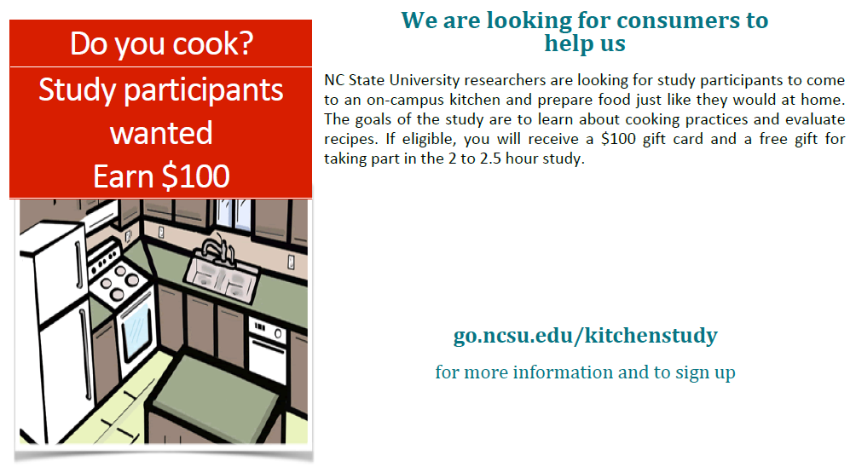

Twitter Advertisement - English


Facebook Advertisement—Spanish



Twitter Advertisement—Spanish



