APPENDIX J
Distributor Interview Thank you Email

OMB Number: 0584-XXXX
Expiration Date: xx/xx/20xx
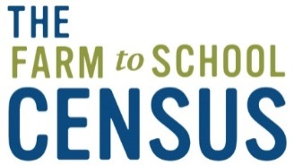

Dear [DISTRIBUTOR NAME],
I am writing on behalf of the entire Farm to School Study Team to say a big THANK YOU to you and [INSERT NAME OF COMPANY] for participating in the Distributor Interview and sharing your industry knowledge and experience regarding the processes and challenges of using local supply chains, and the economic scope and impacts of local food purchases. Your input will provide critical feedback to inform FNS policy decisions.
As always – if you have any questions about the study please contact the Abt project team toll-free at 866-778-1316 from 9 AM to 9 PM ET, or e-mail farmtoschool@abtassoc.com.
Thank you again for your help with this important study. We greatly appreciate your participation.
Sincerely,
Maria Boyle
Project Director
Farm to School Census and Comprehensive Review
Abt Associates

According to the Paperwork Reduction Act of 1995, an agency may not conduct or sponsor, and a person is not required to respond to, a collection of information unless it displays a valid OMB control number. The valid OMB control number for this information collection is 0584-XXXX. The time required to complete this information collection is estimated to average 2 minutes per response, including the time for reviewing instructions, searching existing data sources, gathering and maintaining the data needed, and completing and reviewing the collection of information. Send comments regarding this burden estimate or any other aspect of this collection of information, including suggestions for reducing this burden, to: U.S. Department of Agriculture, Food and Nutrition Services, Office of Policy Support, 3101 Park Center Drive, Room 1014, Alexandria, VA 22302, ATTN: PRA (0584-xxxx). Do not return the completed form to this address

