APPENDIX N.1
Census Reminder Emails from State Child Nutrition Directors to SFAs
(EMAIL FROM STUDY TEAM To STATE CHILD NUTRITION DIRECTORS)

OMB Number: 0584-XXXX
Expiration Date: xx/xx/20xx

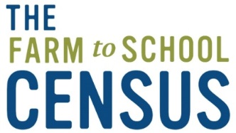

Dear (State CN Director’s Name):
Thank you for helping to make the 2019 Census a success!
We are actively reminding SFAs to participate in the Census, but would greatly appreciate if would send the attached email to all SFAs in your State or territory to remind them to complete the 2019 Census.
If your office has its own system for sending bulletins or newsletters to all SFAs in your State, please feel free to send the attached email via that system instead of using our list. Abt will then send each SFA Director their personalized link to the 2019 Census in our reminder emails.
If you have any questions, please contact the Abt project team from 9 am to 9 pm ET toll-free at 866-778-1316, or e-mail farmtoschool@abtassoc.com.
Thank you in advance for your support in maximizing participation in the 2019 Farm to School Census!
Sincerely,

Maria Boyle
Project Director
Farm to School Census and Comprehensive Review
Abt Associates

Attached: Census Reminder Emails from State Child Nutrition Directors to SFAs
According to the Paperwork Reduction Act of 1995, an agency may not conduct or sponsor, and a person is not required to respond to, a collection of information unless it displays a valid OMB control number. The valid OMB control number for this information collection is 0584-XXXX. The time required to complete this information collection is estimated to average 30 minutes per response, including the time for reviewing instructions, searching existing data sources, gathering and maintaining the data needed, and completing and reviewing the collection of information. Send comments regarding this burden estimate or any other aspect of this collection of information, including suggestions for reducing this burden, to: U.S. Department of Agriculture, Food and Nutrition Services, Office of Policy Support, 3101 Park Center Drive, Room 1014, Alexandria, VA 22302, ATTN: PRA (0584-xxxx). Do not return the completed form to this address

