APPENDIX Q
Census Frequently Asked Questions (FAQs)

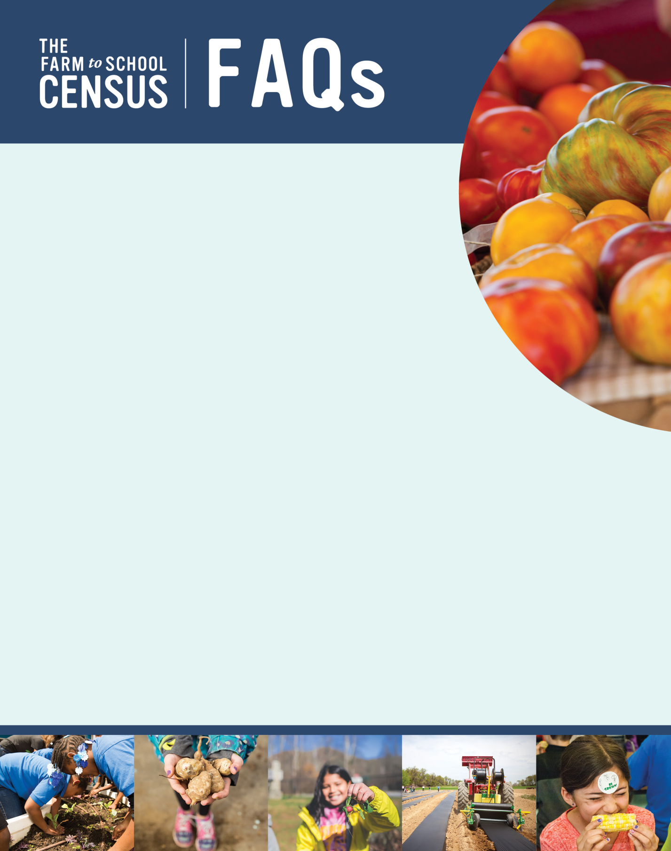

What is the purpose of the Farm to School Census?
The 2019 Farm to School Census (2019 Census) of School Food Authorities (SFAs) will
collect data on local food purchasing for school meals, school food gardens, other
farm to school activities and policies, and evidence of the economic and nutritional
impacts of farm to school activities, among approximately 20,000 SFAs across the
country. The final report will comprehensively examine farm to school efforts and its
evolution since the passage of the 2010 Child Nutrition Reauthorization through 2020.
Where can I find the final Census Report and data?
When posted, the report will be available on this site:
https://farmtoschoolcensus.fns.usda.gov. Your personal data will not be linked to
your Census responses, but all Census data will be made publicly available, as they were in
the past. Click here to see the public data set from the 2015 Census:
https://farmtoschoolcensus.fns.usda.gov/data-explorer
Who was selected to participate?
All public (including charter schools) and private SFAs that participate in the National School
Lunch Program are being asked to complete the Census. SFA names, the names of SFA Directors, and
contact information were provided by State Child Nutrition offices.
I am an SFA Director. What do you need me to do for this study?
We need you to complete the Census. SFA Directors will be emailed a link to the Census. Please follow the link, where you will find instructions, an optional worksheet [Insert link to worksheet], and the Census questions.
The schools in my district don’t do any farm to school activities – do I still need to fill out the Census?
Yes! All public and private school food authorities (SFAs) that participate in the National School Lunch Program (NSLP) in all 50 States, as well as Guam, Puerto Rico, the Virgin Islands, American Samoa, and Washington, D.C. should complete the 2019 Census. This effort will help us understand why and why not SFAs and schools do farm to school activities and will help the USDA provide support to farm to school activities in the future.
What if I don’t know the answers to the Census questions?
You may need to consult with your farm to school partners, such as vendors, school garden coordinators, foodservice staff, or teachers. To help you gather the necessary information for the Census, we prepared an optional worksheet [Insert link to worksheet] that is available on the Census webpage. It will walk you through the information that will be helpful to collect ahead of completing the Census.
Do I need to complete all the Census questions at one time?
No, you do not need to complete the Census all at once. You will be able to answer questions, save your responses, close out of the Census, and return to complete it at a later time.
I don’t think I am the correct person to complete the Census. I don’t know anything about farm to school in my SFA.
If you are not at all knowledgeable about farm to school in your SFA or are no longer the SFA Director, please let the study team know by contacting Maria Boyle at the email or phone number listed below.

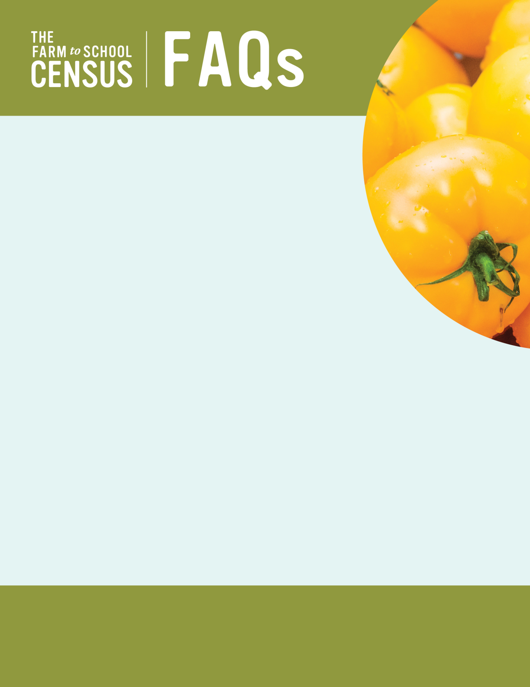

How long will the Census take me to complete?
The Census could take up to 30 minutes to complete for some SFAs. Most will
take between 5 and 30 minutes to complete.
Why should I complete the Census?
Participation by all SFAs will ensure that we have an accurate representation of farm to
school activities, including which farm to school activities SFAs administer, what has
changed since the 2015 Census, how SFAs and the community benefit from farm to school,
and the challenges of participating in farm to school.
When will the Census be conducted?
The 2019 Farm to School Census will be distributed in February 2019.
Who can I contact for more information?

Maria Boyle Ashley Chaifetz
Project Director Project Officer
Farm to School Census and Farm to School Census and
Comprehensive Review Comprehensive Review
Abt Associates FNS/USDA
866-778-1316 703-457-7741
farmtoschool@abtassoc.com Ashley.Chaifetz@fns.usda.gov

Farm to School Regional Leads
Mid-Atlantic Mountain Plains Midwest
Tegan Hagy Andrea Northrup Jenna Segal
609-259-5071 303-844-4417 312-886-4613
tegan.hagy@fns.usda.gov andrea.northup@fns.usda.gov jenna.segal@fns.usda.gov
Southeast Northeast Southwest
Samantha Benjamin-Kirk Danielle Fleury Rachel Spencer
404-562-1813 617-565-1604 214-290-9887
samantha.benjamin-kirk@fns.usda.gov danielle.fleury@fns.usda.gov rachel.spencer@fns.usda.gov
Western
JuliAnna Arnett
415-293-3720
julianna.arnett@fns.usda.gov

According to the Paperwork Reduction Act of 1995, an agency may not conduct or sponsor, and a person is not required to respond to, a collection of information unless it displays a valid OMB control number. The valid OMB control number for this information collection is 0584-XXXX. The time required to complete this information collection is estimated to average 15 minutes per response, including the time for reviewing instructions, searching existing data sources, gathering and maintaining the data needed, and completing and reviewing the collection of information. Send comments regarding this burden estimate or any other aspect of this collection of information, including suggestions for reducing this burden, to: U.S. Department of Agriculture, Food and Nutrition Services, Office of Policy Support, 3101 Park Center Drive, Room 1014, Alexandria, VA 22302, ATTN: PRA (0584-xxxx). Do not return the completed form to this address

