PRE-TRIP VESSEL SAFETY CHECKLIST

NMFS West Coast Region Fisheries Observer Program

Observers must verify the presence of each item on the list when embarking a vessel. Please advise the Logistics Coordinator or Project Manager if a vessel does not provide these safety items. DO NOT LEAVE ON A VESSEL YOU FEEL IS UNSAFE

Trip Number: Vessel Name: _____________________

Observer Name: __________________ Total # People On Board: ___________

Signature: ________________________ Date: ___________________________

USCG Commercial Fishing Vessel Safety Examination Decal

Distance Rating (NM) ________________

Safety Decal Number _________________
Expiration Date _____________________

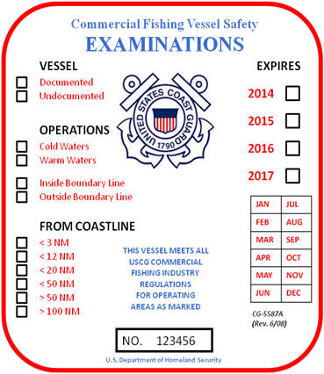

EPIRB

Hydrostatic Release Expiration __________

Battery Expiration ____________________

NOAA Registration Expiration __________

Registered to ________________________
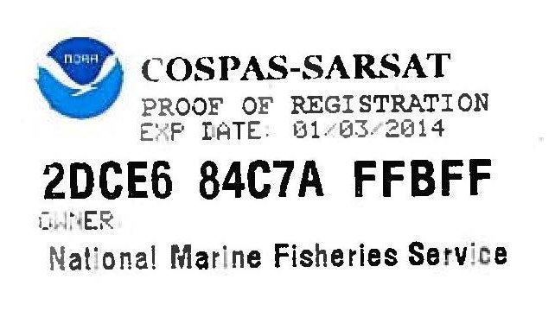

Immersion Suits (required north of 32° N latitude)

Enough for all people on board (Y/N) ____
Survival Craft (check type)

____ Inflatable Liferaft ____ Inflatable Buoyant Apparatus ____ Buoyant Apparatus

Capacity ______

Service Expiration Date ___________

Hydrostatic Release Expiration __________

Installed As Shown? (Y/N) __________

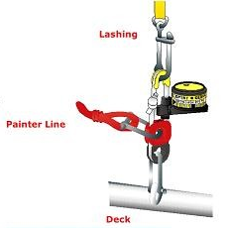

Flares ____ 3 Parachute ____ 6 Handheld ____ 3 Smoke
(minimum required = 3/6/3)

NOTES

Life Rings (check if present)

____ 1 Ring Life Buoy (vessels 26 feet to less than 65 feet)

____ 3 Ring Life Buoys (vessels 65 feet or greater)

Fire Extinguishers

Location 1 ___________________ Charged (Y/N) ____

Location 2 ___________________ Charged (Y/N) ____

Location 3 ___________________ Charged (Y/N) ____

First Aid Equipment Location ___________________

Radios (check all that apply) ____ SSB ____ VHF

GPS/Plotter (check if present) ____

