Screenshots of Advance Landing Notifications on Vessel Monitoring Systems

The proposed rule to implement Amendment 36A to the Fishery Management Plan for Reef Fish in the Gulf of Mexico (Gulf) would require an advance landing notification on any commercial trip that lands reef fish species from the Gulf that are not managed under the individual fishing quota (IFQ) programs, without also landing IFQ-managed species on the same trip.

NMFS uses the Notification of Landing form as part of the Gulf IFQ programs to collect information for the management of IFQ species. The new vessel monitoring systems (VMSs) form version for proposed requirements under Amendment 36A would be modifications of the existing form version. For example, the pending VMS form version would replace an inapplicable question about the species landed and the estimated weight of catch and add a statement to which the vessel operator would affirm that there are no IFQ species on board the vessel.

The figures included on the following pages provide screenshot examples from VMS units required on board fishing vessels with federal commercial permits for Gulf reef fish. The screenshots depict the current commercial IFQ programs’ advanced notice of landing form from two of the VMS vendors’ units. There are several VMS vendors approved by NMFS and each vendor develops software to satisfy data collection requirements and specifications. Therefore, the appearance and exact language for how the questions are asked may differ by vendor; for example, one vendor uses multiple screens, while another uses pop-up boxes. Currently, the actual form screens to submit an advance landing notification for non-IFQ Gulf reef fish species across the VMS vendors are pending development and unavailable to view.

Figure 1. Opening screenshots of the CLS America tablet and Skymate tablet’s commercial advance landing notifications.

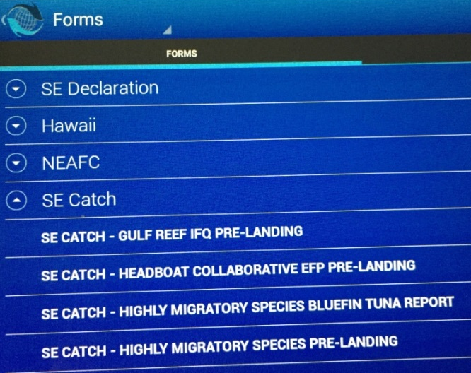
CLS America Screenshots Skymate Screenshots
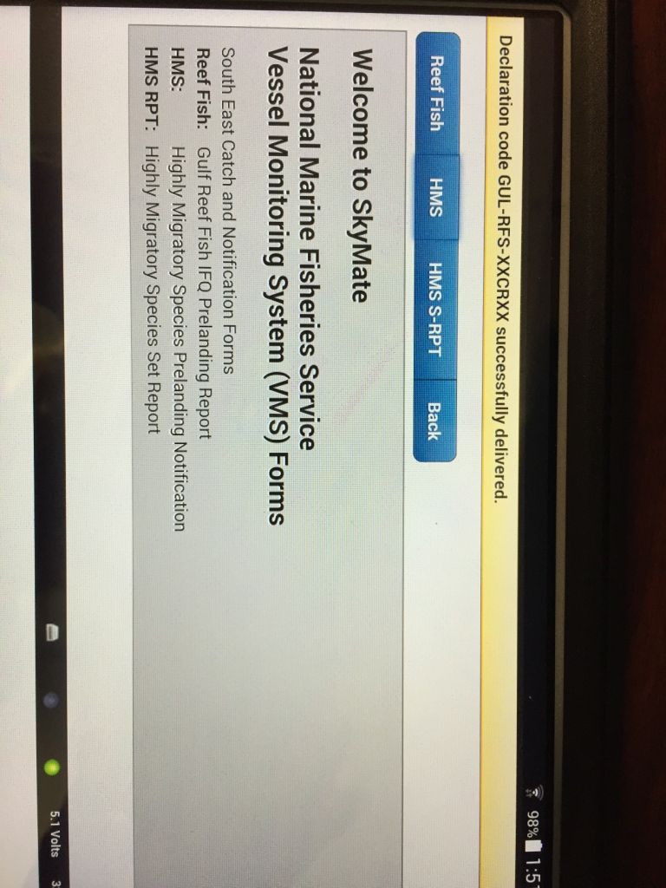

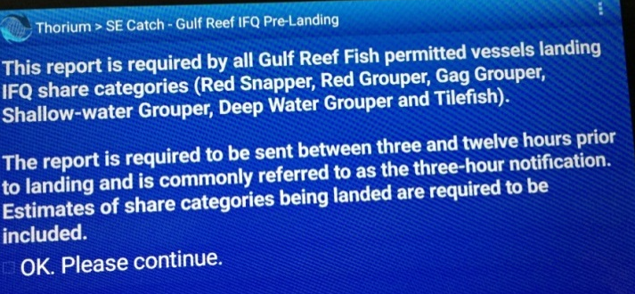

Figure 2. Screenshots of the CLS America tablet and Skymate tablet’s questions for the landing location.

CLS America Screenshots Skymate Screenshots

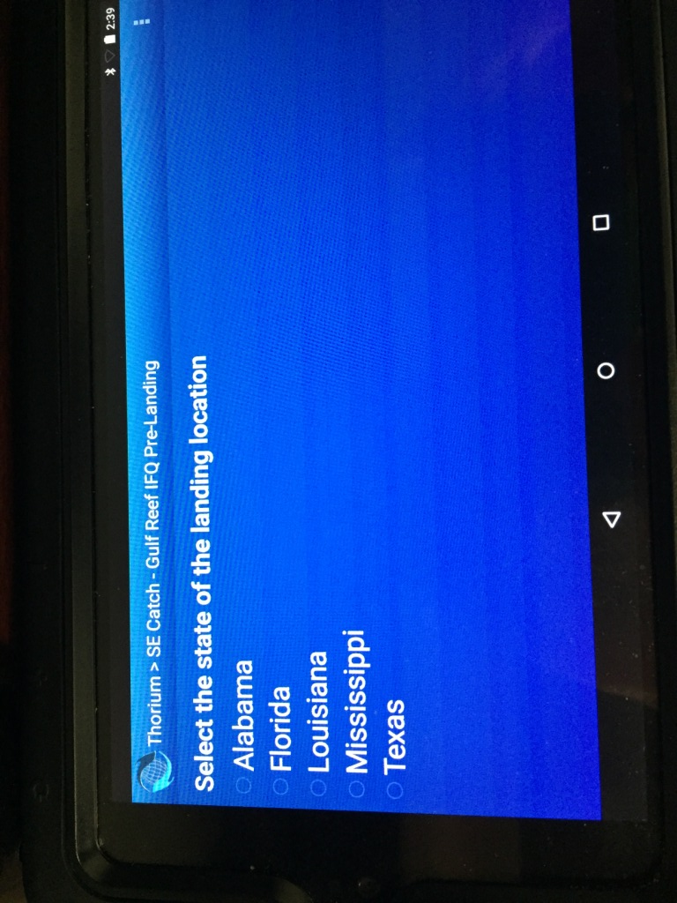
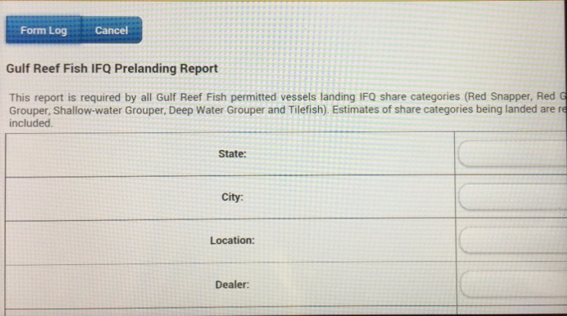

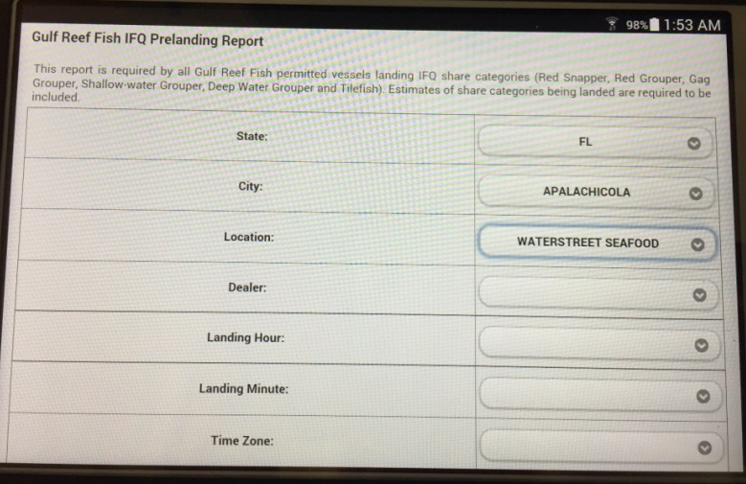
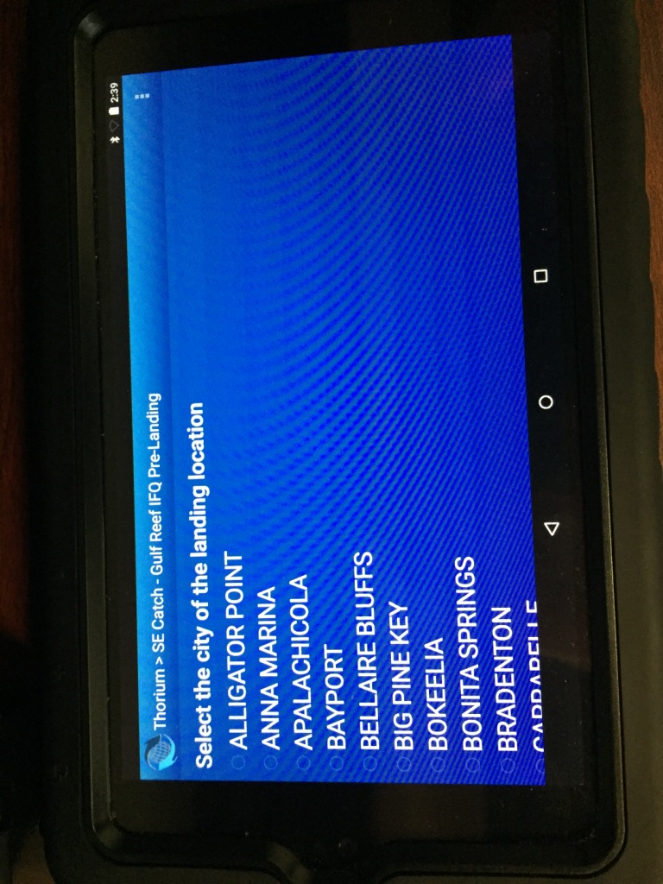
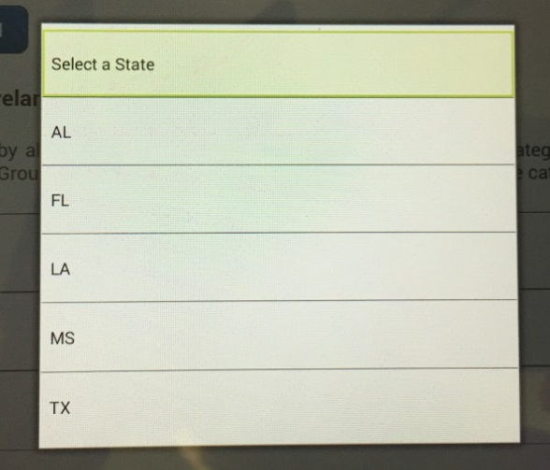
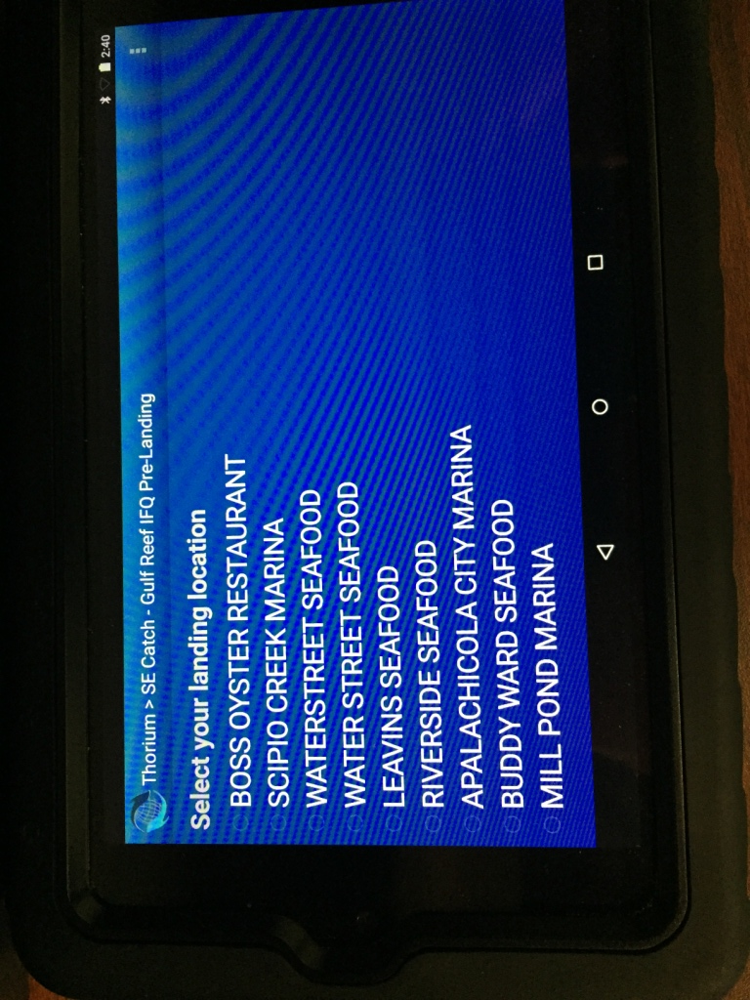

Figure 3. Screenshots of the CLS America tablet and Skymate tablet’s questions for the landing time.

CLS America Screenshots Skymate Screenshots

