Informed Consent to Participate in Research

Principal Investigator: Roger Bostelman, Ph.D.
Study Title: Analysis of Exoskeleton-Use for Enhancing Human Performance to Complete Industrial Tasks
Study Site(s): NIST Gaithersburg, MD, Engineering Mechanics Building 202, rooms 130 and 138.

Introduction
You are being asked to take part in a research study. Research studies include only people who choose to take part. This document is called an informed consent form. Please read this information carefully and take your time making your decision. Ask the researcher or study staff to discuss this consent form with you, please ask him/her to explain any words or information you do not clearly understand. The nature of the study, risks, inconveniences, discomforts, and other important information about the study are provided below.
The person who is in charge of this research study is Roger Bostelman. This person is called the Principal Investigator. However, other research staff may be involved and can act on behalf of the person in charge.

Purpose of the study
The purpose of this study is to begin developing measurement methods to evaluate performance of exoskeletons in two key areas: 1) the fit and movement of the exoskeleton device with respect to the users’ body and 2) the impact that using an exoskeleton has on the performance of users executing tasks that are representative of activities in industrial settings.

Why are you being asked to take part?
We are asking you to take part in this research study because: 1) you are physically fit to perform the tasks (i.e., you can: wear an exoskeleton that weighs approx. 30.3 Lbs (13.7 kg), you can perform knee bends, position tools, and apply forces 30 times twice (60 times total) using tools (up to the approx. weight of 2 gallons of milk), 2) you are at least 18 years old, , and 3) you fit within the exoskeleton manufacturers specification for height (5’ 0” to 6’ 1”) and weight (108 Lbs to 225 Lbs).

Study Procedures:
If you agree to participate in this research study, you will be asked to sign this consent form. This study will involve video recording you as you perform the tasks described below. If you agree to allow us to use your images in future publications or presentations, we will also ask you to provide your permission for this at the end of the form. Background information will be collected to explain the variation in acquired data (e.g., a subject with a replaced knee may perform differently from a subject who has not had a knee replaced). You will be asked to perform one

or more of the tasks described below. You may choose to participate in as many as you want. The researchers will carefully monitor your tests and you may stop a test at any time. We have prepared instruction videos to demonstrate each of the tasks described below.

Research 1 – Task test
During these tests, we will ask you to wear the full exoskeleton suit. We will also measure heart rate to allow us to track how your heart rate increases during the tests and then returns to normal after the test.
There are 6 different tasks where one of the tasks will be chosen for you to participate in this part of the study. Each task is summarized below. Each task may take up to 45 minutes. You will be asked to perform each task with and without the exoskeleton 30 times.
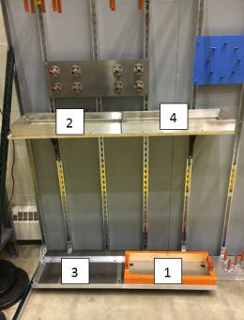Task 1: Load positioning – pick up and move a load onto a tray.

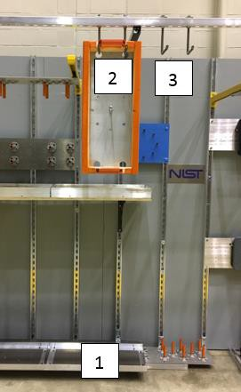Task 2: Load hanging – pick up the load from the tray and hang it on hangers and then move it to other.
Task 3: Load alignment – pick up the load and hang it at an angle.

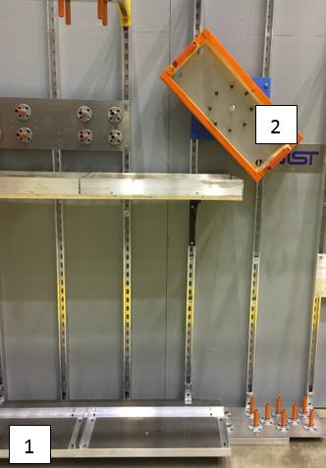
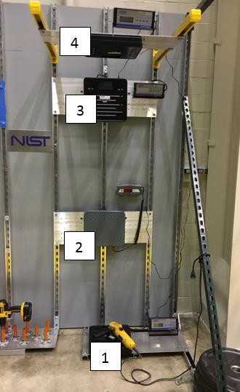Task 4: Force applied - grab a grinder tool from the holder as if attempting to use it with both hands to grind and apply a force of at least 10 Lbs. with the grinder onto 4 different force plates.

Task 5: Peg-in-hole – contact - grab a drill tool from the holder as if attempting to use it with both hands to drill and insert the blank drill bit into a series of tubes located on the floor, wall, and above.
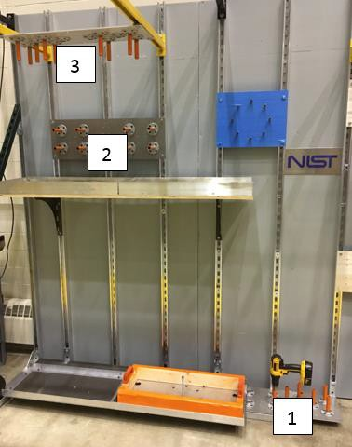

Task 6: Peg-in-hole – non-contact - grab a laser tool, align the tool with the target, and move the switch when the target is acquired. This task will be performed

standing and crouching.
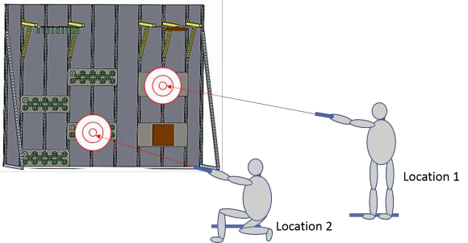

Research 2 - Knee test (approximately 45 minutes)
- You will be asked to put on the lower extremity (leg/hip) exoskeleton according to manufacturer specifications with help from the research team. You may already be wearing the exoskeleton and simply walk to the knee test measurement lab for this test.
- The research team will attach markers to you and the exoskeleton so that we can measure how the exoskeleton moves as you move through tests.
- Knee test, part 1 steps (Stand/Crouch-Static):
  - You will be asked to stand still in an upright position and remain still during data collection.
  - You will be asked to bend your legs to full crouched position (if necessary, while holding onto a chair for support), to stand still in a crouched position and to remain still during data collection. A full crouched position will include touching your back upper leg to your back lower leg.

- Knee test, part 2 steps (Stand/Crouch-Dynamic):
  - You will be asked to stand vertical and bend down to full crouch position and to stand back up. You will be asked to perform this bending and crouching several times.
After you complete the Task and/or Knee test(s), we will ask you to complete a questionnaire about the tests and the exoskeleton suit. At the end of the study, the data will be compiled into results and generically explained. The health information will be used to correlate operator performance of a task with and without wearing the exoskeleton.

Total Number of Participants
Up to 200 individuals will take part in this study at NIST.

Alternatives / Voluntary Participation / Withdrawal
You do not have to participate in this research study.

You should only take part in this study if you want to volunteer. You should not feel that there is any pressure to take part in the study. You are free to participate in this research or withdraw at any time. There will be no penalty or loss of benefits you are entitled to receive if you stop

taking part in this study. Decision to not participate will not affect your job status or student status.
If at any time you choose to withdraw from the test(s), inform the PI and/or research team and the test will immediately end. If the subject withdraws, their data will be destroyed and not used in additional analyses. The PI and/or research team may also end the test(s) prior to completion at any time and providing notice of ending the test to the subject at the stop time or prior.

Benefits
You will receive no benefit(s) by participating in this research study.
The potential benefits of participating in this research study include helping NIST researchers develop methods for measuring the performance of the exoskeleton.

Risks or Discomfort
This research is considered to be minimal risk. That means that the risks associated with this study are the same as what you face every day. There are no known additional risks to those who take part in this study. There is also a very small risk that someone who is not authorized could get access to the data we have stored about you. However, we describe how we will protect your privacy and confidentiality in a later section of this consent form.
The following risks may occur:
    - Lifting and maneuvering loads up to 15 Lbs may cause body strain. Chances of this are minimal and depend on the physically fit individual’s capability to lift, carry, and position light loads several times.
    - Bending arms and legs to normal angles while wearing an exoskeleton may cause bruising, slight pain, or muscle fatigue. Chances of this are minimal and depend on the individuals skin irritation similar to wearing loose fitting and weighted garments (e.g., tool belt, snorkel gear, harness, etc.).
    - Falling due to the subject not being familiar with wearing an exoskeleton.
    - Rubbing of exoskeleton or NIST artifact devices attached to the body may cause skin irritation. Chances of this are minimal and depend on the individuals skin irritation similar to wearing loose fitting and weighted garments (e.g., tool belt, snorkel gear, harness, etc.).
If, at any point while you are completing the tasks, you experience any pain or fatigue that is more than just minor fatigue or discomfort, stop doing the task immediately and tell a member of the research team.

Compensation
You will receive no payment or other compensation for taking part in this study.
The findings from this research may result in the future development of products (e.g., test methods) that are of commercial value. There are no plans to provide you with financial compensation or for you to share in any profits if this should occur.

Costs
There will be no additional costs to you as a result of being in this study. Because the study involves minimal risk, there is little likelihood that you would be injured during your participation. If, however, an injury occurs, you would follow the process for reporting any NIST workplace injury because you will be participating in the study as part of your official duties with your manager’s approval. Please see the information at: https://oshe.nist.gov/web/SitePages/quick_links/report_occupational_injury.aspx, which describes the process for reporting a workplace injury and for filing a Worker’s Compensation Claim.

Privacy and Confidentiality
Your name will never appear in any presentations or publications. If you agree to let us use your images in presentations or publications, then there is a chance that someone may recognize you. Otherwise, we will keep your study records private and confidential. The research team will store the records in a padlocked cabinet with the PI holding the key to the lock. The data will be stored on hard drives, and studied and analyzed by only the research team on only their NIST computers protected by password. Every attempt to keep the data private from others outside of the research team will be enforced as described here.
Certain people may need to see your study records. Anyone who looks at your records must keep them confidential. These individuals include:
- The research team, including the Principal Investigator, study coordinator, and all other research staff. The PI and research team include engineers, computer scientists, and mathematicians with advanced degrees.
- Certain government people who need to know more about the study, and individuals who provide oversight to ensure that we are doing the study in the right way.
- Any agency of the federal, state, or local government that regulates this research, including the NIST Human Subjects Protection Office.
- University of Maryland Loyola
Your identity will be protected to the extent permitted by law, including the Freedom of Information Act. Total confidentiality cannot be guaranteed, since all security measures have vulnerabilities and may be compromised.

Future use of research data and/or specimens
The data will not be used in the future beyond the current study analysis and compilation.

You can get the answers to your questions, concerns, or complaints
If you have any questions, concerns or complaints about this study, or experience an unanticipated problem, or research-related injury, call Roger Bostelman at 301-975-3426.
If you have questions about your rights as a participant in this study, or have complaints, concerns or issues you want to discuss with someone outside the research team, call the Human

Subjects Protection Office at (310) 975-5445.
You will receive a copy of this signed consent form.

Consent to Take Part in this Research Study

I freely give my consent to take part in this study. I understand that by signing this form I am agreeing to take part in research. I agree that I have the ability to physically and safely complete the tasks.
I am at least 18 years of age; and have spoken to one of the study researchers, who answered any questions I had about this study.
Data collected in this study is to be used only for the purposes stated above (publication).

[Please initial one of the following boxes next to the statement you are agreeing consent.]

I approve of using the recorded study information for public use in research papers and presentations.

I do not approve of using the recorded study information for public use in research papers and presentations.

Signature of Person Taking Part in Study Date

Printed Name of Person Taking Part in Study

Statement of Person Obtaining Informed Consent
I have carefully explained to the person taking part in the study what he or she can expect from their participation. I confirm that this research subject speaks the language that was used to explain this research and is receiving an informed consent form in their primary language. This research subject has provided legally effective informed consent.

Signature of Person obtaining Informed Consent Date

Printed Name of Person Obtaining Informed Consent

