ATTACHMENT 4D: MESSAGES, SCREENSHOTS, NOTIFICATIONS, AND INVITATIONS FOR APP-BASED SURVEY
Notifications: Point of Sale Intervention for Tobacco Evaluation (POSITEv)

Messages

App Installation Pop-up
POSITEv would like to send you notifications. Notifications may include alerts, sounds, and icon badges. These can be configured in Settings.
- Don’t allow
- Allow
OMB No. 0910-####
Exp. Date ##/##/20##
RIHSC No. 17-082CTP

App Enrollment Confirmation E-mail
From: fdastudy@rti.org
Date:
To:
Subject: POSITEv: Please verify your email address
Hello,
Thank you for signing up to be a member of the POSITEv community!
To protect your email address we require that you confirm your email address by clicking the link below:

[URL]

Thank You,
POSITEv study staff
For more information please email: fdastudy@rti.org
To no longer receive our emails, click to unsubscribe
OMB No. 0910-####
Exp. Date ##/##/20##
RIHSC No. 17-082CTP

Incentive Redemption E-mail
From: fdastudy@rti.org
Date:
To:
Subject: How to redeem your POSITEv study incentive
Hello,
Thank you for completing the Point of Sale Intervention for Tobacco Evaluation (POSITEv) questionnaire!
To redeem your incentive, please complete the instructions below:
[FILL: Instructions for redemption of $5 electronic gift card ]
Thank You,
POSITEv study staff
For more information please email: fdastudy@rti.org
To no longer receive our emails, click to unsubscribe

OMB No. 0910-####
Exp. Date ##/##/20##
RIHSC No. 17-082CTP

App Disabled E-mail Message 1
From: fdastudy@rti.org
Date:
To:
Subject: Please reactivate the POSITEv app
Dear [FNAME [LNAME]]:
Thank you for your earlier participation in the POSITEv study! We noticed (your POSITEv app is not active/your location services are not turned on/your POSITEv app no longer has access to your location services) on your smartphone. Please open the app to turn it on. Your continued participation is critical to the success of this important research.
Questions? Need technical support? Call our project assistance line at 1-800-957-6457 between 9 am and 5 pm, Eastern Time, Monday through Friday or email us at fdastudy@rti.org. If you have a question about your rights as a study participant, you can call RTI’s Office of Research Protection toll-free at (866) 214-2043.
I hope you choose to help with this important study. Thank you.
Sincerely,
Matthew Farrelly, PhD
RTI International
To no longer receive our emails, click to unsubscribe
OMB No. 0910-####
Exp. Date ##/##/20##
RIHSC No. 17-082CTP

App Disabled E-mail Message 2
From: fdastudy@rti.org
Date:
To:
Subject: Please TAKE ACTION to reactivate the POSITEv app!
Dear [FNAME[LNAME]]:
You are a valued study participant. We noticed (your POSITEv app is not active/your location services are not turned on/your POSITEv app no longer has access to your location services) on your smartphone. Please open the app to turn it on. If we can assist you with this, please contact our helpdesk for assistance in re-installing the app. Our project assistance line is 1-800-957-6457 and is available between 9 am and 5 pm, Eastern Time, Monday through Friday. We are also available by email at fdastudy@rti.org.
I hope you choose to help with this important study. Thank you.
Sincerely,
Matthew Farrelly, PhD
RTI International

To no longer receive our emails, click to unsubscribe
OMB No. 0910-####
Exp. Date ##/##/20##
RIHSC No. 17-082CTP

App Disabled Text Message 1
Your POSITEv app is not working. Please open the app to turn it on. For help, call 1-800-957-6457 or email fdastudy@rti.org. Text STOP to opt out.
OMB No. 0910-####
Exp. Date ##/##/20##
RIHSC No. 17-082CTP

App Disabled Text Message 2
Your POSITEv app is not working. You are a valued study participant. Please open the app to turn it on. For help, call 1-800-957-6457 or email fdastudy@rti.org. Text STOP to opt out.
OMB No. 0910-####
Exp. Date ##/##/20##
RIHSC No. 17-082CTP

Delete App E-mail
From: fdastudy@rti.org
Date:
To:
Subject: Please DELETE the POSITEv app
Dear [FNAME[LNAME]]:
Thank you very much for participating in the POSITEv study. Now that the study has ended, we would like you to delete the app so that it no longer collects information from you. Please follow the instructions below to delete the app.
Here are the instructions:
- If you have an iPhone:
- Tap and hold the POSITEv icon until all the icons start wiggling.
- An X will appear at the top left corner of the icon.
- Tap the X, then tap Delete.
- If you have an Android phone:
- Tap and hold the POSITEv icon until the word Uninstall appears at the top of the phone.
- Drag the POSITEv icon to the word Uninstall.
- Tap OK.
- If this method doesn’t work:
- Locate and tap the Settings icon.
- Select the Apps submenu.
- Select the App manager or App info submenu.
- Tap the POSITEv app.
- Tap Uninstall or Delete.

Questions? Need technical support? Call our project assistance line at 1-800-957-6457 between 9 am and 5 pm, Eastern Time, Monday through Friday or email us at fdastudy@rti.org. If you have a question about your rights as a study participant, you can call RTI’s Office of Research Protection toll-free at (866) 214-2043.
Sincerely,
Matthew Farrelly, PhD
RTI International

To no longer receive our emails, click to unsubscribe
OMB No. 0910-####
Exp. Date ##/##/20##
RIHSC No. 17-082CTP

Example Screenshots
Below are some example screenshots that contain elements that will be present in the app. Since the app will be created by the vendor for the purpose of the Point of Sale Intervention for Tobacco Evaluation study (POSITEv), and there will be differences in the display between iPhones and Android phones, these images are intended to provide a general feel (approximation) for the app’s appearance, but are not meant to represent the exact appearance of the app.

Welcome screenshot
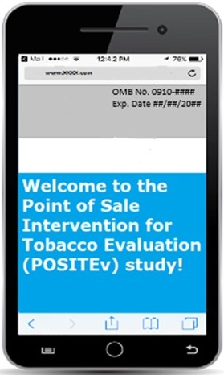

Consent screenshot
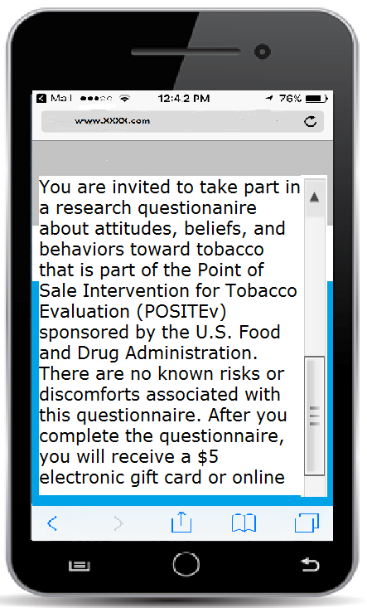

App-based questionnaire item (any number 0-99 can be entered into the box by clicking on it)
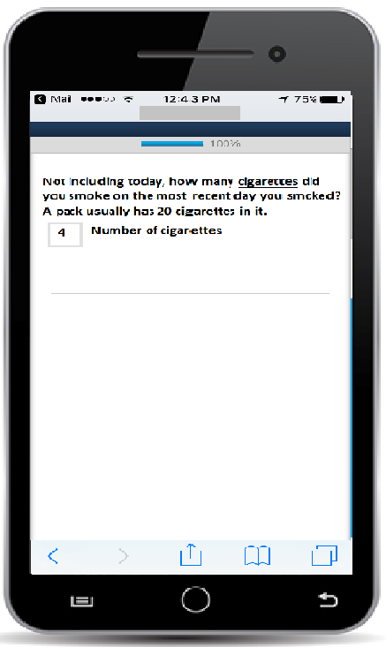

App-based questionnaire item with radio buttons (allows participant to select one response)
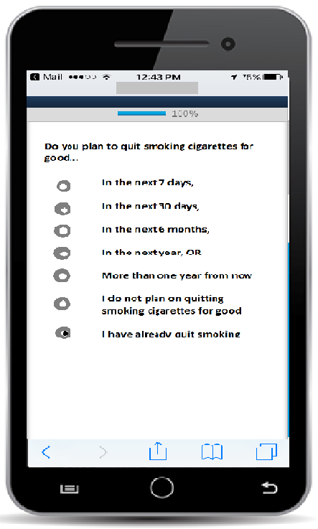

End Questionnaire Screenshot
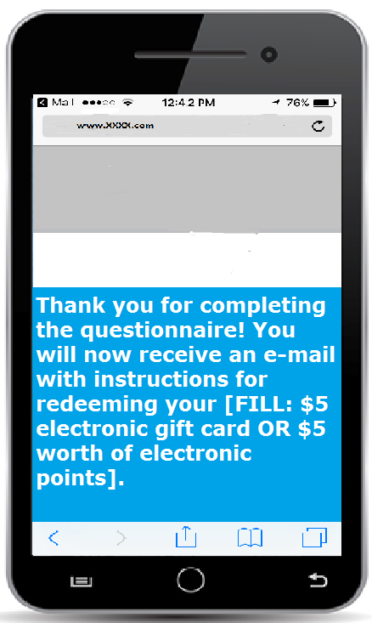

Notifications and Invitations

Push Notifications
Push Notification 1
Complete the 5 minute POSITEv questionnaire for a $5 electronic gift card!
[click on] Learn more
OMB No. 0910-####
Exp. Date ##/##/20##
RIHSC No. 17-082CTP
Push Notification 2
Timing is running out to complete the 5 minute POSITEv questionnaire for a $5 electronic gift card!
[click on] Learn more
OMB No. 0910-####
Exp. Date ##/##/20##
RIHSC No. 17-082CTP
Push Notification 3
Last chance to complete the 5 minute POSITEv questionnaire for a $5 electronic gift card!
[click on] Learn more
OMB No. 0910-####
Exp. Date ##/##/20##
RIHSC No. 17-082CTP

Location Services Notification
Push Notification
POSITEv is not tracking
Turn on location
OMB No. 0910-####
Exp. Date ##/##/20##
RIHSC No. 17-082CTP

In-App Notification
App functionality is limited because location services are off.
[click on] Allow location access.
OMB No. 0910-####
Exp. Date ##/##/20##
RIHSC No. 17-082CTP

Text Invitations
Text Invitation 1
Please complete the 5 minute POSITEv questionnaire for a $5 electronic gift card! Text STOP to opt out. [questionnaire link here]
OMB No. 0910-####
Exp. Date ##/##/20##
RIHSC No. 17-082CTP
Text Invitation 2
Time is running out to complete the 5 minute POSITEv questionnaire for a $5 electronic gift card! Text STOP to opt out. [questionnaire link here]
OMB No. 0910-####
Exp. Date ##/##/20##
RIHSC No. 17-082CTP
Text Invitation 3
Last chance to complete the 5 minute POSITEv questionnaire for a $5 electronic gift card! Text STOP to opt out. [questionnaire link here]
OMB No. 0910-####
Exp. Date ##/##/20##
RIHSC No. 17-082CTP

Email Invitations
Email Invitation 1
Subject Line: Complete the 5 minute POSITEv questionnaire for a $5 electronic gift card!
Dear [FNAME[LNAME]]:

We are contacting you to ask you to participate an app-based questionnaire for the U.S. Food and Drug Administration’s (FDA’s) Center for Tobacco Products’ survey for the Point of Sale Intervention for Tobacco Evaluation (POSITEv). When we interviewed you previously, you agreed to receive information about these short questionnaires.

This is your opportunity to update us on your use of tobacco and your recent tobacco purchases. It will only take about 5 minutes to complete.

You can complete the questionnaire by logging into the following app on your smart phone POSITEv. After completing the questionnaire, you will receive a $5 electronic gift card that can be redeemed from an online vendor.

Your participation is voluntary, and all information will be kept private to the full extent allowable by law.

Questions? Need technical support? Call our project assistance line at 1-800-957-6457 between 9 am and 5 pm, Eastern Time, Monday through Friday, or email us at fdastudy@rti.org. If you have a question about your rights as a study participant, you can call RTI’s Office of Research Protection toll-free at (866) 214-2043.

Your help is very important to the success of this study, and I thank you in advance for your consideration.

Sincerely,
Matthew Farrelly, PhD
RTI International

To no longer receive our emails, click to unsubscribe
OMB No. 0910-####
Exp. Date ##/##/20##
RIHSC No. 17-082CTP
Email Invitation 2
Subject Line: Timing is running out to complete the 5 minute POSITEv questionnaire for a $5 electronic gift card!

Dear [FNAME[LNAME]]:
There is still time to complete the app-based questionnaire for the U.S. Food and Drug Administration’s (FDA’s) Center for Tobacco Products’ Point of Sale Intervention for Tobacco Evaluation (POSITEv).

All the information you provide will be kept private, and you can choose to skip any questions you do not want to answer. But, the study will not succeed without your participation.

You can complete the questionnaire by logging into the following app on your smart phone: POSITEv. After completing the questionnaire, you will receive a $5 electronic gift card that can be redeemed from an online vendor.

Questions? Need technical support? Call our project assistance line at 1-800-957-6457 between 9 am and 5 pm, Eastern Time, Monday through Friday or email us at fdastudy@rti.org. If you have a question about your rights as a study participant, you can call RTI’s Office of Research Protection toll-free at (866) 214-2043.

I look forward to hearing from you.

Sincerely,
Matthew Farrelly, PhD
RTI International

To no longer receive our emails, click to unsubscribe

OMB No. 0910-####
Exp. Date ##/##/20##
RIHSC No. 17-082CTP
Email Invitation 3
Subject Line: Last chance to complete the 5 minute POSITEv questionnaire for a $5 electronic gift card!

Dear [FNAME[LNAME]]:

You have until [date] to complete the app-based questionnaire for the U.S. Food and Drug Administration’s (FDA’s) Center for Tobacco Products’ Point of Sale Intervention for Tobacco Evaluation (POSITEv).
Your continued participation is critical to the success of this important research.
You can complete the questionnaire by logging into the following app on your smart phone: POSITEv. After completing the questionnaire, you will receive a $5 electronic gift card that can be redeemed from an online vendor.

The information collected will improve our understanding of tobacco use and purchasing behaviors. Your participation is voluntary. All the information you provide will be kept private, and you can choose to skip any questions you do not want to answer.

Questions? Need technical support? Call our project assistance line at 1-800-957-6457 between 9 am and 5 pm, Eastern Time, Monday through Friday or email us at fdastudy@rti.org. If you have a question about your rights as a study participant, you can call RTI’s Office of Research Protection toll-free at (866) 214-2043.

I hope you choose to help with this important study. Thank you.

Sincerely,
Matthew Farrelly, PhD
RTI International

To no longer receive our emails, click to unsubscribe
OMB No. 0910-####
Exp. Date ##/##/20##
RIHSC No. 17-082CTP

