ATTACHMENT 4. EXPRESSED CLAIMS SCREENER

Screener
[If “Prefer not to answer” endorsed for any of the screener question, GO IMMEDIATELY TO Exit 1]

[INTRO PAGE, STATING]:
THANK YOU for agreeing to take this survey! First, we are going to ask you some questions about you and your tobacco use.
[NEXT PAGE]

[Age]
S1. How old are you?
_______ years [ALLOW 18–99; if 17 or under, GO TO EXIT1]
(99) Prefer not to answer [GO TO EXIT1]
[REQUIRED AGE GROUPS ARE ‘18-25’ AND ‘26 and older’. INCLUDE THE RAW, CONTINUOUS AGE VARIABLE IN THE DATASET.]
(Source: Implied claims questionnaire)

[CURRENT SMOKING]
S2. Do you now smoke cigarettes every day, some days, or not at all?
(1) Every day
(2) Some days
(3) Not at all
(99) Prefer not to answer
(Source: Adapted from PATH)

[current E-cigarette Use]
S3 INTRO: The next question is about e-cigarettes, including vape pens, e-hookahs, hookah pens, personal vaporizers, mods, tanks, e-pipes, and e-cigars. Some common brands include Juul, Vuse, blu, Logic, MarkTen, NJOY, and Vapin Plus.
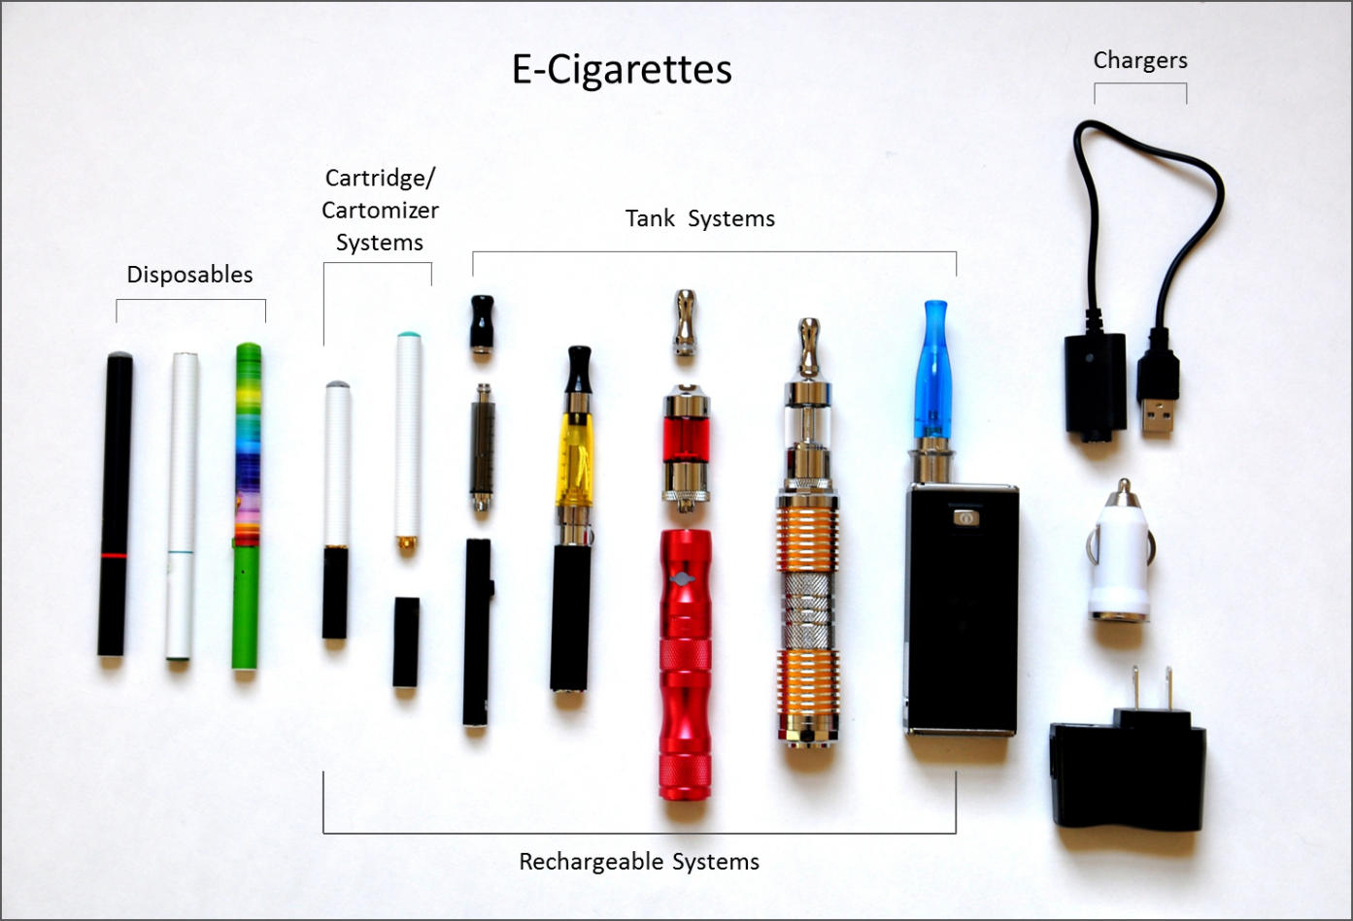
(Image source: CTP)
S3. Do you now use e-cigarettes [EC ROLLOVER: E-cigarettes include vape pens, e-hookahs, hookah pens, personal vaporizers, mods, tanks, e-pipes, and e-cigars] every day, some days, or not at all?
(1) Every day
(2) Some days
(3) Not at all
(99) Prefer not to answer
(Source: Adapted from PATH)

[CURRENT Smokeless Use]
S4 INTRO: The next question asks about snuff, also called smokeless tobacco, dip, chew, and snus. People put this in their mouth and usually chew or suck on it and sometimes spit when using it.
Snuff is available in different cuts and flavors. Common brands include Grizzly, Copenhagen, and Skoal.
Snus is a type of smokeless tobacco that comes in a small pouch that you put inside your lip. Common brands include Camel Snus, General Snus, and Skoal Snus.

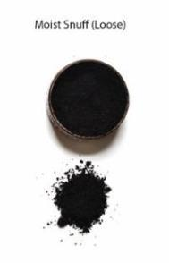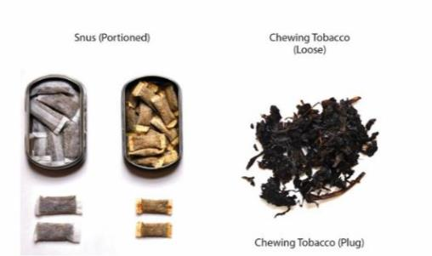
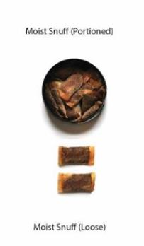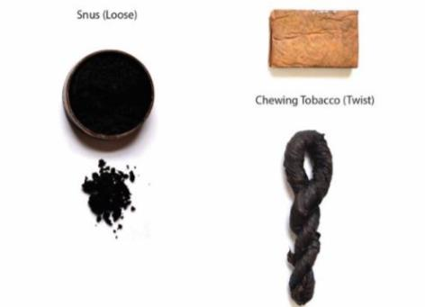

[Smokeless Frequency/Intensity]
S4. Do you now use snuff [ST ROLLOVER: also called smokeless tobacco, dip, chew, and snus] every day, some days, or not at all?
(1) Every day
(2) Some days
(3) Not at all
(99) Prefer not to answer
(Source: Adapted from PATH)

[OTHER TOBACCO Use]
S5. Do you now smoke cigars, cigarillos, or little cigars every day, some days, or not at all?
(1) Every day
(2) Some days
(3) Not at all
(99) Prefer not to answer
(Source: Adapted from PATH)
S6. Do you now smoke tobacco in a hookah or water pipe every day, some days, or not at all?
(1) Every day
(2) Some days
(3) Not at all
(99) Prefer not to answer
(Source: Adapted from PATH)
S7. What is the highest grade or level of school you have completed?
(1) Some high school or less
(2) GED
(3) High school diploma
(4) Some college but no degree
(5) Associate degree
(6) Bachelor’s degree
(7) Master’s degree or higher
(99) Prefer not to answer
(Source: Adapted from PATH)
[If S5 = 1 OR 2 (cigar user), OR S6 = 1 OR 2 (hookah user), AND S2=3 OR 99 (not current cigarette user) S3=3 OR 99 (not current e-cigarette user) AND S4=3 OR 99 (not current snuff user), GO TO Exit 1]

Exit 1: We’re sorry, but you are not eligible for this study. There are many possible reasons why people are not eligible for this study. These reasons were decided earlier by the researchers. Thank you for your interest in this study and for taking the time to answer our questions today.

Paperwork Reduction Act Statement: The public reporting burden for this information collection has been estimated to average 4 minutes per response to complete the screener (the time estimated to read, review, respond). Send comments regarding this burden estimate or any other aspects of this information collection, including suggestions for reducing burden, to PRAStaff@fda.hhs.gov.

