ATTACHMENT 1: This Free Life Campaign Video Storyboards

Video 1: STORYBOARD FOR LABELS Flagship :30 Spot
[Add Video Link]

VISUALS | COPY
Open on talent in a small, boldly DIY decorated studio apartment. We see her looking down at a leather jacket. | VO: I own every part of who I am.
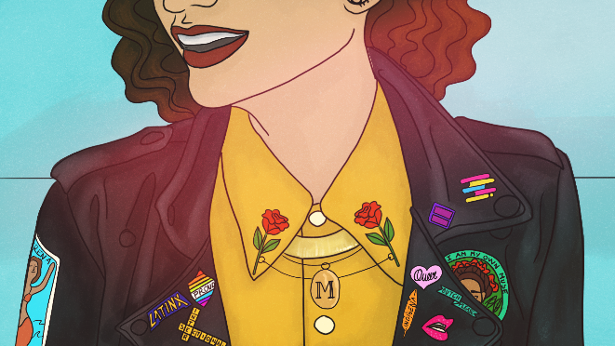
Cut to multiple, intimate close-ups of her hands, adding flair to the jacket (pins, patches, etc.). Each one, a word that she identifies with: LATINX. FIGHTER. GLITTER. GRIT. INDIGENOUS. ARTIST. EQUAL. PROUD. | VO: A fully realized person...
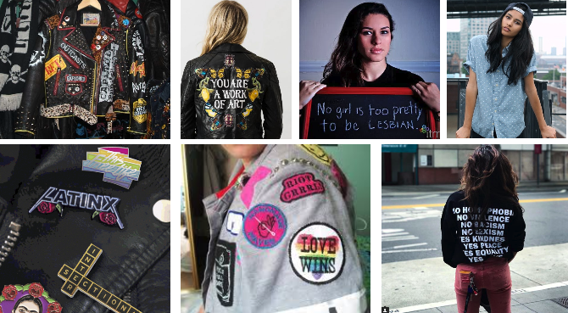
Cut to frame that shows a loteria card patch on the sleeve of the jacket. | VO: ...who embraces my complexity...and rejects any threat to it.
Cut to a wide shot of the talent in a social space; wearing the finished jacket, covered in words. | VO: Because smoking can damage nearly every part of my body,
Camera pans to talent’s face. She looks into the camera proudly. | Lead to Camera: and I refuse to damage or ANY part of who I am by smoking cigarettes.
After speaking the line, talent walks away from the camera, revealing a large, artistically painted “tobacco-free” label on the back of her jacket. | AVO: This Free Life. Freedom to be, tobacco-free.
ENDCARD | Announcer VO:  This Free Life  Freedom to be, tobacco-free.
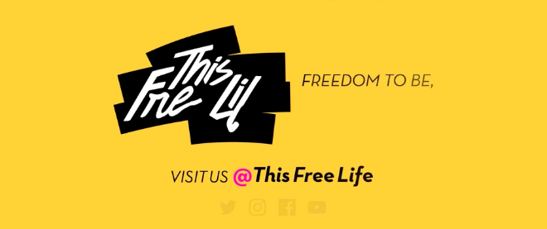

Video 2: STORYBOARD FOR LOVE ME (KENTRELL) Flagship :30 Spot
Video: Love, Me Kentrell (male)
Audio: Quiet piano and slow strings underscore a pensive voiceover.
VISUALS | COPY
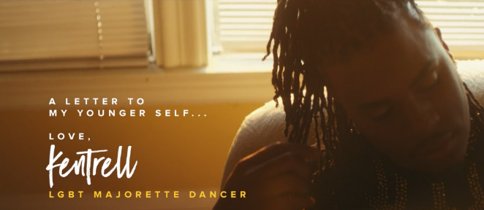
Male young adult talent (Kentrell) reflects on camera while dancing. Onscreen text: A LETTER TO MY YOUNGER SELF… | Male VO:  I would tell myself
Shot of Kentrell without Majorette costume, in vulnerable state. | There will be pain that I cannot save you from.  People will have a hard time letting you be the person you were meant to be.
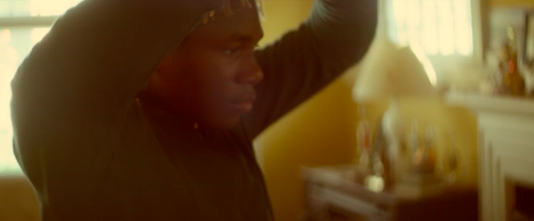
Shots of Kentrell:  Onscreen text: “Never miss a step” | But never miss a step
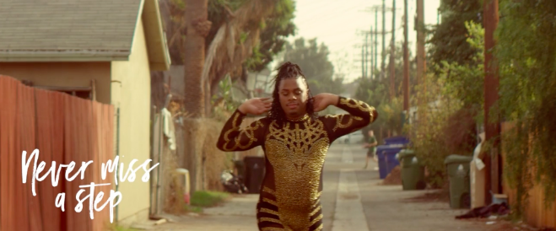
Kentrell is shown walking down city street toward camera. Camera pans to a new scene with Kentrell back in a house removing a jacket covering up his majorette outfit. | And while I can’t stop other from trying to hurt you,
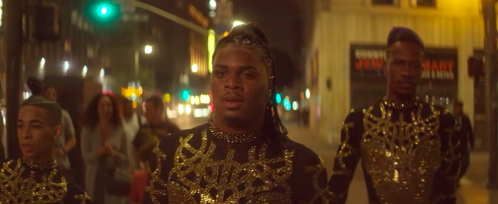
Kentrell is shown again dancing in the city streets.  Onscreen text: “never harm yourself” | You will learn to never harm yourself.
Kentrell is shown again dancing in the city streets and camera pans to house shot of Kentrell  Onscreen text: “never letting smoking” | Never let something like
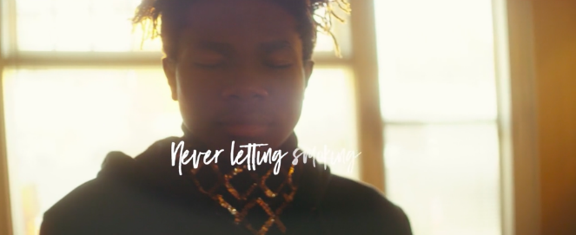
Kentrell is shown dancing in the city street toward camera. Stylized text: “Never letting smoking damage nearly every part of your body.” | Smoking damages nearly ever part of your body.
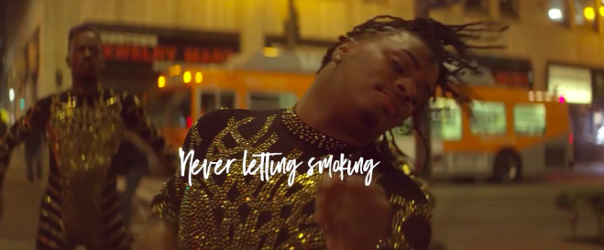
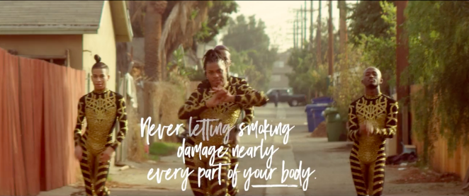

A pensive Kentrell is facing the camera. Scenes of Kentrell happily being himself. Stylized text: “Let love in” | Because you will block that toxic, and let love in
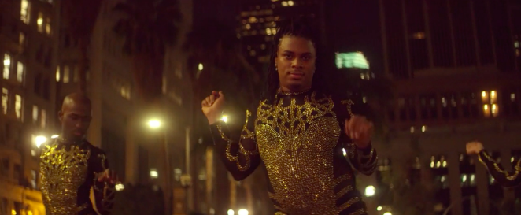

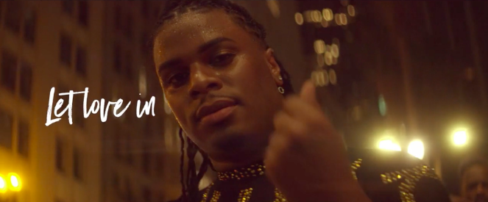

ENDCARD | Announcer VO:  This Free Life  Freedom to be, tobacco-free.

Video 3: STORYBOARD FOR LOVE ME (LILA) Flagship :30 Spot
Video: Love, Me Lila (female)
Audio: Quiet piano and slow strings underscore a pensive voiceover.

VISUALS | COPY
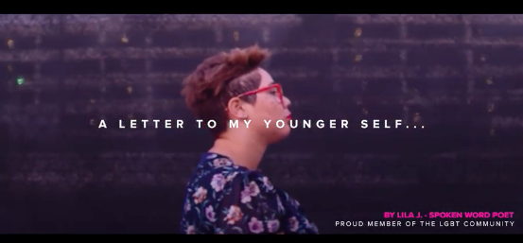
Female young adult talent (Lila) walks on the street. Onscreen text: A LETTER TO MY YOUNGER SELF… | Female VO:  Little Lila.
A preteen girl who looks like Lila (“Little Lila”) is shown relaxing on a couch in a living room picking at stickers on the wall. It cuts to a shot of her looking out the window. | You will find your sexuality is not a curse.
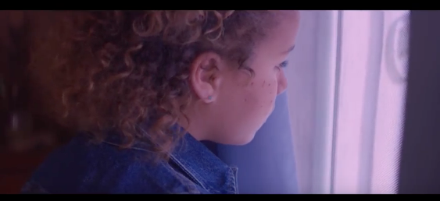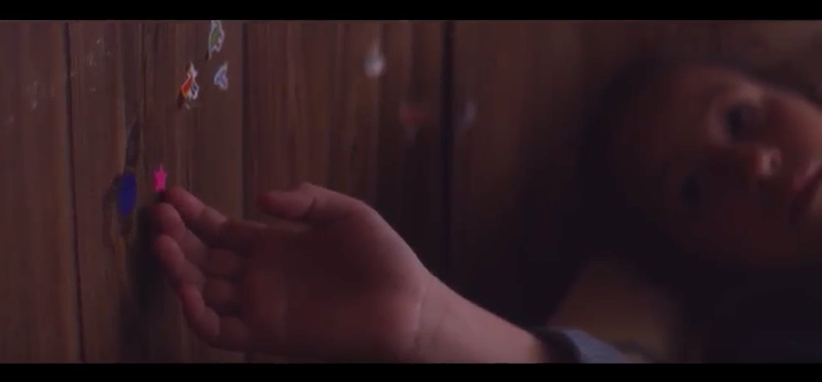
Young adult Lila is shown sitting at a bus stop reading from a red journal. | That nothing will hurt your body. Yours to protect.
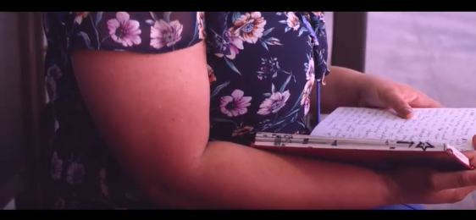
Lila is shown walking down city street toward camera. She opens a door and walks into the same empty room where we previously saw Little Lila on the couch while stylized text mirrors the VO: “toxic, you’ll reject.” | Any anything toxic, you’ll reject.
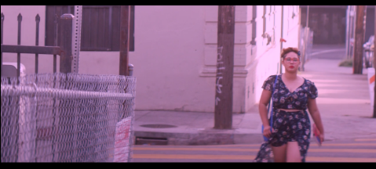
Little Lila is shown walking down city street toward camera left. Focus cuts back to young adult Lila sitting on the same couch that Little Lila began the spot on. Lila is looking around reminiscently. Stylized text appears to match the VO: “Cigarettes can damage nearly every part of your body.” Some words fade as focus changes to Little Lila: “Cigarettes damage your body.” | Including cigarettes, that can damage nearly every part of your body.
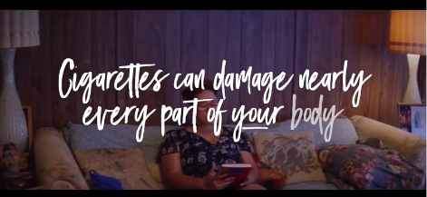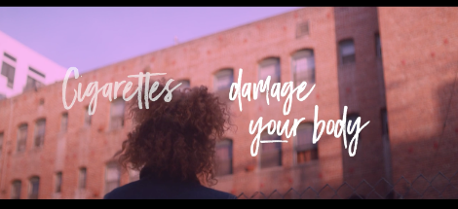
Lila is shown walking down city street toward camera left. Halfway through this line, focus shifts to Little Lila also facing camera. | Little Lila,  You have found your voice. And you are already on your way
Little Lila mouths the last word of Lila’s VO: | Home.
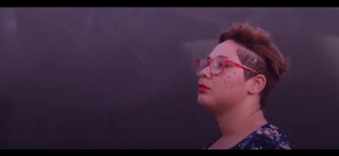
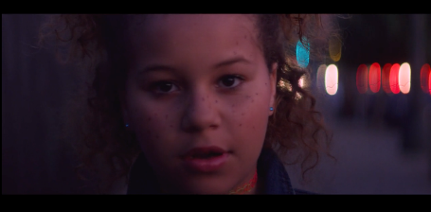
Lila stands and exits frame beneath stylized text “Love, Lila.”
ENDCARD | Announcer VO:  This Free Life  Freedom to be, tobacco-free.
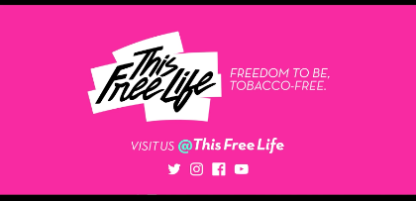
Video 4: STORYBOARD FOR Our Story Flagship :30 Spot
[Add Video Link]
Audio: Slow piano and strings build into upbeat full band with medium tempo.

VISUALS | COPY
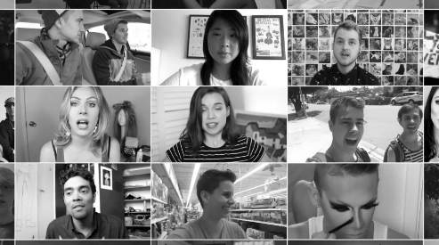
Clips sourced from LGBT YouTubers pages are our shown in black and white. | VO:  Born in a black-and-white world…
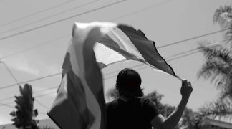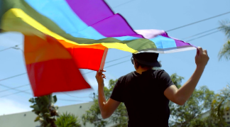
A young woman is walking away from camera holding a striped flag in black-and-white shot. As VO says ‘color in the mirror,’ the shot jumps into full color and slow motion, showing a rainbow flag. | VO:  We saw color in the mirror.
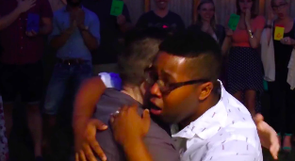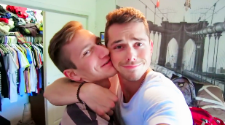
More shots of YouTubers: a woman hugging another woman, a man hugging another man looking into the camera. | VO:  Found love for our own truth
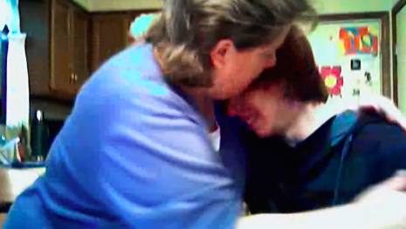
A young man and his mother are shown sitting in a kitchen, home-video quality. The boy begins to cry as the mother reassures him and hugs him.
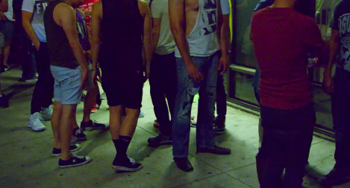
Generic, faceless shots of young adults in LGBT nightlife settings (waiting in line for a club, milling through a bar). A man is shown entering a convenience store and handing money to the cashier. Darker tones, less color.  Rapid shots of happy, diverse YouTubers and LGBT folks are smashed with increasing speed. Fade to black as VO says, ‘tobacco.’ | VO:  But a factor that seems casual, is claiming tens of thousands of LGBT lives every year.  Tobacco.
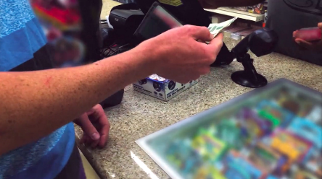
Faceless torsos are shown handling boxes of cigarettes on street corners. | VO:  Yes, smoking can damage nearly every part of our bodies.  Even smoking on some days can undermine our future.
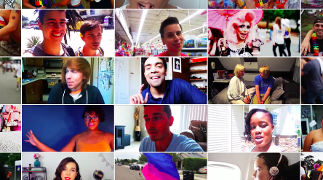
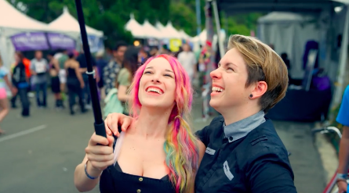
Multi-shot where YouTube a dozen YouTube clips share the screen in a grid under inspiring music. Cut to individual videos of happy LGBT young adults, decorated in Pride gear. | VO:  So why now inflict this damage to ourselves? No. This new life, free from the shadows, will also be free from tobacco.
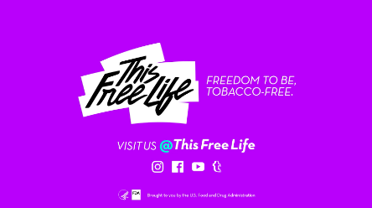
ENDCARD | Announcer VO:  This Free Life  Freedom to be, tobacco-free. Visit us at This Free Life.

Video 5: STORYBOARD FOR PICK YOUR POISON Flagship :30 Spot
[Add Video Link]

VISUALS | COPY
Open on two friends in a moody, neon-lit diner, eating a late night meal. The FRIEND has an unlit cigarette between his fingers. The LEAD gives a disapproving look. | FRIEND: (Mid-conversation) Come on! Smoking when I go out is not a big deal.  LEAD: You’re obviously not getting it...
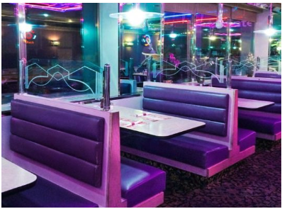
The LEAD snaps his fingers and we cut to the same place, stylized to indicate we are now in a dream state. He is suddenly dressed like the Evil Queen from Snow White. | FRIEND: (Confused) Why…?  LEAD: (Cutting him off) I’m dressed like this in all my fantasies, just stay with me.
He pours a dark, sludgy liquid into 7 small vials. Each one is labeled with a day of the week. | LEAD: Here’s some poison. No matter how much you take it’s gonna shorten your life. So how many days would you drink it?  FRIEND: *blinks* None, obviously.
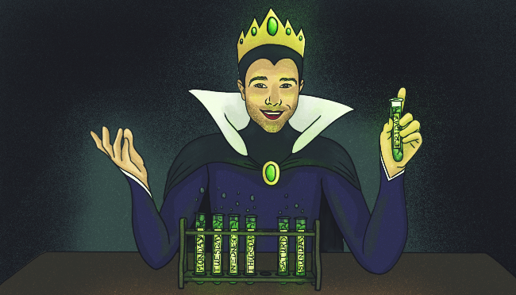
His FRIEND is grossed out and begins to understand. The LEAD offers him the Friday vial. | LEAD: How ‘bout just Fridays?
The FRIEND fully understands now and declines. | Safe from the dark places and the troubles that chase you,  You will find a way
We return to reality. HOWEVER, he is still dressed as the Queen. The “Friday” vial the LEAD was holding up is now a cigarette. | LEAD: See? Even smoking just when you go out, cuts your life short. Get it?  FRIEND: (Smirking) Yes, but I don’t get this outfit.
LEAD: (Placing the cigarette in a nearby bin) | LEAD: Witch, please.
ENDCARD | Announcer VO:  This Free Life  Freedom to be, tobacco-free.

