APHIS/CDC Form 2: Request to Transfer Select Agents and Toxins

When you select Principal Investigator name, the IT system auto populates the information found on Section A.

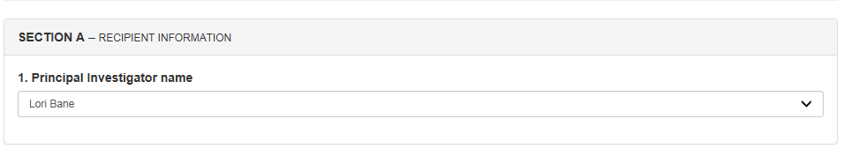

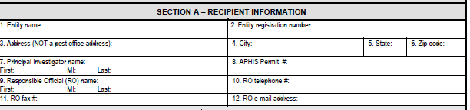

For the below screen print, this is found in Section B of the form. For name of the carrier question, it is question #39 on the form.
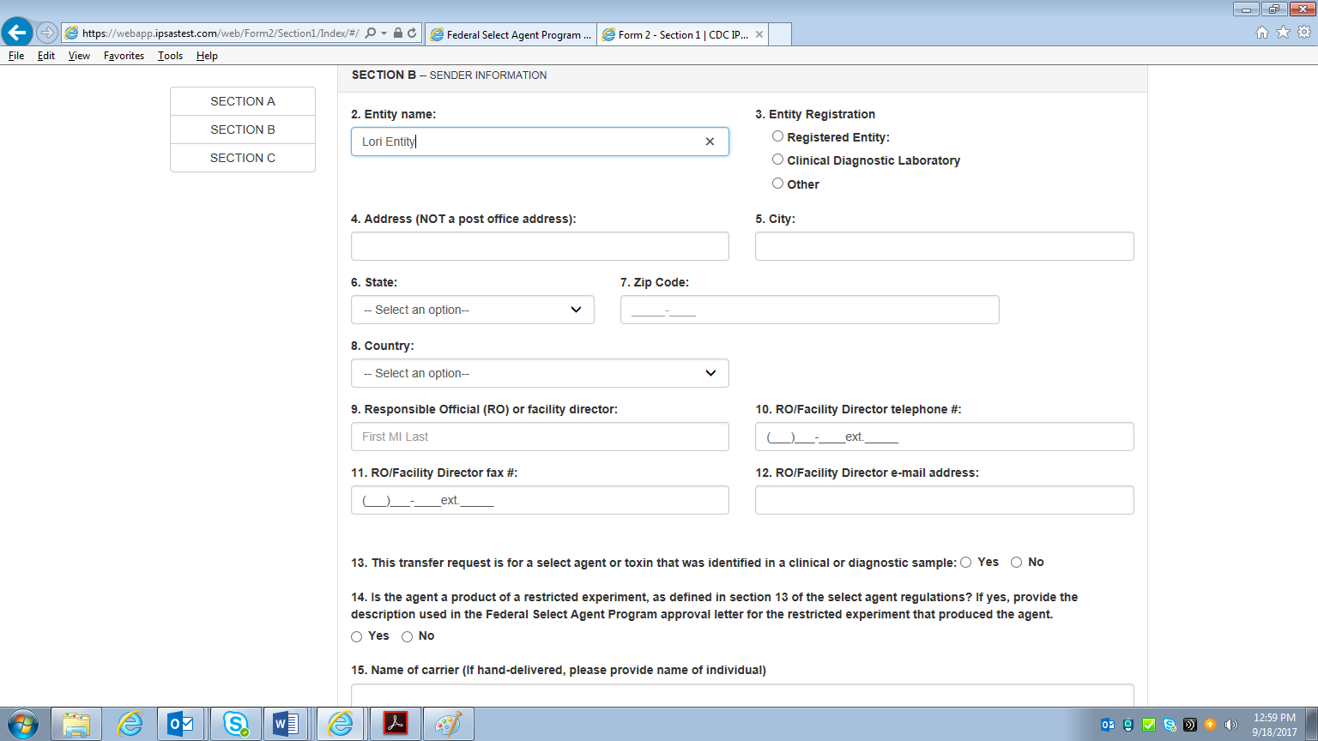

For the below screen print, this is found in Section C of the form.
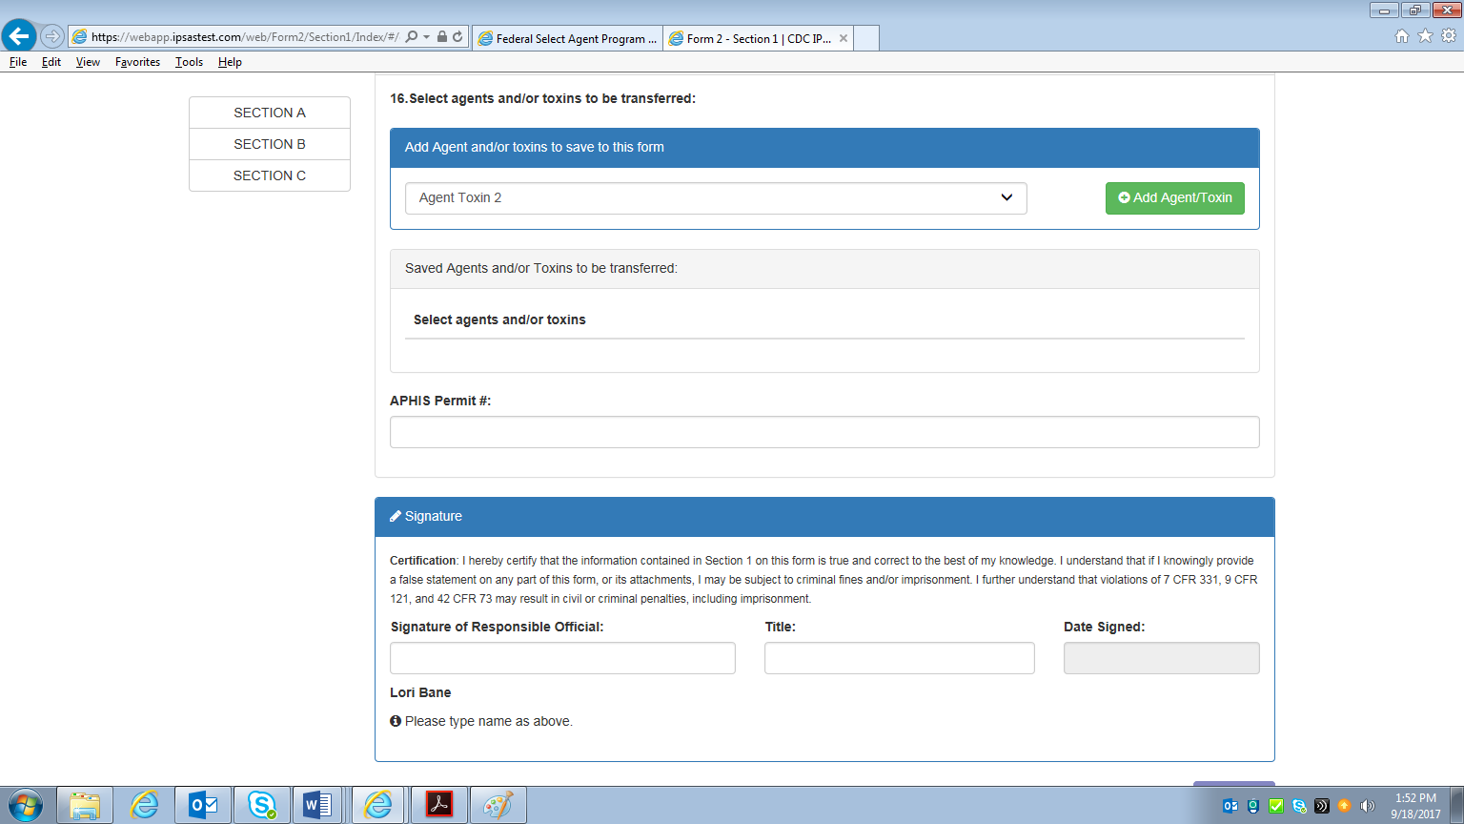

For the below screen print, this is found in Section D of the form.
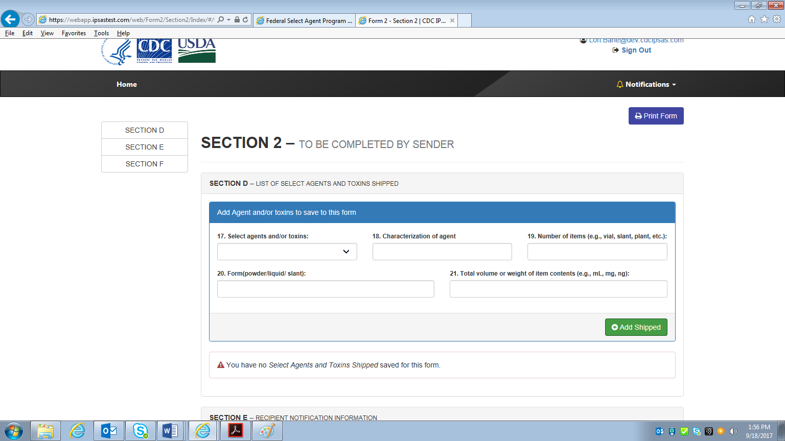

For the below screen print, this is found in Section E of the form.
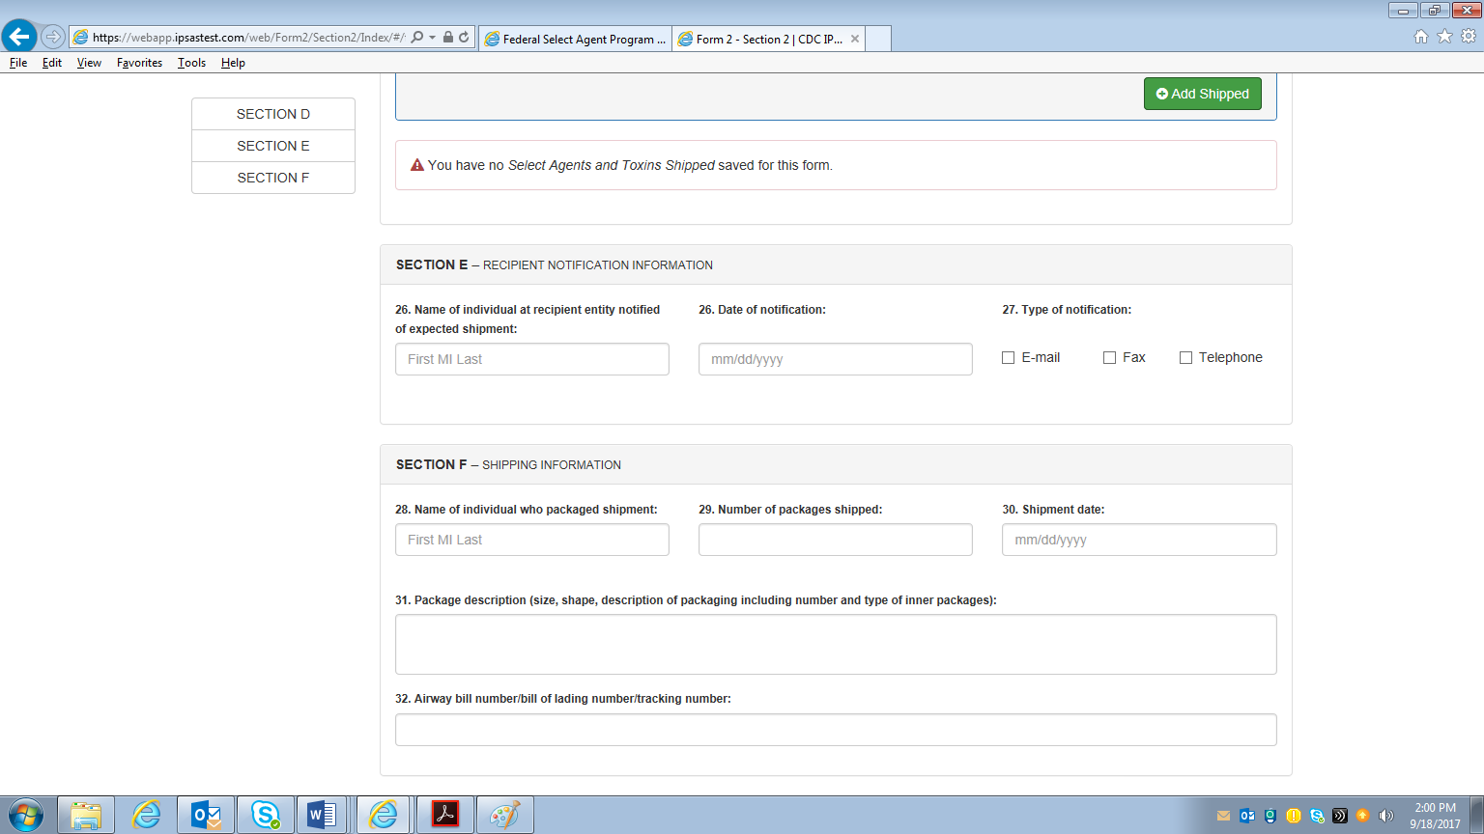

For the below screen print, this is found in Section F of the form.
