Expiration Date: XX/XXXX

**MLMS Assister Training Profile Mock-Up**

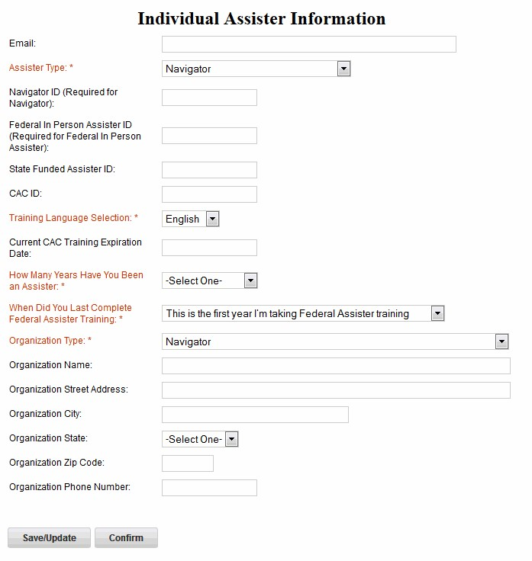

Graphic 1- Individual Assister Information - Full Page screen-shot mock-up

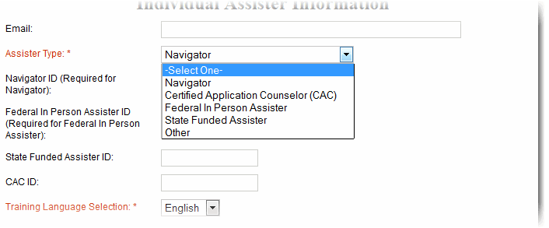

Graphic 2 - Individual Assister Information - Screen-shot mock-up with Assister Type drop down expanded

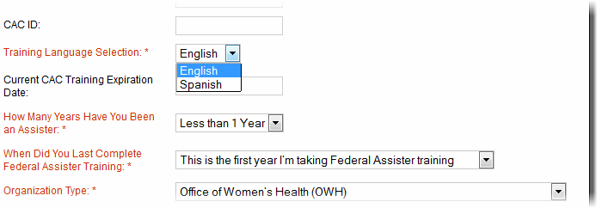

Graphic 3 - Individual Assister Information - Screen-shot mock-up with Training Language Selection drop down expanded

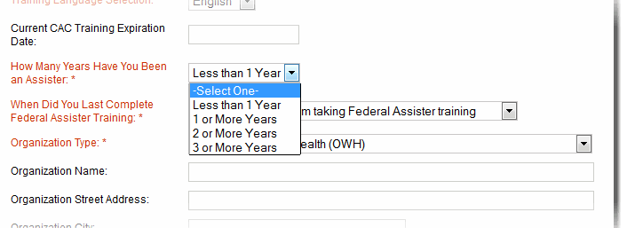

Graphic 4 - Individual Assister Information - Screen-shot mock-up with How Many Years Have You Been an Assister drop down expanded

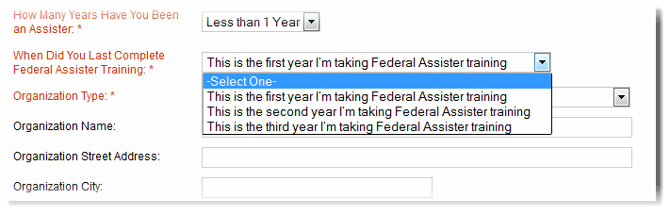

Graphic 5 - Individual Assister Information - Screen-shot mock-up with When Did You Last Complete Federal Assister Training drop down expanded

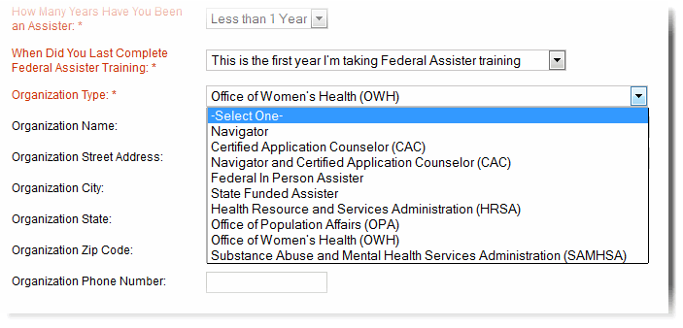

Graphic 6 - Individual Assister Information - Screen-shot mock-up with Organization drop down expanded

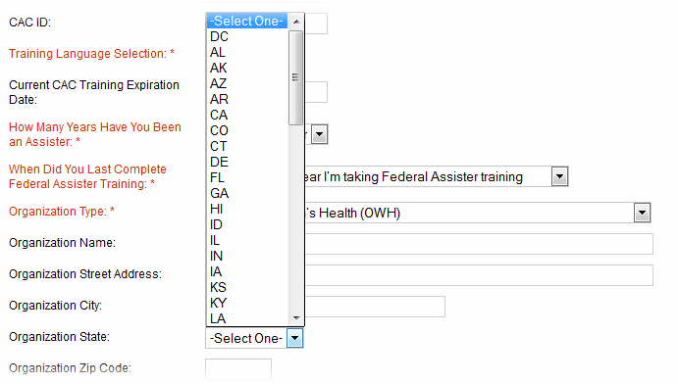

Graphic 7 - Individual Assister Information - Screen-shot mock-up with Organization State drop down expanded (complete list not shown)