OCSE O&M and Continuous Improvements
System Framework
User Screen Flow
Version 4.0
April 16, 2018
Administration for Children and Families
Office of Child Support Enforcement
330 C Street, SW, 5th Floor
Washington, DC 20201

This document was prepared for the United States Department of Health and Human Services, Office of Child Support Enforcement under HHSN316201200034W by Leidos Innovations Corporation. The work was authorized in compliance with the following specific prime task order:
Delivery Order Number: C-34668-O
Delivery Order Title: System Framework
Document Date: April 16, 2018
Document Number: C2-211L1.81.01

Table of Contents
1. Registration 1-1
2. Activation 2-1
3. Login 3-1
4. Profile Updates 4-1
5. Credential Management 5-1
6. General Pages 6-1
List of Figures and Charts
Figure 1-1: Welcome to Child Support Portal 1-1
Figure 1-2: This Portal Page Is For You If 1-3
Figure 1-3: Child Support Portal User Registration (Step 1) 1-4
Figure 1-4: Child Support Portal User Registration (Step 2) 1-5
Figure 1-5: Child Support Portal User Registration (Step 3) 1-6
Figure 1-6: Child Support Portal User Registration (Step 4) 1-7
Figure 1-7: Child Support Portal User Registration (Step 5) 1-8
Figure 1-8: Child Support Portal User Registration (Step 6) 1-9
Figure 1-9: Child Support Portal User Registration Review (Step 7) 1-10
Figure 1-10: Child Support Portal User Registration Request Submitted 1-11
Figure 2-1: This Portal Page Is For You If 2-1
Figure 2-2: Login Certification 2-2
Figure 2-3: User Activation 2-3
Figure 2-4: Activation Confirmation 2-4
Figure 3-1: This Portal Page Is For You If 3-1
Figure 3-2: Login Certification 3-2
Figure 3-3: Login – via Text 3-3
Figure 3-4: Login – via Voice 3-4
Figure 3-5: Child Support Portal Home Page 3-5
Figure 4-1: Profile Update 4-1
Figure 4-2: Profile Update Confirmation 4-3
Figure 5-1: Login Certification 5-1
Figure 5-2: Forgot User ID 5-2
Figure 5-3: Credential Management – Forgot User ID Confirmation 5-3
Figure 5-4: Login – Forgot/Change Password 5-4
Figure 5-5: Forgot/Change Password 5-5
Figure 5-6: Forgot/Change Password – Challenge Questions 5-6
Figure 5-7: Forgot/Change Password – Reset Password 5-7
Figure 5-8: Change Password Confirmation 5-8
Figure 6-1: Timeout Warning 6-1
Figure 6-2: Session Timed Out 6-2
Figure 6-3: System Error 6-3
Figure 6-4: Account Locked (Credential Management and Activation Pages) 6-4
Figure 6-5: Frequently Asked Questions 6-5
Figure 6-6: Contact Us 6-6
Chart 1-1: Welcome to Child Support Portal 1-2
Chart 1-2: This Portal Page Is For You If 1-3
Chart 1-3: Enter User Affiliation 1-5
Chart 2-1: Login Certification 2-2
Chart 2-2: User Activation 2-3
Chart 3-1: Login Certification 3-2
Chart 3-2: Login 3-4
Chart 3-3: Child Support Portal Home Page 3-5
Chart 4-1: Account Update 4-2
Chart 5-1: Login Certification 5-1
Chart 5-2: Forgot User ID 5-2
Chart 5-3: Login – Forgot/Change Password 5-4
Chart 5-4: Login Forgot/Change Password 5-5
Chart 5-5: Forgot/Change Password (Reset Password) 5-7

Registration
This document describes the process to submit a request for user registration for access to the Child Support Portal.
Figure 1-1: Welcome to Child Support Portal
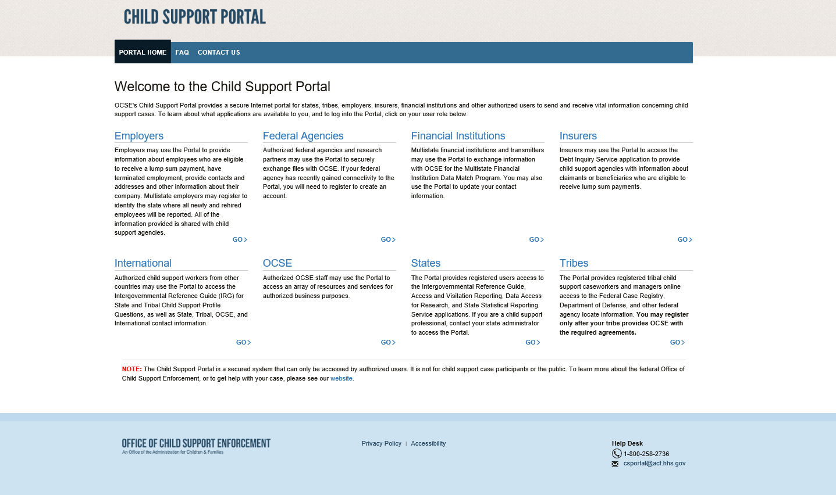
Note: Figure 1-1 shows the header and footer for all CSP screens. The header may contain additional links (e.g., Logout, Comments, FAQ, Contact Us, Print, Portal Home). The footer may contain additional links (e.g., Office of Child Support Enforcement, Privacy Policy, Accessibility, Help Desk email address).
We excluded the headers and footers from many of the screen images to improve the readability of this document.
Chart 1-1 describes the functions available from the Welcome to Child Support Portal page, including in the header and footer.
Chart 1-1: Welcome to Child Support Portal
Link | Description
Portal Home | Indicates this is the Home Page for the Portal
FAQ | Displays the FAQs for security
Contact Us | Displays the Help Desk Contact Page, which lists the contact phone number and e-mail address for the Portal Administrator and applications on the Portal
User Affiliations | There are eight affiliations: Employers, Federal Agencies, Financial Institutions, Insurers, International, OCSE, States, and Tribes.  The user selects the affiliation they want to register for. A list of functions for the selected affiliation display.
Office of Child Support Enforcement | Opens a new web page with details about the Office of Child Support Enforcement.
Privacy Policy | Displays the Child Support Portal Privacy Policy
Accessibility | Opens a new web page with details on the Administration for Children and Families’ (ACF) commitment to making its websites accessible to the widest possible audience, including the disabled and impaired.
Help Desk | Lists the contact information for the Help Desk
GO | The user clicks GO under the user role they are registering for to view a list functions for the role selected. All roles navigate to This Portal Page Is For You If. The registration form is not role-specific at this point.
Users click one of the user affiliations or Go to navigate to the This Portal Page Is For You If, Figure 1-2.
The description to the left will list the functions the user may be able to perform, depending on the affiliation chosen.
Figure 1-2: This Portal Page Is For You If
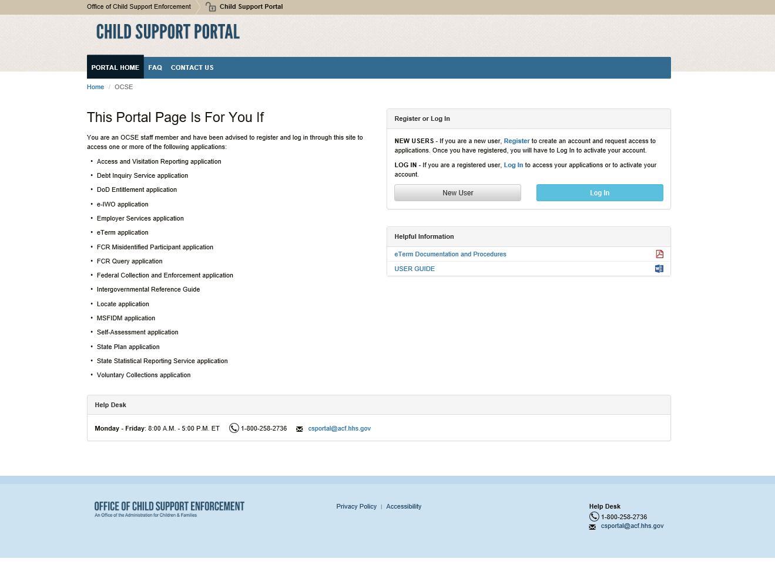
Chart 1-2 describes the functions available from This Portal Page Is For You If page.
Chart 1-2: This Portal Page Is For You If
Link | Description
This Portal Page Is For You If | Displays a list of functions available to the user role you selected.
New User | Opens the Child Support Portal User Registration page
Log In | Opens the Child Support Portal Log In page.
Helpful Information | Displays links to documents or websites that may be helpful in using the Portal.

Figure 1-3: Child Support Portal User Registration (Step 1)
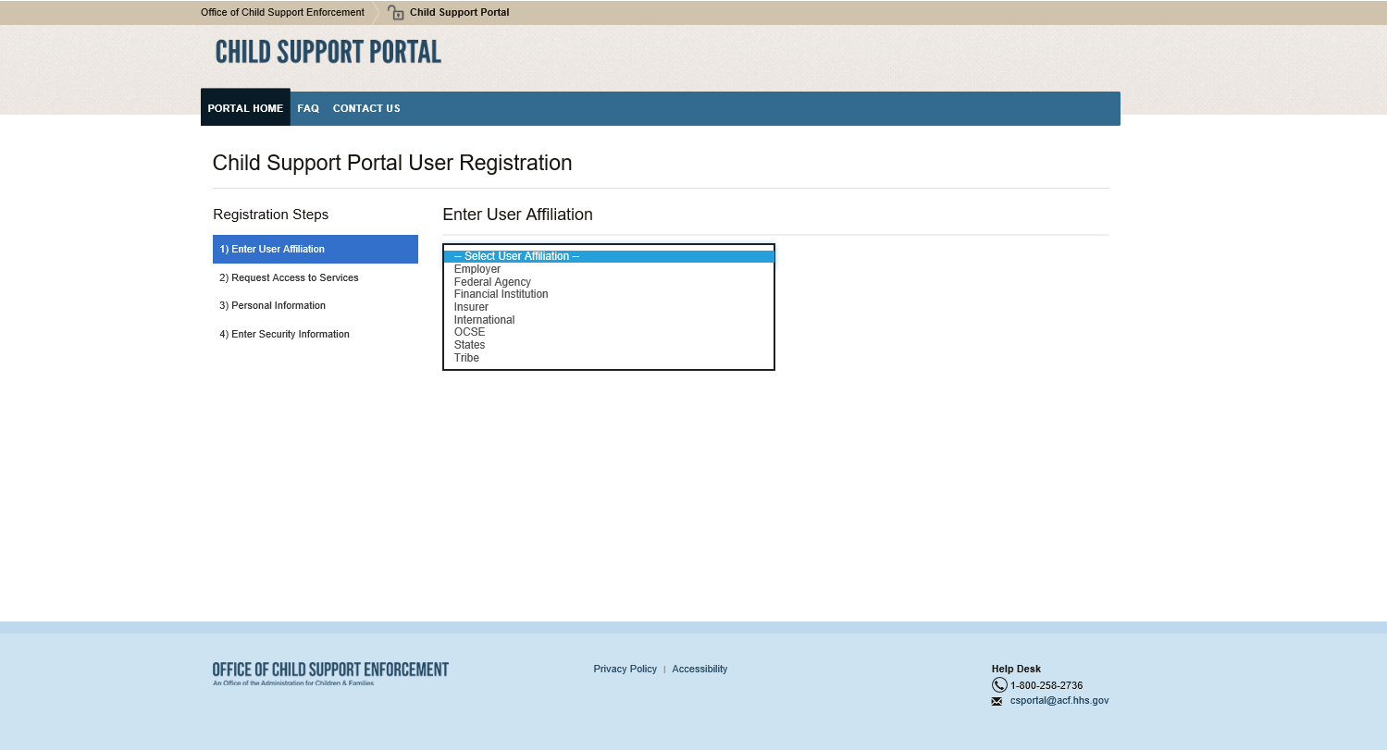
Click Enter User Affiliation to select an affiliation from the a list of affiliations. (In this example, we chose OCSE.)
Depending on the affiliation selected, a new section with sub-groups may appear, requesting additional information.
Figure 1-4 displays if OCSE is selected.
Figure 1-4: Child Support Portal User Registration (Step 2)
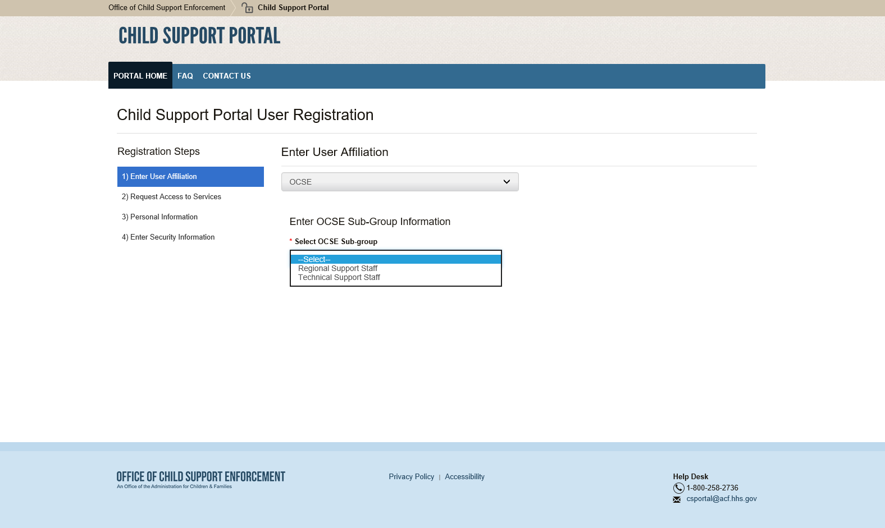
Chart 1-3 describes the functions available from the Enter User Affiliation page.
Chart 1-3: Enter User Affiliation
Link | Description
Enter User Affiliation | Opens a list of user affiliations
Enter OCSE Sub-Group Information | In this OCSE example, select Regional or Technical Support Staff  Selections available for other affiliations, will vary from the example (See next row.)
Sub-Groups for Other Affiliations (Information requested for the other user types) | - Employer, Insurer, and Financial Institution: FEIN  - Federal Agency: Agency name  - Tribe: Tribe name  - International: Country name  - State: State name
After making selections from the affiliation list, the page expands to display a list of functions under Request Access to Services.
Figure 1-5: Child Support Portal User Registration (Step 3)
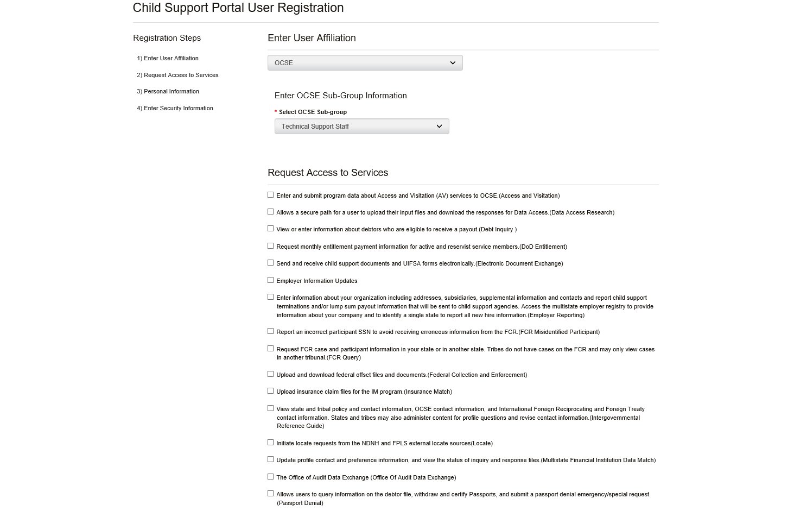
Click the functions you want to access.
Complete the required fields for personal information and work location. (Required fields have asterisks.)
Figure 1-6: Child Support Portal User Registration (Step 4)
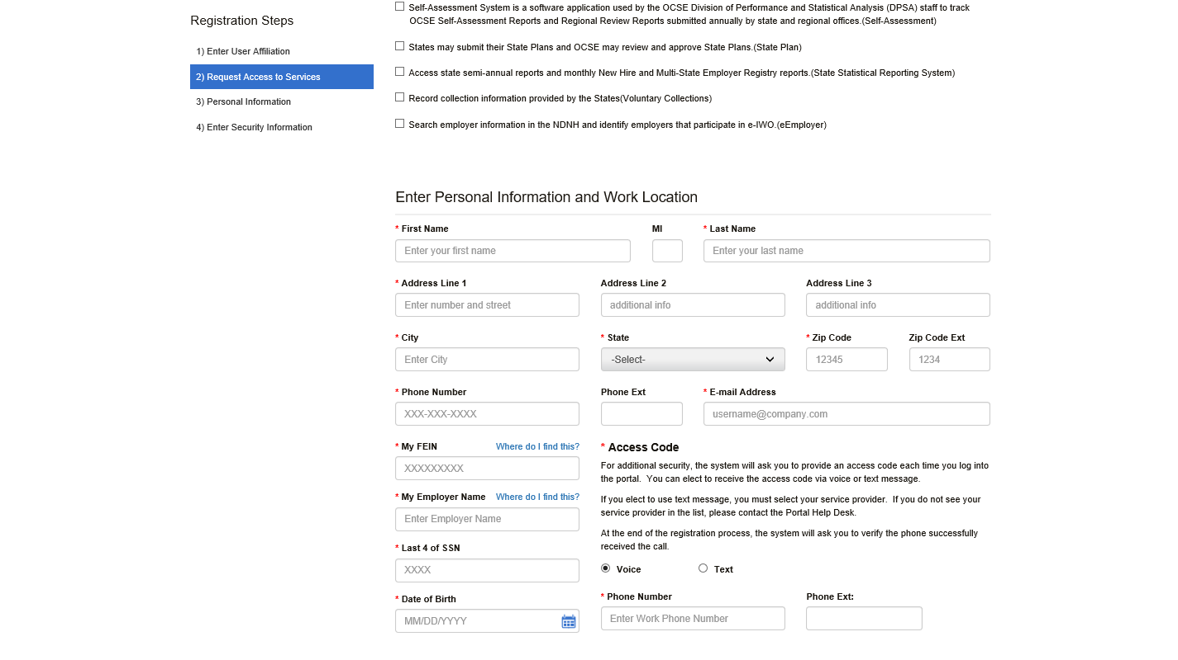
Complete the Access Code section. For increased security, OCSE requires users to enter an access code each time they log in. Users have a choice of a Voice option – a phone call, or a Text option – a text message on your cell phone.
Complete the required fields for Security Information.
Figure 1-7: Child Support Portal User Registration (Step 5)
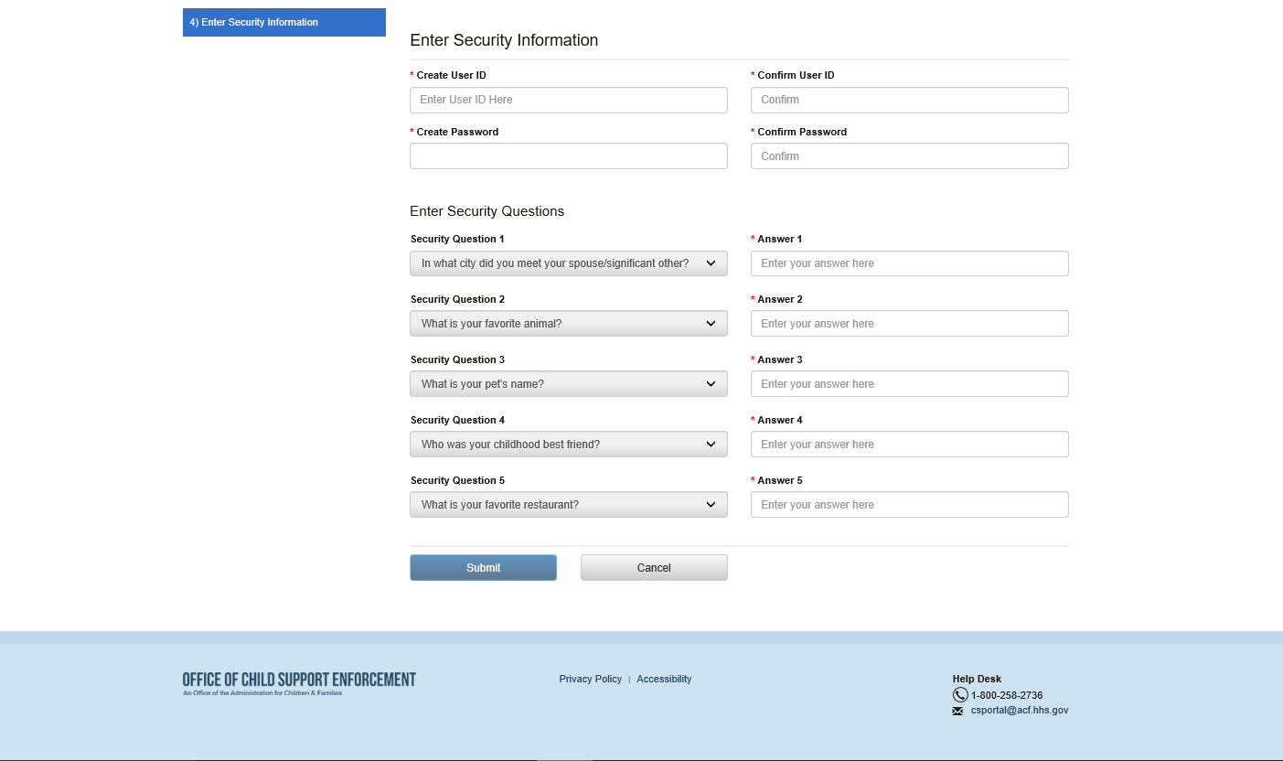
Click Submit to submit registration and display Figure 1-8.
Figure 1-8 displays a summary of information and allows the user to request an access code, and then confirm information.
Figure 1-8: Child Support Portal User Registration (Step 6)
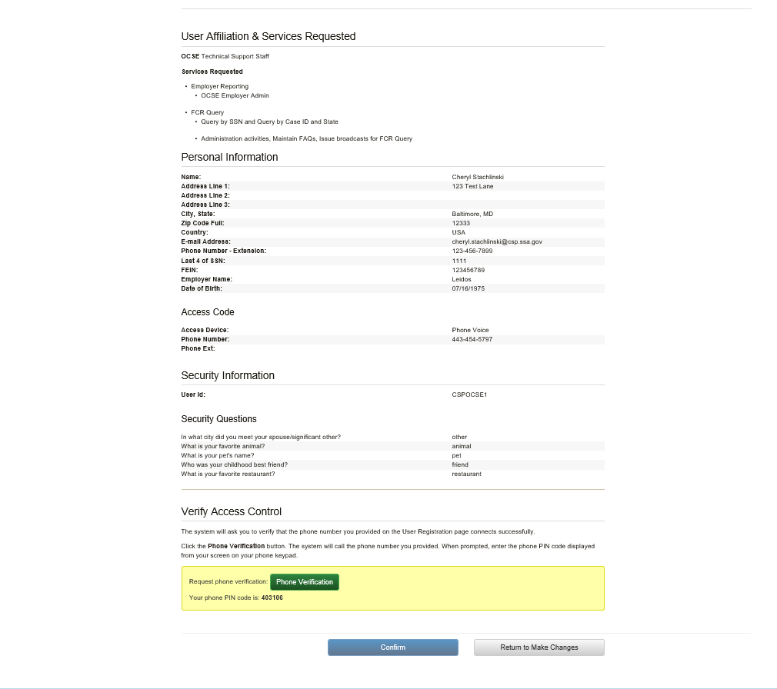
Click Phone Verification to receive a call to enter a PIN.
After successful verification, Figure 1-9 displays. As part of two-factor authentication, the system sends an email or text message with an access code to the media device selected on the Child Support Portal User Registration page, Figure 1-6. The user must enter the access code to complete the registration process.

Figure 1-9: Child Support Portal User Registration Review (Step 7)
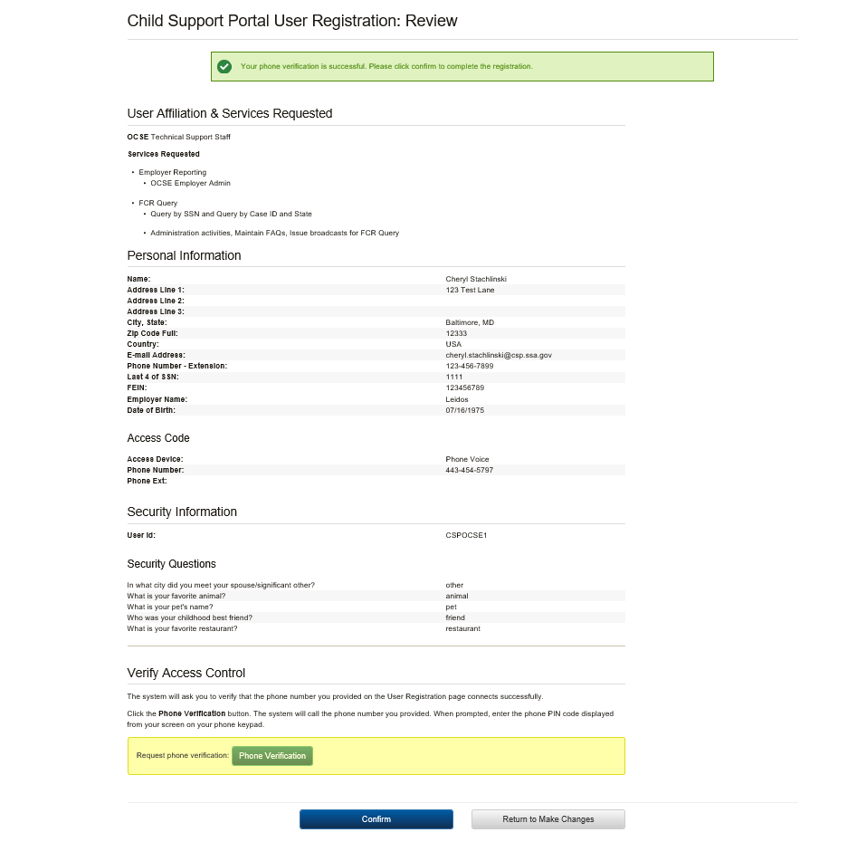
Click Confirm to navigate to the User Confirmation to receive verification that the registration is complete. Figure 1-10 displays.

Click Return to Make Changes if any information needs to be updated.
Figure 1-10 shows the system verified the user successfully submitted the registration.
Figure 1-10: Child Support Portal User Registration Request Submitted
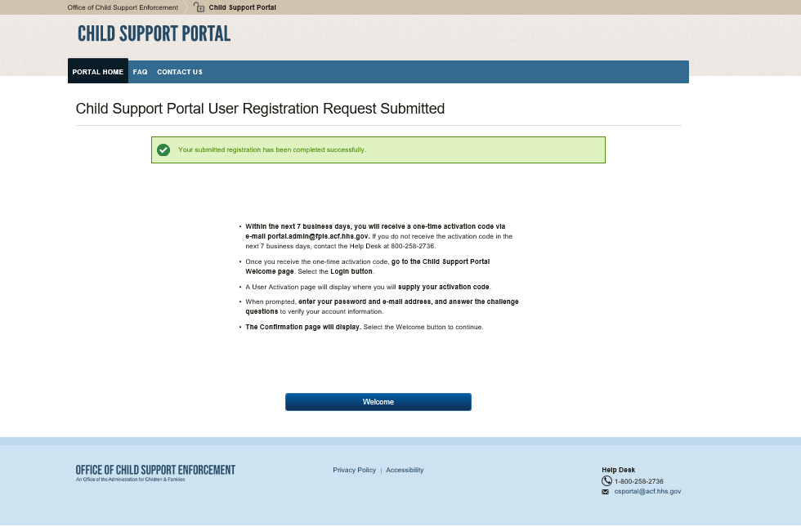
Click Welcome to navigate to the Welcome to the Child Support Portal page.
This concludes this part of the registration. The Help Desk will email the user an access code, so the user can complete the activation process and log into the Portal.

Activation
The user Portal again clicks a user affiliation to open the This Page Is For You If page.
Figure 2-1: This Portal Page Is For You If
Click Log In to open the Login Certification page.
Figure 2-2 shows the Login Certification page displayed when logging into the system.
Figure 2-2: Login Certification
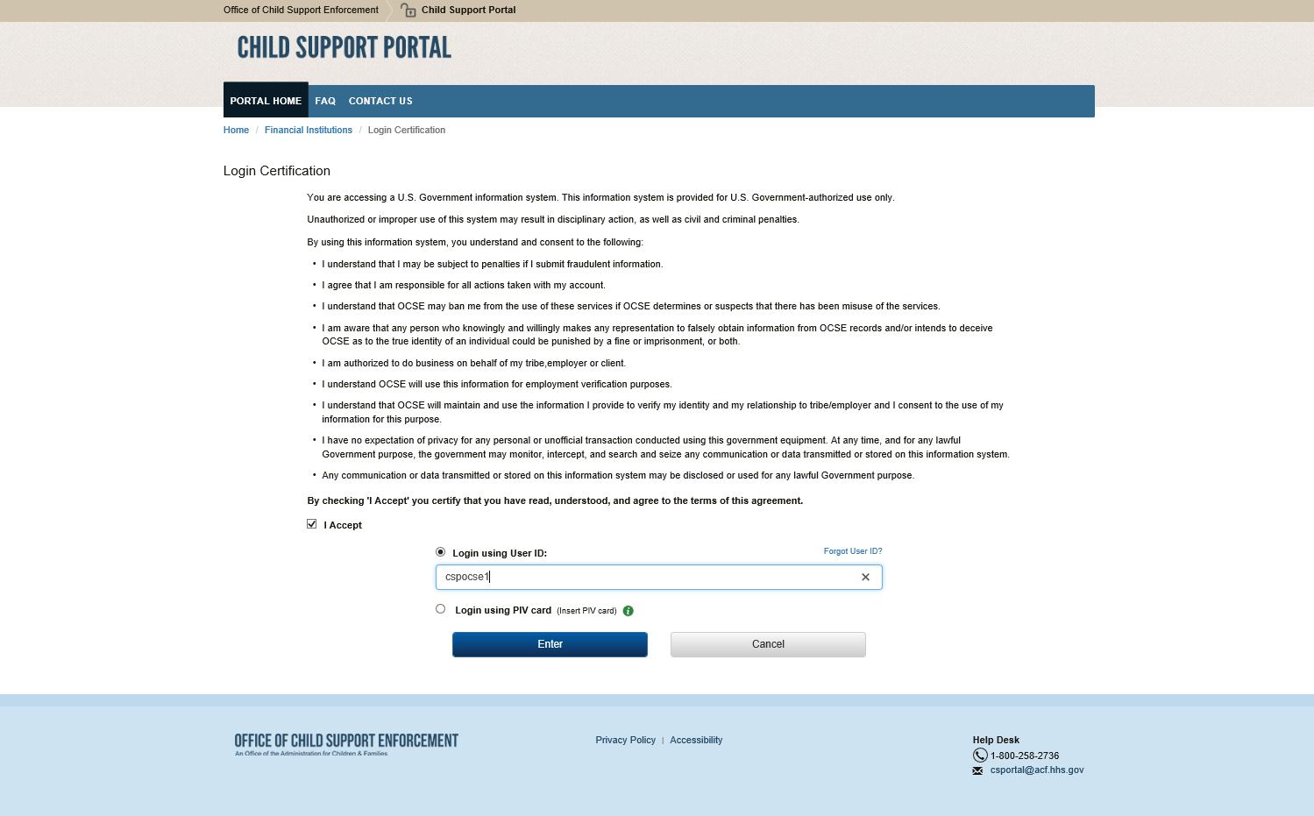
Click the check box to accept the terms of agreement.
Enter your User ID, and then click Enter.
Chart 2-1 describes the functions available from the Login Certification page.
Chart 2-1: Login Certification
Element | Description
I Accept | Checking the box certifies that the user agrees to the terms of agreement
Login using User ID | Allows the user to access the Portal by entering a user ID
Forgot User ID? | Opens the Forgot User ID page
Login using PIV card | Allows the user to access the Portal using a PIV card (internal users only)
I  (Information Link) | Provides extra information about PIV card access
Click Enter to open the User Activation page.
Figure 2-3 shows the page for completing account activation.
Figure 2-3: User Activation
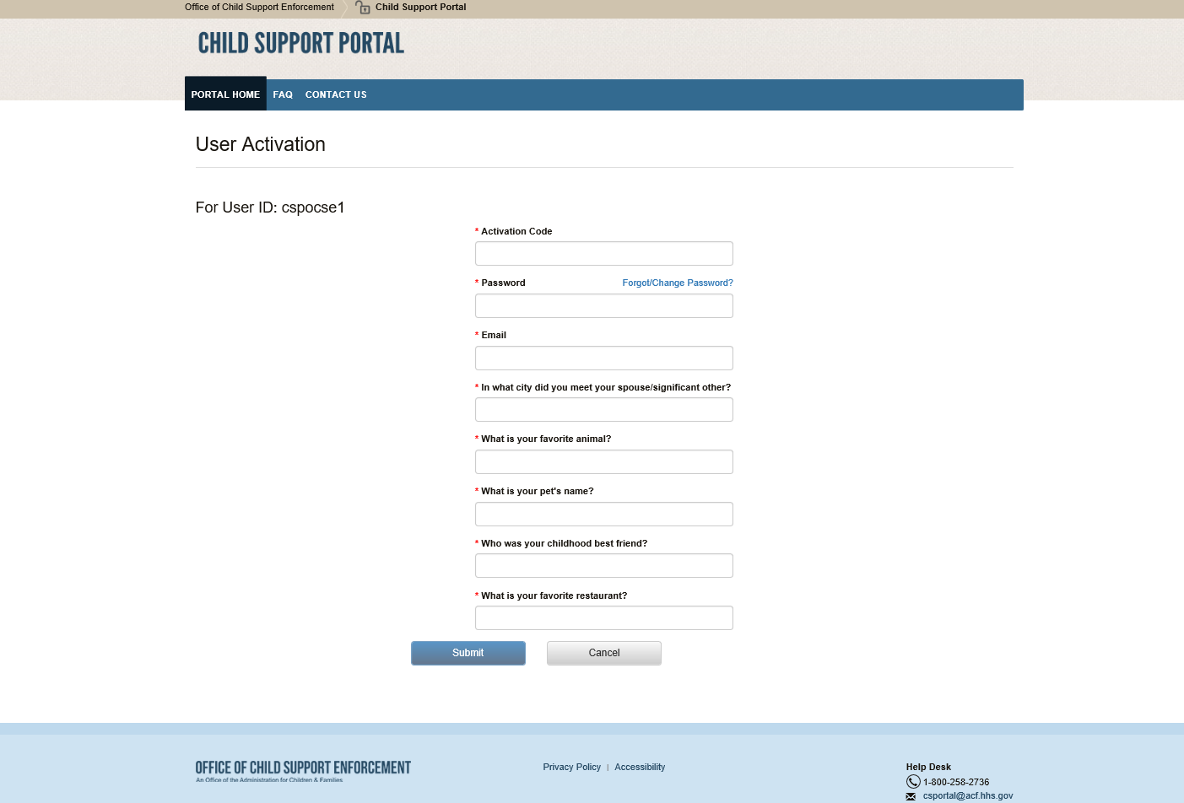
Chart 2-2 describes the functions available from the User Activation page.
Chart 2-2: User Activation
Element | Description
User ID | Displays a system-generated user ID
Activation Code | Allows the user to enter the activation code received from the Portal
Password | Allows the user to enter a password
Forgot/Change Password | Opens the Forgot/Change Password page to reset the password
Challenge Questions | Requires the user to answer the questions
Click Submit to open the Activation Confirmation page, Figure 2-4.
Figure 2-4 shows a confirmation that the user’s account is now activated.
Figure 2-4: Activation Confirmation
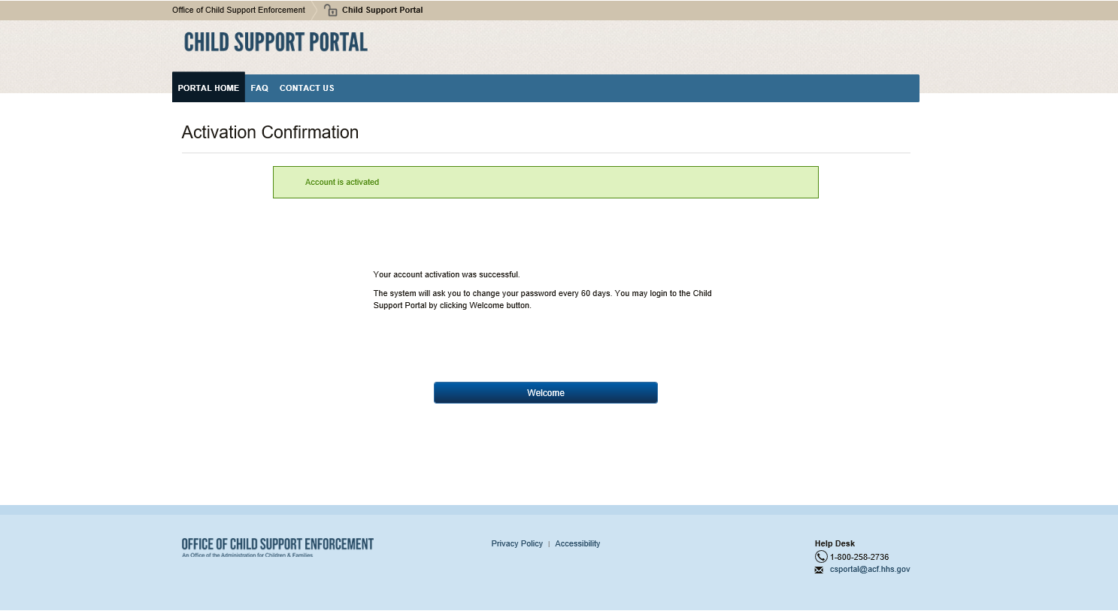
Click Welcome to open the Welcome to the Child Support Portal page.

Login
Figure 3-1 shows the page used to initiate logging in by clicking Log In.
Figure 3-1: This Portal Page Is For You If
Figure 3-2: Login Certification
Chart 3-1 describes the functions available on the Login Certification page.
Chart 3-1: Login Certification
Element | Description
I Accept | Check the box to agree to the terms of the agreement
Log In using User ID | Allows the user to access the Portal using a user ID
Forgot User ID? | Opens the Forgot User ID screen
Login using PIV card | Allows user to access the Portal using a PIV card (internal users)
i  (Information Icon) | Provides extra information concerning PIV card access
Click Enter to open the Login page.
Figure 3-3 shows the Login page when the user elected to receive an access code via text..
Figure 3-3: Login – via Text
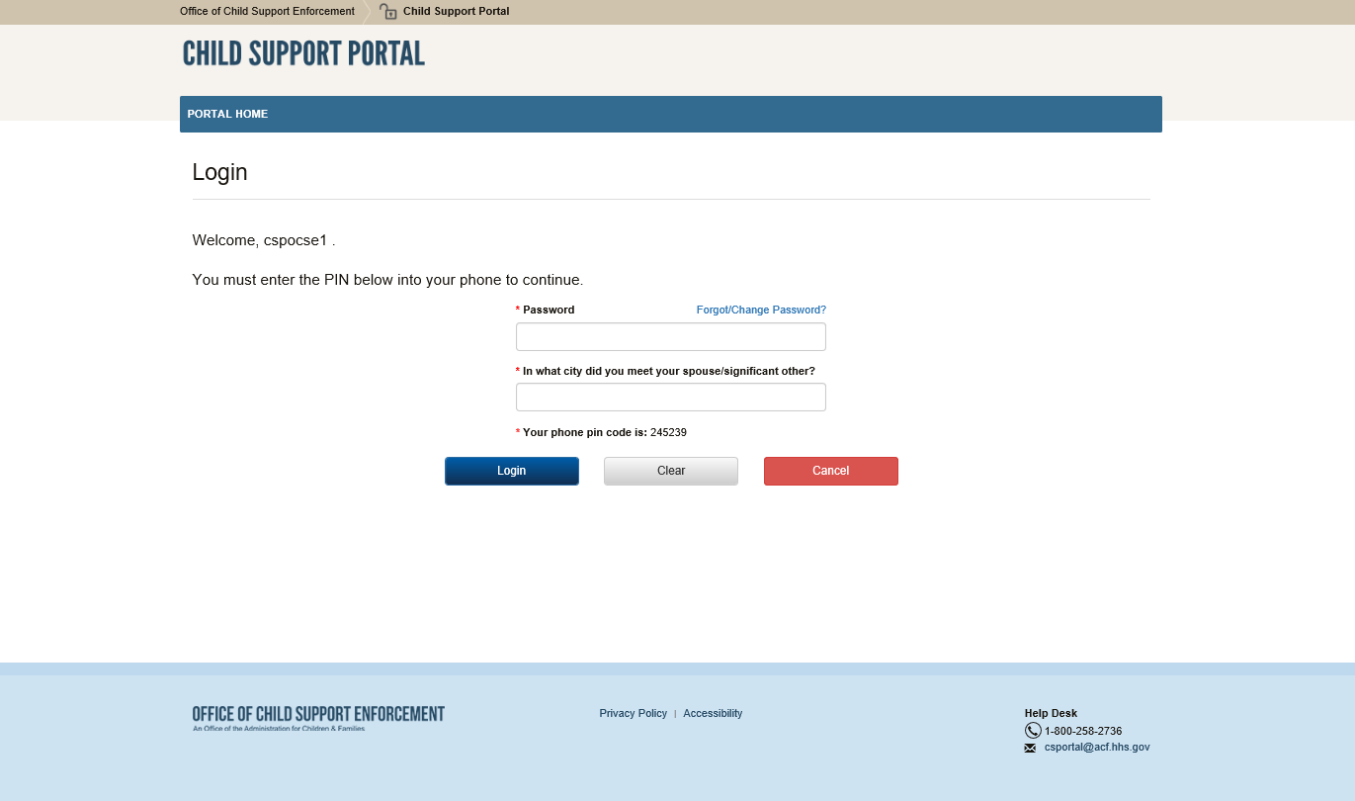
Figure 3-4 shows the Login page when the user elected to receive an access code via voice.
Figure 3-4: Login – via Voice
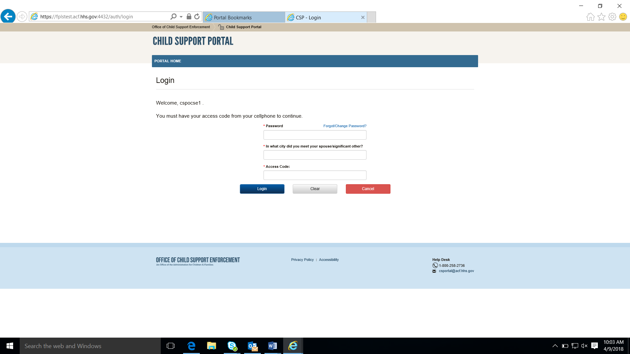
Chart 3-2 describes the functions available from the Login page.
Chart 3-2: Login
Element | Description
Password | Enter a password
Forgot/Change Password? | Opens the Forgot/Change Password page
Challenge Question | Enter an answer to the challenge question
Access Code | Enter the access code received via email or text (chosen during registration)
Enter your password, answer the challenge question, enter an access code received via voice or text, and then click Login.
Figure 3-3 shows the Child Support Portal Home page.
Figure 3-5: Child Support Portal Home Page
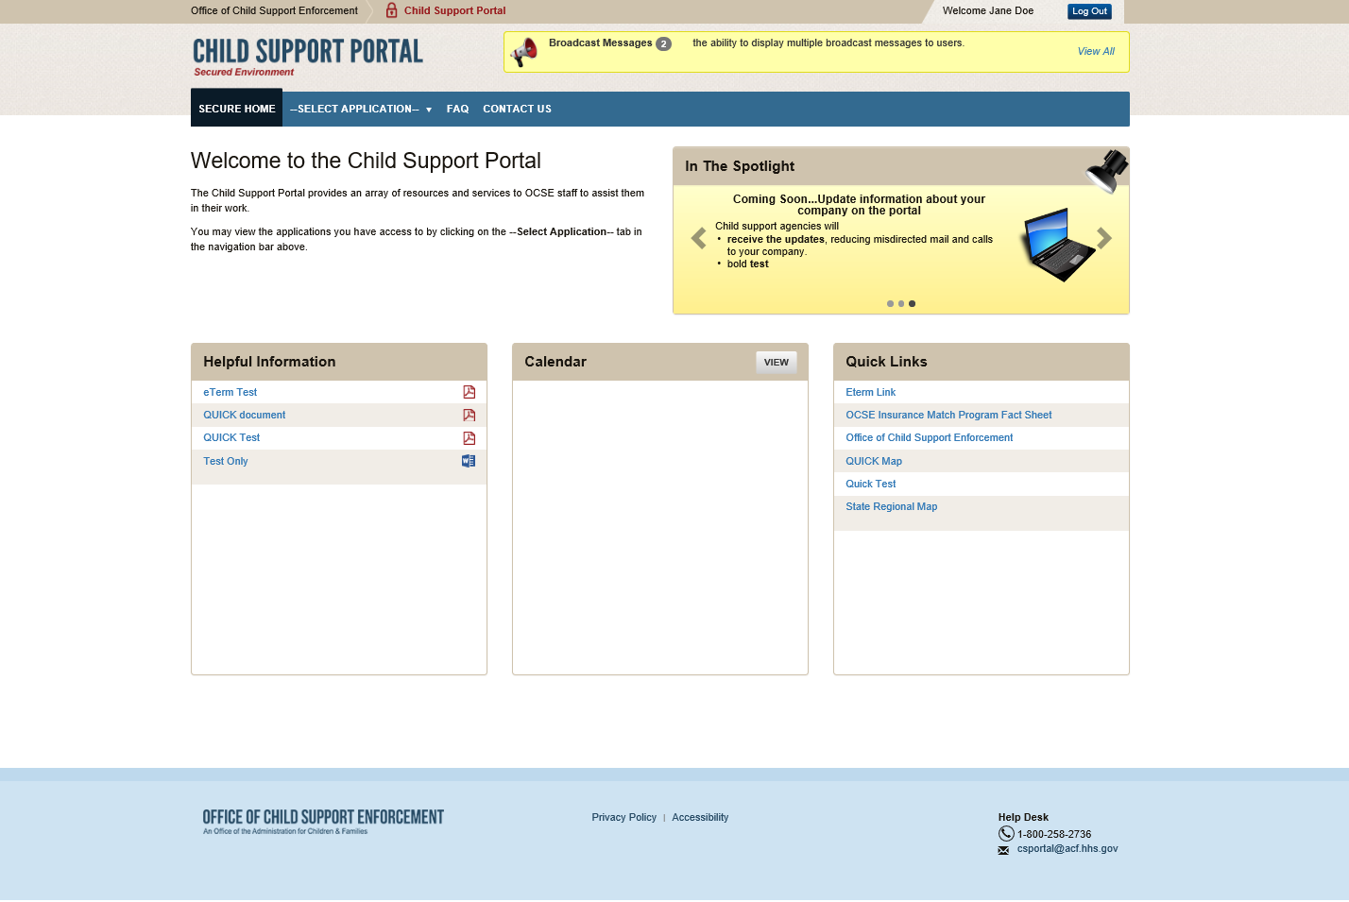
Chart 3-3 describes the functions available from the Child Support Portal Home page.
Chart 3-3: Child Support Portal Home Page
Element | Description
Welcome <User Name> | User can update their account profile
Broadcast Messages | Messages of interest for users of all affiliations on the Portal, such as availability, maintenance, changes, and the like
Secure Home | Indicates that this is the Portal Home Page
Select Application | Select an application for which you have privileges
FAQ | Frequently Asked Questions about the Portal
Contact Us | Displays the Help Desk Contact information
In the Spotlight | Information about new items or events on the Portal
Helpful Information | Documents provided for further information
Calendar | Displays events of interest to users
Quick Links | Links provided for reference

Profile Updates
Figure 4-1 shows the page displayed when the user selects Profile Update from the left menu on the Child Support Portal Home page.
Figure 4-1: Profile Update
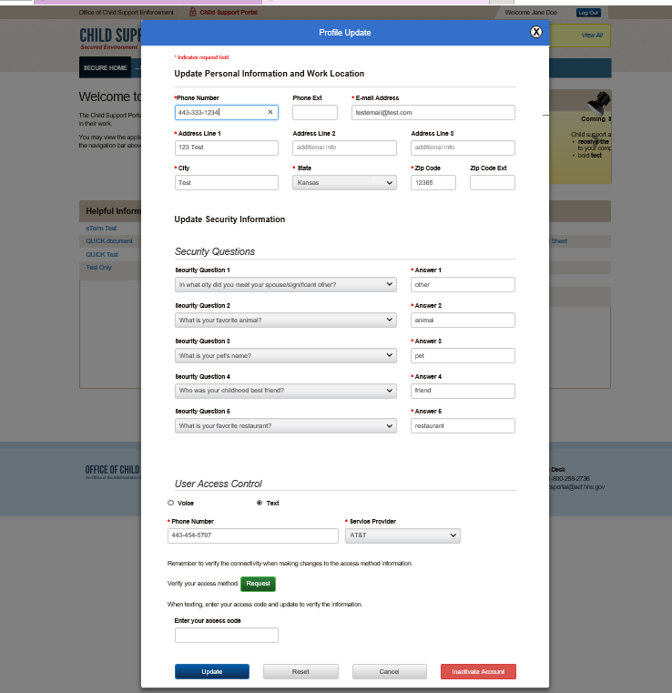
Chart 4-1 displays the information a user can update.
Chart 4-1: Profile Update
Element | Description
Update Personal Information and Work Location Section | Displays the user’s personal and location information
Update Security Information Section | Displays the challenge questions the user selected and the responses the user provided
User Access Control Section | Displays access code choices of voice or text used for two-factor authentication
Request | Click to request an access code
Update | Click to save and confirm the account update
Reset | Click to reset any unsaved updated information
Cancel | Click to cancel the transaction and open the Welcome to Child Support Portal page
Inactivate Account | Click to disable the account
Figure 4-2 shows the Profile Update Confirmation page displayed when a user updates their account.
Figure 4-2: Profile Update Confirmation
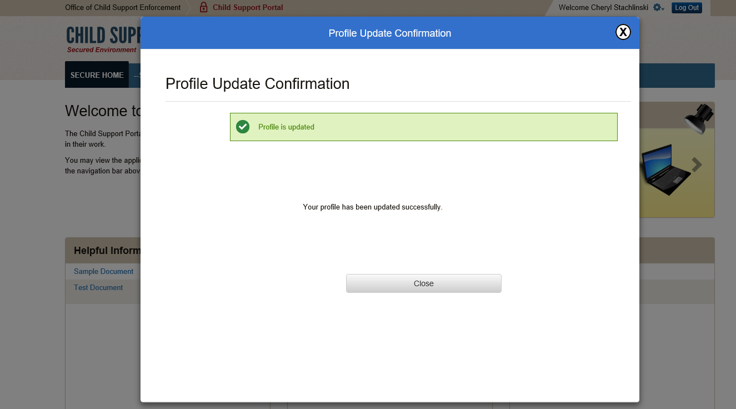
Click Close to return to the Welcome to Child Support Portal page

Credential Management
Figure 5-1 displays the Login Certification page.
Figure 5-1: Login Certification
Chart 5-1 describes the functions that are available from the Login Certification page.
Chart 5-1: Login Certification
Element | Description
I Accept | Click to certify the user agrees with the terms of the agreement
Login using User ID | Allows the user to access the Portal with a user ID
Forgot User ID? | Opens the Forgot User ID screen
Login using PIV card | Allows the user to access the Portal using a PIV card (internal users only)
i (Information Icon) | Provides extra information about PIV card access
Enter | Click to enter the login information
Cancel | Click to return to the This Portal Page Is For You If page
Click I Agree checkbox to accept the terms of the agreement.
Click Forgot User ID?
Figure 5-2 displays the Forgot User ID page.
Figure 5-2: Forgot User ID
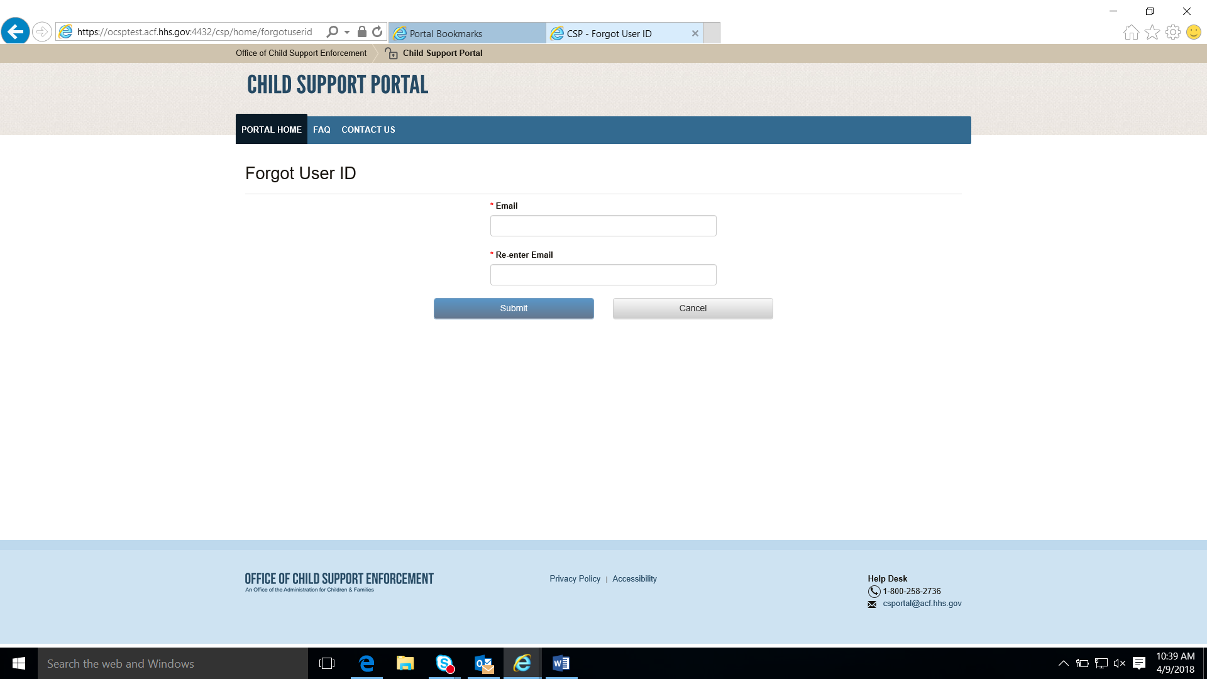
Chart 5-2 describes the functions available from the Forgot User ID page.
Chart 5-2: Forgot User ID
Element | Description
Email Address | Enter an email address to request the user ID
Re-enter Email Address | Re-enter the email address to confirm it
Click Submit to open the Credential Management – Forgot User ID Confirmation page.
Figure 5-3 displays the confirmation that the system sent the ID to the user’s email account.
Figure 5-3: Credential Management – Forgot User ID Confirmation
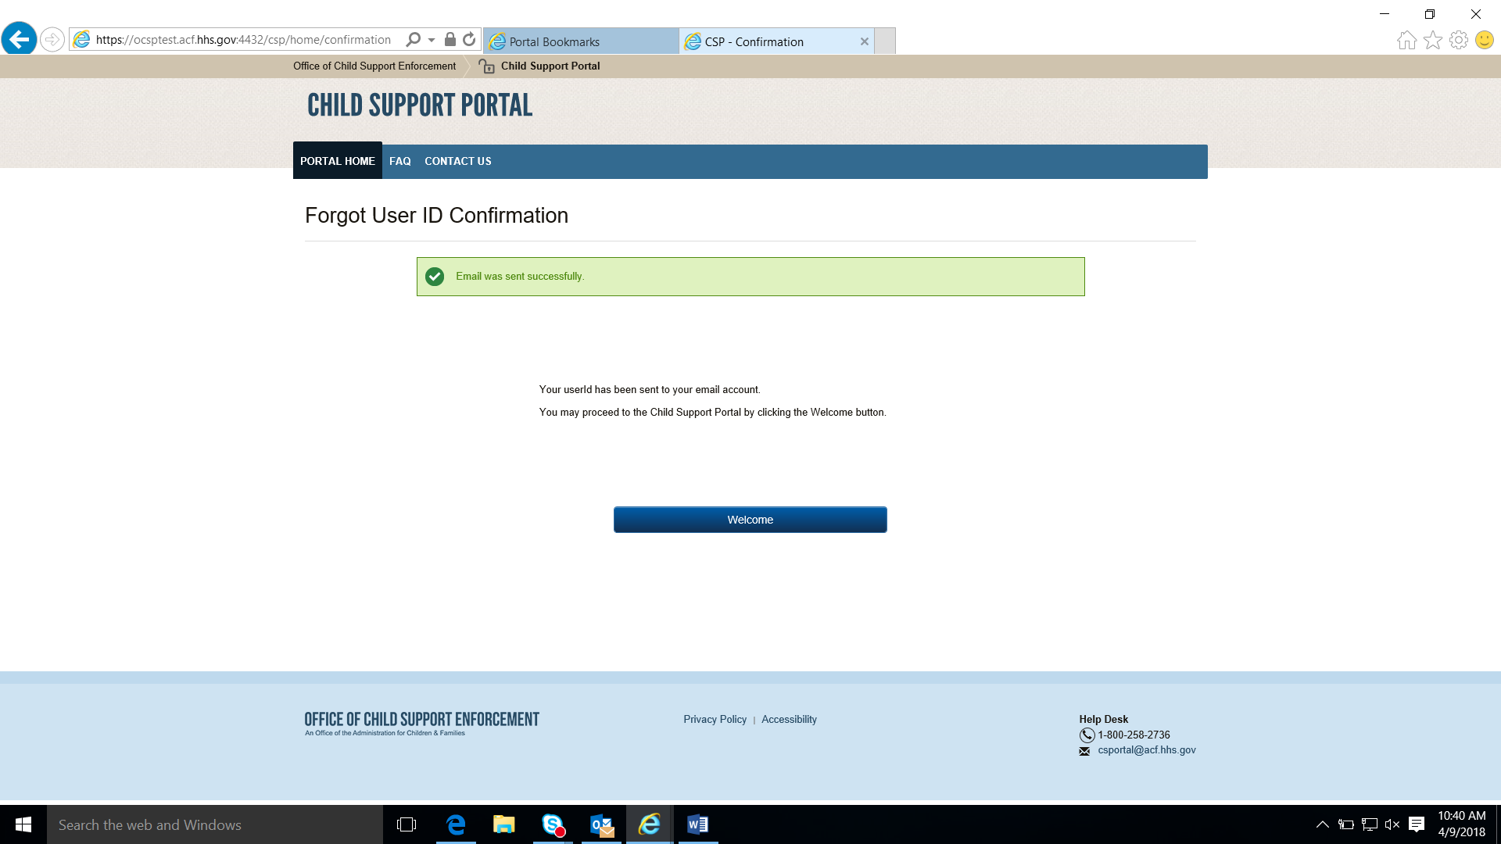
Click Welcome to open the Welcome to the Child Support Portal page.

Figure 5-4: Login – Forgot/Change Password
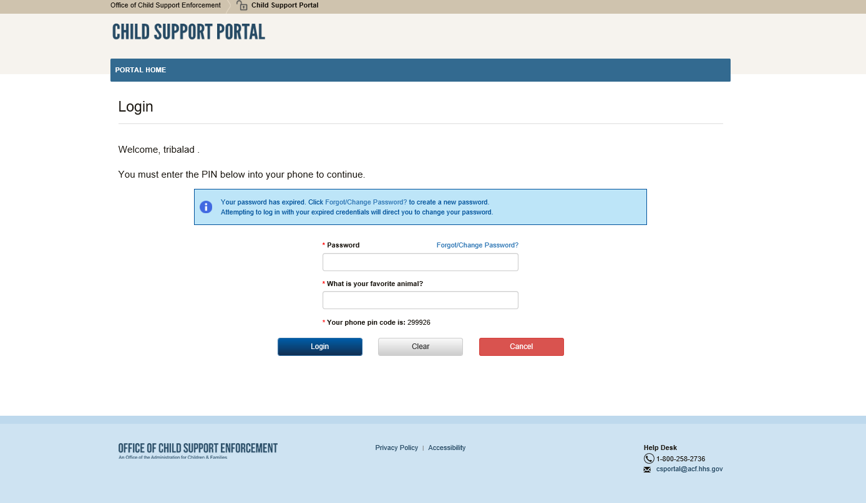
Chart 5-3 describes the functions available from the Login – Forgot User ID page.
Chart 5-3: Login – Forgot/Change Password
Element | Description
Login Guide | Opens screen that provides information on completing the Login Process
Password | Enter password
Forgot/Change Password? | Opens the Forgot/Change Password page
Challenge Question | Answer the challenge question
Access Code/  Your phone pin code is: | Entes a temporary access code received via an e-mail or text message received from the Portal.
Logon | Click to enter information to access portal
Clear | Click to clear data entered
Cancel | Click to navigate to Welcome to the Child Support Portal
Click Login to authenticate the password, challenge question answer, and access code.
Click Resend Code to have the system send a new code.
Figure 5-5 displays the page to request a password reset.
Figure 5-5: Forgot/Change Password
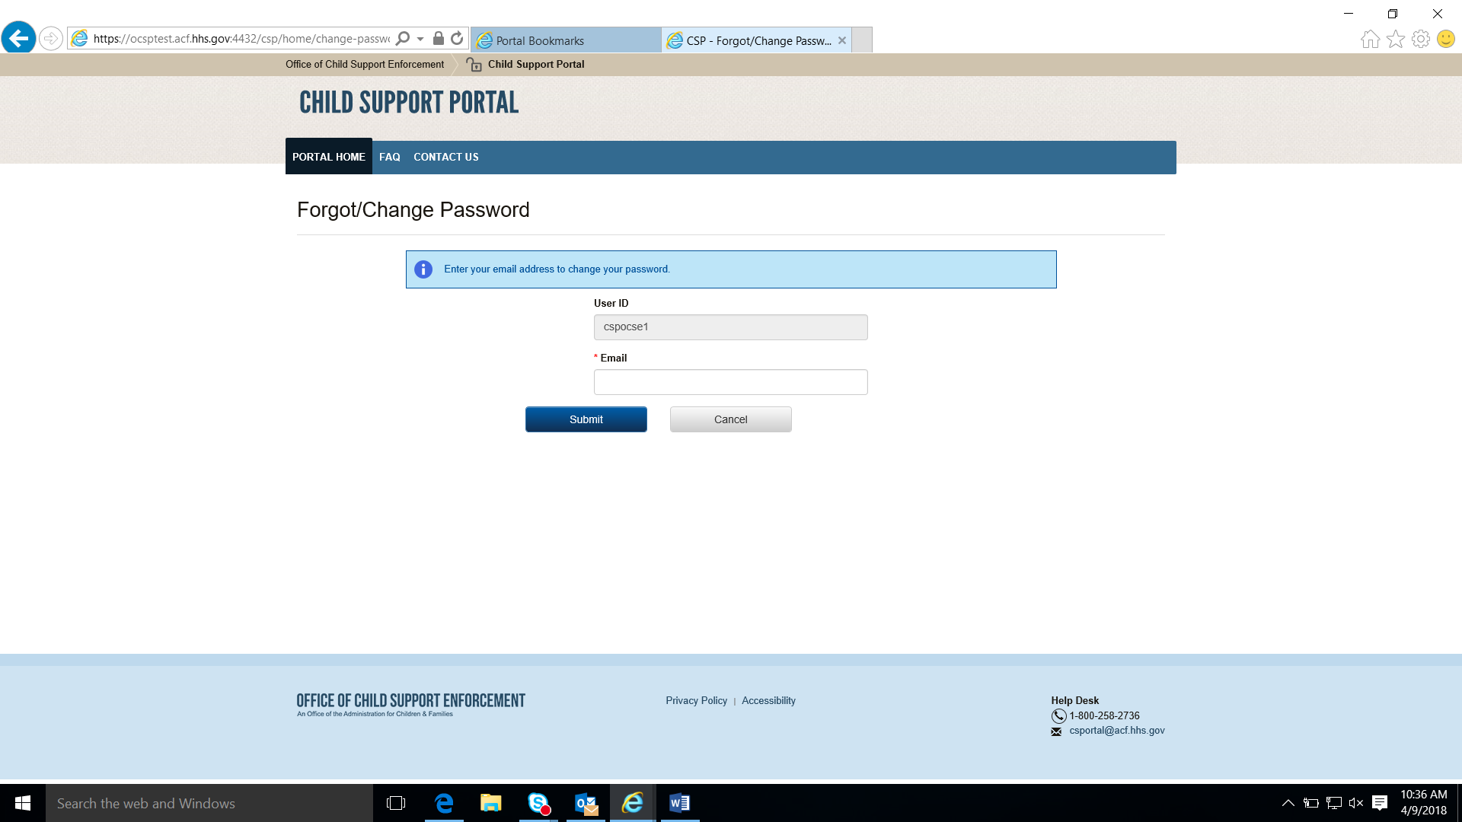
Chart 5-4 describes the functions available from the Forgot/Change Password page.
Chart 5-4: Login Forgot/Change Password
Element | Description
User ID | Displays a system-generated user ID
Email | Enter email address
Enter an email address for access to a password reset page, and then click Submit to open the Forgot/Change Password – Challenge Questions page.
Figure 5-6 displays a page for the user to answer challenge questions.
Figure 5-6: Forgot/Change Password – Challenge Questions
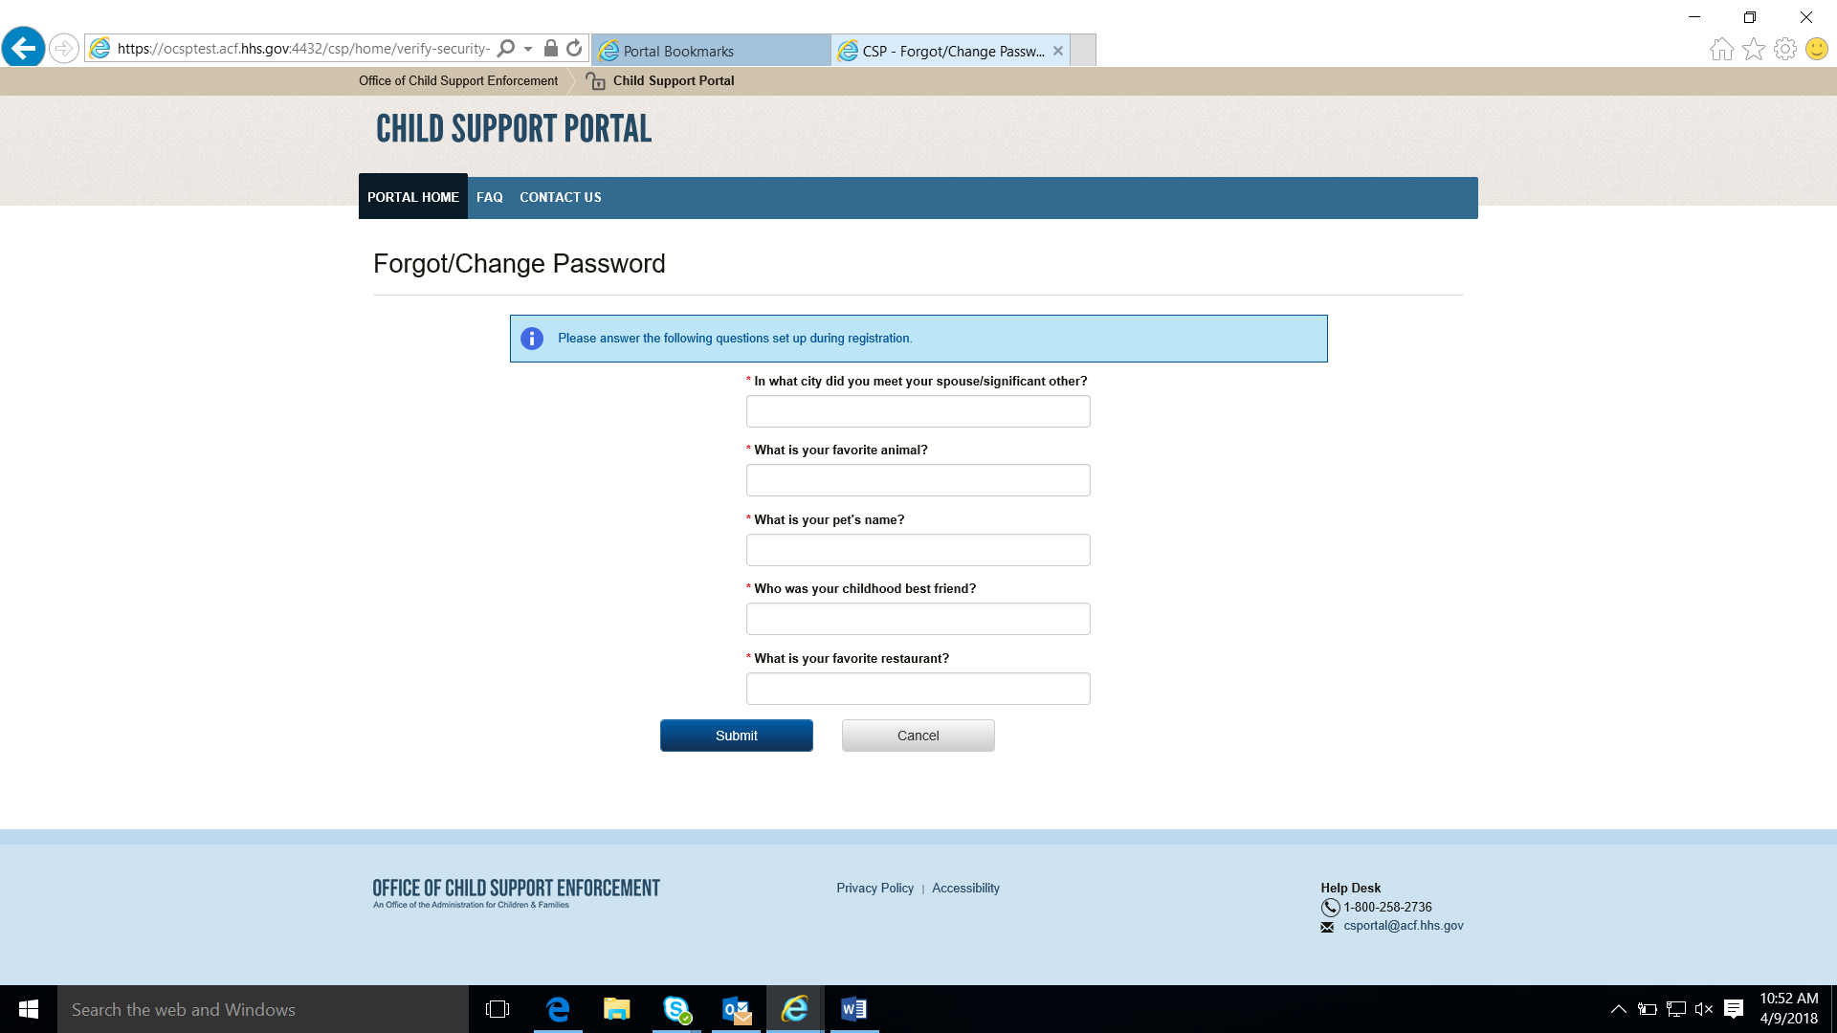
Answer the challenge questions, and then click Submit to open the Forgot/Change Password –Reset Password page.
Figure 5-7 shows the reset password page.
Figure 5-7: Forgot/Change Password – Reset Password
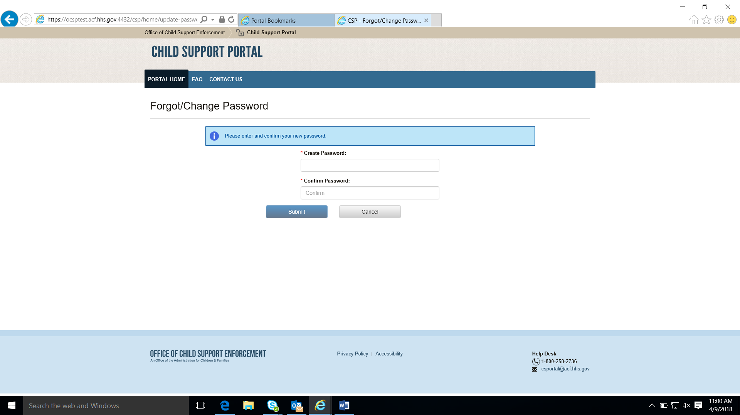
Chart 5-5 describes the functions available on the Forgot/Change Password – Reset Password page.
Chart 5-5: Forgot/Change Password (Reset Password)
Element | Description
Create Password | Allows the user to enter a new password
Confirm Password | Allows the user to confirm the new password
Click Submit to open the Change Password Confirmation page.
Figure 5-8 confirms the password change.
Figure 5-8: Change Password Confirmation
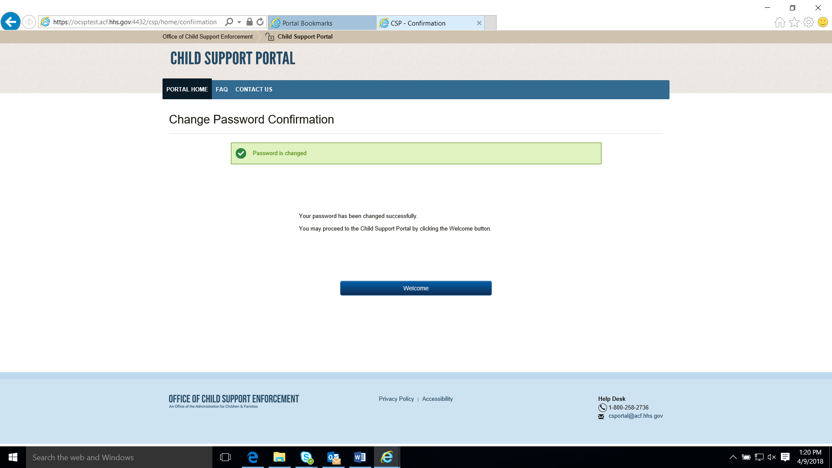
Click Welcome to open the Welcome to the Child Support Portal page.

General Pages
Figure 6-1 displays the timeout warning message.
Figure 6-1: Timeout Warning
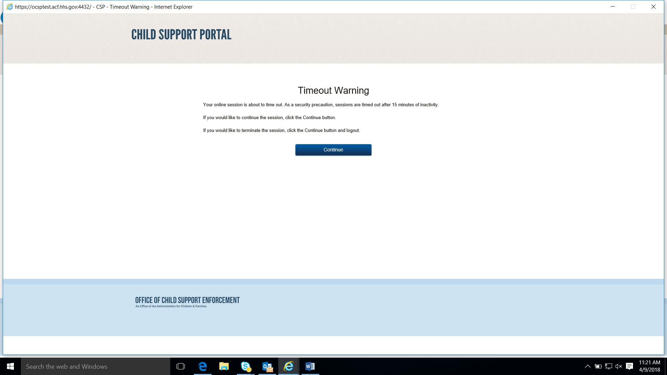
Click Continue to refresh the session, close the browser, and return to the previously displayed page.
Figure 6-2 displays the Session Timed Out message. After receiving this message, the user must log in again.
Figure 6-2: Session Timed Out
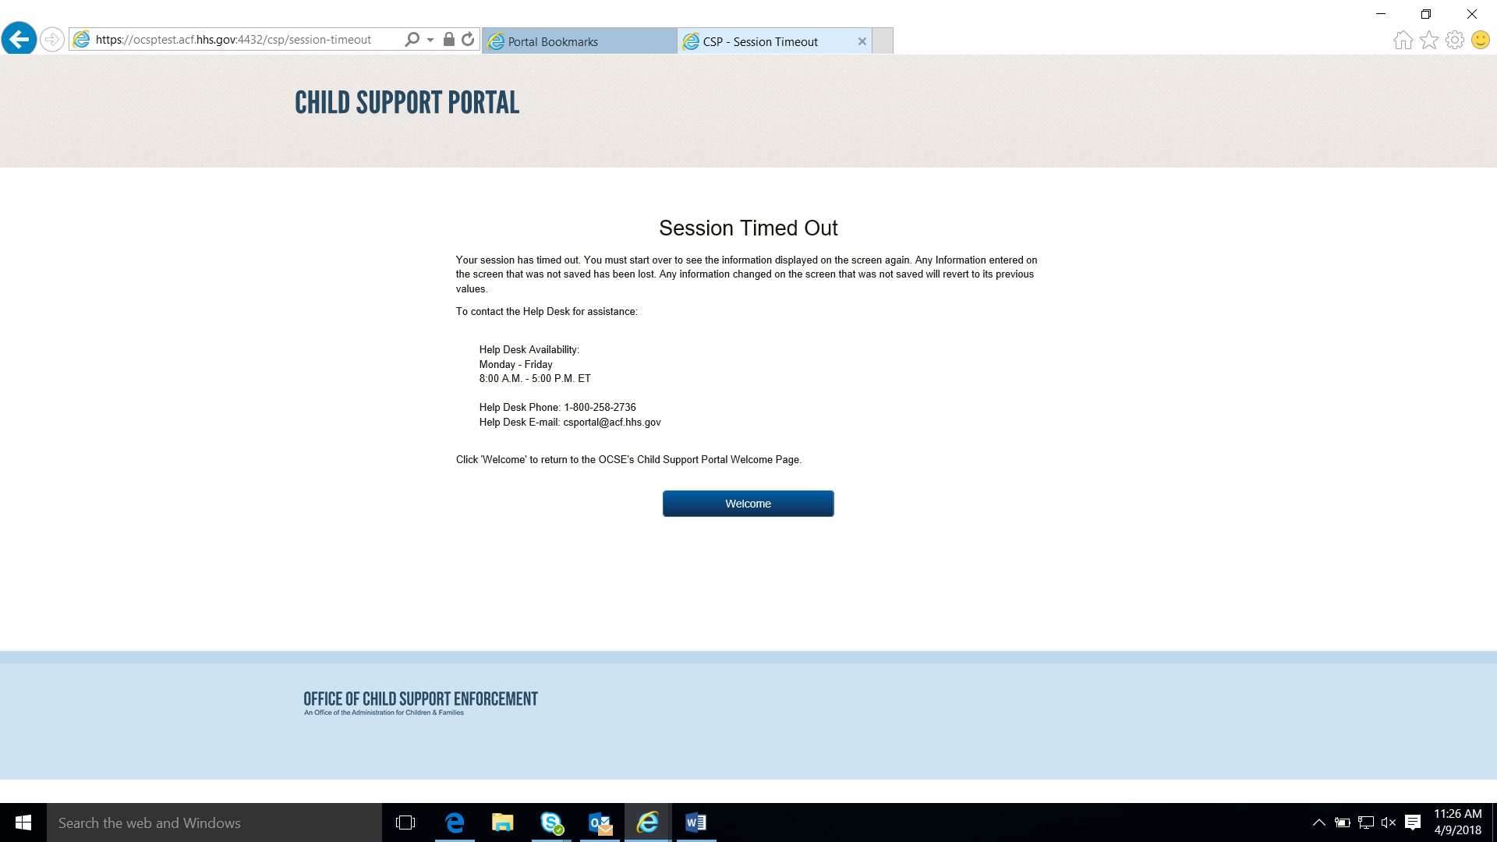
Click Welcome to open the Welcome to Child Support Portal page.

Figure 6-3 displays an example of a system error.
Figure 6-3: System Error
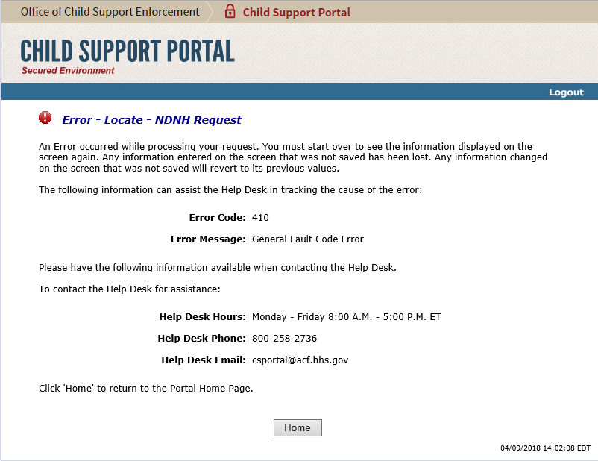
Click Home to open the Welcome to the Child Support Portal page.
Figure 6-4 displays a message that the system locked the account because of the number of invalid login attempts. The user must contact the Help Desk to unlock.
Figure 6-4: Account Locked (Credential Management and Activation Pages)
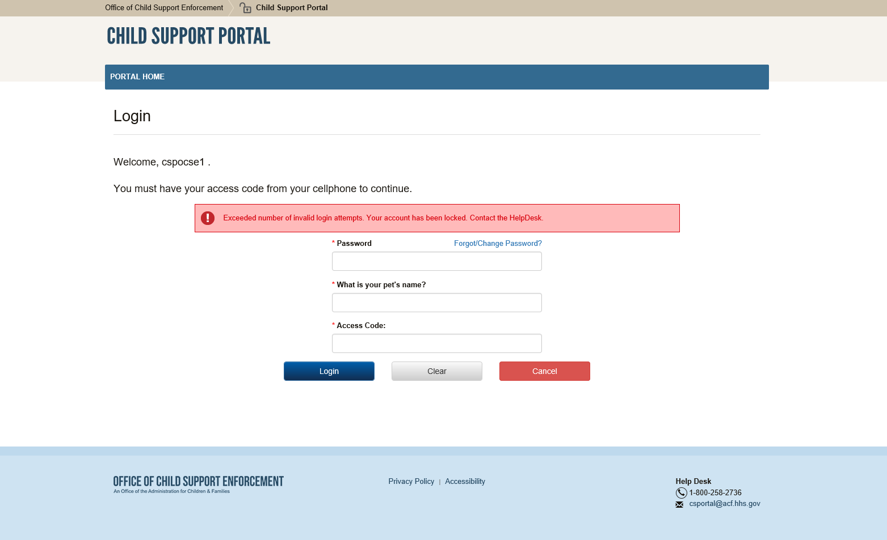
Click Welcome to open the Welcome to Child Support Portal page.
Enter your password, answer the challenge question, and enter an access code, and then click Login.
Figure 6-5 displays the FAQ page, displaying the answers to frequently asked questions about the Portal.
Figure 6-5: Frequently Asked Questions
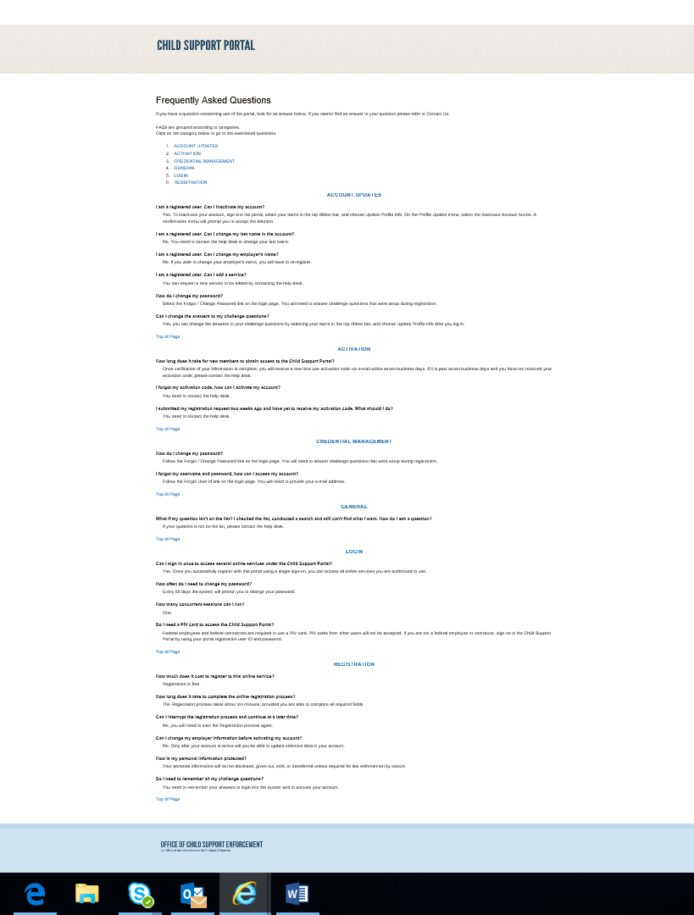
Chart 6-5 describes the functions available from the Frequently Asked Questions page.
Chart 6-5: Frequently Asked Questions
Element | Description
Category List | Click a category, and the system displays the section
Top of Page | Returns to the top of the page

Figure 6-6 displays the Contact Us information for the Portal Help Desk.
Figure 6-6: Contact Us
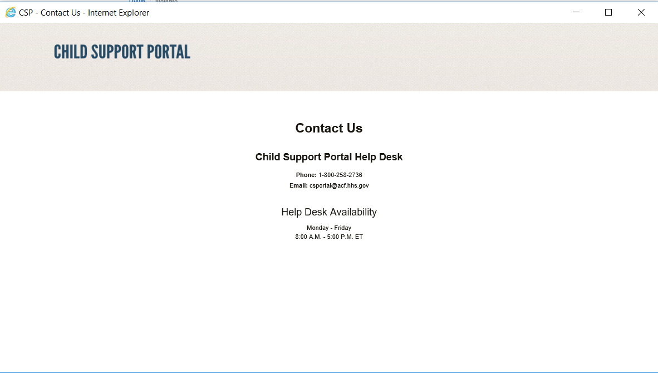
Figure 6-7 shows the security alert message if the user’s system has an issue with the site security.
Figure 6-7: Security Alert – User Accepts Certificate
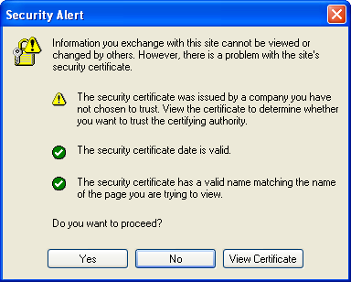
Click Yes to open the Welcome to Child Support Portal.
Click No to cancel the current operation.
Click View Certificate to open the certificate information.
Figure 6-8 shows the message a user sees before disabling their account.
Figure 6-8: Disable Account Message
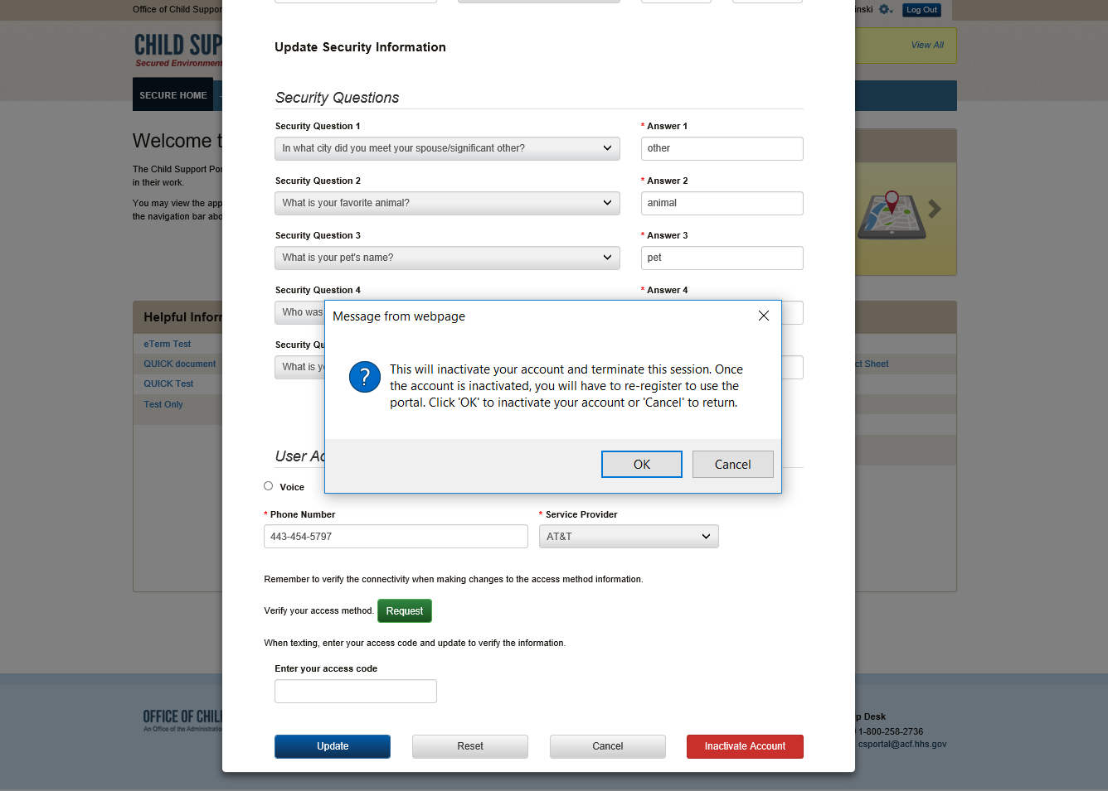
Click OK to disable the user’s account.

The Paperwork Reduction Act of 1995(Pub.L. 104-13)

Public reporting burden for this collection of information is estimated to average 0.15 hours, per response, including the time for reviewing instructions, gathering and maintaining the data needed, and reviewing the collection of information. An agency may not conduct or sponsor, and a person is not required to respond to, a collection of information, unless it displays a currently valid OMB control number.

