Supplemental Document: Justification for a no material/non-substantive change

ATF requests the following 2 changes to ATF Form 7(5310.12)/7CR(5310.16), collection 1140- 0018, due to the fact ATF changed the bank that processes our applications:

- Page 4, large instruction box – delete old bank address and replace with new address

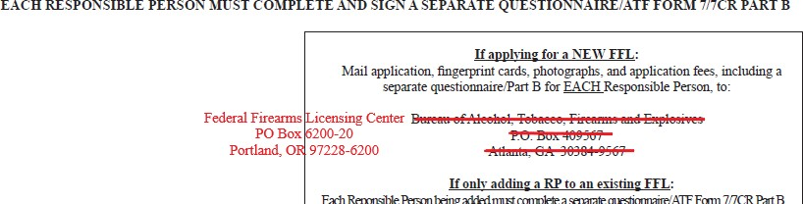
- Instructions page, #14 – delete old bank address and replace with new address

ATF requests the following 2 changes to the Part B Supplement for ATF Form 7(5310.12)/7CR(5310.16), collection 1140-0018, due to the fact ATF changed the bank that processes our applications:

- Page 2, large instruction box – delete old bank address and replace with new address

- Page 4, instruction #14 – delete old bank address and replace with new address
