**CDX Landing Page for Section 5 Submissions:**

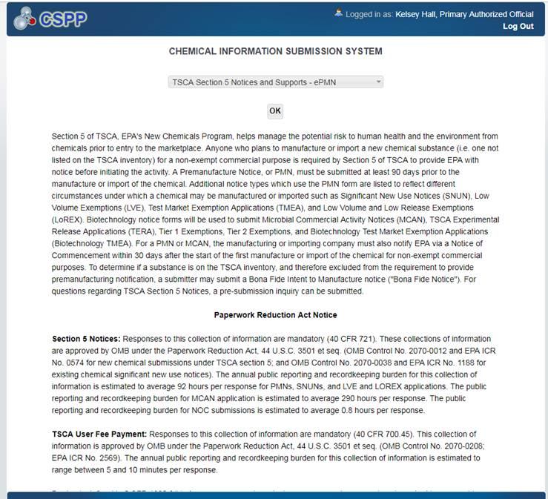

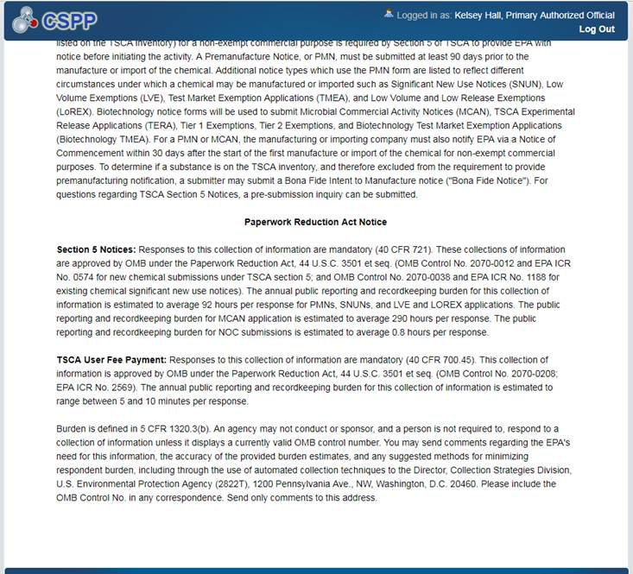

**CDX Landing Page for Section 6 Submissions:**

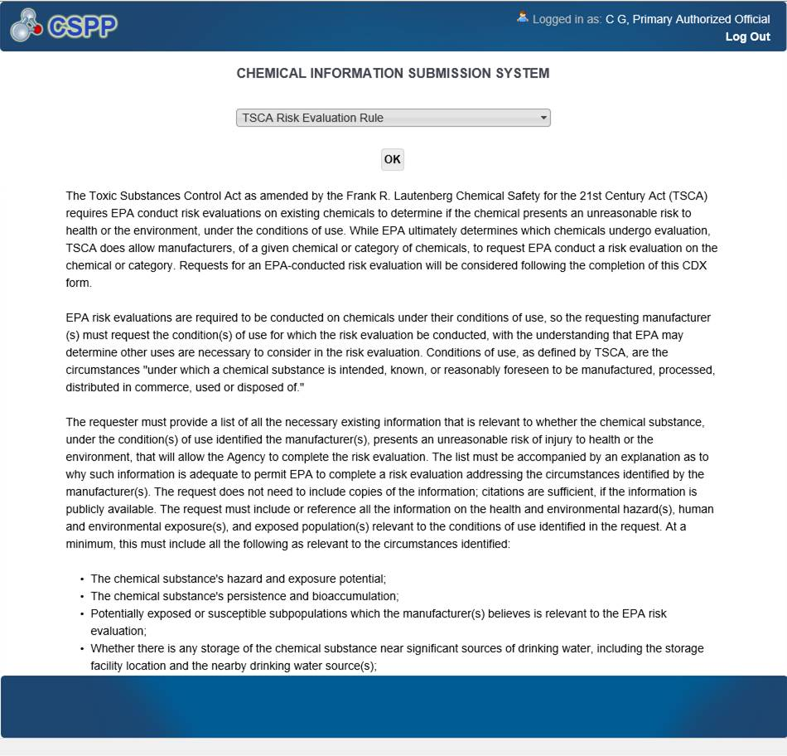

*Continued on next page (Scroll down on screen).*

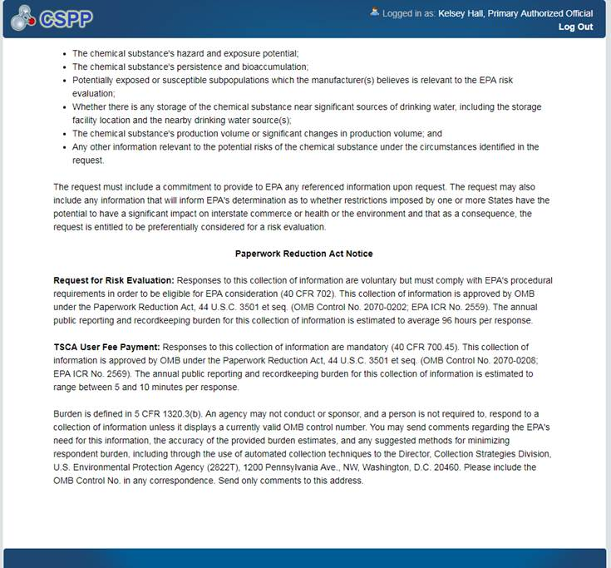

**CDX New Payment Widget for Section 5 and 6 Submissions:**

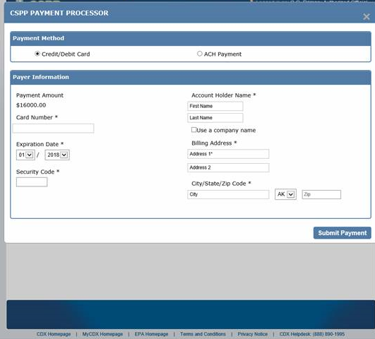

**Section 5 Fees Certification Screen – New for Exemption Submissions:**

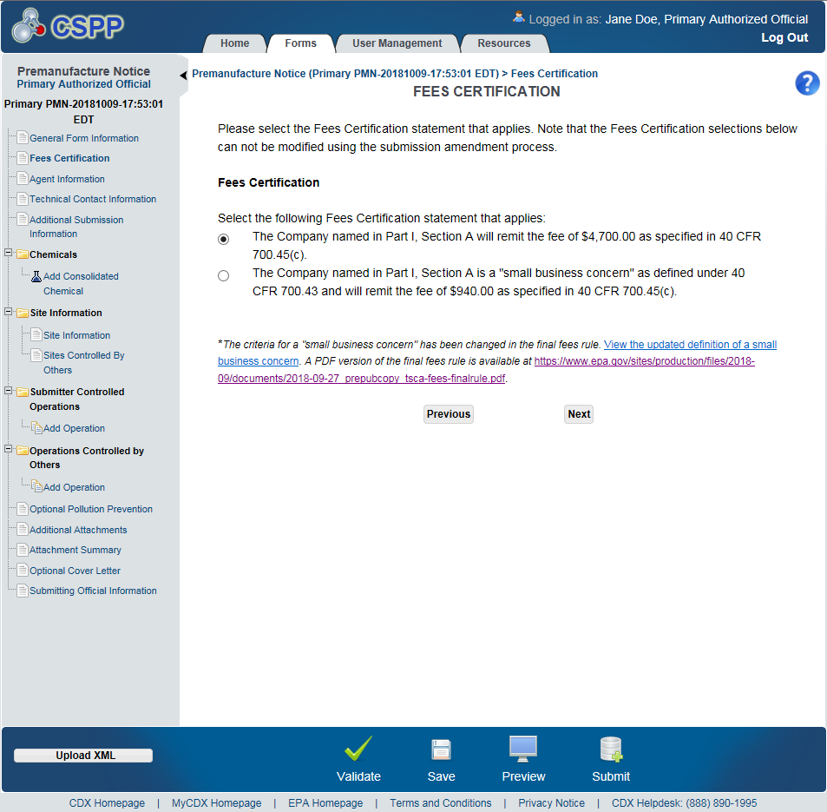

**Section 5 Fees Certification Screen – New for TMEA Exemptions:**

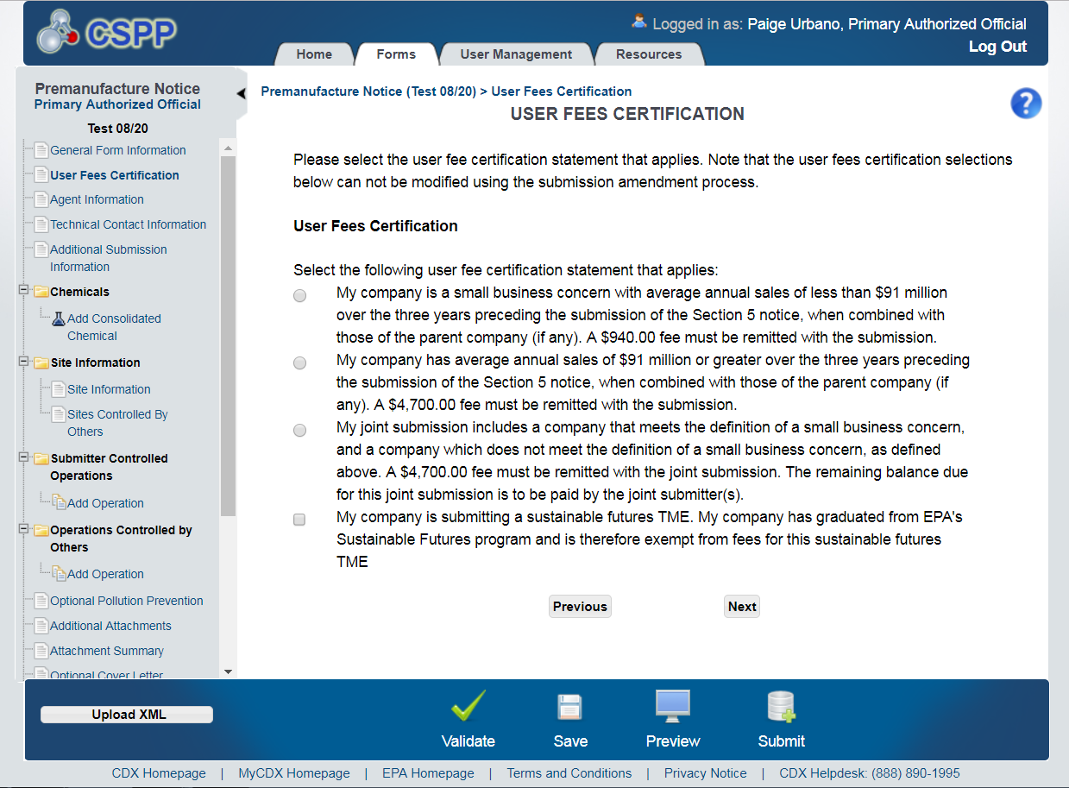

**Section 6 Fees Certification Screen – New for Manufacturer Requests:**

