Instructions for Reporting
2016 TSCA Chemical Data Reporting

DRAFT (10/17/18)

{These instructions will be updated for the 2020 CDR Submission period to incorporate the changes to confidentiality claims
as described in the ICR renewal supporting statement.}

U.S. Environmental Protection Agency
Office of Pollution Prevention and Toxics

March 2, 2016 (DRAFT)
HIGHLIGHTS OF 2016 TSCA CHEMICAL DATA REPORTING (CDR)
- The determination of the need to report is based on production volume during any calendar year since the last principal reporting year (i.e., 2012-2015).
- Information on the reportable chemical substance must be reported during the 2016 CDR submission period, June 1, 2016 to September 30, 2016 (40 CFR 711.20).
- All reporting companies must report CDR data electronically, using e-CDRweb, the CDR web-based reporting tool, and EPA’s Central Data Exchange (CDX) system. Prior to submitting data, submitters must register with CDX.
- Reporting is required for all chemical substances listed on the TSCA Inventory, both organic and inorganic, other than polymers, microorganisms, naturally occurring chemical substances, certain forms of natural gas, and water (40 CFR 711.5 and 711.6) when manufacture (including import) of those chemical substances meets the other reporting requirements. Chemical substances that are the subject of any of certain listed TSCA actions may not be eligible for partial or full exemptions (40 CFR 711.6).
- The separate reporting threshold for submitting processing and use information has been eliminated. Manufacturers (including importers) reporting to CDR are required to report processing and use data, for calendar year 2015, for all reportable chemical substances when the reporting threshold of 25,000 lb (or 2,500 lb if the subject of certain TSCA actions) is met at any site during any calendar year during the submission period (i.e., 2012-2015) (40 CFR 711.15(b)).
- The reporting threshold is 2,500 lb (1,134 kg) for any person who manufactured a chemical substance that is the subject of a rule proposed or promulgated under TSCA section 5(a)(2), 5(b)(4) or 6; an order issued under TSCA section 5(e) or 5(f); or relief that has been granted under a civil action under TSCA section 5 or 7. The effects of these TSCA actions on CDR reporting are assessed based on the status of the chemical substance as of the beginning of the submission period, June 1, 2016 (40 CFR 711.8(b) and 40 CFR 711.15).
- Small manufacturers are exempt from CDR requirements unless they manufacture (including import) 2,500 lb or more of a chemical substance that is the subject of a rule proposed or promulgated under sections 4, 5(b)(4), or 6 of TSCA, or is the subject of an order in effect under section 5(e) of TSCA, or is the subject of relief that has been granted under a civil action under sections 5 or 7 of TSCA (40 CFR 711.9) and (TSCA § 8(a)(3)(A)(ii)).
- Information submitted under CDR may be claimed as confidential; however, such claims must be made at the time of submission and substantiated in accordance with the CDR rule. Submitters must provide upfront substantiation of confidentiality claims for processing and use information as well as for confidentiality claims for site or chemical identity. A blank response or a response that is designated as “not known or reasonably ascertainable” may not be claimed as confidential (40 CFR 711.30).
- Visit the CDR Web site (http://www.epa.gov/cdr) for program updates and announcements, other guidance materials for 2016 reporting, and contact information for technical assistance.

TABLE OF CONTENTS

1. Introduction 1-1
1.1 Background and Statutory Authority 1-1
1.2 Changes to CDR Requirements for 2016 1-2
2. Reporting Requirements 2-1
2.1 Step I: Is Your Chemical Substance Subject to the CDR Rule? 2-1
2.1.1 Is Your Chemical Substance Manufactured for Commercial Purposes?
(Question A) 2-2
2.1.2 Is Your Chemical Substance on the TSCA Inventory? (Question B) 2-10
2.1.3 Is Your Chemical Substance Potentially Exempt from Reporting?
(Question C) 2-13
2.1.4 Is your Chemical Substance Ineligible for an Exemption Because it is
the Subject of Certain TSCA Actions? (Question D) 2-15
2.2 Step II: Are You a Manufacturer Who Is Required to Report? 2-16
2.2.1 Did You Manufacture (Including Import) 25,000 lb or More of the Chemical Substance at a Single Site During any of the Calendar Years since the Last Principal Reporting Year? (Question E) 2-17
2.2.2 Did You Manufacture (Including Import) 2,500 lb or More of the Chemical Substance (if it is the Subject of Certain TSCA Actions? (Question F) 2-18
2.2.3 Do You Qualify For a Small Manufacturer Exemption? (Question G) 2-21
2.2.4 Did You Manufacture a Chemical Substance that is the Subject of
Certain TSCA Actions? (Question H) 2-21
2.2.5 Do You Qualify for Any Other Reporting Exemptions? (Question I) 2-23
2.3 Step III: What Information Must You Report? 2-25
2.3.1 Is Your Chemical Substance Subject to Full Reporting due to Its TSCA
Regulatory or Consent Agreement Status? (Question J) 2-28
2.3.2 Is Your Chemical Substance Listed as a Petroleum Process Stream?
(Question K) 2-28
2.3.3 Is Your Chemical Substance Listed as a Chemical for Which There is
Low Current Interest in the CDR Processing and Use Information? (Question L) 2-28
3. When You Must Report 3-1
4. Instructions for Completing CDR Form U 4-1
4.1 Certification 4-1
4.2 Reporting Standard 4-1
4.3 Part I - Section A. Parent Company Information 4-4
4.3.1 Parent Company Name (Block 1.A.1) 4-5
4.3.2 Parent Company Dun & Bradstreet D-U-N-S® Number (Block 1.A.2) 4-5
4.3.3 Parent Company Address (Blocks 1.A.3 through 1.A.8) 4-6
4.4 Part I - Section B. Site Information 4-6
4.4.1 Special Provisions for Certain Sites 4-6
4.4.2 Site Name (Block 1.B.1) 4-8
4.4.3 Site Dun & Bradstreet Number D-U-N-S® (Block 1.B.2) 4-8
4.4.4 Site Street Address (Blocks 1.B.3 through 1.B.8) 4-8
4.5 Part I - Section C. Technical Contact Information 4-9
4.5.1 Technical Contact Name and Company Name (Blocks 1.C.1 and 1.C.2) 4-9
4.5.2 Technical Contact Telephone Number and Email Address
(Blocks 1.C.3 and 1.C.4) 4-10
4.5.3 Technical Contact Mailing Address (Blocks 1.C.5 through 1.C.8) 4-10
4.6 Part II - Section A. Chemical Substance Identification 4-10
4.6.1 Confidentiality of Chemical Substance Information (Block 2.A.1) 4-12
4.6.2 Chemical Substance Identifying Number (Block 2.A.2) 4-15
4.6.3 ID Code (Block 2.A.3) 4-16
4.6.4 Chemical Name (Block 2.A.4) 4-17
4.6.5 Special Provisions for Importers and Joint Submitters 4-17
4.7 Part II - Section B. Manufacturing Information 4-18
4.7.1 Confidentiality of Company Information (Block 2.B.1) 4-18
4.7.2 Confidentiality of Site Information (Block 2.B.2) 4-18
4.7.3 Confidentiality of Technical Contact Information (Block 2.B.3) 4-19
4.7.4 Reporting Manufacturing Information for Calendar Year 2015 (Blocks 2.B.4. through2.B.20) 4-20
4.7.5 Reporting Past Production Volume (PV) (Block 2.B.20) 4-26
4.8 Part III - Processing and Use Information 4-26
4.8.1 Part III - Section A. Industrial Processing and Use Data (Blocks 3.A.1
through 3.A.10) 4-29
4.8.2 Part III - Section B. Consumer and Commercial Use Data (Blocks 3.B.1
through 3.B.10) 4-36
4.9 Part IV – Joint Submissions 4-41
4.9.1 Need for a Joint Submission 4-41
4.9.2 Submitting as a Manufacturer (including Importer) or Primary Submitter 4-42
4.9.3 Submitting as a Supplier, as a Secondary or Tertiary Submitter 4-45
4.9.4 Reporting a Confidential Chemical Substance 4-51
5. How to Obtain Copies of Documents Cited in This Instructions Document 5-1
5.1 Obtaining Copies of the TSCA Rules 5-1
5.2 Obtaining Copies of the Public Portion of the TSCA Inventory 5-1
5.3 Obtaining Copies of Other Information Materials for the 2016 CDR 5-1

Appendices
Appendix A—Glossary………………………………………………………………………...A-1

Appendix B—Chemical Substances that are the Subject of Certain TSCA Orders,
Proposed or Final TSCA Rules, or Relief Granted under Civil Actions,
or Consent Agreements........................................................................................B-1

Appendix C—Chemical Substances Partially Exempt from Reporting in 2016……………….C-1

Appendix D—Descriptions for Codes for reporting Processing or Use Operations,
Industrial Sectors, Industrial Function Categories, and Consumer and
Commercial Product Categories………………...……………………………..D-1

LIST OF FIGURES

Figure 2-1. Decision Logic Diagram for Evaluating Step I ....................................................... 2-2

Figure 2-2. Decision Logic Diagram for Evaluating Whether a Byproduct Chemical
Substance is Subject to the CDR Rule…………………………………………..... 2-7

Figure 2-3. Decision Logic Diagram for Evaluating Step II……..………………………….. 2-17

Figure 2-4. Decision Logic Diagram for Evaluating Step III ..………..…………………….. 2-27
LIST OF TABLES

Table 2-1. Chemical Substances Covered by the Exemption for Certain
.Forms of Natural Gas ............................................................................................ 2-14

Table 2-2. Examples of Evaluating Substances for the Naturally Occurring
Exemption (40 CFR 711.6(a)(3)) .......................................................................... 2-15

Table 2-3. Production Volume Threshold Examples............................................................... 2-19

Table 2-4. Small Manufacturer Exemption Examples (40 CFR 711.8) ................................. 2-22

Table 2-5. Examples of Manufacturing/Importing Activities Under Circumstances
Which Do/Do Not Require Reporting .................................................................. .2-25

Table 4-1. Examples of the Application of the “Known to or Reasonably Ascertainable”
Reporting Standard to Processing and Use Data........................................................4-3

Table 4-2. Substantiation Questions To Be Answered When Making Chemical
Identity CBI Claims (from 40 CFR 711.30(b)(1)) ................................................. 4-13

Table 4-3. ID Code for Chemical Identifying Numbers ......................................................... 4-17

Table 4-4. Substantiation Questions To Be Answered When Making Site
Identity CBI Claims (40 CFR 711.30(c)(1)) .......................................................... 4-19

Table 4-5. Examples of Reporting Production Volume for Part II – Manufacturing
Information…………………………………………………………………….… 4-22

Table 4-6. Codes for Reporting Number of Workers Reasonably Likely to be Exposed ...... 4-23

Table 4-7. Codes for Reporting Maximum Concentration ..................................................... 4-24

Table 4-8. Substantiation Questions To Be Answered When Making Processing and Use
Information CBI Claims (40 CFR 711.30(d)(1)) .................................................. 4-28

Table 4-9. Codes Corresponding to Industrial Processing or Use Operations ....................... 4-30

Table 4-10. Industrial Sectors ................................................................................................. 4-30

Table 4-11. Codes for Reporting Industrial Function Categories (IFCs) ............................... 4-32

Table 4-12. Examples of Reporting Industrial Processing and Use Information ................... 4-34

Table 4-13. Codes for Reporting Numbers of Sites................................................................. 4-34

Table 4-14. Codes for Reporting Number of Workers Reasonably Likely to be
Exposed During Processing and Use ................................................................... 4-35

Table 4-15. Product Category Codes ...................................................................................... 4-39

Table 4-16. Examples of Products Intended for Use by Children .......................................... 4-41

PREFACE

The primary goal of this document is to help the regulated community comply with the requirements of the CDR rule. This document does not substitute for that rule, nor is it a rule itself. It does not impose legally binding requirements on the regulated community or on the U.S. Environmental Protection Agency (EPA).

Manufacturers (including importers) are required by the CDR rule to report to EPA information concerning the manufacturing, processing, and use of certain chemical substances listed on the TSCA Chemical Substance Inventory. The CDR requirements have changed since the last collection, which occurred in 2012 and was based on 2011 production data. Manufacturers (including importers) are subject to the revised reporting requirements based on manufacturing (including importing) activities conducted since the last principal reporting year (i.e., calendar years 2012-2015).

The 2016 submissions are due by September 30, 2016, and must be submitted via the Internet using e-CDRweb and EPA’s Central Data Exchange (CDX). e-CDRweb is a web-based reporting tool that allows manufacturers (including importers) to file a paperless CDR submission and receive instant receipt confirmation of their submissions. Electronic reporting is expected to significantly reduce errors in the reported data. User guides focused solely on Instructions for using CDX and eCDRweb are available under the Instructions & guidance tab on the How To Report Under Chemical Data Reporting page of the CDR website.

This instructions document contains the following chapters and appendices:

- Chapter 1 - Introduction to the CDR and changes made since the 2012 reporting cycle.

- Chapter 2 - Reporting requirements to determine which chemical substances are reportable, who must report, and what information must be reported.

- Chapter 3 - When you must report.

- Chapter 4 - Instructions for completing Form U.

- Chapter 5 - How to obtain copies of documents cited in this Instructions document.

- Appendix A - Glossary.

- Appendix B - Chemical substances that are the subject of certain TSCA orders, proposed or final TSCA rules, relief granted under civil actions, or consent agreements.

- Appendix C - Chemicals substances partially exempt from reporting in 2016.

- Appendix D - Descriptions of codes for reporting Processing or Use Operations, Industrial Sectors, Industrial Function Categories, and Consumer and Commercial Product Categories.

Introduction

Background and Statutory Authority

In 1977, the U.S. Environmental Protection Agency (EPA) promulgated a rule under the Toxic Substances Control Act (TSCA) section 8(a), 15 U.S.C. 2607(a), to compile and keep current an inventory of chemical substances in commerce in the United States. This inventory is called the TSCA Chemical Substance Inventory (TSCA Inventory). In 1986, EPA promulgated the Inventory Update Reporting (IUR) rule, also under TSCA section 8(a), to facilitate the periodic updating of the TSCA Inventory and to support activities associated with implementing TSCA. The IUR rule has been amended since 1986, most recently in 2011.

As part of the 2011 IUR Modifications final rule (Modifications rule), EPA changed the identification of the regulation from IUR to Chemical Data Reporting (CDR) and moved the codified rule from 40 CFR Part 710 to 40 CFR Part 711. Throughout these Instructions, EPA has retained the use of the term “IUR” to reflect historical terminology and uses the term “CDR” to describe the revised reporting requirements.

Some of the changes promulgated in the Modifications rule are being implemented for the first time during the 2016 reporting. These include changes to reporting thresholds and the requirement to report production volume for all calendar years during the reporting period.

Due to the Modifications rule, EPA requires electronic submission of CDR data over the Internet using the e-CDRweb reporting tool and EPA’s Central Data Exchange (CDX). EPA’s CDX is the point of entry on the Environmental Information Exchange Network for environmental data submissions to the Agency. It allows you to file a paperless CDR submission, significantly reducing data errors, and receive instant receipt confirmation of your submission.

This document pertains to CDR reporting during 2016. It provides detailed information and examples to assist manufacturers (including importers) in reporting under the CDR rule. Sample screenshots of the e-CDRweb tool are provided throughout this document to guide you through the completion of your Form U. These screenshots are not based on actual data, but are hypothetical situations generated to assist submitters in completing Form U. Appendix A provides a glossary of CDR terms, which may help you to understand the 2016 reporting requirements.

This document is not a substitute for the CDR rule in 40 CFR Part 711. To the extent that any inconsistencies exist between the CDR rule and this document, the requirements as promulgated in the rule should be followed. You should carefully review 40 CFR Part 711 to determine whether you are required to report information under the CDR rule.

To comply with the CDR rule, it is important to have a thorough understanding of the TSCA Inventory and the procedures available to determine whether a chemical substance is listed on the TSCA Inventory. Chapter 5 of this document explains how you can obtain copies of TSCA rules, including the CDR rule, and access the non-confidential TSCA Inventory.

Changes to CDR Requirements for 2016
In 2011, EPA changed the 2006 IUR requirements by promulgating the IUR Modifications rule. Most of the changes came into effect for the 2012 submission; however, a set of changes is being implemented for the first time for the 2016 submission. This section summarizes the changes that are new for 2016. More specific information is provided in the relevant chapters of this instruction manual.

Requirement to report - consider all calendar years since last principal reporting year

Reporting is triggered if the annual reporting threshold is met during any of the calendar years since the last principal reporting year. For the 2016 submission period, this involves separately considering the volumes of a chemical substance manufactured (including imported) at a single site during the calendar years 2012, 2013, 2014, and 2015, because 2011 was the last principal reporting year. (See Sections 2.2.1 and 2.2.2.)

Reduced reporting thresholds for chemical substances that are the subject of certain TSCA actions

Reporting is generally necessary for substances whose manufactured (including imported) volume was 25,000 lb (11,340 kg) or more at a single site during a calendar year from 2012 to 2015. However, a lower threshold applies for a chemical substance that is the subject of certain TSCA actions. For such chemicals, reporting is required if the volume manufactured (including imported) at a site is 2,500 lb (1,134 kg) or more. (40 CFR 711.8(b)) The following TSCA actions trigger the reduced reporting threshold:

- A rule proposed or promulgated under TSCA section 5(a)(2), 5(b)(4), or 6
- An order in effect under TSCA section 5(e) or 5(f)
- Relief that has been granted under a civil action under TSCA section 5 or 7 (see Section 2.2.2.)

The same reporting threshold applies for manufacturing and for processing and use activities

Once the need to report is triggered due to either 25,000 lb (11,340 kg) or 2,500 lb (1,134 kg), as applicable, the manufacturer (including importer) reports information relating to manufacturing, processing, and use activities for that chemical substance. (40 CFR 711.15(b)). There is no longer a separate threshold for reporting processing and use information.

Information relating to processing and use activities is reported for the principal reporting year only. For the 2016 CDR reporting period, 2015 is the principal reporting year.

Chemicals specifically listed in 40 CFR 711.6(b) are partially exempted from CDR requirements; manufacturers are not required to report information relating to processing and use activities for those substances. (See Section 2.3.)

Report total annual volume manufactured (including imported) for four different years

For a site, manufacturers (including importers) report the total annual production volume for each year since the last principal reporting year. For 2016, the manufacturer (including importer) reports the total production volume (domestically manufactured plus imported) for 2012, 2013, and 2014. For 2015, the manufacturer (including importer) separately reports the domestically manufactured and imported production volumes. (40 CFR 711.15(b)) (See Section 4.7.5.)

The need to report production volume for all years since the last principal reporting year is new for 2016; for 2012, reporting for 2010 and 2011 only was required and, previous to 2012, reporting for only the principal reporting year (e.g., 2005) was required.

Reporting Requirements
This chapter explains the reporting requirements for the 2016 CDR reporting cycle. CDR reporting requirements apply to manufacturers (including importers) of chemical substances. The term ‘chemical substance’ is defined in Appendix A.

For the 2016 submission period, manufacturers (including importers) are required to use e-CDRweb, the CDR reporting tool, and EPA’s CDX to create an electronic version of Form U and to submit information in response to the requirements of the CDR rule. (40 CFR Part 711) You must register with CDX to submit online, and you must register the name of the company on whose behalf you are submitting a Form U. EPA will no longer accept paper submissions or electronic media (diskette, CD-Rom, etc.) for any CDR submission. (40 CFR 711.35)

If you reported under the 2012 CDR, you should review the reporting requirements carefully because they have changed. You may be required to report information on chemical substances for which you did not need to report in previous IUR or CDR reporting cycles.
You should consider the following three steps to determine whether you are required to report for each chemical substance that you domestically manufacture (including import) into the United States during each year since the last principal reporting year (i.e., consider calendar years 2012, 2013, 2014, and 2015):

- Step I: Is your chemical substance subject to the CDR rule?
- Step II: Are you a manufacturer (including importer) who is required to report?
- Step III: What information must you report?

This chapter discusses each of these steps and the associated reporting requirements in more detail.

Step I: Is Your Chemical Substance Subject to the CDR Rule?
Under the CDR rule, reporting for the 2016 CDR reporting cycle is generally required for a chemical substance that is manufactured (including imported), is on the TSCA Inventory as of June 1, 2016, and is not specifically exempted by 40 CFR 711.6(a). The term “CDR reportable chemical substance” will be used throughout this document to refer to a chemical substance that fulfills these requirements. Figure 2-1 presents a decision logic diagram to assist you in determining whether you manufacture a CDR reportable chemical substance. The following subsections explain each question in greater detail.
A CDR reportable chemical substance is a chemical substance that is domestically manufactured or imported into the United States, is listed in the TSCA Inventory, and is not specifically exempted by 40 CFR 711.6(a).

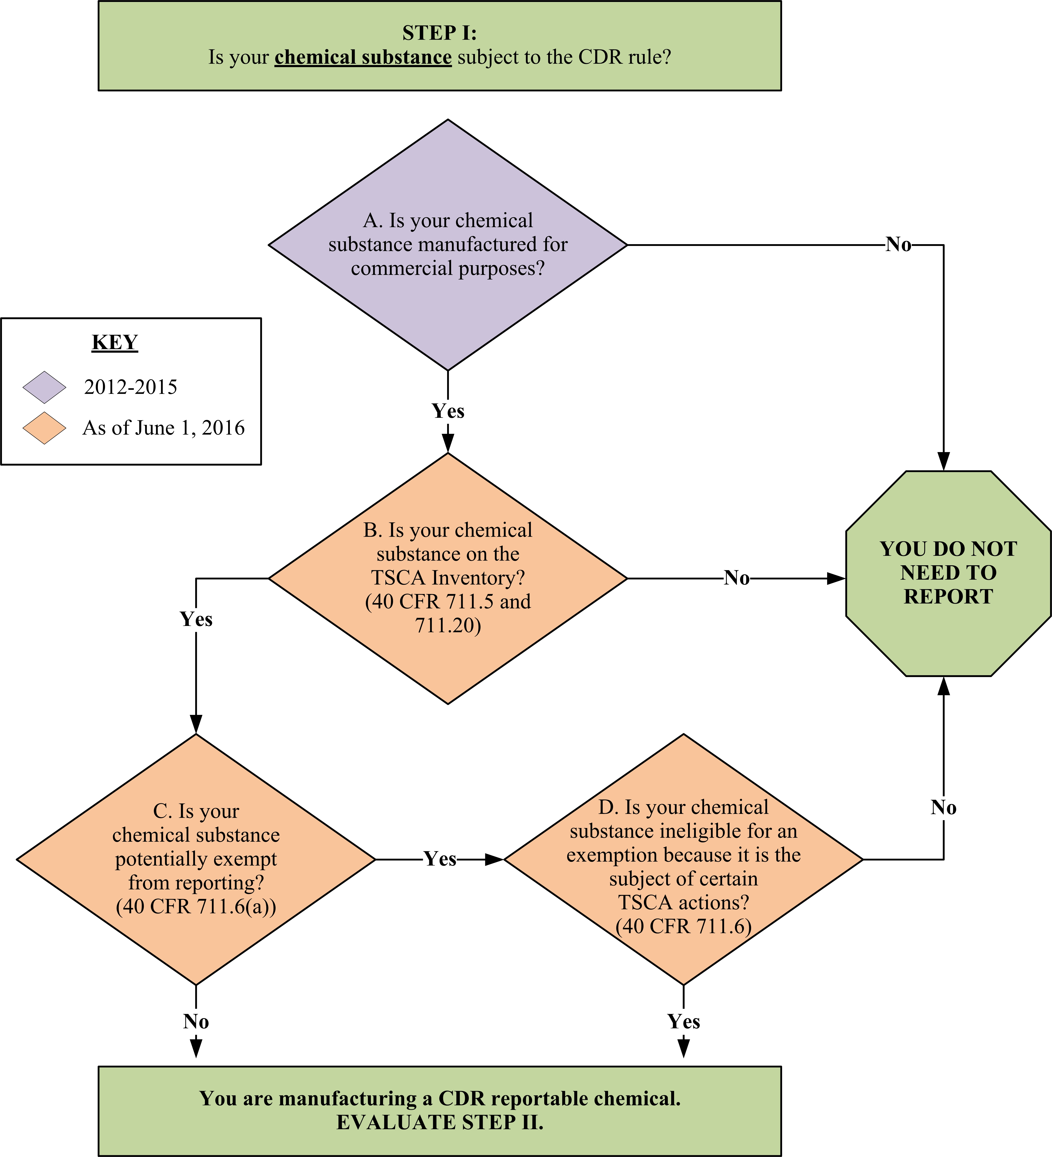

Figure 2-1. Decision Logic Diagram for Evaluating Step I

Is Your Chemical Substance Manufactured for Commercial Purposes? (Question A)

The first step in determining your reporting requirements is to determine whether you meet the definition of manufacture or manufacturer. The following manufacturing-related terms are defined below:

- Manufacture – To manufacture, produce, or import for commercial purposes. Manufacture includes the extraction, for commercial purposes, of a component chemical substance from a previously existing chemical substance or complex combination of chemical substances. When a chemical substance, manufactured other than by import, is:

(1) produced exclusively for another person who contracts for such production, and

(2) that other person specifies the identity of the chemical substance and controls the total amount produced and the basic technology for the plant process, then that chemical substance is co-manufactured by the producing manufacturer and the person contracting for such production (40 CFR 711.3).

- Manufacture for commercial purposes – (1) To import, produce, or manufacture with the purpose of obtaining an immediate or eventual commercial advantage for the manufacturer, and includes among other things, such “manufacture” of any amount of a chemical substance or mixture:

(i) For commercial distribution, including for test marketing.

(ii) For use by the manufacturer, including use for product research and development, or as an intermediate.

(2) Manufacture for commercial purposes also applies to chemical substances that are produced coincidentally during the manufacture, processing, use, or disposal of another chemical substance or mixture, including both byproducts that are separated from that other substance or mixture and impurities that remain in that chemical substance or mixture. Such byproducts and impurities may, or may not, in themselves have commercial value. They are nonetheless produced for the purpose of obtaining a commercial advantage since they are part of the manufacture of a chemical product for a commercial purpose (40 CFR 704.3).

- Manufacturer – A person who manufactures a chemical substance (40 CFR 711.3).

Thus, the manufacture of a chemical substance by a toll manufacturer is considered manufacturing, even in instances where another person is also considered to be manufacturing that chemical substance by contract (see Section 2.1.1.1). Both the toll manufacturer and the contracting party would be considered the co-manufacturers of the chemical substance.

For purposes of the CDR rule, a chemical substance is manufactured (including imported) only if it is manufactured (including imported) for commercial purposes. See TSCA Section 8(f), TSCA Section 3(7), and 40 CFR 704.3, which includes a parallel definition of “Import for commercial purposes.” As identified above, the term manufacture for commercial purposes means that the chemical substance is produced for the purpose of obtaining a commercial advantage. Manufacture for commercial purposes also applies to chemical substances that are produced coincidentally during the manufacture, processing, use, or disposal of another chemical substance or mixture, including both byproducts that are separated and impurities that remain in a chemical substance or mixture. (40 CFR 704.3)

Manufacturing by Contract

The person who contracts with another person, such as a toll manufacturer, to manufacture a chemical substance is considered to be the co-manufacturer, along with the toll manufacturer of that chemical substance.

As specified in the definition for manufacture, manufacturing by contract is a situation where the contracted person manufactures or produces the chemical substance exclusively for the contracting person, and where the contracting person specifies the identity of the chemical substance and controls the total amount produced and the basic technology of the plant process.

Changes to Company Ownership or Legal Identity

Under 40 CFR 711.8(a), the reporting obligation falls to the “person who manufactured.” EPA recognizes that in some cases, business transactions occurring during the submission period have led to questions about who is now the “person who manufactured.” The scenarios in Fact Sheet: Reporting After Changes to Company Ownership or Legal Identity are intended to serve as a general aid in appropriately resolving these questions, but they will not necessarily account for all the relevant circumstances of a particular transaction. It is ultimately the manufacturer’s responsibility to report appropriately under CDR, notwithstanding the complexity of its own business transactions.

Byproducts and Impurities
Can a byproduct be manufactured if the main product is an article?

Yes, potentially. You need to consider whether you are manufacturing a chemical substance as a byproduct when you are manufacturing an article. For example, if your use or processing of a chemical substance (chemical A) to manufacture an article coincidentally produces a different chemical substance (chemical B), apart from the article you intended to manufacture, then you have manufactured a byproduct chemical substance. This situation may occur, for example, when you are stripping a chemical substance off of a part of the article, and the stripping process results in the formation of a different chemical substance (possibly resulting in a “used” stripping solution).

Byproducts

Byproducts are chemical substances that are produced without a separate commercial intent during the manufacture, processing, use, or disposal of another chemical substance(s) or mixture(s) (40 CFR 704.3). If the byproduct is manufactured (including imported) in a volume of 25,000 lb (or 2,500 lb if it is the subject of certain TSCA actions) or more at a single site during the principal reporting year, then its manufacture (including import) is potentially subject to CDR requirements. Figure 2-1 presents a decision logic diagram to assist you in determining whether you manufacture a byproduct that is a CDR reportable chemical substance.

Byproducts may or may not, in themselves, have commercial value. They are nonetheless produced for the purpose of obtaining a commercial advantage because they are part of the manufacture of a chemical product for a commercial purpose. Thus, chemical substances that are the byproducts of the manufacture, processing, use, or disposal of another chemical substance or mixture, like any other manufactured chemical substance, are subject to CDR reporting if they are listed on the TSCA Inventory, are not otherwise excluded from reporting, and their manufacturers are not specifically exempted from CDR requirements.

There are, however, conditions under which byproducts are not required to be reported. If, after it is manufactured (including imported), your byproduct chemical substance is not put to use for a separate commercial purpose (see 40 CFR 711.10(c) and 40 CFR 720.30(h)), you do not need to report it. If your byproduct’s only separate commercial purpose “is for use by public or private organizations that (1) burn it as a fuel, (2) dispose of it as a waste, including in a landfill or for enriching soil, or (3) extract component chemical substances from it for commercial purposes” (see 40 CFR 720.30(g)), then that byproduct is also excluded from CDR reporting. This exclusion applies only to the byproduct; it does not apply to the component chemical substances extracted from the byproduct.

In interpreting section 40 CFR 720.30(g), you should consider the following important points.

- Regarding 40 CFR 720.30(g)(1), note that where that same quantity of a byproduct is burned as a fuel, and is also being burned for other non-exempt commercial purposes (e.g., if the combustion residue is used as a process input), then the exemption under 40 CFR 720.30(g)(1) would not apply. To provide a specific example: in a paper pulping process, black liquor is burned to generate power, and it then undergoes a chemical change to become manufactured smelt. The smelt is then used as a process inputs in the manufacture of white liquor which is then returned to the pulping process. The exemption under 40 CFR 720.30(g)(1) would not apply to the manufacture of the black liquor because the black liquor’s post-combustion commercial purposes include non-exempt commercial purposes. If a certain amount of the black liquor was instead burned solely to generate power and a separate amount was used for a non-exempt commercial purpose, the exemption under 40 CFR 720.30(g)(1) would have applied only to the amount burned solely to generate power. If the black liquor were instead incinerated solely for destruction, the exemption under 40 CFR 720.30(h)(2) would have applied.
Is there a distinction for CDR byproduct reporting when a byproduct is burned for fuel or incinerated as a waste?

Any distinction between burning a byproduct as a fuel or incinerating it as a waste is generally not relevant under the CDR. This is because the CDR exempts both byproducts whose “only commercial purpose” is for burning as a fuel (40 CFR 720.30(g)(1)), and byproducts that are “not used for commercial purposes” (40 CFR 720.30(h)(2)). This latter category would include incineration, solely for destruction.
- Regarding 40 CFR 720.30(g)(2), although the manufacture of a byproduct is not reportable if the byproduct is subsequently disposed of as a waste for purposes of enriching the soil (e.g., to change the soil properties in a desirable way, such as by serving as a filler to make the soil less dense or enhancing moisture retention), a substance used as a fertilizer is not necessarily an excluded byproduct. For instance, if the substance’s ordinary manner of use is as a fertilizer, then the substance is not a byproduct in the first place, and the provisions at 40 CFR 720.30(g) are inapplicable.

- Regarding 40 CFR 720.30(g)(3), individual component chemical substances extracted from a byproduct are reportable substances if they are extracted for a commercial purpose, even if the manufacture of the byproduct itself is not reportable pursuant to 720.30(g).

A “component chemical substance” means a chemical substance that already exists in the byproduct. If the recycling process involves breaking chemical bonds or forming new chemical bonds to convert a chemical substance in the byproduct into a different chemical substance (which is then extracted), then the recycling process does not count as extracting a component chemical substance of the byproduct. Note: In circumstances where other substances in the byproduct are chemically reacted in order to facilitate the separation of a desired component chemical substance, such that the component chemical substance itself is not chemically changed before being extracted, then the process does constitute an extraction of the unchanged component chemical substance.

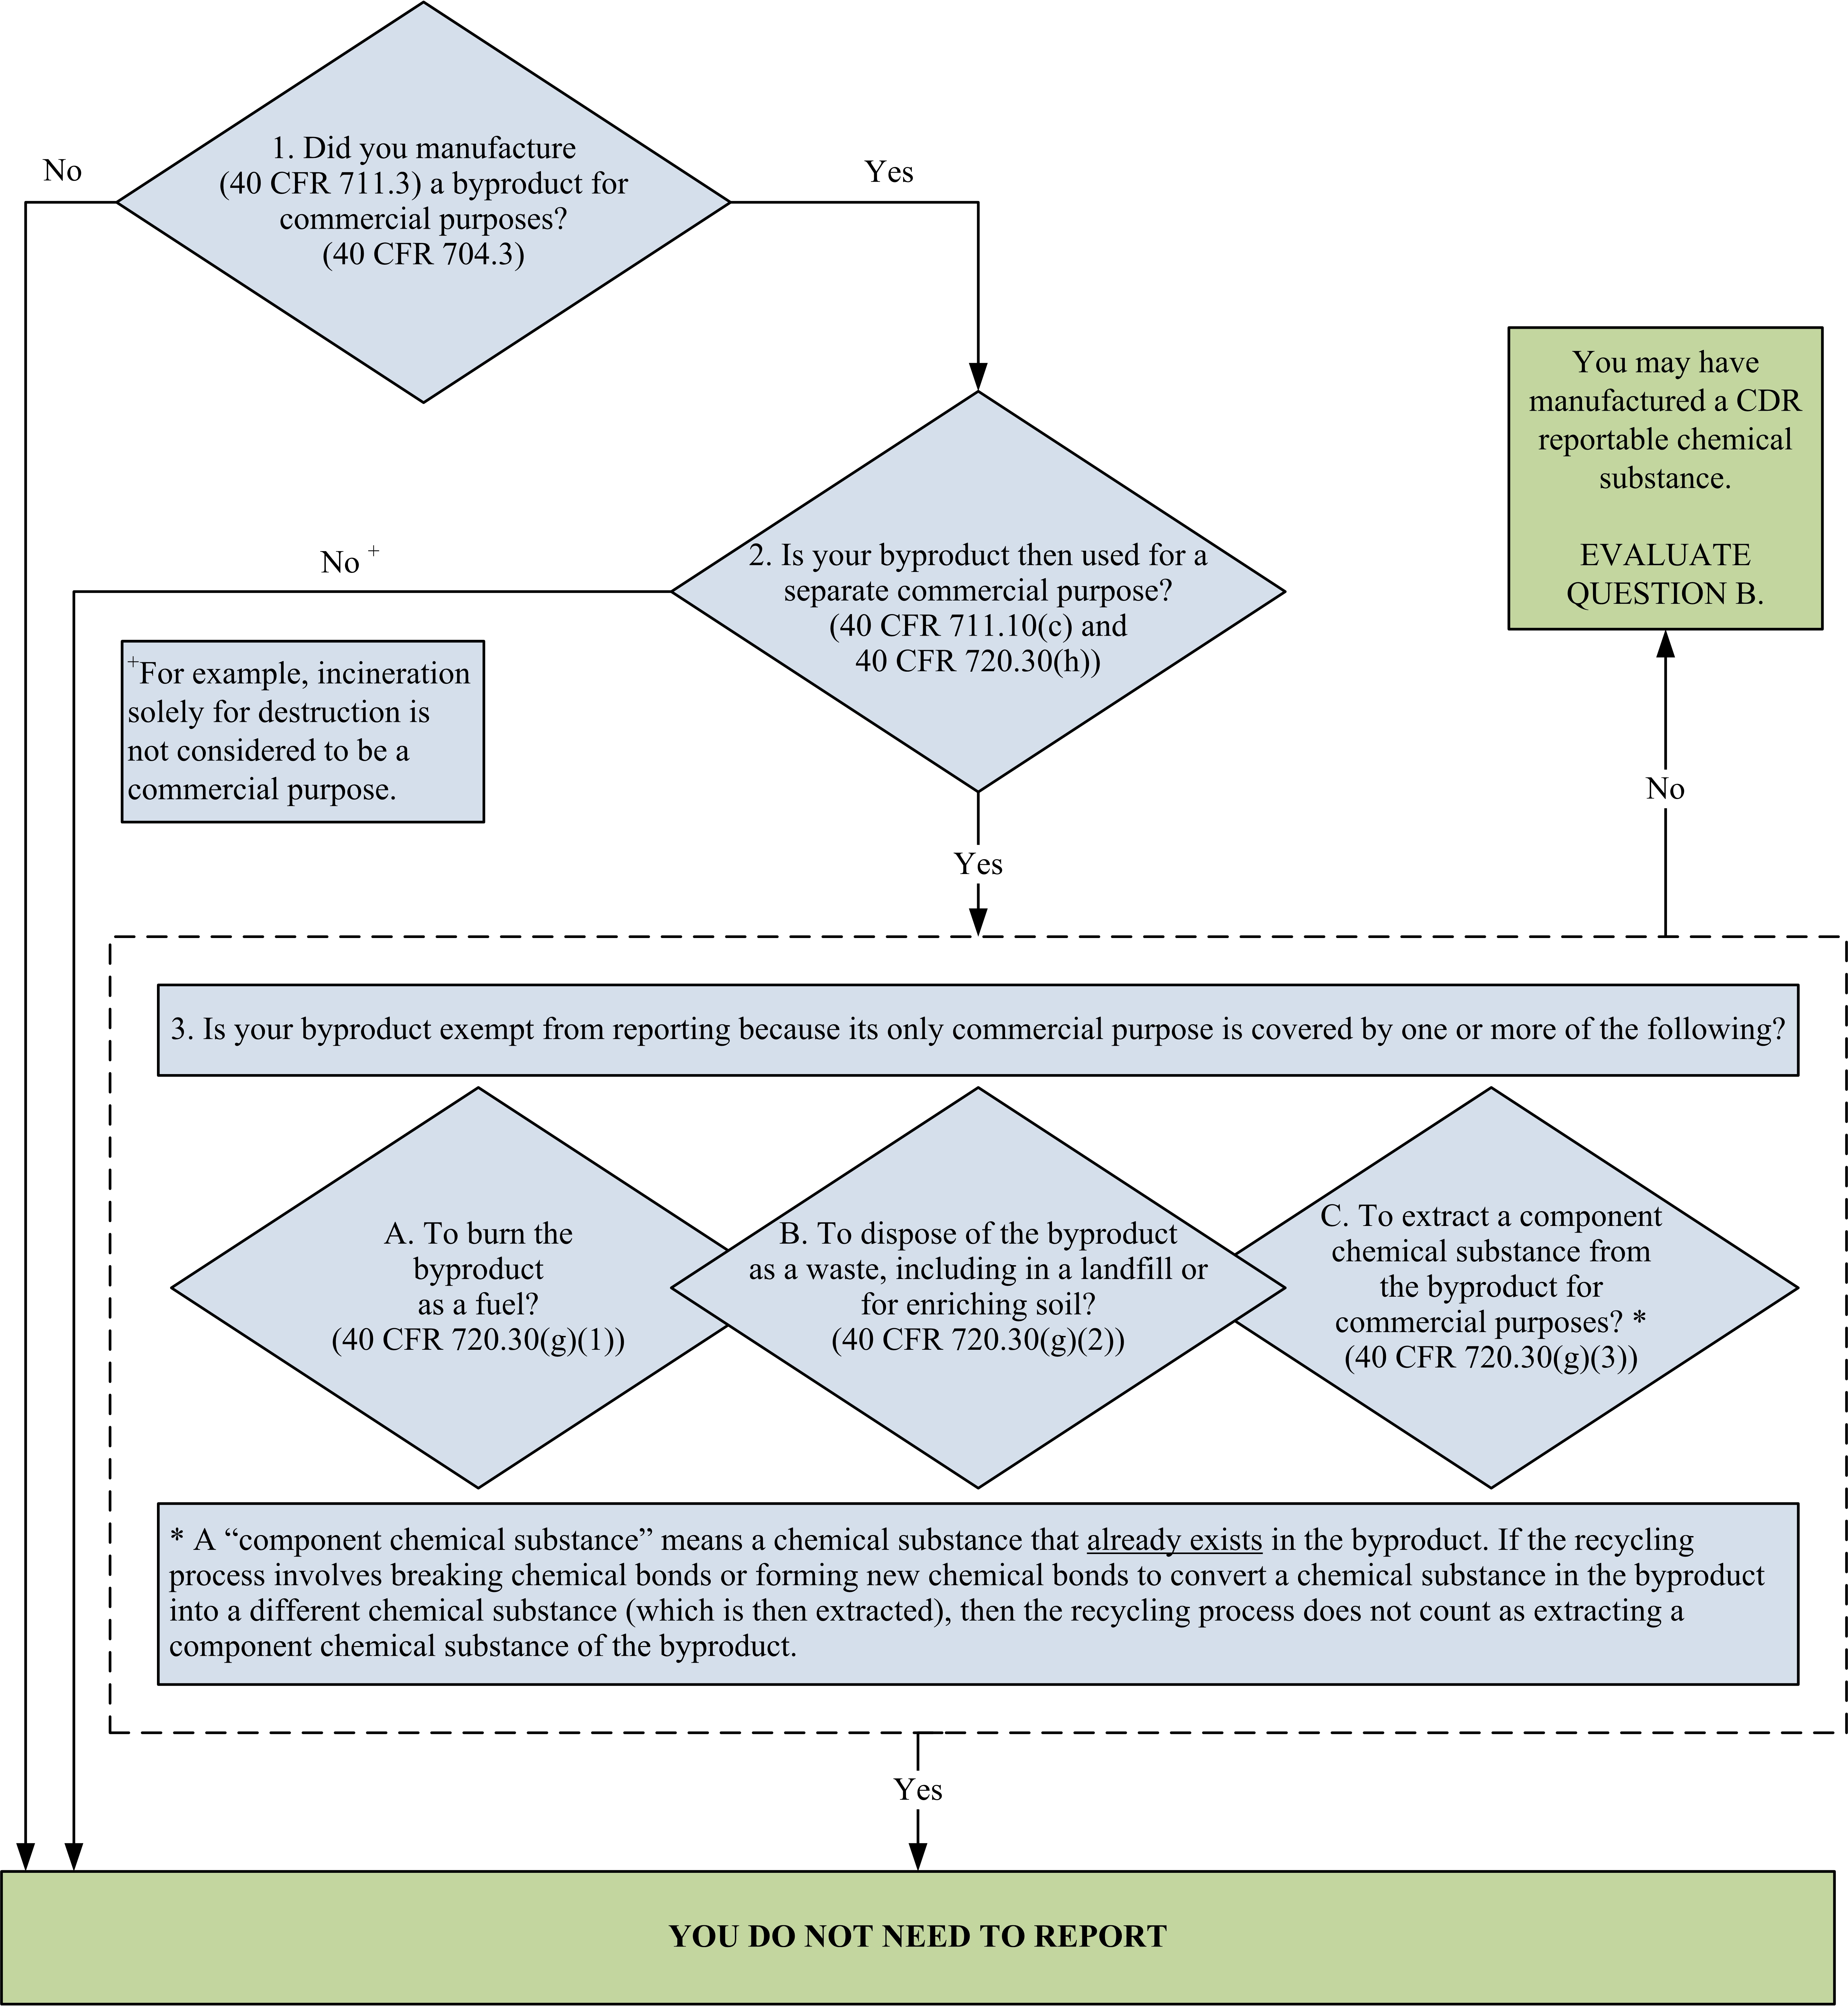

Figure 2-2. Decision Logic Diagram for Evaluating Whether a Byproduct Chemical Substance is Subject to the CDR Rule
You should note that your byproduct may have a separate commercial purpose even if you do not intentionally commercialize it. You may be sending the byproduct, which you consider a waste, to another person or site. If that other person or site uses your byproduct in such a manner that it has a commercial purpose, then you are potentially required to report the byproduct for purposes of CDR (assuming you meet other reporting requirements such as production volume and the chemical substance is not otherwise exempted from reporting).

It is important to properly identify your byproduct chemical substance. Byproducts are formed by a reaction, and, generally, EPA considers each combination of substances resulting from a reaction to be either:

1. A mixture, composed of two or more well-defined chemical substances to be named and listed separately; or
2. A reaction product, or combination of chemicals from a reaction, to be listed as a single chemical substance, using one name that collectively describes the products or the reactants used to make the products. This type of byproduct is typically complex.

Complex byproducts can be identified as a single chemical substance that represents the process stream. Complex chemical substances are listed on the TSCA Inventory as chemical substances of Unknown or Variable composition, Complex reaction products and Biological materials (“UVCB” chemical substances). In such cases, it is not necessary to determine the volumes of the individual chemicals that comprise the UVCB chemical substance; rather, the single UVCB chemical substance name is proper. Further information on UVCB chemical substances is available on the EPA website at http://www.epa.gov/tsca-inventory/chemical-substances-unknown-or-variable-composition-complex-reaction-products-and .

Although complex byproducts may be named as a single UVCB chemical substance, in certain circumstances it may be appropriate to treat a product combination as a mixture of chemical substances or even just a single well-defined chemical substance, even though there are uncharacterized components to the mixture. Specifically, where the submitter has a factual basis to reasonably conclude that the uncharacterized components are exempt from CDR irrespective of their chemical identity, a lack of information about the chemical identity of those exempt components is not an obstacle to treating the remainder of the product combination as a mixture for CDR purposes. Thus, for example, where a submitter reasonably concludes (after considering all the facts known and reasonably ascertainable) that the uncharacterized components of a byproduct will not be used for commercial purposes after they are manufactured (or if the only commercial purpose is for one of the uses listed in 40 CFR 720.30(g)), for CDR purposes the submitter may treat the byproduct as the remaining component, or as a mixture of the remaining components. The submitter then considers the need to report for the remaining component(s).

By contrast, where a submitter has not characterized certain components of a product combination or byproduct stream, and lacks the basis to conclude that those components are necessarily exempt from CDR, it is not appropriate to treat that product combination or byproduct stream as a mixture. For example, if a submitter cannot reasonably assess whether or not an uncharacterized fraction of its byproduct will be subsequently used for a commercial purpose, it is likely that the submitter will need to treat that byproduct as a single UVCB chemical substance for CDR purposes.

Below are a few examples describing byproduct reporting. Additional information, including a closer examination of specific byproduct reporting scenarios, is provided in the document: 2012 Chemical Data Reporting Byproduct and Recycling Scenarios, in the CDR Frequently Asked Questions, and in industry-specific fact sheets. These and other resources are available on the CDR website, at http://www.epa.gov/cdr.
Example 2-1. For example, a manufacturing process involving the use of solvent A results in spent solvent A. Depending upon the specific manufacturing scenario, there are two different ways that the manufacturer could characterize spent solvent A. How the reclaimed solvent A is reported is dependent upon the manufacturer’s characterization for TSCA.

- Spent solvent A is characterized as a mixture of individual chemical substances: In this case, separating solvent A from the mixture is not considered manufacturing, and the manufacturer does not report for CDR purposes the recycled solvent A. Note that, depending upon what is done with the remaining portion of the mixture, any components of the mixture that were manufactured may need to be individually reported.
- Spent solvent A is characterized as a manufactured UVCB chemical substance: In this case, the solvent A extracted from the spent solvent A is also considered to be manufactured, and therefore is reportable for purposes of CDR. In this situation, the UVCB chemical substance itself may be exempt for purposes of CDR. (40 CFR 720.30(g)(3))

A byproduct that is manufactured for a commercial purpose and, after manufacture, is used for a separate commercial purpose, may be excluded from reporting under CDR by 40 CFR 720.30(g)(2). 40 CFR 720.30(g)(2) states that if the byproduct’s only commercial purpose is for use by public or private organizations that dispose of it as a waste, including in a landfill or for enriching soil, the byproduct is exempt from being reported under CDR.

Example 2-2. Efforts to comply with other Federal, state, or municipal rules, such as the use of pollution control devices, may also result in the manufacture of reportable chemical substances. For example, an energy company may operate a sulfur recovery plant as a pollution control device to minimize sulfur oxides emissions. The sulfur recovery plant generates elemental sulfur, a chemically different chemical substance from sulfur oxides. The sulfur therefore has been manufactured for a commercial purpose because it is a chemical substance formed from the byproduct sulfur oxides emissions, which is an activity conducted for the commercial purpose of operating a power plant. If the elemental sulfur is then used for a commercial purpose (other than those listed in 40 CFR 720.30(g)), the energy company may incur reporting obligations under the CDR rule for the byproduct sulfur oxides as well as for the sulfur.

Examples 2-3 and 2-4 describe manufacturers that may be subject to RCRA requirements and how the 720.30(g)(2) byproduct exemption applies in these circumstances.
Example 2-3. Company ABC manufactures a byproduct. The byproduct does not qualify as a RCRA hazardous waste and does not meet the requirements of any exemption in 40 CFR 261.4. The manufacturer wishes to dispose of the byproduct, which can be used to enrich soil (e.g., to change the soil properties in a desirable way like serving as a filler to make the soil less dense or enhancing moisture retention). Company ABC provides this byproduct to another person who then disposes of it as a waste by spreading it on land to enrich the soil. If this disposal of the byproduct is the byproduct’s sole commercial use, the byproduct qualifies for the CDR reporting exemption under 40 CFR 720.30(g)(2). Company ABC is not subject to reporting under the CDR, respecting the manufacture of its byproduct.
Example 2-4. Company ABC manufactures Byproduct X, which is not considered a RCRA solid waste because it serves as a feedstock to produce a zinc fertilizer and meets the requirements of 40 CFR 261.4(a)(20) (i.e., it is a hazardous secondary material used to make zinc fertilizers). The zinc fertilizer that is produced meets the requirements of 40 CFR 261.4(a)(21). Byproduct X is not being disposed of as a waste and therefore does not meet the CDR byproduct exemption at 40 CFR 720.30(g)(2). Company ABC is subject to reporting under the CDR, respecting the manufacture of its byproduct.

If your byproduct is manufactured (including imported) for commercial purposes, and it is subsequently put to use for a commercial purpose other than those listed in 40 CFR 720.30(g), you may be required to report this chemical substance and should evaluate Question B on Figure 2-1 (see also Section 2.1.2).

Impurities

An impurity is a chemical substance which is unintentionally present with another chemical substance (40 CFR 704.3). Although impurities may be produced for the purpose of obtaining a commercial advantage because they are part of the manufacture of a chemical product for a commercial purpose, they are not manufactured for distribution in commerce as chemical substances per se and have no commercial purpose separate from the chemical substance, mixture, or article of which they are a part. Thus a chemical substance that is manufactured or imported solely as an impurity is not subject to the CDR reporting requirements. See 40 CFR 720.30(h)(1).

Is Your Chemical Substance on the TSCA Inventory? (Question B)

The following subsections provide information to help you determine whether your chemical substance is listed on the TSCA Inventory.

What is the TSCA Inventory?

Authorized by section 8(b) of TSCA, the TSCA Inventory is a list of chemical substances manufactured (including imported) for commercial purposes in the United States. The TSCA Inventory was compiled originally in the late 1970s; chemical substances have been added continually through EPA’s New Chemicals Program. EPA keeps a Master Inventory File, which is the authoritative list of all the chemical substances reported to EPA for inclusion on the TSCA Inventory. Information on how to access the non-confidential portion of the TSCA Inventory file, commonly referred to as the “public TSCA Inventory,” is available at http://www.epa.gov/tsca-inventory. The public TSCA Inventory contains chemical substances for which the identity is not considered confidential and the generic identification of chemical substances for which the specific identity has been claimed as TSCA Confidential Business Information (CBI). The TSCA Inventory status of chemical substances can also be determined from EPA’s Substance Registry Services (SRS), available at http://www.epa.gov/srs. See Section 2.1.3 for information about chemical substances that may be potentially exempt from reporting.

How Do You Determine Whether a Chemical Substance is Listed on the TSCA Chemical Substance Inventory?

The following methods may help you determine whether your chemical substance is listed on the TSCA Inventory:

- Locate the chemical substance on the public section of the TSCA Inventory (see Chapter 5 for information on obtaining the TSCA Inventory);

- Search SRS for information on the TSCA Inventory listing status (note that you can search the SRS directly by accessing the website at www.epa.gov/srs or by using the CDR reporting tool);

- Search company records to determine whether the chemical substance was previously reported to EPA under CDR;

- Search company records for a commenced PMN or other communication with EPA that confirmed the chemical substance was on the TSCA Inventory; and

- Search company records for a Notice of Commencement of manufacture or import for a PMN substance that was submitted to EPA.

The last three methods may be particularly helpful if your chemical substance is listed on the confidential portion of the TSCA Inventory.

Several commercial databases have incorporated the public section of the TSCA Inventory (which excludes chemical substances with confidential identities) and can indicate whether a given chemical substance is listed on that portion of the TSCA Inventory. Because these databases are not generated or reviewed by EPA, the Agency cannot guarantee the accuracy of the information. If you use a commercial database that fails to include all reportable chemical substances and, as a result, you fail to report information for these chemical substances, you may be in violation of TSCA (40 CFR 711.1(c)).

The CDR reporting related to mixtures and UVCB substances (chemical substances that are of Unknown or Variable composition, Complex reaction products, or Biological materials) requires careful consideration by submitters. Whenever a submitter

Hydrates are mixtures of the corresponding non-hydrated chemical substance and water and, therefore, are not listed on the TSCA Inventory. Note that you may be required to report the corresponding non-hydrated component chemical substance. Adjust the reported production volume to exclude water.
has manufactured or imported a combination of several chemicals, the submitter must first determine whether for TSCA purposes it is a mixture or a single UVCB chemical substance. A mixture is any combination of chemicals that meets the statutory definition of “mixture” at TSCA section 3(8). (See Appendix A). Mixtures are not reported to CDR – rather the mixture’s component chemical substances, the chemical substances that make it up, are potentially subject to reporting, as described below. A UVCB substance is an indefinite combination of chemicals, that does not meet the statutory definition of “mixture” at TSCA section 3(8), whose number and individual identities and/or composition are not precisely or completely known. A UVCB combination of chemicals is subject to reporting under CDR and is considered a single chemical substance. Generally, the determination of whether a combination of chemicals is a mixture or a UVCB substance is made by the time that substance has been commercialized and, as such, would be clear early in the CDR process. The following discussion is presented with this generality in mind.

- If you imported a mixture, you will need to report the individual chemical components of the mixture to the extent that your total volume for the individual chemical substance triggers reporting (i.e., generally, to the extent that such volume reaches the reporting threshold, 25,000 lb or 2,500 lb if the subject of certain TSCA actions).

- If you domestically manufactured a mixture, you will need to determine whether any chemical substances were formed from a chemical reaction that occurred as part of manufacturing the mixture. If a chemical reaction has occurred, a chemical substance formed from the chemical reaction may be subject to reporting, based on its production volume or the applicability of other exemptions. If a chemical reaction has not occurred, you have not manufactured any reportable chemical substances in the production of the mixture. In such a case, the production of the mixture has not triggered any CDR reporting requirement.

- Domestic manufacturers and importers should also consider whether the combination of the chemicals they have domestically manufactured or imported (respectively) should be chemically identified for TSCA purposes as a single UVCB chemical substance instead of a mixture.

EPA has developed two Inventory nomenclature guidance documents related to the mixture-UVCB determination titled: (1) Toxic Substances Control Act Inventory Representation for Chemical Substances of Unknown or Variable Composition, Complex Reaction Products and Biological Materials: UVCB Substances. Available online at: http://www.epa.gov/sites/production/files/2015-05/documents/uvcb.pdf ; (2) Toxic Substances Control Act Inventory Representation for Combinations of Two or More Substances: Complex Reaction Products. Available on-line at: http://www.epa.gov/sites/production/files/2015-05/documents/rxnprods.pdf
Example 2-5. Company X manufactures 100,000 lb of magnesium sulfate heptahydrate, which is considered under TSCA to be a mixture of magnesium sulfate and water. The non-hydrous portion of the magnesium sulfate heptahydrate mixture, magnesium sulfate, constitutes 48,838 lb, which exceeds the 25,000 lb threshold. Therefore, Company X is required to report 48,838 lb of magnesium sulfate under the CDR rule.
In the event that you are not able to find your chemical substance on the TSCA Inventory, contact the TSCA Hotline at (202) 554-1404 for assistance to determine whether reporting is required. If your chemical substance is on the TSCA Inventory, you should review Question C on Figure 2-1 (Section 2.1.3) to determine whether you qualify for any other reporting exemptions.

Is Your Chemical Substance Potentially Exempt from Reporting? (Question C)

Five groups or categories of chemical substances, though included on the TSCA Inventory, are largely exempt from reporting under the CDR rule. These groups are polymers, microorganisms, certain forms of natural gas, naturally occurring chemical substances, and water. Sections 2.1.3.1 through 2.1.3.5 provide more details for each group of chemical substances. You may also refer to 40 CFR 711.6(a) for precise definitions of these groups. Note, however, that these exempted chemical substances (except for chemical substances that are exempted because they are naturally occurring) become subject to reporting again if they are the subject of any of certain TSCA actions. Section 2.1.4 provides details for when the exemption does not apply. Note that the act of importing does not change the identity of a chemical substance or group. For example, a naturally occurring chemical substance remains naturally occurring when it is imported.
Polymers, microorganisms, certain forms of natural gas, and water are not exempted from reporting when they are the subject of any certain TSCA actions. See Section 2.1.4 for more details.

To help identify chemical substances that are exempt from reporting under the CDR rule, EPA has labeled most of these chemical substances on the TSCA Inventory with the letters “XU.” In the SRS, most of these chemical substances are identified as being “TSCA CDR Exempt” under the Statutes/Regulations heading. This and other flags are embedded into the Substance Registry Services (SRS) chemical lookup within the current edition of e-CDRweb reporting tool and have been updated to reflect the 2016 reporting requirements. When the chemical lookup function is used, and the selected chemical has been assigned a special flag, the reporting tool will display a notice on the screen indicating the exemption status of the chemical. Please note that you are advised to use the flags only as a guide; you are responsible for verifying whether a chemical substance listed on the TSCA Inventory is exempt from reporting.

If your chemical substance is not in one of the following five categories of chemical substances, it is a CDR reportable chemical substance and you should review Step II of the reporting requirements (Section 2.2, Figure 2-3). If your chemical substance is in one of the five categories, you should review Question D (Section 2.1.4).

Polymers

Polymers are in most cases exempt from CDR reporting. The CDR definition of polymer is sufficiently broad to include virtually all those chemical substances that are generally considered polymers. The definition also includes siloxanes and silicones, silsesquioxanes, rubber, lignin, polysaccharides (such as starch and gums), proteins (such as gelatin and hemoglobin), and enzymes. However, for chemical substances that result from hydrolysis, depolymerization, or chemical modification of polymers, regardless of the extent of these processes, if the final products are no longer polymeric (e.g., a mixture of amino acids that is the result of hydrolysis of a polypeptide), the chemical substances are not considered to be polymers and must be reported if not otherwise excluded (40 CFR 711.6(a)(1)). See Appendix A or 40 CFR 711.6(a)(1) for the specific definition of polymers for purposes of the CDR rule.

Microorganisms

Microorganisms are exempt from CDR reporting. A microorganism is any combination of chemical substances that is a living organism and that meets the definition of “microorganism” at 40 CFR 725.3. Any chemical substance produced from a living microorganism is reportable unless otherwise excluded (40 CFR 711.6(a)(2)).

Certain Forms of Natural Gas

Table 2-1 identifies certain forms of natural gas that are exempt from CDR reporting (see 40 CFR 711.6(a)(4)).

Table 2-1. Chemical Substances Covered by the Exemption for Certain Forms of Natural Gas

Form of Natural Gas | CAS Registry Number
Natural gas (petroleum), raw liquid mix | 64741-48-6
Natural gas condensates | 68919-39-1
Gasoline natural | 8006-61-9
Gasoline (natural gas), natural | 68425-31-0
Natural gas | 8006-14-2
Natural gas, dried | 68410-63-9

Naturally Occurring Substances

Chemical substances that are described in 40 CFR 710.4(b) of the TSCA Inventory Reporting Regulations are considered “naturally occurring.” Such chemical substances are not reportable under CDR if the chemical substance is produced solely by means described in section 710.4(b). Examples of chemical substances that are typically naturally occurring materials are raw agricultural commodities, water, air, crude oil, rocks, ores, and minerals. However, because the section 710.4(b) exemption is process-specific rather than chemical-specific, if you manufacture any chemical substance in a manner other than just as described in section 710.4(b), you are required to report it unless it is otherwise exempted (40 CFR 711.6(a)(3)). For this reason, minerals and certain agricultural products are sometimes considered not to be naturally occurring because of the means by which they are produced or isolated. Whether a chemical substance is considered “naturally occurring” depends on the manner in which it is produced and isolated. Table 2-2 presents some examples of evaluating chemical substances for the naturally occurring chemical substance exemption.

Table 2-2. Examples of Evaluating Chemical Substances for the Naturally Occurring Exemption (40 CFR 711.6(a)(3))

Calcined clays formed by heating naturally occurring clay typically must be reported because such heating is generally not done solely to remove water; a chemical change is primarily intended.

Chemical substances that are removed/isolated from nature by physical or natural means are typically considered to be “naturally occurring.” Using water to extract a chemical substance from a naturally occurring chemical substance is considered a natural means of removal. However, using any other solvent is not considered a natural means of removal and would result in the extracted chemical substance being potentially subject to reporting.

In an electrostatic separation, small particles are removed from a liquid or gas stream. The process is essentially analogous to gravitational separation. Chemical substances that are processed by this means are considered to be “naturally occurring.”

Mined coal is typically included in the naturally occurring chemical substances category.

Ammonia and nitric acid are generally produced by chemical synthesis and are, therefore, generally not considered to be “naturally occurring.”

Water

Water, including both naturally occurring water and manufactured water (CASRN 7732 18-5), is exempt from CDR reporting.

Is your Chemical Substance Ineligible for an Exemption Because it is the Subject of Certain TSCA Actions? (Question D)

With the exception of naturally occurring chemical substances, chemical substances must be reported if they are the subject of any of the following (even if the chemical substance is otherwise exempt, (40 CFR 711.6)):

- A rule proposed or promulgated under Sections 4, 5(a)(2),5(b)(4), or 6 of TSCA;\
- An order issued under TSCA Sections 5(e) or 5(f);
- Relief that has been granted under a civil action under TSCA Sections 5 or 7; or
- An enforceable consent agreement (ECA) under 40 CFR Part 790.

See Appendix B for an overall chart that describes the effects on CDR requirements of the different TSCA actions.

Example 2-6. Company A manufactured 35,000 lb of Chemical X, a polymer, in 2014. Chemical X is part of an enforceable consent agreement (ECA) between EPA and Company A, in which Company A is performing additional testing on Chemical X. Although Chemical X is a polymer that normally would be exempt from CDR reporting, it is part of an ECA and, thus, Company A is required to report Chemical X for the 2016 CDR. Additionally, Company B manufactures 40,000 lb of Chemical X in 2015. Although Company B is not a party to the ECA, Company B is also required to report Chemical X for the 2016 CDR.
Special flags are used throughout the TSCA Inventory to identify those substances on the Inventory that are the subject of an EPA rule or order promulgated under TSCA, as well as to indicate the types of full or partial exemptions from TSCA reporting requirements. These flags are embedded into the Substance Registry Services (SRS) chemical lookup within the current edition of e-CDRweb reporting tool and have been updated to reflect the 2016 reporting requirements. When the chemical lookup function is used, and the selected chemical has been assigned a special flag, the reporting tool will display a notice on the screen indicating the TSCA action or exemption status of the chemical. Please note that you are advised to use the flags only as a guide; you are responsible for verifying whether a chemical substance listed on the TSCA Inventory is exempt from reporting or ineligible for exemption from reporting. If you have determined that your chemical substance is a CDR reportable chemical substance, evaluate Step II on Figure 2-3 to determine whether you are a manufacturer (including importer) who is required to report.

Step II: Are You a Manufacturer Who Is Required to Report?
If you determined from Step I that you manufacture (including import) a CDR reportable chemical substance, Figure 2-3 presents a decision logic diagram that may help you determine whether you are a manufacturer (including importer) who must then report. The following subsections explain each question in greater detail.

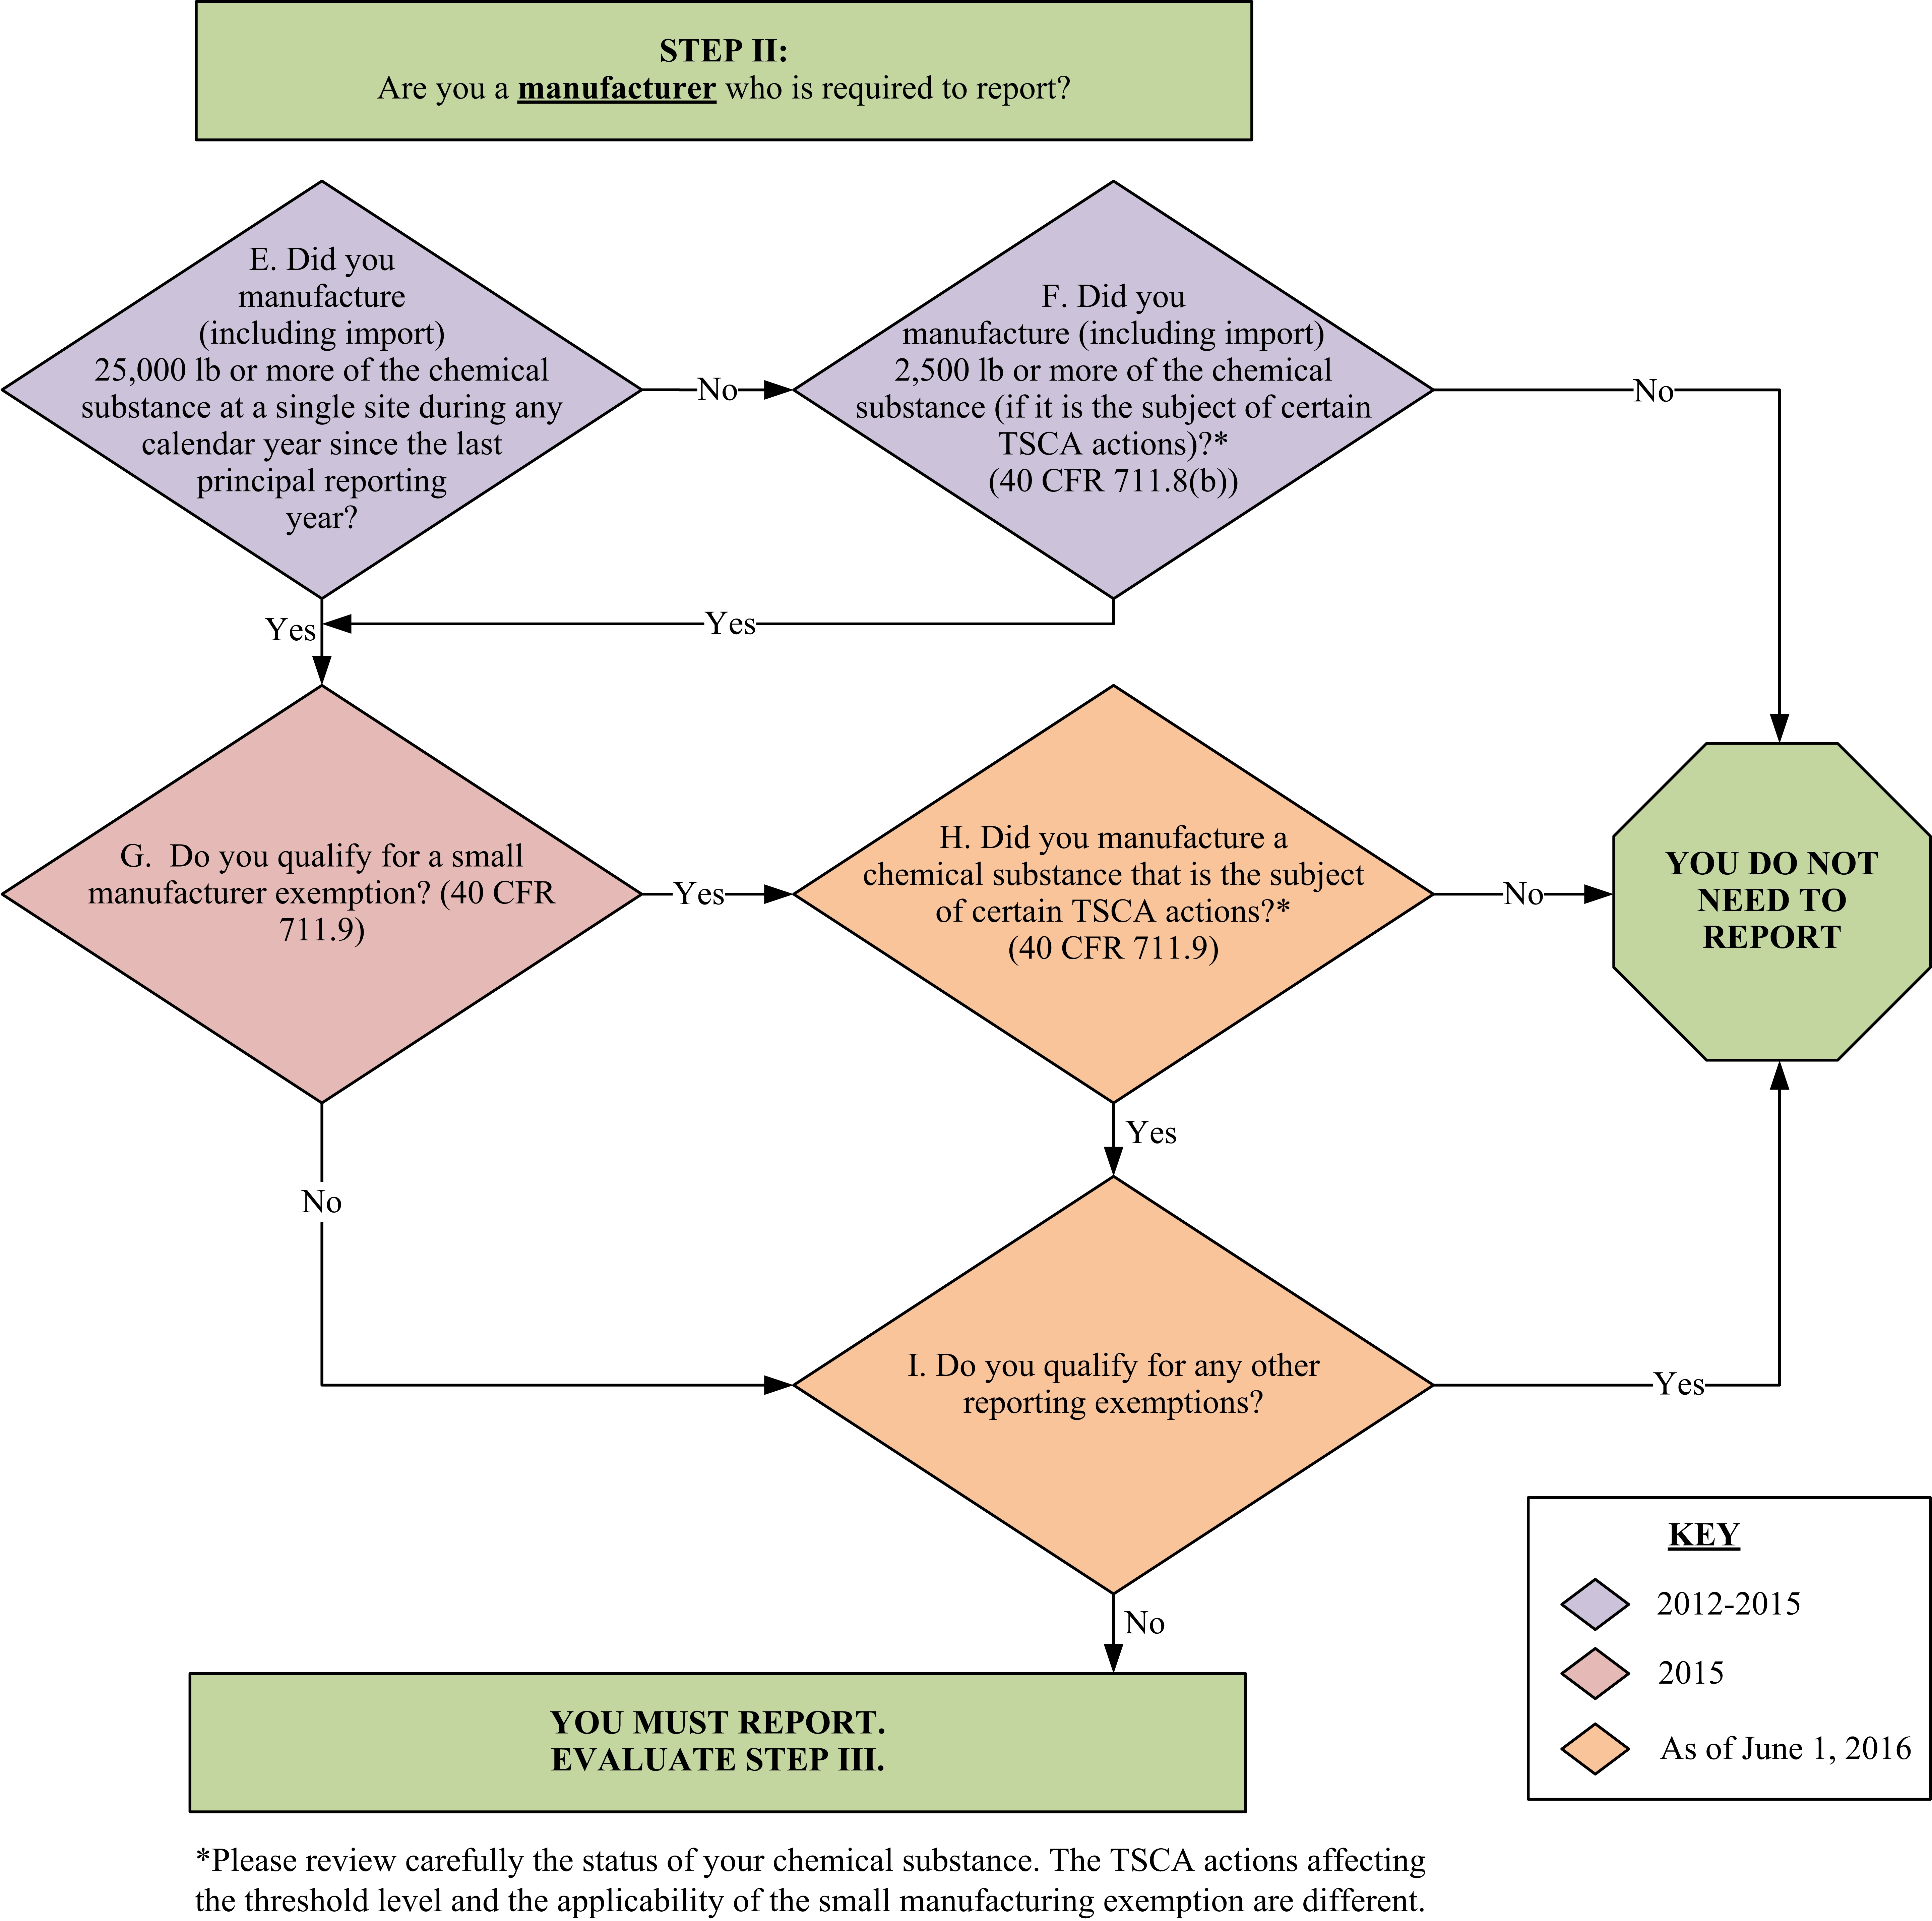

Figure 2-3. Decision Logic Diagram for Evaluating Step II

Did You Manufacture (Including Import) 25,000 lb or More of the Chemical Substance at a Single Site During any of the Calendar Years since the Last Principal Reporting Year? (Question E)

You are subject to CDR reporting if you manufactured (including imported) a chemical substance in production volumes of 25,000 lb or greater at any single site you owned or controlled during any calendar year since the last CDR principal reporting year. (A reduced reporting threshold of 2,500 lb now applies to chemical substances subject to certain TSCA actions - see Section 2.2.2.) For the 2016 CDR, the last principal reporting year was 2011. Therefore, you need to consider production for calendar years 2012, 2013, 2014, and 2015. If you both domestically manufacture and import the same chemical substance, add the domestically manufactured and imported volumes at each site for a calendar year to determine whether the amount of the chemical substance meets or exceeds the 25,000 lb threshold during that calendar year. Do not subtract the volume of chemical substance directly exported. The site at which a chemical substance is imported is described in 40 CFR 711.3 and Section 4.4.1 of this document.

Information about determining production volumes for mixtures is provided at the end of 2.2.2.

Did You Manufacture (Including Import) 2,500 lb or More of the Chemical Substance (if it is the Subject of Certain TSCA Actions? (Question F)

Under 40 CFR 711.8(b) and 40 CFR 711.15, the reporting threshold is 2,500 lb (1,134 kg) for any person who manufactured a chemical substance that is the subject of any of the following TSCA actions:

- A rule proposed or promulgated under TSCA section 5(a)(2), 5(b)(4) or 6
- An order issued under TSCA section 5(e) or 5(f)
- Relief that has been granted under a civil action under TSCA section 5 or 7

You are subject to CDR reporting if you manufactured (including imported) a chemical substance which is subject to a TSCA action listed above in production volumes of 2,500 lb or greater at any single site you owned or controlled during any calendar year since the last CDR principal reporting year. For the 2016 CDR, the last principal reporting year was 2011. Therefore, you need to consider production for calendar years 2012, 2013, 2014, and 2015. If you both domestically manufacture and import the same chemical substance, add the domestically manufactured and imported volumes at each site for a calendar year to determine whether the amount of the chemical substance meets or exceeds the 2,500 lb threshold during that year. Do not subtract the volume of chemical substance directly exported. The site at which a chemical substance is imported is described in 40 CFR 711.3 and 4.4.1 of this document.
Substances that have undergone a change in TSCA regulatory status from 2012 to June 1, 2016

- The effects of TSCA actions on CDR reporting are assessed based on the status of the chemical substance as of the beginning of the submission period, when the reporting obligation becomes current. For reporting obligations in 2016 that depend on whether a chemical substance “is the subject of” a listed action, consider the status of a chemical substance as of June 1, 2016.
- A change in TSCA regulatory status does not mean that submitters should apply different reporting thresholds to manufacture occurring before and after the effective date of the action. Only one reporting threshold applies to a chemical substance for the 2016 CDR. The correct reporting threshold is determined based on the chemical substance’s status as of June 1, 2016.

Table 2-3 provides examples of how the production volume threshold applies.

Table 2-3. Production Volume Threshold Examples

Description | 2016 Reporting Requirement
Company A, which has only one manufacturing site, manufactured 26,000 lb of Chemical X, which is not exempt from reporting, at its site in 2013. | Company A must report for Chemical X because it manufactured 25,000 lb or more of Chemical X at its sole manufacturing site in 2013.
Company B, which has only one manufacturing site, manufactured 26,000 lb of Chemical X at its site in 2012 and 20,000 lb of Chemical X in 2014. | Company B is required to report for Chemical X because it manufactured more than 25,000 lb of Chemical X in 2012.
Company C has two manufacturing sites for Chemical X. In 2012 through 2015, Site 1 manufactured 13,000 lb per year of Chemical X and Site 2 manufactured 15,000 lb per year. Chemical X is not the subject of any of the TSCA actions listed in 40 CFR 711.8(b)... | The 25,000-lb threshold is applicable for Chemical X. Company C is not required to report for Chemical X at either site because production was less than 25,000 lb at each site during all the years in the reporting period.
Company D has two manufacturing sites for Chemical X. In 2012 through 2015, Site 1 manufactured 10,000 lb per year of Chemical X and Site 2 manufactured 150,000 lb per year of Chemical X. Chemical X is not the subject of any of the TSCA actions listed in 40 CFR 711.8(b).. | The 25,000-lb threshold is applicable for Chemical X. Company D must report for Chemical X at Site 2 because at this location production was 25,000 lb or more. Company D is not required to report for Chemical X for Site 1 because production was less than 25,000 lb during all the years in the reporting period.
Company E has one site where it imports and manufactures Chemical X. Company E manufactured 21,000 lb of Chemical X and imported 5,000 lb of Chemical X in 2015. | Company E must report for Chemical X because the aggregate volume produced at and imported by its site in 2015 was 25,000 lb or more.
Company F has one site where it manufactured 30,000 lb of Chemical X in 2012. The company directly exported 25,000 lb of Chemical X and sold the remaining 5,000 lb in the United States. | Company F must report for Chemical X because it manufactured over 25,000 lb in 2012. The amount directly exported does not affect the determination of the need to report.
Company G manufactured 5,000 lb of Chemical Z per year during 2012 through 2015. Chemical Z is subject to a TSCA section 4 test rule with a sunset date of June 30, 2016. Chemical Z is not the subject of any of the TSCA actions listed in 40 CFR 711.8(b). | Company G is not required to report for Chemical Z. Chemical Z is subject to the 25,000 lb reporting threshold, because a TSCA section 4 test rule is not a TSCA action which triggers use of the reduced reporting threshold (i.e., it is not one of the actions listed in 40 CFR 711.8(b)).
A TSCA section 5(a)(2) significant new use rule (SNUR) is issued for Chemical Y in 2013. The annual production volumes for Chemical Y by Company H are 1,000 lb in 2012, 10,000 lb in 2013, 5,000 lb in 2014, and 2,000 lb in 2015. | As of the beginning of the submission period (June 1, 2016), Chemical Y is a chemical substance that is the subject of a TSCA section 5(a)(2) SNUR; therefore, a reduced reporting threshold of 2,500 lb would apply. Because the 2,500 lb reporting threshold was exceeded at least once from 2012 to 2015, Company H must report for Chemical Y.
A TSCA section 5(a)(2) SNUR was issued for Chemical Y in 2013 and revoked in February 2016. Chemical Y is not currently the subject of any of the TSCA actions listed in 40 CFR 711.8(b). The annual production volumes for Chemical Y by Company H are 1,000 lb in 2012, 10,000 lb in 2013, 5,000 lb in 2014, and 2,000 lb in 2015. | As of the beginning of the submission period on June 1, 2016, the SNUR is no longer in effect. Therefore, the reporting threshold for Chemical Y is 25,000 lb. Because the production volume did not meet or exceed 25,000 lb in at least one year from 2012 to 2015, Company H is not required to report for Chemical Y.
A proposed TSCA section 5(a)(2) SNUR for Chemical P is published in the Federal Register on August 1, 2016. Chemical P is not currently the subject of any of the other TSCA actions listed in 40 CFR 711.8(b). The annual production volumes for Chemical P by Company J are 2,000 lb in 2012, 20,000 lb in 2013, 2,500 lb in 2014, and 12,000 lb in 2015. | As of the beginning of the 2016 submission period on June 1, 2016, Chemical P is not the subject of a proposed or promulgated SNUR. Therefore, the 2016 CDR reporting threshold for Chemical P is 25,000 lb. Publication of the SNUR after June 1, 2016 would not cause the 2016 CDR reporting threshold to change during the 2016 submission period. Because the production volume did not meet or exceed 25,000 lb in at least one year from 2012 to 2015, Company J is not required to report for Chemical P.

Meeting the Reporting Threshold for Chemical Substances in Mixtures

In many cases, reportable chemical substances are components of a mixture. Although mixtures themselves are not reportable, the 25,000-lb (or 2,500-lb threshold if the subject of certain TSCA actions) is applicable for each CDR reportable chemical substance comprising a mixture; therefore, the chemical substances making up a mixture may individually be reportable. If you manufacture chemical substances as part of a mixture, you would determine your CDR reporting requirements by following Questions A-F (Sections 2.1.1 through 2.2.2) for each chemical substance in the mixture. As described in section 2.1.2.2, hydrates are mixtures of the corresponding non-hydrated chemical substance and water.

UVCB Chemical Substances: Note that, under TSCA, a complex combination of chemical substances is in most cases considered to be a single UVCB chemical substance. In such cases, reporting is triggered based on the volume of the UVCB chemical substance manufactured (that is, the whole entity), and not based on the volume of individual chemical components which may be present in the UVCB chemical substance. See Section 2.1.1.3 for further discussion of UVCB chemical substances.

Imported Mixtures: As an importer (see 40 CFR 704.3) of a mixture of chemical substances listed on the TSCA Inventory, you must determine whether the individual component chemical substances of a mixture are reportable. To do so, you would determine whether the annual aggregated volume of a particular reportable chemical substance was 25,000 lb or 2,500-lb or more at the site that controls the importation. The threshold volume is applicable for each CDR reportable chemical substance in a mixture. You can determine the production volume for each chemical substance in the mixture that you imported during a particular calendar year by using the weight and percent composition of the chemical substance in the mixture. For each imported chemical substance, you would aggregate the volume of the chemical substance in all annual imports associated with the reporting site as defined in 40 CFR 711.3 and add the amount of the chemical substance domestically manufactured at the same site, if any, to determine whether the total volume of the chemical manufactured (including imported) meets the 25,000-lb or 2,500-lb threshold. Note that a chemical substance that is imported solely in small quantities for research and development, as an impurity, or as part of an article or in a manner described in 40 CFR 720.30(g) and (h) is not subject to the CDR reporting requirements (40 CFR 711.10).

If you have determined that you are manufacturing a CDR reportable chemical substance and meet the applicable reporting threshold of 25,000 lb (or 2,500 lb if subject to certain TSCA actions), evaluate Question G to determine whether you qualify for a small manufacturer exemption.

Do You Qualify For a Small Manufacturer Exemption? (Question G)

You qualify as a small manufacturer if you meet either of the following criteria (40 CFR 704.3):

- Your total sales during the principal reporting year (2015), combined with those of your parent company, domestic or foreign (if any), are less than $4 million regardless of annual production volume.

- Your total sales during the principal reporting year (2015), combined with those of your parent company, domestic or foreign (if any), are less than $40 million and your annual production volume of that chemical substance does not exceed 100,000 lb at any individual plant site. If the annual production volume of the chemical substance at any of your sites is more than 100,000 lb, you are required to report only for those sites. Note that under this criterion, it is possible to qualify as a small manufacturer with respect to some chemical substances and not others or with respect to some sites and not others.

For purposes of the definition of a small manufacturer, total annual sales include all sales of the company, not just the total sales of a given chemical substance.

If you have determined that you are a small manufacturer of a CDR reportable chemical substance, evaluate Question H (described in the next section) to determine whether you are exempt from any reporting.

If you do not qualify for a small manufacturer exemption, evaluate Question I in Figure 2-3 (further described in Section 2.2.5) to determine whether you qualify for any other reporting exemptions.

Did You Manufacture a Chemical Substance that is the Subject of Certain TSCA Actions? (Question H)

Small manufacturers are exempt from CDR requirements unless they manufacture (including import) a chemical substance that is the subject of a rule proposed or promulgated under sections 4, 5(b)(4), or 6 of TSCA, or is the subject of an order in effect under section 5(e) of TSCA, or is the subject of relief that has been granted under a civil action under sections 5 or 7 of TSCA (40 CFR 711.9) and (TSCA § 8(a)(3)(A)(ii)).The SRS provides information regarding which chemical substances fall into these groups. Table 2-4 provides examples of how the small manufacturing exemption applies.

Table 2-4. Small Manufacturer Exemption Examples (40 CFR 711.9)

Description | 2016 Reporting Requirement
Site 1, which is one of several sites owned by Company A, had a production volume of 120,000 lb of Chemical X in 2013. The total annual sales of Company A (all sites combined) were $1.25 million in 2015. | Site 1 is not required to report for Chemical X because combined sales in 2015 did not exceed $4 million.
Site 2, which is one of several sites owned by Company B, had a production volume of 90,000 lb of Chemical X in 2012, 75,000 lb in 2013, 82,000 in 2014, and 95,000 in 2015. The total annual sales of Company B (all sites combined) were $20 million in 2015. None of the other sites produce Chemical X. | Site 2 is not required to report for Chemical X because annual production volume of that chemical substance did not exceed 100,000 lb at any of Company B’s sites during 2012-2015, and Company B had total annual sales of less than $40 million.
Site 3, which is one of several sites owned by Company C, had a production volume of 200,000 lb per year of Chemical X in 2012 through 2015. Site 4, another site owned by Company C, had a production volume of 75,000 lb per year of Chemical X in 2012 through 2015. The total annual sales of Company C (all sites combined) were $30 million in 2015. | Company C must report for Chemical X at Site 3 because annual production volume at Site 3 exceeded 100,000 lb in at least one year from 2012 to 2015. Company C is not required to report for Chemical X at Site 4 because annual production volume at site 4 did not exceed 100,000 lb and total annual sales was less than $40 million.
Site 5, which is one of several sites owned by Company D, had a production volume of 50,000 lb of Chemical X in 2014. The total annual sales of Company D (all sites combined) were $100 million in 2015. | Company D must report for Chemical X at Site 5 because total annual sales in 2015 exceeded $40 million and the production volume of Chemical X at Site 5 exceeded 25,000 lb in at least one year from 2012 to 2015.
Site 6, which is one of several sites owned by Company E, had a production volume of 120,000 lb of Chemical X in 2012. The total annual sales of Company E (all sites combined) were $1.25 million in 2015. Chemical X is subject to a section 4 test rule. | Site 6 is required to report for Chemical X. Even though combined sales are less than $4 million, this chemical substance is subject to a test rule and therefore must be reported.
Site 7, owned by Company F, whose total annual sales is $30 million in the principal reporting year (2015), manufactures Chemical X, which is the subject of a TSCA section 5(e) consent order and a TSCA section 5(a)(2) SNUR. The annual production volume of Chemical X ranges between 3,000 and 5,000 lb from 2012-2015. | Site 7 is required to report for Chemical X. Based on the sales of less than $40 million and production volume below 100,000 lb, Company F would qualify as a small manufacturer. Chemical X being the subject of a SNUR does not affect the small manufacturer exemption. However, Chemical S being the subject of a 5(e) consent order does affect the exemption: the small manufacturer exemption does not apply to Company F with respect to its manufacture of Chemical X.  Both the SNUR and the 5(e) consent order trigger the reduced reporting threshold of 2,500 lb. Therefore, because Chemical X is subject to a SNUR and a section 5(e) consent order and because Company F has produced Chemical X in amounts above 2,500 lb in at least one year from 2012 to 2015 (in this case all four years), Company F would be required to report.
Site 8 is owned by Company G and manufactured 25,000 lbs of Chemical X in 2012 and 20,000 lbs in 2013. Chemical X was the subject of a TSCA section 4 test rule promulgated in 2015. Company G’s total annual income was the following: $1 million in 2012, $2 million in 2013, $3 million in 2014, and $5 million in 2015. | Site 8 is required to report for Chemical X. On June 1, 2016, Chemical X is subject to a TSCA section 4 test rule, which means that Company G cannot apply the small manufacturer exemption to its manufacture of this substance.  Because annual production volume of Chemical G was 25,000 lb or greater in at least one year from 2012 to 2015 (in this case in 2012), Company G must report for Chemical X.
Site 9 is owned by Company H and manufactures Chemical X. Chemical X has been subject for several years to a TSCA section 4 test rule which sunsets on May 1, 2016. Company H, whose total annual sales were $3 million in 2015, has manufactured Chemical X in annual amounts above 25,000 lb from 2012-2015. | Company H is not required to report for Chemical X. Although Chemical X was the subject of a TSCA section 4 test rule (which could have eliminated the ability to apply the small manufacturer exemption to manufacture of Chemical X), June 1, 2016 is after the sunset date. As of June 1, 2016, Chemical X is no longer the subject of a TSCA section 4 test rule. Therefore, Company H, with total annual sales less than $4 million in 2015, would be eligible to apply the small manufacturer exemption to its manufacture of Chemical X.

Do You Qualify for Any Other Reporting Exemptions? (Question I)

If you manufacture a reportable chemical substance solely under the following circumstances, you are not required to report for those chemical substances under the CDR rule:

- The chemical substance is manufactured solely in small quantities for research and development (40 CFR 711.10(a)).

- The chemical substance is imported as part of an article (40 CFR 711.10(b)). An article is defined in 40 CFR 704.3 as “a manufactured item (1) which is formed to a specific shape or design during manufacture, (2) which has end-use function(s) dependent in whole or in part upon its shape or design during end use, and (3) which has either no change of chemical composition during its end use or only those changes resulting in composition which have no commercial purpose separate from that of the article, and that result from a chemical reaction that occurs upon end use of other chemical substances, mixtures, or articles; except that fluids and particles are not considered articles regardless of shape or design.”

EPA considers imported items articles if they are manufactured in a specific shape or design for a particular end-use application and this design is maintained as an essential feature in the finished product. Thus, EPA views materials such as metal or plastic sheets, wire, coated fabric, rolled carpet, sheets of plywood, and other similar materials as articles, even if, for example, subsequent to import they are rolled or drawn thinner, cut, printed, laminated, or thermoformed, provided they meet the above definition. Chemical substances that are part of such articles are not subject to reporting under the CDR rule. If the shape of an item does not serve a function with respect to the item’s end use (e.g., it is imported in a particular shape for the sake of shipping convenience) then it would not be considered an article. Thus, chemical substances that are part of items not considered by EPA as articles, such as metal ingots, billets, and blooms are subject to reporting under the CDR rule.
For additional information, see Fact Sheet: Imported Articles.

- The chemical substance is manufactured as an impurity, a non-isolated intermediate, or under any of the other circumstances identified in 40 CFR 720.30(g) and (h). (40 CFR 711.10(c))
For additional information, see Fact Sheet: Non-Isolated Intermediates

- If, within one year prior to the start of the submission period, (i.e., June 1, 2015 to May 31, 2016), you submitted all of the information required by the CDR rule in response to another rule promulgated under section 8(a) of TSCA (such as the Preliminary Assessment Information Reporting (PAIR) rule at 40 CFR Part 717, Subpart B), you are not required to report the same information under CDR for the same chemical substance during 2016 (40 CFR 711.22(a)).

Table 2-5 presents examples of these circumstances.

If you manufacture a CDR reportable chemical substance in quantities greater than 25,000 lb (or 2,500 lb if the subject of certain TSCA actions), and do not qualify for any reporting exemptions, you should evaluate Step III, described in the following section, to determine what information you must report for your chemical substance.

Table 2-5. Examples of Manufacturing/Importing Activities Under Circumstances Which Do/Do Not Require Reporting

Description | 2016 Reporting Requirement
Company A manufactures 400,000 lb of a chemical intermediate called Chemical X during the production of a polymer. Chemical X is manufactured in Reactor 1 and is subsequently entirely consumed when reacted with other chemicals. Chemical X never leaves Reactor 1, except for sampling purposes. | Company A does not need to report Chemical X because it is considered to be a non-isolated intermediate and is therefore fully exempt.
Company B manufactures 400,000 lb of a chemical intermediate called Chemical Y during the production of a polymer. Chemical Y is manufactured in Reactor 1 and transferred to a storage tank until needed. Chemical Y is then transferred to Reactor 2 where it is mixed with other reactants to form the desired polymer, at which point Chemical Y is destroyed. Chemical Y never leaves this production site. | Company B is required to report Chemical Y. When Chemical Y was transferred to the storage tank, it was isolated, and, thus, does not meet the definition for “non-isolated intermediate.”
Company C imports 10 million lb of Chemical Z in the form of thin sheets. Company C cuts these sheets into the desired size and shape, which are sold to consumers. | Company C is not required to report Chemical Z because it is considered to be an article and therefore exempt from reporting.
Company D imports 10 million lb of Chemical W in the form of pellets. Company D subsequently melts and molds Chemical W into the desired shape, which is sold directly to consumers. | Company D is required to report Chemical W because it imported pellets whose shape or design when imported was not related to their end use.
Company D domestically manufactures 10 million lb of Chemical W. Company D subsequently sells Chemical W to Company E in the form of pellets. Company E melts and molds the pellets. | Company D is required to report as the manufacturer of Chemical W. Company E is not required to report because it is neither manufacturing nor importing Chemical W.

Step III: What Information Must You Report?
Once you determine from Steps I and II that you are a manufacturer (including importer) of a CDR reportable chemical substance and are required to report, this section will help you determine what information you must report.
The reporting threshold for processing and use activities is the same as that for manufacturing information.

You must use the same reporting threshold for reporting processing and use information as you use for reporting all manufacturing information (i.e., either 25,000 lb or 2,500 lb).

You are required to report the information described in 40 CFR 711.15(b) in Parts I and II and, unless you qualify for a partial exemption, Part III of Form U.

Basic company and site identification information, (submitted on Part I of Form U) is required by 40 CFR 711.15(b)(1) and (b)(2). Chemical identification and information pertaining to the manufacture (including import) of chemical substances (submitted on Part II of Form U) is required by 40 CFR 711.15(b)(3). Note that the basic company and site information is reported once per site, while the manufacturing information is reported separately for each reportable chemical substance at the site. Industrial processing and use, and consumer and commercial uses of the chemical substance (submitted on Part III of Form U) is required by 40 CFR 711.15(b)(4). Processing and use information is only reported for the principle reporting year (2015).

Manufacturers (including importers) of partially exempt chemical substances listed in 40 CFR 711.6(b)(1) and 711.6(b)(2) are not required to report processing and use information described in 40 CFR 711.15(b)(4) for those chemical substances, but are otherwise required to report the information requested on basic identity and manufacturing information described in 40 CFR 711.15(b)(2) and (3) for those chemical substances. Note that these partial exemptions are negated if the chemical substance is the subject of any of certain TSCA actions.

Figure 2-4 presents a decision logic diagram to assist you in determining the CDR information you must report. The following subsections explain each question in greater detail.
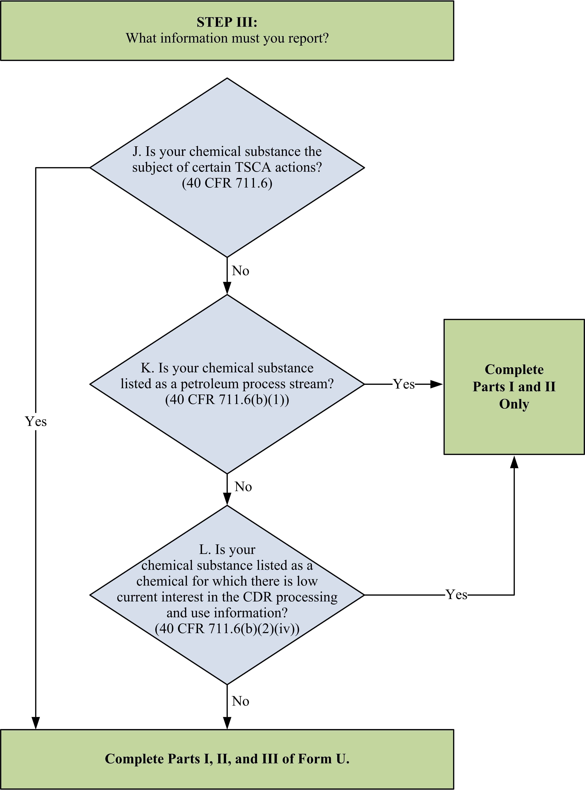

Figure 2-4. Decision Logic Diagram for Evaluating Step III

Is Your Chemical Substance Subject to Full Reporting due to Its TSCA Regulatory or Consent Agreement Status? (Question J)

Chemical substances that are the subject of certain TSCA regulatory actions (40 CFR 711.6). See Section 2.1.4 for a more detailed description of the chemical substances that meet these criteria. If you manufacture (including import) these chemical substances at quantities at or above the applicable reporting threshold (i.e., either 25,000 or 2,500 lb if the subject of certain TSCA actions), you must report all CDR information (i.e., manufacturing, processing, and use information) regardless of any exemptions for which the chemical substance would otherwise qualify. The SRS provides information on TSCA regulatory status of chemical substances.

If your chemical substance is not part of a regulatory action or consent agreement, continue to evaluate Questions K and L as seen on Figure 2-4 and also described further in the following sections to determine whether your chemical substance is partially exempt.

Is Your Chemical Substance Listed as a Petroleum Process Stream? (Question K)

Manufacturers (including importers) of certain petroleum process streams, regardless of the production volume, do not need to complete Part III of Form U for these chemical substances. The chemical substances termed “petroleum process streams” for purposes of CDR that are partially exempt from CDR requirements are those listed by CAS Registry Number at 40 CFR 711.6(b)(1).

Is Your Chemical Substance Listed as a Chemical for Which There is Low Current Interest in the CDR Processing and Use Information? (Question L)

EPA created a partial exemption for certain chemical substances for which EPA has identified a low current interest in their processing and use information. The specific chemical substances are listed at 40 CFR 711.6(b)(2)(iv). The most recent additions to the partially exempt chemicals list can be found under the Petition Results tab of the How To Report Under Chemical Data Reporting page of the CDR website.

If your CDR reportable chemical substance manufactured (including imported) in quantities at or above the applicable reporting threshold (i.e., either 25,000 or 2,500 lb if subject to certain TSCA actions) is partially exempt, you are required to report only Parts I and II of the reporting form. Otherwise, you are required to report Parts I, II, and III of the reporting form, covering manufacturing, processing, and use information for your CDR reportable chemical substance. Chapter 3 will help you determine when you must report this information to EPA.

Example 2-7. Company ABC produces Chemical Q, which is not the subject of any of the TSCA actions listed in 40 CFR 711.6 or 711.8(b), nor is it listed as a petroleum process stream or identified as low current interest for EPA. At the site, Chemical Q was produced in amounts of 30,000 lb in 2012 and 50,000 lb in 2014. It was only produced in amounts of 10,000 lb in 2013 and 5,000 lb in 2015

Because Chemical Q is not the subject of any of the TSCA actions listed in 40 CFR 711.8(b), the 25,000 lb threshold would be applicable for Chemical Q. Since the 25,000 lb threshold was exceeded at least once from 2012 to 2015 (in this case, in 2012 and 2014), Company ABC would be subject to reporting. Chemical Q is not the subject of any of the TSCA actions listed in 711.6, is not listed as a petroleum process stream or identified as low current interest for EPA, so it is not partially exempt. Therefore, for the principal reporting year of 2015, Company ABC would report additional manufacturing information and the processing and use data based on the 5,000 lb it produced that year.
Example 2-8. Company DEF begins producing Chemical Z in 2013. Chemical Z is not the subject of any of the TSCA actions listed in 40 CFR 711.8(b). The production volumes at the site are 2,000 lb in 2013, 25,000 lb in 2014, and no production for 2015.

Chemical Z is not the subject of any of the TSCA actions listed in 40 CFR 711.8(b); therefore, the 25,000 lb threshold would be applicable for Chemical Z. Since the 25,000 lb threshold was met in 2014, Company DEF would be subject to reporting. However, since there was no production in 2015, the principal reporting year, the production volume would be reported as zero, the manufacturing information needed to be reported would be limited to the company and plant site information (40 CFR 711.15(b)(2)) and the chemical specific information on identity as well as the production volume for 2013 and 2014 (40 CFR 711.15(b)(3)).

When You Must Report
For the 2016 reporting cycle, you are required to report information (pertaining to calendar years 2012, 2013, 2014, and 2015) during the 2016 submission period. The 2016 submission period begins June 1, 2016 and ends September 30, 2016 (40 CFR 711.20).

Your submissions for the 2016 reporting cycle must be submitted to EPA via the Internet and through EPA’s Central Data Exchange (CDX) no later than September 30, 2016. You should note that registration with CDX is required prior to accessing e-CDRweb to submit your CDR information (40 CFR 711.35). Separate user guides are available covering the specifics of CDR registration and use of the e-CDRweb reporting tool. If you are required to report, failure to file your report during this period is a violation of TSCA sections 8(a) and 15 and may subject you to penalties. (40 CFR 711.1(c))

Instructions for Completing CDR Form U
This chapter will help you complete the CDR Form U. Separate user guides are available covering the specifics of CDX registration and use of the e-CDRweb reporting tool. Section 4.1 describes how to certify your submission. Section 4.2 discusses the reporting standard – the effort required to comply with the CDR rule. Sections 4.3 through 4.9 provide information to help you complete each required section of Form U.

You are required to use the CDR reporting tool, e-CDRweb, to submit information for each CDR reportable chemical substance. If you are reporting information for more than one chemical substance at your site, you must report information for all reportable chemical substances on one Form U. However, you must submit a separate Form U for each site for which you are required to report.

The certification statement and Part I of Form U are completed once per reporting site. Parts II and III are completed for each reportable chemical substance at the site. Part IV is reserved for the special case of a joint submission, and is completed by the secondary submitter.

Note: Items such as the validation page and the SRS search page will appear in separate windows. Ensure that your pop-up blocker is disabled before you begin to complete Form U.

Certification
Your CDR submission must be certified, indicating that your submitted information has been completed in compliance with the CDR requirements and that any confidentiality claims are true and correct. To certify, the certification statement must be electronically signed and dated by an authorized official at your company. The authorized official typically is a senior official with management responsibility for the person (or persons) completing the form. You must include the printed name, title, and email address for the person signing the certification. See the user guide on CDX Registration for information on how to complete an electronic signature agreement.

This certification statement applies to all the information supplied on the form and should be signed only after the form has been completed. Note that knowingly providing false or misleading information or concealing required information may be punishable by fine or imprisonment or both under TSCA section 16(b).

Reporting Standard
Submitters are required to exercise certain levels of due diligence in gathering the information required by the CDR rule. You must report your information to the extent that the information is known to or reasonably ascertainable by you and your company. The term “known to or reasonably ascertainable by” is defined in 40 CFR 704.3 and discussed more fully below.
Known to or reasonably ascertainable by means all information in a person’s possession or control, plus all information that a reasonable person similarly situated might be expected to possess, control, or know.

Under TSCA section 8(a), EPA may collect information associated with chemical substances to the extent that it is known to or reasonably ascertainable by the submitter. This includes, but is not limited to, information that may be possessed by employees or other agents of the company reporting under the CDR rule, including persons involved in the research, development, manufacturing, or marketing of a chemical substance and includes knowledge gained through discussions, symposia, and technical publications. For purposes of CDR, the known to or reasonably ascertainable by standard applies to all the information required by the rule.

Examples of types of information that are considered to be in a person’s possession or control, or that a reasonable person similarly situated might be expected to possess, control, or know include:

- Files maintained by the submitter, such as marketing studies, sales reports, or customer surveys;

- Information contained in standard references, such as MSDSs, that contain use information or concentrations of chemical substances in mixtures; and

- Information from the Chemical Abstracts Service (CAS) and from Dun & Bradstreet D-U-N S®.

The hypothetical examples in Table 4-1 illustrate the anticipated application of the “known to or reasonably ascertainable” reporting standard, in the specific context of the collection of processing and use data under the CDR. Because the standard applies on a case-by case basis, however, these examples cannot substitute for a complete analysis of a submitter’s particular circumstances.

Table 4-1. Examples of the Application of the “Known to or Reasonably Ascertainable” Reporting Standard for Processing and Use Data.
Scenarios, Actions, and Outcomes
Scenario: Company XYZ discovers that it has no knowledge of how a particular reportable chemical substance (chemical substance #1) is processed or used by its customers. Company XYZ usually maintains marketing data documenting customers’ use of its chemicals, in line with the reasonable business practices typical of comparable manufacturers, but it irrevocably lost these data for chemical substance #1 due to an inadvertent computer malfunction. Company XYZ has many customers, but it expects that it could substantially reconstruct this missing information by briefly contacting its largest customer and asking that customer what chemical substance #1 is generally used for.

Application of KRA Reporting Standard:
If: | Then:
Company XYZ contacts its largest customer and reports on the basis of the processing and use data that the customer was willing to provide. | Duties Likely Fulfilled
Company XYZ did not endeavor to supplement the information it already knew. | Duties Not Fulfilled

Scenario: Company XYZ has never maintained information on how a particular reportable chemical substance (chemical substance #2) is processed or used by its customers. However, it is typical for comparable manufacturers to collect such information as part of their reasonable business practices. Company XYZ has many customers but it expects that it could substantially fill this data gap by reviewing the public web site of its largest customer.

Application of KRA Reporting Standard:
If: | Then:
Company XYZ reviews its largest customer’s web site, and reports on the basis of the information contained in the web site. | Duties Likely Fulfilled
Company XYZ did not endeavor to supplement the information it already knew. | Duties Not Fulfilled

Scenario: Company ABC maintains seasonal marketing data on changes in use patterns for a particular chemical substance (chemical substance #3). Comparable manufacturers typically only maintain such data on an annual basis, in line with reasonable business practices. Company ABC irrevocably loses its summer marketing data for chemical substance #3, due to an inadvertent computer malfunction. Company ABC expects that it could substantially reconstruct the missing summer marketing data by contacting its largest customer and asking the customer what it used or processed chemical substance #3 for in the past summer.

Application of KRA Reporting Standard:
If: | Then:
Instead of attempting to reconstruct the summer data by contacting its largest customer, Company ABC reports on the basis of the processing and use data that it already knows (regarding the winter, spring, and fall of the year). | Duties Likely Fulfilled
Company ABC designated the information as “not known or reasonably ascertainable” simply because one of the seasonal marketing reports was missing. | Duties Not Fulfilled

Scenario: Company ABC has never maintained information on how a particular reportable chemical substance (chemical substance #4) is processed or used by its customers. However, it is typical for comparable manufacturers to collect such information as part of their reasonable business practices. Company ABC has one major customer and ten minor customers.

Application of KRA Reporting Standard:
If: | Then:
Company ABC asks its major customer to supply information about how chemical substance #4 is processed and used, but that customer is unwilling to supply this information. Company ABC reasonably expects that the only remaining way to substantially fill this data gap would be to send a survey to its ten minor customers. Company ABC reports that the information is “not known or reasonably ascertainable” to it. | Duties Likely Fulfilled
Company ABC did not endeavor to obtain processing and use information from its customers and designated the information as “not known or reasonably ascertainable.” | Duties Not Fulfilled

Part I - Section A. Parent Company Information
You must provide information about your U.S. parent company. For purposes of CDR, your U.S. parent company is the highest level company, located in the United States, which directly owns at least 50 percent of the voting stock of the manufacturer. This definition is limited to this context, is distinct from the more geographically broad definition of “parent company” used in 40 CFR 704.3, and does not apply to the determination of whether a person meets the small manufacturer exemption. Corporate names should be treated as U.S. parent company names for companies with multiple sites. When a site is owned by more than one company and none of the site owners directly owns at least 50 percent of its voting stock, the site should provide the name of the U.S. parent company of either the site operator or the owner with the largest ownership interest in the site.

Example 4-1. Bestchem Corporation is not owned or controlled by any other corporation but has sites throughout the country whose names begin with Bestchem. In this case, Bestchem Corporation should be listed as the U.S. parent company.

Note: Information provided during CDX registration will populate your U.S. parent company identification information in Section A. Please double check this information to ensure all required fields are complete and accurate. If any information is incorrect or incomplete, the authorized official should make the necessary changes in CDX.

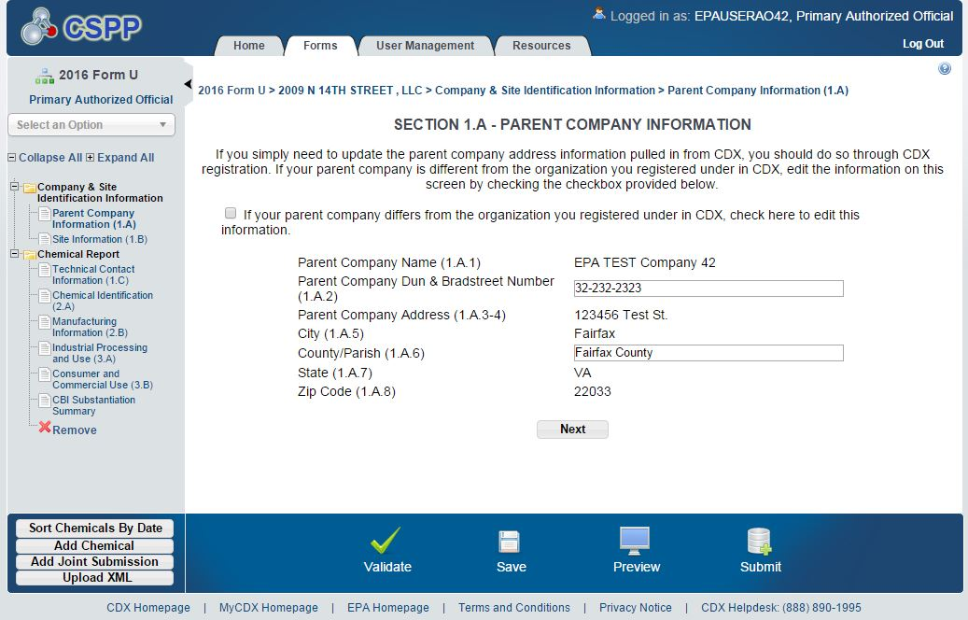

Parent Company Name (Block 1.A.1)

Enter the full name of the U.S. parent company, if applicable. The U.S. parent company name is the name of the highest level company, located in the United States, which directly owns at least 50 percent of the voting stock of the manufacturer. You should include any additional identifying terms such as Inc., Ltd., L.L.C., etc.

Parent Company Dun & Bradstreet D-U-N-S® Number (Block 1.A.2)

Enter the 9-digit Dun & Bradstreet D-U-N-S® number (D&B number) associated with the parent company name entered in Block 1.A.1. The number may be obtained from the treasurer or financial officer of the company.

D&B assigns separate numbers to subsidiaries and parent companies; you should make sure that the number you provide EPA belongs to your U.S. parent company. To verify the accuracy of your site and U.S. parent company D&B number and name, go to https://www.dnb.com/product/dlw/form_cc4.htm or call 1-800-234-3867. Callers to the toll free phone number should understand that the D&B support representatives will need to verify that callers requesting the D&B number are an agent of the business. D&B recommends knowing basic information such as when the business originated, officer names, and the name, address, and phone number for the facility.

You must obtain a D&B number for the U.S. parent company, if none exists. If your U.S. parent company does not have a D&B number, you can request one from your local office of D&B. There is no charge for this service and you are not required to disclose sensitive financial information to get a number. For more information on obtaining a D&B number, see
https://www.dnb.com. If you are already listed with D&B, but do not know your number, you can call 1-800-234-3867 for assistance.

Parent Company Address (Blocks 1.A.3 through 1.A.8)

Enter the mailing address of the U.S. parent company name entered in Block 1.A.1, including the appropriate county or parish, using standard addressing techniques as established by the U.S. Postal Service. Post office box numbers should be accompanied by a street address. If a post office box is listed, it should be listed after the street address.

Part I - Section B. Site Information
EPA requires the following information to be reported for each plant site at which a reportable chemical substance is manufactured: the site name, site D&B number, street address, city, county (or parish), state, and zip code.

Note: Information provided during CDX registration will populate your site identification information in Section B. Please double check this information to ensure all required fields are complete and accurate. If any information is incorrect or incomplete, the authorized official should make the necessary changes in CDX.

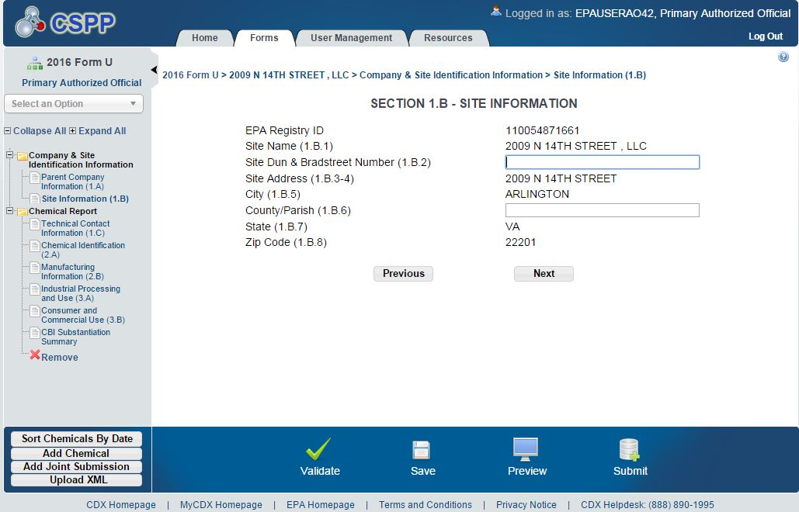

Special Provisions for Certain Sites

The definition of site at 40 CFR 711.3 has special provisions for the following situations: importation, manufacturing by contract, and portable manufacturing units sent out from a single distribution center. These provisions have a direct bearing on the site which must be identified in Part I, Section B of Form U.

Special Provisions for Importers

The site where you import a chemical substance is considered the site of the operating unit within your organization that is directly responsible for importing the chemical substance and that controls the import transaction (e.g., the company’s U.S. headquarters). For CDR, all importers must provide a U.S. address for the controlling site; this site may be your company’s headquarters in the United States. If there is no such operating unit or headquarters in the United States, the site address for the importer is the U.S. address of an agent acting on the importer’s behalf who is authorized to accept service of process for the importer (40 CFR 711.3). In the event that more than one person may meet the definition of “importer” (40 CFR 704.3), only one person should report. See 40 CFR 711.22(b).

Example 4-2. The headquarters of your company is located in New Town. Your company owns a plant site located in Old Town, which is in a different state. A headquarters employee purchases and arranges to have 500,000 lb of Chemical X imported from Japan to the Old Town plant site. The headquarters site in New Town controls the import transaction and is the site reported on Form U.

Example 4-3. The headquarters of your company is located in New Town. Your company owns three manufacturing sites, Sites 1, 2, and 3, all located in different states. An employee based at headquarters purchases and arranges to have 500,000 lb of Chemical X imported from Japan. The chemical is distributed as follows: 20,000 lb is delivered to Site 1; 180,000 lb is delivered to Site 2; and 300,000 lb is delivered to Site 3. The headquarters in New Town controls the import transaction for all three sites, and therefore is responsible for reporting all 500,000 lb of Chemical X. The site reported on Form U is New Town.

Special Provisions for Manufacturing by Contract

For chemical substances manufactured under contract, i.e., by a toll manufacturer, the site is the location where the chemical substance is physically manufactured (definition of site, 40 CFR 711.3). When a company contracts with a toll manufacturer to manufacture a chemical substance and each party meets the definition of manufacturer as set forth in 40 CFR 711.3, they may determine among themselves who should submit the required report for the site. However, in such cases, both the toll manufacturer and the contracting company are liable if no report is made. See 40 CFR 711.22(c). Nevertheless, even if the contracting company submits the Form U, the site is still the location where the chemical substance is physically manufactured.

Special Provisions for Portable Manufacturing Units

Two examples of portable manufacturing units are tanks used to manufacture calcium hydroxide slurry for use in building construction and road and highway projects, and tanks used to mix anhydrous ammonia and water to manufacture ammonium hydroxide prior to application on agricultural lands. EPA is interested in including chemical substance manufacturing that is, for instance, performed by road crews or is occurring at construction sites at which chemical substances are mixed on site to create a different chemical substance. Because the site of physical manufacturing could change on a frequent basis, the distribution center shall be considered the site for portable manufacturing units sent to different locations from a single distribution center. Manufacturers would report the aggregated production volume for all of the portable manufacturing units sent out to different locations from a single distribution center whose address would be reported as the site location.

Site Name (Block 1.B.1)

Enter the full name of the site. You should include any additional identifying terms such as Inc., Ltd., L.L.C., etc.

Site Dun & Bradstreet Number D-U-N-S® (Block 1.B.2)

D&B assigns separate numbers to subsidiaries and parent companies; make sure that the number you provide EPA in block 1.B.2 belongs to the individual site for which you are reporting. You must obtain a D&B number for the site, if none exists. If the site does not have a D&B number, you can request one from your local office of D&B. Please refer to Section 4.3.2 for information on obtaining a D&B number.

Site Street Address (Blocks 1.B.3 through 1.B.8)

Enter your site mailing address, including the appropriate county or parish (or other jurisdictional indicator), using standard addressing techniques as established by the U.S. Postal Service. Post Office box numbers should be accompanied by a street address. If a Post Office box is listed, it should be listed after the street address.

Part I - Section C. Technical Contact Information

This section requests information about the person whom EPA may contact for clarification of the information in your CDR submission. The technical contact should be a person who can answer questions about the reported chemical substance(s). Typically, a person located at the manufacturing site is best able to answer such questions. However, companies may use their discretion in selecting a technical contact or multiple technical contacts, as provided by the e-CDRweb tool. Submitters should consider, in selecting the technical contact, that EPA may have follow-up questions about a CDR submission, one or more years after the submission date. The technical contact need not be the person who signed the certification statement. You can select your technical contact from the drop down list of support registrants or enter information for a new technical contact.

Note: If you select from the list of support registrants, the technical contact information provided during CDX registration will populate Section C. Please double check this information to ensure all required fields are complete and accurate. If any information is incorrect or incomplete, the authorized official should make the necessary changes in CDX.

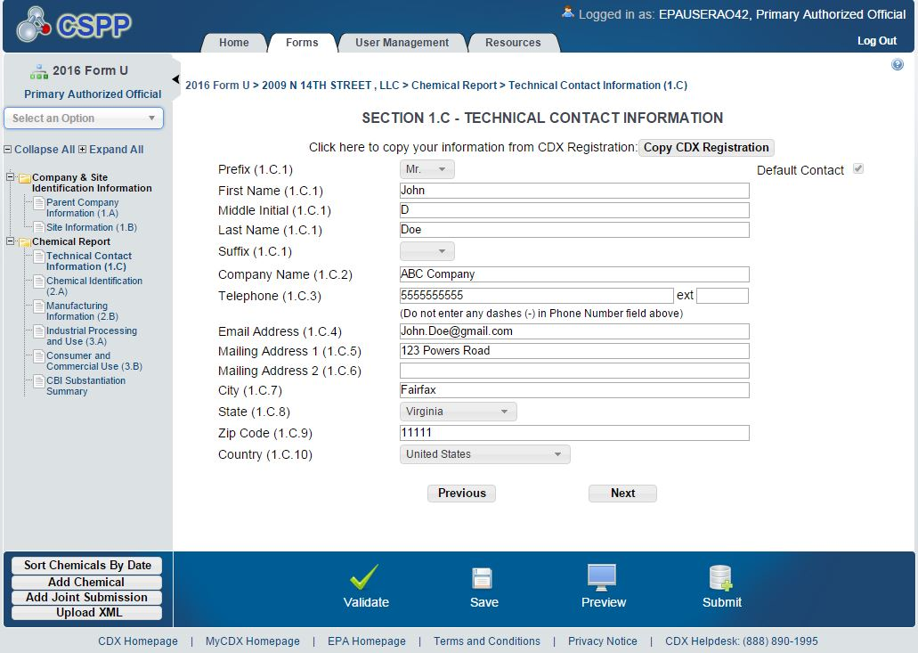

Technical Contact Name and Company Name (Blocks 1.C.1 and 1.C.2)

Enter the name of the person whom EPA may contact for clarification of information submitted on Form U. Enter the name of the company employing the technical contact.

Technical Contact Telephone Number and Email Address (Blocks 1.C.3 and 1.C.4)

Enter the technical contact’s telephone number, including the area code, and the contact’s email address.

Technical Contact Mailing Address (Blocks 1.C.5 through 1.C.8)

Enter the technical contact’s full mailing address, using standard addressing techniques as established by the U.S. Postal Service. Post Office box numbers should be accompanied by a street address. If a Post Office box is used as a mailing address, the street address should be given in Block 1.C.5 followed by the Post Office box number in Block 1.C.6. Companies may use their discretion in populating one or multiple technical contacts; however, only one technical contact can be identified per chemical report in a single Form U.

Part II - Section A. Chemical Substance Identification
You must use the Agency’s Substance Registry Services (SRS) to report the chemical substance identification information consisting of the currently correct Chemical Abstracts (CA) Index Name and the correct corresponding Chemical Abstracts Service (CAS) Registry Number (CASRN), as described in Sections 4.6.2 and 4.6.4. The SRS is EPA’s central system for information about chemical substances that are tracked or regulated by EPA or other sources. It is the authoritative resource for basic information about chemicals, biological organisms, and other chemical substances of interest to EPA and its state and tribal partners.

The correct CA Index Name and CASRN must be reported separately for each CDR reportable chemical substance at your site. If you wish to report a chemical substance listed on the confidential portion of the TSCA Inventory, you will need to report the chemical substance using a TSCA Accession Number (the generic name corresponding to the Accession Number will automatically be incorporated into your form). See Section 4.6.1 for details on how to report confidential chemical substances.
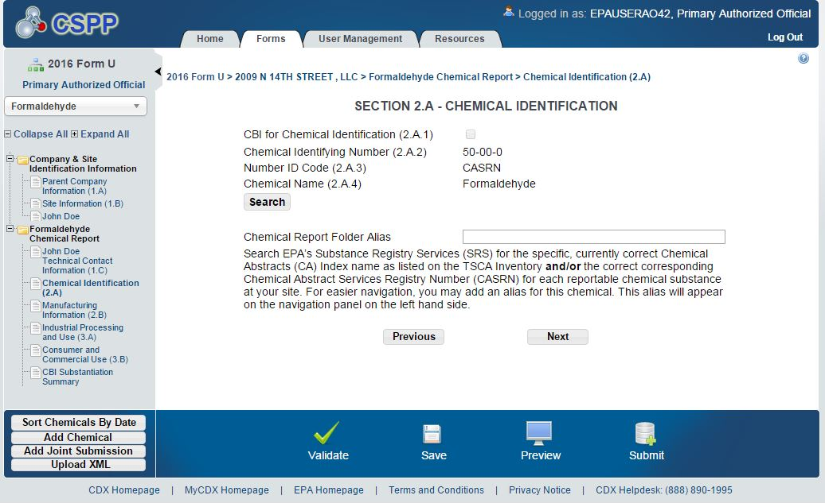

You will be able to connect directly to the SRS database from the reporting tool to report the correct CA Index Names and CASRNs for all of your non-confidential chemical substances on the TSCA Inventory. TSCA Accession Numbers and generic chemical names will be listed for chemical substances on the confidential portion of the TSCA Inventory. The use of the SRS to obtain the identities for all CDR reportable chemical substances is a convenient way to meet the chemical nomenclature requirement and will help to prevent errors in the reporting of chemical identification information for the CDR.
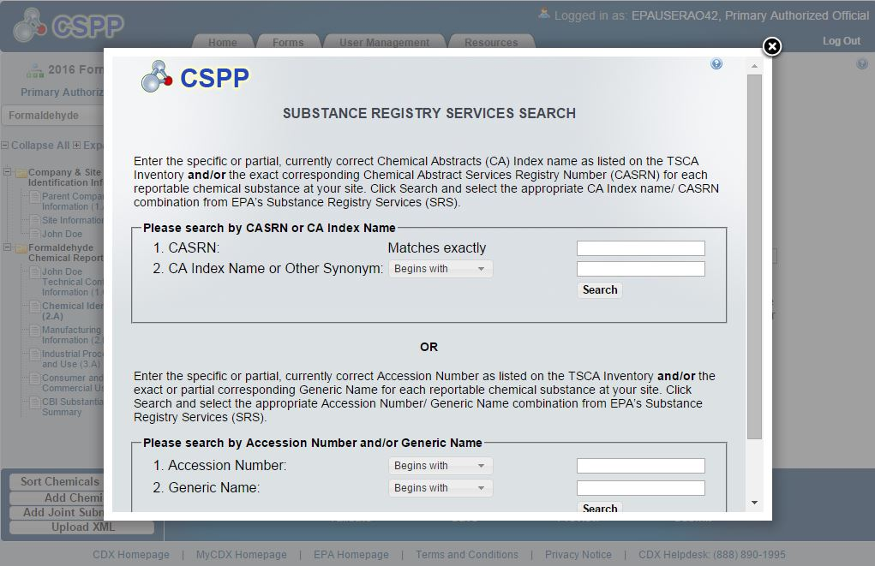

Confidentiality of Chemical Substance Information (Block 2.A.1)

If you wish to report a chemical substance listed on the confidential portion of the TSCA Inventory, you will need to report the chemical substance using a TSCA Accession Number. The generic chemical name corresponding to the TSCA Accession Number will also be automatically incorporated into your form.

You may claim as confidential the identity of a chemical substance that is already listed as confidential on the TSCA Inventory (40 CFR 711.30(b)). To do so, you must check the appropriate CBI box in Part II, Section A and submit detailed written answers to the substantiation questions listed in Table 4-2. The identities of chemical substances listed on the public version of the TSCA Inventory are already publicly known. Therefore, claims for confidential treatment of the identity of a chemical substance which is listed on the public section of the TSCA Inventory are not valid and will not be allowed using the reporting tool. The Agency limits chemical identity CBI claims to only those chemical substances listed on the confidential portion of the Master Inventory File.

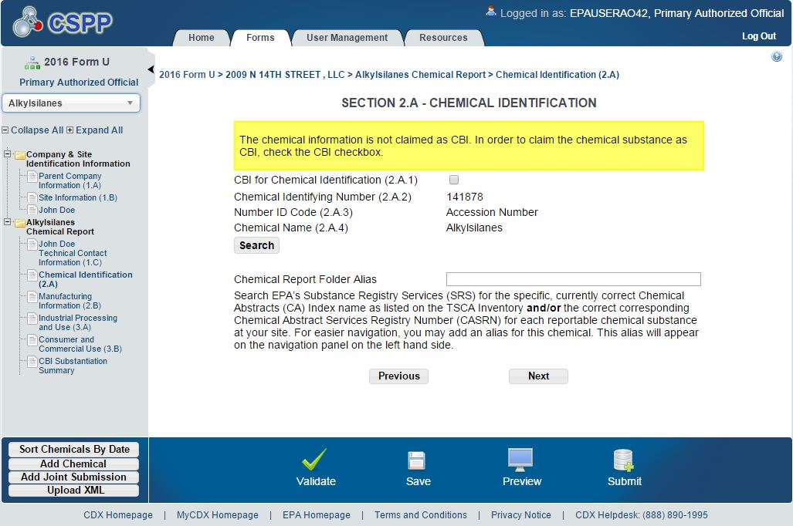

CBI claims for chemical identity will be accepted only when accompanied by a separate written substantiation for the chemical substances claimed as CBI. Clicking the checkbox next to “CBI for Chemical Identification” triggers the substantiation questions upon clicking “Next”. If you fail to substantiate the claim for confidentiality of the chemical identity in accordance with applicable rules, EPA may make the information available to the public without further notice to you. Note that checking this box does not protect the link between your company and the chemical substance; it only asserts a CBI claim for the specific identity of the chemical substance.

Table 4-2. Substantiation Questions To Be Answered When Asserting Chemical Identity CBI Claims (40 CFR 711.30(b)(1))
No. | Question
1. | What harmful effects to your competitive position, if any, or to your supplier’s competitive position, do you think would result from the identity of the chemical substance being disclosed in connection with reporting under the CDR? How could a competitor use such information? Would the effects of disclosure be substantial? What is the causal relationship between the disclosure and the harmful effects?
2. | For how long should confidential treatment be given? Until a specific date, the occurrence of a specific event, or permanently? Why?
3. | Has the chemical substance been patented? If so, have you granted licenses to others with respect to the patent as it applies to the chemical substance? If the chemical substance has been patented, and therefore disclosed through the patent, why should it be treated as confidential?
4. | Has the identity of the chemical substance been kept confidential to the extent that your competitors do not know it is being manufactured or imported for a commercial purpose by anyone?
5. | Is the fact that the chemical substance is being manufactured (including imported) for a commercial purpose available to the public, for example, in technical journals, libraries, or State, local, or Federal agency public files?
6. | What measures have you taken to prevent undesired disclosure of the fact that the chemical substance is being manufactured (including imported) for a commercial purpose?
7. | To what extent has the fact that this chemical substance is manufactured (including imported) for commercial purposes been revealed to others? What precautions have been taken regarding these disclosures? Have there been public disclosures or disclosures to competitors?
8. | Does this particular chemical substance leave the site of manufacture (including import) in any form (e.g., as product, effluent, emission)? If so, what measures have been taken to guard against the discovery of its identity?
9. | If the chemical substance leaves the site in a product that is available to the public or your competitors, can the chemical substance be identified by analysis of the product?
10. | For what purpose do you manufacture (including import) the chemical substance?
11. | Has EPA, another Federal agency, or any Federal court made any pertinent confidentiality determinations regarding this chemical substance? If so, please attach copies of such determinations.

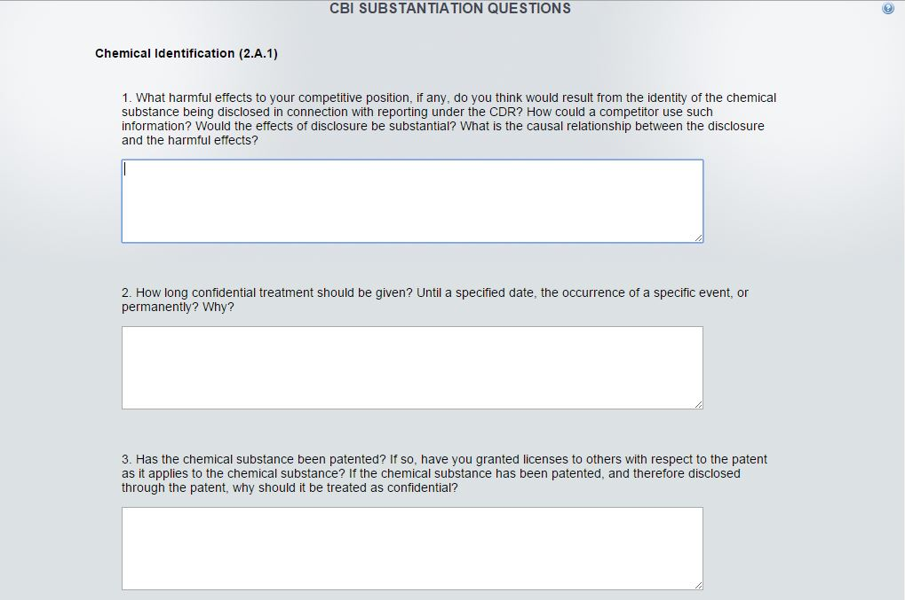

Chemical Substance Identifying Number (Block 2.A.2)

Every chemical substance reported in accordance with CDR must be accompanied by its correct CASRN, corresponding to the chemical substance’s specific chemical name as described in 4.6.4. (40 CFR 711.15(b)(3)(i)). You may enter either a CASRN (Block 2.A.2) or the specific name of the chemical substance (Block 2.A.4) to select the appropriate CASRN/Chemical Abstracts (CA) Index Name combination from the SRS database.
Report the correct CASRN for your chemical substance if it is listed on the non-confidential portion of the TSCA Inventory. If your chemical substance is listed on the confidential portion of the TSCA Inventory and you wish to continue having the chemical identity be confidential, report the EPA-designated TSCA Accession Number. Each TSCA Inventory chemical substance has at least one of these types of numbers.

EPA is requiring that you report only the CASRN as a chemical identifying number, except in the case of confidential chemical substances. In the case of confidential chemical substances, EPA is requiring that you report only the TSCA Accession Number as a chemical identifying number. If, in the past, you reported using the PMN case number of a confidential substance, you can use the PMN case number to search the SRS to populate the pertinent chemical identification information for the confidential chemical substance listed on the TSCA Inventory. In the SRS, you can readily find a cross-reference list that displays the Accession Number, generic chemical name, and the PMN case number (or for an initial TSCA Inventory substance, the TSCA Inventory reporting form number) for any confidential chemical substance listed on the TSCA Inventory. You can then select from the SRS the correct Accession Number
corresponding to the confidential chemical substance intended to be reported (the generic name corresponding to the Accession Number will automatically be incorporated into your report).

There are certain circumstances where you occasionally may not be sure of the particular PMN case number and Accession Number the Agency has assigned to one of its confidential chemical substances, such that you would not be able to definitely determine this solely from searching the SRS. This could happen, for example, if the chemical substance were originally reported as part of a consolidated PMN and you did not learn from EPA which particular case number in the consolidated PMN number sequence corresponds to which of the several reported confidential chemical substances. This could also happen if a certain PMN represented a mixture of two or more confidential chemical substances, such that multiple Accession Numbers were assigned to the different chemical substances reported in that single PMN, and you didn’t already request the particular Accession Numbers from EPA for the individual chemical substances comprising that multi-component type of PMN. In such circumstances, you should contact EPA well before initiating CDR reporting to obtain the required Accession Numbers from the Agency.

Submitters who are not able to identify the Accession Number by searching the SRS should contact EPA, in writing on company letterhead, well before initiating CDR reporting to obtain the Accession Number assigned when the Notice of Commencement (NOC) was submitted to the Agency. Individuals are urged to submit a complete and accurate TSCA Inventory Correspondence at least one month before the submission deadline. Note that incomplete and/or inaccurate requests may be rejected. The Agency will respond to such inquiries in as timely a manner as possible. It is the responsibility of the submitter to contact the Agency for such information in sufficient time to allow for the Agency to respond.

Please send requests for a TSCA Accession Number as soon as possible to:

By U.S. Postal Service:  U.S. Environmental Protection Agency Office of Pollution Prevention and Toxics 1200 Pennsylvania Ave, NW (7407M) Room 6428  Washington, DC 20460  Attention: Industrial Chemistry Branch | By Hand Delivery or Courier:  U.S. Environmental Protection Agency Office of Pollution Prevention and Toxics Confidential Business Information Center EPA East Building, Room 6428  1201 Constitution Ave, NW Washington, DC 20004  202-564-8930; 202-564-8940

ID Code (Block 2.A.3)

The code corresponding to the type of identifying number you selected in the SRS will be entered in Block 2.A.1. See codes in Table 4-3.

Table 4-3. ID Code for Chemical Identifying Numbers

If the Number You are Reporting is a(n) | This Code Will be Entered
TSCA Accession Number | A
CAS Registry Number | C

Chemical Name (Block 2.A.4)

EPA is requiring the reporting of the CA Index Name currently used to list the chemical substance on the TSCA Inventory as the chemical name reported for CDR. You may enter either a CASRN (Block 2.A.2) or the specific name of the chemical substance (Block 2.A.4) to select the appropriate CASRN/Chemical Abstracts (CA) Index Name combination from the SRS database.

In cases where a chemical substance is listed on the confidential portion of the TSCA Inventory, you are to report the chemical substance’s Accession Number which is listed on the non-confidential portion of the TSCA Inventory and is included in the SRS (the generic name corresponding to the Accession Number will automatically be incorporated into your report). In order to continue to protect the confidentiality of the underlying specific chemical identification information (i.e., the CASRN and specific chemical name), you must claim the chemical identity as CBI and complete the upfront substantiation. Doing so will maintain the confidentiality of the underlying specific chemical name and CASRN of the confidential chemical substance. The Accession Number and generic chemical name will remain non-confidential. Failure to identify the chemical identity as CBI and complete the upfront substantiation will waive any CBI claim to the chemical identity and will result in the transfer of the chemical substance from the confidential portion of the TSCA Inventory to the non-confidential, publicly releasable, portion of the TSCA Inventory.

Special Provisions for Importers and Joint Submitters

You may report an alternate chemical name, and in the case of importers, a trade name, in those instances where your supplier will not disclose to you the specific chemical name of the imported TSCA Inventory chemical substance or a reactant used to manufacture the TSCA Inventory chemical substance because the name is claimed confidential. In these cases, you and the supplier may report the information required in a joint submission, which is further discussed in Section 4.9 of this chapter. If you as the importer cannot provide the chemical name, supply a trade name or other designation to identify the proprietary chemical substance and provide the supplier’s (secondary submitter’s) company information. Complete as much of the Form U as you can. In addition, you must use e-CDRweb to ask the supplier (secondary submitter) of the confidential chemical substance to directly provide EPA with the correct chemical identity (as described in Section 4.6.2), in a joint submission with you. Your request to the supplier must include instructions for submitting chemical identity information electronically, using e-CDRweb and CDX (see 40 CFR 711.35), and for clearly referencing your submission. Contact information for the supplier, a trade name or other designation for the chemical substance or mixture, and a copy of the request to the supplier must be included with your submission for the chemical substance.

Similarly, in the event that you as a manufacturer completing a Form U cannot provide the complete chemical identity because you manufacture the reportable chemical substance using a reactant having a specific chemical identity claimed as confidential by its supplier, supply a trade name or other designation to identify the proprietary chemical substance and provide the supplier’s (secondary submitter’s) company information. Complete as much of the Form U as you can. In addition, you must use e-CDRweb to ask the supplier to directly provide to EPA the correct chemical identity of the confidential reactant in a joint submission. Such request must include instructions for submitting chemical identity information electronically using e-CDRweb and CDX (see 40 CFR 711.35), and for clearly referencing your submission. Contact information for the supplier, a trade name or other designation for the chemical substance, and a copy of the request to the supplier must be included with your submission referencing the chemical substance.

In both cases, if the secondary submitter chooses to respond to the primary submitter’s request, the secondary submitter would use e-CDRweb to identify the chemical substance in question and the percent composition of each component chemical substance of the trade name product or mixture.

EPA will only accept joint submissions that are submitted electronically using e-CDRweb and CDX (see 40 CFR 711.35) and that clearly reference the Form U submission to which they refer. See Section 4.9 in this chapter for more information on preparing joint submissions. These special provisions only apply in cases where the supplier will not reveal the pertinent chemical identity to you because it is claimed confidential. In the event that you actually know the chemical identity of a chemical substance subject to CDR reporting, you must provide that information irrespective of a supplier’s confidentiality claims.

Part II - Section B. Manufacturing Information
The following subsections describe the manufacturing information required to be reported for each chemical substance.

Confidentiality of Company Information (Block 2.B.1)

Check the CBI box in this block to assert a confidentiality claim for the link between the chemical substance and the company information reported in Part I, Section A. Checking other CBI boxes on the form will not protect this link. You may claim this connection as confidential for some chemical substances for which you are reporting, while not making the claim for others (each chemical substance manufactured at a site is reported in separate sections of Form U). EPA will not impute the existence of a CBI claim for company identity from a CBI claim associated with a different chemical substance.

Confidentiality of Site Information (Block 2.B.2)

Check the CBI box in this block and complete the substantiation questions to assert a confidentiality claim for the link between the chemical substance and the site identity reported in Part I, Section B. Checking the CBI box automatically triggers the substantiation questions. See Table 4-4 for substantiation questions related to site identity. If you fail to substantiate the site CBI claim in accordance with the applicable rules, EPA may make the information available to the public without further notice to you.

You may claim the connection between chemical substance and site as confidential for some chemical substances for which you are reporting, while not making the claim for others (each chemical substance is reported separately in Form U). EPA will not impute the existence of a CBI claim for site identity from a CBI claim associated with a different chemical substance.

EPA also has observed that submitters sometimes claim only their company identity, but not their site identity, as confidential. EPA will not impute the existence of a CBI claim for site identity from a CBI claim for company identity, even if the company name appears within the site identity information.

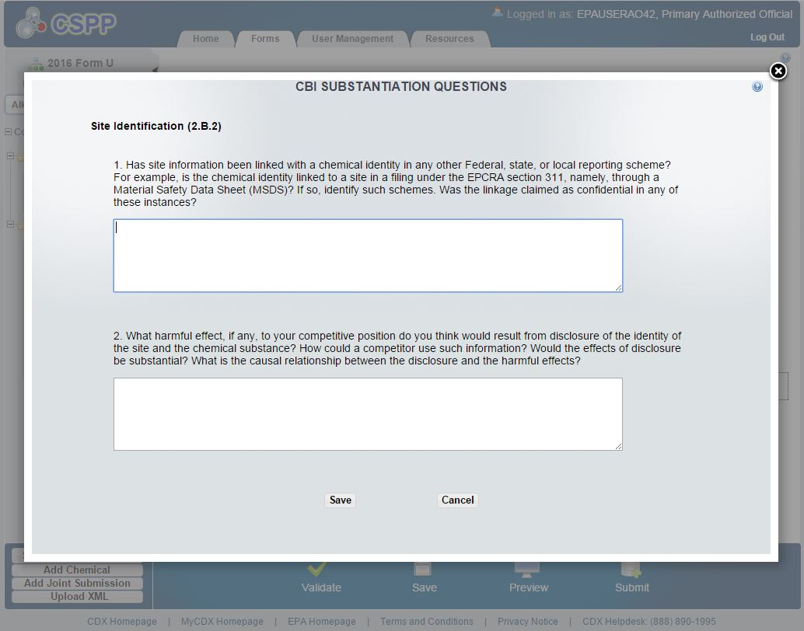

Table 4-4. Substantiation Questions To Be Answered When Asserting Site
Identity CBI Claims (40 CFR 711.30(c)(1))
No. | Question
1. | Has site information been linked with a chemical identity in any other Federal, state, or local reporting scheme? For example, is the chemical identity linked to a facility in a filing under the EPCRA section 311, namely through a Material Safety Data Sheet (MSDS)? If so, identify all such schemes. Was the linkage claimed as confidential in any of these instances?
2. | What harmful effect, if any, to your competitive position do you think would result from disclosure of the identity of the site and the chemical substance? How could a competitor use such information? Would the effects of disclosure be substantial? What is the causal relationship between the disclosure and the harmful effects?

Confidentiality of Technical Contact Information (Block 2.B.3)

Check the CBI box in this block to assert a confidentiality claim for the link between the chemical substance and the technical contact information reported in Part I, Section C of Form U. You may claim this connection as confidential for some chemical substances for which you are reporting, while not making the claim for others (each chemical substance is reported separately in Form U). EPA will not impute the existence of a CBI claim for technical contact information from a CBI claim associated with a different chemical substance.

Reporting Manufacturing Information for Calendar Year 2015 (Blocks 2.B.4. through2.B.20)

This section of the CDR describes the manufacturing data elements that should be reported for your CDR reportable chemical substance for the calendar year 2015, the principal reporting year for the 2016 submission period. If any information is not known or reasonably ascertainable by you (including your company), enter or select “NKRA” for “not known or reasonably ascertainable” in the box corresponding to that data element. You may also check the CBI box next to each data element to claim data as confidential. However, keep in mind that you cannot claim an “NKRA” designation as confidential.

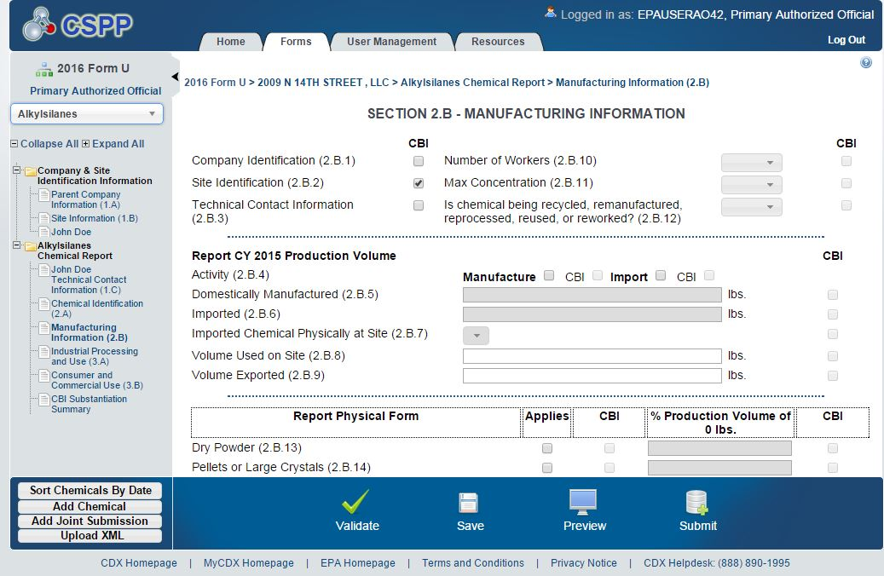

Activity (Domestically Manufacture and/or Import) (Block 2.B.4)

Check the box(es) that describe whether you domestically manufacture or import the chemical substance. If you both domestically manufacture and import the same chemical substance, check both boxes.

Domestically Manufactured Production Volume (Block 2.B.5)

Report the volume of the chemical substance domestically manufactured at your site during calendar year 2015, in pounds. Report the quantity to at least two significant figures; it should be accurate to the extent known to or reasonably ascertainable by you. Production volumes should be reported in numeric format, without commas (e.g., 6352000). For example, “2 million” or “2 E6" are not acceptable, nor are production volumes with decimals or abbreviations such as M (e.g., 12,000,000 = 12M) or K (e.g., 50,000 = 50K).

Imported Production Volume (Block 2.B.6)

Report the volume of chemical substance imported by your site in 2015, in pounds. Report the quantity to at least two significant figures; it should be accurate to the extent known to or reasonably ascertainable by you. You should use the same numeric format as described for Block 2.B.5, domestically manufactured production volume. Imported and domestically manufactured production volumes are reported separately for each chemical substance at each site. e-CDRweb has built-in validation systems that provide automated chemical identity and threshold checks.

Note that if you import various mixtures containing reportable chemical substances, you should add all import volumes associated with each chemical substance. For instance, if you import three mixtures and each mixture contains Chemical A, then you would determine the volume of Chemical A in each mixture and report the aggregated amount.

For Imported Chemical Substances, Is the Chemical Never Physically at Site? (Block 2.B.7)

Use the drop down box to select one of the following choices:

Y = Yes, the imported chemical substance is never physically at the reporting site (e.g., if you ship the chemical substance from a foreign country directly to another location such as a warehouse, a processing or use site, or a customer’s site),

N = No, the imported chemical substance is actually physically present at the site.

NKRA = It is not known to or reasonably ascertainable by you whether the imported chemical substance is physically present at the site.

Production Volume Used On-Site (Block 2.B.8)

Report the total volume of the domestically manufactured and imported chemical substance used at the reporting site, in pounds. The number represents the volume of the chemical substance that does not leave the manufacturing site. The production volume used on-site should not exceed the sum of the domestically manufactured and imported volumes minus the volume exported (i.e., (Block 2.B.5 + Block 2.B.6) –Block 2.B.9). If you report “Y” in Block 2.B.7, indicating that the imported chemical substance is never physically present at the reporting site (for example because you ship it directly from a foreign supplier to your client’s warehouse), you would report “0” in block 2.B.8, because that volume is not used at your site. Report the quantity to at least two significant figures; it should be accurate to the extent known to or reasonably ascertainable by you. You should use the same numeric format as described for Block 2.B.5, domestically manufactured production volume. e-CDRweb has built-in validation systems that provide automated chemical identity/threshold checks.

Production Volume Exported (Block 2.B.9)

Report the production volume directly exported and not domestically processed or used, in pounds. The volume exported should not exceed the sum of the domestically manufactured and imported volumes (i.e., (Block 2.B.5 + Block 2.B.6). Note that direct exporting includes sending a chemical substance to a distributor who then exports it without repackaging it, even if it is relabeled. Direct exporting does not include sending a chemical substance to a distributor who repackages and relabels it. The latter case would be considered a processing and use activity potentially reportable under Part III of Form U. Report the quantity to at least two significant figures; it should be accurate to the extent known to or reasonably ascertainable by you. You should use the same numeric format as described for Block 2.B.5, domestically manufactured production volume.

Table 4-5. Examples of Reporting Production Volume for Part II
– Manufacturing Information
Description | 2016 Reporting Requirement
Site 1 domestically manufactures 30,000 lb of Chemical X. | Site 1 should report 30,000 lb as domestically manufactured for Chemical X. The total production volume (i.e., the domestically manufactured volume) should be used to report the remaining CDR information.
Site 2 domestically manufactures 15,000 lb of Chemical X and directly imports 15,000 lb of Chemical X. | Site 2 should report 15,000 lb as domestically manufactured. Because Site 2 controls the import transaction, Site 2 should also report 15,000 lb as imported for Chemical X. The total production volume (i.e., sum of the domestically manufactured and import volumes) should be used to report the remaining CDR information.
Site 3 domestically manufactures 30,000 lb of Chemical X. Of the 30,000 lb manufactured, Site 3 directly exports 10,000 lb to a foreign customer. | Site 3 should report 30,000 lb as domestically manufactured and 10,000 lb as exported for Chemical X. The production volume not directly exported should be used to report the remaining CDR information.
Site 4 domestically manufactures 70,000 lb and imports 30,000 lb of Chemical X. Site 4 uses 20,000 lb of Chemical X on site. | Site 4 should report 70,000 lb as domestically manufactured, 30,000 lb as imported and 20,000 lb as used on site. The total production volume (i.e., sum of the domestically manufactured and import volumes) should be used to report the remaining CDR information.
In 2015, Company B coordinates the import of 100,000 lb of Chemical X, which is imported directly to three different sites owned by Company B. Site 5 receives 40,000 lb and Sites 6 and 7 each receive 30,000 lb of Chemical X. | Company B should report 100,000 lb as imported for Chemical X. The total production volume (i.e., the imported volume) should be used to report the remaining CDR information. Because the three sites controlled by Company B did not control the import transaction, the sites are not required to report the imported volumes.
Site 6 domestically manufactures 10,000 lb of Chemical X, which is not the subject of any of the certain TSCA actions | Site 6 is not required to report because production was less than 25,000 lb. Note that if Chemical X were the subject of one of the listed TSCA actions, reporting would be required because the production volume exceeds the 2,500 lb threshold.

Number of Workers (Block 2.B.10)

Report the total number of workers reasonably likely to be exposed to each reportable chemical substance at each site during calendar year 2015 (40 CFR 711.15(b)(3)(vii)). For Block 2.B.10, use the drop down box to select the code corresponding to the appropriate range for the number of workers reasonably likely to be exposed to a reportable chemical substance during manufacture. Table 4-6 shows the codes and ranges which appear in the drop down box.

Table 4-6. Codes for Reporting Number of Workers Reasonably Likely to be Exposed
Code | Range of Workers Reasonably Likely to be Exposed
W1 | Fewer than 10 workers
W2 | At least 10 but fewer than 25 workers
W3 | At least 25 but fewer than 50 workers
W4 | At least 50 but fewer than 100 workers
W5 | At least 100 but fewer than 500 workers
W6 | At least 500 but fewer than 1,000 workers
W7 | At least 1,000 but fewer than 10,000 workers
W8 | At least 10,000 workers

“Reasonably likely to be exposed” means “an exposure to a chemical substance which, under foreseeable conditions of manufacture, processing, distribution in commerce, or use of the chemical substance, is more likely to occur than not to occur. Such exposures would normally include, but would not be limited to, activities such as charging reactor vessels, drumming, bulk loading, cleaning equipment, maintenance operations, materials handling and transfers, and analytical operations. Covered exposures include exposures through any route of entry (inhalation, ingestion, skin contact, absorption, etc.), but excludes accidental or theoretical exposures” (40 CFR 711.3).

Persons reasonably likely to be exposed to a chemical substance include workers whose employment requires them to pass through areas where chemical substances are manufactured, processed, or used (e.g., production workers and foremen, process engineers, and plant managers). Workers employed to drive vehicles which transport the chemical substance should be included in the number of workers reasonably likely to be exposed to the chemical substance if they come into contact with the chemical substance during loading or unloading. For example, workers engaged in the connection or disengagement of hoses used to load or unload the chemical substance should be included. However, workers involved solely with transporting chemical substances in sealed containers that are totally enclosed with no potential for exposure should not be included.

In addition, when a site employs temporary, seasonal, or contract workers in the manufacture of a reportable chemical substance, these workers should be included in the number of workers reasonably likely to be exposed to a chemical substance if they work in areas where the chemical substance is manufactured. The term does not include those employees whose jobs are not associated with potential exposures to a chemical substance or mixture (e.g., administrative staff who never enter areas where the chemical substance is manufactured) and who are unlikely to be exposed to a chemical substance for even a brief period of time. No allowance is made for personal protective equipment or for engineering controls that reduce but do not preclude exposure to a chemical substance; however, if contact between a worker and a chemical substance is highly improbable, the worker should not be included among those persons reasonably likely to be exposed to the chemical substance.

When there is no potential exposure to a chemical substance, the code W1 corresponding to fewer than 10 workers would be reported. This would be the case, for instance, when a chemical substance is imported in sealed containers and resold without repackaging or is shipped from a foreign source directly to a customer.

Maximum Concentration (Block 2.B.11)

Report the maximum concentration, measured by percentage of weight, of your reportable chemical substance at the time it is reacted on-site to produce a different chemical substance (site-limited) or as it leaves the site (40 CFR 711.15(b)(3)(viii)).The concentration must be accurate to the extent that information is known to or reasonably ascertainable by you. In your determination of the maximum concentration, do not include concentrations of the product sent off-site for non-commercial purposes (40 CFR 710.1(a)).

For each chemical substance, from the drop down box select the code which corresponds to the appropriate maximum concentration range of the chemical substance. Table 4-7 shows the codes and concentration ranges which appear in the drop down box. If the maximum concentration falls between two ranges, round your estimate to the nearest one percent using standard rounding procedures. Report the code that corresponds to the appropriate range. Report the maximum concentration regardless of the various physical forms in which the chemical substance may be sent off-site or reacted on-site to produce a different chemical substance.

Table 4-7. Codes for Reporting Maximum Concentration
Code | Concentration Range (weight percent)
M1 | Less than 1% by weight
M2 | At least 1 but less than 30% by weight
M3 | At least 30 but less than 60% by weight
M4 | At least 60 but less than 90% by weight
M5 | At least 90% by weight

Is Chemical Substance Being Recycled, Remanufactured, Reprocessed, or Reused? (Block 2.B.12)

Use the drop down box to select one of the following choices

Y = Yes, the manufactured chemical substance, such as a byproduct, is to be recycled, remanufactured, reprocessed, or reused.

N = No, the manufactured chemical substance, such as a byproduct, is not to be recycled, remanufactured, reprocessed, or reused.

NKRA = It is not known to or reasonably ascertainable by you whether the manufactured chemical substance, such as a byproduct, is to be recycled, remanufactured, reprocessed, or reused.

By selecting “Yes,” you indicate that the manufactured chemical substance, which otherwise would be disposed of as a waste, is being removed from the waste stream and is being used or reused for a commercial purpose.

Example 4-4. The papermaking process involves the pulping of wood and several processing steps which generate white (CASRN 68131-33-9), black (CASRN 66071-92-9), and green (CASRN 68131-30-6) pulping liquors. During papermaking, wood pulping using the white liquor generates a black pulping liquor waste product, which is typically burned, resulting in the production of energy and an inorganic smelt that becomes green liquor. Green liquor is further processed to generate white liquor, which is used in the wood pulping process. The pulping liquors generated by the pulping cycle are CDR reportable chemical substances that are considered recycled, remanufactured, reprocessed, or reused. Block 2.B.12 should be selected for these chemical substances.

Physical Form and Percentage of Production Volume (Blocks 2.B.13 through 2.B.19)

Report all physical forms of the chemical substance at the time it is reacted or as it leaves your site and the percentage of production volume (including both domestically manufactured and imported volumes) for each physical form (40 CFR 711.15(b)(3)(viii)). For each chemical substance at each site, the submitter must report as many physical forms as applicable by selecting the appropriate blocks which correspond to the following six physical forms:

- Dry Powder
- Pellets or Large Crystals
- Water- of Solvent-Wet Solid
- Other Solid
- Gas or Vapor
- Liquid

Select “Unknown”, if the physical form of the chemical substance is not known to or reasonably ascertainable by you.

Report the percentage of the total production volume of the chemical substance for each physical form reacted onsite or sent off-site rounded off to the closest 10 percent (40 CFR 711.15(b)(3)(ix)). If the chemical substance is sent off-site in more than one physical form, report all the physical forms in which it is sent off-site. These percentages may total more or less than 100% due to rounding.
Example 4-5. Determining Percentage of Production Volume
Company A domestically manufactures 75,000 lb and imports 25,000 lb of Chemical X, for a total production volume of 100,000 lb. Forty-eight percent (48,000 lb) of the production volume is produced as dry powder, 24 percent (24,000 lb) is produced as pellets, 24 percent (24,000 lb) as a liquid solution, and 4 percent (4,000 lb) as a water-wet solid. Company A would report the following:

Dry Powder 50% Pellets or Large Crystals 20% Water- or Solvent-Wet Solid 0% Other Solid 0% Gas or Vapor 0% Liquid 20%

Reporting Past Production Volume (PV) (Block 2.B.20)

If the reporting threshold of 25,000 pounds is met or exceeded during any calendar year since 2011 (or 2,500 lb or more for chemical substances subject to certain TSCA actions), reporting is required for each calendar year in the CDR submission period. Report the total volume of the chemical substance manufactured at your site (includes domestically manufactured and imported volumes) during calendar year 2012, 2013, and 2014 in pounds. Report the production volume to at least two significant figures; it should be accurate to the extent known to or reasonably ascertainable by you. Production volumes should be reported in numeric format, with or without commas (i.e., 58,000 or 6352000). For example, “2 million” or “2 E6" are not acceptable, nor are production volumes with decimals or abbreviations such as M (e.g., 12,000,000 = 12M) or K (e.g., 50,000 = 50K).

Part III - Processing and Use Information
In addition to completing Parts I and II, you must complete Part III of Form U for reportable chemical substances manufactured (including imported), unless the chemical substance is partially exempt. See Sections 2.3.3 and 2.3.4 to determine whether you qualify for a partial exemption. You should report the processing and use activities for the total 2015 production volume reported (both domestically manufactured (Block 2.B.5.) and imported (Block 2.B.6.)) in Part II.
Information regarding processing or use activities must be reported to the extent that it is known to or reasonably ascertainable by the submitter (40 CFR 711.15(b)(4)).
The processing or use information should be reported to the extent that it is known to or reasonably ascertainable by you (40 CFR 711.15). Under the “known to or reasonably ascertainable by” standard, a submitter would therefore prepare its report about the processing and use of a chemical substance it manufactures (including imports), without confining its inquiry solely to what is known to managerial and supervisory employees, but would also be expected to review information which the manufacturer (including importer) may have in their possession or control, plus all information that a reasonable person similarly situated might be expected to possess, control, or know. The inquiry would be as extensive as a reasonable person, similarly situated, might be expected to perform within the organization. Information derived from customer surveys or other customer contacts, like any other information, would be “known to” the submitter if it is available after a reasonable inquiry within the organization. The standard does not necessarily require that the manufacturer conduct an exhaustive survey of all employees.

EPA would like to furthermore clarify that submitters are not required to conduct a new or additional customer survey (i.e., to pose a comprehensive set of identical questions to multiple customers) under this standard. If particular information cannot be derived or reasonably estimated from the information available to the company without conducting further customer surveys, it is not “known to or reasonably ascertainable” to the submitter for purposes of the CDR. However, to the extent that customer surveys are already in the submitter’s possession or control, and to the extent that reasonable efforts to analyze or derive information from already-available customer surveys may inform processing and use information that is reported, the information is generally “known to or reasonably ascertainable.” Section 4.2 contains additional information on the “known to or reasonably ascertainable by” reporting standard.

If any information is not known or reasonably ascertainable by you (including your company), enter or select “NKRA” for “not known or reasonably ascertainable” in the box corresponding to that data element.

You may check the CBI box next to each data element to claim data as confidential. However, keep in mind that you cannot claim an “NKRA” designation as confidential. Checking a CBI box associated with a specific processing and use data element automatically triggers substantiation questions. See Table 4-8 for substantiation questions to be answered when asserting CBI claims for processing and use information.
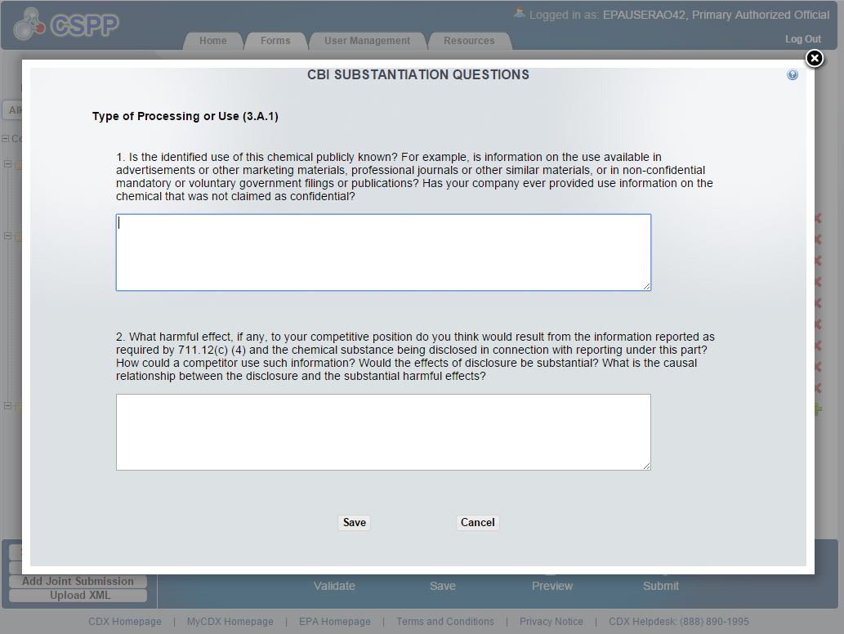

Table 4-8. Substantiation Questions To Be Answered When Asserting Processing and Use Information CBI Claims (40 CFR 711.30(d)(1))
No. | Question
1. | Is the identified use of this chemical substance publicly known? For example, is information on the use available in advertisements or other marketing materials, professional journals or other similar materials, or in non-confidential mandatory or voluntary government filings or publications? Has your company ever provided use information on the chemical substance that was not claimed as confidential?
2. | What harmful effect, if any, to your competitive position or to your customer’s competitive position do you think would result from disclosure of the processing and use data and the chemical substance? How could a competitor use such information? Would the effects of disclosure be substantial? What is the causal relationship between the disclosure and the harmful effects?

Part III - Section A. Industrial Processing and Use Data (Blocks 3.A.1 through 3.A.10)

For each CDR chemical substance manufactured (including imported), report up to ten unique combinations of the following data elements: the Type of Process or Use Operation (TPU) (described in Section 4.8.1.1), the Industrial Sector (IS) (described in Section 4.8.1.2), and the Industrial Function Category (IFC) (described in Section 4.8.1.3) (40 CFR 711.15(b)(4)(i)). A combination of these three data elements defines a potential exposure scenario for risk-screening and priority-setting purposes. For each of these unique combinations, you are also required to report the percentage of production volume (described in Section 4.8.1.4), the number of sites (described in Section 4.8.1.5), and the number of workers (described in Section 4.8.1.6) (40 CFR 711.15(b)(4)(i)). If more than ten unique combinations apply to a chemical substance, you need only report the ten combinations for the chemical substance that cumulatively represent the largest percentage of production volume, measured by weight (40 CFR 711.15(b)(4)(i)(C)). The reporting tool will allow you to enter more than ten combinations if you choose to do so.

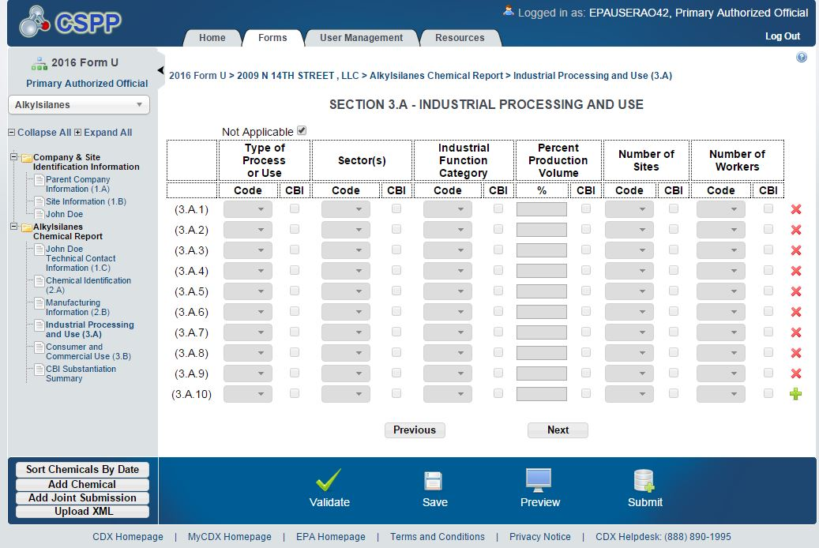

Type of Processing or Use Operation

To the extent that it is known to or reasonably ascertainable by you, use the drop down box to select the code which corresponds to the appropriate Type of Processing or Use Operation (TPU) for the particular combination of IS and IFC codes. Table 4-9 shows the codes and TPUs which appear in the drop down box. Note that if a chemical substance is fully reacted (i.e., reporting “PC” for the processing code), then the chemical substance is consumed and further processing and use information for that chemical substance will not exist. In such a situation, there is no further downstream processing and use information to be reported for that particular type of processing or use operation under 40 CFR 711.15(b)(4). A processing or use code may be reported more than once if more than one IS and/or IFC code applies to the same processing or use operation. Definitions for each code are provided in Appendix D, which may assist you in determining which code to report.

Table 4-9. Codes for Reporting Type of Industrial Processing or Use Operations
Code | Operation
PC | Processing as a reactant
PF | Processing—incorporation into formulation, mixture, or reaction product
PA | Processing—incorporation into article
PK | Processing—repackaging
U | Use—non-incorporative activities

Industrial Sectors

You must select from the drop down box the code which corresponds to the appropriate Industrial Sector (IS) for all sites that receive a reportable chemical substance from you either directly or indirectly (including through a broker/distributor, from a customer of yours, etc.) and that process and use of the reportable chemical substance to the extent that this information is known to or reasonably ascertainable by you (40 CFR 711.15(b)(4)(i)(B)). Table 4-10 shows the codes and sectors which appear in the drop down box. Because an industrial sector may apply to more than one processing and use scenario for a chemical substance, the same IS code may be reported with different combinations of IFC and TPU codes.

A listing identifying the correspondence between NAICS codes and IS codes is provided on the Replacement of 5-digit NAICS Codes with Industrial Sector Codes page of the CDR website at http://www.epa.gov/chemical-data-reporting/replacement-5-digit-naics-codes-industrial-sector-codes. . Submitters who do not know a specific NAICS code may be able to identify a more general category.

When you chose the IS “Other,” you also need to provide a written description of the use of the chemical substance. Your description may include the NAICS code.

Table 4-10. Industrial Sectors (IS)
Code | Sector Description
IS1 | Agriculture, forestry, fishing and hunting
IS2 | Oil and gas drilling, extraction, and support activities
IS3 | Mining (except oil and gas) and support activities
IS4 | Utilities
IS5 | Construction
IS6 | Food, beverage, and tobacco product manufacturing
IS7 | Textiles, apparel, and leather manufacturing
IS8 | Wood product manufacturing
IS9 | Paper manufacturing
IS10 | Printing and related support activities
IS11 | Petroleum refineries
Code | Sector Description
IS12 | Asphalt paving, roofing, and coating materials manufacturing
IS13 | Petroleum lubricating oil and grease manufacturing
IS14 | All other petroleum and coal products manufacturing
IS15 | Petrochemical manufacturing
IS16 | Industrial gas manufacturing
IS17 | Synthetic dye and pigment manufacturing
IS18 | Carbon black manufacturing
IS19 | All other basic inorganic chemical manufacturing
IS20 | Cyclic crude and intermediate manufacturing
IS21 | All other basic organic chemical manufacturing
IS22 | Plastic material and resin manufacturing
IS23 | Synthetic rubber manufacturing
IS24 | Organic fiber manufacturing
IS25 | Pesticide, fertilizer, and other agricultural chemical manufacturing
IS26 | Pharmaceutical and medicine manufacturing
IS27 | Paint and coating manufacturing
IS28 | Adhesive manufacturing
IS29 | Soap, cleaning compound, and toilet preparation manufacturing
IS30 | Printing ink manufacturing
IS31 | Explosives manufacturing
IS32 | Custom compounding of purchased resin
IS33 | Photographic film paper, plate, and chemical manufacturing
IS34 | All other chemical product and preparation manufacturing
IS35 | Plastics product manufacturing
IS36 | Rubber product manufacturing
IS37 | Nonmetallic mineral product manufacturing (includes clay, glass, cement, concrete, lime, gypsum, and other nonmetallic mineral product manufacturing.
IS38 | Primary metal manufacturing
IS39 | Fabricated metal product manufacturing
IS40 | Machinery manufacturing
IS41 | Computer and electronic product manufacturing
IS42 | Electrical equipment, appliance, and component manufacturing
IS43 | Transportation equipment manufacturing
IS44 | Furniture and related product manufacturing
IS45 | Miscellaneous manufacturing
IS46 | Wholesale and retail trade
IS47 | Services
IS48 | Other (requires additional information)

Industrial Function Category

Select from the drop down box the code that corresponds to the appropriate Industrial Function Category (IFC) for each particular combination of TPU and IS that you report (40 CFR 711.15(b)(4)(i)(C)). Table 4-11 shows the codes and IFCs that appear in the drop down box. Descriptions for each IFC are provided in Appendix D. If you select U999 (Other), provide a description of the industrial function of the chemical substance.

Table 4-11. Codes for Reporting Industrial Function Categories (IFCs)
Code | Category
U001 | Abrasives
U002 | Adhesives and sealant chemicals
U003 | Adsorbents and absorbents
U004 | Agricultural chemicals (non-pesticidal)
U005 | Anti-adhesive agents
U006 | Bleaching agents
U007 | Corrosion inhibitors and anti-scaling agents
U008 | Dyes
U009 | Fillers
U010 | Finishing agents
U011 | Flame retardants
U012 | Fuels and fuel additives
U013 | Functional fluids (closed systems)
U014 | Functional fluids (open systems)
U015 | Intermediates
U016 | Ion exchange agents
U017 | Lubricants and lubricant additives
U018 | Odor agents
U019 | Oxidizing/reducing agents
U020 | Photosensitive chemicals
U021 | Pigments
U022 | Plasticizers
U023 | Plating agents and surface treating agents
U024 | Process regulators
U025 | Processing aids, specific to petroleum production
U026 | Processing aids, not otherwise listed
U027 | Propellants and blowing agents
U028 | Solids separation agents
U029 | Solvents (for cleaning and degreasing)
U030 | Solvents (which become part of product formulation or mixture)
U031 | Surface active agents
U032 | Viscosity adjustors
U033 | Laboratory chemicals
U034 | Paint additives and coating additives not described by other categories
U999 | Other (specify)

Percentage of Production Volume

Estimate the percentage of total 2015 production volume that is attributable to each unique combination of TPU, IS, and IFC. The percentage should be accurate to the extent that it is known to or reasonably ascertainable by you. Round your estimates to the nearest 10 percent of production volume (40 CFR 711.15(b)(4)(i)(D)). If you would like to provide more specific percentages, please do so. Do not round a particular combination that accounts for less than five percent of the total production volume to zero percent if the production volume attributable to that combination is greater than or equal to 25,000 lb. In such cases, you must report the percentage of production volume attributable to that combination to the nearest one percent of production volume (40 CFR 711.15(b)(4)(i)(D)).

The total percentage of production volumes associated with the TPU, IS, and IFC combinations may add up to more than 100 percent, given that you are reporting on distribution of a chemical substance to sites in your control as well as downstream sites, some of which are not immediate purchasers from your original manufacturing site. Additionally, the total percentage of production volume may add up to less than 100 percent if, for example:
How to determine your percent production volume:

1. Determine the production volume that is attributable to each unique combination of TPU, IS, and IFC.
2. Determine your total production volume for 2015.
a. Add together the volume domestically
manufactured and the volume imported.
b. DO NOT subtract the volume used on-site or the volume exported
3. Divide the volume determined in step 1 by the volume determined in step 2 and multiply by 100.

- You do not know or cannot reasonably ascertain information about how all of your production volume is processed or used;
- More than 10 combinations of codes are applicable to your chemical substance; or
- You export a portion of the production volume.

Table 4-12 provides examples of reporting industrial processing and use data.

Table 4-12. Examples of Reporting Industrial Processing and Use Information
Description | 2016 Reporting Requirement
Site 1 manufactures 500,000 lb of Chemical X for processing for incorporation into a mixture. All of the production is for use in industrial sector IS17 (Synthetic Dye and Pigment Manufacturing). Of the production volume, 67% (335,000 lb) is used as a dye and 33% (165,000 lb) is used as a pigment. | On line 3.A.1 of Form U, enter PF for type of process or use, IS17 for industrial sector, U008 for IFC, and 70% for production volume. On line 3.A.2 of Form U, enter PF for type of process or use, IS17 for industrial sector, U021 for IFC, and 30% for production volume.
Site 1 manufactures 500,000 lb of Chemical X for processing for incorporation into a mixture. All of the production is for use under industrial sector IS17 (Synthetic Dye and Pigment Manufacturing). Of the production volume, 97% (485,000 lb) is used as a coloring agent for dyes and 3% (15,000 lb) is used as a coloring agent for pigments. | On line 3.A.1 of Form U, enter PF for type of process or use, IS17 for industrial sector, U008 for IFC, and 100% for production volume. On line 3.A.2 of Form U, enter PF for type of process or use, IS14 for industrial sector, and U021 for IFC. Because less than 25,000 lb is used for pigments, enter 0% for production volume.
Site 1 manufactures 12,000,000 lb of Chemical X for processing for incorporation into a mixture. All of the production is for use under industrial sector IS17 (Synthetic Dye and Pigment Manufacturing). Of the production volume, 97% (11,640,000 lb) is used as a coloring agent for dyes and 3% (360,000 lb) is used as a coloring agent for pigments. | On line 3.A.1 of Form U, enter PF for type of process or use, IS17 for industrial sector, U008 for IFC, and 100% for production volume. Because the use in pigments, IFC U021, accounts for 100,000 lb or more, on line 3.A.2 of Form U, enter PF for type of process or use, IS17 for industrial sector, U021 for IFC, and 3% for production volume.

Number of Sites Code

For each unique combination of TPU, IS, and IFC, select from the drop down box the code which corresponds to the appropriate number range for the total number of industrial sites, including those not under your control, that process or use each reported chemical substance to the extent that such information is known or reasonable ascertainable by you (40 CFR 711.15(b)(4)(i)(E)). In the event you both manufacture (including import) and process or use the same reportable chemical substance at the reporting plant site, your site would be counted as both a manufacturing site in Part II of Form U and a processing or use site reported in Part III of Form U (40 CFR 711.15(b)(4)). Table 4-13 shows the codes and site number ranges which appear in the drop down box.

Table 4-13. Codes for Reporting Numbers of Sites

Code | Range
S1 | Fewer than 10 sites
S2 | At least 10 but fewer than 25 sites
S3 | At least 25 but fewer than 100 sites
S4 | At least 100 but fewer than 250 sites
S5 | At least 250 but fewer than 1,000 sites
S6 | At least 1,000 but fewer than 10,000 sites
S7 | At least 10,000 sites

Number of Workers Code

For each unique combination of Type of Process or Use Operation, Industrial Sector, and Industrial Function Category, estimate the total number of workers that are reasonably likely to be exposed to the chemical substance at sites that process or use the chemical substance (40 CFR 711.15(b)(4)(i)(F)). Include workers at sites that are not under your control as well as those sites you control. For each chemical substance, select from the drop down box the code that corresponds to the estimated range of the number of workers reasonably likely to be exposed. To claim this information as confidential, check the box adjacent to the reported information. Table 4-14 shows the codes and worker ranges which appear in the drop down box.

Table 4-14. Codes for Reporting Number of Workers Reasonably Likely to
be Exposed During Processing and Use
Code | Range of Workers Reasonably Likely to be Exposed
W1 | Fewer than 10 workers
W2 | At least 10 but fewer than 25 workers
W3 | At least 25 but fewer than 50 workers
W4 | At least 50 but fewer than 100 workers
W5 | At least 100 but fewer than 500 workers
W6 | At least 500 but fewer than 1,000 workers
W7 | At least 1,000 but fewer than 10,000 workers
W8 | At least 10,000 workers

“Reasonably likely to be exposed” means “an exposure to a chemical substance which, under foreseeable conditions of manufacture (including import), processing, distribution in commerce, or use of the chemical substance, is more likely to occur than not to occur. Such exposures would normally include, but would not be limited to, activities such as charging reactor vessels, drumming, bulk loading, cleaning equipment, maintenance operations, materials handling and transfers, and analytical operations. Covered exposures include exposures through any route of entry (inhalation, ingestion, skin contact, absorption, etc.), but excludes accidental or theoretical exposures” (40 CFR 711.3).

Persons reasonably likely to be exposed to a chemical substance include workers whose employment requires them to pass through areas where chemical substances are manufactured, processed, or used (e.g., production workers and foremen, process engineers, and plant managers). Workers employed to drive vehicles that transport the chemical substances should be included in the number of workers reasonably likely to be exposed to the chemical substance if they come into contact with the chemical substance during loading or unloading. For example, workers engaged in the connection or disengagement of hoses used to load or unload the chemical substance should be included. However, workers involved solely with transporting chemical substances in sealed (totally enclosed with no potential for exposure) containers should not be included.

In addition, when a site employs temporary, seasonal, or contract workers in the manufacture of a reportable chemical substance, these workers should be included in the number of workers reasonably likely to be exposed to a chemical substance if they work in areas where the chemical substance is manufactured. The term does not include those employees whose jobs are unassociated with potential exposures to a chemical substance or mixture (e.g., administrative staff who never enter areas where the chemical substance is manufactured) and who are unlikely to be exposed to a chemical substance for even a brief period of time. No allowance is made for personal protective equipment or for engineering controls that reduce but do not preclude exposure to a chemical substance; however, if contact between a worker and a chemical substance is highly improbable, the worker should not be included among those persons reasonably likely to be exposed to the chemical substance.

Part III - Section B. Consumer and Commercial Use Data (Blocks 3.B.1 through 3.B.10)

For purposes of CDR reporting, a commercial use means the use of a chemical substance or a mixture (including as part of an article) in a commercial enterprise providing saleable goods or a service (40 CFR 711.3). A consumer use, on the other hand, means the use of a chemical substance or a mixture (including as part of an article) when sold to or made available to consumers for their use (40 CFR 711.3).

You are required to report information that is known to or reasonably ascertainable by you concerning the consumer and commercial end uses of each chemical substance manufactured (including imported) at sites you control and at sites controlled by people to whom you have either directly or indirectly (including through a broker/distributor, from a customer, etc.) distributed the reportable chemical substance (40 CFR 711.15(b)(4)).

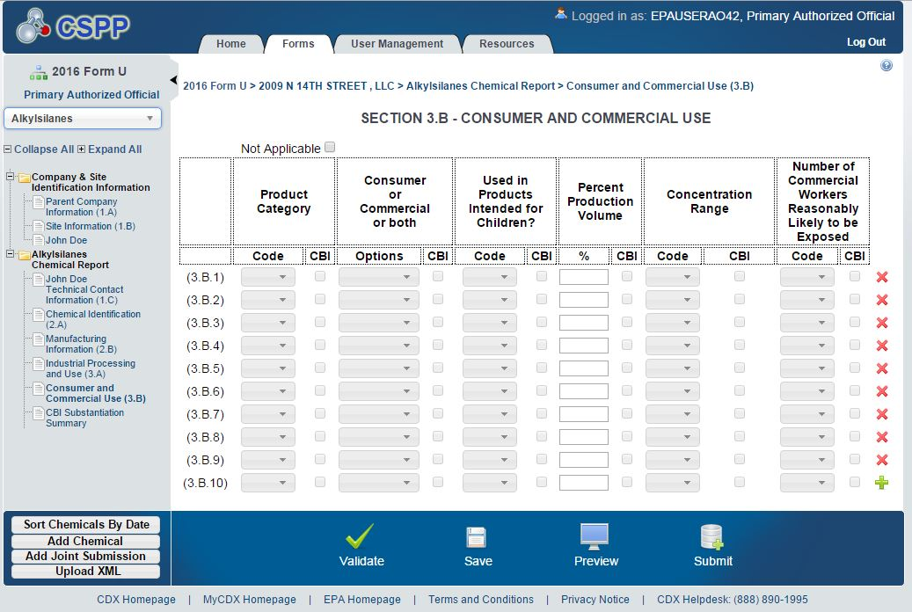

Product Category

You must designate up to ten product categories which correspond to the actual use of the chemical substance by selecting from the drop down box the codes which correspond to the appropriate product categories (40 CFR 711.15(b)(4)(ii)(A)). The reporting tool will allow you to enter more than ten categories if you choose to do so. Table 4-15 shows the codes and product categories which appear in the drop down box.

If you select C909 (Other), you must provide a description of the product category. If more than ten codes apply, you need report only the ten codes for the chemical substance that cumulatively represent the largest percentage of production volume, measured by weight (40 CFR 711.15(b)(4)(ii)(A)).

Table 4-15. Product Category Codes

Code | Description
Chemical Substances in Furnishing, Cleaning, Treatment/Care Product
C101 | Floor coverings
C102 | Foam seating and bedding products
C103 | Furniture and furnishings not covered elsewhere
C104 | Fabric, textile, and leather products not covered elsewhere
C105 | Cleaning and furnishing care products
C106 | Laundry and dishwashing products
C107 | Water treatment products
C108 | Personal care products
C109 | Air care products
C110 | Apparel and footwear care products
Chemical Substances in Construction, Paint, Electrical, and Metal Products
C201 | Adhesives and sealants
C202 | Paints and coatings
C203 | Building/construction materials - wood and engineered wood products
C204 | Building/construction materials not covered elsewhere
C205 | Electrical and electronic products
C206 | Metal products not covered elsewhere
C207 | Batteries
Chemical Substances in Packaging, Paper, Plastic, Hobby Products
C301 | Food packaging
C302 | Paper products
C303 | Plastic and rubber products not covered elsewhere
C304 | Toys, playground, and sporting equipment
C305 | Arts, crafts, and hobby materials
C306 | Ink, toner, and colorant products
C307 | Photographic supplies, film, and photochemicals
Chemical Substances in Automotive, Fuel, Agriculture, Outdoor Use Products
C401 | Automotive care products

Code | Description
C402 | Lubricants and greases
C403 | Anti-freeze and de-icing products
C404 | Fuels and related products
C405 | Explosive materials
C406 | Agricultural products (non-pesticidal)
C407 | Lawn and garden care products
Chemical Substances in Products not Described by Other Codes

C980 | Non-TSCA use
C909 | Other (specify)

Consumer and/or Commercial Use

For each Product Category reported, select from the drop down box in the “Consumer and/or Commercial” column in Part III.B of Form U the options to indicate whether the use is a consumer use or a commercial use (40 CFR 711.15b)(4)(ii)(B). If the product has both consumer and commercial uses, select both options.

Use in Product(s) Intended for Use by Children

Within each consumer product category reported, you must determine whether any amount of each reportable chemical substance manufactured (including imported) by you is present in or on any consumer product(s) intended for use by children age 14 or younger, regardless of the concentration of the chemical substance remaining in or on the product (40 CFR 711.15(b)(4)(ii)(C)). If you determine that your chemical substance or mixture is used in a consumer product intended for use by children, select “Yes” from the drop down box in the “Used in Product(s) Intended for Children” column in Part III.B of Form U. If you determine that your chemical substance or mixture is not used in a consumer product intended for use by children, select “No” from the drop down box. If information as to whether the chemical substance is used in or on any consumer products intended for use by children is not known to or reasonably ascertainable by you, select “NKRA” from the drop down box. If your chemical substance is not used in products intended for use by children (i.e., you answered ‘No’ in Part III.B), you are encouraged not to claim the information as confidential.

EPA defines “intended for use by children” to mean the chemical substance or mixture is used in or on a product that is specifically intended for use by children age 14 or younger (40 CFR 711.3). Your chemical substance or mixture is intended for use by children if you answer “yes” to at least one of the following questions about the product into which your chemical substance or mixture is incorporated:

- Is the product commonly recognized (i.e., by a reasonable person) as being intended for use by children age 14 or younger?

- Does the manufacturer of the product state through product labeling or other written materials that the product is intended or will be used by children age 14 or younger?

- Is the advertising, promotion, or marketing of the product aimed at children age 14 or younger?

Table 4-16 illustrates some examples of “Use in Product(s) Intended for Use by Children.” For example, certain products (e.g., crayons, coloring books, diapers, and toy cars) are typically used by children age 14 or younger. If you determine that your chemical substance or mixture is used in crayons, for example, you would report “Y” for children’s use for C305.

Certain products, such as household cleaning products, automotive supplies, and lubricants, typically are not intended to be used by children age 14 or younger. As such, if you determine that your chemical substance or mixture is used in automotive care products and lubricants, for example, you would report “no” for children’s use for categories C401 and C402.

Table 4.16. Examples of Products Intended for Use by Children
Codes | Category | Examples
Chemical Substances in Furnishings, Cleanings, Treatment/Care Products
C102 | Foam seating and bedding products | Child’s car seat, children’s sheets
C103 | Furniture and furnishings not covered elsewhere | Baby cribs, changing tables
C104 | Fabrics, textile, and leather products not covered elsewhere | Children’s clothing
C108 | Personal care products | Baby shampoo, children’s bubble bath
Chemical Substances in Construction, Paint, Electrical and Metal Products
C201 | Adhesives and sealants | Craft glue, model glue
C202 | Paints and coatings | Finger paints, water colors intended for use by children
C205 | Electrical and electronic products | Electronic games, remote control cars
Chemical Substances in Packaging, Paper, Plastic, Hobby Products
C302 | Paper products | Diapers, baby wipes, coloring books
C303 | Plastic and rubber products not covered elsewhere | Pacifiers
C304 | Toys, playground, and sporting equipment | Toy trucks, dolls, toy cars, wagons, action figures, balls, swing sets, slides, skates, baseball gloves
C305 | Arts, Crafts, and Hobby Materials | Chemicals used as colorants in crayons, coloring inks, markers
Chemical Substances in Automotive, Fuel, Agriculture, Outdoor Use Products
C407 | Lawn and garden products | Lawn and gardening tools designed specifically for children (e.g., kids rake)
C909 | Other (specify) | Other items specifically intended for use by children age 14 or younger

Percentage of Production Volume

Estimate the percentage of your production volume that is attributable to each specific consumer and commercial end use carried out at sites under your control, as well as at sites that receive a reportable chemical substance from you either directly or indirectly (including through a broker/distributor, from a customer, etc.), to the extent that such information is known to or reasonably ascertainable to you (40 CFR 711.15(b)(4)(ii)(D)). You should round estimates to the nearest ten percent of production volume (40 CFR 711.15(b)(4)(ii)(D)). If you would like to provide more specific percentages, please do so. You may not round a consumer and commercial product category that accounts for five percent or less of the total production volume attributable to that consumer and commercial product category is greater than or equal to 25,000 lb. (40 CFR 711.15(b)(4)(ii)(D). In such cases, you must report the percentage of production volume attributable to that consumer and commercial product category to the nearest one percent of the production volume (40 CFR 711.15(b)(4)(ii)(D).

Note that the total percentage of production volumes reported may add up to more or less than 100 percent. Rounding to the nearest ten percent can result in summed percentages either above or below 100 percent. Additionally, the total percentage of production volume may add up to less than 100 percent if, for example:
How to determine your percent production volume:

1. Determine the production volume that is attributable to each consumer and commercial end use.
2. Determine your total production volume for 2015.
a. Add together the volume domestically
manufactured and the volume imported.
b. DO NOT subtract the volume used on-site or the volume exported
3. Divide the volume determined in step 1 by the volume determined in step 2 and multiply by 100.

- You do not know or cannot reasonably ascertain information about how all your production volume is used in consumer and commercial products;
- More than ten commercial or consumer product categories are applicable to your chemical substance; or
- A portion of your production is consumed in industrial uses or exported.

Maximum Concentration Code

When the chemical substance you manufacture (including import) is used in commercial or consumer products, you are required to report the estimated typical maximum concentration (measured by weight) of each chemical substance in each commercial or consumer product category reported in Part III of Form U (40 CFR 711.15(b)(4)(ii)(E)). For each chemical substance used in a reported commercial or consumer product, select from the drop down box the code that corresponds to the appropriate concentration range. Table 4-7 shows the codes and concentration ranges which appear in the drop down box.

Number of Commercial Workers Code

Report the total number of commercial workers, including those at sites not under your control that are reasonably likely to be exposed while using the reportable chemical substance, with respect to each commercial use (40 CFR 711.15(B)(4)(II)(F)). For each chemical substance with a commercial use reported in Part III, select code which corresponds to the appropriate range of commercial workers reasonably likely to be exposed. Table 4-14 shows the code and worker ranges which appear in the drop down box.

“Reasonably likely to be exposed” means “an exposure to a chemical substance which, under foreseeable conditions of manufacture (including import), processing, distribution in commerce, or use of the chemical substance, is more likely to occur than not to occur. Such exposures would normally include, but would not be limited to, activities such as charging reactor vessels, drumming, bulk loading, cleaning equipment, maintenance operations, materials handling and transfers, and analytical operations. Such exposures also include commercial worker exposure during the use phase which could include but is not limited to using cleaning products, paints, dry cleaning solvents, and adhesives. Covered exposures include exposures through any route of entry (inhalation, ingestion, skin contact, absorption, etc.), but excludes accidental or theoretical exposures” (40 CFR 711.3).

Persons reasonably likely to be exposed to a chemical substance include workers whose employment requires them to pass through areas where chemical substances are processed or used (e.g., production workers and foremen, process engineers, and plant managers). Workers employed to drive vehicles that transport the chemical substances should be included in the number of workers reasonably likely to be exposed to the chemical substance if they come into contact with the chemical substance during loading or unloading. For example, workers engaged in the connection or disengagement of hoses used to load or unload the chemical substance should be included. However, workers involved solely with transporting chemical substances in sealed (totally enclosed with no potential for exposure) containers should not be included. Similarly, workers employed during the use phase at sites not under your control such as workers that provide commercial cleaning services, painting, dry cleaning, and repairs should be included in the number of workers reasonably likely to be exposed to the chemical substance.

In addition, when a site employs temporary, seasonal, or contract workers in the processing or use of a reportable chemical substance, these workers should be included in the number of workers reasonably likely to be exposed to a chemical substance if they work in areas where the chemical substance is processed or used. The term does not include those employees whose jobs are unassociated with potential exposures to a chemical substance or mixture (e.g., administrative staff who never enter areas where the chemical substance is manufactured) and who are unlikely to be exposed to a chemical substance for even a brief period of time. No allowance is made for personal protective equipment or for engineering controls that reduce but do not preclude exposure to a chemical substance; however, if contact between a worker and a chemical substance is highly improbable, the worker should not be included among those persons reasonably likely to be exposed to the chemical substance.

Part IV – Joint Submissions

Need for a Joint Submission

Joint submissions are allowed only in those instances where a supplier will not disclose to the manufacturer (including importer) the specific chemical name of the imported chemical substance or of a reactant used to manufacture a chemical substance, because the supplier claims the specific chemical name is confidential.

This may happen, for instance, when a company is importing a mixture under a trade name, and the foreign manufacturer refuses to reveal the chemical identity of a confidential component of the mixture. In this case, the importer and the supplier can jointly report the information through a joint submission. The importer must ask the supplier of the confidential chemical substance to directly provide EPA with the correct chemical identity in Part IV of Form U (see 40 CFR 711.15(b)(3)(i)(A)).

This may also happen in the event a manufacturer cannot provide the entire chemical identity of a chemical substance it manufactures because the chemical substance is manufactured using a reactant having a specific chemical identity that the reactant supplier claims as confidential and will not reveal to the manufacturer. In this case, the manufacturer and the supplier of the reactant can jointly report the information through a joint submission. The manufacturer must submit a report directly to EPA containing all information he or she knows or can reasonably ascertain about the chemical identity. Furthermore, the manufacturer must also ask the reactant supplier to directly provide to EPA the correct chemical identity of the confidential reactant in Part IV of Form U (see 40 CFR 711.15(b)(3)(i)(B)). More detailed instructions for completing a joint submission can be found in the e-CDRweb user guides.

A manufacturer (including importer) can identify, on a chemical-by-chemical basis, the supplier for a chemical substance. A site may have different suppliers for different chemical substances in its submission. The e-CDRweb tool will generate a unique ID number for each chemical substance (identified by a trade name). Therefore, a supplier may receive multiple ID numbers from a manufacturer (including importer). A supplier may also report multiple chemical substances under one ID number in the case that the ID number refers to a mixture. In that situation, the supplier will be identifying the chemical substances that comprise the mixture.

Because signatures are required by each party of a joint submission, they must each register with CDX, and complete their own sections of the same Form U report. (See separate Instructions documents for electronic reporting). The reporting tool will match both submissions based upon the unique ID number sent by the manufacturer (including importer) to notify the supplier of the partial CDR submission. Suppliers do not have access to any of the information submitted to EPA by the manufacturer. Likewise, manufacturers cannot see the information that the supplier reports to EPA. This way, the confidentiality of information for all submitters is protected. The information provided by both submitters will be combined and processed as one joint submission once they are received by EPA.

NOTE: In the event that a manufacturer (including importer) actually knows or can reasonably ascertain the chemical identity (e.g., the CASRN or Accession Number) of a chemical substance subject to CDR reporting, the manufacturer (including importer) must provide that information irrespective of a supplier’s confidentiality claims. If such a primary submitter wishes to claim the chemical identity as confidential, to do so it must check the CBI box and provide upfront substantiation as described in 4.6.1 of this chapter.

Submitting as a Manufacturer (including Importer) or Primary Submitter

If you are a manufacturer (including importer), as primary submitter, you should:

1. Register with CDX. See separate instructions on CDX registration.

2. Complete Parts II and III of Form U for all your reportable chemical substances as described earlier in this chapter. If you would like to create a joint submission, you can add one or more joint submission folders (one for each trade product) for each reportable chemical substance supplied to you by clicking the “Add Joint Submission” button from the bottom Action Bar. A new Joint Submission Report folder will be created in the left Navigation Tree.

Part II- Section A: Chemical Identification -- Joint Submission Information (Blocks 2.A.5 through 2.A.12)

You can access the Joint Submission Section 2A—Chemical Identification screen using the “Chemical Identification (2.A)” link in the Navigation Tree. The screen will display “Section 2.A – Chemical Identification (Joint Submissions Information).” Enter the trade name or another name to identify the proprietary mixture, and your secondary submitter's company name and complete mailing address. You may provide additional information about the trade name product (e.g., chemical substances that you know are components of the trade name product) in Block 2.A.6.

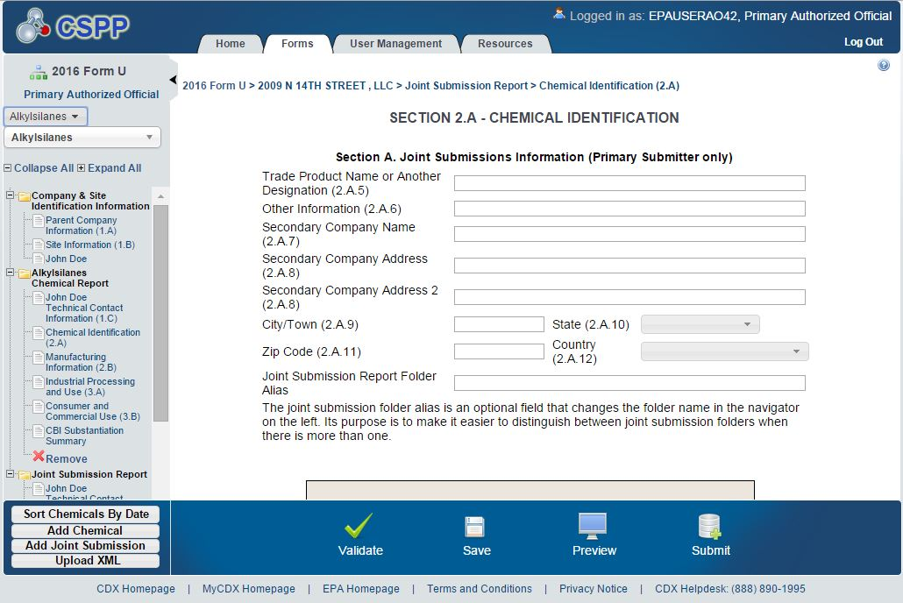

Follow the instructions in the box labeled “Unique Identifier for Joint Submission” to communicate with the secondary submitter via email. The tool will generate an email with a unique ID number and language that you can use to notify your secondary submitter of the partial CDR submission containing information for the trade name product. The ID number will be used to link the joint reports in an internal database. The email will request that the secondary submitter report the correct chemical identity information to EPA using e-CDRweb and refer them to the CDR web site (http://www.epa.gov/cdr) for information on registering with CDX and completing Part IV of Form U. You can indicate whether you would like the tool to send a copy of your email to EPA, thereby providing a record of the request to the secondary submitter.

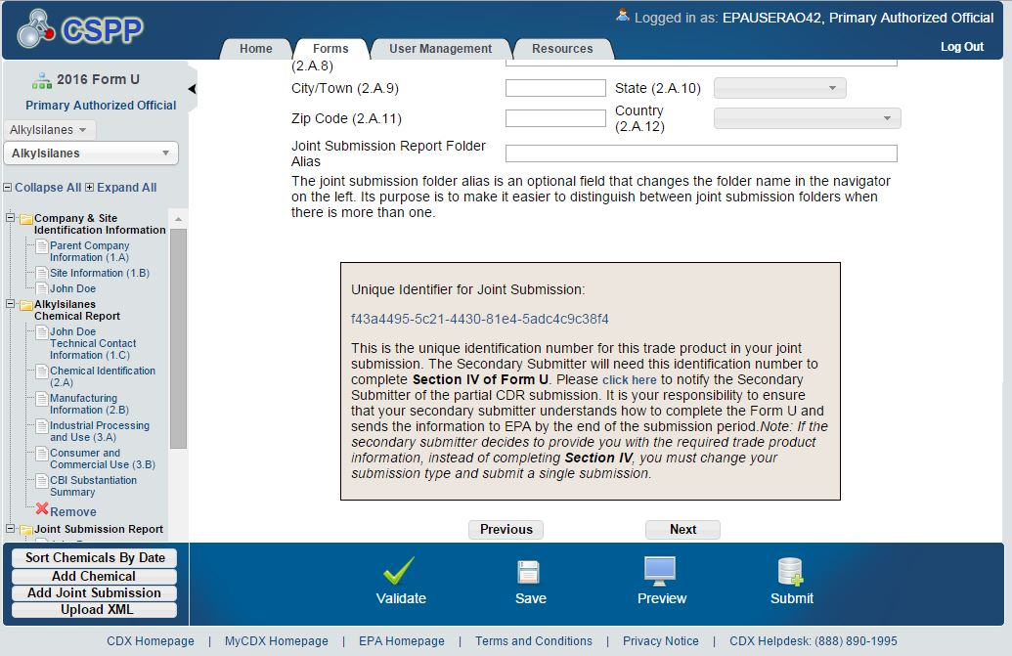

Part II-Section B: Manufacturing Information (Blocks 2.B.1 through 2.B.20)

You can access the Section 2.B. – Manufacturing Information screen by clicking the “Manufacturing Information (2.B)” link in the Navigation Tree. Enter the manufacturing information for the proprietary chemical substance as described in Section 4.7 of this chapter.

Part III: Processing and Use Information (Blocks 3.A.1 through 3.B.10)

You can access the Section 3.A. – Industrial Processing and Use screen and the Section 3.B – Consumer and Commercial Use screen by clicking on their respective links in the Navigation Tree. Enter the processing and use information for the proprietary chemical substance as described in Chapter 4.8 of this document.

3. Submit the form to EPA via CDX. Please verify that all fields are correct on the preview screen.

4. It is your responsibility to ask your supplier, or secondary submitter, to complete Part IV of Form U and send the information to EPA by the end of the submission period. It is also your responsibility to include a copy of your request to your secondary submitter with the portion of the Form U that you send to EPA. Using the reporting tool, a copy of record will be available to the primary and the secondary submitters after EPA receives each portion of a joint submission. If the secondary submitter decides to provide you directly with the required trade name product information, you should change your submission type and submit a single submission.

Submitting as a Supplier, as a Secondary or Tertiary Submitter

Secondary and Tertiary Submitters

In most cases, the supplier will manufacture the chemical substance being supplied to the manufacturer and will therefore be able to provide EPA with the information requested in Part IV of Form U. In this case, the supplier will be the secondary submitter.

However, there may be instances where a foreign supplier purchases a mixture, under a trade name, from another company (tertiary company) and does not know the chemical components of the mixture. The foreign supplier can ask the company manufacturing the trade secret mixture or chemical substance to directly provide EPA with the correct chemical identity in Part IV of Form U. In this case, the tertiary company would register with CDX and use the Unique Identifier for Joint Submissions, sent to the foreign supplier by the manufacturer (including importer), to complete Part IV of Form U.

The foreign supplier does not have access to any of the information submitted to EPA by the tertiary company. Likewise, the tertiary company cannot see the information the foreign supplier reports to EPA. This way, the confidentiality of information for both the foreign supplier and tertiary company is protected.

The supplier, whether a secondary submitter or a tertiary submitter, should:

1. Register with CDX. See separate instructions on registering with CDX.

2. Complete Part IV of Form U.

Section A: Company Information (Blocks 4.A.1 through 4.A.8)

Your company information (domestic or foreign company name and mailing address) provided during CDX registration will populate Section A. Please double check this information to ensure all required fields are complete and accurate.

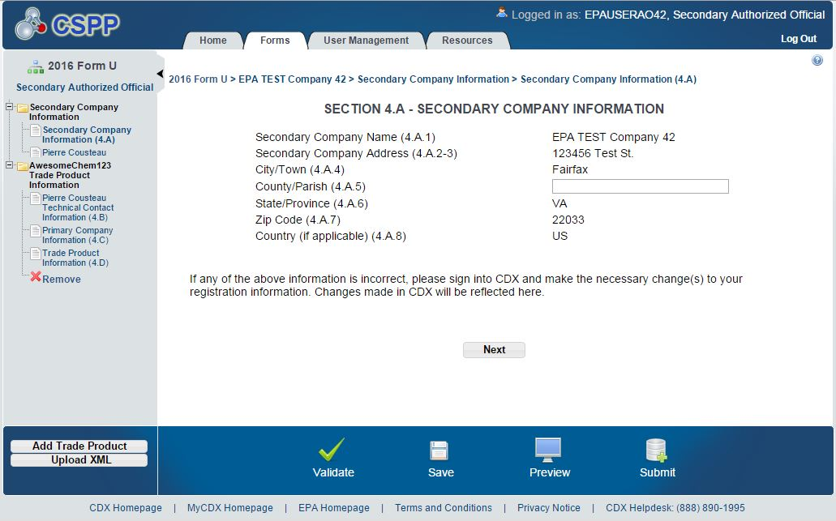

Section B: Technical Contact Information (Blocks 4.B.1 through 4.B.10)

You are responsible for designating a technical contact for your company. Enter the technical contact information as described Section 4.5 of this document.

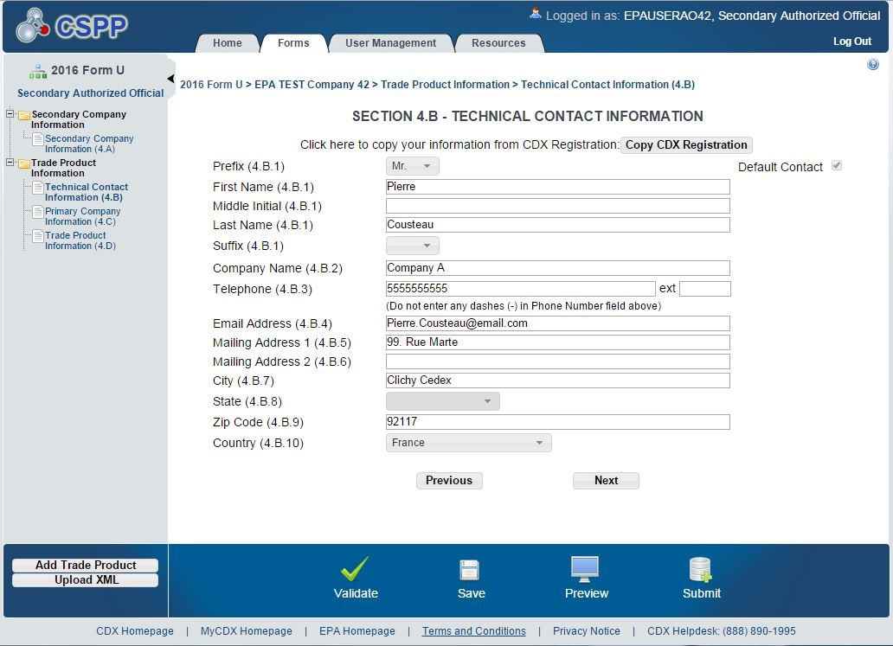

Section C: Primary Company Information

Enter the Unique Identifier for Joint Submissions number provided to you by the manufacturer (including importer). Click the “Populate” button to generate the trade product name provided by the manufacturer (including importer). Verify the information and click the “Next” button to enter the information to identify the chemical substance.

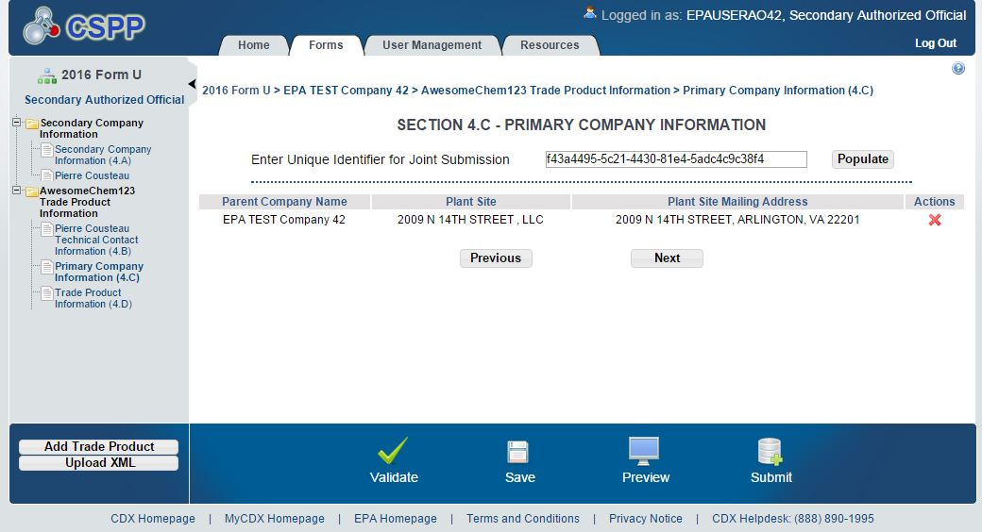

Section D: Trade Product Identification Information

In this section of the Form U, enter your trade product name (which may be different than the name provided by the primary submitter) and the chemical composition of the product.

Step 1: Enter the trade product name used to identify the chemical substance in Box 4.D.1.

Step 2: In Section 4.D.2, click on the magnifying glass under the “Action” column and select the correct CA Index Name and CASRN for the chemical substance from the SRS.

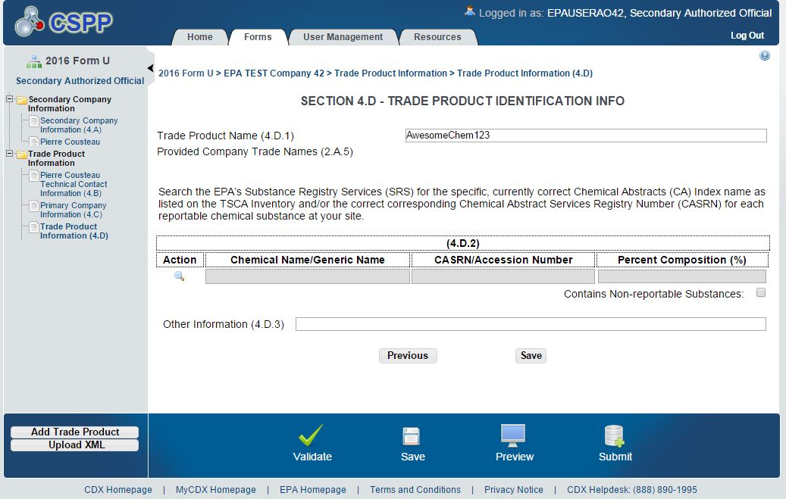

The reporting tool is directly linked to the non-confidential portion of the TSCA Inventory through the SRS database, which lists all chemical substances on the TSCA Inventory. Most chemical substances are identified by CA Index Name and CASRN. Chemical substances listed on the confidential portion of the TSCA Inventory are identified in SRS using a TSCA Accession Number and generic name.

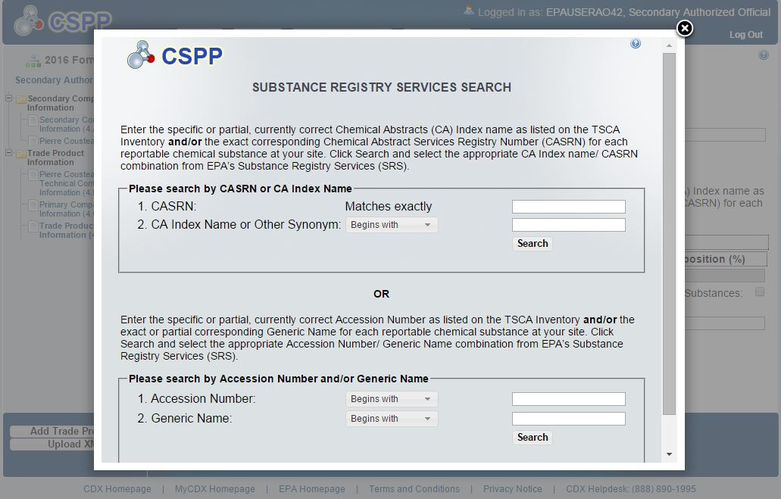
In the case of a chemical substance listed on the confidential portion of the TSCA Inventory, a secondary or tertiary submitter does not need to claim the underlying chemical identity CBI or provide upfront substantiation. For such a chemical substance, EPA will presume that the chemical identity associated with the Accession Number is subject to a confidentiality claim when it is reported by a secondary or tertiary submitter. See the next section for more information on reporting a chemical substance listed on the confidential portion of the TSCA Inventory. In addition, EPA will presume that the information reported in Section 4.D. of Form U, and the connection between the chemical identity and the primary company associated with the joint submission, is subject to a confidentiality claim when it is reported by a secondary submitter. Likewise, EPA will presume that the information reported in Section 4.D. of Form U, and the connection between the chemical identity and the secondary company associated with the joint submission, is subject to a confidentiality claim when it is reported by a tertiary submitter.

Step 3: Enter the percent composition of each component chemical substance of the trade name product or mixture.

Step 4: You may provide additional information associated with the chemical substance in Block 4.D.3.

Submit the file to EPA via CDX. Please verify that all fields are correct on the preview screen.

Reporting a Confidential Chemical Substance

In the case of confidential chemical substances, report the TSCA Accession Number (the generic name corresponding to the Accession Number will automatically be incorporated into your report). Submitters who, in the past, have reported using the PMN case number of a confidential chemical substance can identify the Accession Number from the SRS by searching on the PMN case number. In the SRS, a submitter can readily find a cross-reference list that displays the Accession Number, generic chemical name, and the PMN case number (or for an initial TSCA Inventory chemical substance, the TSCA Inventory reporting form number) for any confidential chemical substance listed on the TSCA Inventory. Please note that a generic name often is not specific to a given TSCA Inventory chemical substance and may be used to represent multiple specific chemical identities. The TSCA Accession Number, however, is unique to the specific confidential chemical substance.

Submitters who are not able to identify the Accession Number by searching the SRS should contact EPA, in writing or via fax on company letterhead, well before initiating CDR reporting to obtain the Accession Number assigned when the Notice of Commencement (NOC) was submitted to the Agency. Individuals are urged to submit a complete and accurate TSCA Inventory Correspondence via fax or by U.S. mail at least one month before the submission deadline. Note that incomplete and/or inaccurate requests may be rejected. The Agency will respond to such inquiries in as timely a manner as possible. It is the responsibility of the submitter to contact the Agency for such information in sufficient time to allow for the Agency to respond.

Please send requests for a TSCA Accession Number as soon as possible to:

By Fax: 202-564-9538

By U.S. Postal Service:
U.S. Environmental Protection Agency Office of Pollution Prevention and Toxics Document Control Office (7407M)
1200 Pennsylvania Ave, NW Washington, DC 20460
By Hand Delivery or Courier:
U.S. Environmental Protection Agency Office of Pollution Prevention and Toxics Confidential Business Information Center EPA East Building, Room 6428
1201 Constitution Ave, NW Washington, DC 20004
202-564-8930; 202-564-8940

How to Obtain Copies of Documents Cited in This Instructions Document

Obtaining Copies of the TSCA Rules
The CDR rule, 40 CFR Part 711, is available on the internet at the following address: http://www.access.gpo.gov/nara/cfr/waisidx_05/40cfr710_05.html

You may also contact the TSCA Hotline by telephone at (202) 554-1404 or by email tsca-hotline@epa.gov for assistance.

Obtaining Copies of the Public Portion of the TSCA Inventory
Information on how to access the non-confidential version of the TSCA Inventory and help using the files is available on EPA’s website at http://www.epa.gov/oppt/existingchemicals/pubs/tscainventory/howto.html.

Obtaining Copies of Other Information Materials for the 2016 CDR
EPA has developed several documents to provide additional information on submitting information for the 2016 CDR. All materials are available on the “How To Report Under Chemical Data Reporting” page of the CDR website at http://www2.epa.gov/chemical-data-reporting/how-report-under-chemical-data-reporting.

User Guides:
- Instructions on CDX registration
- e-CDRweb user guides

2016 Chemical Data Reporting Frequently Asked Questions

Online Training Modules
- Module 1: New Requirements for 2016 CDR
- Module 2: Reporting Requirements for the 2016 CDR
- Module 3: Completing Form U for 2016
- Module 4: Registering with CDX for CDR Reporting
- Module 5: Using the e-CDRweb Reporting Tool
- Module 6: Joint Submissions
- Module 7: Byproduct Chemical Substances

Fact Sheets:
- Reporting Thresholds for 2016
- Chemical Substances which are the Subject of Certain TSCA Actions
- Reporting After Changes to Company Ownership or Legal Identity
- Importers
- Imported Articles

Appendix A

Glossary

The definitions and descriptions of terms used in CDR reporting provided below are taken from 40 CFR Part 711 unless otherwise noted.

Act means the Toxic Substances Control Act, 15 U.S.C. 2601 et seq.

Administrator means the Administrator of the U.S. Environmental Protection Agency. (See TSCA 3(1))

Article means a manufactured item (1) which is formed to a specific shape or design during manufacture, (2) which has end-use function(s) dependent in whole or in part upon its shape or design during end use, and (3) which has either no change of chemical composition during its end use or only those changes of composition which have no commercial purpose separate from that of the article, and that result from a chemical reaction that occurs upon end use of other chemical substances, mixtures, or articles; except that fluids and particles are not considered articles regardless of shape or design. (40 CFR 704.3)

Byproduct means a chemical substance produced without separate commercial intent during the manufacture, processing, use, or disposal of another chemical substance(s) or mixture(s). (40 CFR 704.3)

Central Data Exchange (CDX) means EPA's centralized electronic document receiving system, or its successors, including associated instructions for registering to submit electronic documents.

Chemical substance means any organic or inorganic substance of a particular molecular identity, including any combination of such substances occurring in whole or in part as a result of a chemical reaction or occurring in nature, and any chemical element or uncombined radical. “Chemical substance” does not include:
(1) Any mixture;
(2) Any pesticide (as defined in the Federal Insecticide, Fungicide, and Rodenticide Act) when manufactured, processed, or distributed in commerce for use as a pesticide;
(3) Tobacco or any tobacco product;
(4) Any source material, special nuclear material, or byproduct material (as such terms are defined in the Atomic Energy Act of 1954 and the regulations issued under such Act);
(5) Any article the sale of which is the subject to the tax imposed by section 4181 of the Internal Revenue Code of 1954 (determined without regard to any exemptions from such tax provided by section 4182 or 4221 or any other provision of such Code); and
(6) Any food, food additive, drug, cosmetic, or device (as such terms are defined in section 201 of the Federal Food, Drug, and Cosmetic Act) when manufactured, processed, or distributed in commerce for use as a food, food additive, drug, cosmetic, or device. (See TSCA 3(2))

Commerce means trade, traffic, transportation, or other commerce: (A) between a place in a State and any place outside of such State, or (B) which affects trade, traffic, transportation, or commerce described in clause (A). (TSCA 3(3))

Commercial use means the use of a chemical substance or a mixture containing a chemical substance (including as part of an article) in a commercial enterprise providing saleable goods or services.

Consumer use means the use of a chemical substance or a mixture containing a chemical substance (including as part of an article) when sold to or made available to consumers for their use.

Customs territory of the United States, as referenced in TSCA section 3 and defined in general note 2 of the Harmonized Tariff Schedule of the United States, includes only the States, the District of Columbia, and Puerto Rico.

Distribute in commerce and distribution in commerce, when used to describe an action taken with respect to a chemical substance or mixture or article containing a substance or mixture mean to sell, or the sale of, the substance, mixture, or article in commerce; to introduce or deliver for introduction into commerce, or the introduction or delivery for introduction into commerce of, the substance, mixture, or article; or to hold, or the holding of, the substance, mixture, or article after its introduction into commerce. (TSCA 3(4))

e-CDRweb means the electronic, web-based tool provided by EPA for the completion and submission of the CDR Form U report.

EPA means the United States Environmental Protection Agency. (40 CFR 704.3)

Importer means
(1) any person who imports any chemical substance or any chemical substance as part of a mixture or article into the customs territory of the United States, and includes:
(i) the person primarily liable for the payment of any duties on the merchandise, or
(ii) an authorized agent acting on his/her behalf.
(2) Importer also includes, as appropriate:
(i) The consignee.
(ii) The importer of record.
(iii) The actual owner if an actual owner's declaration and superseding bond have been filed in accordance with 19 CFR 141.20.
(iv) The transferee, if the right to draw merchandise in a bonded warehouse has been transferred in accordance with subpart C of 19 CFR part 144.
(3) For the purposes of this definition, the customs territory of the United States consists of the 50 States, Puerto Rico, and the District of Columbia. (40 CFR 704.3)

Impurity means a chemical substance which is unintentionally present with another chemical substance. (40 CFR 704.3)

Industrial function means the intended physical or chemical characteristic for which a chemical substance or mixture is consumed as a reactant; incorporated into a formulation, mixture, reaction product, or article; repackaged; or used.

Industrial use means use at a site at which one or more chemical substances or mixtures are manufactured (including imported) or processed.

Intended for use by children means the chemical substance or mixture is used in a product that is specifically intended for use by children age 14 or younger. A chemical substance or mixture is intended for use by children when the submitter answers “yes” to at least one of the following questions for the product into which the submitter’s chemical substance or mixture is incorporated:
(1) Is the product commonly recognized (i.e., by a reasonable person) as being intended for children age 14 or younger?
(2) Does the manufacturer of the product state through product labeling or other written materials that the product is intended or will be used by children age 14 or younger?
(3) Is the advertising, promotion, or marketing of the product aimed at children age 14 or younger?

Intermediate means any chemical substance that is consumed, in whole or in part, in chemical reactions used for the intentional manufacture of other chemical substances or mixtures, or that is intentionally present for the purpose of altering the rates of such chemical reactions. (40 CFR 704.3)

Known to or reasonably ascertainable by means all information in a person’s possession or control, plus all information that a reasonable person similarly situated might be expected to possess, control, or know. (40 CFR 704.3)

Manufacture means to manufacture, produce, or import for commercial purposes. Manufacture includes the extraction, for commercial purposes, of a component chemical substance from a previously existing chemical substance or complex combination of substances. When a chemical substance, manufactured other than by import, is: (1) produced exclusively for another person who contracts for such production, and (2) that other person specifies the identity of the chemical substance and controls the total amount produced and the basic technology for the plant process, then that chemical substance is co-manufactured by the producing manufacturer and the person contracting for such production.

Manufacturer means a person who manufactures a chemical substance.

Manufacture for commercial purposes means: (1) to import, produce, or manufacture with the purpose of obtaining an immediate or eventual commercial advantage for the manufacturer, and includes among other things, such “manufacture” of any amount of a chemical substance or mixture:
(i) For commercial distribution, including for test marketing.
(ii) For use by the manufacturer, including use for product research and development, or as an intermediate.

(2) Manufacture for commercial purposes also applies to substances that are produced coincidentally during the manufacture, processing, use, or disposal of another substance or mixture, including both byproducts that are separated from that other substance or mixture and impurities that remain in that substance or mixture. Such byproducts and impurities may, or may not, in themselves have commercial value. They are nonetheless produced for the purpose of obtaining a commercial advantage since they are part of the manufacture of a chemical product for a commercial purpose. (40 CFR 704.3)

Master Inventory File means EPA's comprehensive list of chemical substances which constitute the Chemical Substances Inventory compiled under section 8(b) of the Act. It includes substances reported under Part 710 of this chapter and substances reported under Part 720 of this chapter for which a Notice of Commencement of Manufacture or Import has been received under §720.120 of this chapter.

Microorganism means any combination of chemical substances that is a living organism and that meets the definition of microorganism at 40 CFR 725.3. Any chemical substance produced from a living microorganism is reportable under the CDR regulation unless otherwise excluded.

Mixture means any combination of two or more chemical substances if the combination does not occur in nature and is not, in whole or in part, the result of a chemical reaction; except that such term does include any combination which occurs, in whole or in part, as a result of a chemical reaction if none of the chemical substances comprising the combination is a new chemical substance and if the combination could have been manufactured for commercial purposes without a chemical reaction at the time the chemical substances comprising the combination were combined. (TSCA 3(8))

Naturally occurring substance is any chemical substance which is naturally occurring and: (1) which is (i) unprocessed or (ii) processed only by manual, mechanical, or gravitational means, by dissolution in water, by flotation, or by heating solely to remove water; or (2) which is extracted from air by any means. (40 CFR 710.4(b))

Non-isolated intermediate means any intermediate that is not intentionally removed from the equipment in which it is manufactured, including the reaction vessel in which it is manufactured, equipment which is ancillary to the reaction vessel, and any equipment through which the substance passes during a continuous flow process, but not including tanks or other vessels in which the substance is stored after its manufacture. (40 CFR 704.3)

Person means any individual, firm, company, corporation, joint venture, partnership, sole proprietorship, association, or any other business entity; any State or political subdivision thereof, or any municipality; any interstate body; and any department, agency, or instrumentality of the Federal government. (40 CFR 704.3)

Polymer means any chemical substance described with the word fragments “*polym*”, “*alkyd”, or “oxylated” in the Chemical Abstracts (CA) Index Name in the Master Inventory File, where the asterisk (*) in the listed word fragments indicates that any sets of characters may precede, or follow, the character string defined. Polymers also include any chemical substance which is identified in the Master Inventory File as siloxane(s) and silicone(s), silsesquioxane(s), a protein (albumin, casein, gelatin, gluten, hemoglobin), an enzyme, a polysaccharide (starch, cellulose, or gum), rubber, or lignin. The polymer exclusion does not apply to a polymeric

substance that has been hydrolyzed, depolymerized, or otherwise chemically modified, except in cases where the intended product of this reaction is totally polymeric in structure.

Principal reporting year means the latest complete calendar year preceding the submission period.

Process means to process for commercial purposes. (40 CFR 704.3)

Process for commercial purposes means the preparation of a chemical substance or mixture after its manufacture for distribution in commerce with the purpose of obtaining an immediate or eventual commercial advantage for the processor. Processing of any amount of a chemical substance or mixture is included in this definition. If a chemical substance or mixture containing impurities is processed for commercial purposes, then the impurities also are processed for commercial purposes. (40 CFR 704.3)

Processor means any person who processes a chemical substance or mixture. (40 CFR 704.3)

Reasonably likely to be exposed means an exposure to a chemical substance which, under foreseeable conditions of manufacture (including import), processing, distribution in commerce, or use of the chemical substance, is more likely to occur than not to occur. Such exposures would normally include, but would not be limited to, activities such as charging reactor vessels, drumming, bulk loading, cleaning equipment, maintenance operations, materials handling and transfers, and analytical operations. Covered exposures include exposures through any route of entry (inhalation, ingestion, skin contact, absorption, etc.), but excludes accidental or theoretical exposures.

Repackaging means the physical transfer of a chemical substance or mixture, as is, from one container to another container or containers in preparation for distribution of the chemical substance or mixture in commerce.

Reportable chemical substance means a chemical substance described in §711.5.

Site means a contiguous property unit. Property divided only by a public right-of-way shall be considered one site. More than one plant may be located on a single site.

(a) For chemical substances manufactured under contract, i.e., by a toll manufacturer, the site is the location where the chemical substance is physically manufactured.

(b) The site for an importer who imports a chemical substance described in §711.5 is the U.S. site of the operating unit within the person's organization that is directly responsible for importing the substance. The import site, in some instances, may be the organization's headquarters in the United States. If there is no such operating unit or headquarters in the United States, the site address for the importer is the United States address of an agent acting on behalf of the importer who is authorized to accept service of process for the importer.
(c) For portable manufacturing units sent out to different locations from a single distribution center, the distribution center shall be considered the site.

Site-limited means a chemical substance is manufactured and processed only within a site and is not distributed for commercial purposes as a substance or as part of a mixture or article outside the site. Imported substances are never site-limited. Although a site-limited chemical substance is not distributed for commercial purposes outside the site at which it is manufactured and processed, the substance is considered to have been manufactured and processed for commercial purposes.

Small quantities solely for research and development (or “small quantities solely for purposes of scientific experimentation or analysis or chemical research on, or analysis of, such substance or another substance, including such research or analysis for the development of a product”) means quantities of a chemical substance manufactured, imported, or processed or proposed to be manufactured, imported, or processed solely for research and development that are no greater than reasonably necessary for such purposes. (40 CFR 704.3)

State means any State of the United States, the District of Columbia, the Commonwealth of Puerto Rico, the Virgin Islands, Guam, the Canal Zone, American Samoa, the Northern Mariana Islands, or any other territory or possession of the United States. (TSCA 3(13))

Submission period means the period in which manufacturing, processing, and use data are submitted to EPA.

Test marketing means the distribution in commerce of no more than a predetermined amount of chemical substance, mixture, or article containing that chemical substance or mixture, or a mixture containing that substance, by a manufacturer or processor, to no more than a defined number of potential customers to explore market capability in a competitive situation during a predetermined testing period prior to the broader distribution of that chemical substance, mixture, or article in commerce. (40 CFR 704.3)

United States, when used in the geographic sense, means all of the States. (TSCA 3(14))

U.S. Parent Company means the highest level company, located in the United States that directly owns at least 50 percent of the voting stock of the manufacturer.

Use means any utilization of a chemical substance or mixture that is not otherwise covered by the terms manufacture or process. Relabeling or redistributing a container holding a chemical substance or mixture where no repackaging of the chemical substance or mixture occurs does not constitute use or processing of the chemical substance or mixture.

Appendix B

Chemical Substances that Are the Subject of Certain TSCA Actions

This appendix provides assistance in determining whether your chemical substance is the subject of certain TSCA actions that affect your ability to use the exemptions allowed for in the CDR rule. Certain chemical substances, such as polymers, microorganisms, naturally occurring substances, certain natural gases, and water, generally are exempted from reporting under CDR (see 40 CFR 711.6). Small manufactures as described in 40 CFR 711.9 also generally are exempted from reporting under CDR. Table B-1 provides a brief description of these two provisions. If, however, a chemical substance is the subject of certain TSCA actions, the exemption may no longer be applicable. Table B-2 provides a comparison of the effects of TSCA actions on different CDR requirements or exemptions. See Section 2-19 for further discussion.

You can access a list of the chemical substances using EPA’s Substance Registry Services (SRS) at www.epa.gov/srs. In SRS, you can search for either a specific chemical or you can search for a complete list of chemicals related to a type of regulation or other characteristic that affects the status of a chemical related to CDR. Note that CDR submitters are ultimately responsible for adhering to a chemical’s reporting requirements that are based upon the status of the chemical in SRS on June 1, 2016, which is the first day of the CDR submission period.

To search for a specific chemical, visit the SRS “Search and Retrieve” webpage, type in a substance name in the “Synonym” field or a CASRN in the “Substance Identifier” field, and select “Search”. Link to the chemical result that most closely meets your search needs. Select “Program and Regulatory Information.” You can see the “Statutes/Regulations” and other characteristics that apply to the chemical.

To search for a list of chemicals that are related to a regulation or other CDR-related characteristic, visit the SRS “Search and Retrieve” webpage and select “Search by List”. Select the chemical list that you would like to view and select “Search.” To see only 2016 CDR-specific lists, type “2016 CDR” in the “Filter” box and select “Filter.” The “2016 CDR” chemical list titles follow, along with a description (if necessary) and the corresponding “TSCA Action” or other CDR characteristic.

Table B-1. Explanation of Reporting Requirements

40 CFR 711 | Reporting Requirements | Explanation of Reporting Requirements
§ 711.6 | Some groups or categories of chemical substances are exempted from some or all of the reporting requirements of this part, with the following exception: A chemical substance described in paragraph (a)(1), (a)(2), or (a)(4), or (b) of this section is not exempted from any of the reporting requirements of this part if that chemical substance is the subject of a rule proposed or promulgated under TSCA section 4, 5(a)(2), 5(b)(4), or 6, or is the subject of a consent agreement developed under the procedures of 40 CFR part 790, or is the subject of an order issued under TSCA section 5(e) or 5(f), or is the subject of relief that has been granted under a civil action under TSCA section 5 or 7… | Information must be reported for chemical substances that would otherwise be wholly or partially exempted from CDR requirements because they are the subject of certain TSCA actions.
§ 711.9 | A person described in § 711.8 is not subject to the requirements of this part if that person qualifies as a small manufacturer as that term is defined in 40 CFR 704.3. Notwithstanding this exclusion, a person who qualifies as a small manufacturer is subject to this part with respect to any chemical substance that is the subject of a rule proposed or promulgated under TSCA section 4, 5(b)(4), or 6, or is the subject of an order in effect under TSCA section 5(e), or is the subject of relief that has been granted under a civil action under TSCA section 5 or 7. | The exemption for small businesses does not apply to persons who manufacture (including import) a chemical substance that is the subject of certain TSCA actions. Even in such circumstances, however, the volume thresholds for reporting found in §711.8 still apply.

Table B-2. Comparison of the effects of TSCA actions on different CDR requirements or exemptions

TSCA action | CDR requirement
 | Subject to 2,500 lb reporting threshold | Not eligible for certain full or partial exemptions from reporting | Not eligible for small manufacturer exemption
TSCA section 4 rules
(proposed or promulgated)
Enforceable Consent Agreements (ECAs)
TSCA section 5(a)(2) SNURs
(proposed or promulgated)
TSCA section 5(b)(4) rules
(proposed or promulgated)
TSCA section 6 rules
(proposed or promulgated)
TSCA section 5(e) orders
TSCA section 5(f) orders
TSCA section 5 civil actions
TSCA section 7 civil actions

Appendix C

Chemical Substances Partially Exempt from Reporting in 2016

Chemical substances that are partially exempt from reporting requirements under the CDR rule in 2016 are listed in 40 CFR 711.6(b)(1) and 711.6(b)(2); these lists are included below. Note that inorganic chemical substances are no longer partially exempt from reporting requirements in 2016, so submitters should report complete information on inorganic chemical substances, including processing and use information.

IMPORTANT: This document is intended to be an information resource. While EPA has tried to provide an accurate list of chemical substances, the list may contain errors and omissions. This list should not be relied upon in lieu of the Code of Federal Rules. In the event of a conflict between this list and the Code of Federal Rules, this list will not be considered controlling.

Table C-1. Partially Exempt Chemical Substances Termed “Petroleum Process Streams” Under 40 CFR 711.6(b)(1)

 | CAS Registry Number |  | Product
 | 8002–05–9 |  | Petroleum
 | 8002–74–2 |  | Paraffin waxes and hydrocarbon waxes
 | 8006–20–0 |  | Fuel gases, low and medium B.T.U.
 | 8008–20–6 |  | Kerosine (petroleum)
 | 8009–03–8 |  | Petrolatum
 | 8012–95–1 |  | Paraffin oils
 | 8030–30–6 |  | Naphtha
 | 8032–32–4 |  | Ligroine
 | 8042–47–5 |  | White mineral oil (petroleum)
 | 8052–41–3 |  | Stoddard solvent
 | 8052–42–4 |  | Asphalt
 | 61789-60-4 |  | Pitch
 | 63231–60–7 |  | Paraffin waxes and hydrocarbon waxes, microcryst.
 | 64741–41–9 |  | Naphtha (petroleum), heavy straight-run
 | 64741–42–0 |  | Naphtha (petroleum), full-range straight-run
 | 64741–43–1 |  | Gas oils (petroleum), straight-run
 | 64741–44–2 |  | Distillates (petroleum), straight-run middle
 | 64741–45–3 |  | Residues (petroleum), atm. Tower
 | 64741–46–4 |  | Naphtha (petroleum), light straight-run
 | 64741–47–5 |  | Natural gas condensates (petroleum)
 | 64741–49–7 |  | Condensates (petroleum), vacuum tower
 | 64741–50–0 |  | Distillates (petroleum), light paraffinic

 | CAS Registry Number |  | Product
 | 64741–51–1 |  | Distillates (petroleum), heavy paraffinic
 | 64741–52–2 |  | Distillates (petroleum), light naphthenic
 | 64741–53–3 |  | Distillates (petroleum), heavy naphthenic
 | 64741–54–4 |  | Naphtha (petroleum), heavy catalytic cracked
 | 64741–55–5 |  | Naphtha (petroleum), light catalytic cracked
 | 64741–56–6 |  | Residues (petroleum), vacuum
 | 64741–57–7 |  | Gas oils (petroleum), heavy vacuum
 | 64741–58–8 |  | Gas oils (petroleum), light vacuum
 | 64741–59–9 |  | Distillates (petroleum), light catalytic cracked
 | 64741–60–2 |  | Distillates (petroleum), intermediate catalytic cracked
 | 64741–61–3 |  | Distillates (petroleum), heavy catalytic cracked
 | 64741–62–4 |  | Clarified oils (petroleum), catalytic cracked
 | 64741–63–5 |  | Naphtha (petroleum), light catalytic reformed
 | 64741–64–6 |  | Naphtha (petroleum), full-range alkylate
 | 64741–65–7 |  | Naphtha (petroleum), heavy alkylate
 | 64741–66–8 |  | Naphtha (petroleum), light alkylate
 | 64741–67–9 |  | Residues (petroleum), catalytic reformer fractionator
 | 64741–68–0 |  | Naphtha (petroleum), heavy catalytic reformed
 | 64741–69–1 |  | Naphtha (petroleum), light hydrocracked
 | 64741–70–4 |  | Naphtha (petroleum), isomerization
 | 64741–73–7 |  | Distillates (petroleum), alkylate
 | 64741–74–8 |  | Naphtha (petroleum), light thermal cracked
 | 64741–75–9 |  | Residues (petroleum), hydrocracked
 | 64741–76–0 |  | Distillates (petroleum), heavy hydrocracked
 | 64741–77–1 |  | Distillates (petroleum), light hydrocracked
 | 64741–78–2 |  | Naphtha (petroleum), heavy hydrocracked
 | 64741–79–3 |  | Coke (petroleum)
 | 64741–80–6 |  | Residues (petroleum), thermal cracked
 | 64741–81–7 |  | Distillates (petroleum), heavy thermal cracked
 | 64741–82–8 |  | Distillates (petroleum), light thermal cracked
 | 64741–83–9 |  | Naphtha (petroleum), heavy thermal cracked
 | 64741–84–0 |  | Naphtha (petroleum), solvent-refined light
 | 64741–85–1 |  | Raffinates (petroleum), sorption process
 | 64741–86–2 |  | Distillates (petroleum), sweetened middle
 | 64741–87–3 |  | Naphtha (petroleum), sweetened
 | 64741–88–4 |  | Distillates (petroleum), solvent-refined heavy paraffinic
 | 64741–89–5 |  | Distillates (petroleum), solvent-refined light paraffinic
 | 64741–90–8 |  | Gas oils (petroleum), solvent-refined

 | CAS Registry Number |  | Product
 | 64741–91–9 |  | Distillates (petroleum), solvent-refined middle
 | 64741–92–0 |  | Naphtha (petroleum), solvent-refined heavy
 | 64741–95–3 |  | Residual oils (petroleum), solvent deasphalted
 | 64741–96–4 |  | Distillates (petroleum), solvent-refined heavy naphthenic
 | 64741–97–5 |  | Distillates (petroleum), solvent-refined light naphthenic
 | 64741–98–6 |  | Extracts (petroleum), heavy naphtha solvent
 | 64741–99–7 |  | Extracts (petroleum), light naphtha solvent
 | 64742–01–4 |  | Residual oils (petroleum), solvent-refined
 | 64742–03–6 |  | Extracts (petroleum), light naphthenic distillate solvent
 | 64742–04–7 |  | Extracts (petroleum), heavy paraffinic distillate solvent
 | 64742–05–8 |  | Extracts (petroleum), light paraffinic distillate solvent
 | 64742–06–9 |  | Extracts (petroleum), middle distillate solvent
 | 64742–07–0 |  | Raffinates (petroleum), residual oil decarbonization
 | 64742–08–1 |  | Raffinates (petroleum), heavy naphthenic distillate decarbonization
 | 64742–09–2 |  | Raffinates (petroleum), heavy paraffinic distillate decarbonization
 | 64742–10–5 |  | Extracts (petroleum), residual oil solvent
 | 64742–11–6 |  | Extracts (petroleum), heavy naphthenic distillate solvent
 | 64742–12–7 |  | Gas oils (petroleum), acid-treated
 | 64742–13–8 |  | Distillates (petroleum), acid-treated middle
 | 64742–14–9 |  | Distillates (petroleum), acid-treated light
 | 64742–15–0 |  | Naphtha (petroleum), acid-treated
 | 64742–16–1 |  | Petroleum resins
 | 64742–18–3 |  | Distillates (petroleum), acid-treated heavy naphthenic
 | 64742–19–4 |  | Distillates (petroleum), acid-treated light naphthenic
 | 64742–20–7 |  | Distillates (petroleum), acid-treated heavy paraffinic
 | 64742–21–8 |  | Distillates (petroleum), acid-treated light paraffinic
 | 64742–22–9 |  | Naphtha (petroleum), chemically neutralized heavy
 | 64742–23–0 |  | Naphtha (petroleum), chemically neutralized light
 | 64742–24–1 |  | Sludges (petroleum), acid
 | 64742–25–2 |  | Lubricating oils (petroleum), acid-treated spent
 | 64742–26–3 |  | Hydrocarbon waxes (petroleum), acid-treated
 | 64742–27–4 |  | Distillates (petroleum), chemically neutralized heavy paraffinic
 | 64742–28–5 |  | Distillates (petroleum), chemically neutralized light paraffinic
 | 64742–29–6 |  | Gas oils (petroleum), chemically neutralized
 | 64742–30–9 |  | Distillates (petroleum), chemically neutralized middle
 | 64742–31–0 |  | Distillates (petroleum), chemically neutralized light
 | 64742–32–1 |  | Lubricating oils (petroleum), chemically neutralized spent
 | 64742–33–2 |  | Hydrocarbon waxes (petroleum), chemically neutralized

 | CAS Registry Number |  | Product
 | 64742–34–3 |  | Distillates (petroleum), chemically neutralized heavy naphthenic
 | 64742–35–4 |  | Distillates (petroleum), chemically neutralized light naphthenic
 | 64742–36–5 |  | Distillates (petroleum), clay-treated heavy paraffinic
 | 64742–37–6 |  | Distillates (petroleum), clay-treated light paraffinic
 | 64742–38–7 |  | Distillates (petroleum), clay-treated middle
 | 64742–39–8 |  | Neutralizing agents (petroleum), spent sodium carbonate
 | 64742–40–1 |  | Neutralizing agents (petroleum), spent sodium hydroxide
 | 64742–41–2 |  | Residual oils (petroleum), clay-treated
 | 64742–42–3 |  | Hydrocarbon waxes (petroleum), clay-treated microcryst.
 | 64742–43–4 |  | Paraffin waxes (petroleum), clay-treated
 | 64742–44–5 |  | Distillates (petroleum), clay-treated heavy naphthenic
 | 64742–45–6 |  | Distillates (petroleum), clay-treated light naphthenic
 | 64742–46–7 |  | Distillates (petroleum), hydrotreated middle
 | 64742–47–8 |  | Distillates (petroleum), hydrotreated light
 | 64742–48–9 |  | Naphtha (petroleum), hydrotreated heavy
 | 64742–49–0 |  | Naphtha (petroleum), hydrotreated light
 | 64742–50–3 |  | Lubricating oils (petroleum), clay-treated spent
 | 64742–51–4 |  | Paraffin waxes (petroleum), hydrotreated
 | 64742–52–5 |  | Distillates (petroleum), hydrotreated heavy naphthenic
 | 64742–53–6 |  | Distillates (petroleum), hydrotreated light naphthenic
 | 64742–54–7 |  | Distillates (petroleum), hydrotreated heavy paraffinic
 | 64742–55–8 |  | Distillates (petroleum), hydrotreated light paraffinic
 | 64742–56–9 |  | Distillates (petroleum), solvent-dewaxed light paraffinic
 | 64742–57–0 |  | Residual oils (petroleum), hydrotreated
 | 64742–58–1 |  | Lubricating oils (petroleum), hydrotreated spent
 | 64742–59–2 |  | Gas oils (petroleum), hydrotreated vacuum
 | 64742–60–5 |  | Hydrocarbon waxes (petroleum), hydrotreated microcryst.
 | 64742–61–6 |  | Slack wax (petroleum)
 | 64742–62–7 |  | Residual oils (petroleum), solvent-dewaxed
 | 64742–63–8 |  | Distillates (petroleum), solvent-dewaxed heavy naphthenic
 | 64742–64–9 |  | Distillates (petroleum), solvent-dewaxed light naphthenic
 | 64742–65–0 |  | Distillates (petroleum), solvent-dewaxed heavy paraffinic
 | 64742–67–2 |  | Foots oil (petroleum)
 | 64742–68–3 |  | Naphthenic oils (petroleum), catalytic dewaxed heavy
 | 64742–69–4 |  | Naphthenic oils (petroleum), catalytic dewaxed light
 | 64742–70–7 |  | Paraffin oils (petroleum), catalytic dewaxed heavy
 | 64742–71–8 |  | Paraffin oils (petroleum), catalytic dewaxed light
 | 64742–72–9 |  | Distillates (petroleum), catalytic dewaxed middle

 | CAS Registry Number |  | Product
 | 64742–73–0 |  | Naphtha (petroleum), hydrodesulfurized light
 | 64742–75–2 |  | Naphthenic oils (petroleum), complex dewaxed heavy
 | 64742–76–3 |  | Naphthenic oils (petroleum), complex dewaxed light
 | 64742–78–5 |  | Residues (petroleum), hydrodesulfurized atmospheric tower
 | 64742–79–6 |  | Gas oils (petroleum), hydrodesulfurized
 | 64742–80–9 |  | Distillates (petroleum), hydrodesulfurized middle
 | 64742–81–0 |  | Kerosine (petroleum), hydrodesulfurized
 | 64742–82–1 |  | Naphtha (petroleum), hydrodesulfurized heavy
 | 64742–83–2 |  | Naphtha (petroleum), light steam-cracked
 | 64742–85–4 |  | Residues (petroleum), hydrodesulfurized vacuum
 | 64742–86–5 |  | Gas oils (petroleum), hydrodesulfurized heavy vacuum
 | 64742–87–6 |  | Gas oils (petroleum), hydrodesulfurized light vacuum
 | 64742–88–7 |  | Solvent naphtha (petroleum), medium aliph.
 | 64742–89–8 |  | Solvent naphtha (petroleum), light aliph.
 | 64742–90–1 |  | Residues (petroleum), steam-cracked
 | 64742–91–2 |  | Distillates (petroleum), steam-cracked
 | 64742–92–3 |  | Petroleum resins, oxidized
 | 64742–93–4 |  | Asphalt, oxidized
 | 64742–94–5 |  | Solvent naphtha (petroleum), heavy arom.
 | 64742–95–6 |  | Solvent naphtha (petroleum), light arom.
 | 64742–96–7 |  | Solvent naphtha (petroleum), heavy aliph.
 | 64742–97–8 |  | Distillates (petroleum), oxidized heavy
 | 64742–98–9 |  | Distillates (petroleum), oxidized light
 | 64742–99–0 |  | Residual oils (petroleum), oxidized
 | 64743–00–6 |  | Hydrocarbon waxes (petroleum), oxidized
 | 64743–01–7 |  | Petrolatum (petroleum), oxidized
 | 64743–02–8 |  | Alkenes, C>10 .alpha.-
 | 64743–03–9 |  | Phenols (petroleum)
 | 64743–04–0 |  | Coke (petroleum), recovery
 | 64743–05–1 |  | Coke (petroleum), calcined
 | 64743–06–2 |  | Extracts (petroleum), gas oil solvent
 | 64743–07–3 |  | Sludges (petroleum), chemically neutralized
 | 64754–89–8 |  | Naphthenic acids (petroleum), crude
 | 64771–71–7 |  | Paraffins (petroleum), normal C>10
 | 64771–72–8 |  | Paraffins (petroleum), normal C5-20
 | 67254-74-4 |  | Naphthenic oils
 | 67674–12–8 |  | Residual oils (petroleum), oxidized, compounds with triethanolamine
 | 67674–13–9 |  | Petrolatum (petroleum), oxidized, partially deacidified

 | CAS Registry Number |  | Product
 | 67674–15–1 |  | Petrolatum (petroleum), oxidized, Me ester
 | 67674–16–2 |  | Hydrocarbon waxes (petroleum), oxidized, partially deacidified
 | 67674–17–3 |  | Distillates (petroleum), oxidized light, compounds with triethanolamine
 | 67674–18–4 |  | Distillates (petroleum), oxidized light, Bu esters
 | 67891–79–6 |  | Distillates (petroleum), heavy arom.
 | 67891–80–9 |  | Distillates (petroleum), light arom.
 | 67891-81-0 |  | Distillates (petroleum), oxidized light, potassium salts
 | 67891–82–1 |  | Hydrocarbon waxes (petroleum), oxidized, compounds with ethanolamine
 | 67891–83–2 |  | Hydrocarbon waxes (petroleum), oxidized, compounds with isopropanolamine
 | 67891–85–4 |  | Hydrocarbon waxes (petroleum), oxidized, compounds with triisopropanolamine
 | 67891-86-5 |  | Hydrocarbon waxes (petroleum), oxidized, compounds with diisopropanolamine
 | 68131–05–5 |  | Hydrocarbon oils, process blends
 | 68131–49–7 |  | Aromatic hydrocarbons, C6-10, acid-treated, neutralized
 | 68131–75–9 |  | Gases (petroleum), C3-4
 | 68153–22–0 |  | Paraffin waxes and Hydrocarbon waxes, oxidized
 | 68187–57–5 |  | Pitch, coal tar-petroleum
 | 68187–58–6 |  | Pitch, petroleum, arom.
 | 68187–60–0 |  | Hydrocarbons, C4, ethane-propane-cracked
 | 68307–98–2 |  | Tail gas (petroleum), catalytic cracked distillate and catalytic cracked naphtha fractionation absorber
 | 68307–99–3 |  | Tail gas (petroleum), catalytic polymn. naphtha fractionation stabilizer
 | 68308–00–9 |  | Tail gas (petroleum), catalytic reformed naphtha fractionation stabilizer, hydrogen sulfide-free
 | 68308–01–0 |  | Tail gas (petroleum), cracked distillate hydrotreater stripper
 | 68308–02–1 |  | Tail gas (petroleum), distn., hydrogen sulfide-free
 | 68308–03–2 |  | Tail gas (petroleum), gas oil catalytic cracking absorber
 | 68308–04–3 |  | Tail gas (petroleum), gas recovery plant
 | 68308–05–4 |  | Tail gas (petroleum), gas recovery plant deethanizer
 | 68308–06–5 |  | Tail gas (petroleum), hydrodesulfurized distillate and hydrodesulfurized naphtha fractionator, acid-free
 | 68308–07–6 |  | Tail gas (petroleum), hydrodesulfurized vacuum gas oil stripper, hydrogen sulfide-free
 | 68308–08–7 |  | Tail gas (petroleum), isomerized naphtha fractionation stabilizer
 | 68308–09–8 |  | Tail gas (petroleum), light straight-run naphtha stabilizer, hydrogen sulfide-free
 | 68308–10–1 |  | Tail gas (petroleum), straight-run distillate hydrodesulfurizer, hydrogen sulfide-free
 | 68308–11–2 |  | Tail gas (petroleum), propane-propylene alkylation feed prep deethanizer
 | 68308–12–3 |  | Tail gas (petroleum), vacuum gas oil hydrodesulfurizer, hydrogen sulfide-free
 | 68308–27–0 |  | Fuel gases, refinery
 | 68333–22–2 |  | Residues (petroleum), atmospheric
 | 68333–23–3 |  | Naphtha (petroleum), heavy coker

 | CAS Registry Number |  | Product
 | 68333–24–4 |  | Hydrocarbon waxes (petroleum), oxidized, compds. with triethanolamine
 | 68333–25–5 |  | Distillates (petroleum), hydrodesulfurized light catalytic cracked
 | 68333–26–6 |  | Clarified oils (petroleum), hydrodesulfurized catalytic cracked
 | 68333–27–7 |  | Distillates (petroleum), hydrodesulfurized intermediate catalytic cracked
 | 68333–28–8 |  | Distillates (petroleum), hydrodesulfurized heavy catalytic cracked
 | 68333–29–9 |  | Residues (petroleum), light naphtha solvent extracts
 | 68333–30–2 |  | Distillates (petroleum), oxidized heavy thermal cracked
 | 68333–81–3 |  | Alkanes, C4-12
 | 68333–88–0 |  | Aromatic hydrocarbons, C9-17
 | 68334–30–5 |  | Fuels, diesel
 | 68409–99–4 |  | Gases (petroleum), catalytic cracked overheads
 | 68410–00–4 |  | Distillates (petroleum), crude oil
 | 68410–05–9 |  | Distillates (petroleum), straight-run light
 | 68410–12–8 |  | Distillates (petroleum), steam-cracked, C5-10 fraction, high-temp. stripping products with light steamcracked petroleum naphtha C5 fraction polymers
 | 68410–71–9 |  | Raffinates (petroleum), catalytic reformer ethylene glycol-water countercurrent exts.
 | 68410–96–8 |  | Distillates (petroleum), hydrotreated middle, intermediate boiling
 | 68410–97–9 |  | Distillates (petroleum), light distillate hydrotreating process, low-boiling
 | 68410–98–0 |  | Distillates (petroleum), hydrotreated heavy naphtha, deisohexanizer overheads
 | 68411–00–7 |  | Alkenes, C>8
 | 68425–29–6 |  | Distillates (petroleum), naphtha-raffinate pyrolyzate-derived, gasoline-blending
 | 68425–33–2 |  | Petrolatum (petroleum), oxidized, barium salt
 | 68425–34–3 |  | Petrolatum (petroleum), oxidized, calcium salt
 | 68425–35–4 |  | Raffinates (petroleum), reformer, Lurgi unit-sepd.
 | 68425–39–8 |  | Alkenes, C>10 .alpha.-, oxidized
 | 68441–09–8 |  | Hydrocarbon waxes (petroleum), clay-treated microcryst, contg. polyethylene, oxidized
 | 68459–78–9 |  | Alkenes, C18-24 .alpha.-, dimers
 | 68475–57–0 |  | Alkanes, C1-2
 | 68475–58–1 |  | Alkanes, C2-3
 | 68475–59–2 |  | Alkanes, C3-4
 | 68475–60–5 |  | Alkanes, C4-5
 | 68475–61–6 |  | Alkenes, C5, naphtha-raffinate pyrolyzate-derived
 | 68475–70–7 |  | Aromatic hydrocarbons, C6-8, naphtha-raffinate pyrolyzate-derived
 | 68475–79–6 |  | Distillates (petroleum), catalytic reformed depentanizer
 | 68475–80–9 |  | Distillates (petroleum), light steam-cracked naphtha
 | 68476–26–6 |  | Fuel gases
 | 68476-27-7 |  | Fuel gases, amine system residues
 | 68476–28–8 |  | Fuel gases, C6-8 catalytic reformer

 | CAS Registry Number |  | Product
 | 68476–29–9 |  | Fuel gases, crude oil distillates
 | 68476–30–2 |  | Fuel oil, no. 2
 | 68476–31–3 |  | Fuel oil, no. 4
 | 68476–32–4 |  | Fuel oil, residues-straight-run gas oils, high-sulfur
 | 68476–33–5 |  | Fuel oil, residual
 | 68476–34–6 |  | Fuels, diesel, no. 2
 | 68476–39–1 |  | Hydrocarbons, aliph.-arom.-C4-5-olefinic
 | 68476–40–4 |  | Hydrocarbons, C3-4
 | 68476–42–6 |  | Hydrocarbons, C4-5
 | 68476–43–7 |  | Hydrocarbons, C4-6, C5-rich
 | 68476–44–8 |  | Hydrocarbons, C>3
 | 68476–45–9 |  | Hydrocarbons, C5-10 arom. conc., ethylene-manuf.-by-product
 | 68476–46–0 |  | Hydrocarbons, C3-11, catalytic cracker distillates
 | 68476–47–1 |  | Hydrocarbons, C2-6, C6-8 catalytic reformer
 | 68476–49–3 |  | Hydrocarbons, C2-4, C3-rich
 | 68476–50–6 |  | Hydrocarbons, C>5, C5-6-rich
 | 68476–52–8 |  | Hydrocarbons, C4, ethylene-manuf.-by-product
 | 68476–53–9 |  | Hydrocarbons, C>20, petroleum wastes
 | 68476–54–0 |  | Hydrocarbons, C3-5, polymn. unit feed
 | 68476–55–1 |  | Hydrocarbons, C5-rich
 | 68476–56–2 |  | Hydrocarbons, cyclic C5 and C6
 | 68476–77–7 |  | Lubricating oils, refined used
 | 68476–81–3 |  | Paraffin waxes and Hydrocarbon waxes, oxidized, calcium salts
 | 68476–84–6 |  | Petroleum products, gases, inorg.
 | 68476–85–7 |  | Petroleum gases, liquefied
 | 68476–86–8 |  | Petroleum gases, liquefied, sweetened
 | 68477–25–8 |  | Waste gases, vent gas, C1-6
 | 68477–26–9 |  | Wastes, petroleum
 | 68477–29–2 |  | Distillates (petroleum), catalytic reformer fractionator residue, high-boiling
 | 68477–30–5 |  | Distillates (petroleum), catalytic reformer fractionator residue, intermediate-boiling
 | 68477–31–6 |  | Distillates (petroleum), catalytic reformer fractionator residue, low-boiling
 | 68477–33–8 |  | Gases (petroleum), C3-4, isobutane-rich
 | 68477–34–9 |  | Distillates (petroleum), C3-5, 2-methyl-2-butene-rich
 | 68477–35–0 |  | Distillates (petroleum), C3-6, piperylene-rich
 | 68477–36–1 |  | Distillates (petroleum), cracked steam-cracked, C5-18 fraction
 | 68477–38–3 |  | Distillates (petroleum), cracked steam-cracked petroleum distillates
 | 68477–39–4 |  | Distillates (petroleum), cracked stripped steam-cracked petroleum distillates, C8-10 fraction
 | 68477–40–7 |  | Distillates (petroleum), cracked stripped steam-cracked petroleum distillates, C10-12 fraction

 | CAS Registry Number |  | Product
 | 68477–41–8 |  | Gases (petroleum), extractive, C3-5, butadiene-butene-rich
 | 68477–42–9 |  | Gases (petroleum), extractive, C3-5, butene-isobutylene-rich
 | 68477–44–1 |  | Distillates (petroleum), heavy naphthenic, mixed with steam-cracked petroleum distillates C5-12 fraction
 | 68477–47–4 |  | Distillates (petroleum), mixed heavy olefin vacuum, heart-cut
 | 68477–48–5 |  | Distillates (petroleum), mixed heavy olefin vacuum, low-boiling
 | 68477–53–2 |  | Distillates (petroleum), steam-cracked, C5-12 fraction
 | 68477–54–3 |  | Distillates (petroleum), steam-cracked, C8-12 fraction
 | 68477–55–4 |  | Distillates (petroleum), steam-cracked, C5-10 fraction, mixed with light steam-cracked petroleum naphtha C5 fraction
 | 68477–58–7 |  | Distillates (petroleum), steam-cracked petroleum distillates, C5-18 fraction
 | 68477–59–8 |  | Distillates (petroleum), steam-cracked petroleum distillates cyclopentadiene conc.
 | 68477–60–1 |  | Extracts (petroleum), cold-acid
 | 68477–61–2 |  | Extracts (petroleum), cold-acid, C4-6
 | 68477–62–3 |  | Extracts (petroleum), cold-acid, C3-5, butene-rich
 | 68477–63–4 |  | Extracts (petroleum), reformer recycle
 | 68477–64–5 |  | Gases (petroleum), acetylene manuf. off
 | 68477–65–6 |  | Gases (petroleum), amine system feed
 | 68477–66–7 |  | Gases (petroleum), benzene unit hydrodesulfurizer off
 | 68477–67–8 |  | Gases (petroleum), benzene unit recycle, hydrogen-rich
 | 68477–68–9 |  | Gases (petroleum), blend oil, hydrogen-nitrogen-rich
 | 68477–69–0 |  | Gases (petroleum), butane splitter overheads
 | 68477–70–3 |  | Gases (petroleum), C2-3
 | 68477–71–4 |  | Gases (petroleum), catalytic-cracked gas oil depropanizer bottoms, C4-rich acid-free
 | 68477–72–5 |  | Gases (petroleum), catalytic-cracked naphtha debutanizer bottoms, C3-5-rich
 | 68477–73–6 |  | Gases (petroleum), catalytic cracked naphtha depropanizer overhead, C3-rich acid-free
 | 68477–74–7 |  | Gases (petroleum), catalytic cracker
 | 68477–75–8 |  | Gases (petroleum), catalytic cracker, C1-5-rich
 | 68477–76–9 |  | Gases (petroleum), catalytic polymd. naphtha stabilizer overhead, C2-4-rich
 | 68477–77–0 |  | Gases (petroleum), catalytic reformed naphtha stripper overheads
 | 68477–79–2 |  | Gases (petroleum), catalytic reformer, C1-4-rich
 | 68477–80–5 |  | Gases (petroleum), C6-8 catalytic reformer recycle
 | 68477–81–6 |  | Gases (petroleum), C6-8 catalytic reformer
 | 68477–82–7 |  | Gases (petroleum), C6-8 catalytic reformer recycle, hydrogen-rich
 | 68477–83–8 |  | Gases (petroleum), C3-5 olefinic-paraffinic alkylation feed
 | 68477–84–9 |  | Gases (petroleum), C2-return stream
 | 68477–85–0 |  | Gases (petroleum), C4-rich
 | 68477–86–1 |  | Gases (petroleum), deethanizer overheads
 | 68477–87–2 |  | Gases (petroleum), deisobutanizer tower overheads

 | CAS Registry Number |  | Product
 | 68477–88–3 |  | Gases (petroleum), deethanizer overheads, C3-rich
 | 68477–89–4 |  | Distillates (petroleum), depentanizer overheads
 | 68477–90–7 |  | Gases (petroleum), depropanizer dry, propene-rich
 | 68477–91–8 |  | Gases (petroleum), depropanizer overheads
 | 68477–92–9 |  | Gases (petroleum), dry sour, gas-concn.-unit-off
 | 68477–93–0 |  | Gases (petroleum), gas concn. reabsorber distn.
 | 68477–94–1 |  | Gases (petroleum), gas recovery plant depropanizer overheads
 | 68477–95–2 |  | Gases (petroleum), Girbatol unit feed
 | 68477–96–3 |  | Gases (petroleum), hydrogen absorber off
 | 68477–97–4 |  | Gases (petroleum), hydrogen-rich
 | 68477–98–5 |  | Gases (petroleum), hydrotreater blend oil recycle, hydrogen-nitrogen rich
 | 68477–99–6 |  | Gases (petroleum), isomerized naphtha fractionater, C4-rich, hydrogen sulfide-free
 | 68478–00–2 |  | Gases (petroleum), recycle, hydrogen-rich
 | 68478–01–3 |  | Gases (petroleum), reformer make-up, hydrogen-rich
 | 68478–02–4 |  | Gases (petroleum), reforming hydrotreater
 | 68478–03–5 |  | Gases (petroleum), reforming hydrotreater, hydrogen-methane-rich
 | 68478–04–6 |  | Gases (petroleum), reforming hydrotreater make-up, hydrogen-rich
 | 68478–05–7 |  | Gases (petroleum), thermal cracking distn.
 | 68478–08–0 |  | Naphtha (petroleum), light steam-cracked, C5-fraction, oligomer conc.
 | 68478–10–4 |  | Naphtha (petroleum), light steam-cracked, debenzenized, C8-16-cycloalkadiene conc.
 | 68478–12–6 |  | Residues (petroleum), butane splitter bottoms
 | 68478–13–7 |  | Residues (petroleum), catalytic reformer fractionator residue distn.
 | 68478–15–9 |  | Residues (petroleum), C6-8 catalytic reformer
 | 68478–16–0 |  | Residual oils (petroleum), deisobutanizer tower
 | 68478–17–1 |  | Residues (petroleum), heavy coker gas oil and vacuum gas oil
 | 68478–18–2 |  | Residues (petroleum), heavy olefin vacuum
 | 68478–19–3 |  | Residual oils (petroleum), propene purifn. splitter
 | 68478–20–6 |  | Residues (petroleum), steam-cracked petroleum distillates cyclopentadiene conc., C4 cyclopentadiene free
 | 68478–22–8 |  | Tail gas (petroleum), catalytic cracked naphtha stabilization absorber
 | 68478–24–0 |  | Tail gas (petroleum), catalytic cracker, catalytic reformer and hydrodesulfurizer combined fractionater
 | 68478–25–1 |  | Tail gas (petroleum), catalytic cracker refractionation absorber
 | 68478–26–2 |  | Tail gas (petroleum), catalytic reformed naphtha fractionation stabilizer
 | 68478–27–3 |  | Tail gas (petroleum), catalytic reformed naphtha separator
 | 68478–28–4 |  | Tail gas (petroleum), catalytic reformed naphtha stabilizer
 | 68478–29–5 |  | Tail gas (petroleum), cracked distillate hydrotreater separator
 | 68478–30–8 |  | Tail gas (petroleum), hydrodesulfurized straight-run naphtha separator
 | 68478-31-9 |  | Tail gas (petroleum), isomerized naphtha fractionates, hydrogen sulfide-free

 | CAS Registry Number |  | Product
 | 68478–32–0 |  | Tail gas (petroleum), saturate gas plant mixed stream, C4-rich
 | 68478–33–1 |  | Tail gas (petroleum), saturate gas recovery plant, C1-2-rich
 | 68478–34–2 |  | Tail gas (petroleum), vacuum residues thermal cracker
 | 68512–61–8 |  | Residues (petroleum), heavy coker and light vacuum
 | 68512–62–9 |  | Residues (petroleum), light vacuum
 | 68512–78–7 |  | Solvent naphtha (petroleum), light arom., hydrotreated
 | 68512–91–4 |  | Hydrocarbons, C3-4-rich, petroleum distillates
 | 68513–02–0 |  | Naphtha (petroleum), full-range coker
 | 68513–03–1 |  | Naphtha (petroleum), light catalytic reformed, aromatic-free
 | 68513–11–1 |  | Fuel gases, hydrotreater fractionation, scrubbed
 | 68513–12–2 |  | Fuel gases, saturate gas unit fractionater-absorber overheads
 | 68513–13–3 |  | Fuel gases, thermal cracked catalytic cracking residue
 | 68513–14–4 |  | Gases (petroleum), catalytic reformed straight-run naphtha stabilizer overheads
 | 68513–15–5 |  | Gases (petroleum), full-range straight-run naphtha dehexanizer off
 | 68513–16–6 |  | Gases (petroleum), hydrocracking depropanizer off, hydrocarbon-rich
 | 68513–17–7 |  | Gases (petroleum), light straight-run naphtha stabilizer off
 | 68513–18–8 |  | Gases (petroleum), reformer effluent high-pressure flash drum off
 | 68513–19–9 |  | Gases (petroleum), reformer effluent low-pressure flash drum off
 | 68513–62–2 |  | Disulfides, C5-12-alkyl
 | 68513–63–3 |  | Distillates (petroleum), catalytic reformed straight-run naphtha overheads
 | 68513–65–5 |  | Butane, branched and linear
 | 68513–66–6 |  | Residues (petroleum), alkylation splitter, C4-rich
 | 68513–67–7 |  | Residues (petroleum), cyclooctadiene bottoms
 | 68513–68–8 |  | Residues (petroleum), deethanizer tower
 | 68513–69–9 |  | Residues (petroleum), steam-cracked light
 | 68513–74–6 |  | Waste gases, ethylene oxide absorber-reactor
 | 68514–15–8 |  | Gasoline, vapor-recovery
 | 68514–29–4 |  | Hydrocarbons, amylene feed debutanizer overheads nonextractable raffinates
 | 68514–31–8 |  | Hydrocarbons, C1-4
 | 68514–32–9 |  | Hydrocarbons, C10 and C12, olefin-rich
 | 68514–33–0 |  | Hydrocarbons, C12 and C14, olefin-rich
 | 68514–34–1 |  | Hydrocarbons, C9-14, ethylene-manuf.-by-product
 | 68514–35–2 |  | Hydrocarbons, C14-30, olefin-rich
 | 68514–36–3 |  | Hydrocarbons, C1-4, sweetened
 | 68514–37–4 |  | Hydrocarbons, C4-5-unsatd.
 | 68514–38–5 |  | Hydrocarbons, C4-10-unsatd.
 | 68514-39-6 |  | Naphtha (petroleum), light steam-cracked, isoprene-rich
 | 68514–79–4 |  | Petroleum products, hydrofiner-powerformer reformates

 | CAS Registry Number |  | Product
 | 68515–25–3 |  | Benzene, C1-9-alkyl derivs.
 | 68515–26–4 |  | Benzene, di-C12-14-alkyl derivs.
 | 68515–27–5 |  | Benzene, di-C10-14-alkyl derivs., fractionation overheads, heavy ends
 | 68515–28–6 |  | Benzene, di-C10-14-alkyl derivs., fractionation overheads, light ends
 | 68515–29–7 |  | Benzene, di-C10-14-alkyl derivs., fractionation overheads, middle cut
 | 68515–30–0 |  | Benzene, mono-C20-48-alkyl derivs.
 | 68515–32–2 |  | Benzene, mono-C12-14-alkyl derivs., fractionation bottoms
 | 68515–33–3 |  | Benzene, mono-C10-12-alkyl derivs., fractionation bottoms, heavy ends
 | 68515–34–4 |  | Benzene, mono-C12-14-alkyl derivs., fractionation bottoms, heavy ends
 | 68515–35–5 |  | Benzene, mono-C10-12-alkyl derivs., fractionation bottoms, light ends
 | 68515–36–6 |  | Benzene, mono-C12-14-alkyl derivs., fractionation bottoms, light ends
 | 68516–20–1 |  | Naphtha (petroleum), steam-cracked middle arom.
 | 68526–52–3 |  | Alkenes, C6
 | 68526–53–4 |  | Alkenes, C6-8, C7-rich
 | 68526–54–5 |  | Alkenes, C7-9, C8-rich
 | 68526–55–6 |  | Alkenes, C8-10, C9-rich
 | 68526–56–7 |  | Alkenes, C9-11, C10-rich
 | 68526–57–8 |  | Alkenes, C10-12, C11-rich
 | 68526–58–9 |  | Alkenes, C11-13, C12-rich
 | 68526–77–2 |  | Aromatic hydrocarbons, ethane cracking scrubber effluent and flare drum
 | 68526–99–8 |  | Alkenes, C6-9 .alpha.-
 | 68527–00–4 |  | Alkenes, C8-9 .alpha.-
 | 68527–11–7 |  | Alkenes, C5
 | 68527–13–9 |  | Gases (petroleum), acid, ethanolamine scrubber
 | 68527–14–0 |  | Gases (petroleum), methane-rich off
 | 68527–15–1 |  | Gases (petroleum), oil refinery gas distn. off
 | 68527–16–2 |  | Hydrocarbons, C1-3
 | 68527–18–4 |  | Gas oils (petroleum), steam-cracked
 | 68527–19–5 |  | Hydrocarbons, C1-4, debutanizer fraction
 | 68527–21–9 |  | Naphtha (petroleum), clay-treated full-range straight-run
 | 68527–22–0 |  | Naphtha (petroleum), clay-treated light straight-run
 | 68527–23–1 |  | Naphtha (petroleum), light steam-cracked arom.
 | 68527–26–4 |  | Naphtha (petroleum), light steam-cracked, debenzenized
 | 68527–27–5 |  | Naphtha (petroleum), full-range alkylate, butane-contg.
 | 68553–00–4 |  | Fuel oil, no. 6
 | 68553–14–0 |  | Hydrocarbons, C8-11
 | 68602–79–9 |  | Distillates (petroleum), benzene unit hydrotreater dipentanizer overheads
 | 68602–81–3 |  | Distillates, hydrocarbon resin prodn. higher boiling

 | CAS Registry Number |  | Product
 | 68602–82–4 |  | Gases (petroleum), benzene unit hydrotreater depentenizer overheads
 | 68602–83–5 |  | Gases (petroleum), C1-5, wet
 | 68602–84–6 |  | Gases (petroleum), secondary absorber off, fluidized catalytic cracker overheads fractionater
 | 68602–96–0 |  | Distillates (petroleum), oxidized light, strong acid components, compds. with diethanolamine
 | 68602–97–1 |  | Distillates (petroleum), oxidized light, strong acid components, sodium salts
 | 68602–98–2 |  | Distillates (petroleum), oxidized light, strong acid components
 | 68602–99–3 |  | Distillates (petroleum), oxidized light, strong acid-free
 | 68603–00–9 |  | Distillates (petroleum), thermal cracked naphtha and gas oil
 | 68603–01–0 |  | Distillates (petroleum), thermal cracked naphtha and gas oil, C5-dimer-contg.
 | 68603–02–1 |  | Distillates (petroleum), thermal cracked naphtha and gas oil, dimerized
 | 68603–03–2 |  | Distillates (petroleum), thermal cracked naphtha and gas oil, extractive
 | 68603–08–7 |  | Naphtha (petroleum), arom.-contg.
 | 68603–09–8 |  | Hydrocarbon waxes (petroleum), oxidized, calcium salts
 | 68603–10–1 |  | Hydrocarbon waxes (petroleum), oxidized, Me esters, barium salts
 | 68603–11–2 |  | Hydrocarbon waxes (petroleum), oxidized, Me esters, calcium salts
 | 68603–12–3 |  | Hydrocarbon waxes (petroleum), oxidized, Me esters, sodium salts
 | 68603–13–4 |  | Petrolatum (petroleum), oxidized, ester with sorbitol
 | 68603–14–5 |  | Residual oils (petroleum), oxidized, calcium salts
 | 68603–31–6 |  | Alkenes, C10, tert-amylene concentrator by-product
 | 68603–32–7 |  | Alkenes, C15-20 .alpha.-, isomerized
 | 68606–09–7 |  | Fuel gases, expander off
 | 68606–10–0 |  | Gasoline, pyrolysis, debutanizer bottoms
 | 68606–11–1 |  | Gasoline, straight–run, topping-plant
 | 68606–24–6 |  | Hydrocarbons, C4, butene concentrator by-product
 | 68606–25–7 |  | Hydrocarbons, C2-4
 | 68606–26–8 |  | Hydrocarbons, C3
 | 68606–27–9 |  | Gases (petroleum), alkylation feed
 | 68606–28–0 |  | Hydrocarbons, C5 and C10-aliph. and C6-8-arom.
 | 68606–31–5 |  | Hydrocarbons, C3-5, butadiene purifn. by-product
 | 68606–34–8 |  | Gases (petroleum), depropanizer bottoms fractionation off
 | 68606–36–0 |  | Hydrocarbons, C5-unsatd. rich, isoprene purifn. by-product
 | 68607–11–4 |  | Petroleum products, refinery gases
 | 68607–30–7 |  | Residues (petroleum), topping plant, low-sulfur
 | 68608–56–0 |  | Waste gases, from carbon black manuf.
 | 68647-60–9 |  | Hydrocarbons, C>4
 | 68647–61–0 |  | Hydrocarbons, C4-5, tert-amylene concentrator by-product
 | 68647–62–1 |  | Hydrocarbons, C4-5, butene concentrator by-product, sour
 | 68650–36–2 |  | Aromatic hydrocarbons, C8, o-xylene-lean

 | CAS Registry Number |  | Product
 | 68650–37–3 |  | Paraffin waxes (petroleum), oxidized, sodium salts
 | 68782–97–8 |  | Distillates (petroleum), hydrofined lubricating-oil
 | 68782–98–9 |  | Extracts (petroleum), clarified oil solvent, condensed-ring-arom.-contg.
 | 68782–99–0 |  | Extracts (petroleum), heavy clarified oil solvent, condensed-ring-arom.-contg.
 | 68783–00–6 |  | Extracts (petroleum), heavy naphthenic distillate solvent, arom. conc.
 | 68783–01–7 |  | Extracts (petroleum), heavy naphthenic distillate solvent, paraffinic conc.
 | 68783–02–8 |  | Extracts (petroleum), intermediate clarified oil solvent, condensed-ring-arom.-contg.
 | 68783–04–0 |  | Extracts (petroleum), solvent-refined heavy paraffinic distillate solvent
 | 68783–05–1 |  | Gases (petroleum), ammonia-hydrogen sulfide, water-satd.
 | 68783–06–2 |  | Gases (petroleum), hydrocracking low-pressure separator
 | 68783–07–3 |  | Gases (petroleum), refinery blend
 | 68783–08–4 |  | Gas oils (petroleum), heavy atmospheric
 | 68783–09–5 |  | Naphtha (petroleum), catalytic cracked light distd.
 | 68783–12–0 |  | Naphtha (petroleum), unsweetened
 | 68783–13–1 |  | Residues (petroleum), coker scrubber, condensed-ring-arom.-contg.
 | 68783–15–3 |  | Alkenes, C6-7 .alpha.-
 | 68783–61–9 |  | Fuel gases, refinery, sweetened
 | 68783–62–0 |  | Fuel gases, refinery, unsweetened
 | 68783–64–2 |  | Gases (petroleum), catalytic cracking
 | 68783–65–3 |  | Gases (petroleum), C2-4, sweetened
 | 68783–66–4 |  | Naphtha (petroleum), light, sweetened
 | 68814–47–1 |  | Waste gases, refinery vent
 | 68814–67–5 |  | Gases (petroleum), refinery
 | 68814–89–1 |  | Extracts (petroleum), heavy paraffinic distillates, solvent-deasphalted
 | 68814–87–9 |  | Distillates (petroleum), full-range straight-run middle
 | 68814–90–4 |  | Gases (petroleum), platformer products separator off
 | 68814–91–5 |  | Alkenes, C5-9 .alpha.-
 | 68855–57–2 |  | Alkenes, C6-12 .alpha.-
 | 68855–58–3 |  | Alkenes, C10-16 .alpha.-
 | 68855–59–4 |  | Alkenes, C14-18 .alpha.-
 | 68855–60–7 |  | Alkenes, C14-20 .alpha.-
 | 68911–58–0 |  | Gases (petroleum), hydrotreated sour kerosine depentanizer stabilizer off
 | 68911–59–1 |  | Gases (petroleum), hydrotreated sour kerosine flash drum
 | 68915–96–8 |  | Distillates (petroleum), heavy straight-run
 | 68915–97–9 |  | Gas oils (petroleum), straight-run, high-boiling
 | 68918–69–4 |  | Petrolatum (petroleum), oxidized, zinc salt
 | 68918–73–0 |  | Residues (petroleum), clay-treating filter wash
 | 68918–93–4 |  | Paraffin waxes and Hydrocarbon waxes, oxidized, alkali metal salts

 | CAS Registry Number |  | Product
 | 68918–98–9 |  | Fuel gases, refinery, hydrogen sulfide-free
 | 68918–99–0 |  | Gases (petroleum), crude oil fractionation off
 | 68919–00–6 |  | Gases (petroleum), dehexanizer off
 | 68919–01–7 |  | Gases (petroleum), distillate unifiner desulfurization stripper off
 | 68919–02–8 |  | Gases (petroleum), fluidized catalytic cracker fractionation off
 | 68919–03–9 |  | Gases (petroleum), fluidized catalytic cracker scrubbing secondary absorber off
 | 68919–04–0 |  | Gases (petroleum), heavy distillate hydrotreater desulfurization stripper off
 | 68919–05–1 |  | Gases (petroleum), light straight run gasoline fractionation stabilizer off
 | 68919–06–2 |  | Gases (petroleum), naphtha unifiner desulfurization stripper off
 | 68919–07–3 |  | Gases (petroleum), platformer stabilizer off, light ends fractionation
 | 68919–08–4 |  | Gases (petroleum), preflash tower off, crude distn.
 | 68919–09–5 |  | Gases (petroleum), straight-run naphtha catalytic reforming off
 | 68919–10–8 |  | Gases (petroleum), straight-run stabilizer off
 | 68919–11–9 |  | Gases (petroleum), tar stripper off
 | 68919–12–0 |  | Gases (petroleum), unifiner stripper off
 | 68919–15–3 |  | Hydrocarbons, C6-12, benzene-recovery
 | 68919-16-4 |  | Hydrocarbons, catalytic alkylation, by-products, C3-6
 | 68919–17–5 |  | Hydrocarbons, C12-20, catalytic alkylation by-products
 | 68919–19–7 |  | Gases (petroleum), fluidized catalytic cracker splitter residues
 | 68919–20–0 |  | Gases (petroleum), fluidized catalytic cracker splitter overheads
 | 68919–37–9 |  | Naphtha (petroleum), full-range reformed
 | 68920–06–9 |  | Hydrocarbons, C7-9
 | 68920–07–0 |  | Hydrocarbons, C<10-linear
 | 68920–64–9 |  | Disulfides, di-C1-2-alkyl
 | 68921–07–3 |  | Distillates (petroleum), hydrotreated light catalytic cracked
 | 68921–09–5\ |  | Distillates (petroleum), naphtha unifiner stripper
 | 68921–08–4 |  | Distillates (petroleum), light straight-run gasoline fractionation stabilizer overheads
 | 68921–67–5 |  | Hydrocarbons, ethylene-manuf.-by-product distn. residues
 | 68952–76–1 |  | Gases (petroleum), catalytic cracked naphtha debutanizer
 | 68952–77–2 |  | Tail gas (petroleum), catalytic cracked distillate and naphtha stabilizer
 | 68952–78–3 |  | Tail gas (petroleum), catalytic hydrodesulfurized distillate fractionation stabilizer, hydrogen sulfide-free
 | 68952–79–4 |  | Tail gas (petroleum), catalytic hydrodesulfurized naphtha separator
 | 68952–80–7 |  | Tail gas (petroleum), straight-run naphtha hydrodesulfurizer
 | 68952–81–8 |  | Tail gas (petroleum), thermal-cracked distillate, gas oil and naphtha absorber
 | 68952–82–9 |  | Tail gas (petroleum), thermal cracked hydrocarbon fractionation stabilizer, petroleum coking
 | 68953–80–0 |  | Benzene, mixed with toluene, dealkylation product
 | 68955–27–1 |  | Distillates (petroleum), petroleum residues vacuum

 | CAS Registry Number |  | Product
 | 68955–28–2 |  | Gases (petroleum), light steam-cracked, butadiene conc.
 | 68955–31–7 |  | Gases (petroleum), butadiene process, inorg.
 | 68955–32–8 |  | Natural gas, substitute, steam-reformed desulfurized naphtha
 | 68955–33–9 |  | Gases (petroleum), sponge absorber off, fluidized catalytic cracker and gas oil desulfurizer overhead fractionation
 | 68955–34–0 |  | Gases (petroleum), straight-run naphtha catalytic reformer stabilizer overhead
 | 68955–35–1 |  | Naphtha (petroleum), catalytic reformed
 | 68955–36–2 |  | Residues (petroleum), steam-cracked, resinous
 | 68955–76–0 |  | Aromatic hydrocarbons, C9-16, biphenyl deriv.-rich
 | 68955–96–4 |  | Disulfides, dialkyl and di-Ph, naphtha sweetening
 | 68956–47–8 |  | Fuel oil, isoprene reject absorption
 | 68956–48–9 |  | Fuel oil, residual, wastewater skimmings
 | 68956–52–5 |  | Hydrocarbons, C4-8
 | 68956–54–7 |  | Hydrocarbons, C4-unsatd.
 | 68956–55–8 |  | Hydrocarbons, C5-unsatd.
 | 68956–70–7 |  | Petroleum products, C5-12, reclaimed, wastewater treatment
 | 68988–79–4 |  | Benzene, C10-12-alkyl derivs., distn. residues
 | 68988–99–8 |  | Phenols, sodium salts, mixed with sulfur compounds, gasoline alk. scrubber residues
 | 68989–88–8 |  | Gases (petroleum), crude distn. and catalytic cracking
 | 68990–35–2 |  | Distillates (petroleum), arom., hydrotreated, dicyclopentadiene-rich
 | 68991–49–1 |  | Alkanes, C10-13, arom.-free desulfurized
 | 68991–50–4 |  | Alkanes, C14-17, arom.-free desulfurized
 | 68991–51–5 |  | Alkanes, C10-13, desulfurized
 | 68991–52–6 |  | Alkenes, C10-16
 | 69013–21–4 |  | Fuel oil, pyrolysis
 | 69029–75–0 |  | Oils, reclaimed
 | 69430–33–7 |  | Hydrocarbons, C6-30
 | 70024–88–3 |  | Ethene, thermal cracking products
 | 70528–71–1 |  | Distillates (petroleum), heavy distillate solvent ext. heart-cut
 | 70528–72–2 |  | Distillates (petroleum), heavy distillate solvent ext. vacuum overheads
 | 70528–73–3 |  | Residues (petroleum), heavy distillate solvent ext. vacuum
 | 70592–76–6 |  | Distillates (petroleum), intermediate vacuum
 | 70592–77–7 |  | Distillates (petroleum), light vacuum
 | 70592–78–8 |  | Distillates (petroleum), vacuum
 | 70592–79–9 |  | Residues (petroleum), atm. tower, light
 | 70693–00–4 |  | Hydrocarbon waxes (petroleum), oxidized, sodium salts
 | 70693–06–0 |  | Aromatic hydrocarbons, C9-11
 | 70913–85–8 |  | Residues (petroleum), solvent-extd. vacuum distilled atm. residuum

 | CAS Registry Number |  | Product
 | 70913–86–9 |  | Alkanes, C18-70
 | 70955–08–7 |  | Alkanes, C4-6
 | 70955–09–8 |  | Alkenes, C13-14 .alpha.-
 | 70955–10–1 |  | Alkenes, C15-18 .alpha.-
 | 70955–17–8 |  | Aromatic hydrocarbons, C12-20
 | 71243–66–8 |  | Hydrocarbon waxes (petroleum), clay-treated, microcryst., oxidized, potassium salts
 | 71302–82–4 |  | Hydrocarbons, C5-8, Houdry butadiene manuf. by-product
 | 71329–37–8 |  | Residues (petroleum), catalytic cracking depropanizer, C4-rich
 | 71808–30–5 |  | Tail gas (petroleum), thermal cracking absorber
 | 72230–71–8 |  | Distillates (petroleum), cracked steam-cracked, C5-17 fraction
 | 72623–83–7 |  | Lubricating oils (petroleum), C>25, hydrotreated bright stock-based
 | 72623–84–8 |  | Lubricating oils (petroleum), C15-30, hydrotreated neutral oil-based, contg. solvent deasphalted residual oil
 | 72623–85–9 |  | Lubricating oils (petroleum), C20-50, hydrotreated neutral oil-based, high-viscosity
 | 72623–86–0 |  | Lubricating oils (petroleum), C15-30, hydrotreated neutral oil-based
 | 72623–87–1 |  | Lubricating oils (petroleum), C20-50, hydrotreated neutral oil-based
 | 73138-65-5 |  | Hydrocarbon waxes (petroleum), oxidized, magnesium salts
 | 92045-43-7 |  | Lubricating oils (petroleum) hydrocracked nonaromatic solvent deparaffined
 | 92045-58-4 |  | Naphtha (petroleum), isomerization, C6-fration
 | 92062-09-4 |  | Slack wax (petroleum), hydrotreated
 | 93762–80–2 |  | Alkenes, C15-18
 | 98859-55-3 |  | Distillates (petroleum), oxidized heavy, compounds with diethanolamine
 | 98859-56-4 |  | Distillates (petroleum), oxidized heavy, sodium salts
 | 101316-73-8 |  | Lubricating oils (petroleum), used, noncatalytically refined
 | 164907-78-2 |  | Extracts (petroleum), asphaltene-low vacuum residue solvent
 | 164907-79-3 |  | Residues (petroleum), vacuum, asphaltene-low
 | 178603-63-9 |  | Gas oils (petroleum), vacuum, hydrocracked, hydroisomerized, hydrogenated, C10-25
 | 178603-64-0 |  | Gas oils (petroleum), vacuum, hydrocracked, hydroisomerized, hydrogenated, C15-30, branched and cyclic
 | 178603-65-1 |  | Gas oils (petroleum), vacuum, hydrocracked, hydroisomerized, hydrogenated, C20-40, branched and cyclic
 | 178603-66-2 |  | Gas oils (petroleum), vacuum, hydrocracked, hydroisomerized, hydrogenated, C25-55, branched and cyclic
 | 212210-93-0 |  | Solvent naphtha (petroleum), heavy aromatic, distillation residues
 | 221120-39-4 |  | Distillates (petroleum), cracked steam-cracked, C5-12 fraction
 | 445411-73-4 |  | Gas oils (petroleum), vacuum, hydrocracked, hydroisomerized, hydrogenated, C10-25, branched and cyclic

Table C-2. Partially Exempt Chemical Substances Under 40 CFR 711.6(b)(2)

 | CAS Registry Number |  | Chemical Name
 | 50-70-4 |  | D-Glucitol
 | 50-81-7 |  | L-Ascorbic acid
 | 50-99-7 |  | D-Glucose
 | 56-87-1 |  | L-Lysine
 | 56-81-5 |  | 1,2,3-Propanetriol
 | 57-50-1 |  | .alpha.-D-Glucopyranoside, .beta.-D-fructofuranosyl
 | 58-95-7 |  | 2H-1-Benzopyran-6-ol, 3,4-dihydro-2,5,7,8-tetramethyl-2-[(4R,8R)-4,8,12 trimethyltridecyl]-,acetate, (2R)-
 | 59-02-9 |  | 2H-1-Benzopyran-6-ol, 3,4-dihydro-2,5,7,8-tetramethyl-2-[(4R,8R)-4,8,12 trimethyltridecyl]-, (2R)-
 | 59-51-8 |  | Methionine
 | 69-65-8 |  | D-Mannitol
 | 87-79-6 |  | L-Sorbose
 | 87-99-0 |  | Xylitol
 | 96-10-6 |  | Aluminum, chlorodiethyl
 | 97-93-8 |  | Aluminum, triethyl-
 | 100-99-2 |  | Aluminum, tris(2-methylpropyl)-
 | 123-94-4 |  | Octadecanoic acid, 2,3-dihydroxypropyl ester
 | 124-38-9 |  | Carbon dioxide
 | 137-08-6 |  | .beta.-Alanine, N-[(2R)-2,4-dihydroxy-3,3-dimethyl-1-oxobutyl]-, calcium alt (2:1)
 | 142-47-2 |  | L-Glutamic acid, monosodium salt
 | 150-30-1 |  | Phenylalanine
 | 563-43-9 |  | Aluminum, dichloroethyl
 | 1070-00-4 |  | Aluminium, trioctyl
 | 1116-70-7 |  | Aluminum, tributyl
 | 1116-73-0 |  | Aluminum, trihexyl
 | 1191-15-7 |  | Aluminum, hydrobis (2-methylpropyl)
 | 1317-65-3 |  | Limestone
 | 1333-74-0 |  | Hydrogen
 | 1592-23-0 |  | Octadecanoic acid, calcium salt
 | 7440-37-1 |  | Argon
 | 7440-44-0 |  | Carbon
 | 7727-37-9 |  | Nitrogen
 | 7782-42-5 |  | Graphite
 | 7782-44-7 |  | Oxygen
 | 8001-21-6 |  | Sunflower oil
 | 8001-22-7 |  | Soybean oil
 | 8001-23-8 |  | Safflower oil
 | 8001-26-1 |  | Linseed oil
 | 8001-29-4 |  | Cottonseed oil
 | 8001-30-7 |  | Corn oil

 | CAS Registry Number |  | Chemical Name
 | 8001-31-8 |  | Coconut oil
 | 8001-78-3 |  | Caster oil, hydrogenated
 | 8001-79-4 |  | Castor oil
 | 8002-03-7 |  | Peanut oil
 | 8002-13-9 |  | Rape oil
 | 8002-43-5 |  | Lecithins
 | 8002-75-3 |  | Palm oil
 | 8006-54-0 |  | Lanolin
 | 8016-28-2 |  | Lard, oil
 | 8016-70-4 |  | Soybean oil, hydrogenated
 | 8021-99-6 |  | Charcoal, bone
 | 8029-43-4 |  | Syrups, hydrolyzed starch
 | 11103-57-4 |  | Vitamin A
 | 12075-68-2 |  | Aluminum, di-.mu.-chlorochlorotriethyldi
 | 12542-85-7 |  | Aluminum, trichlorotrimethyldi
 | 16291-96-6 |  | Charcoal
 | 26836-47-5 |  | D-Glucitol, monooctadecanoate
 | 61789-44-4 |  | Fatty acids, castor-oil
 | 61789-97-7 |  | Tallow
 | 61789-99-9 |  | Lard
 | 64147-40-6 |  | Castor oil, dehydrated
 | 64755-01-7 |  | Fatty acids, tallow, calcium salts
 | 65996-63-6 |  | Starch, acid-hydrolyzed
 | 65996-64-7 |  | Starch, enzyme-hydrolyzed
 | 67701-01-3 |  | Fatty acids, C12-18
 | 68002-85-7 |  | Fatty acids, C14-22 and C16-22-unsatd.
 | 68131-37-3 |  | Syrups, hydrolyzed starch, dehydrated
 | 68188-81-8 |  | Grease, poultry
 | 68308-36-1 |  | Soybean meal
 | 68308-54-3 |  | Glycerides, tallow mono-, di- and tri-, hydrogenated
 | 68334-00-9 |  | Cottonseed oil, hydrogenated
 | 68334-28-1 |  | Fats and Glyceridic oils, vegetable, hydrogenated
 | 68409-76-7 |  | Bone meal, steamed
 | 68424-45-3 |  | Fatty acids, linseed-oil
 | 68424-61-3 |  | Glycerides, C16-18 and C18-unsatd. mono- and di
 | 68425-17-2 |  | Syrups, hydrolized starch, hydrogenated
 | 68439-86-1 |  | Bone, ash
 | 68442-69-3 |  | Benzene, mono-C10-14-alkyl derivs.
 | 68476-78-8 |  | Molasses
 | 68514-27-2 |  | Grease, catch basin
 | 68514-74-9 |  | Palm oil, hydrogenated
 | 68525-87-1 |  | Corn oil, hydrogenated

 | CAS Registry Number |  | Chemical Name
 | 68648-87-3 |  | Benzene, C10-16-alkyl derivs.
 | 68918-42-3 |  | Soaps, stocks, soya
 | 68952-94-3 |  | Soaps, stocks, vegetable-oil
 | 68956-68-3 |  | Fats and glyceridic oils, vegetable
 | 68989-98-0 |  | Fats and Glyceridic oils, vegetable, residues
 | 73138-67-7 |  | Lard, hydrogenated
 | 120962-03-0 |  | Canola oil
 | 129813-58-7 |  | Benzene, mono-C10-13-alkyl derivs.
 | 129813-59-8 |  | Benzene, mono-C12-14-alkyl derivs.
 | 129813-60-1 |  | Benzene, mono-C14-16-alkyl derivs.

Appendix D

Descriptions of Codes for Reporting Processing or Use Operations, Industrial Sectors, Industrial Function Categories, and Consumer and Commercial Product Categories

The following descriptions were developed by EPA to assist persons submitting information in response to 40 CFR 711.15(b)(4) and reported in Part III of CDR Form U. For more information, see EPA’s document, “Inventory Update Rule (IUR) Amendment Technical Support Document: Exposure-Related Data Useful for Chemical Risk Screening” and “Inventory Update Rule (IUR) Technical Support Document: Selection of Consumer and Commercial Product Categories” located in the rulemaking record (EPA-HQ-OPPT-2004-0054).

Table D-1. Processing or Use Operation Descriptions

 | Code |  | Operation |  | Description
 | PC | Processing as a reactant |  | Chemical substance is used in chemical reactions for the manufacturing of another chemical substance or product.
 | PF | Processing—incorporation into formulation, mixture, or reaction product |  | Chemical substance is added to a product (or product mixture) prior to further distribution of the product.
 | PA | Processing—incorporation into article |  | Chemical substance becomes an integral component of an article distributed for industrial, trade, or consumer use.
 | PK | Processing—repackaging |  | Preparation of a chemical substance for distribution in commerce in a different form, state, or quantity. This includes transferring the chemical substance from a bulk container into smaller containers. This definition does not apply to sites that only relabel or redistribute the reportable chemical substance without removing the chemical substance from the container in which it is received or purchased.
 | U | Use—non-incorporative activities |  | Chemical substance is otherwise used (e.g., as a chemical processing or manufacturing aid).

Table D-2. Industrial Sector (IS) Code Descriptions

NAICS | IS Code | IS Title
11 | IS1 | Agriculture, Forestry, Fishing and Hunting
211 | IS2 | Oil and Gas Drilling, Extraction, and Support Activities
213

212 | IS3 | Mining (except Oil and Gas) and Support Activities
22 | IS4 | Utilities
23 | IS5 | Construction
311 | IS6 | Food, beverage, and tobacco product manufacturing
312

313 | IS7 | Textiles, apparel, and leather manufacturing
314

315

316

321 | IS8 | Wood Product Manufacturing
322 | IS9 | Paper Manufacturing
323 | IS10 | Printing and Related Support Activities
32411 | IS11 | Petroleum Refineries
32412 | IS12 | Asphalt Paving, Roofing, and Coating Materials Manufacturing
324191 | IS13 | Petroleum Lubricating Oil and Grease Manufacturing
324199 | IS14 | All Other Petroleum and Coal Products Manufacturing
32511 | IS15 | Petrochemical Manufacturing
32512 | IS16 | Industrial Gas Manufacturing
32513 | IS17 | Synthetic Dye and Pigment Manufacturing
325182 | IS18 | Carbon Black Manufacturing
32518 | IS19 | All Other Basic Inorganic Chemical Manufacturing
325192 | IS20 | Cyclic Crude and Intermediate Manufacturing
32519 | IS21 | All Other Basic Organic Chemical Manufacturing
325211 | IS22 | Plastic Material and Resin Manufacturing
325212 | IS23 | Synthetic Rubber Manufacturing
32522 | IS24 | Organic Fiber Manufacturing
3253 | IS25 | Pesticide, Fertilizer, and Other Agricultural Chemical Manufacturing
3254 | IS26 | Pharmaceutical and Medicine Manufacturing
32551 | IS27 | Paint and Coating Manufacturing
32552 | IS28 | Adhesive Manufacturing
3256 | IS29 | Soap, Cleaning Compound, and Toilet Preparation Manufacturing
32591 | IS30 | Printing Ink Manufacturing
32592 | IS31 | Explosives Manufacturing
325991 | IS32 | Custom Compounding of Purchased Resin
325992 | IS33 | Photographic Film Paper, Plate, and Chemical Manufacturing
325998 | IS34 | All Other Chemical Product and Preparation Manufacturing
3261 | IS35 | Plastics Product Manufacturing
3262 | IS36 | Rubber Product Manufacturing
327 | IS37 | Nonmetallic Mineral Product Manufacturing (includes clay, glass, cement, concrete, lime, gypsum, and other nonmetallic mineral product manufacturing.

NAICS | IS Code | IS Title
331 | IS38 | Primary Metal Manufacturing
332 | IS39 | Fabricated Metal Product Manufacturing
333 | IS40 | Machinery Manufacturing
334 | IS41 | Computer and Electronic Product Manufacturing
335 | IS42 | Electrical Equipment, Appliance, and Component Manufacturing
336 | IS43 | Transportation Equipment Manufacturing
337 | IS44 | Furniture and Related Product Manufacturing
339 | IS45 | Miscellaneous Manufacturing
42 | IS46 | Wholesale and Retail Trade
44

45

48

49

51 | IS47 | Services
52

53

54

55

56

61

62

71

72

81

92

 | IS48 | Other (requires additional information)

Table D-3. Industrial Function Category Descriptions

 | Code |  | Industrial Function Categories |  | Description
 | U001 |  | Abrasives |  | Chemical substances used to wear down or polish surfaces by rubbing against the surface. Examples include sandstones, pumice, silex, quartz, silicates, aluminum oxides, and glass.
 | U002 |  | Adhesives and sealant chemicals |  | Chemical substances used to promote bonding between other substances, promote adhesion of surfaces, or prevent seepage of moisture or air. Examples include epoxides, isocyanates, acrylamides, phenol, urea, melamine, and formaldehyde.
 | U003 |  | Adsorbents and absorbents |  | Chemical substances used to retain other substances by accumulation on their surface or by assimilation. Examples of adsorbents include silica gel, activated alumina, and activated carbon. Examples of absorbents include straw oil, alkaline solutions, and kerosene.
 | U004 |  | Agricultural chemicals (non pesticidal) |  | Chemical substances used to increase the productivity and quality of farm crops. Examples include phosphates, lime, nitrates, potash compounds, alum, ammonia and ammonium salts, urea, and mineral supplements.
 | U005 |  | Anti-adhesive agents |  | Chemical substances used to prevent bonding between other substances by discouraging surface attachment. Examples include anti-adherents, antiblock agents, detackifiers, dusting agents, mould release agents, and parting agents.
 | U006 |  | Bleaching agents |  | Chemical substances used to lighten or whiten a substrate through chemical reaction, usually an oxidative process which degrades the color system. Examples generally fall into one of two groups: chlorine containing bleaching agents (e.g. chlorine, hypochlorites, N-chloro compounds and chlorine dioxide); and, peroxygen bleaching agents (e.g. hydrogen peroxide, potassium permanganate, and sodium perborate).
 | U007 |  | Corrosion inhibitors and antiscaling agents |  | Chemical substances used to prevent or retard corrosion or the formation of scale. Examples include phenylenediamine, chromates, nitrates, phosphates, and hydrazine.
 | U008 |  | Dyes |  | Chemical substances used to impart color to other materials or mixtures (i.e. substrates) by penetrating into the surface of the substrate. Examples types include azo, anthraquinone, amino azo, aniline, eosin, stilbene, acid, basic or cationic, reactive, dispersive, and natural dyes.
 | U009 |  | Fillers |  | Chemical substances used to provide bulk, increase strength, increase hardness, or improve resistance to impact. Fillers incorporated in a matrix reduce production costs by minimizing the amount of more expensive substances used in the production of articles. Examples include calcium carbonate, barium sulfate, silicates, clays, zinc oxide and aluminum oxide.
 | U010 |  | Finishing agents |  | Chemical substances used to impart such functions as softening, static-proofing, wrinkle resistance, and water repellence. Substances may be applied to textiles, paper, and leather. Examples include quaternary ammonium compounds, ethoxylated amines, and silicone compounds.
 | U011 |  | Flame retardants |  | Chemical substances used on the surface of or incorporated into combustible materials to reduce or eliminate their tendency to ignite when exposed to heat or a flame for a short period of time. Examples include inorganic salts, chlorinated or brominated organic compounds, and organic phosphates/phosphonates.

 | Code |  | Industrial Function Categories |  | Description
 | U012 |  | Fuels and fuel additives |  | Chemical substances used to create mechanical or thermal energy through chemical reactions, or which are added to a fuel for the purpose of controlling the rate of reaction or limiting the production of undesirable combustion products, or which provide other benefits such as corrosion inhibition, lubrication, or detergency. Examples of fuels include coal, oil, gasoline, and various grades of diesel fuel. Examples of fuel additives include oxygenated compound such as ethers and alcohols, antioxidants such as phenylenediamines and hindered phenols, corrosion inhibitors such as carboxylic acids, amines, and amine salts, and blending agents such as ethanol.
 | U013 |  | Functional fluids (closed systems) |  | Liquid or gaseous chemical substances used for one or more operational properties in a closed system. Examples include: heat transfer agents (e.g., coolants and refrigerants) such as polyalkylene glycols, silicone oils, liquefied propane, and carbon dioxide; hydraulic/transmission fluids such as mineral oils, organophosphate esters, silicone, and propylene glycol; and dielectric fluids such as mineral insulating oil and high flash point kerosene. This code does not include fluids used as lubricants.
 | U014 |  | Functional fluids (open systems) |  | Liquid or gaseous chemical substances used for one or more operational properties in an open system. Examples include antifreezes and de-icing fluids such as ethylene and propylene glycol, sodium formate, potassium acetate, and, sodium acetate. This code also includes substances incorporated into metal working fluids.
 | U015 |  | Intermediates |  | Chemical substances consumed in a reaction to produce other chemical substances for commercial advantage. A residual of the intermediate chemical substance which has no separate function may remain in the reaction product.
 | U016 |  | Ion exchange agents |  | Chemical substances, usually in the form of a solid matrix, that are used to selectively remove targeted ions from a solution. Examples generally consist of an inert hydrophobic matrix such as styrene divinylbenzene or phenol-formaldehyde, cross-linking polymer such as divinylbenzene, and ionic functional groups including sulfonic, carboxylic or phosphonic acids. This code also includes aluminosilicate zeolites.
 | U017 |  | Lubricants and lubricant additives |  | Chemical substances used to reduce friction, heat, or wear between moving parts or adjacent solid surfaces, or that enhance the lubricity of other substances. Examples of lubricants include mineral oils, silicate and phosphate esters, silicone oil, greases, and solid film lubricants such as graphite and PTFE. Examples of lubricant additives include molybdenum disulphide and tungsten disulphide.
 | U018 |  | Odor agents |  | Chemical substances used to control odors, remove odors, mask odors, or impart odors. Examples include benzenoids, terpenes and terpenoids, musk chemicals, aliphatic aldehydes, aliphatic cyanides, and mercaptans.
 | U019 |  | Oxidizing/reducing agents |  | Chemical substances used to alter the valence state of another substance by donating or accepting electrons or by the addition or removal of hydrogen to a substance. Examples of oxidizing agents include nitric acid, perchlorates, hexavalent chromium compounds, and peroxydisulfuric acid salts. Examples of reducing agents include hydrazine, sodium thiosulfate, and coke produced from coal.

 | Code |  | Industrial Function Categories |  | Description
 | U020 |  | Photosensitive chemicals |  | Chemical substances used for their ability to alter their physical or chemical structure through absorption of light, resulting in the emission of light, dissociation, discoloration, or other chemical reaction. Examples include sensitizers, fluorescents, photovoltaic agents, ultraviolet absorbers, and ultraviolet stabilizers.
 | U021 |  | Pigments |  | Chemical substances used to impart color to other materials or mixtures (i.e. substrates) by attaching themselves to the surface of the substrate through binding or adhesion. This code includes fluorescent agents, luminescent agents, whitening agents, pearlizing agents, and opacifiers. Examples include metallic oxides of iron, titanium, zinc, cobalt, and chromium; metal powder suspensions; lead chromates; vegetable and animal products; and synthetic organic pigments.
 | U022 |  | Plasticizers |  | Chemical substances used in plastics, cement, concrete, wallboard, clay bodies, or other materials to increase their plasticity or fluidity. Examples include phthalates, trimellitates, adipates, maleates, and lignosulphonates.
 | U023 |  | Plating agents and surface treating agents |  | Chemical substances applied to metal, plastic, or other surfaces to alter physical or chemical properties of the surface. Examples include metal surface treating agents, strippers, etchants, rust and tarnish removers, and descaling agents.
 | U024 |  | Process regulators |  | Chemical substances used to change the rate of a chemical reaction, start or stop the reaction, or otherwise influence the course of the reaction. Process regulators may be consumed or become part of the reaction product.
 | U025 |  | Processing aids, specific to petroleum production |  | Chemical substances added to water-, oil-, or synthetic drilling muds or other petroleum production fluids to control viscosity, foaming, corrosion, alkalinity and pH, microbiological growth, hydrate formation, etc., during the production of oil, gas, and other products from beneath the earth's surface.
 | U026 |  | Processing aids, not otherwise listed |  | Chemical substances used to improve the processing characteristics or the operation of process equipment or to alter or buffer the pH of the substance or mixture, when added to a process or to a substance or mixture to be processed. Processing agents do not become a part of the reaction product and are not intended to affect the function of a substance or article created. Examples include buffers, dehumidifiers, dehydrating agents, sequestering agents, and chelators.
 | U027 |  | Propellants and blowing agents |  | Chemical substances used to dissolve or suspend other substances and either to expel those substances from a container in the form of an aerosol or to impart a cellular structure to plastics, rubber, or thermo set resins. Examples include compressed gasses and liquids and substances which release ammonia, carbon dioxide, or nitrogen.
 | U028 |  | Solids separation agents |  | Chemical substances used to promote the separation of suspended solids from a liquid. Examples include flotation aids, flocculants, coagulants, dewatering aids, and drainage aids.
 | U029 |  | Solvents (for cleaning or degreasing) |  | Chemical substances used to dissolve oils, greases and similar materials from textiles, glassware, metal surfaces, and other articles. Examples include trichloroethylene, perchloroethylene, methylene chloride, liquid carbon dioxide, and n-propyl bromide.

 | Code |  | Industrial Function Categories |  | Description
 | U030 |  | Solvents (which become part of product formulation or mixture) |  | Chemical substances used to dissolve another substance (solute) to form a uniformly dispersed mixture (solution) at the molecular level. Examples include diluents used to reduce the concentration of an active material to achieve a specified effect and low gravity materials added to reduce cost.
 | U031 |  | Surface active agents |  | Chemical substances used to modify surface tension when dissolved in water or water solutions, or reduce interfacial tension between two liquids or between a liquid and a solid or between liquid and air. Examples include carboxylates, sulfonates, phosphates, carboxylic acid, esters, and quaternary ammonium salts.
 | U032 |  | Viscosity adjustors |  | Chemical substances used to alter the viscosity of another substance. Examples include viscosity index (VI) improvers, pour point depressants, and thickeners.
 | U033 |  | Laboratory chemicals |  | Chemical substances used, often in small quantities, in a laboratory for chemical analysis, chemical synthesis, extracting and purifying other chemicals, dissolving other substances, and similar activities. Examples of laboratory chemicals include substances that change color to indicate pH, redox potential or other endpoints, halogenated and non-halogenated solvents, chemicals used in titrations and chromatography, Grignard reagents used in organic synthesis, laboratory reagents, and inorganic acids and bases.
 | U034 | Paint additives and coating additives not described by other codes |  | Chemical substances used in a paint or coating formulation to enhance properties such as water repellence, increased gloss, improved fade resistance, ease of application, foam prevention, etc. Examples of paint additives and coating additives include polyols, amines, vinyl acetate ethylene emulsions, and aliphatic polyisocyanates.
 | U999 | Other (specify)

Table D-4. Consumer and Commercial Product Category Descriptions

 | Code | Product Category |  | Description
 | Chemical Substances in Furnishing, Cleaning, Treatment/Care Products
 | C101 | Floor coverings |  | Chemical substances contained in floor coverings that are intended for consumer or commercial or use should be reported under this code. Examples of floor coverings include carpet, rugs, vinyl, linoleum, laminate, tile, and stone products. This code does not include wood and pressed wood flooring products included in Building/Construction Materials – Wood and Engineered Wood Products code.
 | C102 | Foam seating and bedding products |  | Chemical substances contained in foam mattresses, pillows, cushions, and similar foam seating, furniture and furnishings that are intended for consumer or commercial use should be reported under this code. Examples of foam seating and bedding products include sofas and chairs for residential/office use, automobile and truck seats, airplane seats, and mattress pads.
 | C103 | Furniture and furnishings not covered elsewhere |  | Chemical substances contained in furniture and furnishings made from metal, wood, leather, plastic or other materials that are intended for consumer or commercial use should be reported under this code. Examples of products include movable and installed furniture such as tables, chairs, benches, desks, cabinets, shelving, stools, television stands, display cases, book cases, and storage units. This code does not include foam seating and bedding products.
 | C104 | Fabric, textile, and leather products not covered elsewhere |  | Chemical substances contained in fabric, textile and leather products to impart color and other desirable properties such as water/soil/stain repellence, wrinkle resistance, or flame resistance that are intended for consumer or commercial use should be reported under this code. Examples of products include apparel (outerwear, sportswear, and sleepwear), footwear (sandals and athletic shoes), window treatments (curtains and blinds), table linens (table coverings, place mats, and cloth napkins), bed linens (sheets, pillow cases/coverings, and blankets/bed coverings), bath linens (towels, wash cloths, and bath mats) and fabric, textile and leather products that are not covered elsewhere.
 | C105 | Cleaning and Furniture Care Products |  | Chemical substances contained in products that are used to remove dirt, grease, stains, and foreign matter from furniture and furnishings, or to cleanse, sanitize, bleach, scour, polish, protect, or improve the appearance of surfaces and intended for consumer or commercial use should be reported under this code. Examples of cleaning and furnishing care products include cleaners used on glass, floors, tub and tile, ovens and drains; scouring powders; dusting products; waxes; polishes; and stain repellent sprays. This code does not include laundry and dish washing products.
 | C106 |  | Laundry and dishwashing products |  | Chemical substances contained in laundry and dishwashing products and aids formulated as liquid, granular, powder, gel, cakes, and flakes that are intended for consumer or commercial use should be reported under this code. Examples of laundry and dishwashing products include detergents, fabric softeners, pre-soaks and prewashes to remove soil and stains, dryer sheets, bleach, rinse aids, and film, lime and rust removers.

 | Code | Product Category |  | Description
 | C107 | Water treatment products |  | Chemical substances contained in water treatment products that are designed to disinfect, reduce contaminants or other undesirable constituents, and condition and/or improve aesthetics of water and intended for consumer or commercial use should be reported under this code. Examples of water treatment products include pH adjusters, filter media, water treatment tablets/drops, and point of use/point of entry ion exchangers.  U.S. ONLY: Excludes any substance that is manufactured, processed, or distributed in commerce for use as a pesticide as defined in the Federal Insecticide, Fungicide, and Rodenticide Act.  CANADA ONLY: Excludes any substance contained in pest control products as defined under the Pest Control Products Act.
 | C108 | Personal care products |  | Chemical substances contained in personal care products that are used for cleansing/grooming/improving or altering skin/hair/or teeth, and intended for consumer or commercial use should be reported under this code. Examples of personal care products include bath and shower products; make-up products; hair, nail, oral and skin care products; sunscreen and suntan products; deodorants; and perfumes.  U.S. ONLY: Excludes any cosmetic, drug or device as such terms are defined in section 201 of the Federal Food, Drug, and Cosmetic Act.
 | C109 | Air care products |  | Chemical substances contained in products that are used to odorize or de odorize indoor air in homes, offices, motor vehicles, and other enclosed spaces and intended for consumer or commercial use should be reported under this code. Examples of air care products include aerosol sprays, liquid/solid/gel diffusers, air fresheners, scented candles and incense.
 | C110 | Apparel and footwear care products |  | Chemical substances contained in apparel and footwear care products intended for consumer and commercial use and that are applied post-market should be reported under this code. Examples of apparel and footwear care products include footwear polishes/waxes, garment waterproofing sprays, and stain repellents.
 | Chemical Substances in Construction, Paint, Electrical, and Metal Products
 | C201 | Adhesives and sealants |  | Chemical substances contained in adhesive and sealant products used to fasten other materials together or prevent the passage of liquid or gas that are intended for consumer or commercial use should be reported under this code. Examples of adhesive and sealant products include glues, binders, adhesives, pastes, sealants, fillers, putties, and caulking compounds.
 | C202 | Paints and coatings |  | Chemical substances contained in paints or coatings that are intended for consumer or commercial use should be reported under this code. Examples of paint and coating products include interior and exterior architectural and marine paints, bridge/iron coatings, varnishes, lacquers, paint thinners, removers, wood stains and shellac.
 | C203 |  | Building/construction materials – wood and engineered wood products |  | Chemical substances contained in building and construction materials made of wood and pressed/engineered wood products that are intended for commercial or consumer use should be reported under this code. Examples of products include lumber, posts and timbers, exterior siding, moulding, mill work, cabinetry, paneling, veneer, flooring, stair parts, plywood and sheathing, railings and decking.

 | Code | Product Category |  | Description
 | C204 | Building/construction materials not covered elsewhere |  | Chemical substances contained in building and construction materials not covered elsewhere that are intended for consumer or commercial use should be reported under this code. Examples of products include insulation materials such as foams and fibers, roofing and gutters, ceiling products, exterior siding, drywall, concrete, masonry and cement, building hardware, fencing, decking, hardware and fasteners (nuts, bolts, screws, nails, and tacks), plumbing, duct work, abrasive and sanding products, sheet metal, plaster, weather stripping, wire or wiring systems, and bricks.
 | C205 | Electrical and electronic products |  | Chemical substances contained in electrical and electronic products that are intended for consumer or commercial use should be reported under this code. Examples of electrical and electronic products include computers, office equipment, appliances, electric lighting, electrical wire and cables, radios, televisions and monitors, telephones, multi-media devices, digital cameras, adapters, alarms (burglar, fire, smoke), and communication equipment.
 | C206 | Metal products not covered elsewhere |  | Chemical substances contained in metal products not covered elsewhere that are intended for consumer or commercial use should be reported under this code. Examples of metal products not covered elsewhere include metal products produced by forging, stamping, plating, turning, and other processes; hand tools; metal tubing/pipes/duct work; wire fencing; tableware; and small appliances and cookware (frying pan, waffle iron, electric kettle).
 | C207 | Batteries |  | Chemical substances contained in non-rechargeable and rechargeable batteries including dry and wet cell units that store energy that are intended for consumer or commercial use should be reported under this code. Examples of battery products include zinc carbon, alkaline, lead-acid, lithium-ion, nickel-metal hydride, and other batteries used in electrical and electronic products, cell phones, computers, remote controls, toys, and cars.
 | Chemical Substances in Packaging, Paper, Plastic, Hobby Products
 | C301 | Food packaging |  | Chemical substances contained in single or multi-layered packaging consisting of paper, plastic, metal/foil or other materials which have or may have direct contact with food and are intended for consumer or commercial use should be reported under this code. Examples of food packaging include container and wrappings products such as food storage containers, plastic cling wrap, bags (microwavable popcorn bags, boil-in-bags, and freezer storage bags) and other food packaging items (bottles, cans, boxes and trays).
 | C302 | Paper products |  | Chemical substances contained in paper products intended for consumer or commercial use should be reported under this code. Examples of paper products include newsprint coated and uncoated papers for writing, printing and photocopying; facial and toilet tissue, paper napkins, paper tablets/notepads, paper forms, envelopes, texts and published materials (books and magazines); file folders; wrapping papers; and specialty papers. This code does not include paper used in food packaging.
 | C303 |  | Plastic and rubber products |  | Chemical substances contained in rubber and plastic products not covered elsewhere that are intended for consumer or commercial use should be reported under this code. Examples of plastic and rubber products not covered elsewhere include tires, shower curtains, non-metal cookware (non electric), non-food specific containers (bags, bottles, and jars), rubber bands, and waders.

 | Code | Product Category |  | Description
 | C304 | Toys, Playground, and Sporting Equipment |  | Chemical substances contained in toys, playground, and sporting equipment made of wood, metal, plastic or fabric that are intended for consumer or commercial use should be reported under this code. Examples of products include toys (dolls, cars, puzzles, and games), playground equipment (gym sets, playhouses and structures, swing sets) and sporting equipment (bicycles, skates, balls, team sports equipment) intended for indoor or outdoor use, and playground surfaces (rubber, mulch).
 | C305 | Arts, crafts, and hobby materials |  | Chemical substances contained in arts, crafts, and hobby materials that are intended for consumer or commercial use should be reported under this code. Examples of arts, crafts, and hobby materials include art/hobby paints, markers and other writing and drawing materials; natural and synthetic clays used in pottery, ceramics and sculpture; jewelry-making supplies including glass, stone and lapidary materials; stained-glass making supplies; picture framing supplies; and, building and science hobby kits.
 | C306 | Ink, toner, and colorant products |  | Chemical substances contained in ink, toners and colorants used for writing, printing, creating an image on paper and other substrates, or applied to substrates to change their color or hide images that are intended for consumer or commercial use should be reported under this code. Examples of products include black or colored powders used in copy machines and printers to produce xerographic images; pigmented liquids contained in cartridges, bottles, or other dispensers used for writing or printing; and, correction fluids and tapes. This code does not include pigments or colorants added to paints and coatings which should be reported under the paints and coatings code.
 | C307 | Photographic supplies |  | Chemical substances contained in photographic supplies, film, photo-processing chemicals, and photographic paper that are intended for consumer or commercial use should be reported under this code. Examples of products include processing solutions (for developing, stopping, and fixing photos), slide and negative film, and, glossy and matte photographic paper.
 | Chemical Substances in Automotive, Fuel, Agriculture, Outdoor Use Products
 | C401 | Automotive care products |  | Chemical substances contained in products used in automotive cleaning and care of exterior and interior vehicle surfaces that are intended for consumer or commercial use should be reported under this code. Examples of automotive care products include car waxes, polishes, cleaners, and sealers; car wash solutions; vinyl/rubber/plastic protectants; automotive carpet and upholstery cleaners; wheel and tire care products; exterior trim protectants; and touch-up paint products. This code does not include antifreeze, de-icing products, or lubricants.
 | C402 | Lubricants and greases |  | Chemical substances contained in products to reduce friction, heat generation and wear between solid surfaces that are intended for consumer or commercial use should be reported under this code. Examples of lubricants and greases include engine oils; transmission, brake and hydraulic fluids; gear oils; and, calcium, sodium, lithium, and silicone-based greases.
 | C403 |  | Anti-freeze and de-icing products |  | Chemical substances added to fluids, especially water, to reduce the freezing point of the mixture, or applied to surfaces to melt or prevent build up of ice that are intended for consumer or commercial use should be reported under this code. Examples of products include antifreeze liquids, windshield de icers, aircraft de-icers, lock release agents, ice melting crystals, and rock salt.

 | Code | Product Category | Description
 | C404 | Fuels and related products | Chemical substances burned to produce heat, light or power, or added to inhibit corrosion, provide lubrication, increase efficiency of use, or decrease production of undesirable by-products that are intended for consumer or commercial use should be reported under this code. Examples of fuels and related products include gasoline, diesel fuels, propane, butane, kerosene, lamp oils, white gas (naphtha), natural gas, stabilizers, anti-knock agents, corrosion inhibitors, detergents, fuel dyes, oxygenates, antioxidants, odor agents, non-scented candles, lighter fluids, and, matches.
 | C405 | Explosive materials | Chemical substances capable producing a sudden expansion usually accompanied by the production of heat and large changes in pressure upon initiation, that are intended for consumer or commercial use should be reported under this code. Examples of products include pyrotechnics, high explosives and propellants, igniter, primer, initiatory, illuminants, smoke and decoy flares, and, incendiaries.
 | C406 | Agricultural products (non pesticidal) | Chemical substances used to increase the productivity and quality of plant, animal and forestry crops produced on a commercial scale should be reported under this code. Examples of agricultural products (non-pesticidal) include fertilizers, additives (time release agents, adjuvants and surfactants which promote even distribution of herbicides and pesticides but are added separately), colorants (used to mark fields and improve the appearance of Christmas tress), application aids (defoamers and foamers), pH adjusters, moisture retention agents, soil conditioners, and, seed coatings.  U.S. ONLY: Excludes any substance that is manufactured, processed, or distributed in commerce for use as a pesticide as defined in the Federal Insecticide, Fungicide, and Rodenticide Act.  CANADA ONLY: Includes animal feed (any substance or mixture of substances for consumption by livestock, providing the nutritional requirements of livestock, or the purpose of preventing or correcting nutritional disorders of livestock, as defined in the Feeds Act and Regulations).
 | C407 | Lawn and garden products | Chemical substances contained in lawn, garden, outdoor or potted plant, and tree care products that are intended for consumer or commercial use should be reported under this code. Examples of lawn and garden care products include fertilizers and nutrient mixtures, soil amendments, mulches, pH adjustors, water retention beads, vermiculite, and perlite.  U.S. ONLY: Excludes any substance that is manufactured, processed, or distributed in commerce for use as a pesticide as defined in the Federal Insecticide, Fungicide, and Rodenticide Act.  CANADA ONLY: Excludes any substance contained in pest control products as defined under the Pest Control Products Act.
 | Chemical Substances in Products Not Described by Other Codes
 | C980 | Non-TSCA Use | Chemical substances contained in products intended for consumer or commercial use that are not regulated by TSCA should be reported under this code. Examples of products with non-TSCA uses include pesticide, insecticide, rodenticide and fungicide formulations; food or drink for humans or animals; articles intended for use in the diagnosis, cure, mitigation, treatment, or prevention of disease in humans or animals; substances intended to be applied to the human body other than soap; any radioactive source material, special nuclear material, or byproduct material; pistols, revolvers, fire arms, or ammunition; and tobacco or tobacco products.
 | C909 | Other (specify)

This example has been further clarified to illustrate the application of the 40 CFR 720.30(g)(1) exemption when other uses are involved.
Found at http://www.epa.gov/cdr/pubs/guidance/2012_CDR_Byproducts_Scenaros.pdf.
Found by clicking Frequent Questions on the sidebar of the CDR website, at http://www.epa.gov/cdr.
The Toxic Substances Control Act Hotline (tsca-hotline@epa.gov) is available to answer general questions about TSCA requirements. The TSCA Hotline operates Monday through Friday, from 8:30 a.m. to 5:00 p.m. Eastern time. Call (202) 554-1404. FAX requests for documents are received every day, at all times, on (202) 554-5603.
See Sec 4.7.1 for information concerning CBI claims for Parent Company Information.
See Sec 4.7.2 for information concerning CBI claims for Site Information.
See Sec 4.7.3 for information concerning CBI claims for Technical Contact Information.
In the preamble to the final CDR rule, EPA advised that “if a chemical substance is sent to a distributor who then exports it,” the manufacturer reporting in accordance with the CDR rule should “report...the transfer to a distributor under the processing and use portion of the IUR reporting form.” 76 FR 50845. In this document, the explanation of regulatory requirements has been further clarified to identify the exception in the case of relabeling (and not repackaging), consistent with the regulations themselves (definitions of “repackaging” and “use,” at 40 CFR 711.3) and other prior guidance. See 64 FR 46789 (1999).

