

e-CDRweb User Guide – Secondary Authorized Official

Environmental Protection Agency

Office of Pollution Prevention and Toxics

Delivery Order # GS00Q09BGD0022

Task Order # EP-G11H-00154

Project # TDD 9.21

Version 0.01 - Draft

February 24, 2016
Table of Contents
Table of Contents i
List of Exhibits ii
Revision Log iv
1 Introduction 1
2 System Requirements 2
2.1 Supported Browsers 2
2.2 Screen Resolution 2
3 Secondary Authorized Official (AO) Functions 3
3.1 Log in to the e-CDRweb Tool 4
3.2 Home Screen Navigation 4
3.3 User Management 6
3.4 Complete a CDR Form U 7
4 Validate 28
5 Submit to EPA via CDX 30
5.1 Submit Electronically – CROMERR Certification 30
5.2 CROMERR LOGIN 33
5.3 CROMERR Security Question 34
5.4 Submit to EPA via CDX 35
5.5 CROMERR Submission 36
6 Download Copy of Record 38
7 Create an Amendment 41
7.1 Amendment and Late Submission Explanation 42
8 Resources 45
Appendix A. Acronyms and Abbreviations 46

List of Exhibits
Exhibit 3-1: Chemical Information Submission System Screen 4
Exhibit 3-2: e-CDRweb Home Screen 5
Exhibit 3-3: User Management Screen 7
Exhibit 3-4: CDR Form U Access Screen 9
Exhibit 3-5: Create Passphrase Screen 10
Exhibit 3-6: Enter Passphrase Screen 11
Exhibit 3-7: Navigation Tree 13
Exhibit 3-8: Navigation Prompt 14
Exhibit 3-9: Action Bar - Validate 14
Exhibit 3-10: Action Bar – Save 15
Exhibit 3-11: Action Bar – Preview 15
Exhibit 3-12: Action Bar – Submit 15
Exhibit 3-13: Action Bar – Links 16
Exhibit 3-14: Upload XML Screen 16
Exhibit 3-15: Windows Explorer Pop-Up Window 17
Exhibit 3-16: Section 4.A - Secondary Company Information Screen 18
Exhibit 3-17: Section 4.B - Technical Contact Information Screen (Edit Mode) 20
Exhibit 3-18: Section 4.B - Technical Contact Information Screen (Populated) 21
Exhibit 3-19: Section 4.C - Primary Company Information Screen (Populated) 22
Exhibit 3-20: Section 4.D - Trade Product Identification Info Screen 23
Exhibit 3-21: Substance Registry Services Search Window 25
Exhibit 3-22: Substance Registry Services Search Window (Search Results) 26
Exhibit 3-23: Section 4.D - Trade Product Identification Info Screen (Populated) 27
Exhibit 4-1: CDR Form U Validation Pop-up Window 29
Exhibit 5-1: Submission Prompt 30
Exhibit 5-2: Submission Process: Validation Screen 31
Exhibit 5-3: Submission Process: PDF Generation Screen 32
Exhibit 5-4: Cross Media Electronic Reporting Regulation (CROMERR) Certification Screen 33
Exhibit 5-5: CROMERR LOGIN Screen 34
Exhibit 5-6: CROMERR Security Question Screen 35
Exhibit 5-7: Submit to CDX Screen 36
Exhibit 5-8: CROMERR Submission Screen 37
Exhibit 6-1: CDR Form U Screen (Copy of Record) 38
Exhibit 6-2: Copy of Record 39
Exhibit 6-3: Prompt Screen 40
Exhibit 7-1: CDR Form U Access– Amendment 41
Exhibit 7-2: Unlock Prompt 42
Exhibit 7-3: Explanation Link 43
Exhibit 7-4: Amendment and Late Submission Explanation Screen 44
Exhibit 8-1: Resources Screen 45

Revision Log
Date | Version No. | Description | Author | Reviewer | Review Date
02/24/16 | 0.01 | Initial Draft of Chemical Data Reporting Secondary AO User Guide | C. Yeh | J. Bronick | 02/24/16

Introduction
This document presents the user guide for the Office of Pollution Prevention and Toxics (OPPT) e-CDRweb tool. The e-CDRweb tool is the electronic, web-based tool provided by the U.S. Environmental Protection Agency (EPA) for the submission of Chemical Data Reporting (CDR) information, which can only be accessed through EPA’s Central Data Exchange (CDX). This document is the user guide for the Secondary Authorized Official (AO) user of the e-CDRweb tool. User guides are available for the Primary AO and Support and for the Secondary Support at www.epa.gov/cdr.
As a Secondary AO, you can create, modify, and submit a Joint CDR Form U (Form U). You can also amend a submitted Joint CDR Form U and download the associated Copy of Record (CoR). Submit only one form for each of your sites and if more than one chemical is reportable under CDR at that specific site, report information for all reportable chemicals on one Joint CDR Form U.
Further details on the capabilities of the Secondary AO can be found below in Section 3.
The primary goal of this document is to help the regulated community use the e-CDRweb tool in order to comply with the requirements of the CDR rule. This document does not substitute for that rule, nor is it a rule itself. It does not impose legally binding requirements on the regulated community or on EPA.
For questions concerning information to be reported using e-CDRweb, please review the guidance and other materials on the CDR website (www.epa.gov/cdr) or contact the CDR team by sending an email to eCDRweb@epa.gov.
For questions concerning CDX registration or e-CDRweb tool requirements, please contact the Central Data Exchange (CDX) Help Desk at helpdesk@epacdx.net or call 1-888-890-1995 between the hours of 8am – 6pm eastern standard time (EST).

System Requirements
In order to use the e-CDRweb tool, the following are required:
- An e-mail account
- JavaScript enabled web browser with pop-up blocker disabled (see Section 2.1 for examples)
- Internet access
- Adobe Acrobat Reader 5.0 or higher
- CDX username and password

Supported Browsers
- Internet Explorer 11 or above
- Go to the following link to download:
http://windows.microsoft.com/en-US/internet-explorer/downloads/ie
- Mozilla Firefox 3.5 or above
- Go to the following link to download:
http://www.mozilla.com/en-US/firefox/all-older.html
- Safari 4 or above
- Go to the following link to download:
http://support.apple.com/kb/dl877
- Google Chrome
- Go to the following link to download:
http://www.google.com/chrome

Screen Resolution
- Screen resolution should be set to 1024 x 768 or greater

Secondary Authorized Official (AO) Functions
The following section describes how to:
- Access the tool
- Navigate the CDR ‘Home’ screen
- Assign Supports to complete a Joint CDR Form U
- Complete a Joint CDR Form U
- Upload an (Extensible Markup Language) XML File
- Submit a Joint CDR Form U to CDX
- Download a Copy of Record
- Create an Amendment
A joint submission is a collaborative process that requires the completion of a single chemical report on a CDR Form U by two different companies. In a joint submission, the Primary Submitter provides the manufacturing, processing, and use data for a trade product, and the Secondary Submitter provides the chemical identity information for the trade product being reported on the Joint CDR Form U.
The Secondary AO is the person responsible for creating and submitting a Joint CDR Form U. The Secondary AO, typically, is a senior official for a company providing a trade product to a Primary company and may be the supervisor of the person (or persons) completing the form.
As a Secondary AO, you can only access the Joint CDR Form U associated with each site for which you registered in CDX. You are the only person who can start a new Joint CDR Form U, ‘unlock’ or reopen a submitted joint form, and electronically sign and submit a Joint CDR Form U. You can assign Supports to enter and edit information for a Joint CDR Form U on your behalf.
The e-CDRweb tool restricts you from creating more than one Joint CDR Form U for each reporting cycle per site. As a Secondary Submitter, you can enter information for only a single Joint CDR Form U that will cover all of your company’s products that are requested by all Primary Submitters.
Once the Primary Submitter identifies you as a Joint Submitter and the name of the desired trade product on his or her portion of the Joint CDR Form U, they will be able to provide you with a Unique Identifier (ID) in order to link the Joint chemical identification information you are providing to complete the Joint CDR Form U. You can start the secondary portion of a joint submission prior to receiving a Unique ID from the Primary Submitter, but will be unable to submit your Joint CDR Form U until you receive and enter the Unique ID from the Primary AO.
You can save, and come back to, a Joint CDR Form U at any point during the data entry process and before officially submitting your Joint CDR Form U. The ‘Save’ functionality allows you to return to the same Joint CDR Form U at any point in the future. You can print the form at any point; however, the ‘Not For Submission’ watermark will be placed on the document anytime it is printed prior to actual submission. Navigation tips are provided following each screen shot.

Log in to the e-CDRweb Tool
After you create an account in CDX and click the ‘Secondary Authorized Official’ link for the Chemical Safety and Pesticide Programs (CSPP) program service, you will be taken to the main ‘Chemical Information Submission System’ screen.
Exhibit 3-1 shows a screen capture of the ‘Chemical Information Submission System’ screen after selecting the “TSCA Chemical Data Reporting (CDR)” option:
Exhibit 3-1: Chemical Information Submission System Screen
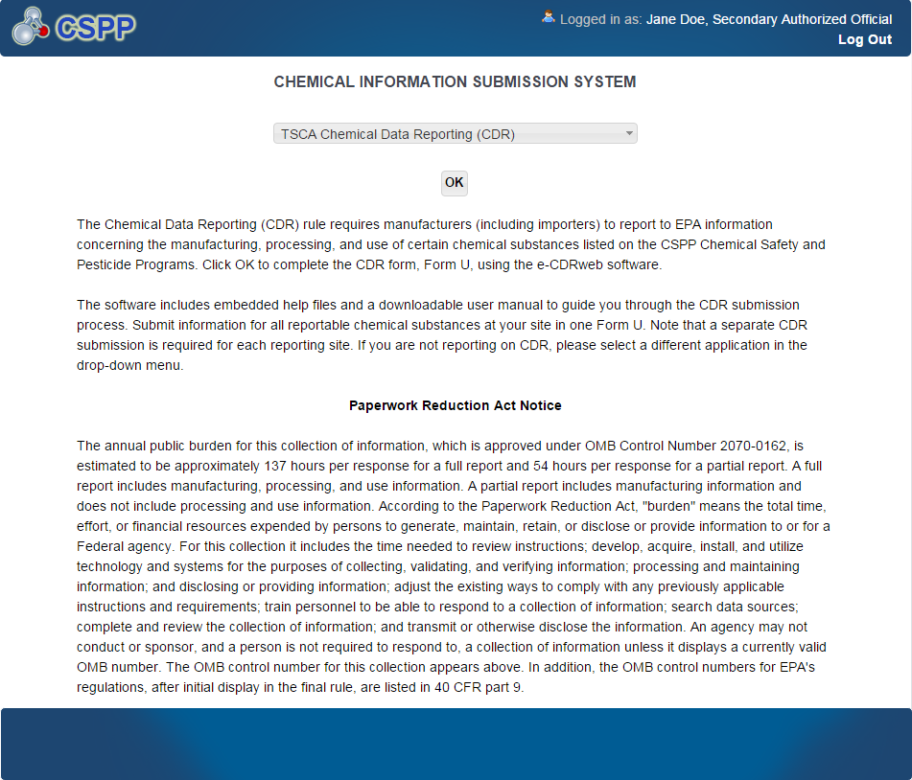

Navigation: To access the ‘Home’ screen, select ‘TSCA Chemical Data Reporting (CDR)’ from the drop-down menu and click the ‘OK’ button.

Home Screen Navigation
You can access the CDR ‘Home’ screen by selecting ‘TSCA Chemical Data Reporting (CDR)’ from the drop-down menu on the ‘Chemical Information Submission System’ screen.
The ‘Home’ screen is the first screen within the e-CDRweb tool. It provides you with links and tabs to access the ‘CDR Form U Access,’ ‘User Management,’ and ‘Resources’ screens. To navigate to any of these screens, click the screen link (in blue text) or click the screen tab (located at the top of the screen). The links and tabs provide you with the same functionality.
- Form U Access: To complete a new Joint CDR Form U or modify an existing form, click the ‘Form U Access’ link or tab to navigate to the ‘CDR Form U Access’ screen. For additional details about the ‘CDR Form U Access’ screen, please refer to Section 3.4.1.
- User Management: To manage the access rights of Supports for each site, click the ‘User Management’ link or tab to navigate to the ‘User Management’ screen. For additional details about the ‘User Management’ screen, please refer to Section 3.3.
- Resources: Click the ‘Resources’ link or tab to navigate to the ‘Resources’ screen. You can find the e-CDRweb user guide, as well as useful links for further guidance on the ‘Resources’ screen. For additional details about the ‘Resources’ screen, please refer to Section 8.
Exhibit 3-2 shows a screen capture of the ‘Home’ screen:
Exhibit 3-2: e-CDRweb Home Screen
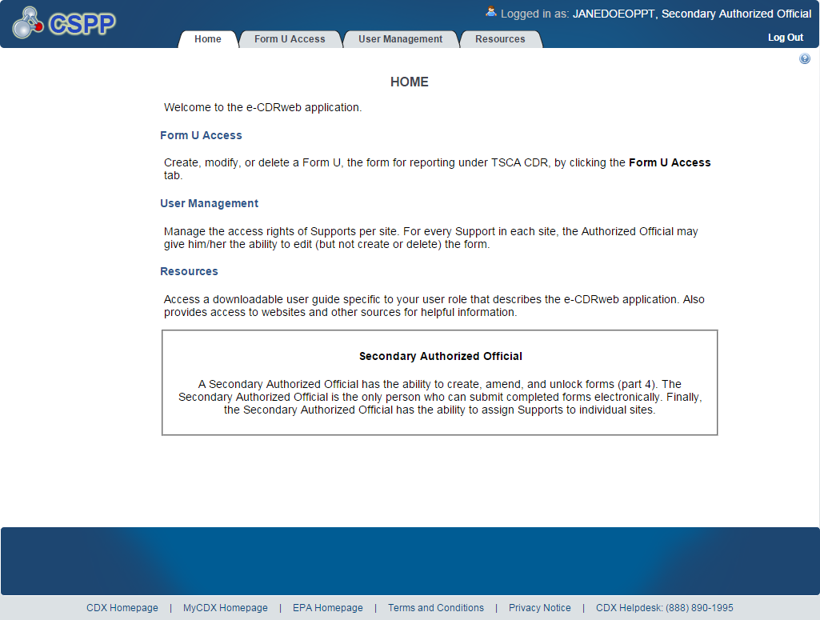

Navigation: To access the ‘User Management’ screen to assign Supports, click the ‘User Management’ link or tab.

User Management
On the ‘User Management’ screen, you can assign one or more Supports to complete or modify a Joint CDR Form U.
Assign Supports:
- Unassigned Users: This section shows all the Supports available to you that can be assigned to complete or modify a Joint CDR Form U for the displayed site. To move Supports from the ‘Unassigned’ section to the ‘Assigned’ section, highlight the individual or multiple Supports and click the ‘add>>’ link. To highlight multiple Supports, hold down the <Ctrl> key on your keyboard while clicking each Support. To highlight multiple consecutive Supports, hold down the <Shift> key on your keyboard while clicking the first and last Support in the range.
- Assigned Users: This section shows all the Supports that are assigned to complete or modify a Joint CDR Form U for a single site. To move Supports from the ‘Assigned’ section to the ‘Unassigned’ section, highlight the individual or multiple Supports and click the ‘<< remove’ link. To highlight multiple Supports, hold down the <Ctrl> key on your keyboard and click each Support. To highlight multiple consecutive Supports, hold down the <Shift> key on your keyboard and click the first and last Support in the range.
When you finish assigning the Supports, click the ‘Save’ button to save your selections.
Exhibit 3-3 shows a screen capture of the ‘User Management’ screen:
Exhibit 3-3: User Management Screen
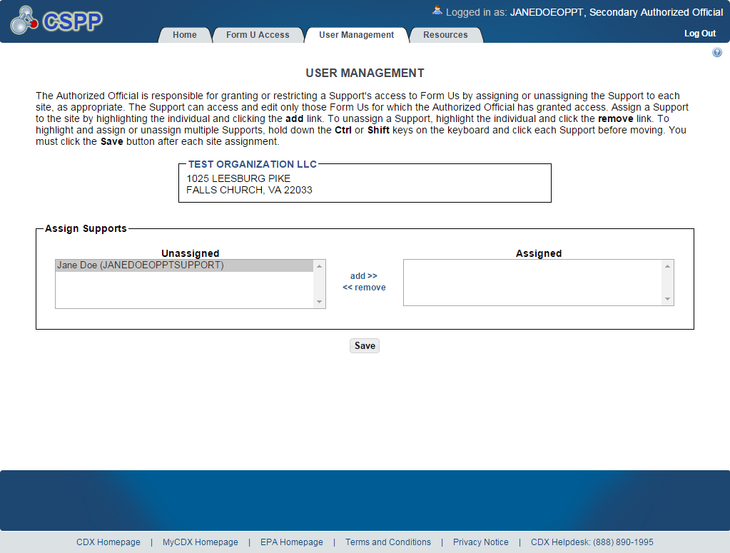

Navigation: Assign Supports to the Joint CDR Form U and click the ‘Save’ button. Click the ‘Form U Access’ link or tab from the ‘Home’ screen to navigate to the ‘CDR Form U Access’ screen.

Complete a CDR Form U
The e-CDRweb tool restricts you to the creation of only one submission for each reporting cycle. As a Secondary Submitter, you can only complete a single Joint CDR Form U that will cover all of your company’s products that are requested by all Primary Submitters.

CDR Form U Navigation
You can access the ‘CDR Form U Access’ screen by clicking the ‘Form U Access’ link or tab from the ‘Home’ screen.
The ‘CDR Form U Access’ screen presents the ‘Secondary Form’ displayed in table format. When you first access the ‘CDR Form U Access’ screen, your ‘Secondary Form’ will show a status of ‘Not Started.’ The column headers are denoted by bolded blue text in a gray background. The status column tracks the status of the Joint CDR Form U.
Start a New Joint CDR Form U: To start a new Joint CDR Form U submission, click the ‘Secondary Form’ link, which has a status of ‘Not Started.’ You will be required to create a passphrase that will be associated with that particular form. Please be sure to select a passphrase that you will remember, as passphrases cannot be reset or unlocked once a submission is created. Refer to Section 3.4.2 for instructions on creating a passphrase.
Edit an Existing Form U: To modify an existing Joint CDR Form U, click the ‘Secondary Form’ link that has a status of ‘In Progress.’ You will be required to enter the passphrase associated with that particular Joint CDR Form U in order to edit the form. Refer to Section 3.4.3 and Sections 3.4.7 through Section 3.4.10 for further instructions on viewing and modifying a Joint CDR Form U that has a status of ‘In Progress.’
Edit a Submitted Form U: To edit a submitted Joint CDR Form U (i.e., to make an amendment), you must first unlock the particular Joint CDR Form U by clicking the lock icon ( INCLUDEPICTURE "http://devngn.epacdxnode.net/cdx-oppt-iur/images/lock.png" \* MERGEFORMATINET ) under the ‘Actions’ column. You will be required to enter the passphrase associated with the Joint CDR Form U to gain access to amend the form. After you have made changes to the form, the complete Joint CDR Form U will be submitted as an amendment, replacing the original Joint CDR Form U. Include all information you intend to communicate within the amended form. Refer to Section 7 for further instructions on amending an original Joint CDR Form U.

In addition to the ‘Form’ and ‘Status’ columns, the ‘CDR Form U Access’ screen displays the following columns:
- Modify Date: The ‘Modify Date’ column displays the date the Joint CDR Form U was last modified.
- Submission Date: The ‘Submission Date’ displays the date that you submitted a Joint CDR Form U to EPA via CDX. This date is populated only after you submit a Joint CDR Form U.
- Copy of Record: Click the download arrow icon ( INCLUDEPICTURE "../../../Documents%20and%20Settings/sdose/Local%20Settings/Documents%20and%20Settings/sdose/Local%20Settings/Documents%20and%20Settings/sdose/Local%20Settings/Temporary%20Internet%20Files/Content.Outlook/Local%20Settings/Temporary%20Internet%20Files/Local%20Settings/Temporary%20Internet%20Files/Local%20Settings/Documents%20and%20Settings/sdose/Documents%20and%20Settings/sdose/Desktop/mockups/eIUR/images/down.png" \* MERGEFORMAT ) to navigate to the ‘Copy of Record’ screen. You must first enter your passphrase and CROMERR login information to gain access to the ‘Copy of Record’ screen. Click the download arrow icon ( INCLUDEPICTURE "../../../Documents%20and%20Settings/sdose/Local%20Settings/Documents%20and%20Settings/sdose/Local%20Settings/Documents%20and%20Settings/sdose/Local%20Settings/Temporary%20Internet%20Files/Content.Outlook/Local%20Settings/Temporary%20Internet%20Files/Local%20Settings/Temporary%20Internet%20Files/Local%20Settings/Documents%20and%20Settings/sdose/Documents%20and%20Settings/sdose/Desktop/mockups/eIUR/images/down.png" \* MERGEFORMAT ) on the ‘Copy of Record’ screen to download a copy of the submitted Joint CDR Form U to your local hard drive. The download arrow icon ( INCLUDEPICTURE "../../../Documents%20and%20Settings/sdose/Local%20Settings/Documents%20and%20Settings/sdose/Local%20Settings/Documents%20and%20Settings/sdose/Local%20Settings/Temporary%20Internet%20Files/Content.Outlook/Local%20Settings/Temporary%20Internet%20Files/Local%20Settings/Temporary%20Internet%20Files/Local%20Settings/Documents%20and%20Settings/sdose/Documents%20and%20Settings/sdose/Desktop/mockups/eIUR/images/down.png" \* MERGEFORMAT ) displays only after you submit a Joint CDR Form U. Refer to Section 6 for further instructions on downloading a CoR.
- Action: Click the red X to delete a CDR Form U. Click the ‘Lock’ icon to edit a submitted form and complete an amendment.

Exhibit 3-4 shows a screen capture for the ‘CDR Form U Access’ screen:
Exhibit 3-4: CDR Form U Access Screen
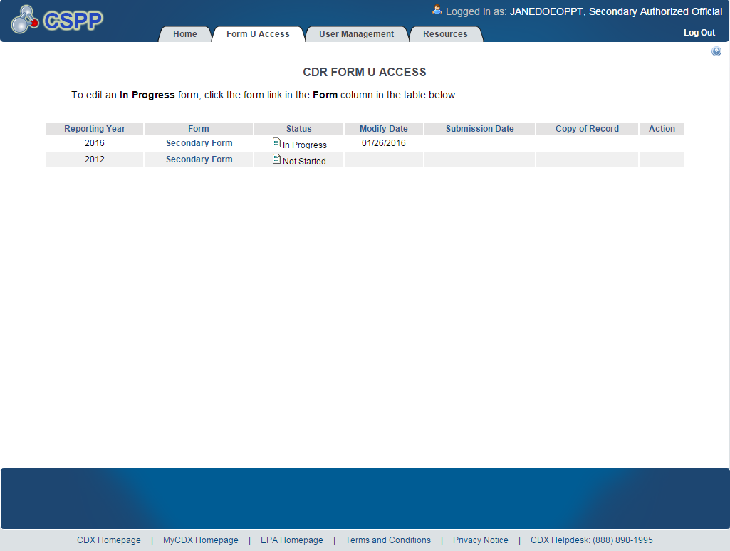
Navigation: Click the ‘Secondary Form’ link with a status of ‘Not Started’ to navigate to the ‘Create Passphrase’ screen.

Create Passphrase Screen
The ‘Create Passphrase’ screen allows you to create and associate a passphrase with a new CDR Form U.
Create New Passphrase: To create and associate a passphrase with a Form U, enter a passphrase that is at least 8 characters in length and does not exceed 20 characters. To protect your account, your passphrase should contain a combination of letters and numbers. The passphrase may include spaces, but should not contain special characters (for example, +, ?, and *). You can associate the same passphrase with multiple Form Us.
You will be responsible for remembering the passphrase and distributing it to only authorized Supports for your site. If you forget the passphrase, you will not be able to access the CDR Form U to print, submit, or make changes.
For security reasons, the system administrator will not have access to your passphrase and will not be able to retrieve it or reset it to a new one.
Exhibit 3-5 shows a screen capture of the ‘Create Passphrase’ screen:
Exhibit 3-5: Create Passphrase Screen
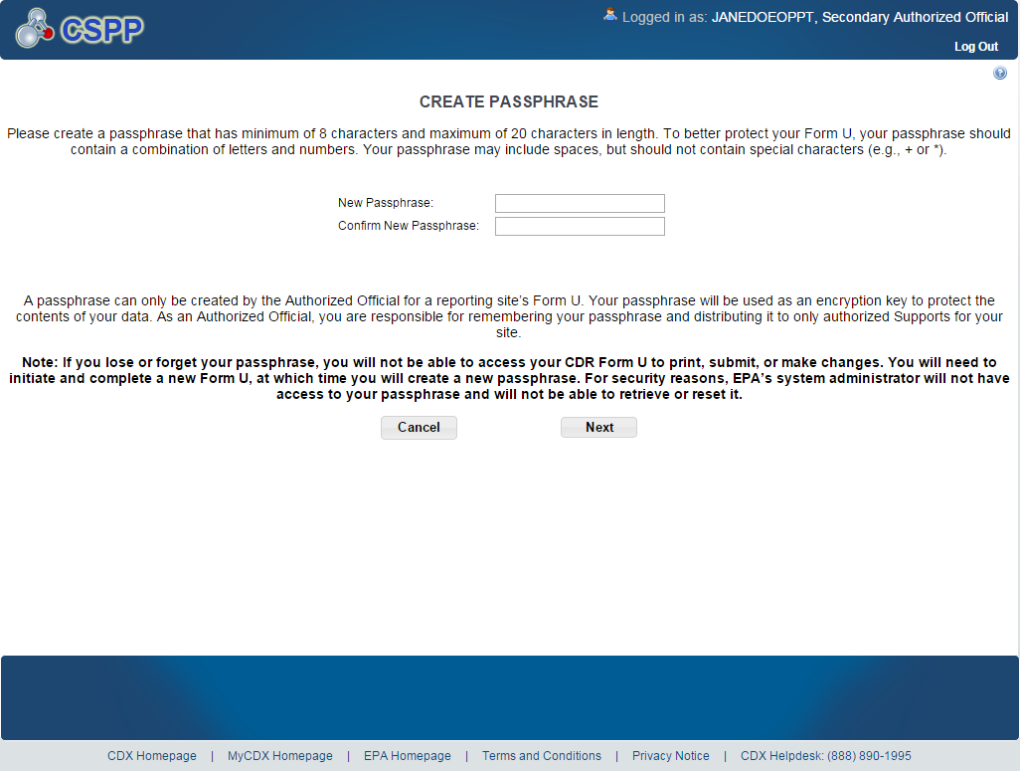
Navigation: Create a passphrase and click the ‘Next’ button to navigate to the ‘Section 4.A – Secondary Company Information’ screen.

Enter Passphrase Screen
If you have previously created a passphrase for the Joint CDR Form U you are accessing, then enter the passphrase on the ‘Enter Passphrase’ screen and click the ‘Next’ button.
Exhibit 3-6 shows a screen capture of the ‘Enter Passphrase’ screen:
Exhibit 3-6: Enter Passphrase Screen
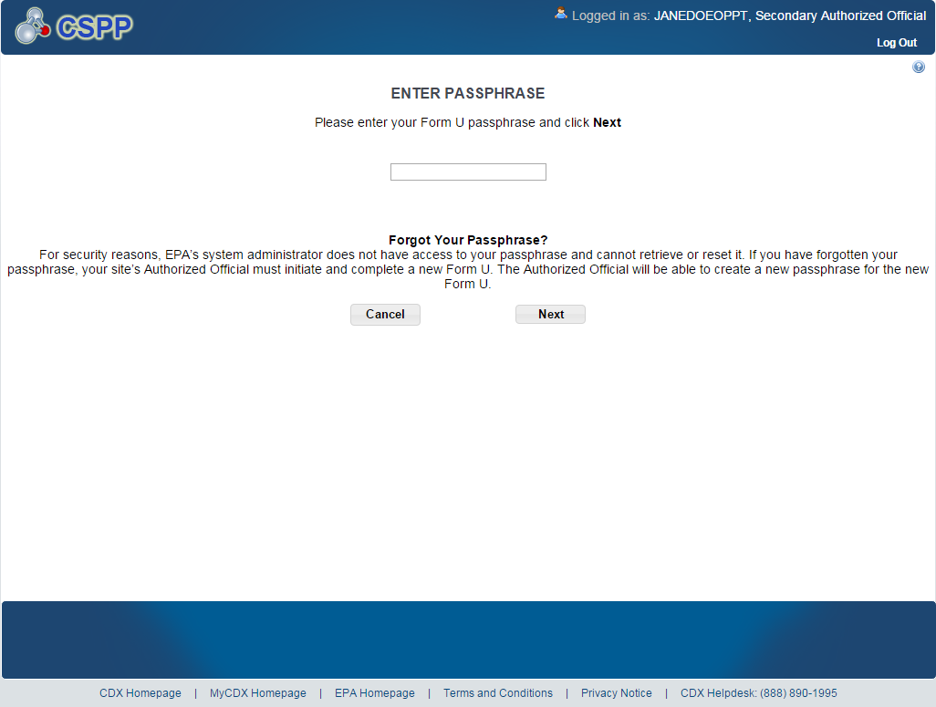

Navigation: Enter the passphrase that you created for the Joint CDR Form U and click the ‘Next’ button to navigate to the ‘Section 4.A – Secondary Company Information’ screen.

Navigation Tree
The navigation tree is located on the left side of the form section on each screen. You can perform the following functions using the navigation tree:
- Collapse and Expand folders: Each section of the form falls under a collapsible folder in the navigation tree, allowing you to save space and easily view items in the navigation tree. When the folder is expanded, click the minus sign (-), by the folder icon ( INCLUDEPICTURE "http://devngn.epacdxnode.net/cdx-oppt-iur/images/folder.png" \* MERGEFORMATINET ), or click the folder title link to collapse that section of the navigation tree. When the folder is collapsed, click the plus sign (+), by the folder icon ( INCLUDEPICTURE "http://devngn.epacdxnode.net/cdx-oppt-iur/images/folder.png" \* MERGEFORMATINET ), or click the folder title link to expand that section of the navigation tree. When you place your cursor over the folder title link, it will highlight in red.
- Navigate between screens: You can use the navigation tree to navigate between the various screens within the tool and the different sections of the form, but you are required to save all information entered on a particular screen before navigating to the next screen or the information will be lost. Each section of the form is denoted with a form icon ( INCLUDEPICTURE "http://devngn.epacdxnode.net/cdx-oppt-iur/images/page_white_text.png" \* MERGEFORMATINET ). You can click either the form icon ( INCLUDEPICTURE "http://devngn.epacdxnode.net/cdx-oppt-iur/images/page_white_text.png" \* MERGEFORMATINET ) or the section title link to navigate between screens. A prompt message will appear after you click a link in the navigation tree, indicating, ‘Are you sure you want to leave the current page? Any unsaved changes will be lost.’ If you choose the ‘OK’ button, you will be taken to the desired screen without saving any of the data in the previous screen. If you choose the ‘Cancel’ button, the prompt message will close and you will not be taken further.

Exhibit 3-7 shows a screen capture of the navigation tree:
Exhibit 3-7: Navigation Tree
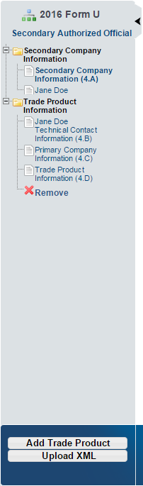

Exhibit 3-8 shows a screen capture of the navigation prompt:
Exhibit 3-8: Navigation Prompt
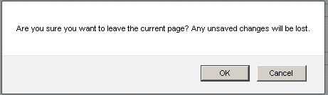
- Remove a folder: Each ‘Trade Product’ folder within the navigation tree has a ‘Remove’ icon ( INCLUDEPICTURE "http://devngn.epacdxnode.net/cdx-oppt-iur/images/cross.png" \* MERGEFORMATINET ). Click the ‘Remove’ icon ( INCLUDEPICTURE "http://devngn.epacdxnode.net/cdx-oppt-iur/images/cross.png" \* MERGEFORMATINET ) to remove the entire folder and all of its associated sections and information. Note: If you remove a folder, there is no way to retrieve it. You must add a new folder and fill in all corresponding data again.
- Add Trade Product: Click the ‘Add Trade Product’ button located at the bottom of the navigation tree to add any number of additional trade products to the joint submission sections of the navigation tree.
- Upload an XML File: Click the ‘Upload XML’ button to upload an XML file. Refer to Section 3.4.6 for details about the ‘Upload XML’ function.
- Open and Close the navigation tree: To provide more visual form space, a navigation arrow () that opens and closes the navigation tree is located to the right of the navigation tree. Click the arrow () to close the navigation tree and increase the space of the form content. Alternatively, click the arrow () on the closed navigation tree to open the navigation tree.

Action Bar
The action bar is located at the bottom of the form section on each screen. You can perform the following functions using the action bar:
- Validate: Click the ‘Validate’ icon ( INCLUDEPICTURE "http://devngn.epacdxnode.net/cdx-oppt-iur/images/tick_32.png" \* MERGEFORMATINET ) at any stage during the completion of a Joint CDR Form U. A ‘CDR Form U Validation’ pop-up window displays every time you click the ‘Validate’ icon ( INCLUDEPICTURE "http://devngn.epacdxnode.net/cdx-oppt-iur/images/tick_32.png" \* MERGEFORMATINET ). The ‘CDR Form U Validation’ pop-up window displays a report of all the warning messages and errors that failed validation. Refer to Section 4 for more information on validating a Joint CDR Form U.
Exhibit 3-9 shows a screen capture of the action bar showing the ‘Validate’ icon:
Exhibit 3-9: Action Bar - Validate


- Save: Click the ‘Save’ icon ( INCLUDEPICTURE "http://devngn.epacdxnode.net/cdx-oppt-iur/images/save_32.png" \* MERGEFORMATINET ) at any stage during the completion of a Joint CDR Form U. After you click the ‘Save’ icon ( INCLUDEPICTURE "http://devngn.epacdxnode.net/cdx-oppt-iur/images/save_32.png" \* MERGEFORMATINET ), the data entered on the screen will save. The ‘Save’ function does not validate any data entered.
Exhibit 3-10 shows a screen capture of the action bar showing the ‘Save’ icon:
Exhibit 3-10: Action Bar – Save
- Preview: Click the ‘Preview’ icon ( INCLUDEPICTURE "http://devngn.epacdxnode.net/cdx-oppt-iur/images/monitor_32.png" \* MERGEFORMATINET ) at any stage during the completion of a Joint CDR Form U to preview the form. After you click the ‘Preview’ icon ( INCLUDEPICTURE "http://devngn.epacdxnode.net/cdx-oppt-iur/images/monitor_32.png" \* MERGEFORMATINET ), a draft watermarked PDF version of the form may generate and display in a separate window.
Exhibit 3-11 shows a screen capture of the action bar showing the ‘Preview’ icon:
Exhibit 3-11: Action Bar – Preview
- Submit: Click the ‘Submit’ icon () to submit the Joint CDR Form U after all sections of the form have been completed by you or a Support. After you click the ‘Submit’ icon (), the validation process is initiated. Refer to Section 4 for further instructions on validation errors. You can continue with the submission process only after clearing all validation errors. Refer to Section 5 for more information on submitting a form.

Exhibit 3-12 shows a screen capture of the action bar showing the ‘Submit’ icon:
Exhibit 3-12: Action Bar – Submit

- Additional Links: You can click on any of the additional links, located at the bottom of the page, for helpful information while completing a Joint CDR Form U.
- If you click on the ‘CDX Homepage’ link, you will be taken to the ‘CDX Homepage.’
- If you click on the ‘MyCDX Homepage’ link, you will be taken to the ‘CDX Login.’
- If you click on the ‘EPA Homepage’ link, you will be taken to the ‘EPA Homepage.’
- If you click on the ‘Terms and Conditions’ link, you will be taken to the ‘CDX Terms and Conditions’ screen.
- If you click on the ‘Privacy Notice’ link, you will be taken to the ‘CDX Privacy and Security Notice’ screen.
Exhibit 3-13 shows a screen capture of the links located below the action bar at the bottom of the screen:
Exhibit 3-13: Action Bar – Links

Upload an XML File
You can upload an XML file by clicking the ‘Upload XML’ button at the bottom left side of the action bar.
When you click the ‘Upload XML’ button, a Windows Explorer pop-up window displays.
Exhibit 3-14 shows the screen capture of the ‘Upload XML’ screen:
Exhibit 3-14: Upload XML Screen
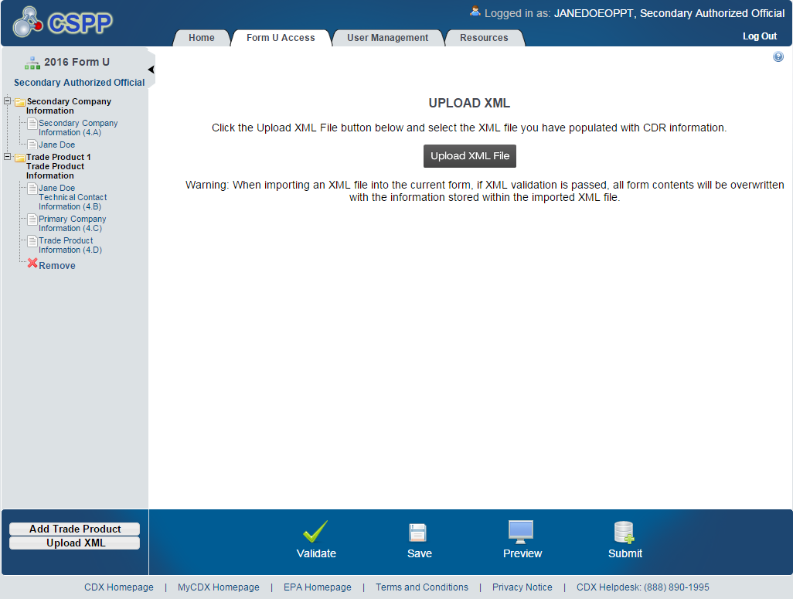
Upload an XML File: Navigate to the location on your computer where you have stored the XML file that you want to upload. Select the XML file from your local hard drive and click the ‘Open’ button. You will be taken back to the ‘Upload XML’ screen and the system will process and validate the XML file.
Exhibit 3-15 shows a screen capture of the Windows Explorer pop-up window:
Exhibit 3-15: Windows Explorer Pop-Up Window
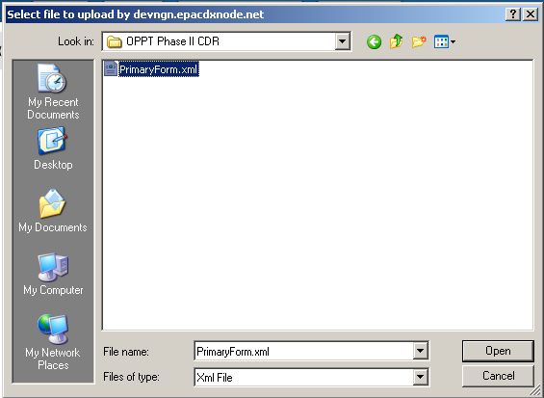
XML Validation: If the upload is successful, you will be taken to the ‘Upload XML Successful’ screen. From the ‘Upload XML Successful’ screen, click a link within the navigation tree to access a specific screen.
If you upload an XML file that is not consistent with the e-CDRweb schema, you will receive a message indicating that the document did not pass validation.
Access the Form U: To view your Joint CDR Form U after uploading the XML file, click a link within the navigation tree to access a specific page and edit your form.
Submit the Form U: To submit the Joint CDR Form U, click the ‘Submit’ icon ( INCLUDEPICTURE "http://devngn.epacdxnode.net/cdx-oppt-iur/images/database_add_32.png" \* MERGEFORMATINET ) located in the bottom action bar of the application. Refer to Section 5 for more details about the submit functionality.

Section 4.A – Secondary Company Information
To access the ‘Section 4.A – Secondary Company Information’ screen, click the ‘Secondary Form’ link and enter/create the passphrase associated with that particular Joint CDR Form U.
To protect the trade secrets of the Secondary Submitter, the e-CDRweb tool allows you to report the identity of the trade secret chemical substance or the Primary Submitter’s product, while preventing the Primary Submitter from having access to your information.
County/Parish (4.A.5): Enter the county/parish information in Section 4.A.5.
The remaining data fields are pre-populated based on the information collected during CDX registration.
Exhibit 3-16 shows a screen capture of the ‘Section 4.A - Secondary Company Information’ screen:
Exhibit 3-16: Section 4.A - Secondary Company Information Screen
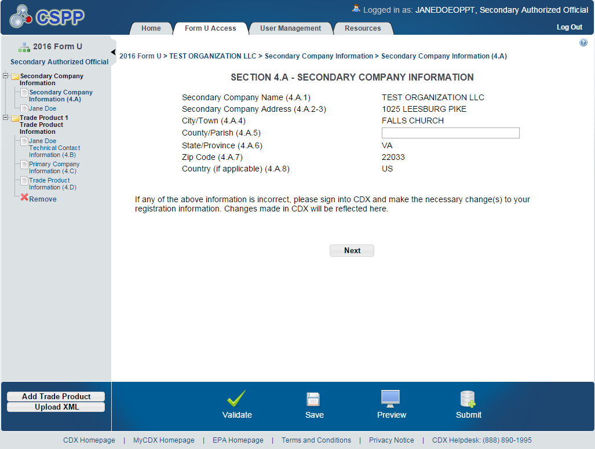
Navigation: Click the ‘Next’ button on the ‘Section 4.A - Secondary Company Information’ screen to navigate to the ‘Section 4.B – Technical Contact Information’ screen. You can also access this screen by using the ‘Technical Contact Information (4.B)’ link in the navigation tree.

Section 4.B – Technical Contact Information
You can access the ‘Section 4.B – Technical Contact Information’ screen by clicking the ‘Next’ button on the ‘Section 4.A – Secondary Company Information’ screen. You can also access the ‘Section 4.B – Technical Contact Information’ screen by clicking the ‘Technical Contact Information (4.B)’ link from the navigation tree.

The technical contact should be a person who can answer questions about the reported chemical substance(s). Typically, a person located at the manufacturing site is best able to answer such questions; however, you may use your discretion in selecting a technical contact or multiple technical contacts. When selecting a technical contact, consider that EPA may have follow-up questions about a CDR submission, one or more years after the submission date. The technical contact need not be the person who signed the certification statement.

You can assign one technical contact per chemical substance and one per ‘Trade Product Name’ in a joint submission. Since there can be multiple technical contacts, each associated with a different chemical substance, you can either create a new contact, choose an existing contact, or modify an existing contact.

Creating a Technical Contact: When you first access the ‘Section 4.B – Technical Contact Information’ screen, all of the fields will be editable. The ‘Default Contact’ checkbox is checked by default. Each time you add a new trade product, the associated default technical contact is displayed (to help avoid entering the same information multiple times).
- Copy CDX Registration: Click the ‘Copy CDX Registration’ button to copy your contact information from the CDX registration profile.
- Technical Contact Name (4.B.1): Enter the name of the person whom EPA may contact about information submitted for a chemical substance.
- Company Name (4.B.2): Enter the name of the company for whom the technical contact works.
- Technical Contact Telephone Number and Email Address (4.B.3 and 4.B.4): Enter the technical contact’s telephone number, including the area code, and the technical contact’s email address. Do not enter any dashes or parentheses when entering the telephone number.
- Technical Contact Mailing Address (4.B.5 through 4.B.10): Enter the technical contact’s full mailing address. Post office box numbers should be accompanied by a street address. If a post office box is used as a mailing address, enter the street address in field 4.B.5 and enter the post office box number in field 4.B.6.
- Default Contact: Check the ‘Default Contact’ checkbox if you want to make the person the default technical contact for all chemical substances. The ‘Default Contact’ checkbox is checked upon default when initially navigating to the page.

Exhibit 3-17 shows a screen capture of the ‘Section 4.B - Technical Contact Information’ screen:
Exhibit 3-17: Section 4.B - Technical Contact Information Screen (Edit Mode)
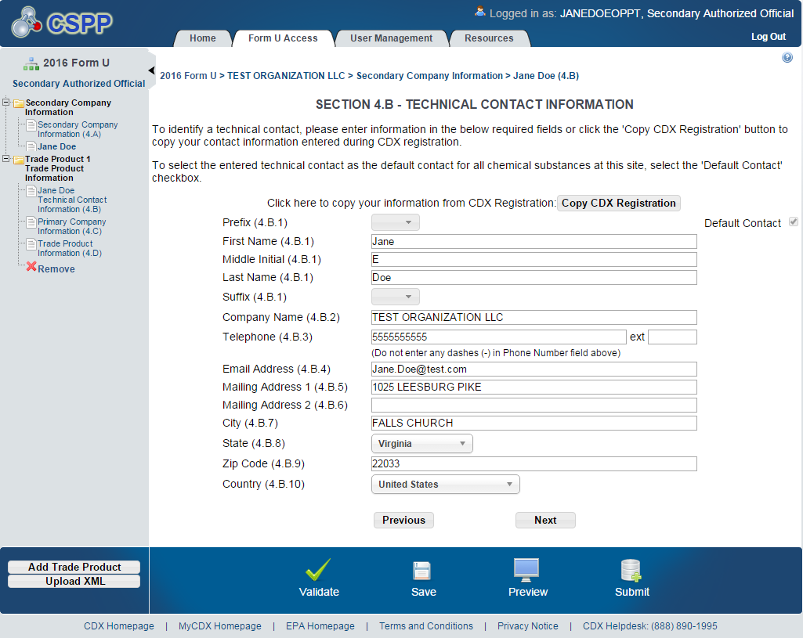

Edit an existing technical contact: You can edit an existing technical contact by clicking the technical contact’s name link under the ‘Secondary Company Information’ folder in the navigation tree. The technical contact information previously created will display in the ‘Section 4.B – Technical Contact Information’ screen and the fields will be editable. Make applicable changes and click the ‘Save’ icon ( INCLUDEPICTURE "http://devngn.epacdxnode.net/cdx-oppt-iur/images/save_32.png" \* MERGEFORMATINET ) to save your changes.
Creating multiple technical contacts: You can add a new technical contact (after you have created at least one technical contact). Click the ‘Technical Contact Information (4.B)’ link from the navigation tree. You will see the technical contact information that you entered previously. Click the ‘Create New Contact’ link to clear the form to add a new technical contact.

Exhibit 3-18 shows a screen capture of the ‘Section 4.B - Technical Contact Information’ screen after it is populated:
Exhibit 3-18: Section 4.B - Technical Contact Information Screen (Populated)
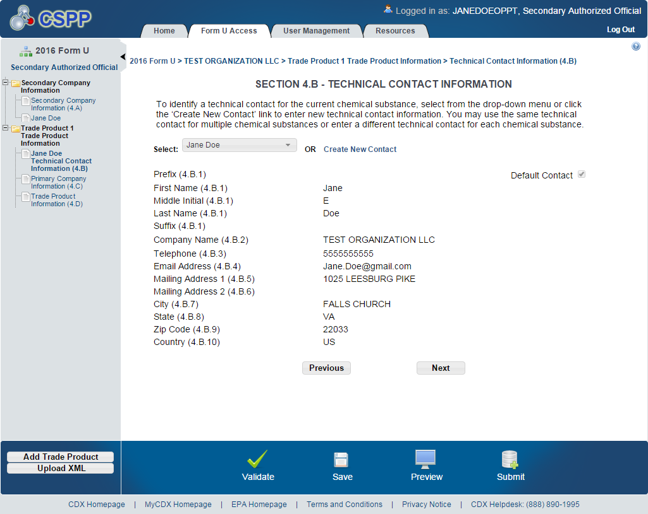
Navigation: Click the ‘Next’ button to navigate to the ‘Section 4.C – Primary Company Information’ screen. You can also click the ‘Primary Company Information (4.C)’ link under the ‘Trade Product Information’ folder on the navigation tree.

Section 4.C – Primary Company Information
You can access the ‘Section 4.C – Primary Company Information’ screen by clicking the ‘Next’ button from the ‘Section 4.B – Technical Contact Information’ screen or by clicking the ‘Primary Company Information (4.C)’ link from the navigation tree.
To populate the primary company information, enter the Unique Identifier (ID) that was generated and emailed to you by the Primary Submitter.
Unique ID: The ‘Unique ID’ links your submission to the Primary Submitter’s submission. The ‘Parent Company Name,’ ‘Plant Site,’ and ‘Plant Site Mailing Address’ fields will populate after you enter the ‘Unique ID’ and click the ‘Populate’ button. If the Primary Submitter has deleted the joint submission before you populate the ‘Unique ID,’ an error message will indicate that the ‘Unique ID’ is invalid. You are required to report a minimum of one primary company for a trade product name. If the Primary Submitter has deleted the joint submission after you populated the ‘Unique ID,’ an error message will generate during validation or submission of the form.
Exhibit 3-19 shows a screen capture of the ‘Section 4.C - Primary Company Information’ screen after it is populated:
Exhibit 3-19: Section 4.C - Primary Company Information Screen (Populated)
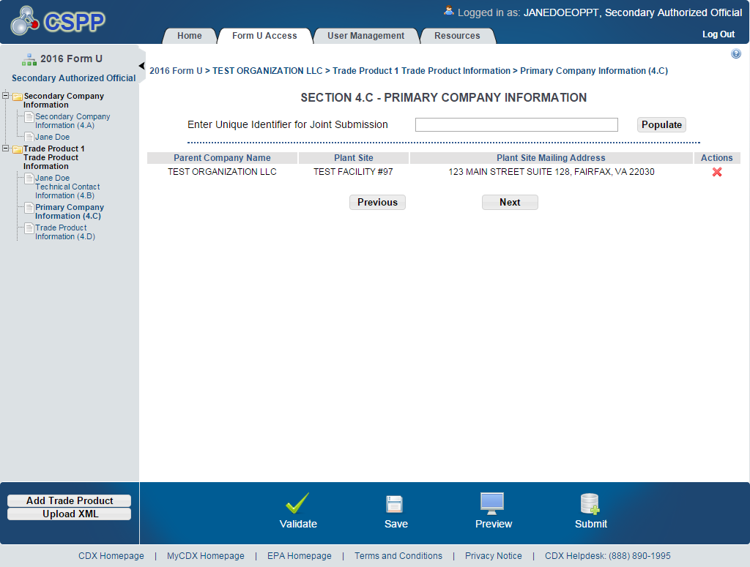

Navigation: Populate at least one primary company for a trade product name and click the ‘Next’ button to navigate to the ‘Section 4.D – Trade Product Identification Information’ screen. You can also access this screen by using the ‘Trade Product Information (4.D)’ link in the navigation tree.

Section 4.D – Trade Product Identification Information
You can access the ‘Section 4.D – Trade Product Identification Info’ screen by clicking the ‘Next’ button from the ‘Section 4.C – Primary Company Information’ screen or by clicking the ‘Trade Product Information (4.D)’ link from the navigation tree.
Trade Product Name (4.D.1): Enter the secondary company’s ‘Trade Product Name.’
Provided Company Trade Names (2.A.5): This field is pre-populated based on the ‘Unique ID’ you entered and populated into the ‘Section 4.C – Primary Company Information’ screen.
Search for a Chemical Substance in Substance Registry Services (SRS) Search: You can search for a chemical substance by using the search mechanism in SRS Search. Click the search icon () located under the ‘Action’ column. The ‘Substance Registry Services Search’ pop-up window generates each time you click the search icon ().

Exhibit 3-20 shows a screen capture of the ‘Section 4.D - Trade Product Identification Info’ screen when it is first accessed:
Exhibit 3-20: Section 4.D - Trade Product Identification Info Screen
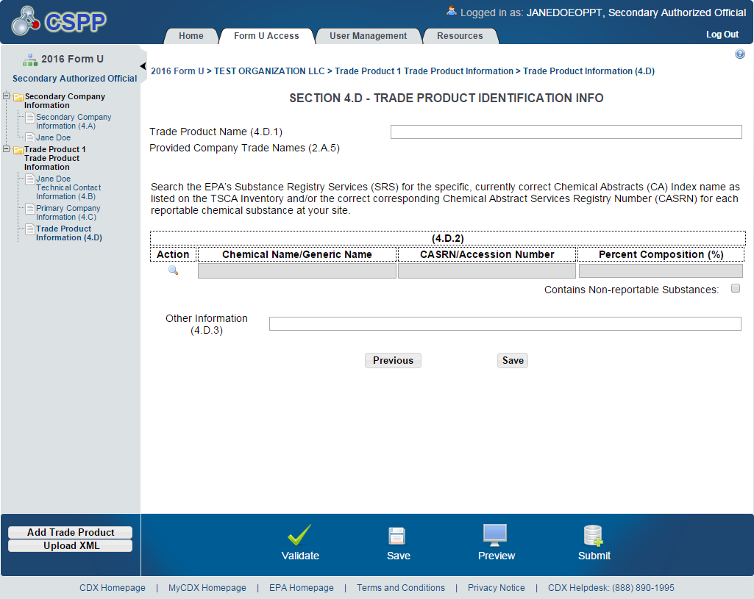
Navigation: From the ‘Section 4.D - Trade Product Identification Info’ screen click the search icon () to launch the SRS search pop-up window. Search for the desired chemical substance by entering search criteria.
On the SRS Search window, you can search for the desired chemical substance by various search fields. To search SRS, enter one of the following search fields and click the ‘Search’ button.
For chemical substances listed on the non-confidential portion of the TSCA Inventory, Search by Chemical Abstracts Service Registry Number (CASRN) or Chemical Abstracts (CA) Index Name: Enter data in the ‘CASRN’ field and/or the ‘CA Index Name or Other Synonym’ field and click the ‘Search’ button. Search results will display in a table format at the bottom of the screen. If no information is retrieved back from SRS, the bottom of the screen will display a ‘No Results Found’ message. If you enter data into both of the fields and click the ‘Search’ button, the system will perform an ‘and’ search. Search results are retrieved that match both of the search criteria fields and will display in a table format at the bottom of the screen.
- CASRN: You may enter a full CASRN or another identifying number. Search results will display CASRNs or other numbers that exactly match the numbers that you entered.
- CA Index Name or Other Synonym: You may enter a full or partial CA index name, biological name, EPA registry name, or other synonym. Search results will display CA index names or other synonyms that contain, begin with, or exactly match the name that you entered. Use the drop-down menu to specify the search criteria.
For chemical substances listed on the confidential portion of the TSCA Inventory, Search by Accession Number and/or Generic Name: Enter data in the ‘Accession Number’ field and/or the ‘Generic Name’ field and click the ‘Search’ button. Search results will display in a table format at the bottom of the screen. If no information is retrieved back from SRS, the bottom of the screen will display a ‘No Results Found’ message.
- TSCA Accession Number: You may enter a full or partial Accession number. Search results will display Accession numbers that contain, begin with, or exactly match the numbers that you entered. Use the drop-down menu to specify the search criteria.
- Generic Name: You may enter a full or partial generic name. Search results will display generic names that contain, begin with, or exactly match the name that you entered. Use the drop-down menu to specify the search criteria.

Exhibit 3-21 shows a screen capture of the ‘Substance Registry Services Search’ window:
Exhibit 3-21: Substance Registry Services Search Window
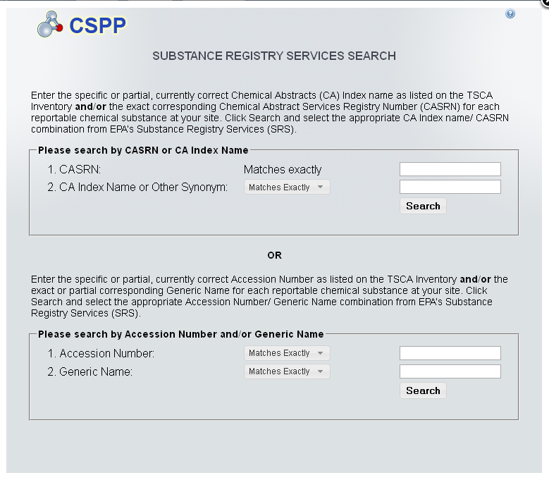

Exhibit 3-22 shows a screen capture of the ‘Substance Registry Services Search’ window:
Exhibit 3-22: Substance Registry Services Search Window (Search Results)
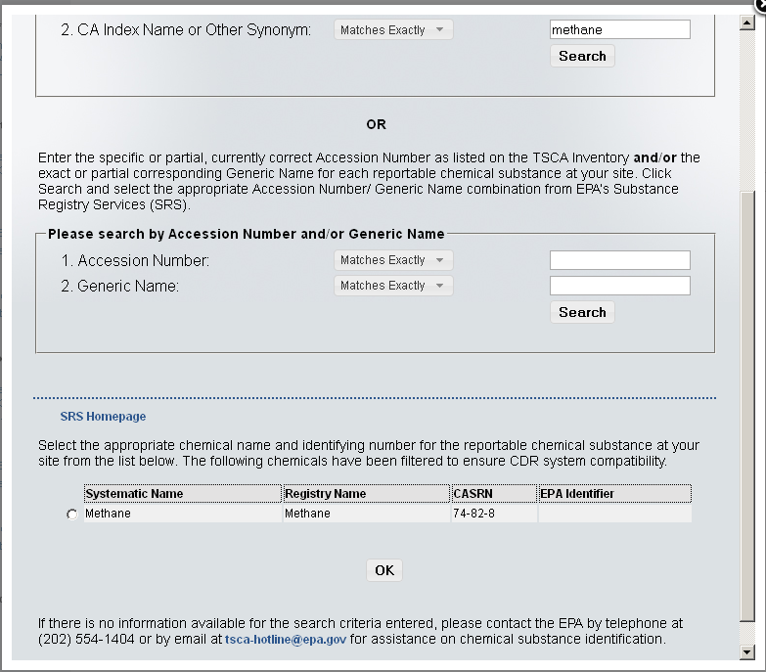
Navigation: Select the chemical substance from the ‘Substance Registry Services Search’ window by selecting the radio button (located to the left of the chemical name) and clicking the ‘OK’ button. You will be taken to the ‘Section 4.D – Trade Product Identification Info’ screen.
The chemical substance name will populate on the ‘Section 4.D – Trade Product Identification Info’ screen under the ‘Section 4.D.2’ table as read-only. Based on what you searched for in SRS, either the CASRN or the accession number will be displayed under the ‘CASRN/Accession Number’ column.
If you wish to add multiple chemical substances, repeat the above steps. You cannot add the same chemical substance more than once. If you need to delete a chemical substance from the table, click the ‘Delete’ icon ().

Exhibit 3-23 shows a screen capture of the ‘Section 4.D - Trade Product Identification Info’ screen after it is populated:
Exhibit 3-23: Section 4.D - Trade Product Identification Info Screen (Populated)
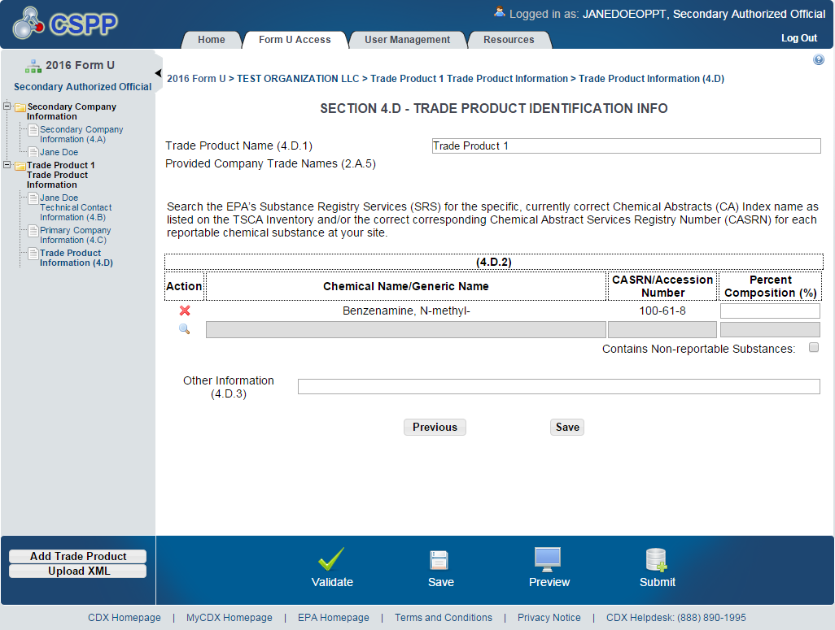
After populating the chemical(s) substance information, you are required to enter the percent composition for each chemical substance under the Section 4.D.2 table. The total of all the chemical substances percent composition (%) must add up to, but not exceed, 100%. You can check the ‘Contains Non-reportable Substances’ checkbox if the percent composition (%) is less than 100%.
The ‘Section 4.D – Trade Product Identification Info’ screen is the last screen in the Joint CDR Form U. Once you have completed all sections, you can click the ‘Save’ button on the page and continue with validating the form and submitting. Refer to Section 4 for instructions on validating a Joint CDR Form U and Section 5 for instructions on submitting a Joint CDR Form U.

Validate
You can click the ‘Validate’ icon ( INCLUDEPICTURE "http://devngn.epacdxnode.net/cdx-oppt-iur/images/tick_32.png" \* MERGEFORMATINET ) at any stage during the completion of a Joint CDR Form U to check for missing or invalid data. The ‘CDR Form U Validation’ pop-up window will display every time you click the ‘Validate’ icon ( INCLUDEPICTURE "http://devngn.epacdxnode.net/cdx-oppt-iur/images/tick_32.png" \* MERGEFORMATINET ). The ‘CDR Form U Validation’ pop-up window will display a report of all the validation errors and warning messages.
Validation Errors: Errors are denoted by an error icon ( INCLUDEPICTURE "http://devngn.epacdxnode.net/cdx-oppt-iur/images/exclamation.png" \* MERGEFORMATINET ) and can be fixed by clicking the error link. The links will display the screen section (e.g., Technical Contact Information (4.B)), the field section name (e.g., 4.B.1), and the associated error. After you click a link, the main screen will display the section where the error occurred so you can easily fix the issue. Once you have fixed the error, click the ‘Validate’ icon ( INCLUDEPICTURE "http://devngn.epacdxnode.net/cdx-oppt-iur/images/tick_32.png" \* MERGEFORMATINET ) again to refresh the ‘CDR Form U Validation’ pop-up window. If the information you fixed passes validation, the error will be removed from the ‘CDR Form U Validation’ pop-up window. You must correct all validation errors in order to submit the form to EPA via CDX. Once all validation errors have been resolved, if the ‘Validate’ icon ( INCLUDEPICTURE "http://devngn.epacdxnode.net/cdx-oppt-iur/images/tick_32.png" \* MERGEFORMATINET ) is clicked, the ‘CDR Form U Validation’ screen will indicate that there are no validation errors.
Warning Messages: Warnings are denoted by a warning icon ( INCLUDEPICTURE "http://devngn.epacdxnode.net/cdx-oppt-iur/images/warning_16.png" \* MERGEFORMATINET ) and can be addressed by clicking the warning link. The links will display the screen section, field section name, and the associated warning. After you click a link, the main screen will display the section where the warning occurred so you can verify the data’s validity. Once you have corrected or verified the data, click the ‘Validate’ icon ( INCLUDEPICTURE "http://devngn.epacdxnode.net/cdx-oppt-iur/images/tick_32.png" \* MERGEFORMATINET ) again to refresh the ‘CDR Form U Validation’ pop-up window. If the information you corrected or verified passes validation, the warning will be removed from the ‘CDR Form U Validation’ pop-up window. Once all validation warnings have been resolved, if the ‘Validate’ icon ( INCLUDEPICTURE "http://devngn.epacdxnode.net/cdx-oppt-iur/images/tick_32.png" \* MERGEFORMATINET ) is clicked, the ‘CDR Form U Validation’ screen will indicate that there are no validation warnings. Although you should verify that the data indicated in the warning is valid, the tool will still allow you to pass validation and submit a form to EPA with active warning messages.

Close the ‘CDR Form U Validation’ pop-up window by clicking the ‘X’ button at the top right of the screen.

Exhibit 4-24 shows a screen capture of the ‘CDR Form U Validation’ pop-up window:
Exhibit 4-24: CDR Form U Validation Pop-up Window
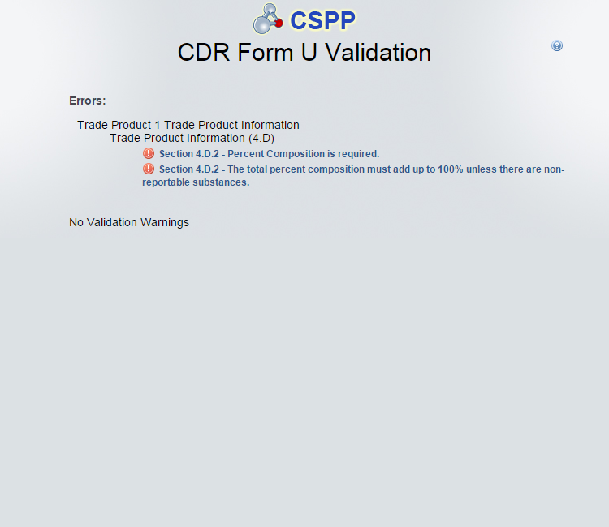

Submit to EPA via CDX
As a Secondary AO, you have the ability to sign and submit a Joint CDR Form U to EPA. Any assigned Supports cannot sign and submit a Joint CDR Form U to EPA. The save functionality will allow you to return to that same form at any point in the future. You can also print the form at any point; however, the ‘Not For Submission’ watermark will be placed on the document.

Submit Electronically – CROMERR Certification
Click the ‘Submit’ icon () located in the bottom action bar of the Joint CDR Form U to access the ‘Submission Process’ Cross-Media Electronic Reporting Regulation (CROMERR) screen.
CROMERR provides the legal framework for electronic reporting under all of EPA’s environmental regulations.
Upon clicking the ‘Submit’ icon (), you will receive a prompt indicating ‘This will begin the Form U submission process. Do you wish to proceed?’
Exhibit 5-25 shows a screen capture of the submission prompt:
Exhibit 5-25: Submission Prompt
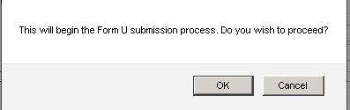
Click the ‘OK’ button to continue the submission and proceed to the validation process.

Exhibit 5-26 shows a screen capture of the ‘Submission Process: Validation’ screen:
Exhibit 5-26: Submission Process: Validation Screen
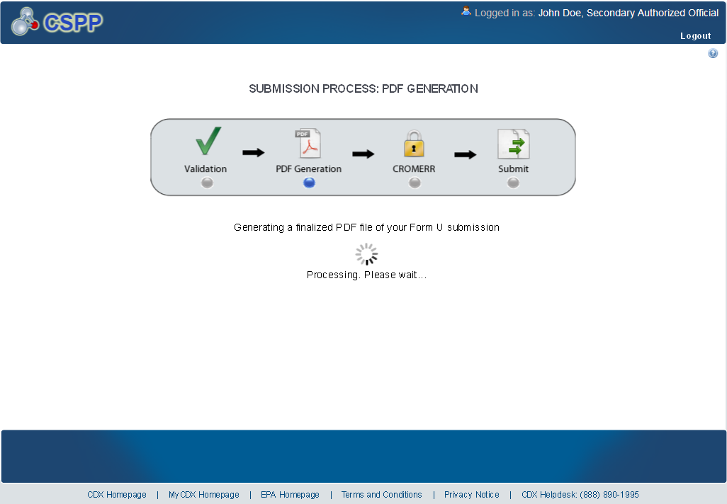
Once validation has been successfully completed, you have the option to preview the draft watermarked version of the Joint CDR Form U, which will be displayed as a PDF.

Exhibit 5-27 shows a screen capture of the ‘Submission Process: PDF Generation’ screen:
Exhibit 5-27: Submission Process: PDF Generation Screen
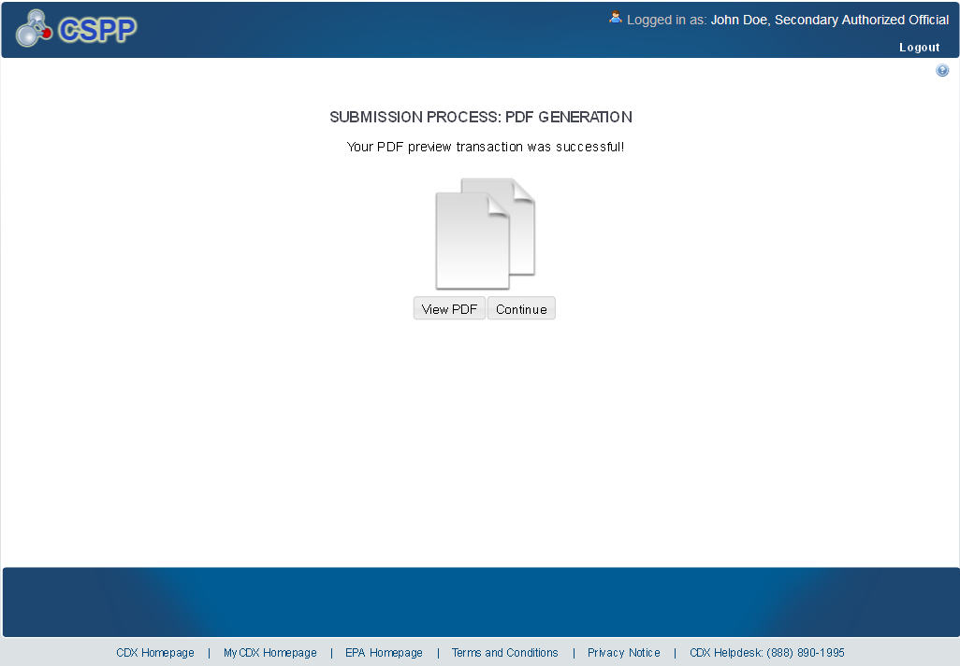
Navigation: Click the ‘View PDF’ button to view the Joint CDR Form U. A watermarked draft PDF version of the form will be displayed in a separate window. Once you are satisfied with the contents of the form, click the ‘Continue’ button to proceed with the submission process.
On the ‘Cross-Media Electronic Reporting Regulation (CROMERR) Certification’ screen, you will be asked to certify your submission. By clicking the ‘I Certify’ button on the CROMERR screen, you are authenticating all the information entered on the Joint CDR Form U and agreeing to take full responsibility for the submission of the data. If you are not yet ready to authenticate the information, click the ‘Cancel’ button.

Exhibit 5-28 shows a screen capture of the ‘Cross-Media Electronic Reporting Regulation (CROMERR) Certification’ screen:
Exhibit 5-28: Cross Media Electronic Reporting Regulation (CROMERR) Certification Screen
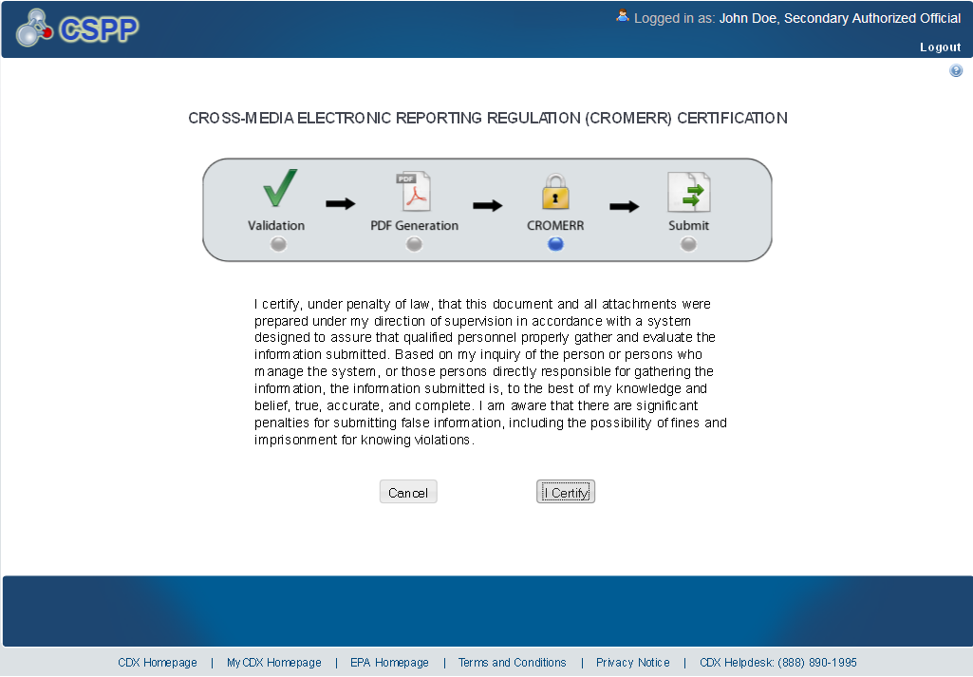
Navigation: Click the ‘I Certify’ button to navigate to the ‘CROMERR LOGIN’ screen.

CROMERR LOGIN
To submit the Joint CDR Form U, log in to CDX using the credentials you provided during CDX registration:
- Password: Enter your CDX registration password

Exhibit 5-29 shows a screen capture of the ‘CROMERR LOGIN’ screen:

Exhibit 5-29: CROMERR LOGIN Screen
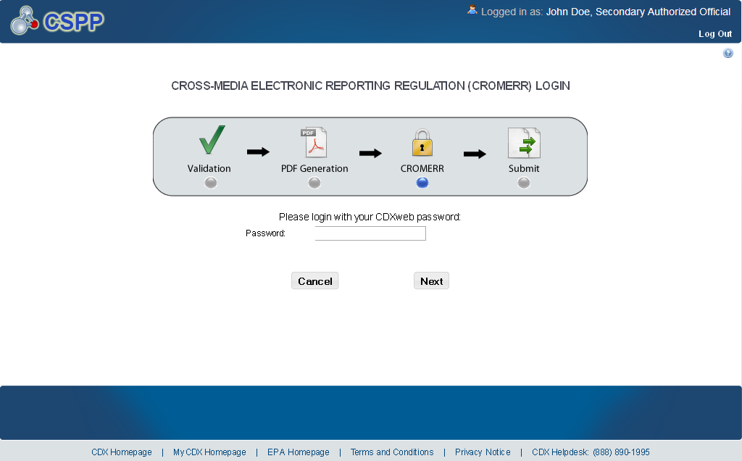
Navigation: Enter your CDX password and click the ‘Next’ button to navigate to the ‘Cross-Media Electronic Reporting Regulation (CROMERR) Security Question’ screen.

CROMERR Security Question
The ‘Cross-Media Electronic Reporting Regulation (CROMERR) Security Question’ screen randomly selects and displays one (1) of the five (5) CROMERR eSIG-PIN questions that you answered on the 20-5-1 question screen during CDX registration.
eSIG-PIN Authorization Code: Provide the answer to the question that was pulled from the list of CDX registration security questions.

Exhibit 5-30 shows a screen capture of the ‘Cross-Media Electronic Reporting Regulation (CROMERR) Security Question’ screen:

Exhibit 5-30: CROMERR Security Question Screen
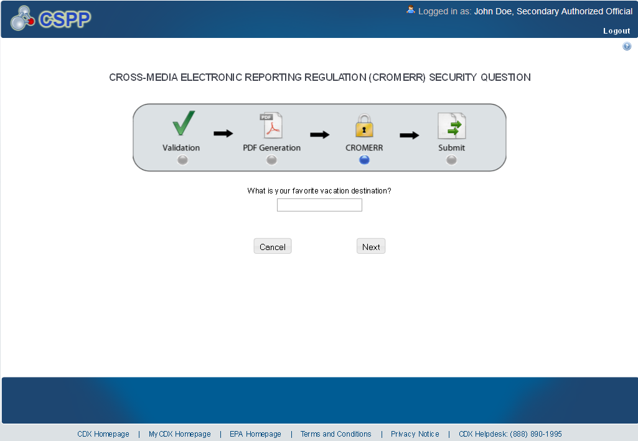
Navigation: Answer the security question and click the ‘Next’ button to navigate to the ‘Submit to CDX’ screen.

Submit to EPA via CDX
On the ‘Submit to CDX’ screen, you will see a certification message. Read the message and acknowledge by clicking the ‘Confirm’ button. Once you have clicked the ‘Confirm’ button, your Joint CDR Form U will be submitted to EPA.

Exhibit 5-31 shows a screen capture of the ‘Submit to CDX’ screen:

Exhibit 5-31: Submit to CDX Screen

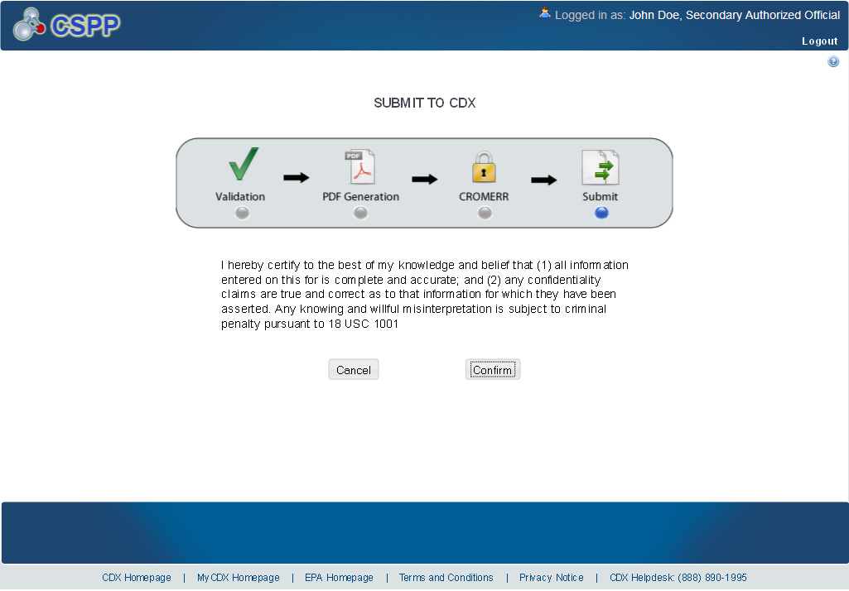
Navigation: Click the ‘Confirm’ button to navigate to the ‘Cross-Media Electronic Reporting Regulation (CROMERR) Submission’ screen.

CROMERR Submission
On the ‘Cross-Media Electronic Reporting Regulation (CROMERR) Submission’ screen, you will see a message indicating the submission has been successfully submitted to the EPA via CDX.

Exhibit 5-32 shows a screen capture of the ‘Cross-Media Electronic Reporting Regulation (CROMERR) Submission’ screen:
Exhibit 5-32: CROMERR Submission Screen

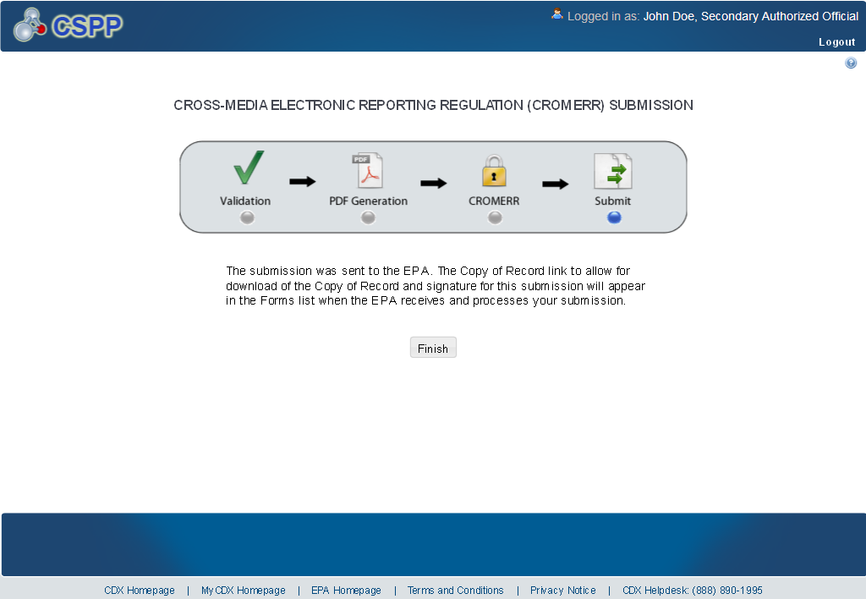
Navigation: Clicking the ‘Finish’ button will take you back to the ‘Home’ screen. Click the ‘Form U Access’ link to find your submitted Joint CDR Form U. On the ‘CDR Form U Access’ screen, the form will have a status of ‘Complete’ under the ‘Status’ column. In addition to displaying a status of ‘Complete,’ a lock icon () will be displayed under the ‘Action’ column. Only a Secondary AO can unlock a previously submitted Joint CDR Form U that has already been submitted. A Secondary AO will also need to unlock a Joint CDR Form U before a Support can amend the form.

Download Copy of Record
You may obtain a copy of your submitted Joint CDR Form U in accordance with CROMERR. To download a Copy of Record (CoR), navigate to the ‘CDR Form U Access’ screen and locate a site for which you have successfully submitted a Joint CDR Form U. The form should have a status of ‘Complete.’
Exhibit 6-33 shows a screen capture of the ‘CDR Form U Access’ screen with the download arrow icon () displayed:

Exhibit 6-33: CDR Form U Screen (Copy of Record)
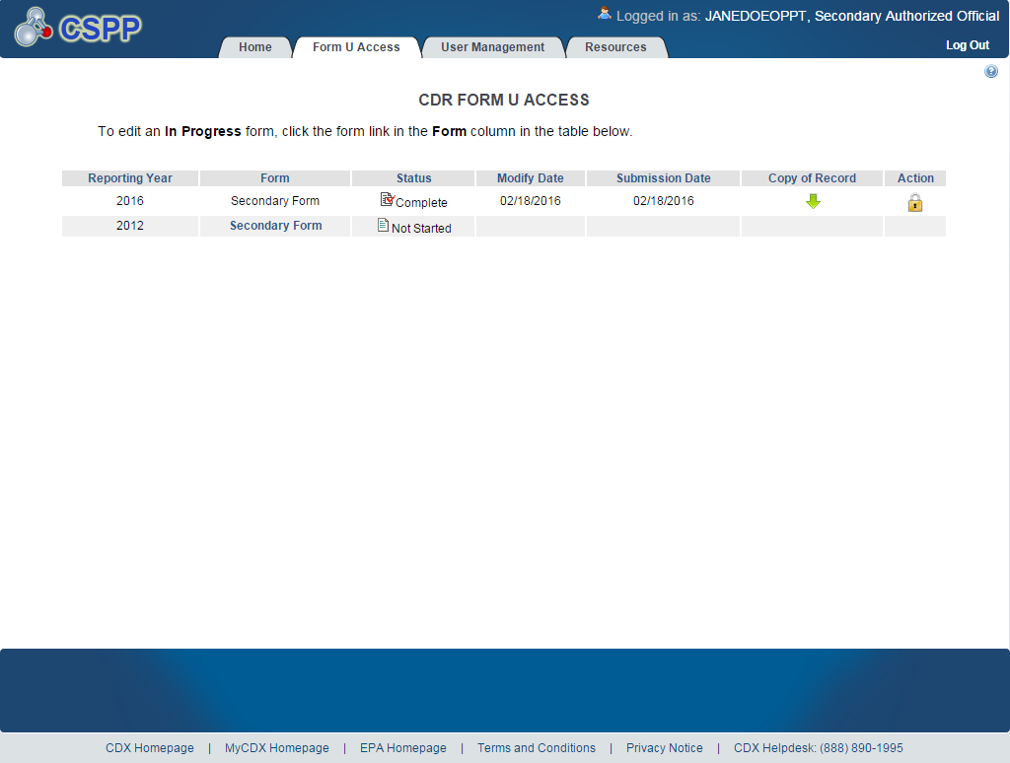

Navigation: Click the download arrow icon () under the ‘Copy of Record’ column. You will be taken to the ‘Enter Passphrase’ screen to enter the passphrase associated with that Joint CDR Form U. Once you have entered your passphrase, click the ‘Next’ button to navigate to the ‘Cross-Media Electronic Reporting Regulation (CROMERR) LOGIN’ screen. Enter your CDX login credentials and click the ‘OK’ button. If your login was successful, you will be taken to the ‘Cross-Media Electronic Reporting Regulation (CROMERR) Security Question’ screen. The ‘Cross-Media Electronic Reporting Regulation (CROMERR) Security Question’ screen randomly selects and displays one of the five CROMERR eSIG-PIN questions that you answered on the 20-5-1 question screen during CDX registration. Answer the CROMERR security question and click the ‘OK’ button. If your answer was correct, you will be taken to the ‘Copy of Record’ screen.

Exhibit 6-34 shows a screen capture of the ‘Copy of Record’ screen for downloading a CoR:
Exhibit 6-34: Copy of Record
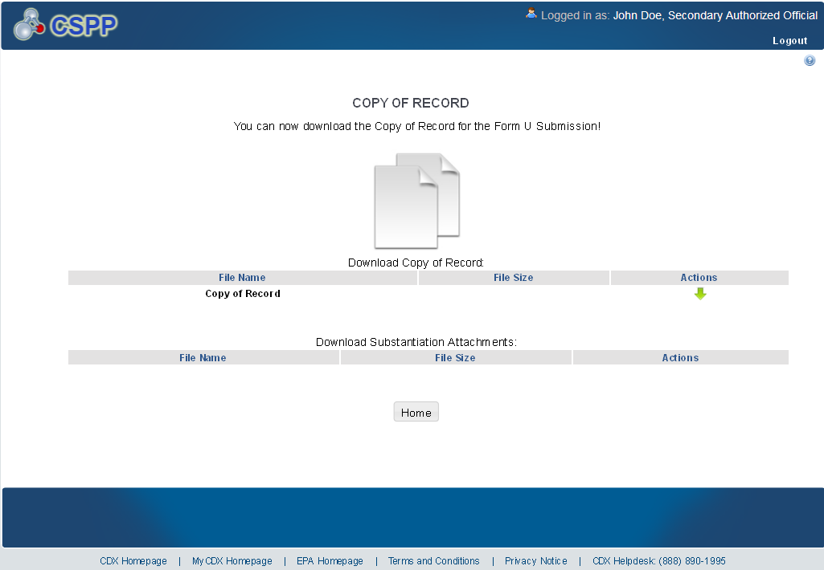
Click the download arrow icon () to download a PDF and an XML file of the Joint CDR Form U. Upon clicking the download arrow icon (), a download prompt will be displayed asking you to save the files to your local hard drive. Click the ‘Save File’ button and click the ‘OK’ button to download and save the zip file to your local hard drive.

Exhibit 6-35 shows a screen capture of the prompt screen:

Exhibit 6-35: Prompt Screen
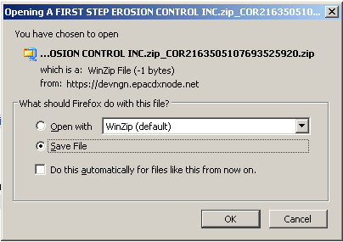
If you click the download arrow icon (), you will download:
- A PDF version of the CDR Form U
- An XML version of the CDR Form U

Create an Amendment
To amend a submitted Joint CDR Form U, navigate to the ‘CDR Form U Access’ screen and locate a secondary form for which you previously submitted a Joint CDR Form U. The form should display a status of ‘Complete’ under the ‘Status’ column. In addition to displaying a status of ‘Complete,’ the lock icon ( INCLUDEPICTURE "http://devngn.epacdxnode.net/cdx-oppt-iur/images/lock.png" \* MERGEFORMATINET ) will be displayed under the ‘Action’ column.
Exhibit 7-36 shows a screen capture of the ‘CDR Form U Access’ screen displaying the lock icon ( INCLUDEPICTURE "http://devngn.epacdxnode.net/cdx-oppt-iur/images/lock.png" \* MERGEFORMATINET ):
Exhibit 7-36: CDR Form U Access– Amendment
Navigation: Click the lock icon ( INCLUDEPICTURE "http://devngn.epacdxnode.net/cdx-oppt-iur/images/lock.png" \* MERGEFORMATINET ) under the ‘Action’ column to start an amendment.
After clicking the lock icon ( INCLUDEPICTURE "http://devngn.epacdxnode.net/cdx-oppt-iur/images/lock.png" \* MERGEFORMATINET ), you will receive a prompt to confirm the unlock process. If you unlock a Joint CDR Form U, you will be required to resubmit the form to EPA after you finish making your changes. If you do not want to continue with the amendment, click the ‘Cancel’ button to cancel the amendment process and return to the ‘CDR Form U Access’ screen. Click the ‘OK’ button to close the prompt and continue with the amendment. Since the amended form replaces the original form, verify that the amended form contains all of the information that needs to be submitted.

Exhibit 7-37 shows a screen capture of the unlock prompt:
Exhibit 7-37: Unlock Prompt
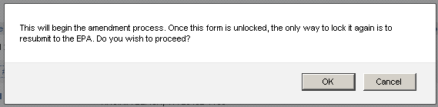
After you click the ‘OK’ button, you will be taken to the ‘Enter Passphrase’ screen. You must enter the passphrase that was originally associated with the CDR Form U to start the amendment process. After you enter the passphrase and click the ‘Next’ button you will be taken to the ‘Section 4.A – Secondary Company Information’ screen.
At this point, the ‘CDR Form U Access’ screen will display a status of ‘In Progress’ under the ‘Status’ column, and the unlocked icon ( INCLUDEPICTURE "http://devngn.epacdxnode.net/cdx-oppt-iur/images/unlock.png" \* MERGEFORMATINET ) will be displayed under the ‘Action’ column; however, you will not see these changes until you navigate back to the ‘CDR Form U Access’ screen.

Amendment and Late Submission Explanation
When you amend your submission, change only the information that needs to be changed. Your amended submission will replace your previous submission and therefore should be a complete Joint CDR Form U. After you finish editing or completing the form, you must provide an explanation as to why you are amending the original form. You can access the ‘Amendment and Late Submission Explanation’ screen by clicking the ‘Explanation’ link located under the ‘Amendment and Late Submission’ folder within the navigation tree.

Exhibit 7-38 shows a screen capture of the ‘Explanation’ link in the navigation tree:
Exhibit 7-38: Explanation Link
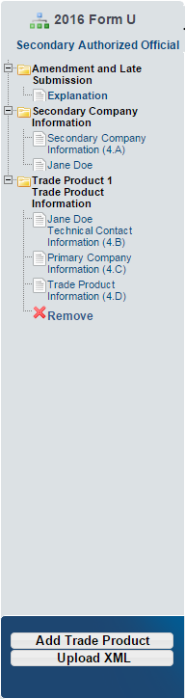

Exhibit 7-39 shows a screen capture of the ‘Amendment and Late Submission Explanation’ screen:
Exhibit 7-39: Amendment and Late Submission Explanation Screen
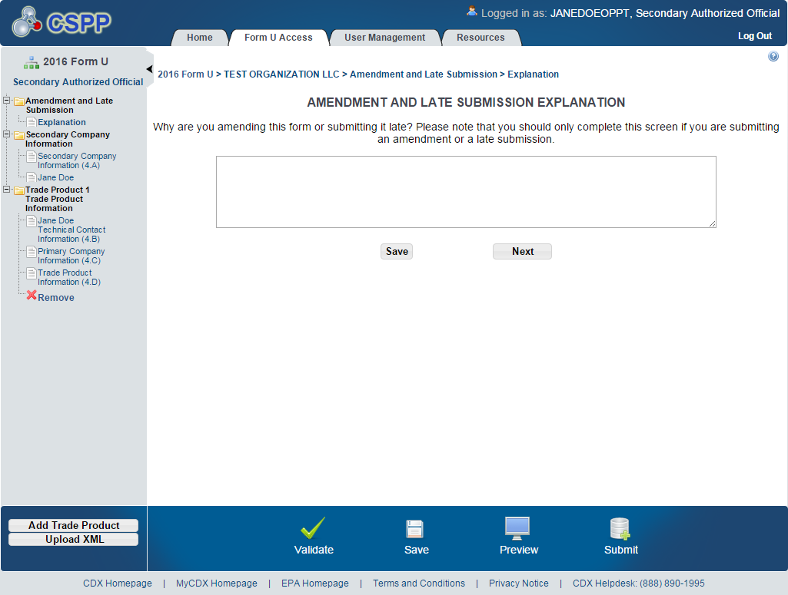
Once you finish editing the Joint CDR Form U and providing an explanation on the ‘Amendment and Late Submission Explanation’ screen, click the ‘Save’ button and submit the amended form to EPA as described in Section 5.

Resources
You can access the ‘Resources’ screen by clicking the ‘Resources’ tab located at the top of the screen at any time during the submission process. You can also access the ‘Resources’ screen by clicking on the ‘Resources’ link on the ‘Home’ screen. The ‘Resources’ screen provides you with links to all of the e-CDRweb user guides as well as links to additional resources. Click the ‘e-CDRweb User Guide’ link to access the e-CDRweb user guide documents.
Chemical Data Reporting Homepage: If you click on this link, a new internet browser window will display the CDR Homepage.
CDX Homepage: If you click on this link, a new internet browser window will display the CDX Homepage.
TSCA Chemical Substances Inventory: If you click on this link, a new internet browser window will display the ‘TSCA Chemical Substances Inventory’ screen.
Exhibit 8-40 shows a screen capture of the ‘Resources’ screen:
Exhibit 8-40: Resources Screen
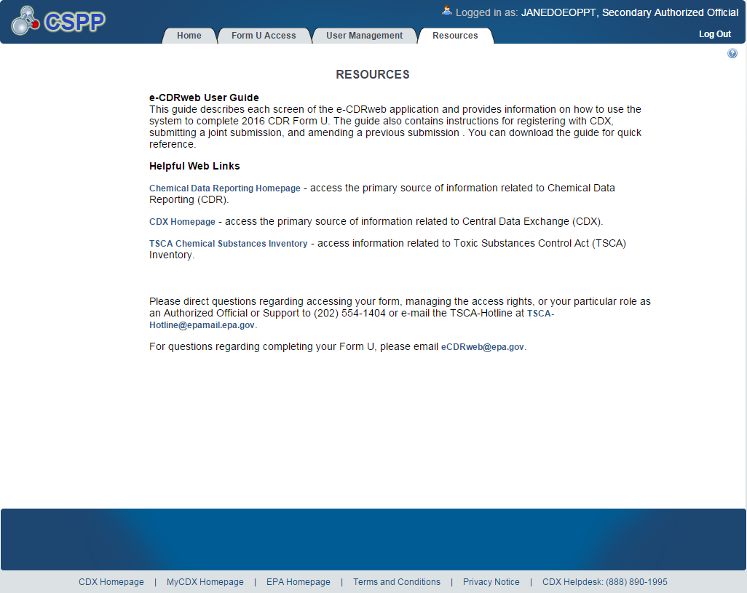

Appendix A. Acronyms and Abbreviations
The following exhibit displays all the acronyms and abbreviations used in this document:
Acronym | Full Name
AO | Authorized Official
CA | Chemical Abstract
CASRN | Chemical Abstract Service Registry Number
CDR | Chemical Data Reporting
CDX | Central Data Exchange
CoR | Copy of Record
CROMERR | Cross-Media Electronic Reporting Regulation Security System
CSPP | Chemical Safety and Pesticide Programs
D&B | Dun and Bradstreet
EPA | Environmental Protection Agency
e-CDRweb | Chemical Data Reporting web
ID | Identifier
OPPT | Office of Pollution Prevention and Toxics
PDF | Portable Document Format
SRS | Substance Registry Services
TSCA | Toxic Substances Control Act
XML | Extensible Markup Language

