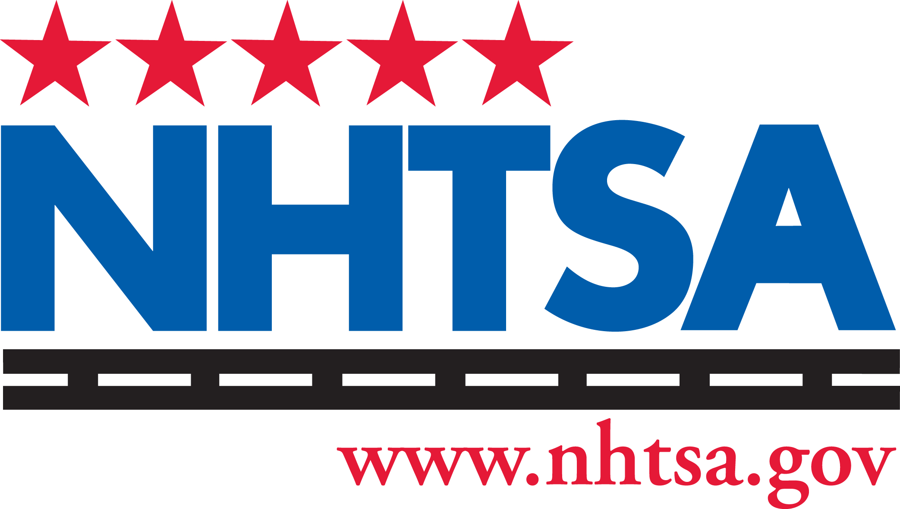National Highway Traffic Safety Administration
Our Mission: Save lives, prevent injuries, reduce vehicle-related crashes

Statement of Conformity
(April 2013)

OMB No. 2127-0002
Exp. 04-30--2017

Import and Certification Division 1200 New Jersey Ave., SE, Room W45-205
Washington, DC 20590
Fax: 202-493-0073
Website Address: www.nhtsa.dot.gov/cars/rules/import/

RI Name

Model Year

Customs Entry #

RI #

Address Where Vehicle Was Conformed

Make/Model

VIN

Entry Date

Port Code

Manufacture Date (Mo/Yr)
Service Insurance Policy #

Odometer ( ) miles ( ) km

Insurer

Address Where Vehicle Can Be Inspected
Vehicle Type

Is this your initial certification for this make, model, and model

Vehicle Eligibility #
year?
Yes No

Conformity to the FMVSS and other applicable requirements has been accomplished by one of the following:
O - Conformed at time of original manufacture M - Modified to conform after original manufacture N - Not applicable

No. | FMVSS | O | M | N | No. | FMVSS | O | M | N | No. | FMVSS | O | M | N

101 | Controls and Displays | 129 | Non-Pneumatic Tires | 220 | School Bus Rollover Protection
102 | Transmission Shift Sequence | 131 | School Bus Pedestrian Safety | 221 | School Bus Joint Strength
103 | Windshield Defrosting, Defogging | 135 | Light Vehicle Brake Systems | 222 | School Bus Seating/Crash Protection
104 | Windshield Wiping and Washing | 138 | Tire Pressure Monitoring System | 223 | Rear Impact Guards
105 | Hydraulic and Electric Brake Systems | 139 | New Pneumatic Radial Tires | 224 | Rear Impact Protection
106 | Brake Hoses | 201 | Occupant Protection Interior Impact | 225 | Child Restraint Anchorage Systems
108 | Lamps, Reflective Devices | 202 | Head Restraints | 226 | Ejection Mitigation
109 | New Pneumatic Tires | 203 | Impact Protection From Steering | 301 | Fuel System Integrity
110 | TIre Selection and Rims | 204 | Steering Control Rearward | 302 | Flammability of Interior Materials
111 | Review Mirrors | 205 | Glazing Materials | 303 | Fuel System Integrity of CNG Vehicles
113 | Hood Latch System | 206 | Door Locks and Retention Components | 304 | CNG Fuel Container Integrity
114 | Theft Protection | 207 | Seating Systems | 305 | Electric-Powered Vehicles
116 | Motor Vehicle Brake Fluids | 208 | Occupant Crash Protection | 401 | Internal trunk release
118 | Power Operated Window Systems | 209 | Seat Belt Assemblies | 404 | Platform Lift Installations
119 | New Pneumatic Tires | 210 | Seat Belt Assembly Anchorages | 500 | Low Speed Vehicles
120 | TIre Selection and Rims | 212 | Windshield Mounting |  | 49 CFR
121  122 | Air Brake Systems  Motorcycle Brake Systems | 213  214 | Child Restraint Systems  Side Impact Protection | 565 | VIN Requirements
123 | Motorcycle Controls and Displays | 216 | Roof Crush Resistance | 567 | Certification
124  126 | Accelerator Control Systems  Electronic Stability Control | 217  219 | Bus Exits, Window Retention, Release  Windshield Zone Intrusion | 581 | Bumper Standard
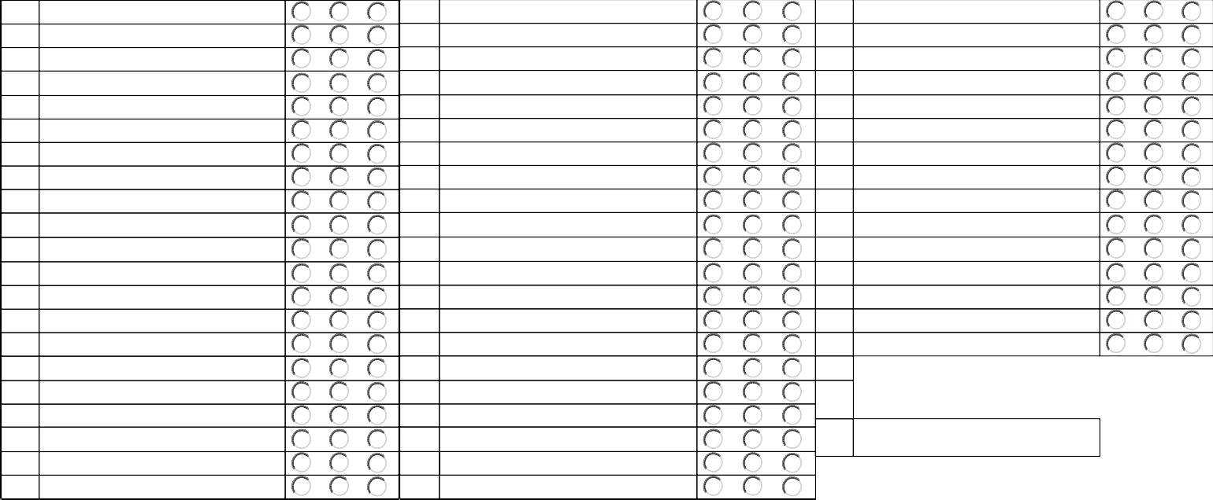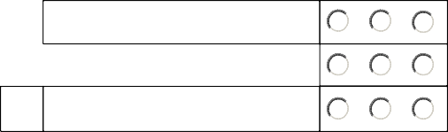I state and provide substantiation that (check only one):
120 | TIre Selection and Rims | 212 | Windshield Mounting
121 | Air Brake Systems | 213 | Child Restraint Systems
122 | Motorcycle Brake Systems | 214 | Side Impact Protection
123 | Motorcycle Controls and Displays | 216 | Roof Crush Resistance
124 | Accelerator Control Systems | 217 | Bus Exits, Window Retention, Release
126 | Electronic Stability Control | 219 | Windshield Zone Intrusion

The vehicle is not subject to any safety recalls as of the time of such certification, or

All noncompliances and defects that are the subject of safety recalls have been remedied.
I certify that (check only one):
The vehicle is not required to comply with the parts marking requirements of the Theft Prevention Standard "Part 541", or

The vehicle, as manufactured or as modified prior to importation, complies with those parts marking requirements.
I certify that (check only one):
I know that the vehicle I am certifying conforms with all applicable Federal motor vehicle safety and bumper standards because I personally witnessed each modification performed on the vehicle to effect compliance, or
I know that the vehicle I am certifying conforms with all applicable Federal motor vehicle safety and bumper standards because the person who performed the necessary modifications to the vehicle is an employee of the above named RI and has provided full documentation of the work that I have reviewed, and I am satisfied that the vehicle as modified complies.
I certify that noncompliant motor vehicle equipment items that were removed from this imported vehicle in the course of performing conformance modifications have been (check only one):

Destroyed,
Exported, or Not Applicable.
RI or Designated Representative Signature:
* (*Must be original, not machine stamp, etc.)

Print Name:

Designation: Date:

PAPERWORK REDUCTION ACT STATEMENT: A federal agency may not conduct or sponsor, and a person is not required to respond to, nor shall a person be subject to a penalty for failure to comply with, a collection of information subject to the requirements of the Paperwork Reduction Act unless that collection of information displays a current valid OMB Control Number. The OMB Control Number for this information collection is 2127-0002. The information collected on this form is necessary to obtain a letter from NHTSA releasing the DOT Conformance bond furnished on form HS-474 to ensure that an imported nonconforming vehicle is brought into conformity with all applicable Federal motor vehicle safety standards within 120 days from its date of importation, or is exported from or abandoned to, the United States. The information is used to verify that the vehicle conforms to, or has been brought into conformity with, all applicable Federal motor vehicle safety and bumper standards. We estimate that it will take approximately 30 minutes to complete the form. The information collected is mandatory under 49 U.S.C. § 30141(d) and 49 CFR 49 CFR 591.5(f). Send comments regarding this burden estimate or any other aspect of this collection of information, including suggestions for reducing this burden to: Information Collection Clearance Officer, National Highway Traffic Safety Administration, 1200 New Jersey Ave, S.E., Room W45-205, Washington, DC, 20590.
NHTSA Form 1484

