**United States Department of Agriculture**

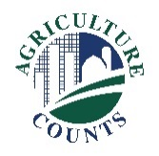

National Agricultural Statistics Service

[Choose office]

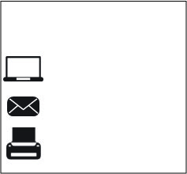

**What should I do next?**

Complete your survey in one of the following ways:

**Online** at [www.agcounts.usda.gov](http://www.agcounts.usda.gov) beginning on [Click for date] ***Online reporting is fast, cost-effective, and secure.*** All you need is the 17-digit survey code on the enclosed form to begin.

By **mail or fax**. Complete the survey questionnaire and mail it back in the return envelope provided or fax it to [Click to enter FAX # - text].

Click here to enter a date

**Why am I getting this letter?**

Enclosed is your [Click here to add Survey Title - text] Survey. Please complete the questionnaire at your earliest convenience. Your information is important. [Click here to enter a brief description of survey benefits]

**How will the data be used?**

[Click here to describe how these survey data are used]

If we do not hear from you by [Click for date], we [Choose one] attempt to contact you to arrange an interview.

Your responses to this survey will be kept confidential and will be available in aggregate form only, ensuring that no individual operation or producer can be identified, as required by federal law. We will publish the survey findings in the [Click here to enter report name – text] report, to be released [Click to add release date].

Thank you for participating and for your support of our programs and U.S. agriculture. If you have any questions, please feel free to contact us at [Click to enter phone number, email, etc. - text].

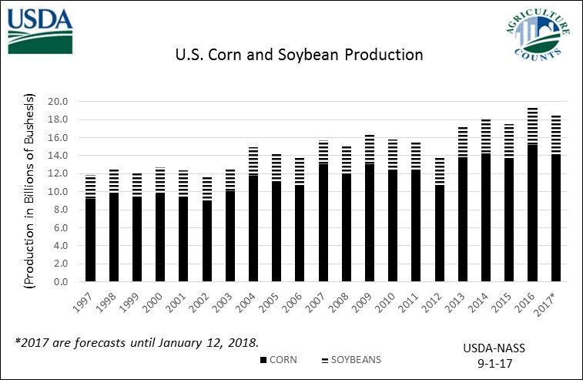Sincerely,

[Click here to enter – Name]

Director/State Statistician, [Choose office]

Enclosure