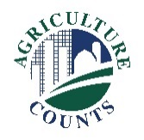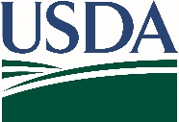**United States Department of Agriculture**

National Agricultural Statistics Service

Eastern Mountain Regional Field Office

**What should I do next?**

Complete your survey in one of the following ways:

**Online** at [www.agcounts.usda.gov](http://www.agcounts.usda.gov) beginning on August 27. ***Online reporting is fast, cost-effective, and secure.*** All you need is the 17-digit survey code on the enclosed form to begin.

By **mail** or **fax**. Complete the survey questionnaire and mail it back in the return envelope provided or fax it to 855-270-2708.



August 27, 2018

**Why am I getting this letter?**

Enclosed is your September 2018 Turkeys Raised Survey. Please complete the questionnaire at your earliest convenience. Your information is important. Turkey producers, processors, retailers, analysts, agribusinesses, and others use the data from the Turkeys Raised survey to gain up-to-date inventory information and make critical decisions about production and marketing strategies. This September report provides data users with a preliminary estimate of turkeys being raised in the current calendar year.

If we do not hear from you by Monday, September 10, 2018, we will contact you to arrange a telephone interview.

The results of this survey will be available in aggregate form only, ensuring that no individual operation or producer can be identified, as required by federal law. We will publish the survey findings in the Turkeys Raised Report, to be released Friday, September 28, 2018 at 3:00 PM ET.

Thank you for participating and for your support of our programs and U.S. agriculture. If you have any questions, please feel free to contact us at 1-800-928-5277.

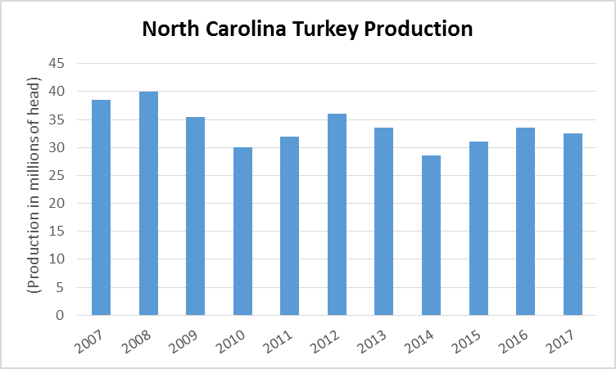

Enclosure

Sincerely,

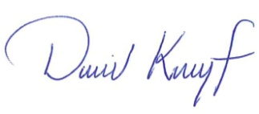

David Knopf

Director, Eastern Mountain Regional Field Office

U.S. Department of Agriculture

National Agricultural Statistics Service

PO Box 1120 Louisville, Kentucky 40201-1120

[www.nass.usda.gov](http://www.nass.usda.gov)

*USDA is an equal opportunity provider, employer, and lender.*