ReConnect Program – Notice of Inquiry

Summary of Comments

On July 27, 2018, the USDA invited comments from the public on the Rural e-Connectivity Pilot Program (“ReConnect Program”). Specifically, the USDA requested comments regarding (1) the definition of Sufficient Access, (2) the best ways to test broadband availability, and (3) measuring program outcomes. The public comment period closed September 10th.

Over 280 comments were received. 98-percent of which were supportive of USDA’s programs.

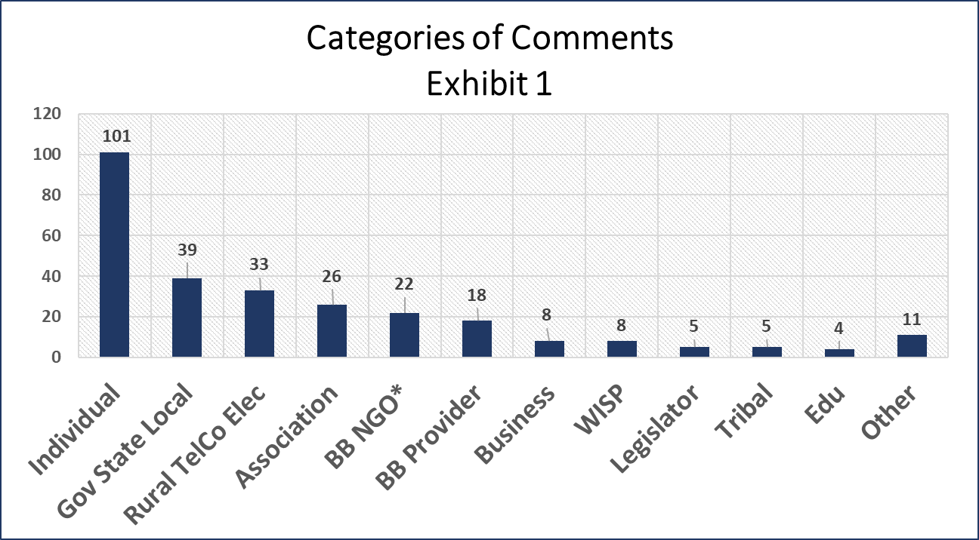**Comment Categories:**

Categories of comments reflect a diverse national range. The single largest category was from individuals, 37-percent. Most of these individuals complained about poor service defined as slow speeds, lack of access to reliable broadband and, or high cost of receiving service. 88-percent of all comments expressed dissatisfaction with their current service. Rural telephone or electric cooperatives from across the United States submitted 12-percent of comments. Generally, they were in support of expanded broadband and the inclusion of utilities as eligible applicants. Similarly, a national cross section of state and local government entities submitted 14-percent of comments. State and local government are strongly supportive of expansion of broadband. Nine percent of comments came from Associations of all types. Many comments suggest focusing on current, regional and future rural broadband needs, with a focus on scalability and capacity of broadband systems. See Exhibit 1.

* Community Based BB Advocates

**Eligible Rural Area Factors**

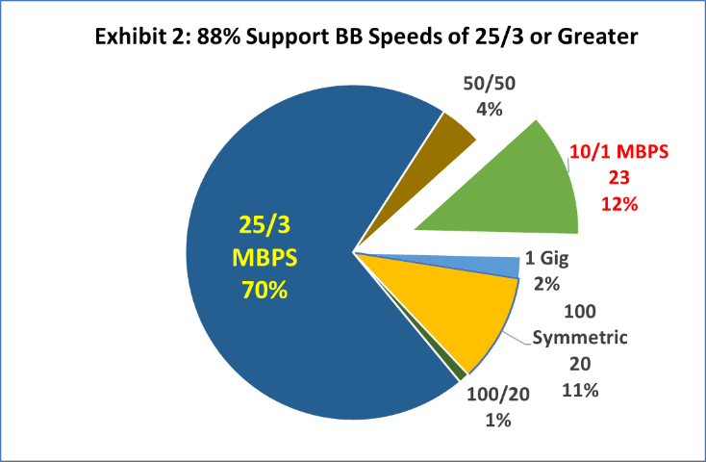**Broadband Speed**, 83-percent of comments identified broadband speed as important. 88-percent of those who specifically commented on speed felt that 25/3 mbps or higher should be the speed criterion defining *served*. Most felt that 10/1 mbps was too slow and that USDA should be consistent with the FCC 25/3 mbps standard. Other comments suggest that upload speed, latency and synchronous speeds should also be broadband criterion. See Exhibit 2.

**Affordability**, defined as *cost of monthly service or cost to connect* home to the nearest fiber was raised by two thirds of comments. Many of the comments suggested that *affordability be included in the definition of unserved*. The *cost to connect* to the nearest fiber was described as a barrier to broadband access. Many individual comments expressed frustration over the refusal of incumbent providers to connect them to higher speed broadband without high connection charges. See Exhibit 3.

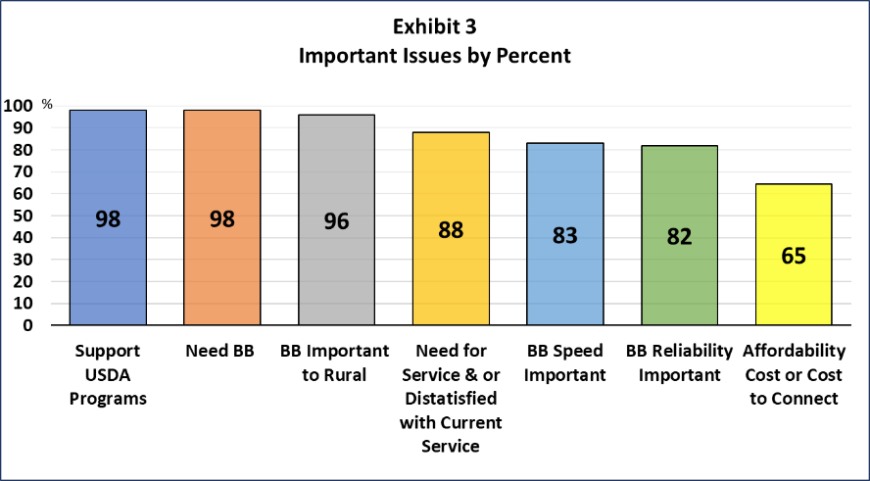**Reliability**, is as important as broadband speed, according to 82-percent of comments. Some felt that a *reliability metric* should be included in the *definition of “unserved”* and broadband capacity. Another metric suggested is *Rural Urban broadband equivalency*. Broadband reliability is critical from a business, telehealth and public safety emergency communication perspective. The spread of virtual at home employment raises the importance of business tier reliable broadband to the home. See Exhibit 3.

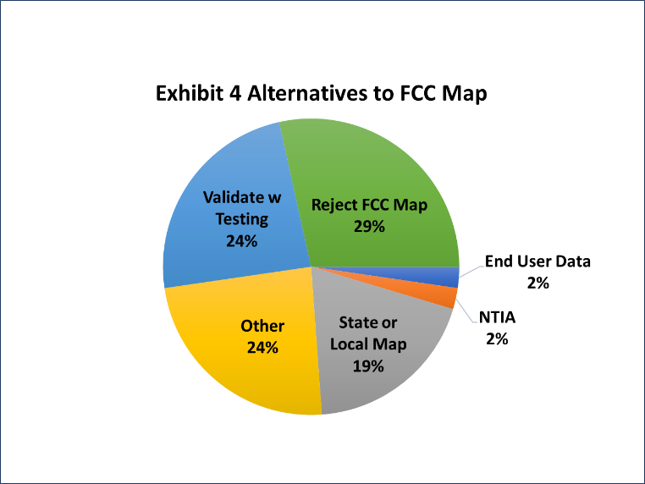**FCC Mapping or Testing**: 52-percent of comments on the FCC broadband maps *rejected using it* *for determination of broadband service.* The remainder made no comment. Of those who mentioned broadband mapping, 28-percent explicitly rejected the FCC map with no alternative suggested. 24-percent suggested validating with testing. These comments also complained that telecommunications companies were inaccurate or misleading in their claim of service. 19-percent suggested using state or local maps as a more accurate alternative. The California Public Utilities Commission offers its broadband map as more substantive and granular. Two-percent suggested using NTIA maps or end user data. Twenty-four-percent had a broad range of different ideas for better mapping alternatives to the FCC map. Commenters felt that the FCC methodology was flawed by (1) using Census Blocks which over represents service in rural areas, and (2) reliance on the advertised speeds from telecommunications companies. They suggest focusing on measuring the gap between *advertised speeds* available and *speeds delivered*; and testing for broadband service *during peak periods of* usage will help establish more accurate real world broadband maps. See Exhibit 4.

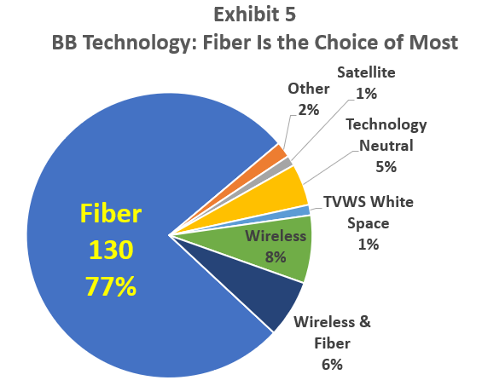**Type of Broadband Technology**: Fiber to the home is supported by 77-percent of those who expressed a view point. This is a diverse group that includes individuals, businesses, rural electrics, broadband providers. Interestingly, National Grange and the Western Governors Association are advocates of whitespace technology because of its potential to connect broadband to farm fields, also advocated by Microsoft. See Exhibit 5.