CHANCE LADDER
Having a heart attack
if you’re over 35
Average Annual Chance
1/77
A wildfire damaging or destroying your house
Dying from any kind of accident

1/200
HIGH CHANCE
1/3,000
Dying in a road accident
1/6,000
Dying from a fall
1/20,000
Dying from a fire
1/50,000
Dying from a lightning strike
1/2,000,000
LOW CHANCE
This “chance ladder” shows the chance of everyday hazards occurring to you over the next 12 months. If you are over 35 years old, the highest chance shown on the ladder is of having a heart attack (this will happen to approximately 1 in 77 people). The chance of your house being damaged by a wildfire if you live in or near a heavily wooded area (this will happen to approximately 1 in 200 homeowners) is quite a bit larger than the chance of dying from a fire (this will happen to approximately 1 in 50,000 people).

CHANCE GRIDS

(1) Annual chance

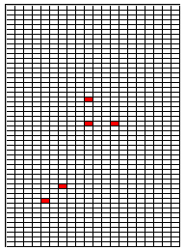
Another way to illustrate the Average Annual Chance of a wildfire damaging your house is shown in the diagram to the left. The “chance grid” shows a neighborhood with 1000 houses, and each square represents one house. The white squares are houses that have not been damaged or destroyed by wildfire, and the red squares are houses that have been damaged or destroyed. Consider this to be a typical, or average, occurrence each year for this neighborhood. To get a feeling for this chance level, close your eyes and place the tip of a pen inside the grid. If it touches a red square, this would signify your house was damaged or destroyed by wildfire.

(2) Ten year chance

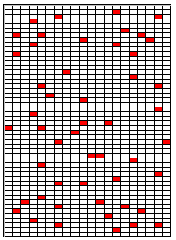
The chance that your house will be damaged by wildfire during a ten year period is approximately 10 times the chance that it would be damaged or destroyed in a single year. The Average Ten Year Chance is shown for the same neighborhood over a ten year period, where red squares represent houses that have been damaged or destroyed during a ten year period and white squares are houses that have not been damaged or destroyed.

YOUR EXPECTED TEN YEAR LOSS
Over a ten year period, the expected wildfire-related loss that you face can be calculated as the chance that a wildfire damages your house during that period multiplied (x) by the amount of damage. This includes the cost of rebuilding any portion of your home that is damaged, replacing its contents, replacing other property (such as cars), and landscaping. The general expected value approach is:

Expected Ten Year Loss = (Average Ten Year Chance of Wildfire Damaging or Destroying the house) x ($ Damage to Property)

For example, if the Average 10 year chance is 50/1,000, and if the damage to your property from a wildfire is $100,000, then the Expected Ten Year Loss is
$5,000 = 0.05 x $100,000

