**OMB Non-substantive Change Request**

**Title: Census Employment Inquiry**

**OMB Control Number: 0607-0139**

**Expiration Date: 08/31/2021**

**Proposed Changes to address fields on online form BC-172 (November 15, 2018)**

The U.S. Census Bureau would like to add clarifying information to the address fields on in their online job application, to assist applicants in providing the correct and full address information needed to process their applications. Part of the selection process includes ensuring the applicants live in the correct area of consideration for the position. If their addresses are not correct, this could slow the processing of the application. The changes are being requested for the online application only, as the paper applications are processed manually and can be corrected as they are processed, if necessary. We are requesting this change be approved by 12/6/2018.

The clarifying information includes, updating the instructions under “HOME ADDRESS” and “NEAREST CROSS STREETS TO YOUR HOME ADDRESS” sections. Providing additional instructions in parenthesis after the word “Address” on three lines, specifically “House Number and Street Name only” on the first address line, “Apartment [Apt]/Unit/Suite [Ste]/Floor/Building [Bldg]/Lot on the second address line, and “Puerto Rico applicants only” on the third address line. In addition, we would show a greyed out sample address in the spaces where the address will be typed by the applicant. See screen shot mock-ups below (Non-Title 13 data is shown).

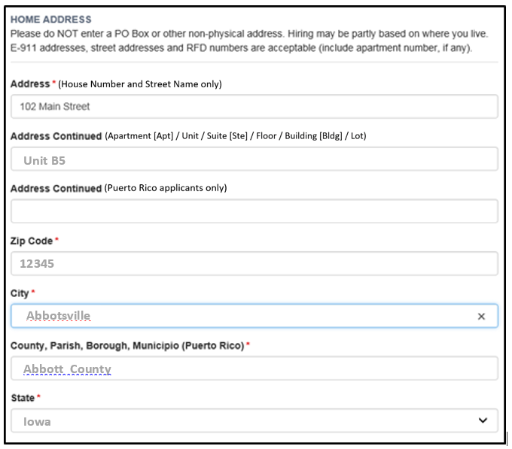

The physical address of your home helps determine your eligibility for many positions, please ensure your address is correct, including the spelling of streets and cities. Also, please include apartment or unit number, if you have one. Please do NOT enter PO Box or other non-physical address. E-911 addresses, street addresses and RFD numbers are acceptable.

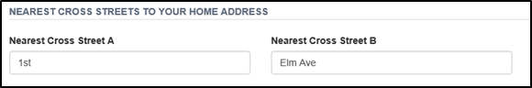

Enter the name of one or more of the nearest streets that intersect your street. Please do not put your own street name or address in these fields.