**Attachment H**

**Department of Commerce**

**United States Census Bureau**

**Annual Survey of Manufactures (ASM)**

**OMB Control No. 0607-0449**

**Eliminated Questions**

Item 5B Exports

Item 11 Inventories Outside of the United States

Email Support Statement from BEA

Item 5B – Exports:

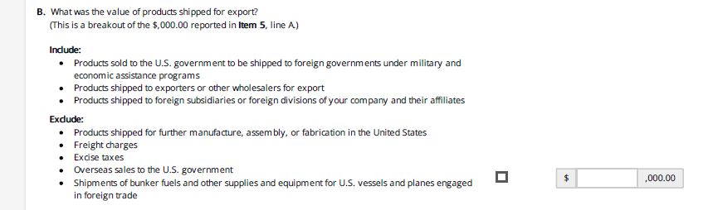

Item 11 Inventories Outside of the United States:

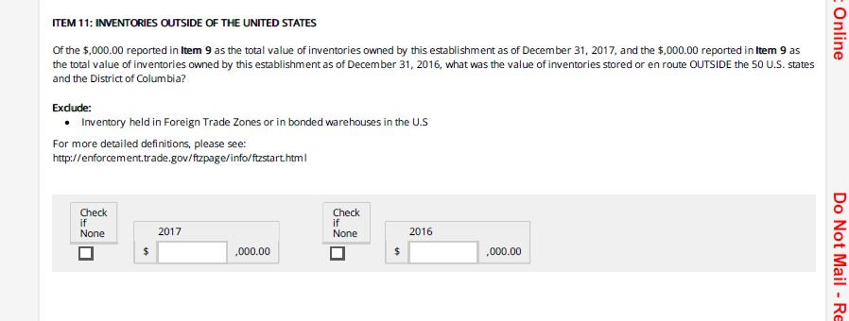

From: "Fixler, Dennis" <Dennis.Fixler@bea.gov>

Date: October 23, 2018 at 6:54:46 PM EDT

To: "Kimberly.P.Moore@census.gov" <Kimberly.P.Moore@census.gov>

Cc: "Julius Smith Jr (CENSUS/EWD FED)" <Julius.Smith.Jr@census.gov>, "Howells, Thomas" <Thomas.Howells@bea.gov>, "Wasshausen, David" <David.Wasshausen@bea.gov>, "Morgan, Edward" <Edward.Morgan@bea.gov>, "Burrell, Tiffany" <Tiffany.Burrell@bea.gov>

Subject: Foreign Inventory Question on ASM

Dear Kim,

The Bureau of Economic Analysis (BEA) supports the discontinuation of the foreign inventory questions on the Census Bureau’s Annual Survey of Manufacturers (ASM). We have been informed by the Census Bureau of the proposed change and support the decision. The modification being proposed to the form will not substantially affect our use of ASM data.

The data collected on the ASM is critical to key components of BEA’s economic statistics specifically our national income and product accounts (NIPAS), input-output (I-O) accounts and the gross domestic product by industry statistics.

We appreciate the Census Bureau’s diligence in always keeping us informed about modifications to this form. If you need additional information, please contact Tiffany Burrell, Source Data Coordinator, at tiffany.burrell@bea.gov.

Best Regards,

Dennis

Dennis Fixler

Chief Economist

Bureau of Economic Analysis