G.410 - PHS 398 Career Development Award Supplemental Form

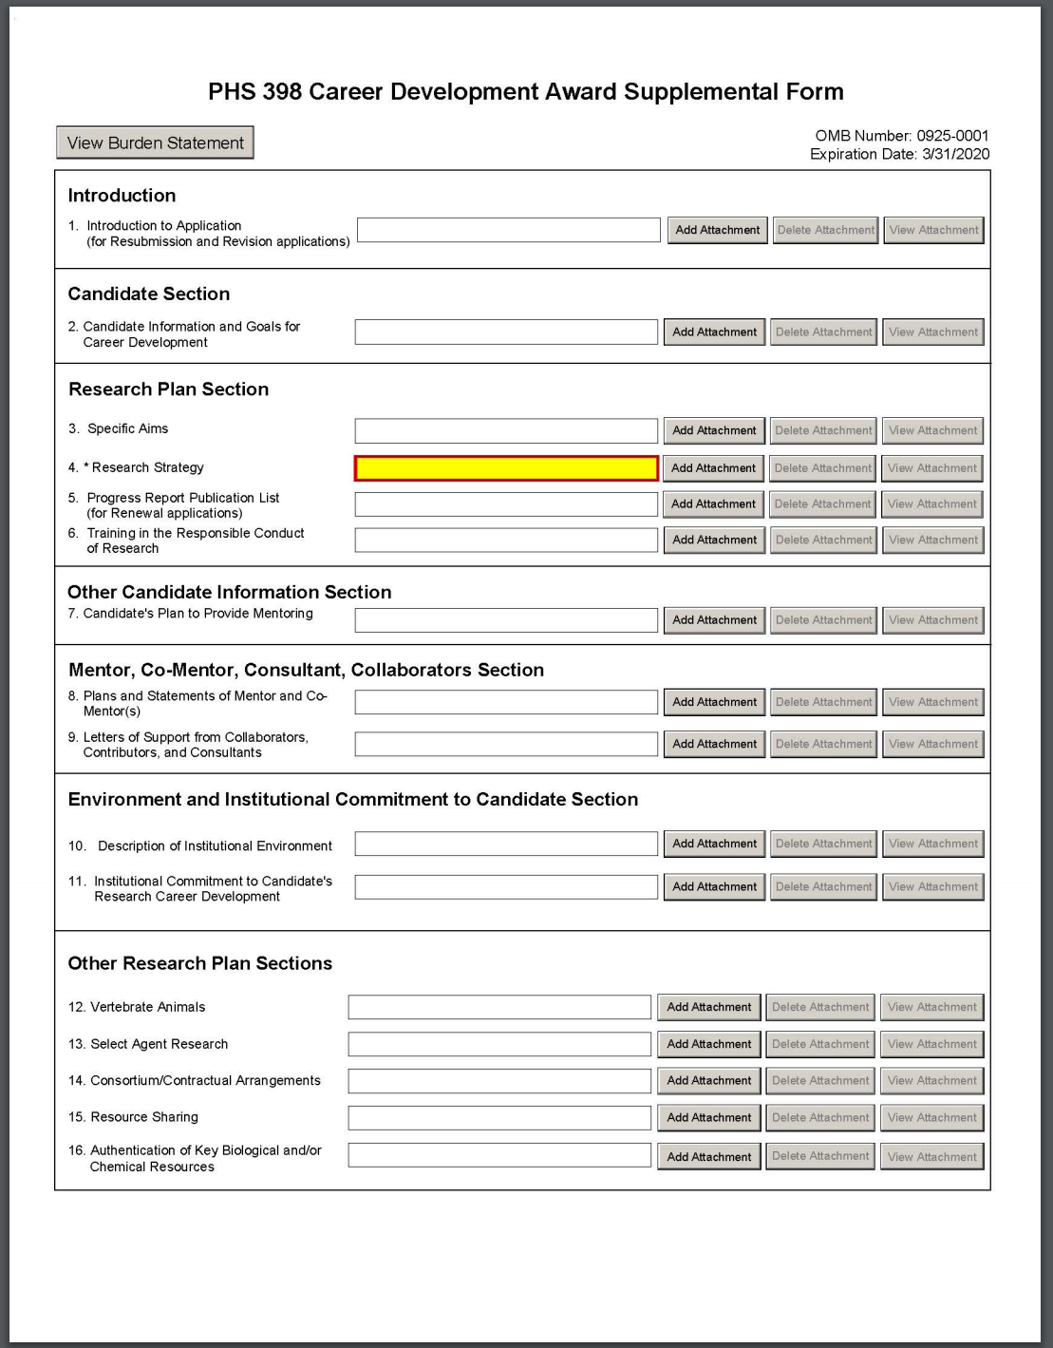

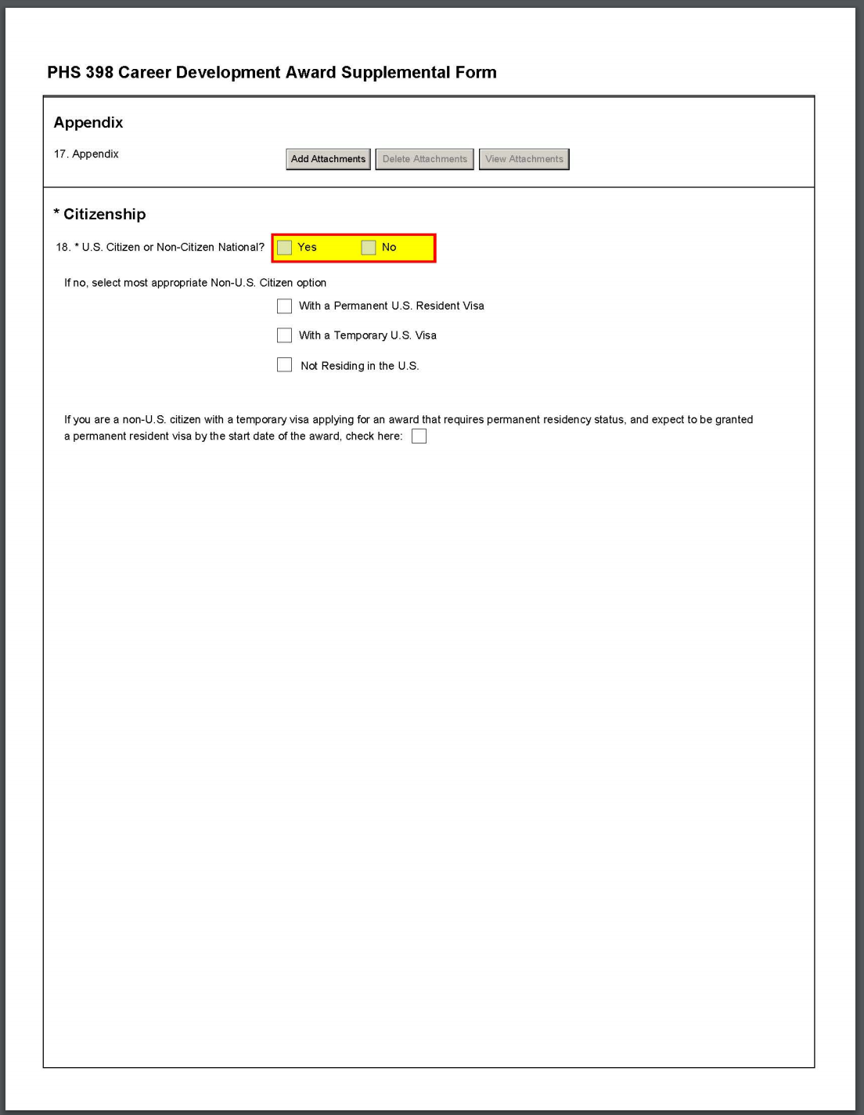

10. Description of Institutional Environment
Who must complete the "Description of Institutional Environment" attachment:
The “Description of Institutional Environment” attachment is required.
Format:
Follow the page limits for the Description of Institutional Environment in the NIH Table of Page Limits unless otherwise specified in the FOA.
Attach this information as a PDF file. See NIH's Format Attachments page.
Content:
Mentored CDA applicants: Describe the institution’s research and career development opportunities related to your area(s) of interest, including the names of key faculty members and other investigators relevant to your proposed developmental plan and capable of productive collaboration with the candidate. Indicate how the necessary facilities and other resources will be made available for both career enhancement and the research proposed in this application – refer to the resources description in G.220 - R&R Other Project Information Form, Facilities and Other Resources in your “Description of Institutional Environment” attachment. Describe opportunities for intellectual interactions with other investigators, including courses offered, journal clubs, seminars, and presentations.
The “Description of Institutional Environment” attachment must include a signed letter on institutional letterhead from a President, Provost, Dean, Department Chair, or other key institutional leader that describes and acknowledges institutional commitment to the following areas:
- Ensuring that proper policies, procedures, and oversight are in place to prevent discriminatory harassment and other discriminatory practices;
- Responding appropriately to allegations of discriminatory practices, including any required notifications to the HHS Office of Civil Rights; and
- Adopting and following institutional procedure for requesting NIH prior approval of a change in the status of the Program Director/Principal Investigator (PD/PI) or other senior/key personnel if administrative or disciplinary action is taken that impacts the ability of the PD/PI or other key personnel to continue his/her role on the NIH award as described in the training grant application.
For more information:
- NIH Guide Notice on Harassment and Discrimination Protections in NIH Career Development Applications
- NIH Grants Policy Statement, Section 4.1.2: Civil Rights Protections.
- NIH Grants Policy Statement, Section 8.1.2.6: Change in Status, Including Absence of PD/PI and Other Senior/Key Personnel Named in the NoA.

Non-mentored CDA applicants: Describe the institution’s research and career development opportunities related to your area(s) of interest, including the names of other faculty members who are willing to collaborate with you. Indicate how the necessary facilities and other resources will be made available for both career enhancement and the research proposed in this application – refer to the resources description in G.220 - R&R Other Project Information Form, Facilities and Other Resources in your “Description of Institutional Environment” attachment. Describe opportunities for intellectual interactions with other investigators, including journal clubs, seminars, and presentations.
The “Description of Institutional Environment” attachment must include a signed letter on institutional letterhead from a President, Provost, Dean, Department Chair, or other key institutional leader that describes and acknowledges institutional commitment to the following areas:
- Ensuring that proper policies, procedures, and oversight are in place to prevent discriminatory harassment and other discriminatory practices;
- Responding appropriately to allegations of discriminatory practices, including any required notifications to the HHS Office of Civil Rights; and
- Adopting and following institutional procedure for requesting NIH prior approval of a change in the status of the Program Director/Principal Investigator (PD/PI) or other senior/key personnel if administrative or disciplinary action is taken that impacts the ability of the PD/PI or other key personnel to continue his/her role on the NIH award as described in the training grant application.
For more information:
- NIH Guide Notice on Harassment and Discrimination Protections in NIH Career Development Applications
- NIH Grants Policy Statement, Section 4.1.2: Civil Rights Protections.
- NIH Grants Policy Statement, Section 8.1.2.6: Change in Status, Including Absence of PD/PI and Other Senior/Key Personnel Named in the NoA.

G. 420 – PHS 398 Research Training Program Plan Form

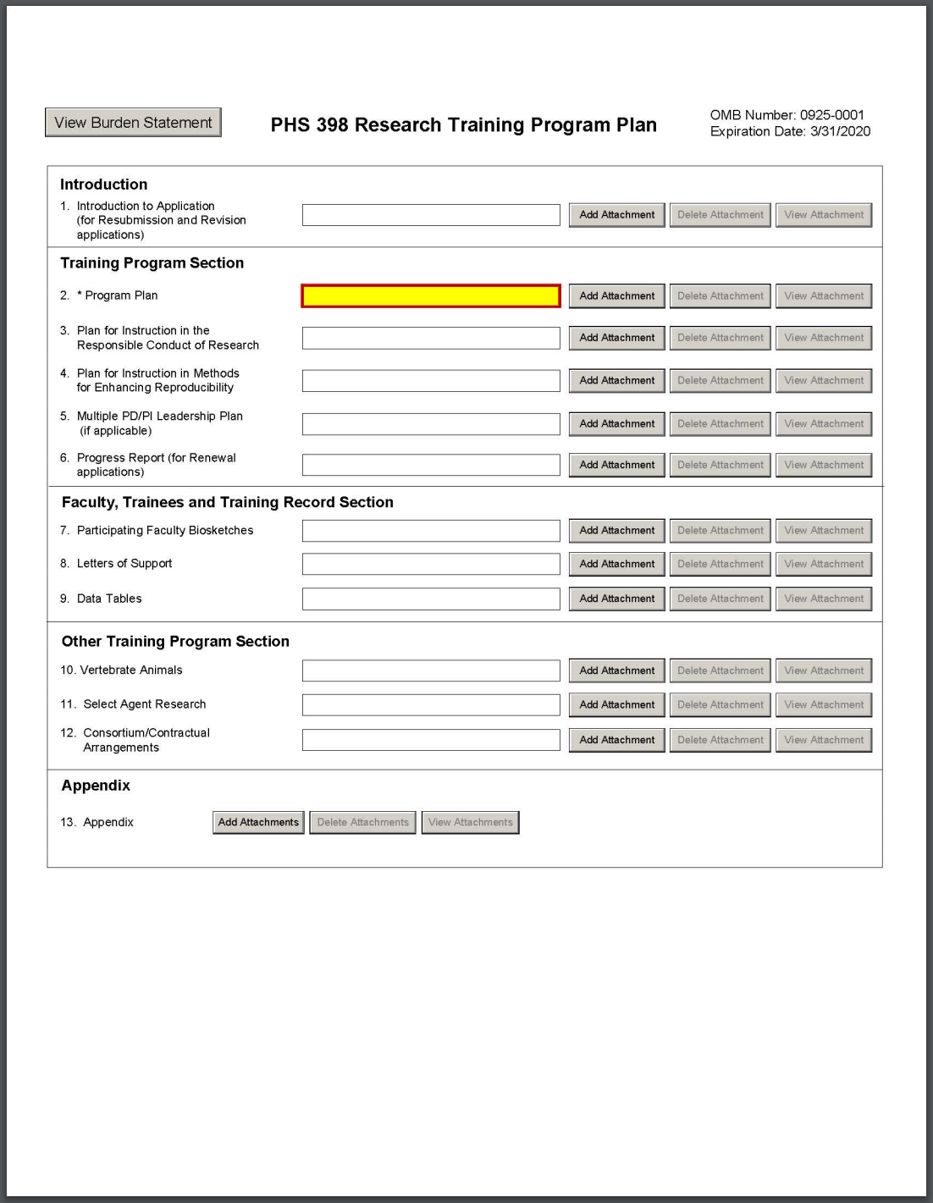
8. Letters of Support
Format:
Combine all Letters of Support into a single PDF file and attach this information here. Do not place these letters in the Appendix. Follow the attachment guidelines on NIH's Format Attachments page.
The Letters of Support instructions will be changing, effective January 25, 2019. Please note that there are two sets of “Content” instructions below, based on the application due dates.
For applications submitted for due dates on or before January 24, 2019:
Content:
Attach letters here from:
- Consultants, if applicable. Letters should include rate/charge for consulting services and confirm their role(s) in the project.
- Senior Administration Officials. This letter should be a signed letter on institutional letterhead, and it should describe the applicant institution’s commitment to the planned program.
Check the FOA (particularly for non-NRSA programs) to determine whether any additional program-specific letters of support are required.
For applications submitted for due dates on or after January 25, 2019:
Content:
Attach letters here from:
- Consultants, if applicable. Letters should include rate/charge for consulting services and confirm their role(s) in the project.
- Senior Administration Officials. This letter should be a signed letter on institutional letterhead, and it should describe the applicant institution’s commitment to the planned program.
- A President, Provost, Dean, Department Chair, or other key institutional leader. This letter should be a signed letter on institutional letterhead, and it should describe and acknowledge institutional commitment to the following areas:
- Ensuring that proper policies, procedures, and oversight are in place to prevent discriminatory harassment and other discriminatory practices;
- Responding appropriately to allegations of discriminatory practices, including any required notifications to the HHS Office of Civil Rights; and
- Adopting and following institutional procedure for requesting NIH prior approval of a change in the status of the Program Director/Principal Investigator (PD/PI) or other senior/key personnel if administrative or disciplinary action is taken that impacts the ability of the PD/PI or other key personnel to continue his/her role on the NIH award as described in the training grant application.
Check the FOA (particularly for non-NRSA programs) to determine whether any additional program-specific letters of support are required.
For more information:
- NIH Guide Notice on Harassment and Discrimination Protections in NIH Training Applications.
- NIH Grants Policy Statement, Section 4.1.2: Civil Rights Protections.
- NIH Grants Policy Statement, Section 8.1.2.6: Change in Status, Including Absence of PD/PI and Other Senior/Key Personnel Named in the NoA.

G.430 - PHS Fellowship Supplemental Form

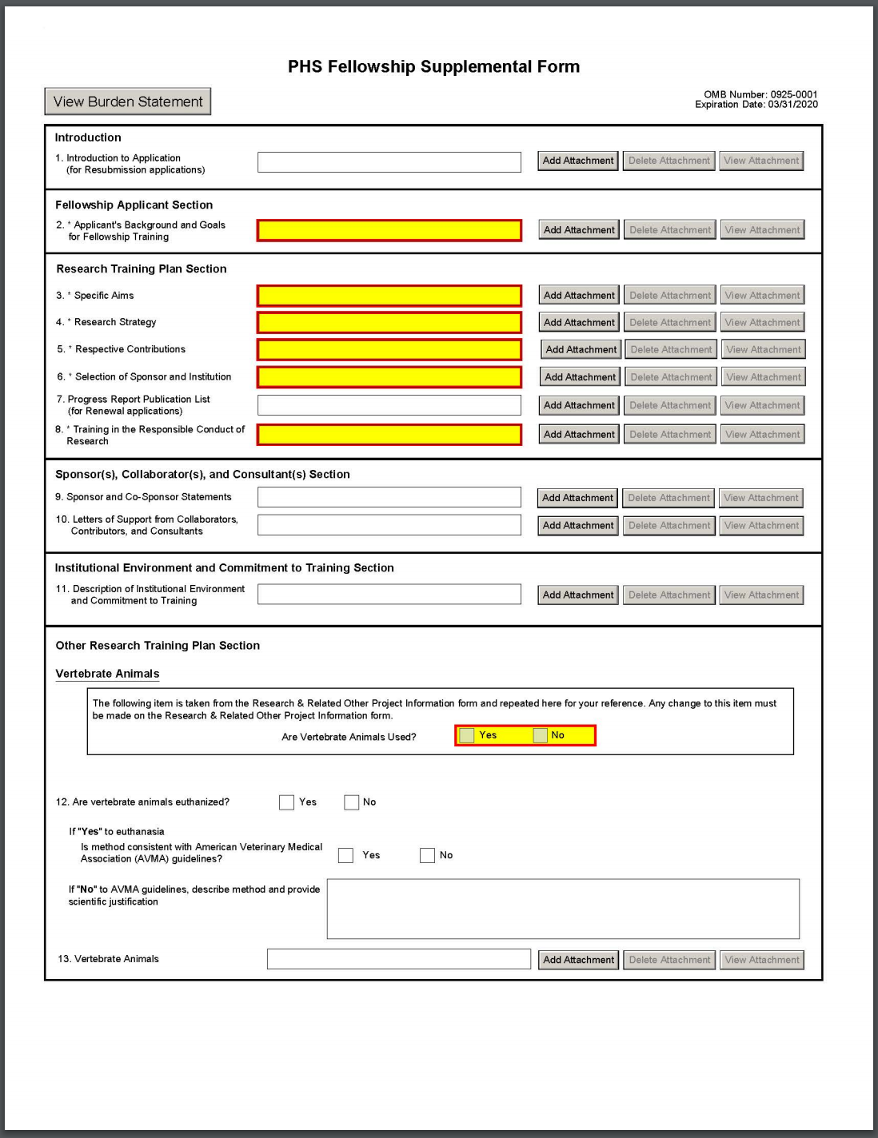

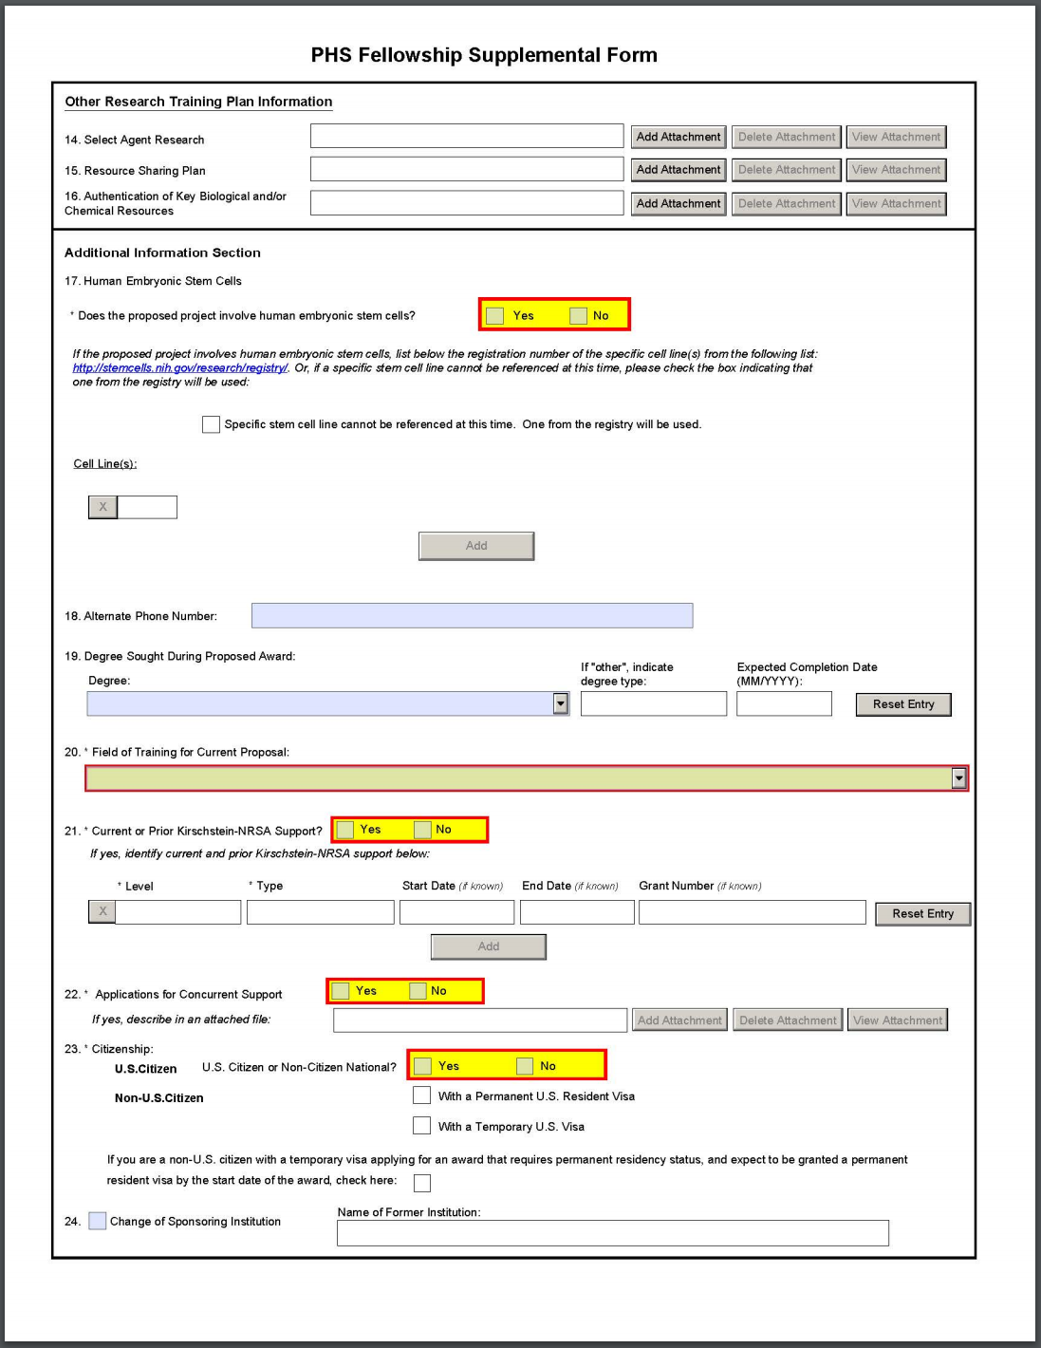

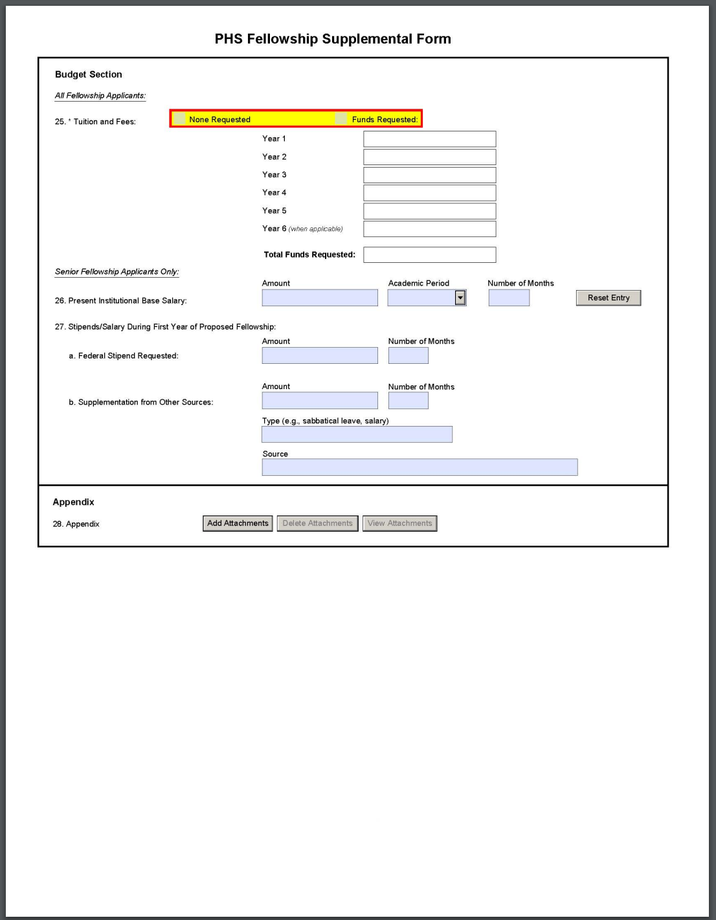

11. Description of Institutional Environment and Commitment to Training
Who must complete the “Description of Institutional Environment and Commitment to Training” attachment:
The “Description of Institutional Environment and Commitment to Training” attachment is required, and includes “Educational Information” for F30 and F31 applications.
Format:
Follow the page limits for the Description of Institutional Environment and Commitment to Training in the NIH Table of Page Limits unless otherwise specified in the FOA.
Attach this information as a PDF file. See NIH's Format Attachments page.
Content:
Document a strong, well-established research program related to the candidate's area of interest. Describe opportunities for intellectual interactions with other individuals in training and other investigators, including courses offered, journal clubs, seminars, and presentations. Indicate the facilities and other resources that will be made available for both career enhancement and the research proposed in this application. Refer to the resources description in G.220 - R&R Other Project Information Form, Facilities and Other Resources, and information provided in the Sponsor and Co-sponsor Statements attachment.
The “Description of Institutional Environment and Commitment to Training” attachment must include a signed letter on institutional letterhead from a President, Provost, Dean, Department Chair, or other key institutional leader that describes and acknowledges institutional commitment to the following areas:
- Ensuring that proper policies, procedures, and oversight are in place to prevent discriminatory harassment and other discriminatory practices;
- Responding appropriately to allegations of discriminatory practices, including any required notifications to the HHS Office of Civil Rights; and
- Adopting and following institutional procedure for requesting NIH prior approval of a change in the status of the Program Director/Principal Investigator (PD/PI) or other senior/key personnel if administrative or disciplinary action is taken that impacts the ability of the PD/PI or other key personnel to continue his/her role on the NIH award as described in the training grant application.
For more information:
- NIH Guide Notice on Harassment and Discrimination Protections in NIH Fellowship Applications.
- NIH Grants Policy Statement, Section 4.1.2: Civil Rights Protections.
- NIH Grants Policy Statement, Section 8.1.2.6: Change in Status, Including Absence of PD/PI and Other Senior/Key Personnel Named in the NoA.

F30 and F31 applications: Educational Information
Describe the institution’s dual-degree (F30) or graduate (F31) program in which the applicant is enrolled. This description should include the structure of the program, the required milestones and their usual timing, the number of courses, any teaching commitments, clinical requirements, qualifying exams, and the average time to degree over the past 10 years. Describe the progress/status of the applicant in relation to the program’s timeline, and the frequency and method by which the program formally monitors and evaluates a student’s progress.
For F30 applications specifically, describe any clinical tutorials during the graduate research years and any activities to ease transition from the graduate to the clinical years of the dual-degree program. Describe any research-associated activities during the clinical years of the dual-degree program.
Include the name of the individual providing this information at the end of the description. This information is typically provided by the director of the graduate program or the department chair.

