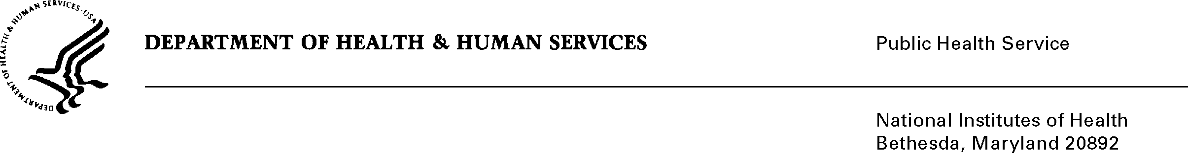
DATE: November 8, 2018

TO: Allan Beckmann
Office of Management and Budget (OMB)
Reports Clearance Officer, DHHS

FROM: Mikia P. Currie
Chief, Project Clearance Branch
National Institutes of Health (NIH)

SUBJECT: Change Request to a Currently Approved Form
(OMB # 0925-0001, Expiration Date 3/31/2020)

NIH is requesting a non-substantive change to Grant Application Instructions (G.410, G.420 and G.430) to inform the extramural community that institutional training grants (T), fellowship (F) and career development (K) applications for the NIH approved under 0925-0001, must include a letter on institutional letterhead signed by a key institutional leader that describes the institutional commitment to ensuring that proper policies, procedures, and oversight are in place to prevent discriminatory harassment and other discriminatory practices. This data will be imported into our system minimizing any additional burden to respondents.

Attachment A: Training, Fellowship, and Career Development (TFK) Form/Instructions

Your full consideration is appreciated.

