eWell Permitting and Reporting System

Logging into eWell
Go to https:// ewell.bsee.gov/ewell/
Select “Click here to login”
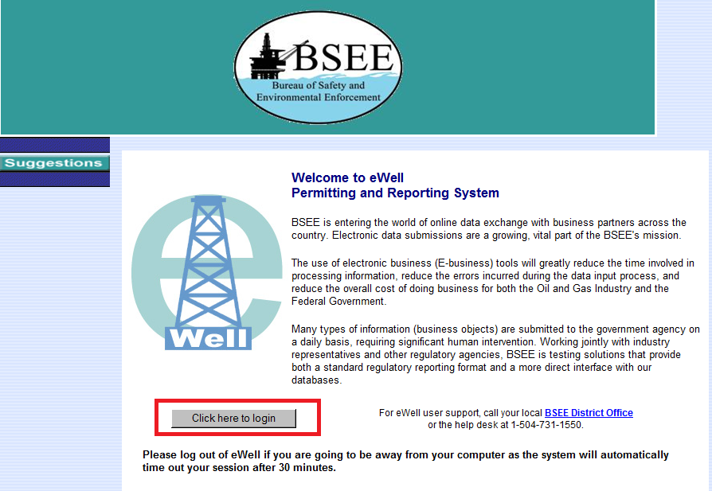

Enter username and [password and select “Login”
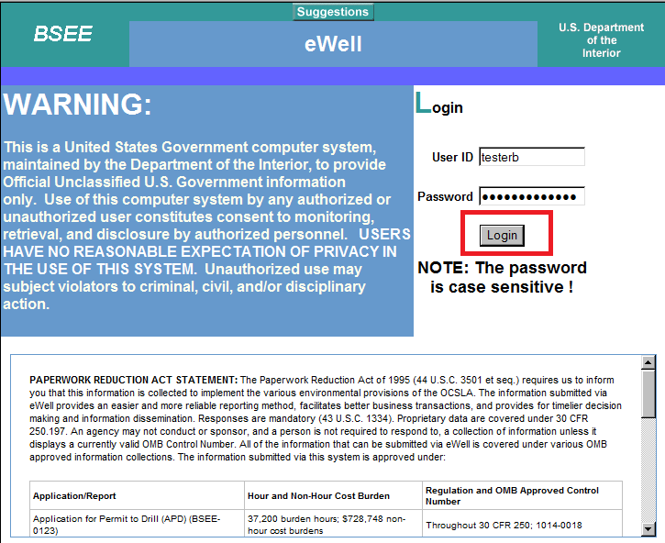
Select the OCS Region and lease operator for which you need to conduct business.
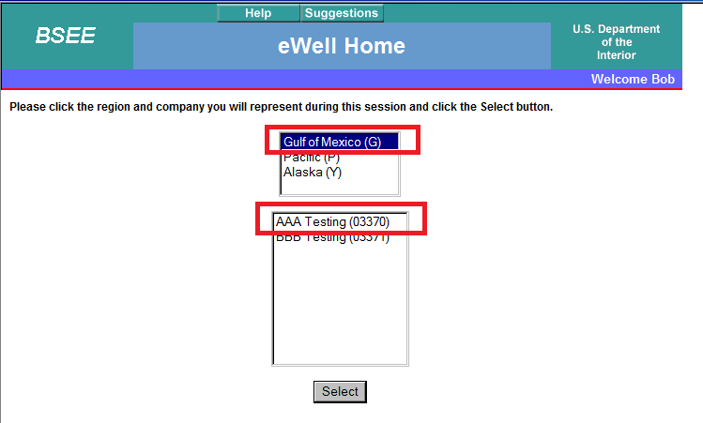
END OF OPERATIONS REPORTS

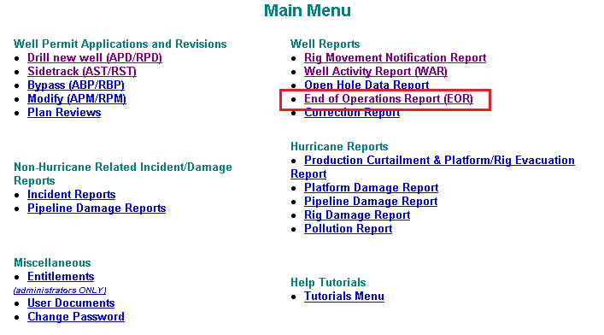

BSEE CREATES THE BLANK EOR WHEN BSEE DETERMINE A REPORT IS NEEDED.
OPERATORS COMPLETE AND SUBMIT THEM

Query the draft EOR. Select the draft EOR and select Edit.
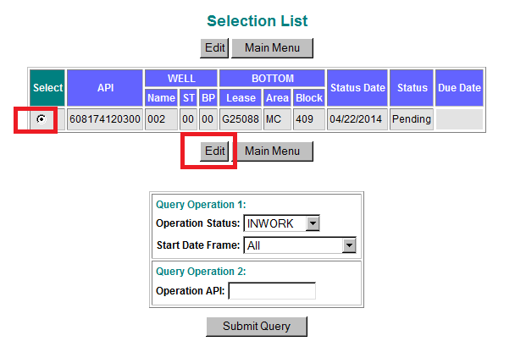

The draft EOR will be displayed. The menu groups the data collection based on the type of operation being reported on the End of Operation report.
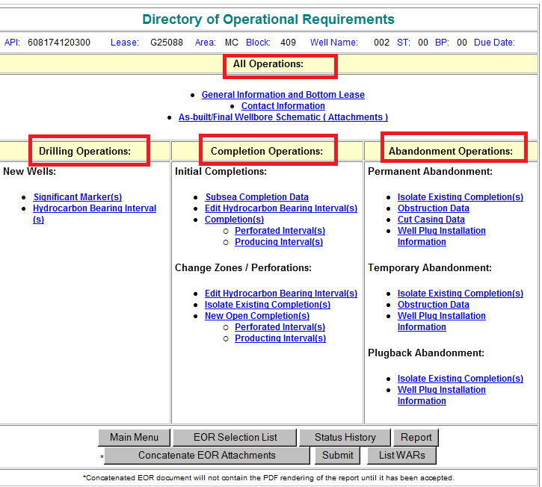

Start with “All Operations” which is populated for all EORs.

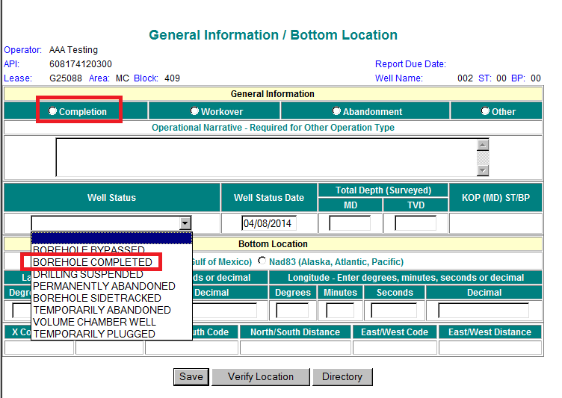

Record decimal degrees latitude and longitude, then Save and Verify Location to have The Application calculate the other data

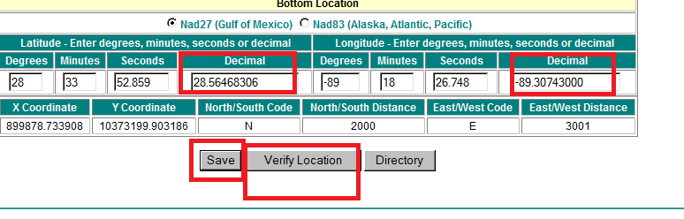
Attachments required by Regulation:

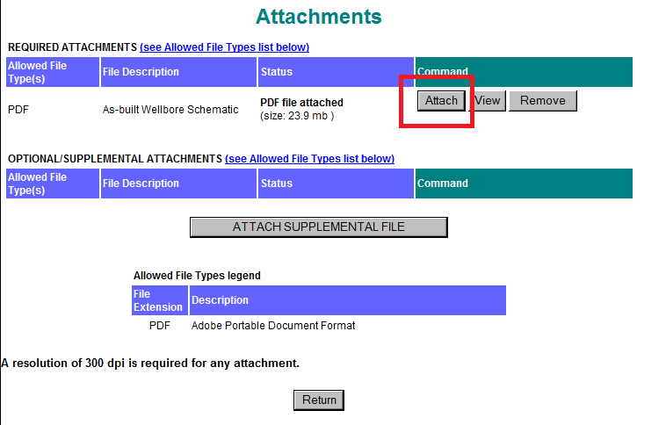

Significant Marker Data:

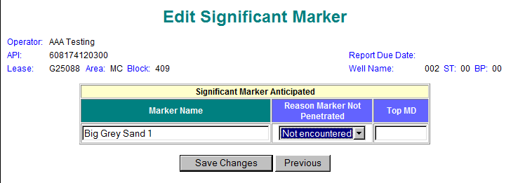

Hydrocarbon-bearing Zones data:

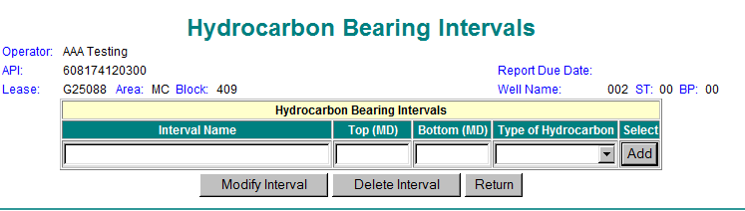

Well Abandonment Data:
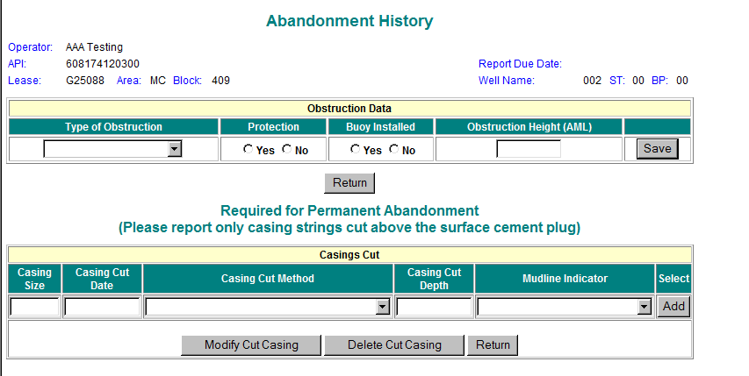

Well Plugs Data:

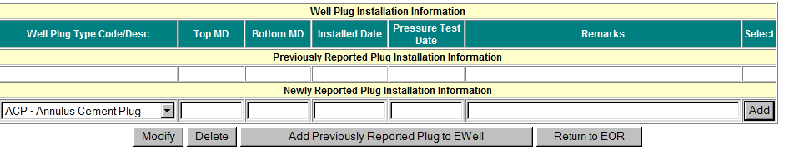

Well Completion Data:

