Trends in International mathematics and science study (TIMSS 2019) MAIN STUDY

OMB# 1850-0695 v.15

AppendiX A:
Main Study Recruitment Materials

&

Appendix B:
TIMSS 2019 Main Study Notification Letters and Supporting Materials

Submitted by:

National Center for Education Statistics
U.S. Department of Education
Institute of Education Sciences
Washington, DC

June 2017
revised November 2018

Appendix A: TIMSS 2019 Main Study Recruitment Materials
Contents
State TIMSS Main Study Letter 3
School District TIMSS 2019 Main Study Letter [First Tier/Second Tier] 4
School TIMSS 2019 Main Study Letter [First Tier/Second Tier] 5
Teacher TIMSS 2019 Main Study Letter 6
TIMSS 2019 Main Study Brochure Content: 8 ½ X 11in Tri-fold 7
TIMSS 2019 Main Study FAQ 11
Summary of School Activities 13
Email to School Coordinator (SC) for MyTIMSS Registration and to Provide School Information (PSI) 15
MyTIMSS Registration and Provide School Information (PSI) Guide 17
Automated Email for all MyTIMSS registrants 21
Automated Email for MyTIMSS School Coordinator registrant 22
MyTIMSS Login Page 23
MyTIMSS Home Page 25
MyTIMSS Provide School Information (PSI) Page 26
Email to School Coordinator (SC) to Submit Class and Student Lists—Grade 4 27
Instructions for Submitting Class Lists- Grade 4 28
Instructions for Submitting Student Lists- Grade 4 32
Submit Class List Page – Grade 4 38
Submit Student List Page – Grade 4 39
TIMSS 2019: Email to School Coordinator (SC) to Submit Class and Student Lists—Grade 8 40
Instructions for Submitting Class Lists—Grade 8 41
Instructions for Submitting Student Lists—Grade 8 44
Submit Class List Page – Grade 8 50
Submit Student List Page – Grade 8 51
MyTIMSS Prepare for Assessment Page 52
Student-Teacher Linkage Form (STLF) Email 54
Student Tracking Form (STF) Email 55
Instructions for Student Tracking Form (STF) 56
Student-Teacher Linkage Form (STLF) Template (Grade 4 vs. Grade 8) 57
Student Tracking Form (STF) Template (eTIMSS vs. Paper Bridge Study) 58
MyTIMSS Documents Page 59
MyTIMSS Important Websites and Contact Us Pages 60
School Principal Questionnaire Login Card/Email 61
Teacher Questionnaire Selection Email 62
Teacher Questionnaire Reminder Email 63
Amazon Gift Card Code Email 64
Online Questionnaire Login Screen Text 65
Student Appointment Card for TIMSS 2019 MS: Grade 8 only 66
Student Login Card 68
Student Certificate of Completion 69
School Certificate of Completion 70

State TIMSS Main Study Letter
[Date]

[Title] [Name First] [Name Last]
[Title/Department]
[State]
[Address 1]
[Address 2]
[City], [State] [Zip code]

Dear [Title] [Name Last]:

The United States is participating in an important international study in 2019: the Trends in International Mathematics and Science Study (TIMSS). TIMSS is the longest ongoing international student assessment. Since 1995, TIMSS has measured trends in academic achievement at grades 4 and 8 in countries around the world, including the United States. Results from TIMSS are used by researchers and policymakers to chart national progress against international standards and other countries around the world, informing national discussions about international competitiveness. For the first time, in 2019 TIMSS will be administered digitally. The electronic version of TIMSS, sometimes called “eTIMSS,” will be on the same scale and comparable to the previous paper versions of TIMSS.

TIMSS is described in more detail in the enclosed materials. In the United States, TIMSS is conducted by the National Center for Education Statistics (NCES), part of the U.S. Department of Education. The U.S. Office of Management and Budget has approved the data collection under OMB#1850-0695. Study findings will not identify participating districts, schools, students, or individual staff. Please see the enclosed FAQ for information about data confidentiality.

NCES is in contact with your state assessment director and NAEP State Coordinator to keep them informed about TIMSS and how it fits in with other NCES data collections, and to facilitate recruitment of sampled schools. While participation in this study is voluntary, your support of school participation in your state is invaluable so that the United States has a representative sample of schools across the country.

If you have questions about the study, please do not hesitate to call Dr. Chris Averett at Westat at (240) 314-2492 or send an email to TIMSS@westat.com. Westat is under contract to NCES to collect the TIMSS data. You may also get more information about this study by contacting Lydia Malley at NCES at (202) 245-7266 or lydia.malley@ed.gov, or by visiting the TIMSS website at http://nces.ed.gov/timss.

Thank you for your time and support.

Sincerely,

Peggy Carr, Ph.D.
Acting Commissioner
National Center for Education Statistics

cc: [State assessment director]
[NAEP State Coordinator]

Enclosures

NCES is authorized to conduct this study under the Education Sciences Reform Act of 2002 (ESRA 2002, 20 U.S.C. §9543). All of the information provided by school staff and students may be used only for statistical purposes and may not be disclosed, or used, in identifiable form for any other purpose except as required by law (20 U.S.C. §9573 and 6 U.S.C. §151).

School District TIMSS 2019 Main Study Letter [First Tier/Second Tier]

Dear [District Superintendent name]:

I am writing to notify you that [number] schools in your district have been randomly selected to participate in an important international study: the Trends in International Mathematics and Science Study (TIMSS). TIMSS is the longest ongoing international student assessment. Since 1995, TIMSS has measured trends in academic achievement at grades 4 and 8 in countries around the world, including the United States. Results from TIMSS are used by researchers and policymakers to chart national progress against international standards and other countries around the world, informing national discussions about international competitiveness. For the first time, in 2019, TIMSS will be administered digitally. The electronic version of TIMSS, sometimes called “eTIMSS,” will be on the same scale and comparable to the previous paper versions of TIMSS.

[Selected schools are notified in advance so that principals can place the assessment date on their calendars and incorporate TIMSS into the planned school program. I am writing to ask for your support of the participation of those selected schools. Most selected students will take the TIMSS assessment on supplied tablets. Some students will take a paper and pencil assessment in order to bridge eTIMSS to previous paper versions of TIMSS. Participating schools will receive $200, and each school’s TIMSS school coordinator (the school staff person designated to work with TIMSS staff) will receive $100 as a thank you for his or her time and effort./Selected schools are notified so that principals can place the assessment date on their calendars. I am writing to ask your district to support the participation of those selected schools. We understand that we are asking schools to participate in TIMSS later in the school year when school calendars are set <or> in addition to participating in the National Assessment of Educational Progress (NAEP) and therefore are offering each school <up to $800> as a thank you for participation. In addition, each school’s TIMSS school coordinator (the school staff person designated to work with TIMSS staff) will receive $100 as a thank you for his or her time and effort.] A school administrator and teachers of the selected students will each be asked to complete a questionnaire. Teachers will receive a $20 Amazon gift card as a thank you for completing the questionnaire. Each student who participates will receive a small gift as a token of appreciation.

TIMSS is described in more detail in the enclosed materials. In the United States, TIMSS is conducted by the National Center for Education Statistics (NCES), part of the U.S. Department of Education, and its data collection is administered by Westat in Rockville, Maryland. The U.S. Office of Management and Budget has approved the data collection under OMB#1850-0695. For information on the confidentiality of the data collected, please see the enclosed FAQ. While participation in this study is voluntary, your support of school participation in your district is invaluable so that the United States has a representative sample of schools across the country. The schools will be contacted soon with more information about the assessment.

The list of selected schools in your district is attached, along with schools selected for NAEP 2019. Please include the TIMSS assessment window (March to May 2019) on your district test calendar. [Name], our NAEP State Coordinator, will contact your staff with additional information.

If you have any questions, please do not hesitate to contact [Name of NSC] call 1-855-445-5604 or send an email to TIMSS@westat.com. You may also get more information about this study by contacting Lydia Malley at NCES at (202) 245-7266 or lydia.malley@ed.gov, or by visiting the TIMSS website at http://nces.ed.gov/timss.

I know that I can count on you to help accomplish our goal of 100 percent participation. Thank you for your time and support.

[Name of Chief State School Officer]

Enclosures

cc: [State Testing Director]
[District Test Coordinator]
[NAEP State Coordinator]

NCES is authorized to conduct this study under the Education Sciences Reform Act of 2002 (ESRA 2002, 20 U.S.C. §9543). All of the information provided by school staff and students may be used only for statistical purposes and may not be disclosed, or used, in identifiable form for any other purpose except as required by law (20 U.S.C. §9573 and 6 U.S.C. §151).

School TIMSS 2019 Main Study Letter [First Tier/Second Tier]

Dear [Principal name],

I am writing to inform you that [school name] has been randomly selected to represent schools across the United States by participating in an import international study: the Trends in International Mathematics and Science Study (TIMSS). TIMSS is the longest ongoing international student assessment. Since 1995, TIMSS has measured trends in academic achievement at grades 4 and 8 in more than 60 countries around the world, including the United States. Results from these assessments are used by researchers and policymakers to chart national progress against international standards and other countries around the world, informing national discussions about international competitiveness. For the first time, in 2019, TIMSS will be administered digitally. The electronic version of TIMSS, sometimes called “eTIMSS,” will be on the same scale and comparable to the previous paper versions of TIMSS.

NCES recognizes the burden of assessments on schools and works to reduce that burden as much as possible both in terms of time and resources. TIMSS will sample two classes of fourth-graders [or two math classes of eighth-graders] in your school. A school administrator and teachers of the selected students will be asked to complete a questionnaire. [As a token of appreciation for participating in TIMSS, your school will receive $200. / We are notifying your school after the school year has already begun, and recognize that school calendars are set <or> We understand that your school has also been selected for the National Assessment of Education Progress (NAEP) and are offering a special indication of appreciation for your school’s time. If you participate, we will provide your school a thank you of <up to $800>.] Your school’s TIMSS school coordinator (a staff person designated to work with TIMSS staff) will receive $100 for his or her time and effort. Teachers of selected students will receive a $20 Amazon gift card for completing a questionnaire. Students who participate in the test will receive a small token of appreciation.

TIMSS is described in more detail in the enclosed materials. In the United States, TIMSS is conducted by the National Center for Education Statistics (NCES), part of the U.S. Department of Education, and its data collection is administered by Westat in Rockville, Maryland. The U.S. Office of Management and Budget has approved the data collection under OMB#1850-0695. Study findings will not identify participating districts, schools, students, or individual staff. For information on the confidentiality of the data collected, please see the enclosed FAQ. While participation in TIMSS is voluntary, your school’s participation is invaluable in ensuring that the United States has a representative sample of schools across the country.

The assessment window is March to May, 2019. Within the next few weeks I will send you an assessment date. Should there be a conflict on this date, a TIMSS representative will work with you to identify an alternative time. Please put this date on your 2018-2019 school calendar. At the beginning of the school year, I will send you detailed information about the assessment and will ask you to identify a school coordinator. TIMSS representatives will provide significant support to schools, bring all necessary materials, including tablets and all equipment, and administer the assessment.

If you have any questions, please do not hesitate to contact me or call the toll-free TIMSS information hotline 1-855-445-5604, or send an email to TIMSS@westat.com. You may also get more information about this study by contacting Lydia Malley at NCES at (202) 245-7266 or lydia.malley@ed.gov, or by visiting the TIMSS website at http://nces.ed.gov/timss.

Your participation in TIMSS 2019 is very important to its success. We need to ensure that students in schools like yours are represented in our evaluation of assessment items and questionnaires. Thank you for your time and for supporting this important international study.

Name of Coordinator
NAEP State Coordinator

cc: [District Test Coordinator]

Enclosures

NCES is authorized to conduct this study under the Education Sciences Reform Act of 2002 (ESRA 2002, 20 U.S.C. §9543). All of the information provided by school staff and students may be used only for statistical purposes and may not be disclosed, or used, in identifiable form for any other purpose except as required by law (20 U.S.C. §9573 and 6 U.S.C. §151).

Teacher TIMSS 2019 Main Study Letter
[Date] Web Address:
[Title] [Name First] [Name Last] Your Study ID:
[Teacher] Your Password:
[School Name]
[Address 1]
[City], [State] [Zip code]

Dear [Title] [Name Last]:

[School Name] is participating in an important international study in 2019: the Trends in International Mathematics and Science Study (TIMSS). TIMSS is the longest ongoing international student assessment. Since 1995, TIMSS has measured trends in academic achievement at grades 4 and 8 in more than 60 countries around the world, including the United States. Results from these assessments are used by researchers and policymakers to chart national progress against international standards and in comparison to other countries around the world, informing national discussions about international competitiveness. For the first time, in 2019, TIMSS will be administered digitally. The electronic version of TIMSS, sometimes called “eTIMSS,” will be on the same scale and comparable to the previous paper versions of TIMSS.

We are asking you to complete a 30-minute questionnaire to provide insight into school and classroom contexts for mathematics and/or science learning, your teaching experience and available resources and instructional practices at your school. You may complete the questionnaire online using a secure website. To access the questionnaire online, please use the web address and unique study ID and password provided on this letter. If you prefer to complete the questionnaire by hardcopy, please use the enclosed business reply envelope to return the completed questionnaire to us. You may also let your school’s TIMSS coordinator, [school coordinator name], know and a hardcopy questionnaire will be provided for you. You will receive an Amazon $20 gift card within a few days of completing the questionnaire as a token of our appreciation.

In the United States, TIMSS is conducted by the National Center for Education Statistics (NCES), part of the U.S. Department of Education, and the data are being collected by Westat. The U.S. Office of Management and Budget has approved the data collection under OMB# 1850-0695. For information on the confidentiality of the data collected, please see the enclosed FAQ. While participation in this questionnaire is voluntary, your participation is invaluable.

If you have any questions, please do not hesitate to call 1-(855)-445-5604 or send an email to TIMSS@westat.com. You may also get more information about this study by contacting Lydia Malley at NCES at (202) 245-7266 or lydia.malley@ed.gov, or by visiting the TIMSS website at http://nces.ed.gov/timss.

Your participation in TIMSS 2019 is very important to its success. We need to ensure that students in schools like yours are represented in our evaluation of assessment items and questionnaires. Thank you for your time and for supporting this important international study.

Peggy Carr, Ph.D.
Acting Commissioner, NCES

Enclosures
NCES is authorized to conduct this study under the Education Sciences Reform Act of 2002 (ESRA 2002, 20 U.S.C. §9543). All of the information you provide may be used only for statistical purposes and may not be disclosed, or used, in identifiable form for any other purpose except as required by law (20 U.S.C. §9573 and 6 U.S.C. §151).

TIMSS 2019 Main Study Brochure Content: 8 ½ X 11in Tri-fold
Title page:

TIMSS USA Logo
Trends in International Mathematics and Science Study (TIMSS)
2019
TIMSS Graphics
IES logo

Inside panels:

What is TIMSS?
The Trends in International Mathematics and Science Study (TIMSS) is an international assessment and research project designed to measure trends in mathematics and science achievement at the fourth- and eighth-grade levels as well as school and teacher practices related to instruction. Since 1995, TIMSS has been administered every 4 years. TIMSS 2019, the seventh study in the series, will involve students from more than 60 countries, including the United States.

TIMSS is sponsored by the International Association for the Evaluation of Educational Achievement (IEA) and conducted in the United States by the National Center for Education Statistics (NCES), part of the U.S. Department of Education.

Why is TIMSS important?
TIMSS provides a unique opportunity to compare U.S. students’ math and science knowledge and skills at the fourth- and eighth-grade levels with that of their peers in countries around the world. TIMSS complements what we learn from national assessments by identifying the strengths and weaknesses of student performance relative to students around the world. The results inform national discussions about education as well as international competitiveness.

TIMSS provides valuable benchmark information on how U.S. students compare to students around the world, allows educators and policymakers to examine other educational systems for practices that could have application to the United States, and contributes to ongoing discussions of ways to improve the quality of education of all students.

What type of assessment is TIMSS?
In 2019, for the first time, TIMSS will be a digitally based assessment administered on supplied tablets. A subset of students will take a paper-and-pencil TIMSS in order to bridge the study to TIMSS 2015 and prior TIMSS. The assessment contains a mix of questions; some require students to select appropriate responses, while others require that students solve problems and provide written answers. The TIMSS mathematics and science assessment is developed through an international process involving input from U.S. and international experts in mathematics, science, and measurement. In a final step, the assessment is endorsed as suitable by all participating countries. Examples of released TIMSS items are available at http://nces.ed.gov/timss/educators.asp.

How does the United States compare internationally?
Results from TIMSS 2015
Mathematics
- U.S. fourth-graders’ average score in mathematics was 539, which was higher than the average scores of students in 34 education systems and lower than the average scores of students in 10 education systems. U.S. fourth-grade students have, on average, shown long-term improvement on the TIMSS mathematics assessments. At the fourth grade, U.S. students’ average mathematics scores increased from 1995, 2003, and 2007 to 2015. The average mathematics score in 2015, however, was not measurably different from the most recent assessment in 2011. Over 20 years, U.S. fourth graders’ average mathematics score increased from 518 points in 1995 to 539 points in 2015.
- U.S. eighth-graders’ average score in mathematics was 518, which was higher than the average scores of students in 24 education systems and lower than the average scores of students in 8 education systems. At the eighth grade, U.S. students’ average mathematics scores increased from all prior time points (1995, 1999, 2003, 2007, and 2011) to 2015. Over 20 years, U.S. eighth-graders’ mathematics scores increased from 492 points in 1995 to 518 points in 2015.
Science
- U.S. fourth-graders’ average score in science was 546, which was higher than the average scores of students in 38 education systems and lower than the average scores of students in 7 education systems. U.S. fourth-grade students have shown improvement on the TIMSS science assessments over some time periods: average scores in 2015 were higher than in 2003 and 2007. However, there was no measurable difference between the average science score in 2015 and the average science score in 1995 or 2011. The apparent difference between the average score in 1995 and in 2015 (542 vs. 546 points) was not statistically significant.
- U.S. eighth-graders’ average score in science was 530, which was higher than the average scores of students in 26 education systems and lower than the average scores of students in 7 education systems. At the eighth grade, U.S. students’ average science scores increased from 1995, 1999, and 2007 to 2015, but there were no measurable differences from 2003 or the most recent time point (2011) to 2015. Over 20 years, U.S. eighth-graders’ science scores increased from 513 points in 1995 to 530 points in 2015.

Additional TIMSS 2015 results can be found at http://nces.ed.gov/surveys/timss.

Back panels:

Other information collected by TIMSS
TIMSS is more than an assessment of student knowledge in mathematics and science. TIMSS also considers the context in which learning occurs. Students, teachers, and schools are asked about a variety of aspects of the environments in which content is taught, learned, practiced, and applied. In this way, TIMSS provides each country with a rich source of information on the factors influencing mathematics and science achievement.

Participating countries and other education systems in TIMSS 2019

North and South America  Canada  Chile  United States  Europe  Albania  Austria  Azerbaijan  Belarus  Belgium (Fl.)  Belgium (Fr.)  Bosnia and  Herzegovina  Bulgaria  Croatia  Cyprus  Czech Republic  Denmark  England  Finland  France  Georgia  Germany  Hungary  Ireland  Italy  Kosovo  Lithuania  Macedonia  Malta  Montenegro  Netherlands  Northern Ireland  Norway  Poland  Portugal  Russian Federation  Serbia  Slovak Republic  Spain  Sweden  Turkey | Asia and Middle East  Armenia  Bahrain  Chinese Taipei  Hong Kong SAR  Iran, Islamic Rep. of  Israel  Japan  Jordan  Kazakhstan  Korea, Rep. of  Kuwait  Macao SAR  Malaysia  Oman  Pakistan  Philippines  Qatar  Singapore  Thailand  United Arab Emirates | Africa  Botswana  Egypt  Morocco  South Africa  Australia and Oceania  Australia  New Zealand
Benchmarking participants
Abu Dhabi, UAE  Dubai, UAE | Moscow City,  Russian Federation  Ningbo City, China | Ontario, Canada  Quebec, Canada

NCES is authorized to conduct TIMSS under the Education Sciences Reform Act of 2002 (ESRA 2002, 20 U.S.C. §9543). Information collected will help the U.S. Department of Education’s ongoing efforts to benchmark student achievement in the United States. Participation is voluntary. All of the information provided by school staff and students may be used only for statistical purposes and may not be disclosed, or used, in identifiable form for any other purpose except as required by law (20 U.S.C. §9573 and 6 U.S.C. §151). The U.S. Office of Management and Budget has approved the data collection under OMB# 1850-0695 (Expires 01/31/2021). Individual responses will be combined with those from other participants to produce summary statistics and reports.

TIMSS USA logo
IEA logo

IES / NCES logo

For questions about TIMSS 2019, contact the toll-free TIMSS information hotline at 855-445-5604 or email TIMSS@westat.com.

TIMSS 2019 Main Study FAQ
Banner: TIMSS USA logo, Frequently Asked Questions
TIMSS 2019

What is TIMSS?
The Trends in International Mathematics and Science Study (TIMSS) is an international assessment and research project designed to measure trends in mathematics and science achievement at the fourth and eighth-grade levels as well as school and teacher practices related to instruction. Since 1995, TIMSS has been administered every 4 years. TIMSS 2019, the seventh study in the series, will involve students from more than 60 countries, including the United States. In 2019, for the first time, TIMSS will be administered digitally. The electronic version of TIMSS, sometimes called “eTIMSS,” will be on the same scale and comparable to the previous paper versions of TIMSS.

Why was my school selected for participation?
Schools of varying demographics and locations were randomly selected so that the overall U.S. sample is representative of the overall U.S. school population. The random selection process is important for ensuring that a country’s sample accurately reflects its schools and, therefore, can fairly be compared with samples of schools from other countries.

Why should my school and students participate?
TIMSS informs national discussions about student skills, education policy, and international competitiveness. It is important for selected schools to participate because they represent similar U.S. schools across the country. When students participate and give their best effort, TIMSS gets the most accurate measure possible of student achievement in the U.S. to compare with other countries.

Will all our fourth- or eighth-grade students be asked to participate?
It depends on the number of fourth- or eighth-grade classrooms in the school. In schools with only one or two such classrooms, all students will be asked to participate. In schools with more than two such classrooms, only students in two randomly selected classrooms will be asked to participate. In addition, some students with special needs or who are English language learners may be excused from the assessment.

Who conducts the TIMSS assessment?
The National Center for Education Statistics (NCES), within the U.S. Department of Education, is authorized to conduct this study under the Education Sciences Reform Act of 2002 (ESRA 2002, 20 U.S.C. §9543), and approval of the U.S. Office of Management and Budget under OMB# 1850-0695. The entire assessment process will be administered on behalf of NCES by trained staff from Westat, a research organization under contract with NCES.

How are the school and teacher questionnaires administered?
The teacher and school questionnaires are administered online from a secure website. Teacher questionnaires ask teachers about their experience, available resources, and instructional practices and take about 30 minutes to complete. School questionnaires ask about school practices and resources and take about 30 minutes to complete.

Do teachers need to help administer the assessment?
No, Westat TIMSS staff will visit the school on the day of the assessment, bringing with them all the materials required. The Westat TIMSS staff will administer the assessments to students.

Do schools need to provide computer equipment for the test?
No, Westat TIMSS staff will bring all the equipment needed for the test, including tablets, styluses, and keyboards.

When will the assessment be conducted?
TIMSS 2019 will be conducted between March and May 2019. Each school will be notified of its scheduled assessment date in summer/fall 2018. Westat TIMSS staff will work with schools to identify an alternate date should there be a conflict on that date.

How long does the assessment take?
The assessment takes 72 minutes at fourth grade and 90 minutes at eighth grade, and there will be breaks between sections and a questionnaire that takes 30 minutes. The two classes will be assessed in sequential sessions, with one class assessed in the morning and the second class assessed in the afternoon.

What will happen with the collected data?
The data from the assessment will be used to evaluate how the knowledge and skills of U.S. students compare to those of their peers in other participating countries. All of the information provided by school staff and students may be used only for statistical purposes and may not be disclosed, or used, in identifiable form for any other purpose except as required by law (20 U.S.C. §9573 and 6 U.S.C. §151). Reports of the findings from the assessment will not identify participating districts, schools, students, or individual staff. Individual responses will be combined with those of other participants to produce summary statistics and reports.

Where can I find more information about TIMSS?
Visit the TIMSS website at http://nces.ed.gov/timss.

For additional information about TIMSS 2019, contact the TIMSS information hotline at 855-445-5604 or email TIMSS@westat.com.

Department of Education logo
IES / NCES logo
IEA logo
OMB# 1850-0695 (Expires 01/31/2021)

Summary of School Activities
Front cover
TIMSS USA Logo
Summary of School Activities
Trends in International Mathematics and Science Study (TIMSS)
2019 Main Study
TIMSS graphic
Inside
Summary of School Activities: TIMSS 2019
 | Fall 2018 | January-March 2019  Prior to assessment day | March-May 2019  Assessment day | Benefits
Principal | - Designate a school coordinator | - Complete an online school questionnaire on the characteristics of the school, its enrollment, resources, policies, and learning environment  - Share the importance of participation in the study with school staff | - Support assessment day activities  - Encourage students to participate and do their best on the assessment | - Represent other similar U.S. schools  - Receive a $200 check for the school
School coordinator | - Confirm an assessment date convenient for your school | - Arrange assessment day location  - Confirm date and location with Westat TIMSS staff  - Provide class lists and student lists through online MyTIMSS portal  - Notify teachers, selected students, and students’ parents of the study and benefit of participating  - Work with Westat TIMSS staff to identify students with special needs  - Collect parental consent forms where required and submit to Westat TIMSS staff  - Coordinate the principal’s completion of the school questionnaire  - Coordinate the teachers’ completion of teacher questionnaires | - Confirm space is appropriate for the assessment  - Collect completed school and teachers questionnaires (if not completed online) and give to Westat TIMSS staff  - Ensure all sampled students attend the assessment session  - Meet with Westat TIMSS staff and provide feedback about the assessment process | - Receive a $100 personal check
Teachers of students selected for TIMSS |  | - Complete online teacher questionnaire |  | - Represent U.S. teachers in the international study  - Receive $20
Selected Students |  |  | - Attend the assessment sessions, complete the assessment and student questionnaire | - Represent the United States in the international study  - Receive a small thank-you gift
Westat TIMSS staff | - Work with the school to set an assessment date  - Help school coordinator with assessment details and logistics  - Protect school and student information | - Call the school coordinator to discuss assessment day location and student participation  - Select classroom sample and notify school of selected classes | - Administer assessment from start to finish  - Furnish all assessment equipment or materials, e.g., tablets, styluses, keyboards, pencils, and test booklets  - Meet with the school coordinator to debrief at the end of the assessment  - Maintain security of all materials | - Ensure quality and uniformity of data collected across the United States

Back Cover
For additional information, go to http://nces.ed.gov/timss or the TIMSS international website at http://timss.bc.edu
For questions about TIMSS 2019, contact the toll-free TIMSS information hotline at 855-445-5604 or email TIMSS@westat.com
OMB# 1850-0695 (Expires 01/31/2021)

Department of Education logo
IEA logo
IEA logo

Email to School Coordinator (SC) for MyTIMSS Registration and to Provide School Information (PSI)
(Yellow highlight for merge data fields; red font for customization)
Dear SC:
We hope that this finds you well and enjoying another terrific school year! We are following up with you to remind you to put the Trends in International Mathematics and Science Study (TIMSS) 2019 main study assessment date, [date], on your school calendar at [school name]. We appreciate your commitment to TIMSS, and we know your students will be excited and proud to represent U.S. students in this important international assessment. The TIMSS 2019 team looks forward to working with you to coordinate TIMSS in your school.
A sample of your grade [grade 4 or 8] classes will be taking TIMSS. In most schools, TIMSS will randomly select about two [math classes if grade 8] classes to participate in the assessment.
You will have a number of responsibilities critical to making TIMSS a success. Please review the attached Summary of School Activities: TIMSS 2019 for an overview of these responsibilities. The MyTIMSS website (www.MyTIMSS2019.com) will assist you with these responsibilities and provide information about the assessment. You can refer to the attached MyTIMSS Registration and Provide School Information (PSI) Guide to assist you through the immediate next steps. Please register on MyTIMSS using this registration ID: [MyTIMSS school registration ID].
Once you have registered, please make sure to complete the questions on the Provide School Information page on the MyTIMSS website.
The timeline below provides an overview of these activities:
• Today – Register on MyTIMSS and answer the questions on the MyTIMSS Provide School Information page.
• January – Prepare and submit a list of classes on the Submit Class List. Once classes are submitted, TIMSS staff will inform you of the selected classes and will email you to submit the list of students in selected classes on the Student List page of MyTIMSS. The TIMSS 2019 team will contact you in January with directions for submitting the class and student lists.
• January through March –
- Receive a packet of TIMSS materials, including a TIMSS 2019 Parent FAQ, sample parent/guardian notification letters, and student appointment cards [student appt cards for grade 8 only]. These materials will also be available on the MyTIMSS website.
- Review lists of students and teachers.
- An assigned TIMSS representative will contact you to discuss assessment logistics and accommodations for students with disabilities or English language learners.
- Notify parents/guardians that their children have been selected for the assessment. A sample parent/guardian notification letter will be available on the MyTIMSS website for you to customize and print on your school letterhead.

- One week before the assessment – Distribute student appointment cards [student appt cards for grade 8 only] (mailed to you prior to assessment) and notify teachers in advance so they know when to release students, and remind them to complete an online TIMSS Teacher Questionnaire, which should have been emailed to them by the TIMSS Team. Request that the school principal complete the TIMSS School Questionnaire as well.
Thank you in advance for your cooperation and effort in helping to coordinate this important assessment. If you have any questions, please feel free to contact the TIMSS information hotline at 1-(855)-445-5604 or TIMSS@westat.com. You may also get more information about this study by visiting the TIMSS website at https://nces.ed.gov/timss/.
Sincerely,
[NAEP State Coordinator]
Attachment: Summary of School Activities: TIMSS 2019
MyTIMSS Registration and PSI Guide

NCES is authorized to conduct TIMSS under the Education Sciences Reform Act of 2002 (ESRA 2002, 20 U.S.C. §9543). All of the information provided by school staff and students may be used only for statistical purposes and may not be disclosed, or used, in identifiable form for any other purpose except as required by law (20 U.S.C. §9573 and 6 U.S.C. §151). The U.S. Office of Management and Budget has approved the data collection under OMB# 1850-0695. Individual responses will be combined with those from other participants to produce summary statistics and reports.

MyTIMSS Registration and Provide School Information (PSI) Guide

Registration + Username/Password
In order to prepare for the TIMSS 2019 main study in grades 4 or 8, you must log in to the MyTIMSS website (www.MyTIMSS2019.com). If you have never logged in to the website for the 2019 main study and cannot find the registration ID number provided to you by your state coordinator, please contact your state coordinator or the TIMSS hotline at TIMSS@westat.com / 1-855-445-5604.
- Once you have your registration ID number, go to the www.MyTIMSS2019.com website and click “Please register.”
- Enter your registration ID and click “Continue.”
- Make sure to confirm the district and school name shown at the top of the page are correct. Then follow the instructions to enter your name and other contact info. If you will be handling most of the TIMSS tasks at your school, make sure to click “Are you the school coordinator for?”
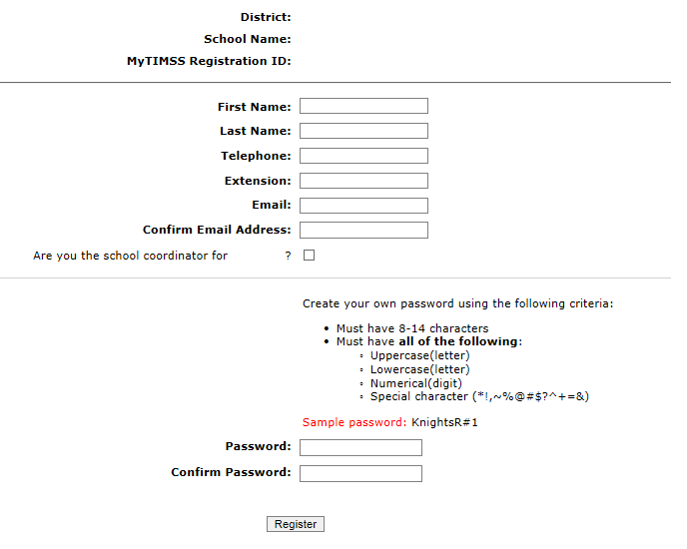
- Then create a password that meets the password criteria and click Register.
- Once created, your username will be emailed to you. Your username is not your email address.
- If you check the “Are you the school coordinator for?” box, you will get an additional email with a Summary of upcoming activities.
- When you first log in, you will see your school name, grade, and assessment date at the top banner. Please make sure those fields are accurate. If not, contact TIMSS@westat.com.
Site Home Page
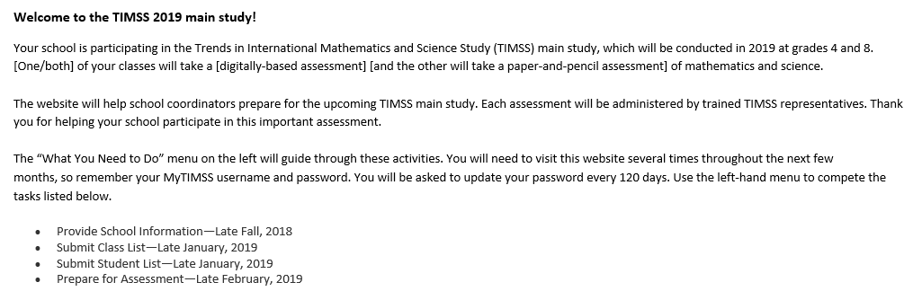
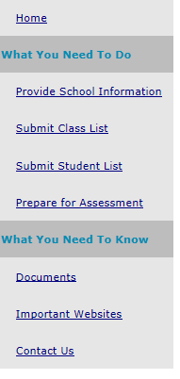
Provide School Information (PSI)
The first step in MyTIMSS is to complete the Provide School Information page. Click the Provide School Information link at the left-hand menu to access this page.
On the PSI page, the information on the left is the current information available for your school. Please make updates in the fields on the right if the current information on the left is blank or incorrect. Make sure to complete both the “School Contact Information” and “School Characteristics” sections. Then click Save.
Note: You will see this red text banner below until all required fields are filled out completely:
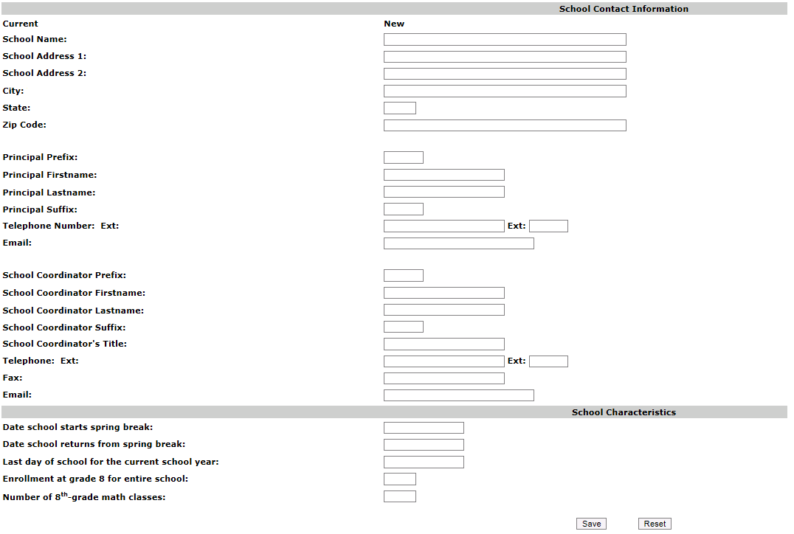
**If you are selected for grade 8, then the last two fields will ask about grade 8 (see pic above). For grade 8 schools, count all math classes with at least one 8th-grade student.
If you are selected for grade 4, then the last two fields will ask about grade 4. (see pic below).
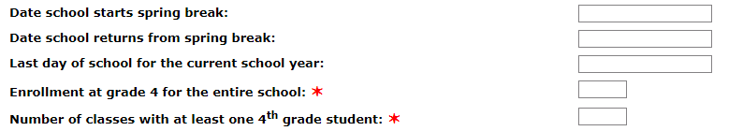
Once complete, you will see this blue text bar shown below at the top of the page.

In January, 2019, we will email to you instructions for submitting class and student lists.
Thank you for you school’s participation in TIMSS 2019!
The TIMSS 2019 Team
855-445-5604
TIMSS@westat.com

Automated Email for all MyTIMSS registrants
(Yellow highlight for merge data fields)
Thank you for creating a MyTIMSS account for the Trends in International Mathematics and Science Study (TIMSS). To access MyTIMSS, go to https://www.MyTIMSS2019.com and enter your username and password.
Username: [username]
Password information: You created your own password upon registering. Use the "Forgot Password" links on MyTIMSS login page if needed. You will be prompted to change your password after 120 days.
MyTIMSS is a secure site that contains confidential information, so it is important to remember your username and password. If you choose to write down this information, store it in a secure place.
If you have questions or need help accessing the website, please contact the TIMSS hotline at TIMSS@westat.com or at 1-855-445-5604 Monday through Friday between 9 a.m. and 5:00 p.m. ET.
Sincerely,
The TIMSS Team
NCES is authorized to conduct TIMSS under the Education Sciences Reform Act of 2002 (ESRA 2002, 20 U.S.C. §9543). All of the information provided by school staff and students may be used only for statistical purposes and may not be disclosed, or used, in identifiable form for any other purpose except as required by law (20 U.S.C. §9573 and 6 U.S.C. §151). The U.S. Office of Management and Budget has approved the data collection under OMB# 1850-0695. Individual responses will be combined with those from other participants to produce summary statistics and reports.

Automated Email for MyTIMSS School Coordinator registrant
(Yellow highlight for merge data fields; red font for customization)
Dear [school coordinator],
Thank you for creating a MyTIMSS account for the Trends in International Mathematics and Science Study (TIMSS) on https://www.MyTIMSS2019.com. MyTIMSS is a secure website for sharing information and files related to your school’s participation in the TIMSS 2019 Main study. The website’s "What You Need to Do" menu will guide you through the upcoming TIMSS activities.
The first step is to complete the Provide School Information page. If you have not already done so, please go to https://www.MyTIMSS2019.com/ProvideSchoolInformation.aspx.
In January, you will need to provide a complete and current list of all of your school’s fourth-grade/eighth-grade mathematics classes for the TIMSS team to randomly select two classes to participate in the TIMSS main study. You will then be asked to submit lists of all students in the selected classes. TIMSS also needs a list of all of your school’s eighth-grade science teachers and the courses they teach to assign teacher questionnaires that will be used to link information about science teachers to the assessed students. We will email you in early January with instructions about how to submit the class list, student list, and teacher list through https://www.MyTIMSS2019.com.
Please see the attached Summary of School Activities for a complete list of activities associated with your school’s participation in the TIMSS 2019 main study.
Thank you very much for participating in TIMSS, and for playing a key role in making the assessment a success in [school name]!
Sincerely,
The TIMSS Team
NCES is authorized to conduct TIMSS under the Education Sciences Reform Act of 2002 (ESRA 2002, 20 U.S.C. §9543). All of the information provided by school staff and students may be used only for statistical purposes and may not be disclosed, or used, in identifiable form for any other purpose except as required by law (20 U.S.C. §9573 and 6 U.S.C. §151). The U.S. Office of Management and Budget has approved the data collection under OMB# 1850-0695. Individual responses will be combined with those from other participants to produce summary statistics and reports.

MyTIMSS Login Page
TIMSS USA LOGO
MyTIMSS 2019
Login

MyTIMSS 2019 is a restricted-use website that contains information on the Trends in International Mathematics and Science Study (TIMSS).

Existing User Login First time visiting the MyTIMSS 2019 site?
Schools can register now!
User Name: Please register
Password:
Forgot Password | Having trouble logging in?
Log In

The National Center for Education Statistics (NCES), within the U.S. Department of Education, conducts TIMSS in the United States as authorized by the Education Sciences Reform Act of 2002 (ESRA 2002, 20 U.S.C. §9543). All of the information you provide may be used only for statistical purposes and may not be disclosed, or used, in identifiable form for any other purpose except as required by law (20 U.S.C. §9573 and 6 U.S.C. §151).
According to the Paperwork Reduction Act of 1995, no persons are required to respond to a collection of information unless such collection displays a valid OMB control number. The valid OMB control number for this voluntary information collection is 1850-0695. The time required to complete this information collection and participate in study activities is estimated to average 240 minutes per school coordinator, including the time to review instructions, search existing data resources, gather the data needed, and complete and review the information collection. If you have any comments or concerns regarding the accuracy of the time estimate(s), suggestions for improving the form, or questions about the status of your individual submission of this form, write directly to: Trends in International Mathematics and Science Study (TIMSS), National Center for Education Statistics, Potomac Center Plaza (PCP), 550 12th St., SW, 4th floor, Washington, DC 20202.
OMB No. 1850-0695, Approval Expires 01/31/2021.

Notice: You are accessing a U.S. Government information system.
This warning banner provides privacy and security notices consistent with applicable federal laws, directives, and other federal guidance for accessing this Government system, which includes all devices/storage media attached to this system. This system is provided for Government-authorized use only. Unauthorized or improper use of this system is prohibited and may result in disciplinary action and/or civil and criminal penalties.

(MyTIMSS 2019 Login page screenshot)
www.mytimss2019.com
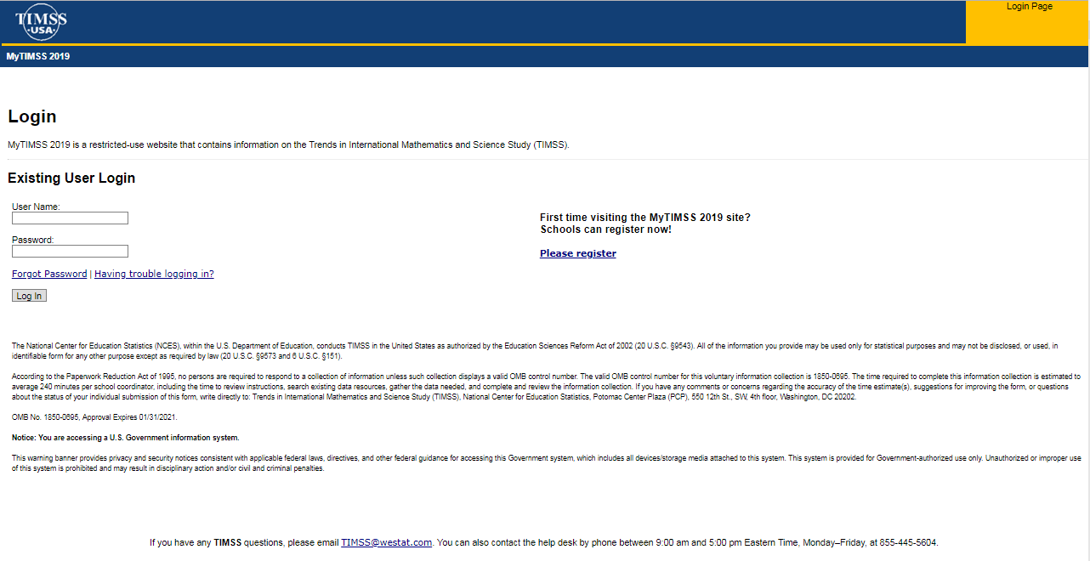

MyTIMSS Home Page

Welcome to the TIMSS 2019 main study!
Your school is participating in the Trends in International Mathematics and Science Study (TIMSS) main study, which will be conducted in 2019 at grades 4 and 8. [One/both] of your selected classes will take a [digitally-based assessment] [and the other will take a paper-and-pencil assessment] of mathematics and science.
This website will help school coordinators prepare for the upcoming TIMSS main study. Each assessment will be administered by trained TIMSS representatives. Thank you for helping your school participate in this important assessment.
The "What You Need to Do" menu on the left will guide you through these activities. You will need to visit this website several times throughout the next few months, so remember your MyTIMSS username and password. You will be asked to update your password every 120 days. Use the left-hand menu to complete the tasks listed below.
- Provide School Information—Late Fall, 2018
- Submit Class List—Late January, 2019
- Submit Student List—Late January, 2019
- Prepare for Assessment—Mid-February, 2019

(MyTIMSS Home Page screenshot)
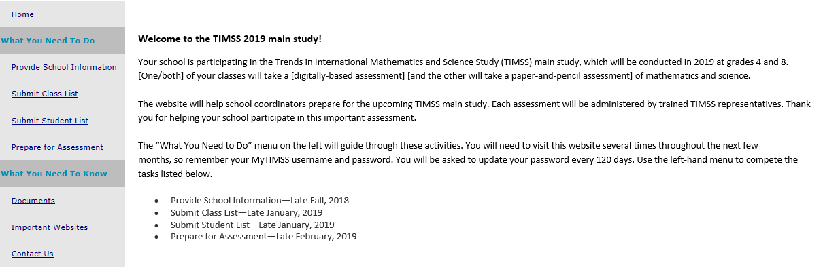

MyTIMSS Provide School Information (PSI) Page
(screenshot)
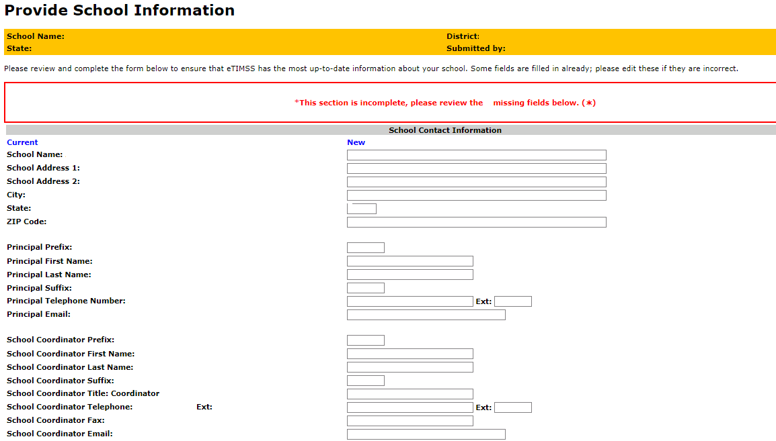
[Grade 4 schools]
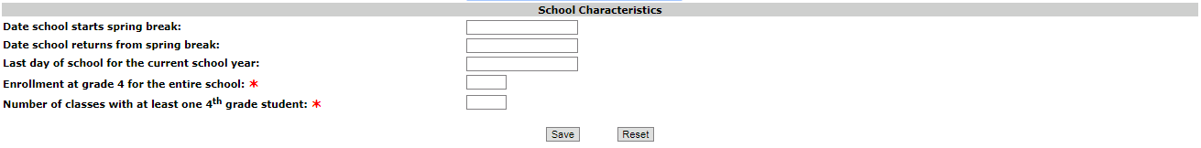
[Grade 8 schools]
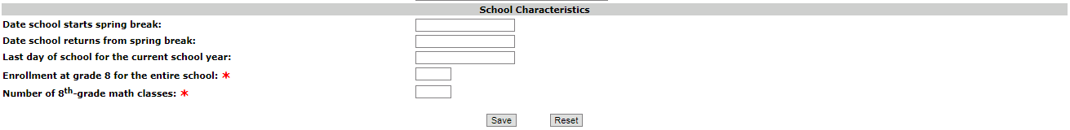

Email to School Coordinator (SC) to Submit Class and Student Lists—Grade 4

Dear [School Coordinator],

Thank you for your school’s participation in TIMSS and thank you for registering on MyTIMSS! TIMSS now needs a complete and current list of all of your school’s fourth-grade classes and all the fourth-grade students in selected classes in order to randomly select classes to participate in TIMSS 2019. You will first submit a list of all your 4th-grade classes and then we will randomly select classes and notify you of just the selected classes for which we need student lists.

Please go to https://www.MyTIMSS2019.com to submit your class and student lists. If you have forgotten your login ID please contact the TIMSS hotline at timss@westat.com or 1 (855) 445-5604. If you have forgotten your password, you can request a new password on the MyTIMSS login page.

After logging in, select Submit Class List from the left hand panel to provide information about your fourth-grade classes. Submitting Class List instructions are attached to this email. These tip sheets and Excel templates can also be found in the Documents section of MyTIMSS.

Please submit your class list by 2/06/19. TIMSS will process your submission and select the sample of fourth-grade classes to be assessed. You will be informed of the selected classes within 5-7 business days of submitting your class lists. After we email you the list of selected classes, we will ask you to submit a student list (and their math/science teachers) for the selected classes only.

If you have any questions about submitting your list, please email or call the TIMSS E-Filing Help Desk at TIMSSefile@westat.com or 1-(855)-445-5604 between 9-5pm ET.

Thank you very much for participating in TIMSS, and for submitting your school's class and student lists!

Sincerely,
The TIMSS 2019 Team
Attachments: Grade 4 Submit Class List Tip Sheet; Grade 4 Submit Student List Tip Sheet

NCES is authorized to conduct this study under the Education Sciences Reform Act of 2002 (ESRA 2002, 20 U.S.C. §9543). All of the information you provide may be used only for statistical purposes and may not be disclosed, or used, in identifiable form for any other purpose except as required by law (20 U.S.C. §9573 and 6 U.S.C. §151).

Instructions for Submitting Class Lists- Grade 4
Submit Class List
TIMSS needs a complete and current list of all of your school’s fourth-grade classes in order to randomly select classes to be assessed. Typically, two classes are sampled by the TIMSS team in each school, and all 4th-grade students in the selected classes are assessed. Submit your class list first, and then the TIMSS Team will email you the list of selected classes. After you receive the list of selected classes, you will be given instructions to submit student lists for the selected classes only.

Go to www.MyTIMSS2019.com and log in.

Enter information about all fourth-grade classes at your school

On www.MyTIMSS2019.com, select Submit Class List from the navigation menu on the left. The table on the page provides a description of all information that is needed. Enter information for each fourth-grade class in the web form. After you have entered information for each class, click on the Save button, and another row will appear for you to enter information about another class. If you have not completely filled out a row, you may get a warning message at the top of the screen that the data must be fixed and resaved. Continue until you have entered information for all classes that contain fourth-grade students. Note: Do not click the Finished button until all classes have been entered. Make sure to click “Save” one last time prior to clicking “Finished.”

Include the following information for each class:

- Class Name (each class name must be unique and descriptive, e.g. “Mrs. Johnson’s 4th grade class;” each row must have a unique new name)
- Class Group or Track (Select “average” track if there are no tracks or group levels)
- Number of 4thgrade students in the class (Do not include 3rd or 5th graders)
- Class Exclusion Status (If applicable; Only use this field if EVERY student in that class cannot take TIMSS)
- Name of Mathematics Teacher
- Email address of Mathematics Teacher
- Name of Science Teacher (Only enter if different from the mathematics teacher)
- Email address of Science Teacher (Only enter if different from the mathematics teacher)

Additional tips for submitting information about your fourth-grade classes:

- Record the Class Name that is typically used by your school to refer to the class, but we recommend it be as descriptive as possible so you can later on identify it easily.
- For classes with students from more than one grade level, include in Number of Students only those students in Grade 4. For example, if the class has 5 third-graders, 6 fourth-graders, and 4 fifth-graders, enter “6” as the Number of Students in this class.
- Use the most current enrollment information.
- Include all classes, even if they typically are excluded from your state testing program, or all students take alternate assessments. You can indicate information about the class in Class Exclusion Status, but only if all students should be excluded.
- Name of Mathematics teacher and name of Science teacher may be the same.
- Print a list of the classes you included for your future reference using the Print button.

Once you have entered information for all the fourth-grade classes in your school, click Save and then the Finished button. Only click Finished AFTER clicking Save.

When you click “Submit Class List” for Grade 4, you will see this description table at the top and an empty form to enter information at the bottom of the page.
Below is a detailed description of what will be needed.

Table of Fields to enter for Grade 4 Class List Submission
✶Class Name (each class name must be unique) | Record the class name that is typically used by your school to refer to the class. For example, it may be that your school uses the grade plus a letter for the class name (4a, 4b, etc.), the grade plus a number (4.1, 4.2, etc.), the teacher name, the class period (Period 1, Period 2, etc.), the class location (Room 7, Room 8, etc.), or some other combination of these items. It is important that unique class names are entered because these names will be used to indicate to the Test Administrator which classes will be tested.
✶Class Group or Track (use Average if none) | If your school assigns students to specific classes based on their ability, please indicate the relevant level: Low ability, Average ability, or High ability. Use average if no group or track level.
✶Number of 4th-grade students in each class | Enter the number of fourth-grade students in each class. In the case of multi-grade classes (e.g., students from more than one grade level in the same class), only the fourth-grade students should be counted as a class in the list. For example, if three Grade 3 students, five Grade 4 students, and ten Grade 5 students form a multi-grade class, then you should record five students for the number of students in this multi-grade class.
Class Exclusion Status (if applicable; if at least one 4th-grade student in this class is able to be assessed, do not use this field) | 1 = Students with functional disabilities; i.e., students who have physical disabilities in such a way that they cannot perform in the TIMSS testing situation. Students with functional disabilities who are able to perform should be accommodated in the test situation, within reason, rather than excluded.  2 = Students with intellectual disabilities; i.e., students who are considered, in the professional opinion of the school principal or by other qualified staff members, to have severe intellectual disabilities or who have been tested as such. This category includes students who are emotionally or mentally unable to follow even the general instructions of the test. Students should not be excluded solely because of poor academic performance or normal disciplinary problems. It should be noted that students with dyslexia, or other such learning disabilities, should be accommodated in the test situation, within reason, rather than excluded.  3 = Non-native language speakers; i.e., students who are unable to read or speak the language(s) of the test and would be unable to overcome the language barrier in the test situation.  If all students in the excluded class do not belong to the same exclusion category, please identify the category corresponding to the majority of students.
✶Name of Mathematics Teacher | Name of Mathematics Teacher of class.
✶Email address of Mathematics Teacher | Email address of Mathematics Teacher of class.
Name of Science Teacher (only if different from Mathematics Teacher) | Name of Science Teacher of class (only if different from Mathematics Teacher).
Email address of Science Teacher (only if different from Mathematics Teacher) | Email address of Science Teacher of class (only if different from Mathematics Teacher).

Enter classes in this table:
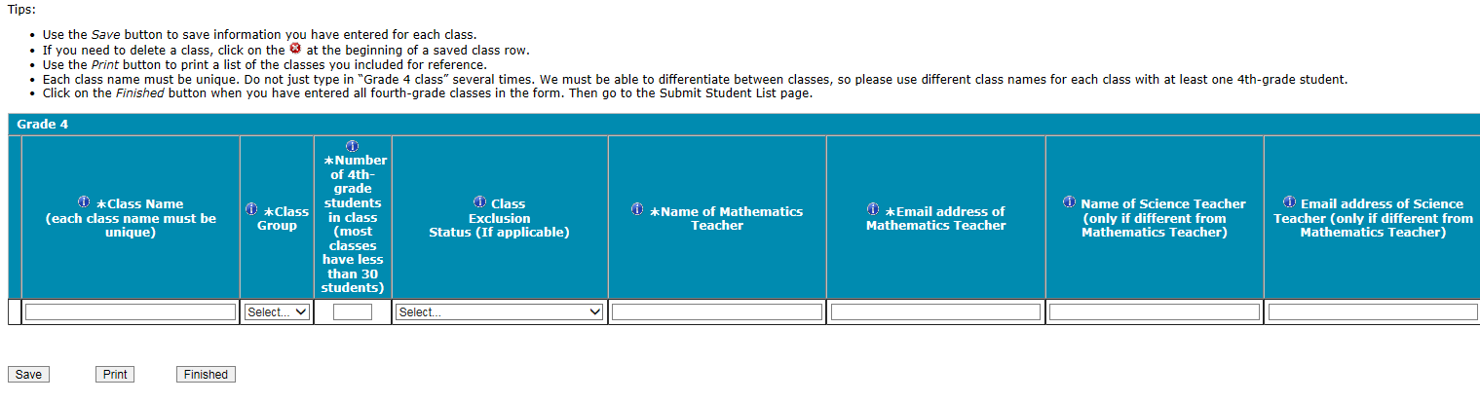
You can hover your mouse cursor over the Information symbol to get more information about each field and its requirements.

The white asterisks indicates the field is required. Enter class details and then click Save after each row. The row will not save if an error occurs. If you see an error message, please correct the text in that row and re-save to activate a new row to enter.

Continue to click “save” and make sure to click “save” after you enter the last class. Do Not click “Finished” until after you click “save” one last time and there are no error messages.
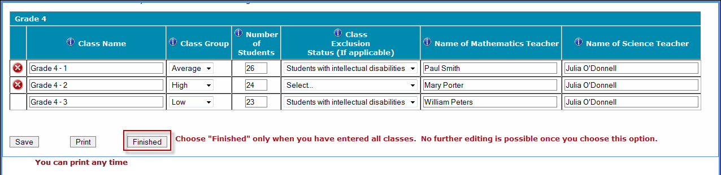

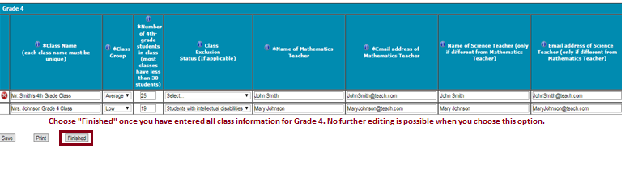

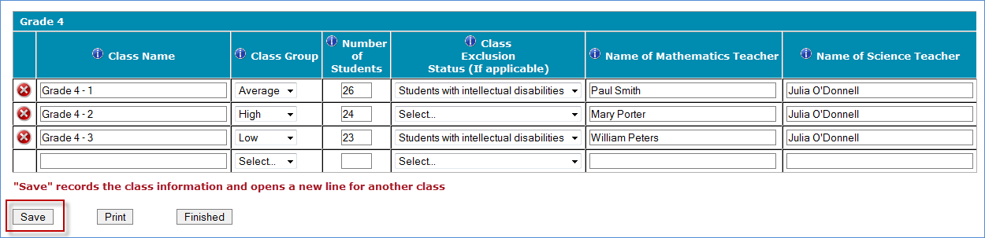
Some possible warnings/errors you may encounter are below.
- Please fill out each required field for every row and re-enter/retry again.
- *The class size you entered was over 75 students.
- Exclusion status must apply to all students in the class. If even one student does not fall in this status then this selection should be removed.
- Invalid email format
- You have entered that there are # grade [ ]students in the PSI page for your selected grade; however, there are # total grade [] students on the class list page. Please make sure this is correct before moving on. Please contact timssefile@westat.com if you have questions.
- You have entered that there are # grade [] classes in the PSI page for your selected grade; however, there are # total classes on the class list page. Please make sure this is correct before moving on. Please contact timssefile@westat.com if you have questions.

Continue to click “save” and make sure to click “save” after you enter the last class. Do Not click “Finished” until after you click “save” one last time and there are no error messages.

Once finished, the TIMSS team will email you within 5-7 business days which grade 4 classes were selected. Then you can submit student lists for the selected classes only.

If you need assistance, email TIMSSefile@westat.com
or call 1-(855)-445-5604.

Instructions for Submitting Student Lists- Grade 4

Once you receive an email notifying you of the selected 4th-grade classes, please provide a complete and current list of all 4th-grade students for the selected classes only. Your electronic student data file (E-File) must be submitted as a Microsoft Excel file.

Go to www.mytimss2019.com and log in.

Use one of the TIMSS Grade 4 Excel Templates (located under the Documents tab on the navigation menu on www.mytimss2019.com). If you cannot submit your student data with this information in an Excel file, please call or email the TIMSS E-file Help Desk at TIMSSefile@westat.com or 1-(855)-445-5604.

Step 1 – Compile Data in an Excel File

Prepare an Excel file with the following data elements for all 4th-grade students in the selected classes.

Data Element | Description
Student Name | The preferred format is First Name, Middle Name (or Initial), and  Last Name in separate columns. However, TIMSS will accept student names in one column.
Sex | Codes (numeric or text) for Male/Female
Date of Birth | The preferred format is Month of Birth and Year of Birth in  separate columns. However, TIMSS will accept Date of Birth in one column.
Student with a Disability  (SD) Status | School-defined codes for:  1=Yes, student has disability and/or IEP  2=No, student does not have disability or IEP
English Language  Learner (ELL) Status | School-defined codes for:  1=Yes, student is ELL  2=No, student is formerly ELL  3=No, student is not ELL
Class | The fourth-grade class the student is enrolled in. Please use the  exact same class names you used in the Submit Class List section.
Mathematics Teacher Name | Math Teacher of the above named class.
Mathematics Teacher Email | Math Teacher Email address (work email)
Science Teacher Name | Science teacher of the above named class. Only needed if different from math teacher.
Science Teacher Email | Science Teacher Email address (work email). Only needed if different than math teacher.
Student Current Grade Level | Enter student’s current grade level

You may use one of the templates provided or create your own Excel file with these data for each student. It is preferred that you include column headers as the first row in your E-File, as in these templates. However, E-Files without column headers will be accepted.

Template 1 has the student name in three separate columns, and month of birth and year of birth in two separate columns.

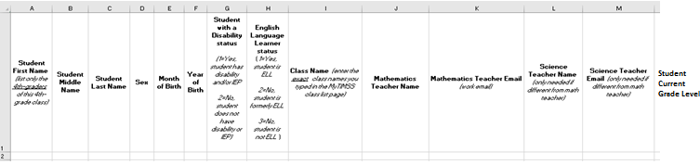

Template 2 has the student name in one column, and month and year of birth in another column.

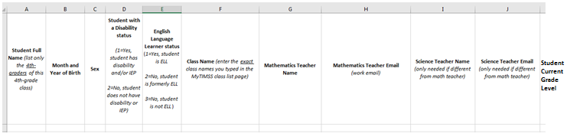

Tips for ensuring the E-File process goes smoothly:

- Use the template or provide column headers. Student information should begin on the second row. There should be no empty rows within the student data.
- Be sure to give your file a unique, descriptive name. Within Excel, click on File, then Save As, and give your file a name such as “Your School Name Grade 4.xls.”
- The first row of data in your file will be read as the column header unless you indicate otherwise on the Submit Student List webpage. Each succeeding row will be considered a student record.
- There should be only one worksheet with data in the Excel file. If there are other worksheets, they must not contain any data.
- Do not provide any other student information.

Please go to the next page for more instructions.

Step 2 – Upload Your Excel File

Once your file is prepared and checked for accuracy and completeness, login to www.mytimss2019.com and
select “Submit Student List” from the left-hand menu.

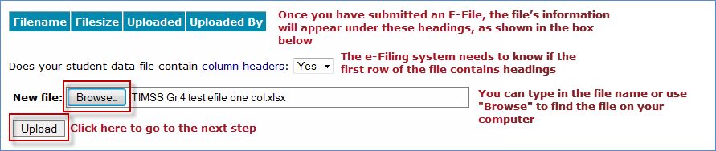

You will see this link for your file if you have uploaded the file.

Please go to the next page for more instructions.

Step 3 – Identify Your Columns

We need to know what information is in each column of your student data file (E-File). If you provided column headers in your E-File (preferred), they are displayed under Column Heading Is in the table. If you did not provide column headers, Column Heading Is will contain numbers for each column in your submitted E-File. Click on the down arrows in Your Column Contains to select descriptions for each column header. If there is no appropriate description in the drop-down list, please select N/A.

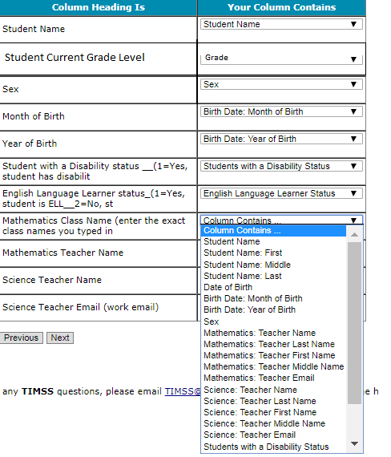

Select Next after all columns have been identified.

Step 4 – Match Your Values to TIMSS Codes

TIMSS also needs to know the values for some of the columns in your E-File. The tables contain the following information for each column:

- Your Values: The values in your E-File
- TIMSS Codes: Click on the down arrow and select the TIMSS Code that best matches Your Values
- Number: The number of students in your E-File with that value
- Percentage: The percentage in your E-File with that value

- Update Birth codes
If you only used one column for DOB instead of separate MOB and YOB columns, you will see this screen below. You can use the “Update all TIMSS Codes” to update all values in the table. If you used separate MOB and YOB columns, go to the next screenshot. TIMSS prefers only receiving separate MOB and YOB columns.

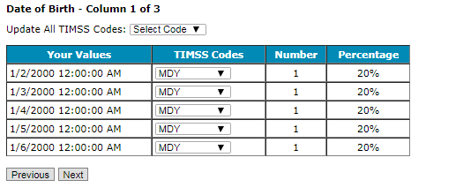
- Update Gender Codes

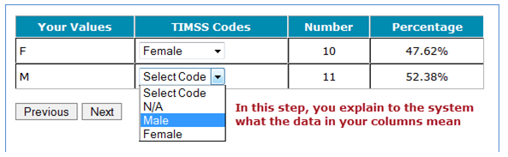
Use the Previous and Next buttons to navigate from column header to column header.

- Class Student Counts
The second to last page should show the counts of students in each class.
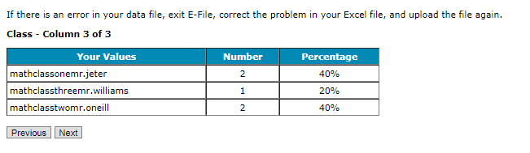
If there is an error in your data file, exit E-File, correct the problem in your Excel file, and upload the file again.

Step 5 – Verify Your E-File
The table in this section summarizes the information you have provided on your student list (E-File). Please review this summary and verify that the information is correct. Total Enrollment at the bottom of the table should match the number of students in your E-File and the total number of students currently enrolled in the selected grade 4 classes.
One possible warning you may encounter is shown below. Please contact TIMSSefile@westat.com if you have questions.
You have entered that there # of students in the PSI page for your selected grade; however, there are # of students in your excel file. Please confirm your excel file has the correct number of students.
Record whether the information is correct or incorrect by selecting the appropriate button at the bottom of the page. Then click the Submit button. If you select INCORRECT, you will need to correct your E-File and resubmit it.
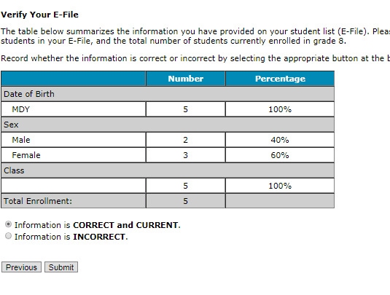
You can also see your column mappings again by clicking the file name link below.

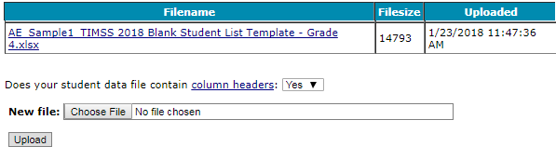
If you need assistance, please contact the TIMSS E-Filing Help Desk at TIMSSefile@westat.com or 1-(855)-445-5604.
Within 5-10 business days, you will be sent an email with instructions to go to the Prepare for Assessment Page. You do not have to navigate to the Prepare for Assessment page until you get this email.
A TIMSS representative will contact you to make arrangements for the assessment.
Submit Class List Page – Grade 4
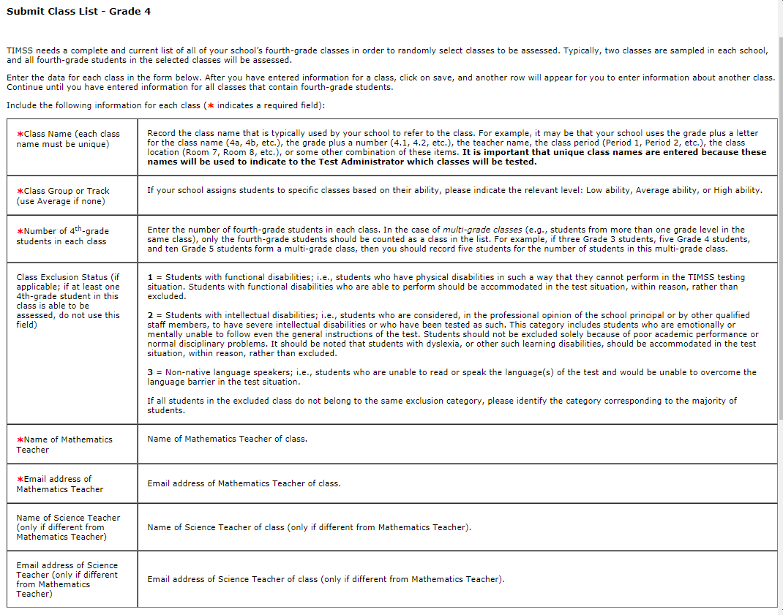
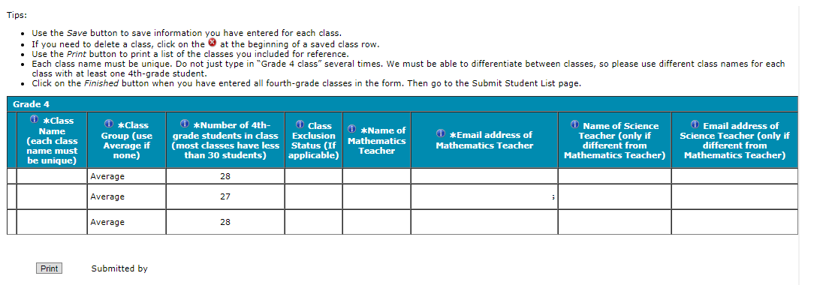

Submit Student List Page – Grade 4
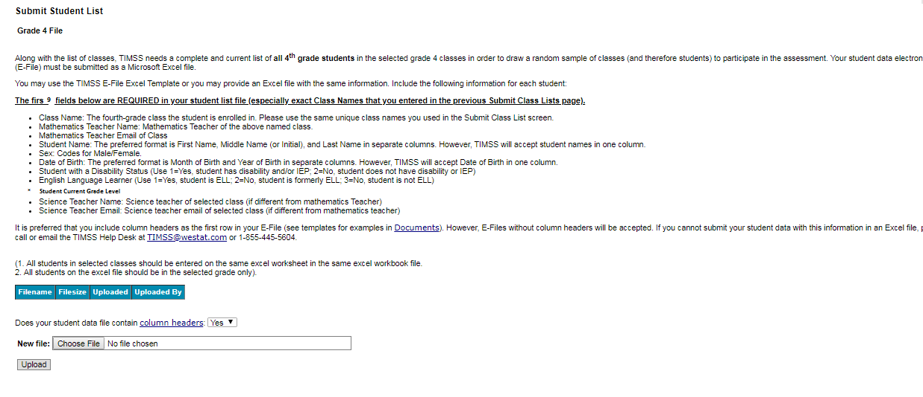

Email to School Coordinator (SC) to Submit Class and Student Lists—Grade 8
Dear [School Coordinator],
TIMSS needs a complete and current list of all of your school’s eighth-grade mathematics classes and all the eighth-grade students in those classes in order to randomly select classes to participate in TIMSS 2019. You will first submit a list of all your 8th-grade mathematics classes and then we will randomly select classes and notify you of just the selected mathematics classes for which we need student lists.
Please go to https://www.mytimss2019.com to submit your class and student lists. If you have forgotten your login ID please contact the TIMSS hotline at timss@westat.com or 1-855-445-5604. If you have forgotten your password, you can request a new password on the MyTIMSS login page.
After logging in, select Submit Class List from the left hand panel to provide information about your eighth-grade mathematics classes and science teachers. Submitting Class List instructions are attached to this email. These tip sheets and Excel templates can also be found in the Documents section of MyTIMSS.
Please submit your class list by 2/06/19. TIMSS will process your submission and select the sample of eighth-grade mathematics classes to be assessed. You will be informed of the selected classes within 5-7 business days of submitting your class lists. After we email you the list of selected mathematics classes, we will ask you to submit a student list (and their math/science teachers) for the selected classes only.
If you have any questions about submitting your list, please email or call the TIMSS E-Filing Help Desk at TIMSSefile@westat.com or 1-855-445-5604. ​
Thank you very much for participating in TIMSS, and for submitting your school's class and student lists!
Sincerely,
The TIMSS 2019 Team
Attachments: Grade 8 Submit Class List Tip Sheet; Grade 8 Submit Student List Tip Sheet
NCES is authorized to conduct this study under the Education Sciences Reform Act of 2002 (ESRA 2002, 20 U.S.C. §9543). All of the information you provide may be used only for statistical purposes and may not be disclosed, or used, in identifiable form for any other purpose except as required by law (20 U.S.C. §9573 and 6 U.S.C. §151).

Instructions for Submitting Class Lists—Grade 8
Submit Class List
Thank you for your school’s participation in TIMSS and thank you for registering on MyTIMSS! TIMSS now needs a complete and current list of all of your school’s eighth-grade mathematics classes in order to randomly select classes to be assessed. Typically, two mathematics classes are sampled by the TIMSS team in each school, and all students in the selected classes are assessed. Submit your class list first, and then the TIMSS Team will email you the list of selected classes. After you receive the list of selected classes, you will be given instructions to submit student lists for the selected classes only.

Go to www.MyTIMSS2019.com and log in.

Enter information about all eighth-grade mathematics classes at your school

On www.MyTIMSS2019.com, select Submit Class List from the navigation menu on the left. The table on the page provides a description of all information that is needed. Enter information for each eighth-grade mathematics class in the web form found at the bottom of the page. After you have entered information for each mathematics class, click on the Save button, and another row will appear for you to enter information about another mathematics class. If you have not completely filled out a row, you may get a warning message at the top of the screen that the data must be fixed and resaved. Make sure to fill out every required field. Continue until you have entered information for all mathematics classes that contain eighth-grade students. Note: Do not click the Finished button until all classes have been entered. Make sure to click “Save” one last time prior to clicking “Finished.”

Include the following information for each class:

- Mathematics Class Name (Be descriptive with names, e.g., Mrs. Johnson’s 4th period algebra class; each row must have a new class name)
- Class Group or Track (Select “average” track if there are no tracks or group levels)
- Number of 8th-grade students in the class (Do not include 7th or 9th-grade students)
- Class Exclusion Status (If applicable; Only use this field if EVERY student in that class cannot take TIMSS)
- Name of Mathematics Teacher
- Email address of Mathematics Teacher

Additional tips for submitting information about your eighth-grade mathematics classes:

- Record the Class Name that is typically used by your school to refer to the class, but we recommend it be as descriptive as possible so you can later on identify it easily.
- For mathematics classes with students from more than one grade level, include in the Number of 8th-grade students in this Mathematics class column only those students in grade 8. For example, if the class has 5 seventh-graders, 6 eighth- graders, and 4 ninth-graders, enter “6” as the Number of 8th-grade students in this mathematics class.
- Use the most current enrollment information.
- Include all classes, even if they typically are excluded from your state testing program, or all students take alternate assessments. You can indicate information about the class in Class Exclusion Status, but only if all students should be excluded.
- Print a list of the mathematics classes you included for your future reference using the Print button.

Once you have entered information for all the eighth-grade mathematics classes in your school, click Save and then the Finished button. Only click Finished AFTER clicking Save.

When you click “Submit Class List” for Grade 8, you will see this description table at the top and an empty form to enter information at the bottom of the page.

Below is a detailed description of what will be needed.
Table of Fields to enter for Grade 8 Class List Submission
✶Mathematics Class Name (each class name must be unique) | Record the class name that is typically used by your school to refer to the class. For example, it may be that your school uses the grade plus a letter for the class name (8a, 8b, etc.), the grade plus a number (8.1, 8.2, etc.), the teacher name, the class period (Period 1, Period 2, etc.), the class location (Room 7, Room 8, etc.), or some other combination of these items. It is important that unique class names are entered because these names will be used to indicate to the Test Administrator which classes will be tested.
✶Class Group or Track (use Average if none) | If your school assigns students to specific classes based on their ability, please indicate the relevant level: Low ability, Average ability, or High ability. Use average if no group or track level.
✶Number of 8th-grade students in this mathematics class | Enter the number of eighth-grade students in each class. In the case of multi-grade classes (e.g., students from more than one grade level in the same class), only the eighth-grade students should be counted as a class in the list. For example, if three Grade 7 students, five Grade 8 students, and ten Grade 9 students form a multi-grade class, then you should record five students for the number of students in this multi-grade class.
Class Exclusion Status (if applicable; if at least one 8th-grade student in this class is able to be assessed, do not use this field) | 1 = Students with functional disabilities; i.e., students who have physical disabilities in such a way that they cannot perform in the TIMSS testing situation. Students with functional disabilities who are able to perform should be accommodated in the test situation, within reason, rather than excluded.  2 = Students with intellectual disabilities; i.e., students who are considered, in the professional opinion of the school principal or by other qualified staff members, to have severe intellectual disabilities or who have been tested as such. This category includes students who are emotionally or mentally unable to follow even the general instructions of the test. Students should not be excluded solely because of poor academic performance or normal disciplinary problems. It should be noted that students with dyslexia, or other such learning disabilities, should be accommodated in the test situation, within reason, rather than excluded.  3 = Non-native language speakers; i.e., students who are unable to read or speak the language(s) of the test and would be unable to overcome the language barrier in the test situation.  If all students in the excluded class do not belong to the same exclusion category, please identify the category corresponding to the majority of students.
✶Name of Mathematics Teacher | Name of the Mathematics Teacher of class.
✶Email address of Mathematics Teacher | Email address of Mathematics Teacher of class.

Enter classes in this table:
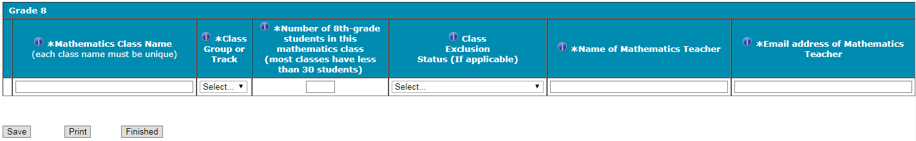

You can hover your mouse cursor over the Information symbol to get more information about each field and its requirements.
The white asterisks indicates the field is required.

Enter class details and then click Save after each row. The row will not save if an error occurs. If you see an error message, please correct the text in that row and re-save to activate a new row to enter.

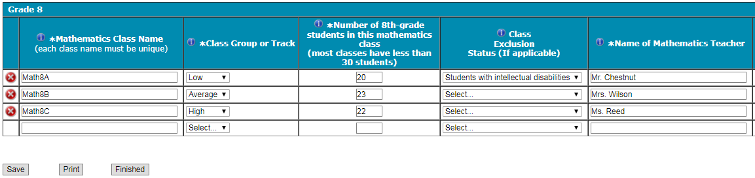

Some possible warnings/errors you may encounter are below.
- Please fill out each required field for every row and re-enter/retry again.
- *The class size you entered was over 75 students.
- Exclusion status must apply to all students in the class. If even one student does not fall in this status then this selection should be removed.
- Invalid email format
- You have entered that there are # grade [ ]students in the PSI page for your selected grade; however, there are # total grade [] students on the class list page. Please make sure this is correct before moving on. Please contact timssefile@westat.com if you have questions.
- You have entered that there are # grade [] classes in the PSI page for your selected grade; however, there are # total classes on the class list page. Please make sure this is correct. Please contact timssefile@westat.com if you have questions.

Continue to click “save” and make sure to click “save” after you enter the last class. Do Not click “Finished” until after you click “save” one last time and there are no error messages.

Once finished, the TIMSS team will email you within 5-7 business days which grade 8 mathematics classes were selected. Then you can submit student lists for the selected classes only.

If you need assistance, email TIMSSefile@westat.com
or call 1-(855)-445-5604.

Instructions for Submitting Student Lists—Grade 8

Along with the list of classes, TIMSS needs a complete and current list of all students in grade 8 in order to draw a random sample of mathematics classes (and therefore students) to participate in the assessment. Your student data electronic file (E-File) must be submitted as a Microsoft Excel file. After you submit the class list, the TIMSS Team will email you the list of selected classes. Please submit the list of students after you have received the names of the
selected classes.

Go to www.mytimss2019.com and log in.

Use one of the TIMSS Grade 8 Excel Templates (located in Documents on www.mytimss2019.com and described below). If you cannot submit your student data with this information in an Excel file, please call or email the TIMSS E-Filing Help Desk at TIMSSefile@westat.com or 1-(855)-445-5604.

Step 1 – Compile Data in an Excel File

Prepare an Excel file with the following data elements for all students in grade 8.

Data Element | Description
Student Name | The preferred format is First Name, Middle Name (or Initial), and  Last Name in separate columns. However, TIMSS will accept student names in one column.
Sex | Codes (numeric or text) for Male/Female
Date of Birth | The preferred format is Month of Birth and Year of Birth in  separate columns. However, TIMSS will accept Date of Birth in one column.
Student with a Disability  (SD) Status | School-defined codes for:  1=Yes, student has disability and/or IEP  2=No, student does not have disability or IEP
English Language  Learner (ELL) Status | School-defined codes for:  1=Yes, student is ELL  2=No, student is formerly ELL  3=No, student is not ELL
Mathematics Class | The mathematics class the student is enrolled in. Please use the  same class names you used in Submit Class List.
Mathematics Teacher Name | Teacher of the above named mathematics class that the student is  taking
Mathematics Teacher Email | Email address of Mathematics Teacher
Science Teacher Name | Name of science teacher who teaches science to each student
Science Teacher Email | Email address of Science Teacher
Student Current Grade Level | Enter student’s current grade level

You may use one of the templates provided or create your own Excel file with these data for each student. It is preferred that you include column headers as the first row in your E-File, as in these templates. However, E-Files without column headers will be accepted.

Template 1 has the student name in three separate columns, and month of birth and year of birth in two separate columns.
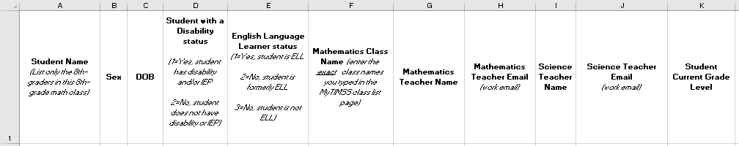

Template 2 has the student name in one column, and month and year of birth in another column.

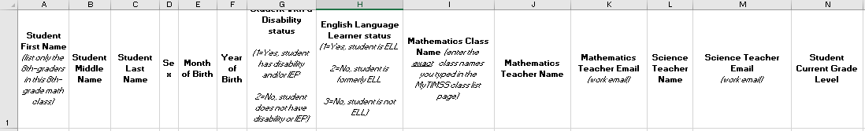

Tips for ensuring the E-File process goes smoothly:

- Use the template or provide column headers. Student information should begin on the second row. There should be no empty rows within the student data.
- Be sure to give your file a unique, descriptive name. Within Excel, click on File, then Save As, and give your file a name such as “Your School Name Grade 8.xls.”
- The first row of data in your file will be read as the column header unless you indicate otherwise on the Submit Student List webpage. Each succeeding row will be considered a student record.
- There should be only one worksheet with data in the Excel file. If there are other worksheets, they must not contain any data.
- Do not provide any other student information

Please go to the next page for more instructions.

Step 2 – Upload Your Excel File

Once your file is prepared and checked for accuracy and completeness, login to www.mytimss2019.com and select “Submit Student List” from the left-hand menu.

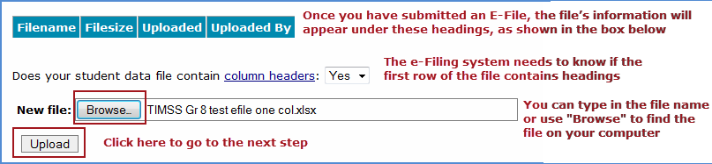

You will see this link for your file after you have uploaded the file.
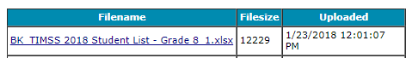

Please go to the next page for more instructions.

Step 3 – Identify Your Columns

We need to know what information is in each column of your student data file (E-File). If you provided column headers in your E-File (preferred), they are displayed under Column Heading Is in the table. If you did not provide column headers, Column Heading Is will contain numbers for each column in your submitted E-File. Click on the down arrows in Your Column Contains to select descriptions for each column header. If there is no appropriate description in the drop-down list, please select N/A.

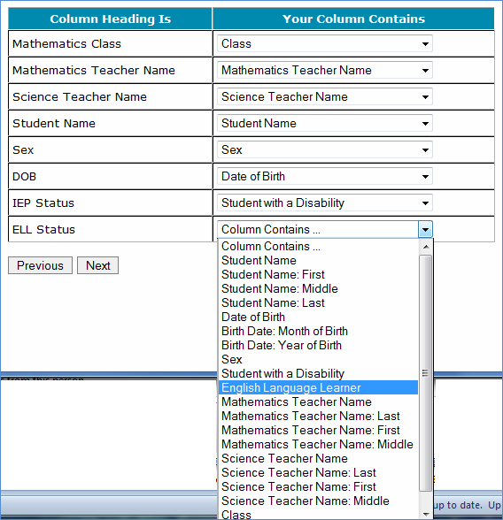

Select Next after all columns have been identified.

Please go to the next page for more instructions.

Step 4 – Match Your Values to TIMSS Codes

TIMSS also needs to know the values for some of the columns in your E-File. The tables contain the following information for each column:

- Your Values: The values in your E-File
- TIMSS Codes: Click on the down arrow and select the TIMSS Code that best matches Your Values
- Number: The number of students in your E-File with that value
- Percentage: The percentage in your E-File with that value

- Update Birth codes
If you only used one column for DOB instead of separate MOB and YOB columns, you will see this screen below. You can use the “Update all TIMSS Codes” to update all values in the table. If you used separate MOB and YOB columns, go to the next screenshot. TIMSS prefers only receiving separate MOB and YOB columns.
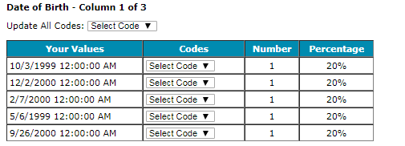

- Update Gender Codes

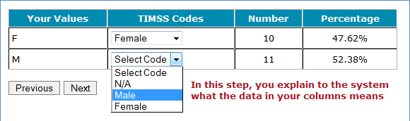

Use the Previous and Next buttons to navigate from column header to column header.
If there is an error in your data file, exit E-File, correct the problem in your Excel file, and upload the file again.

- Class Student Counts
The second to last page should show the counts of students in each class.
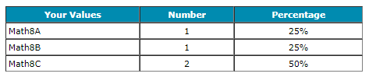

Step 5 – Verify Your E-File

The table in this section summarizes the information you have provided on your student list (E-File). Please review this summary and verify that the information is correct. Total Enrollment at the bottom of the table should match the number of students in your E-File and the total number of students currently enrolled in grade 8.

One possible warning you may encounter is shown below. Please contact TIMSSefile@westat.com if you have questions.
You have entered that there # of students in the PSI page for your selected grade; however, there are # of students in your excel file. Please confirm your excel file has the correct number of students.
Record whether the information is correct or incorrect by selecting the appropriate button at the bottom of the page. Then click the Submit button. If you select INCORRECT, you will need to correct your E-File and resubmit it.

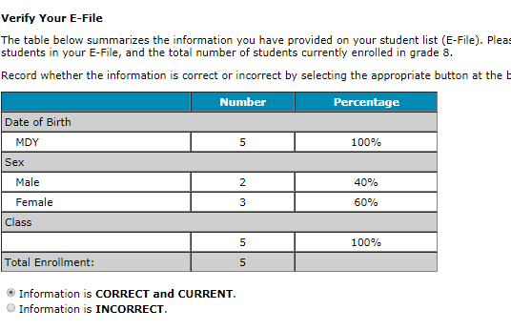

You can also see your column mappings again by clicking the file name link below.

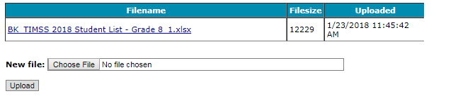

If you need assistance, please contact the TIMSS E-Filing Help Desk at TIMSSefile@westat.com or 1-(855)-445-5604. Within 5-10 business days, you will be sent an email with instructions to go to the Prepare for Assessment Page. You do not have to navigate to the Prepare for Assessment page until you get this email.
A TIMSS representative will contact you to make arrangements for the assessment
Submit Class List Page – Grade 8
(screenshot)
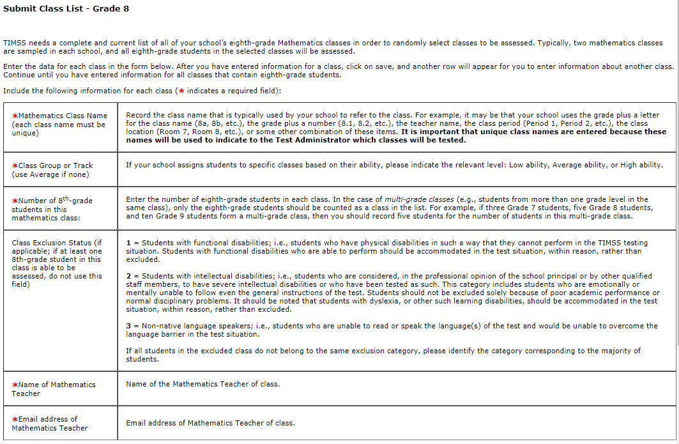
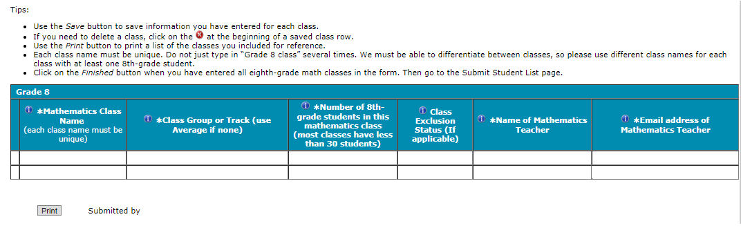

Submit Student List Page – Grade 8
(screenshot)
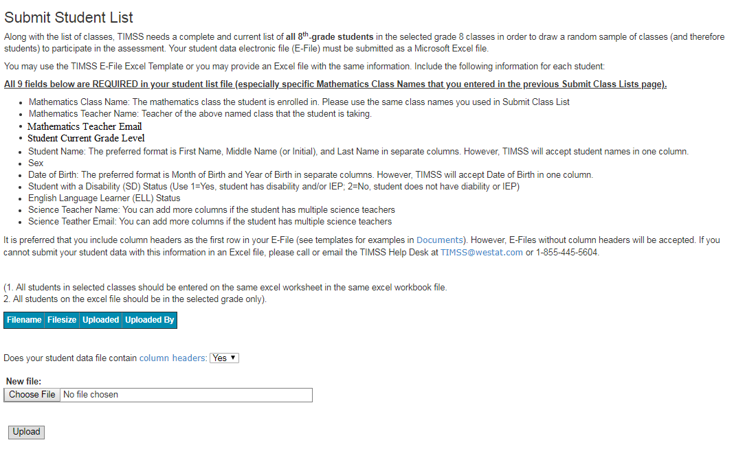

MyTIMSS Prepare for Assessment Page
(red font is customized depending on grade the school was selected for)
Prepare For Assessment
Thank you for providing information about all the fourth-grade classes / eighth-grade math classes in your school! After submitting both class and student lists, you will receive an email telling you that your sample of classes has been selected. Return to this webpage when you receive the email from TIMSSefile@westat.com: “The list of students selected to participate in TIMSS is available in the Student-Teacher Linkage Form (STLF)”
Student Tracking Linkage Form (download both if more than one link is shown)
Student-Teacher Linkage Forms (STLF) – The forms list the selected students and their teachers. Please make sure students and teachers are linked correctly on the form. Instructions on how to access and review the forms were emailed to you and are in the Documents section on this website.
Please note the following:
If the students and teacher linkages appear fine in the STLF, no need to contact the TIMSS E-Filing Help Desk. Three business days later, please return to this page. Two new links will be shown here to download STF1 and STF2 (Student Tracking Forms). This is the form you can review to see if any student names, information, new enrollees, no longer enrolled students, should be updated. Your Test Administrator will contact you to discuss this. Do not contact the TIMSS E-Filing Help Desk unless there are major updates needed on this form. You can discuss the minor updates with your Test Administrator when they call you in the pre-assessment call.
Student Tracking Form (download both if more than one link is shown)
Student Tracking Form (STF)–The forms list the students who have been selected to participate in the assessment at your school. Instructions on how to access and review the forms are in the Documents section on this website. The STF will become available about a week after the STLF has been posted.
Sample Parent Notification Letter and Facts for Parents about TIMSS. You will receive a packet of TIMSS materials including a sample parent/guardian notification letter and a TIMSS Parent FAQ
A sample parent/guardian notification letter is in the Documents section for you to customize and print on your school letterhead. Please distribute the parent notification letter and the Parent FAQ (from our FedEx mailing to you) to the parents of the selected students prior to the assessment. Additionally, a Spanish version of the letter is available in the Documents page. You can also share the Parent FAQ link available here: https://nces.ed.gov/timss/parents/.
As your assessment date approaches, your Test Administrator will be contacting you to finalize the assessment day activities.

Prepare for Assessment page (screenshot)
(Grade 8 example below)
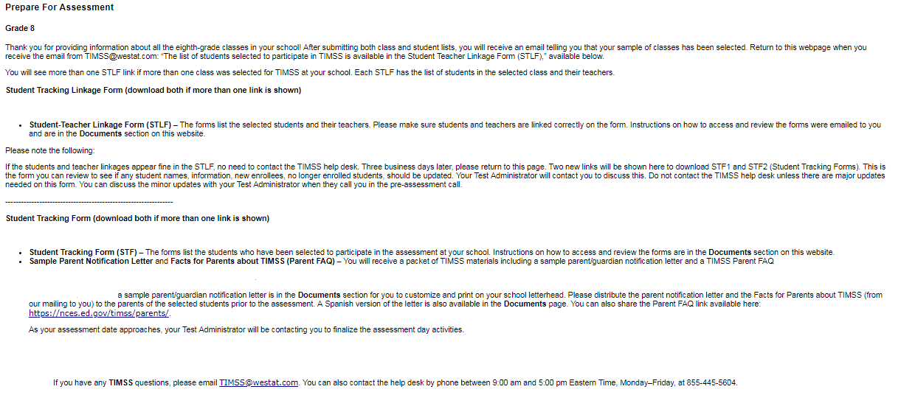

Student-Teacher Linkage Form (STLF) Email
(yellow highlight for mail merge)

Dear [school coordinator],
The list of students selected to participate in TIMSS is available in the Student-Teacher Linkage Form (STLF)!

The Student-Teacher Linkage Form (STLF) lists the students who have been selected to participate in the assessment at your school. This list is based on the class and student information you submitted. To access the STLF, please login at www.MyTIMSS2019.com, then go to Prepare for Assessment and select “Click here to download the STLF.” In the two STLF excel files, there is a worksheet for each set of classes or students selected, so please make sure to review each STLF excel file. Most schools will have two excel files, one for each class.
For the Student-Teacher Linkage Form (STLF), you will only need to make sure the students on that list match the teachers to the selected students in the header of Column 6. If you see any errors, please contact the TIMSS E-Filing Help Desk at TIMSSefile@westat.com or 855-445-5604. Please do not email the list back to us.
In a week of the STLF posting, you will receive an email informing you that the final list of selected students and teachers are available. These lists, called the Student Tracking Forms (STF) will be posted on this same Prepare for Assessment page.
Thank you very much for participating in TIMSS, and for submitting your school's class and student lists!
Sincerely,
The TIMSS Team
NCES is authorized to conduct this study under the Education Sciences Reform Act of 2002 (ESRA 2002, 20 U.S.C. §9543). All of the information you provide may be used only for statistical purposes and may not be disclosed, or used, in identifiable form for any other purpose except as required by law (20 U.S.C. §9573 and 6 U.S.C. §151).

Student Tracking Form (STF) Email
(yellow highlight for mail merge; red for customization)
Dear [School Coordinator],

Thank you for providing information about all the fourth-grade/eighth-grade classes in your school! The list of students and teachers selected to participate in TIMSS is now available in the Student Tracking Forms (STF) available on the MyTIMSS website. Please see below for more details about the forms and parent notification.
- Student Tracking Form (STF) –The forms list the students who have been selected to participate in the assessment at your school. Instructions on how to access and review the forms are attached.
- Sample Parent Notification Letter and Facts for Parents about TIMSS 2019 (Parent FAQ) – A sample parent/guardian notification letter is attached for you to customize and print on your school letterhead. Please distribute the parent notification letter and the Facts for Parents about TIMSS 2019 to the parents of the selected students prior to the assessment. A Spanish version of the letter is available on the MyTIMSS site under Documents.
- FedEx Shipment
  - Within a week, a FedEx shipment of hard-copies of the Facts for Parents about TIMSS 2019 (Parent FAQ) will be delivered to you. You can also distribute them electronically or share the Parent FAQ link available here: https://nces.ed.gov/timss/parents/
  - Student Appointment/invitations cards to give to selected students will be sent to you as well.

As your assessment date approaches, your Test Administrator will be contacting you to finalize the assessment day activities and discuss accommodations, if necessary.
If you have any questions, please do not hesitate to call 855-445-5604 or send an email to TIMSSefile@westat.com. You may also get more information about this study by visiting the TIMSS website at http://nces.ed.gov/timss.
Thank you for your assistance with this study!
Sincerely,
The TIMSS Team
Attachments:
Sample Parent Notification Letter
Facts for Parents about TIMSS 2019 (Parent FAQ)
STF Instructions

NCES is authorized to conduct this study under the Education Sciences Reform Act of 2002 (ESRA 2002, 20 U.S.C. §9543). All of the information you provide may be used only for statistical purposes and may not be disclosed, or used, in identifiable form for any other purpose except as required by law (20 U.S.C. §9573 and 6 U.S.C. §151).

Instructions for Student Tracking Form (STF)

Reviewing the Student Tracking Form (STF)

The two Student Tracking Form (STF) lists the students who have been selected to participate in the assessment at your school. This list is based on the student information you submitted. You can take notes on this form in preparation for the pre-assessment call in which the Test Administrator will ask you about any updates to this form over the phone. To access the STF, please login at www.MyTIMSS2019.com, then go to Prepare for Assessment and select “Click here to download the STF.” Student Appointment/invitations cards to give to selected students will be sent to you in a FedEx delivery.

As the first step in reviewing the Student Tracking Form, please verify the student information for accuracy after you open the excel file you just downloaded. See below for what should be reviewed. Please also make sure the school name and students match what you expect.

- Student’s name is listed in Column 1.
- Date of birth is listed in Column 4.
- Gender (using codes—1 for female and 2 for male) is listed in Column 5.
- Exclusion status in Column 6.
- Participation status in Column 7.
Student Exclusions and Accommodations
If a student is to be excluded from the assessment because he or she requires an accommodation, please make a note in column 6 using the codes at the bottom of the STF.

Participation Status + Newly-enrolled or no-longer-enrolled students
If many of the students listed in the STF are not enrolled in the school, please contact TIMSSefile@westat.com ASAP, but you do not need to contact TIMSSefile@westat.com if only 1 to 3 students are no longer enrolled or are newly enrolled. These new or no-longer-enrolled students can be discussed with your Test Administrator when they call you for the pre-assessment call (usually 1-2 weeks before assessment date). You can make a note on the form regarding these students in the first column in column 7 using the status codes shown at the bottom of the STF. You can also use status codes 1 through 4 to provide more information about a student.

Updates and Questions
If you have updates to the STF, please have the form ready for the pre-assessment call. You can also provide the hardcopy to the Test Administrator when they come to your school on assessment day. If you have any questions about completing this form, please address them with your Test Administrator when they contact you. For urgent questions on the STF, you can also contact the TIMSS E-Filing Help Desk (TIMSSefile@westat.com). The STF is just for you to take notes on in preparation for the pre-assessment call so you know parents of which students should be notified. Please do not send the STF back to us. You can however give it to the Test Administrator in person, if you would like, when they come on the assessment day.

Student-Teacher Linkage Form (STLF) Template (Grade 4 vs. Grade 8)
Grade 4 STLF
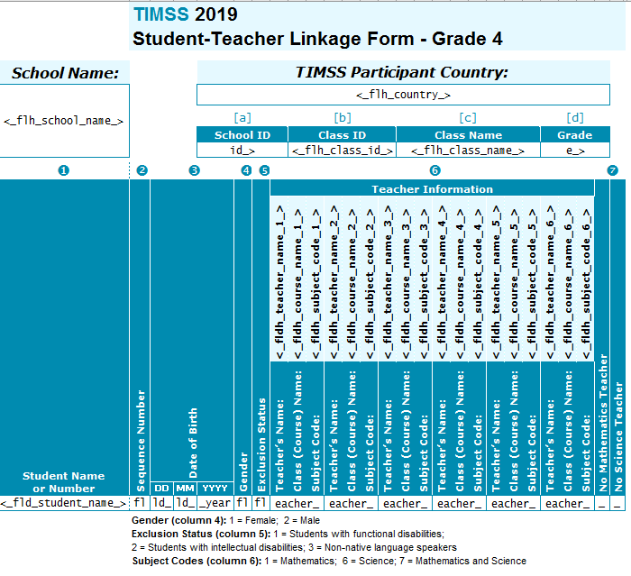
Grade 8 STLF
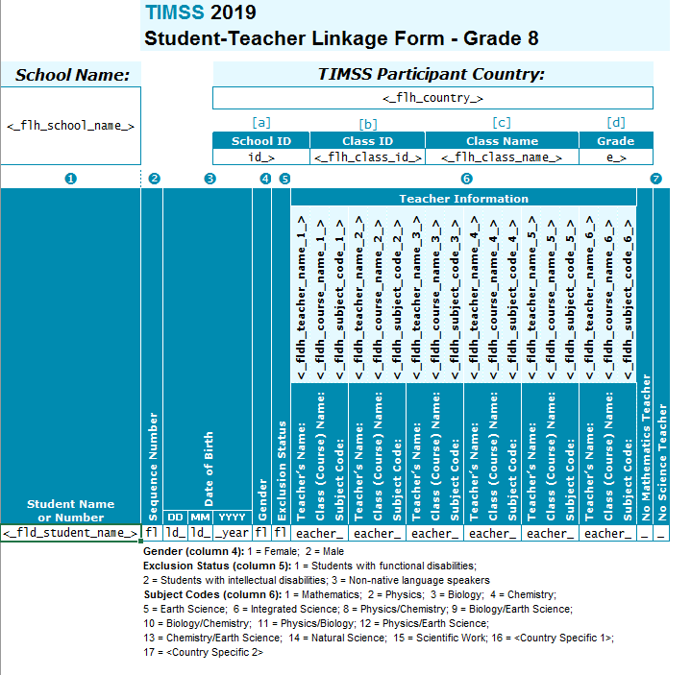

Student Tracking Form (STF) Template (eTIMSS vs. Paper Bridge Study)

eTIMSS STF
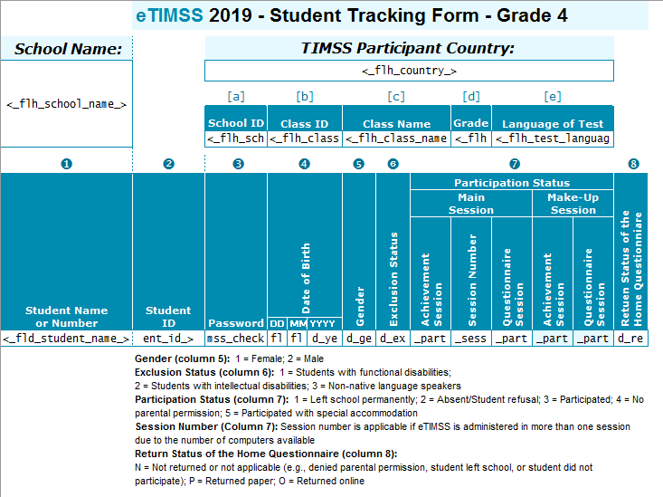
Paper Bridge Study STF
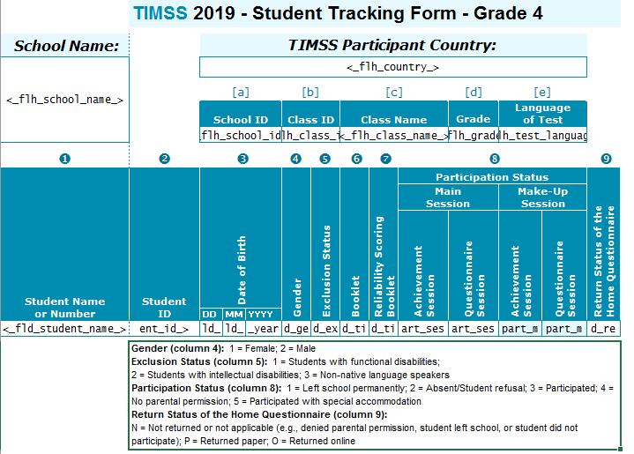

MyTIMSS Documents Page

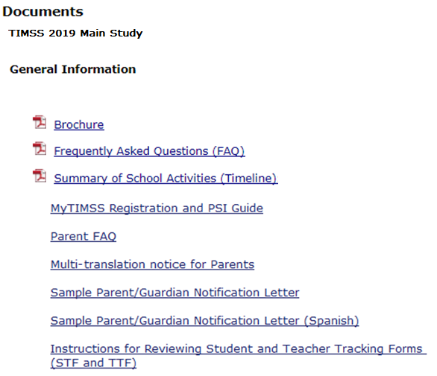
(Grade 4 example below)
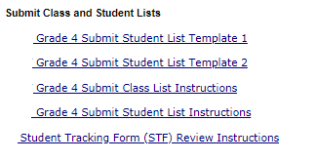

MyTIMSS Important Websites and Contact Us Pages
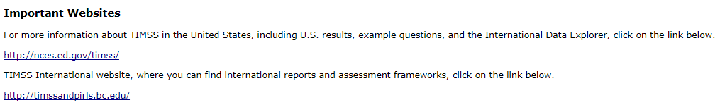

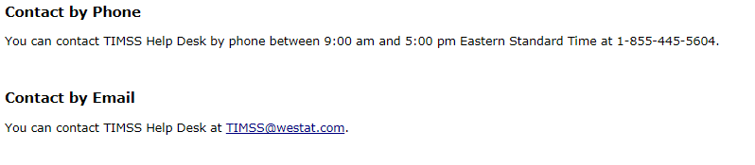

School Principal Questionnaire Login Card/Email

Front of Card:
Welcome to TIMSS!
Your school is participating in the main study for Trends in International Mathematics and Science Study (TIMSS) 2019. This online questionnaire seeks information about schools and provides important context to understanding the achievement of students taking the assessment.

Please go to the web address (URL) given below and log in to the online questionnaire with your “School ID” and “Password”, which are printed on the label attached below. Please contact the TIMSS hotline (TIMSS@westat.com) if you have problems logging on.
The website link is: https://portalg[4/8].mytimss2019.com
[Insert Label]

The online questionnaire does NOT require JavaScript or cookies to work. Responses are saved automatically as you go from question to question. The “Table of Contents” link on the bottom of each page provides an overview of all questions and whether you have completed them. You may leave the questionnaire at any time and log in again later. See notes on the back of this card.
OMB# 1850-0695 (expires 01/31/2021).

Back of Card:
NOTES
- Please use the Previous and Next buttons to navigate backward and forward
- You may exit the questionnaire at any time and log in again later— all of your responses will be saved automatically.
- The Table of Contents provides an overview of all questions and shows whether you have completed all questions.
- To exit the Table of Contents, click on any question link or section header.
- If you would like a printed copy of the online questionnaire, click on the “Prepare Printer Version” link on the Table of Contents page.
- It is estimated that it will take approximately 30 minutes to complete the questionnaire.
- If you have problems accessing the online questionnaire or need assistance, please contact the TIMSS hotline at 1-855-445-5604 or email TIMSS@westat.com.
- If you would prefer to complete a paper questionnaire, please contact your TIMSS School Coordinator.

Thank you for the thought, time, and effort you have put into completing the questionnaire!

NCES is authorized to conduct TIMSS under the Education Sciences Reform Act of 2002 (ESRA 2002, 20 U.S.C. §9543). All of the information provided by school staff and students may be used only for statistical purposes and may not be disclosed, or used, in identifiable form for any other purpose except as required by law (20 U.S.C. §9573 and 6 U.S.C. §151). The U.S. Office of Management and Budget has approved the data collection under OMB# 1850-0695. Individual responses will be combined with those from other participants to produce summary statistics and reports.

Teacher Questionnaire Selection Email
Welcome to TIMSS!
Your school is participating in the main study for the Trends in International Mathematics and Science Study (TIMSS) 2019. This online questionnaire seeks information about teachers’ academic and professional backgrounds, classroom resources, instructional practices, and attitudes toward teaching.

Please go to the web address (URL) given below and log in to the online questionnaire with your “User ID” and “Password”, which are below. Please contact the TIMSS hotline (TIMSS@westat.com) if you have problems logging on. The website link is: [hyperlink]

User ID: [User ID]
Password: [Password]
Subject code: [Subject code]

Responses are saved automatically as you go from question to question. The “Table of Contents” link on the bottom of each page provides an overview of all questions and whether you have completed them. You may leave the questionnaire at any time and log in again later. You must click “Finish” at the last page for us to receive your submission. See notes below.

NOTES
• Please use the Previous and Next buttons to navigate backward and forward
• You may exit the questionnaire at any time and log in again later— all of your responses will be saved automatically.
• The Table of Contents provides an overview of all questions and shows whether you have completed all questions.
• To exit the Table of Contents, click on any question link.
• If you would like a printed copy of the online questionnaire, click on the “Prepare Printer Version” link on the Table of Contents page.
• It is estimated that it will take approximately 30 minutes to complete the questionnaire.
• You must click “Finish” at the last page for us to receive your submission.
• If you have problems accessing the online questionnaire or need assistance, please contact the TIMSS hotline at 1-855-445-5604 or email TIMSS@westat.com.
• If you would prefer to complete a paper questionnaire, please contact your TIMSS School Coordinator.
• After you have completed the questionnaire and within a few days, you will receive a $20 Amazon gift card code from this email address as a token of appreciation for your participation.

Thank you for the thought, time, and effort you have put into completing the questionnaire!

Sincerely,
The U.S. TIMSS 2019 Team

NCES is authorized to conduct TIMSS under the Education Sciences Reform Act of 2002 (ESRA 2002, 20 U.S.C. §9543). All of the information provided by school staff and students may be used only for statistical purposes and may not be disclosed, or used, in identifiable form for any other purpose except as required by law (20 U.S.C. §9573 and 6 U.S.C. §151). The U.S. Office of Management and Budget has approved the data collection under OMB# 1850-0695. Individual responses will be combined with those from other participants to produce summary statistics and reports.

Teacher Questionnaire Reminder Email

Hello,

This is a gentle reminder to please complete the Trends in International Mathematics and Science Study (TIMSS) 2019 online teacher questionnaire. This online questionnaire seeks information about teachers’ academic and professional backgrounds, classroom resources, instructional practices, and attitudes toward teaching.

Please go to the web address (URL) given below and log in to the online questionnaire with your “User ID” and “Password”, which are below. Please contact the TIMSS Hotline (TIMSS@westat.com) if you have problems logging on. The website link is: [hyperlink]

User ID: [User ID]
Password: [Password]
Subject code: [Subject code]
Responses are saved automatically as you go from question to question. The “Table of Contents” link on the bottom of each page provides an overview of all questions and whether you have completed them. You may leave the questionnaire at any time and log in again later. You must click “Finish” at the last page for us to receive your submission. See notes below.

NOTES
• Please use the Previous and Next buttons to navigate backward and forward
• You may exit the questionnaire at any time and log in again later— all of your responses will be saved automatically.
• The Table of Contents provides an overview of all questions and shows whether you have completed all questions.
• To exit the Table of Contents, click on any question link.
• If you would like a printed copy of the online questionnaire, click on the “Prepare Printer Version” link on the Table of Contents page.
• It is estimated that it will take approximately 30 minutes to complete the questionnaire.
• You must click “Finish” at the last page for us to receive your submission.
• If you have problems accessing the online questionnaire or need assistance, please contact the TIMSS hotline at 1-855-445-5604 or email TIMSS@westat.com.
• If you would prefer to complete a paper questionnaire, please contact your TIMSS School Coordinator.
• After you have completed the questionnaire and within a few days, you will receive a $20 Amazon gift card code from this email address as a token of appreciation for your participation.

Thank you for the thought, time, and effort you have put into completing the questionnaire!
Sincerely,
The U.S. TIMSS 2019 Team
NCES is authorized to conduct TIMSS under the Education Sciences Reform Act of 2002 (ESRA 2002, 20 U.S.C. §9543). All of the information provided by school staff and students may be used only for statistical purposes and may not be disclosed, or used, in identifiable form for any other purpose except as required by law (20 U.S.C. §9573 and 6 U.S.C. §151). The U.S. Office of Management and Budget has approved the data collection under OMB# 1850-0695. Individual responses will be combined with those from other participants to produce summary statistics and reports.

Amazon Gift Card Code Email

Thank you for completing the TIMSS Teacher Questionnaire! We appreciate your time and effort to complete the survey. Your participation in TIMSS 2019 is very important to its success.
Here is your $20 Amazon gift card code: [code]. To redeem this gift card, go to www.Amazon.com/redeem.
If you have any questions about the research study, please email or call the TIMSS hotline at TIMSS@westat.com or 1-855-445-5604 between 9 am and 5 pm ET, Monday through Friday.
Thank you again for participating in TIMSS!
Sincerely,
The U.S. TIMSS 2019 Team

Online Questionnaire Login Screen Text
(for the Principal, Teachers, and Students)

TIMSS2019MS - English (United States)
You are not logged in.

Welcome to the IEA - DPC SurveySystem
Online Questionnaires

Please enter your user ID and password (Checksum).
User ID:
Password:

The National Center for Education Statistics (NCES), within the U.S. Department of Education, conducts TIMSS in the United States as authorized by the Education Sciences Reform Act of 2002 (ESRA 2002, 20 U.S.C. §9543). All of the information you provide may be used only for statistical purposes and may not be disclosed, or used, in identifiable form for any other purpose except as required by law (20 U.S.C. §9573 and 6 U.S.C. §151).
According to the Paperwork Reduction Act of 1995, no persons are required to respond to a collection of information unless such collection displays a valid OMB control number. The valid OMB control number for this voluntary information collection is 1850-0695. The time required to complete this information collection is estimated to average 30 minutes per principal, 30 minutes per teacher, and 30 minutes per student, including the time to review instructions, search existing data resources, gather the data needed, and complete and review the information collection. If you have any comments or concerns regarding the accuracy of the time estimate(s), suggestions for improving the form, or questions about the status of your individual submission of this form, write directly to: Trends in International Mathematics and Science Study (TIMSS), National Center for Education Statistics, Potomac Center Plaza (PCP), 550 12th St., SW, 4th floor, Washington, DC 20202.
OMB No. 1850-0695, Approval Expires 01/31/2021.

© IEA Online SurveySystem 2019 - Help

Student Appointment Card for TIMSS 2019 MS: Grade 8 only

Front
(TIMSS USA Graphic and Logo)
Welcome to the U.S. TIMSS Team!
___________________________________
(student name)

Congratulations, you have been selected to be part of a special group of students representing the United States in the TIMSS (Trends in International Mathematics and Science Study) 2019 Main Study.
See back for details.
Back
This spring, selected students from the United States will participate in the main study in 2019.
Join us on....
TIMSS Date:
TIMSS Time:
TIMSS Location:
Please bring your own scientific or graphic calculator to the TIMSS 2019 main study.
During the assessment, you are not permitted to use devices that can connect to the Internet. Aside from the testing equipment, you cannot use a laptop or other portable computer, pocket organizer, device with a typewriter-style keyboard, electronic writing pad, pen input device, or a cell phone.
See front for details.
(TIMSS USA and IES logos)

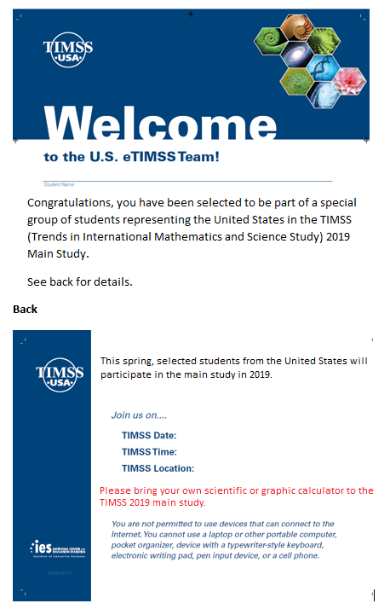

Student Login Card (label with login information will be affixed to the card)
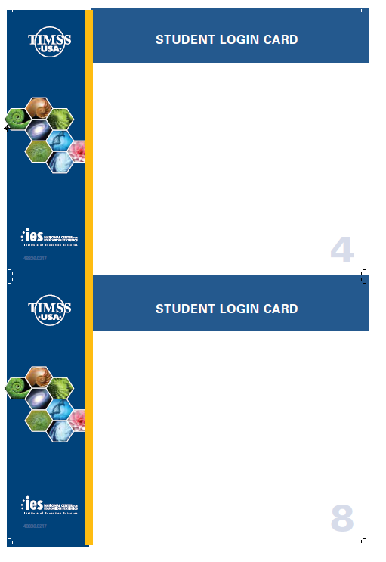

Student Certificate of Completion
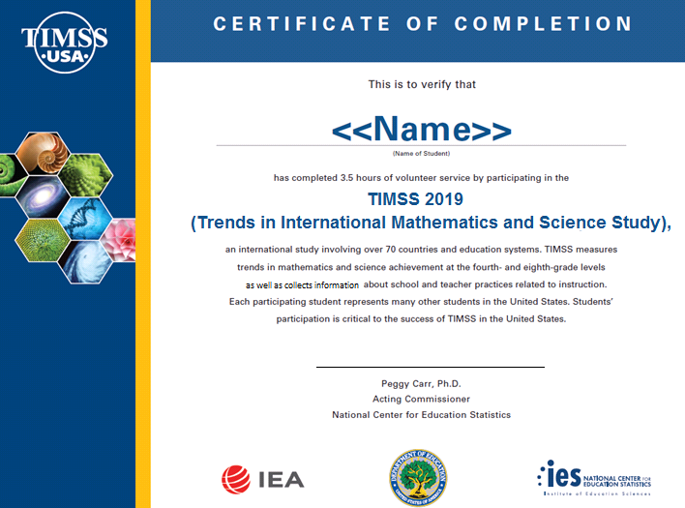

School Certificate of Completion
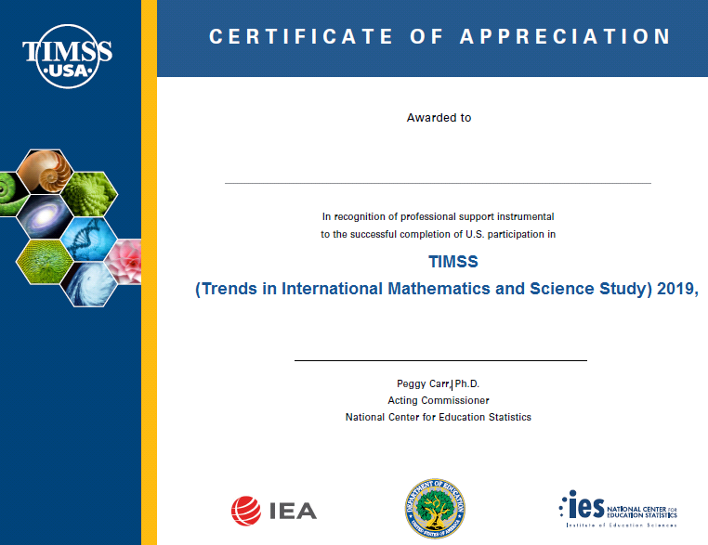

Appendix B: TIMSS 2019 Main Study Notification Letters and Supporting Materials
Contents

Appendix B: TIMSS 2019 Main Study Notification Letters and Supporting Materials 73
TIMSS Main Study Sample Notification Letter: Grade 4 74
TIMSS Main Study Sample Notification Letter: Grade 8 75
TIMSS Main Sample Implicit Consent Letter: Grade 4 76
TIMSS Main Study Sample Implicit Consent Letter: Grade 8 77
TIMSS Implicit Consent Form: Grades 4 and 8 78
TIMSS Main Study Sample Explicit Consent Letter: Grade 4 79
TIMSS Main Study Sample Explicit Consent Letter: Grade 8 80
TIMSS Explicit Consent Form: Grades 4 and 8 81
TIMSS Facts for Parents About the Main Study: Grade 4 82
TIMSS Facts for Parents About the Main Study: Grade 8 83
Multi-translation Notice for Parents 84

TIMSS Main Study Sample Notification Letter: Grade 4

SCHOOL LETTERHEAD

Dear Parent or Guardian,
This letter is to inform you about an important international study of student learning being conducted in our school this spring. The Trends in International Mathematics and Science Study (TIMSS) provides important information for benchmarking student performance in mathematics and science at grades 4 and 8 in the United States against countries around the world. Since 1995, TIMSS has measured worldwide trends in student knowledge of mathematics and science.
Our school has accepted an invitation from the National Center for Education Statistics (NCES), part of the U.S. Department of Education, to participate in TIMSS 2019. {Insert number} of our 4th-grade classes will take part. {This/One of these} is your child’s class. The enclosed summary sheet provides some background information about TIMSS, explains what is involved for each student selected to participate in the study, and gives a contact phone number and email address where you can find answers to any questions you might have.
To have an accurate picture of what U.S. 4th graders can do in mathematics and science, it is important that each student selected take part in the study. In addition to answering mathematics and science questions, students will be asked to complete a questionnaire about themselves. I urge you to support this effort by encouraging your child to take part; however, participation in this study is entirely voluntary. Previous experience suggests that students actually enjoy taking part, and participating students will receive a small gift, which we think they will like.
All of the information collected is safeguarded, as required by law. NCES is authorized to conduct this study under the Education Sciences Reform Act of 2002 (ESRA 2002, 20 U.S.C. §9543). All of the information provided by school staff and students may be used only for statistical purposes and may not be disclosed, or used, in identifiable form for any other purpose except as required by law (20 U.S.C. §9573 and 6 U.S.C. §151). Students and schools are never identified in any reports. All reported statistics refer to the United States as a whole.
Thank you for taking the time to learn about this important study.
Sincerely,
[School official]
Enclosures:
Facts for Parents about TIMSS 2019

TIMSS Main Study Sample Notification Letter: Grade 8

SCHOOL LETTERHEAD

Dear Parent or Guardian,
This letter is to inform you about an important international study of student learning being conducted in our school this spring. The Trends in International Mathematics and Science Study (TIMSS) provides important information for benchmarking student performance in mathematics and science at grades 4 and 8 in the United States against countries around the world. Since 1995, TIMSS has measured worldwide trends in student knowledge of mathematics and science.
Our school has accepted an invitation from the National Center for Education Statistics (NCES), part of the U.S. Department of Education, to participate in TIMSS 2019. {Insert number} of our 8th-grade classes will take part. {This/One of these} is your child’s class. The enclosed summary sheet provides some background information about TIMSS, explains what is involved for each student selected to participate in the study, and gives a contact phone number and email address where you can find answers to any questions you might have.
To have an accurate picture of what U.S. 8th graders can do in mathematics and science, it is important that each student selected take part in the study. In addition to answering mathematics and science questions, students will be asked to complete a questionnaire about themselves. I urge you to support this effort by encouraging your child to take part; however, participation in this study is entirely voluntary. Previous experience suggests that students actually enjoy taking part, and participating students will receive a small gift, which we think they will like.
All of the information collected is safeguarded, as required by law. NCES is authorized to conduct this study under the Education Sciences Reform Act of 2002 (ESRA 2002, 20 U.S.C. §9543). All of the information provided by school staff and students may be used only for statistical purposes and may not be disclosed, or used, in identifiable form for any other purpose except as required by law (20 U.S.C. §9573 and 6 U.S.C. §151). Students and schools are never identified in any reports. All reported statistics refer to the United States as a whole.
Thank you for taking the time to learn about this important study.
Sincerely,
[School Official]
Enclosures:
Facts for Parents about TIMSS 2019

TIMSS Main Sample Implicit Consent Letter: Grade 4

SCHOOL LETTERHEAD

Dear Parent or Guardian,
This letter is to inform you about an important international study of student learning being conducted in our school this spring. The Trends in International Mathematics and Science Study (TIMSS) provides important information for benchmarking student performance in mathematics and science at grades 4 and 8 in the United States against countries around the world. Since 1995, TIMSS has measured worldwide trends in student knowledge of mathematics and science.
Our school has accepted an invitation from the National Center for Education Statistics (NCES), part of the U.S. Department of Education, to participate in TIMSS 2019. {Insert number} of our 4th-grade classes will take part. {This/One of these} is your child’s class. The enclosed summary sheet provides some background information about TIMSS, explains what is involved for each student selected to participate in the study, and gives a contact phone number and email address where you can find answers to any questions you might have.
To have an accurate picture of what U.S. 4th graders can do in mathematics and science, it is important that each student selected take part in the study. In addition to answering mathematics and science questions, students will be asked to complete a questionnaire about themselves. I urge you to support this effort by encouraging your child to take part; however, participation in this study is entirely voluntary. Previous experience suggests that students actually enjoy taking part, and participating students will receive a small gift, which we think they will like.
All of the information collected is safeguarded, as required by law. NCES is authorized to conduct this study under the Education Sciences Reform Act of 2002 (ESRA 2002, 20 U.S.C. §9543). All of the information provided by school staff and students may be used only for statistical purposes and may not be disclosed, or used, in identifiable form for any other purpose except as required by law (20 U.S.C. §9573 and 6 U.S.C. §151). Students and schools are never identified in any reports. All reported statistics refer to the United States as a whole.
If you have any objection to your child joining in the TIMSS activities, please let us know by completing the attached consent form and returning it to the school.
Thank you for taking the time to learn about this important study.
Sincerely,
[School Official]
Enclosures:
Facts for Parents about TIMSS 2019
Parent/Guardian Consent Form

TIMSS Main Study Sample Implicit Consent Letter: Grade 8

SCHOOL LETTERHEAD

Dear Parent or Guardian,
This letter is to inform you about an important international study of student learning being conducted in our school this spring. The Trends in International Mathematics and Science Study (TIMSS) provides important information for benchmarking student performance in mathematics and science at grades 4 and 8 in the United States against countries around the world. Since 1995, TIMSS has measured worldwide trends in student knowledge of mathematics and science.
Our school has accepted an invitation from the National Center for Education Statistics (NCES), part of the U.S. Department of Education, to participate in TIMSS 2019. {Insert number} of our 8th-grade classes will take part. {This/One of these} is your child’s class. The enclosed summary sheet provides some background information about TIMSS, explains what is involved for each student selected to participate in the study, and gives a contact phone number and email address where you can find answers to any questions you might have.
To have an accurate picture of what U.S. 8th graders can do in mathematics and science, it is important that each student selected take part in the study. In addition to answering mathematics and science questions, students will be asked to complete a questionnaire about themselves. I urge you to support this effort by encouraging your child to take part; however, participation in this study is entirely voluntary. Previous experience suggests that students actually enjoy taking part, and participating students will receive a small gift, which we think they will like.
All of the information collected is safeguarded, as required by law. NCES is authorized to conduct this study under the Education Sciences Reform Act of 2002 (ESRA 2002, 20 U.S.C. §9543). All of the information provided by school staff and students may be used only for statistical purposes and may not be disclosed, or used, in identifiable form for any other purpose except as required by law (20 U.S.C. §9573 and 6 U.S.C. §151). Students and schools are never identified in any reports. All reported statistics refer to the United States as a whole.
If you have any objection to your child joining in the TIMSS activities, please let us know by completing the attached consent form and returning it to the school.
Thank you for taking the time to learn about this important study.
Sincerely,
[School Official]
Enclosures:
Facts for Parents about TIMSS 2019
Parent/Guardian Consent Form

TIMSS Implicit Consent Form: Grades 4 and 8
Trends in International Mathematics and Science Study (TIMSS) 2019
Parent/Guardian Consent Form
Your child has been asked to participate in an important international study of student learning called the Trends in International Mathematics and Science Study (TIMSS). Each student who participates will receive a small gift. This assessment will be administered by a team of researchers from Westat, who are operating under contract on behalf of the National Center for Education Statistics (NCES), with the U. S. Department of Education. In spring 2019, 4th and 8th grade questions in electronic formats will be tested on tablet computers in approximately 650 schools in the United States in preparation for the 2019 international study (325 schools that include 4th grade and 325 that include 8th grade).
If you grant permission for your child to participate in TIMSS 2019, you do not need to return this form.
If you do not consent to your child’s participation in TIMSS 2019 please return this form to your child’s school as soon as possible.

I do not grant permission for my child, _______________________________, to participate in the Trends in International Mathematics and Science Study 2019 assessment.

__________________________________________________________________
(Signature of parent or guardian)

Date of signature: _______/_______/____________

PLEASE PRINT:

Student name: _____________________________________________

School name: ______________________________________________

FOR OFFICE USE ONLY:
Student ID: ________________________________________________

TIMSS Main Study Sample Explicit Consent Letter: Grade 4

SCHOOL LETTERHEAD

Dear Parent or Guardian,
This letter is to inform you about an important international study of student learning being conducted in our school this spring. The Trends in International Mathematics and Science Study (TIMSS) provides important information for benchmarking student performance in mathematics and science at grades 4 and 8 in the United States against countries around the world. Since 1995, TIMSS has measured worldwide trends in student knowledge of mathematics and science.
Our school has accepted an invitation from the National Center for Education Statistics (NCES), part of the U.S. Department of Education, to participate in TIMSS 2019. {Insert number} of our 4th-grade classes will take part. {This/One of these} is your child’s class. The enclosed summary sheet provides some background information about TIMSS, explains what is involved for each student selected to participate in the study, and gives a contact phone number and email address where you can find answers to any questions you might have.
To have an accurate picture of what U.S. 4th graders can do in mathematics and science, it is important that each student selected take part in the study. In addition to answering mathematics and science questions, students will be asked to complete a questionnaire about themselves. I urge you to support this effort by encouraging your child to take part; however, participation in this study is entirely voluntary. Previous experience suggests that students actually enjoy taking part, and participating students will receive a small gift, which we think they will like.
All of the information collected is safeguarded, as required by law. NCES is authorized to conduct this study under the Education Sciences Reform Act of 2002 (ESRA 2002, 20 U.S.C. §9543). All of the information provided by school staff and students may be used only for statistical purposes and may not be disclosed, or used, in identifiable form for any other purpose except as required by law (20 U.S.C. §9573 and 6 U.S.C. §151). Students and schools are never identified in any reports. All reported statistics refer to the United States as a whole.
Before we can allow your child to join in the TIMSS activities, we must have your written consent. Please let us know by completing the attached form and returning it to the school.
Thank you for taking the time to learn about this important study and to consider your child’s participation in it.
Sincerely,
[School Official]
Enclosures:
Facts for Parents about TIMSS 2019
Parent/Guardian Consent Form

TIMSS Main Study Sample Explicit Consent Letter: Grade 8

SCHOOL LETTERHEAD

Dear Parent or Guardian,
This letter is to inform you about an important international study of student learning being conducted in our school this spring. The Trends in International Mathematics and Science Study (TIMSS) provides important information for benchmarking student performance in mathematics and science at grades 4 and 8 in the United States against countries around the world. Since 1995, TIMSS has measured worldwide trends in student knowledge of mathematics and science.
Our school has accepted an invitation from the National Center for Education Statistics (NCES), part of the U.S. Department of Education, to participate in TIMSS 2019. {Insert number} of our 8th-grade classes will take part. {This/One of these} is your child’s class. The enclosed summary sheet provides some background information about TIMSS, explains what is involved for each student selected to participate in the study, and gives a contact phone number and email address where you can find answers to any questions you might have.
To have an accurate picture of what U.S. 8th graders can do in mathematics and science, it is important that each student selected take part in the study. In addition to answering mathematics and science questions, students will be asked to complete a questionnaire about themselves. I urge you to support this effort by encouraging your child to take part; however, participation in this study is entirely voluntary. Previous experience suggests that students actually enjoy taking part, and participating students will receive a small gift, which we think they will like.
All of the information collected is safeguarded, as required by law. NCES is authorized to conduct this study under the Education Sciences Reform Act of 2002 (ESRA 2002, 20 U.S.C. §9543). All of the information provided by school staff and students may be used only for statistical purposes and may not be disclosed, or used, in identifiable form for any other purpose except as required by law (20 U.S.C. §9573 and 6 U.S.C. §151). Students and schools are never identified in any reports. All reported statistics refer to the United States as a whole.
Before we can allow your child to join in the TIMSS activities, we must have your written consent. Please let us know by completing the attached form and returning it to the school.
Thank you for taking the time to learn about this important study and to consider your child’s participation in it.
Sincerely,
[School Official]
Enclosures:
Facts for Parents about TIMSS 2019
Parent/Guardian Consent Form

TIMSS Explicit Consent Form: Grades 4 and 8
Trends in International Mathematics and Science Study (TIMSS)
Parent/Guardian Consent Form
Your child has been asked to participate in an important international study of student learning called the Trends in International Mathematics and Science Study (TIMSS). Each student who participates will receive a small gift. This assessment will be administered by a team of researchers from Westat, who are operating under contract on behalf of the National Center for Education Statistics (NCES), with the U. S. Department of Education. In spring 2019, 4th and 8th grade questions in electronic formats will be tested on tablet computers in approximately 650 schools in the United States in preparation for the 2019 international study (325 schools that include 4th grade and 325 that include 8th grade).

Yes, I grant permission for my child to participate in TIMSS 2019.

No, I do not grant permission for my child to participate in TIMSS 2019.

__________________________________________________________________
(Signature of parent or guardian)

Date of signature: _______/_______/____________

PLEASE PRINT:

Student name: _____________________________________________

School name: ______________________________________________

FOR OFFICE USE ONLY:
Student ID: ________________________________________________

TIMSS Facts for Parents About the Main Study: Grade 4
Facts for Parents
About TIMSS 2019
Between March and May of this year, your child’s school will be one of about 325 nationwide taking part in a 4th-grade important international assessment: TIMSS 2019. Schools were selected randomly to represent the nation’s schools and, within each school, 4th-grade students were selected randomly to represent the nation’s 4th graders. Your child was among those students selected to take part in the TIMSS assessment.
What is TIMSS?
TIMSS (Trends in International Mathematics and Science Study) is an international assessment that measures student learning in mathematics and science. Every four years since 1995, TIMSS documents worldwide trends in the knowledge of 4th graders. The National Center for Education Statistics (NCES), within the U.S. Department of Education, conducts TIMSS in the United States. Along with more than 60 other nations, the U.S. will take part in the 2019 TIMSS cycle as we did in 1995, 1999, 2003, 2007, 2011, and 2015.
What is involved?
TIMSS staff will visit the school and administer the assessment on tablet computers that they will bring to the school. In a small number of classes the assessment will be administered on paper. The session will take approximately 2 ½ hours. The assessment itself is 72 minutes with breaks between sections. Students will also be asked some questions about themselves and their educational experience. Participation in the study is voluntary.
What are the benefits?
The nation as a whole benefits from TIMSS by having a greater understanding of how the knowledge and skills of U.S. 4th graders compare with those of 4th graders in other countries. Schools that participate in TIMSS will receive $200, and students who participates will receive a small gift that we believe they will like.
Who administers TIMSS?
The entire assessment is administered by trained staff from Westat, a research organization under contract to the U.S. Department of Education’s National Center for Education Statistics.
All of the information collected is safeguarded, as required by law. NCES is authorized to conduct this study under the Education Sciences Reform Act of 2002 (ESRA 2002, 20 U.S.C. §9543). All of the information provided by school staff and students may be used only for statistical purposes and may not be disclosed, or used, in identifiable form for any other purpose except as required by law (20 U.S.C. §9573 and 6 U.S.C. §151). Students and schools are never identified in any reports. All reported statistics refer to the United States as a whole.
Where can I find out more about TIMSS?
More information about TIMSS is available at the TIMSS website at http://nces.ed.gov/timss or http://timss.bc.edu. Or if you would like to contact a TIMSS staff member directly, please feel free to call the TIMSS hotline at 1-(855)-445-5604 or email us at TIMSS@westat.com.

TIMSS Facts for Parents About the Main Study: Grade 8
Facts for Parents
About TIMSS 2019
Between March and May of this year, your child’s school will be one of about 325 nationwide taking part in an 8th-grade important international assessment: TIMSS 2019. Schools were selected randomly to represent the nation’s schools and, within each school, 8th-grade students were selected randomly to represent the nation’s 8th graders. Your child was among those students selected to take part in the TIMSS assessment.
What is TIMSS?
TIMSS (Trends in International Mathematics and Science Study) is an international assessment that measures student learning in mathematics and science. Every four years since 1995, TIMSS documents worldwide trends in the knowledge of 8th graders. The National Center for Education Statistics (NCES), within the U.S. Department of Education, conducts TIMSS in the United States. Along with more than 60 other nations, the U.S. will take part in the 2019 TIMSS cycle as we did in 1995, 1999, 2003, 2007, 2011, and 2015.
What is involved?
TIMSS staff will visit the school and administer the assessment on tablet computers that they will bring to the school. In a few classes nationwide, the assessment will be administered on paper. The session will take approximately 2½ hours. The assessment itself is 90 minutes with breaks between sections. Students will also be asked some questions about themselves and their educational experience. Participation in the study is voluntary.
What are the benefits?
The nation as a whole benefits from TIMSS by having a greater understanding of how the knowledge and skills of U.S. 8th graders compare with those of 8th graders from other countries. Schools that participate in TIMSS will receive $200, and students who participates will receive a small gift that we believe they will like.
Who administers TIMSS?
The entire assessment is administered by trained staff from Westat, a research organization under contract to the U.S. Department of Education’s National Center for Education Statistics.
All of the information collected is safeguarded, as required by law. NCES is authorized to conduct this study under the Education Sciences Reform Act of 2002 (ESRA 2002, 20 U.S.C. §9543). All of the information provided by school staff and students may be used only for statistical purposes and may not be disclosed, or used, in identifiable form for any other purpose except as required by law (20 U.S.C. §9573 and 6 U.S.C. §151). Students and schools are never identified in any reports. All reported statistics refer to the United States as a whole.
Where can I find out more about TIMSS?
More information about TIMSS is available at the TIMSS website at http://nces.ed.gov/timss or http://timss.bc.edu. Or if you would like to contact a TIMSS staff member directly, please feel free to call the TIMSS hotline at 1-(855)-445-5604 or email us at TIMSS@westat.com.

Multi-translation Notice for Parents

