Privacy Statement
• Authority: 49 CFR 381.400; Pub. L. 114-94, Dec. 4, 2015, 49 USC 31315 Section 5404
• Purpose: FMCSA will be collecting this data for use in the research effort title “Pilot Program to Allow 18- to 21-Year-Old Persons with Military Driving Experience to Operate Commercial Motor Vehicles (CMVs) in Interstate Commerce”. Additionally, this data may be used for future undetermined research efforts, but cannot be used for enforcement purposes.
• Routine Uses: In addition to those disclosures permitted under 5 USC 552a(b) of the Privacy Act of 1974, additional disclosures may be made in accordance with the U.S. Department of Transportation (DOT) Prefatory Statement of General Routine Uses published in the Federal Register on December 29, 2010 (75 FR 82132), under ‘‘Prefatory Statement of General Routine Uses’’ (available at http://www.dot.gov/privacy/privacyactnotices).
• Disclosure: The disclosure of this data is voluntary, however, failure to provide the requested information may result in dismissal from participating in the pilot program. For drivers granted privilege to operate under an exemption through this program, dismissal from the pilot program will result in the denial to continue operating under that exemption.

The purpose of the Under 21 Military Commercial Drivers Pilot Program, is to determine whether 18- to 20-year-old drivers with military experience operating heavy vehicles perform as safely as 21- to 24-year-old heavy vehicle drivers. The pilot program will also determine how military training and experience may generally impact the safety of 18- to 20-year-old heavy vehicle drivers. You will allow the Federal Motor Carrier Safety Administration (FMCSA) to monitor your driving activity (i.e. miles traveled, hours traveled, types of vehicles driven, etc.) and safety performance (i.e. crashes, moving violations, inspection violations, etc.) over a 3-year period. This information is for research purposes only. No identifying information will be publicly disseminated. Also, this information will not be utilized to implement any enforcement or regulatory action. However, as a heavy vehicle driver you are subject to all FMCSA rules and regulations. FMCSA may remove a driver from the pilot or cancel the pilot at any time.
This form collects demographic information on Covered, Control, and Intrastate Group Drivers for the FMCSA Under 21 Military CDL Pilot Program. Covered Group drivers are military service members of the armed forces, including Reserves and National Guard, who are under the age of 21 years old. Control Group drivers are between the ages of 21 and 224 currently licensed with a State commercial driver’s license, and operate a heavy commercial vehicle in interstate commerce. Intrastate Group drivers are between the ages of 18 and 20, currently licensed with a State commercial driver’s license, and operate a heavy commercial vehicle in intrastate commerce.
DRIVER INFORMATION
NAME (Last, First, Middle) | SEX | DATE OF BIRTH (mm/dd/yyyy) |  | STATE /DRIVER LICENSE NUMBER
MILITARY SERVICE (if applicable; required for Covered Drivers)
BRANCH OF SERVICE | MILITARY UNIT | BEGINNING SERVICE DATE (mm/dd/yyyy) |  | ENDING SERVICE DATE (mm/dd/yyyy) (if applicable)
MILITARY OCCUPATIONAL SPECIALTY |  | MILITARY DRIVER LICENSE NUMBER (if currently active) |  | TYPE OF DISCHARGE (if applicable)
COMMANDING OFFICER INFORMATION (current military members only)
COMMANDING OFFICER’S NAME (LAST, FIRST, MIDDLE)
DUTY STATION |  | TELEPHONE NUMBER |  | E-MAIL
STREET | SUITE/ UNIT NUMBER | CITY | STATE | ZIP CODE
CONTROL AND INTRASTATE GROUP DRIVING EXPERIENCE
Do you currently have a commercial driver’s license (CDL): YES NO

If yes, when did you acquire your CDL (mm/dd/yyyy)....................................................................................... ____________________________

COVERED GROUP DRIVING EXPERIENCE
Have you received military training to operate a heavy vehicle: YES NO

If yes, when did you complete your training (mm/dd/yyyy)............................................................................... ____________________________

Mark with an “X” the highest class of vehicles you operate:
Class | Vehicle Description | Example of Vehicles in Class
A | * 5th WHEEL - Truck Tractor/Semitrailer  Any combination of vehicles with a GCWR of 26,001 or more pounds provided the GVWR of the vehicle(s) being towed is in excess of 10,000 pounds. | 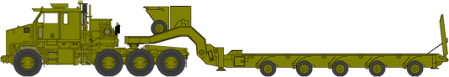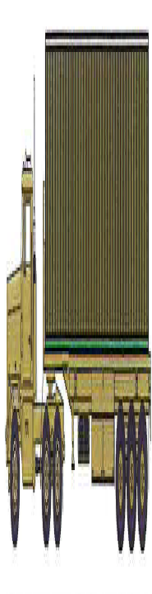
A | * PINTLE HOOK - Truck Trailer Combination  Any combination of vehicles with a GCWR of 26,001 or more pounds provided the GVWR of the vehicle(s) being towed is in excess of 10,000 pounds. | 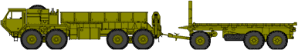
B | Any single vehicle with a GVWR of 26,001 or more pounds or any such vehicle towing a vehicle not in excess of 10,000 pounds GVWR. | 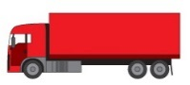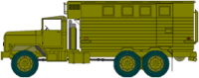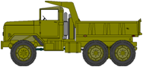

I am qualified to operate vehicles equipped with a full air brake system: YES NO
I am qualified to operate vehicles equipped with an air-over-hydraulic braking system: YES NO
I am qualified to operate vehicles equipped with a manual transmission: YES NO

CONTROL AND INTRASTATE GROUP DRIVERS (CURRENT CDL HOLDERS) ONLY
Did you receive any training in heavy vehicle operations (e.g. truck driving school) prior to obtaining your CDL? YES NO
If yes, approximately how many hours of training? ___________
Did you receive any training in heavy vehicle operations after obtaining your CDL (e.g. on-the-job training)? YES NO
If yes, approximately how many hours of training? ___________
COVERED DRIVERS (18-20 YEAR-OLD MILITARY) ONLY
Did you receive any training in heavy vehicle operations (e.g. truck driving school) besides your military training? YES NO
If yes, approximately how many hours of training? ___________
SIGNATURE ______________________________________________________ DATE (mm/dd/yyyy) ________________

Public Burden Statement
A federal agency may not conduct or sponsor, and a person is not required to respond to, nor shall a person be subject to a penalty for failure to comply with a collection of information subject to the requirements of the Paperwork Reduction Act unless that collection of information displays a current valid OMB Control Number. The OMB Control Number for this information collection is XXXX-XXXX. Public reporting for this collection of information is estimated to be approximately XX minutes per response, including the time for reviewing instructions and completing and reviewing the collection of information. All responses to this collection of information are voluntary. Send comments regarding this burden estimate or any other aspect of this collection of information, including suggestions for reducing this burden to: Information Collection Clearance Officer, Federal Motor Carrier Safety Administration, MC-RRA, 1200 New Jersey Avenue, SE, Washington, D.C. 20590.

