**Initial Email to LELs and SHSOs with Survey Login info**

**(1 week following letter mailed from GHSA to LELs and SHSOs)**

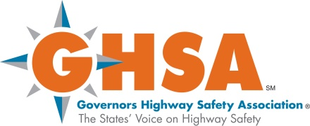 

FROM: “LEL Survey” [support@lelsurvey.com](mailto:support@lelsurvey.com)

Subject Line: “LEL SURVEY” or “SHSO SURVEY” (depending on the respondent)

Dear (title and respondent name),

The National Highway Traffic Safety Administration (NHTSA) and the Governors Highway Safety Association (GHSA) are inviting you to participate in a survey about Law Enforcement Liaisons (LELs) and traffic safety. This survey is an opportunity for you to provide NHTSA and GHSA with important information on your program, and your experiences, challenges and needs as a LEL (LEL manager), so that they can better assist you in your traffic safety mission. TransAnalytics is conducting the survey on behalf of NHTSA and GHSA.

The survey will take approximately 45 minutes to complete. You may work on the survey during your work hours and complete it at your convenience. You can take the survey over multiple shorter sessions, saving it as you work, and then submitting it once you have completed it. We are asking for a turnaround time of 2 to 4 weeks to complete and submit the survey.

The information you will need to access the survey, your login and password are provided below.

Website: <http://lelsurvey.com/>

Login (email) BobSmith@DomainName.xxx

Password: BSmith

The survey is voluntary. Your survey responses will be treated in a **secure and confidential** manner. Upon receipt, TransAnalytics will assign to you a participant number and separate your responses from your name. Only TransAnalytics will know which participant number corresponds to which participating LEL. TransAnalytics and NHTSA will have access to the survey data, but NHTSA and GHSA will **never** have access to any information that links you to your survey responses. Survey reports will present all findings in summary form so that responses cannot be linked to an individual participant.

We hope that you will participate in this important survey. If you have questions about the survey, please call Lawrence Decina, the TransAnalytics Principal Investigator, at 215-538-3820, ext. 102.

If you have technical questions or problems while using the website, you may use the “Contact Us” link at the top of each webpage in the survey. The web developer will email you with a timeframe expected for a response. Thank you for your consideration of this request.

Sincerely,

|  |  |
| --- | --- |
| Lawrence E. Decina  Principal Investigator  TransAnalytics, LLC | Randolph G. Atkins, Jr., Ph.D.,  Social Science Researcher  National Highway Traffic Safety Administration |