**Email Reminder Notices (4 weeks following the original email)**

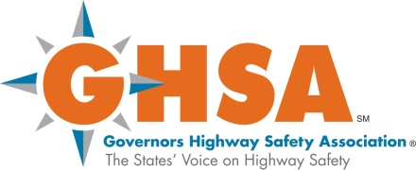 

FROM: “LEL Survey” [support@lelsurvey.com](mailto:support@lelsurvey.com)

Subject Line: “LEL SURVEY” or “SHSO SURVEY” (depending on the respondent).

Dear (title and respondent name),

We have not received your completed LEL (or SHSO) Survey. We hope that you plan to participate in this important survey. This is an opportunity for you to provide NHTSA and GHSA with important information on your program, so they can better assist you in your traffic safety mission.

The information you will need to access the survey, your login and password are provided below.

Website: <http://lelsurvey.com/>

Login (email): BobSmith@DomainName.xxx

Password: BSmith

Please complete your survey within the next 4 weeks, so that we can include your responses in the final aggregated survey information. We need everyone’s responses for a comprehensive picture of LELs’ needs and the challenges they face, to best assist you in your LEL activities.

Your responses will be treated in a **secure and confidential** manner. Survey reports will present all findings as a whole, so individual responses cannot be identified. TransAnalytics and NHTSA will have access to the survey data, but NHTSA and GHSA will **never** have access to survey data that personally identifies you or links you to your responses.

If you have questions about the study, please call Lawrence Decina, the TransAnalytics Principal Investigator, at 215-538-3820, ext. 102.

If you have technical questions or problems while using the website, you may use the “Contact Us” link at the top of each webpage in the survey; the web developer will email you with a timeframe expected for a response.

Thank you for your consideration of this request.

Sincerely,

|  |  |
| --- | --- |
| Lawrence E. Decina  Principal Investigator  TransAnalytics, LLC | Randolph G. Atkins, Jr., Ph.D.,  Social Science Researcher  National Highway Traffic Safety Administration |