## **Appendix D: FOCUS GROUP ACTIVITIES**

## **D.1 Word Associations Flip Pad Activity (Example)**

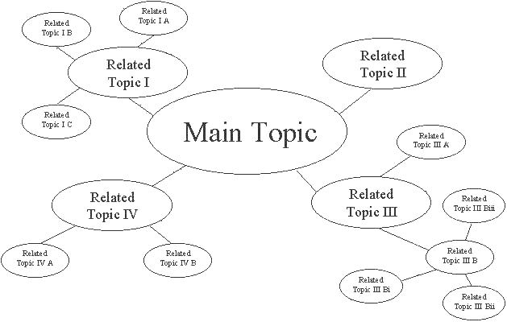

**Census**

## **D.2: Conversation Cards**



*Note: Cards will be adapted to meet specific cultural context as needed.*

## **D.3: Motivators and Barriers Flip Pad Activity**

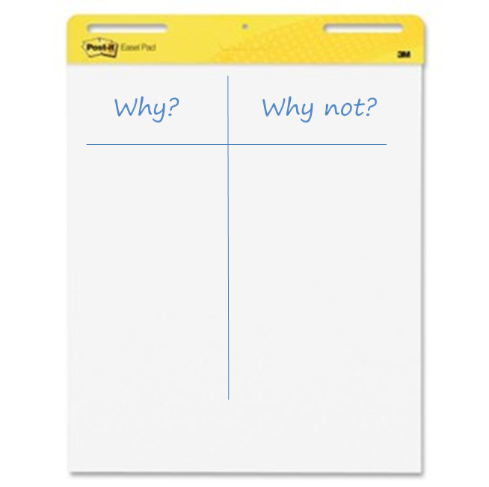

## **D.4: Reasons Activity**

