Appendix F - Focus Group Activities
Unique ID: _______________

ADVERTISEMENT COLOR X
PRINT AD PLACEHOLDER

Use the following symbols up to ten (10) times to mark up the draft advertisement above. Be sure to number your symbols:
 | I like this |  |  | This surprised me
 | I don’t like this |  |  | This makes me happy
 | This confuses me

Symbol | Why did you choose this symbol?
1
2
3
4
5
6
7
8
9
10

Unique ID: _______________

See the below still frames from the advertisement you just watched.

VIDEO AD COLOR X
EXAMPLE
EXAMPLE
EXAMPLE
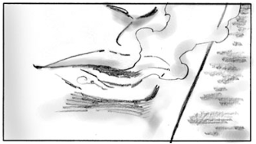
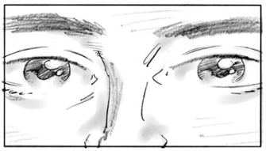

Please answer the following questions:
- What did you like about the ad?
- What did you not like about the ad?
- Was there anything about the ad that confused you? Please describe.
- Was there anything about the ad that surprised you? Please describe.
- Was there anything about the ad that made you happy? Please describe.

Unique ID: _______________

See the below still frames from the advertisement you just watched.

RADIO AD COLOR X

Please answer the following questions:
- What did you like about the radio ad?
- What did you not like about the radio ad?
- Was there anything about the radio ad that confused you? Please describe.
- Was there anything about the radio ad that surprised you? Please describe.
- Was there anything about the radio ad that made you happy? Please describe.

