Appendix F - Focus Group Activities

**Unique ID**: \_\_\_\_\_\_\_\_\_\_\_\_\_\_\_

**ADVERTISEMENT COLOR X**

PRINT AD PLACEHOLDER

Use the following symbols up to ten (10) times to mark up the draft advertisement above. **Be sure to number your symbols**:

|  |  |  |  |  |
| --- | --- | --- | --- | --- |
| C:\Users\vojeda-avitia\Downloads\noun_Circle_1561831_000000.png | I like this |  | **C:\Users\vojeda-avitia\Downloads\noun_exclamation_1151609_000000.png** | This surprised me |
| C:\Users\vojeda-avitia\Downloads\noun_X_593555_000000.png | I don’t like this | **C:\Users\vojeda-avitia\Downloads\noun_Smile_1740164_000000.png** | This makes me happy |
| **C:\Users\vojeda-avitia\Downloads\noun_Question_1388426_000000.png** | This confuses me |  | |

|  |  |
| --- | --- |
| **Symbol** | **Why did you choose this symbol?** |
| 1 |  |
| 2 |  |
| 3 |  |
| 4 |  |
| 5 |  |
| 6 |  |
| 7 |  |
| 8 |  |
| 9 |  |
| 10 |  |

**Unique ID**: \_\_\_\_\_\_\_\_\_\_\_\_\_\_\_

**See the below still frames from the advertisement you just watched.**

**VIDEO AD COLOR X**

EXAMPLE

EXAMPLE

EXAMPLE

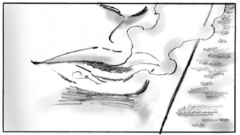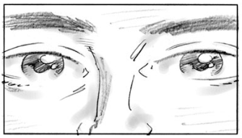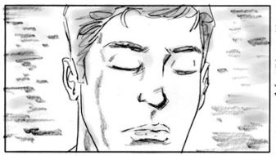

Please answer the following questions:

1. What did you like about the ad?

|  |
| --- |
|  |
|  |
|  |

1. What did you not like about the ad?

|  |
| --- |
|  |
|  |
|  |

1. Was there anything about the ad that confused you? Please describe.

|  |
| --- |
|  |
|  |
|  |

1. Was there anything about the ad that surprised you? Please describe.

|  |
| --- |
|  |
|  |
|  |

1. Was there anything about the ad that made you happy? Please describe.

|  |
| --- |
|  |
|  |
|  |

**Unique ID**: \_\_\_\_\_\_\_\_\_\_\_\_\_\_\_

**See the below still frames from the advertisement you just watched.**

**RADIO AD COLOR X**

Please answer the following questions:

1. What did you like about the radio ad?

|  |
| --- |
|  |
|  |
|  |

1. What did you not like about the radio ad?

|  |
| --- |
|  |
|  |
|  |

1. Was there anything about the radio ad that confused you? Please describe.

|  |
| --- |
|  |
|  |
|  |

1. Was there anything about the radio ad that surprised you? Please describe.

|  |
| --- |
|  |
|  |
|  |

1. Was there anything about the radio ad that made you happy? Please describe.

|  |
| --- |
|  |
|  |
|  |