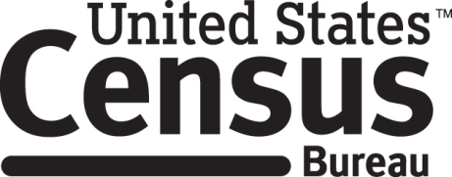

**Consent Form**

**Food and Nutrition Service Cognitive Interview**

The Census Bureau routinely tests the design and content of letters, surveys, and other communication materials in order to produce materials that are clear and easy for people to understand.

______________________ [NAME] consents to take part in a study to test forms and letters that are used to communicate with and gather information from people who receive food assistance benefits. In order to have a complete record of all comments, the interview session will be audio recorded. The Census Bureau plans to use the tapes to improve the forms and letters. Staff directly involved in the project will have access to the recordings. Participation is voluntary and answers will remain strictly confidential.

This study is being conducted under the authority of Title 13 USC. The OMB control number for this study is 0607-0978. This valid approval number legally certifies this information collection.

I have agreed to participate in this Census Bureau research study, and I give permission for my tapes to be used for the purposes stated above.

____________________________ ___________________________

Participant's Signature Researcher's Signature

____________________________ __________________________

Printed Name Printed Name

___________________________ _______________________

Date Date