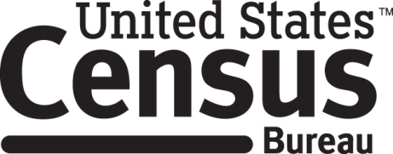

**Consent Form**

**Food and Nutrition Service – Supplemental Nutrition Assistance Program Retailer Application Evaluation**

The Census Bureau conducts many different research studies. For example, the Census Bureau routinely tests the wording, layout and behavior of application forms and surveys in order to obtain the best information possible.

You have volunteered to take part in a study to improve the **Supplemental Nutrition Assistance Program retailer application**. In order to have a complete record of all comments, the interview session will be audio-recorded. The Census Bureau plans to use the recordings to make recommendations to improve the application form. Only staff directly involved in this research project will have access to the recordings. Participation is voluntary and answers will remain strictly confidential.

This study is being conducted under the authority of Title 13 USC. The OMB control number for this study is 0607-0978. This valid approval number legally certifies this information collection.

I have agreed to participate in this Census Bureau research study, and I give permission for my recording to be used for the purposes stated above.

____________________________ ___________________________

Participant's Signature Researcher's Signature

____________________________ ___________________________

Printed Name Printed Name

____________________________ ___________________________

Date Date