**SUPPORTING STATEMENT**

**GREATER ATLANTIC REGION DEALER PURCHASE REPORTS**

**OMB CONTROL NO. 0648-0229**

**A. JUSTIFICATION**

This request is for a revision to the current information collection as a result of a proposed rule, RIN 0648-BF43, to implement measures under the Interstate Fishery Management Plan for Jonah Crab as recommended by the Atlantic States Marine Fisheries Commission. Revisions to existing information collections are listed under the appropriate section for each measure that is being revised by this action.

**1. Explain the circumstances that make the collection of information necessary.**

The National Oceanic and Atmospheric Administration’s National Marine Fisheries Service (NMFS) is responsible for the stewardship of the Nation’s living marine resources and their habitats within the United States Exclusive Economic Zone (EEZ). NMFS works to conserve, protect, and manage these resources to ensure their continuation as functioning components of ecosystems, while also affording economic opportunities and enhancing the quality of life for the American public. Our mandates and authorities are derived from numerous statutes, most significantly the Atlantic Coastal Fisheries Cooperative Management Act (ACFCMA), the Magnuson-Stevens Fishery Conservation and Management Act’s (MSA) National Standards, the Endangered Species Act (ESA), and the Marine Mammal Protection Act (MMPA).

This rulemaking responds to the Atlantic States Marine Fisheries Commission’s recommendations for Federal action and is developed under the authority of the 16 U.S.C. 5101-5109 *et seq*; Title VIII of Pub. L. 103-206, as amended, the [Atlantic Coastal Fisheries Management Act](http://www.asmfc.org/legislation/ACFCMA.pdf) (ACFCMA 1993) *et seq.*).[1] The rule sets forth management measures concerning the Jonah crab fishery based on based on the Commission’s Interstate Fishery Management Plan for Jonah Crab, and Addenda I and II. This action will establish basic fishery management measures for the Jonah crab fishery. This action will establish basic fishery management measures for the Jonah crab fishery. Prior to development of the proposed rule, a detailed analysis of the impacts of the preferred and alternative measures were conducted in a Draft Environmental Impact Statement (DEIS). The DEIS evaluated multiple options to those adopted by the Commission in the Jonah Crab Plan and implemented by the states. This document analyzes the burdens associated with the preferred alternative which mirrors the Commission’s recommendations. An analysis of the other options is presented in the DEIS.

National Standard 2 requires that conservation and management measures shall be based upon the best scientific information available. One of the regulatory steps taken to ensure that these measures are based on the best available scientific information is the collection of data from the users of the resource. Thus, the Secretary has set forth rules for the collection of fishery-dependent data from dealers/processors and vessels in order to monitor, evaluate and enforce the fishery regulations intended to achieve sustainable fisheries. The continuing need for this information is explicit in the management goals and objectives established in the Jonah Crab Plan as established by the Commission.

All Federally-permitted dealers of Atlantic mackerel, squid, butterfish, Atlantic sea scallop, Atlantic surfclam, ocean quahog, Northeast (NE) multispecies, monkfish, summer flounder, scup, black sea bass, Atlantic bluefish, spiny dogfish, Atlantic herring, skates, tilefish, hagfish, American lobster must have been issued and have in their possession a Federal dealer permit in order to purchase such species from fishing vessels. Federally-permitted dealers in the above fisheries are required to submit certain information regarding their fish purchases to NMFS. Trip-level (trip by trip) reports provide the comprehensive data that are necessary for successful long-term management of each fishery.

This revision would require dealers that purchase Jonah crabs, a previously unmanaged species, landed by a Federally-permitted commercial fishing vessel operating within waters regulated by NOAA’s National Marine Fisheries Service Greater Atlantic Regional Fisheries office to be issued a Federal dealer permit for any fishery management plan (FMPs) listed above.

Section 303(a)(5) of the MSA specifically identifies the kinds of data to be collected for FMPs. Comprehensive trip-level reports submitted by dealers include individual vessel information, purchases by species and market category, and pricing information. The use of approved electronic submission processes to collect the information is an essential ingredient in the management of fishery resources because they provide an efficient means to collect that information on which management decisions are made. While Jonah crabs are not managed under the MSA, we are proposing measures that are consistent with MSA-managed species.

In all fisheries requiring mandatory reporting, 'negative reporting' by dealers is required if no fish was purchased during the reporting period. Negative reports are necessary in order to accurately identify dealers who have not purchased fish as opposed to those who have failed to report their purchases.

**2. Explain how, by whom, how frequently, and for what purpose the information will be used. If the information collected will be disseminated to the public or used to support information that will be disseminated to the public, then explain how the collection complies with all applicable Information Quality Guidelines.**

Almost every international, federal, state, and local fishery management authority recognizes the value of fisheries' statistics collections and uses them as part of their management systems. Fisheries statistics are used by economists, biologists, and managers to develop, monitor, and enforce controls on fishery harvests.

The information collected is used by several offices of NMFS, the NEFMC, the MAFMC and the Atlantic States Marine Fisheries Commission (ASMFC) to monitor landings, ensuring that conservation and management actions may be taken in a timely manner. Accurate and timely landings reports are especially important for monitoring commercial landings by species and evaluating the effectiveness of each FMP in achieving its goals and objectives. In addition to the uses specifically relating to management of individual species, the statistics collected through these reports will be incorporated into the NMFS databases which are used in many analyses by various offices of NMFS, the Regional Fishery Management Councils, the United States Coast Guard (USCG), state fishery enforcement agencies, the Departments of State and Commerce, Office of Management and Budget (OMB), the Corps of Engineers, Congressional staffs, the fishing industry, and the public. The data also serve as inputs to a variety of uses such as biological analyses and stock assessments, and in support of Executive Order (E.O.) 12866 “Regulatory Planning and Review”, quota and allocation selections and monitoring, economic profitability profiles, trade and import tariff decisions, allocation of grant funds among states, and identification of ecological interactions among species. Data used are also utilized for monitoring and evaluating ESA and MMPA actions.

Purchases from fishing vessels are submitted by dealers. Vessel-based information required under the mandatory program includes a dealer name, location and permit number, vessel name and permit number, or USCG or state registration number in lieu of the Federal permit number, trip identifier, along with port and state landed. This information is necessary to the accounting systems used by the dealers and is part of the dealer’s own record-keeping requirements. Vessel name and permit number are used to identify the respondent and the legal entity (owners) controlling the fishing practices of the vessel. Vessel fishing permit information is used by NOAA’s Office of Law Enforcement (OLE) to determine violations of quota and reporting regulations. Violations may result in fines, suspension of a fishing permit, or seizure of the catch. Since many vessels are owned by individuals or by corporations, identification, and location of the company purchasing the product and the identification of the vessel from which the product was purchased are necessary to enforce fishery regulations.

Dealers utilizing their surfclam or ocean quahog permit are required to report cage tag numbers when purchasing those species from vessel fishing under an Individual Transferable Quota (ITQ). Cage tag numbers are used to verify landings and monitor compliance in the surfclam and ocean quahog fisheries, which are managed using an ITQ system.

All of this information for most species is needed in order to process the data, and to match each dealer report with the corresponding fishing vessel logbooks (OMB Control No. 0648-0212) submitted by the vessel owners, using these fields as the identifiers. Coordinating the data submitted by vessels and dealers is necessary for monitoring compliance by both parties and for providing verification of reporting. In addition, linking the two data sets allows for the allocation of effort and location data from the vessel logbooks to the corresponding dealer reports which contain the economic data, thus providing a complete representation of the industry. Information regarding the state where landed is used to assign landings to the appropriate state when the data are compiled by NMFS. This is especially important in fisheries where the FMP is based on coast-wide quotas allocated by state, such as summer flounder. The Interstate Fishery Management Plan for American Lobster does not currently require vessel trip reports. Because the Jonah crab fishery is prosecuted by the lobster harvesters using their lobster traps, we are proposing consistent reporting requirements for the Jonah crab fishery (i.e., no harvester reporting).

Species purchased, unit of measure, amount, and value, by species, grade, market category, and disposition code is collected under the mandatory reporting program. The pounds purchased, in combination with the species, are used by NMFS to determine current harvest rates for each fishery on a real-time basis. When certain trigger points are reached, depending on the fishery, NMFS will be able to establish or change a trip limit or close a fishery, as appropriate, in order to meet the regulatory requirements, set forth under each FMP. Species information, such as landings by species and market (size) category, is the basic measure of fishing success from which fishermen, biologists, and economists draw conclusions about the status of the fishery. Species landing information is needed because controlling the quantity of fish harvested is often the means for ensuring continued harvests over time. The unit of measure identifies how the specie is landed, i.e. bushels versus poundage versus individuals. This identifies which conversion factors to use in determining the overall weight in pounds of the landing. Grade categories establish the correct conversion factor back to whole fish weight to accurately determine the amount of fish landed. The market categories are also for the convenience of the dealer because price is size-dependent and the catch is usually culled and sold by market category.

Disposition of seafood products is needed to determine the ultimate fate and use of harvested fish and shellfish. Price and value are used in estimating the earnings and profitability of each fishing trip by the vessel operator and in regulatory impact reviews and economic input-output models requiring such data to estimate the economic effects of changes induced by the biology or management of the fishery. Special economic studies are conducted to obtain detailed information on specific issues or fisheries when resources are available. It should be noted that both species and price information are necessary for the dealer’s own accounting operation; therefore, reporting that information does not constitute an additional reporting burden. Dealer e-mail addresses are being requested on a voluntary basis to allow for confirmation notices to be sent by NMFS when a report has been submitted. The collection of dealer e-mail addresses can also allow for electronic dissemination of information from NMFS to industry.

It is anticipated that the information collected will be disseminated to the public or used to support publicly disseminated information, subject to the data confidentiality provisions of the MSA. NMFS will retain control over the information and safeguard it from improper access, modification, and destruction, consistent with NOAA standards for confidentiality, privacy, and electronic information. See response to Question 10 of this Supporting Statement for more information on confidentiality and privacy. The information collection is designed to yield data that meet all applicable information quality guidelines. Prior to dissemination, the information will be subjected to quality control measures and a pre-dissemination review pursuant to Section 515 of Public Law 106-554.

**3. Describe whether, and to what extent, the collection of information involves the use of automated, electronic, mechanical, or other technological techniques or other forms of information technology.**

Federally-permitted dealers are required to submit detailed reports of all purchases from fishing vessels electronically. To accommodate the varying extent to which dealers use computer applications, dealers can choose how they will submit purchase reports electronically. The options include an online data entry form available at <http://www.accsp.org/safis.htm>, an offline data entry form (fillable and printable), and an acceptable file upload report system implemented by NMFS Service, or by one or more state fishery management agencies.

Due to the required confidentiality of fish purchase reports, information sent from dealers to NMFS is subject to strict encryption standards and is available only to authorized agency personnel and the submitter. Dealers receive a user name and personal identification number (PIN) that enables them to log onto a secure site and submit their reports. Dealers are also allowed to access, review, and edit the information they have submitted using a secure procedure similar to those in common usage throughout the banking industry. These submissions constitute the official reports as required by the various FMPs in the Northeast.

**4. Describe efforts to identify duplication.**

Operational Guidelines on the FMP Process require that each FMP evaluate existing state and Federal laws that govern the fisheries in question, and the findings are made part of each FMP. The Atlantic States Marine Fisheries Commission membership and other participants comprises state and Federal officials responsible for resource management in their state or area. Bringing fisheries managers together for the review of existing state or Federal laws helps to identify other collections that may be gathering the same or similar information. If a state is collecting the required information under its own authority and can provide the data, generally NMFS will use the state's data rather than duplicate state collections. In addition, each FMP undergoes extensive public comment periods where potential participants in the fishery to be managed review the proposed permit application requirements and data collection proposals. Therefore, NMFS is confident it is aware of similar collections if they exist and has avoided duplication to the extent possible.

The exception to duplicate data collection by state and Federal authorities is for certain quota managed species, including summer flounder, scup, black sea bass and Atlantic bluefish, among others. Landings for these species are also collected by the states in some cases because they are managed by a state-allocated quota system as well as by a Federal one. Monitoring the quotas in a timely manner is critical for effective management and so some, but not all, states have implemented their own weekly reporting system. Because landings of these species need to be monitored for each state in the NE Region, Federal law requires reporting of all purchases made by Federally-permitted dealers.

The dealer report submitted by dealers and processors in the Atlantic mackerel, squid, butterfish, Atlantic sea scallop, Atlantic surf clam, ocean quahog, NE multispecies, monkfish, summer flounder, scup, black sea bass, Atlantic bluefish, spiny dogfish, Atlantic herring, Atlantic deep-sea red crab, skate, tilefish, hagfish or American Lobster fisheries duplicates, for the purpose of verification and accuracy, some of the information provided by vessel operators on the Fishing Vessel Trip Report (Form 88-30 or its equivalent) and Shellfish Trip Report Form (Form 88-140) in OMB Control No. 0648-0212. In this case certain duplication is desirable to track harvesting, to identify possible reporting violations, and to ensure fairness in application of the measures among the entire group of allocation holders.

**5. If the collection of information involves small businesses or other small entities, describe the methods used to minimize burden.**

Because all of the dealers who will respond are considered small businesses, separate requirements based on the size of business have not been developed. The dealer electronic reporting system was developed and tested in conjunction with industry members to ensure a system that is functional and useable for their business purposes. The system accommodates, to the extent possible, existing business software application systems that are being used by dealers. The system allows dealers who currently use such applications to upload a data file from their business application to NMFS, minimizing any additional reporting burden. Dealers who choose to keypunch their data directly into the web-based data entry system will be able to use those reports for their own business records, replacing Form 88-30 or its equivalent which many dealers had used as their official transaction record.

**6. Describe the consequences to the Federal program or policy activities if the collection is not conducted or is conducted less frequently.**

The dealer purchase reports provide the only source of first-purchase information by dealers involved in these Federally-managed species. The reports provide critical information on the prices paid for products, the types of products being landed, and the number of dealers involved in the fisheries.

Reporting of null reports by dealers who do not make any purchases during the reporting week allows NMFS to verify compliance, identify non-reporters, and to take the appropriate action in a timely manner without placing an undue burden on the respondents.

If this collection were not conducted, NMFS would be unable to meet its statutory requirements under the Atlantic Coastal Act to complement the Commission’s Interstate Fishery Management Plan for Jonah Crab, and the fisheries in the NE could not be managed effectively, potentially resulting in irrevocable damage to a public resource.

**7. Explain any special circumstances that require the collection to be conducted in a manner inconsistent with OMB guidelines.**

The data collection is consistent with 5 CFR 1320.6 guidelines except that it requires information to be reported more frequently than quarterly. The need for this is described in Question 6.

**8. Provide information on the PRA Federal Register Notice that solicited public comments on the information collection prior to this submission. Summarize the public comments received in response to that notice and describe the actions taken by the agency in response to those comments.** **Describe the efforts to consult with persons outside the agency to obtain their views on the availability of data, frequency of collection, the clarity of instructions and recordkeeping, disclosure, or reporting format (if any), and on the data elements to be recorded, disclosed, or reported.**

A proposed rule seeking public comment on the measures included in the Mid-Atlantic Unmanaged Forage Fish Omnibus Amendment, including the information collections associated with the proposed permit, VTR, and dealer reporting requirements, will be published in the Federal Register coincident with this revision. Notices soliciting public input on these information collections will also be placed in the “Status Report of Greater Atlantic Region Actions” report for the upcoming New England Fishery Management Council and Mid-Atlantic Fishery Council Meetings.

**9. Explain any decisions to provide payments or gifts to respondents, other than remuneration of contractors or grantees.**

Not Applicable.

**10. Describe any assurance of confidentiality provided to respondents and the basis for assurance in statute, regulation, or agency policy.**

As stated on the forms, all data will be kept confidential as required by section 402(b) of the

MSA, and will not be released for public use except in aggregate statistical form, without

identification as to its source. Reports are considered confidential under the Trade Secrets Act as

well.

**11. Provide additional justification for any questions of a sensitive nature, such as sexual behavior and attitudes, religious beliefs, and other matters that are commonly considered private.**

No sensitive questions are asked.

1. **Provide an estimate in hours of the burden of the collection of information.**

This revision is not expected to create any change in burden.

**Table 1. Calculation of Public and Federal Cost and Burden Estimates**

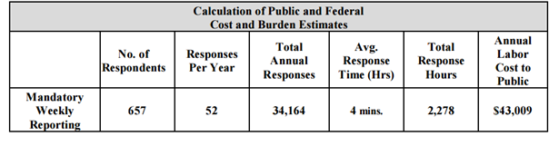

Dealers required to complete and submit Electronic Dealer Purchase Reports include those permitted in the Atlantic mackerel, squid, butterfish, Atlantic sea scallop, NE multispecies, monkfish, summer flounder, scup, black sea bass, Atlantic bluefish, spiny dogfish, Atlantic herring, Atlantic deep-sea red crab, tilefish, skate, Atlantic surfclam and/or ocean quahog fishery, hagfish and American lobster. According to data available through the NE Region Permit database, approximately 657 dealers are permitted for one or more of the fisheries with mandatory electronic reporting requirements.

As indicated in Table 1, the total annual reporting burden associated with this collection is estimated at 2,278 hours. This burden assumes an average response time of 4 minutes to submit electronic data files. The only additional time resulting from this collection is the time required to log in and transfer their existing data file. Dealers opting to enter data online may use the online system for their own business practices and to generate standard business reports. Therefore, the reporting burden reflects only the time needed to gather any additional information needed to complete the reports and to submit the data file or forms to NMFS. In addition, it is anticipated that several of the reports submitted will be negative reports and will take less time to complete or transfer. The reporting costs to the public are based on a respondent wage of $18.88/burden hour.

**13. Provide an estimate of the total annual cost burden to the respondents or record-keepers resulting from the collection (excluding the value of the burden hours in Question 12 above).**

This revision is not expected to create any change to costs.

**Table 2. Calculation of Annual Cost to Respondents Excluding Respondent Time**

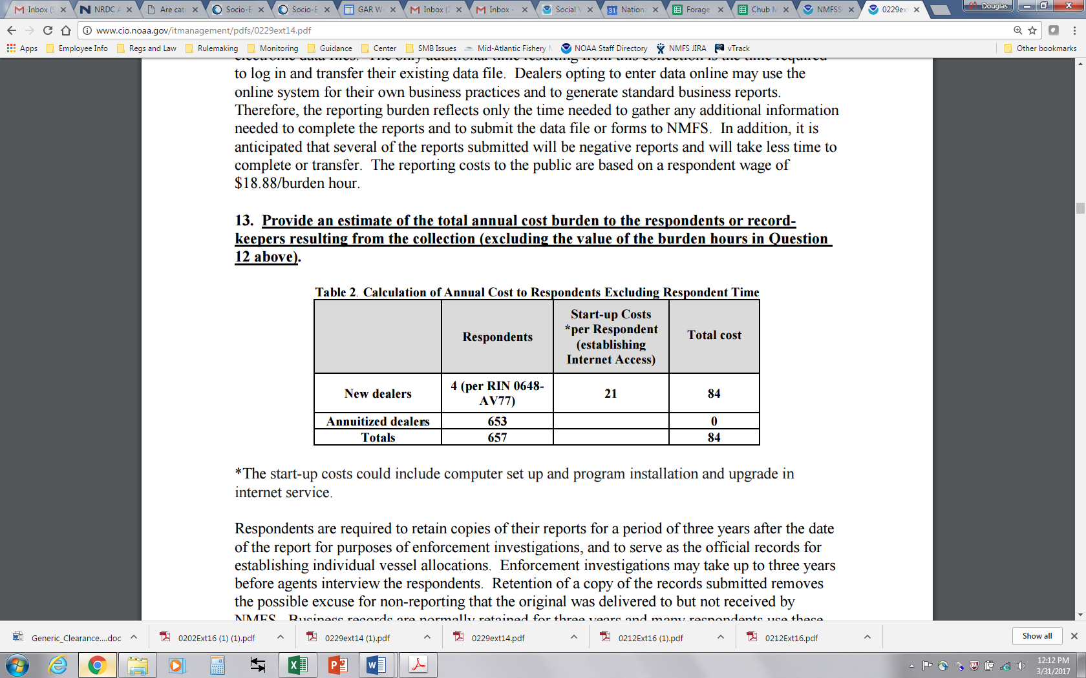

*The start-up costs could include computer set up and program installation and upgrade in internet service.

Respondents are required to retain copies of their reports for a period of three years after the date of the report for purposes of enforcement investigations, and to serve as the official records for establishing individual vessel allocations. Enforcement investigations may take up to three years before agents interview the respondents. Retention of a copy of the records submitted removes the possible excuse for non-reporting that the original was delivered to but not received by NMFS. Business records are normally retained for three years and many respondents use these reports for that purpose, thus there is no impact on the public burden or cost by this requirement.

1. **Provide estimates of annualized cost to the Federal government.**

**Table 3. Government Maintenance Costs**

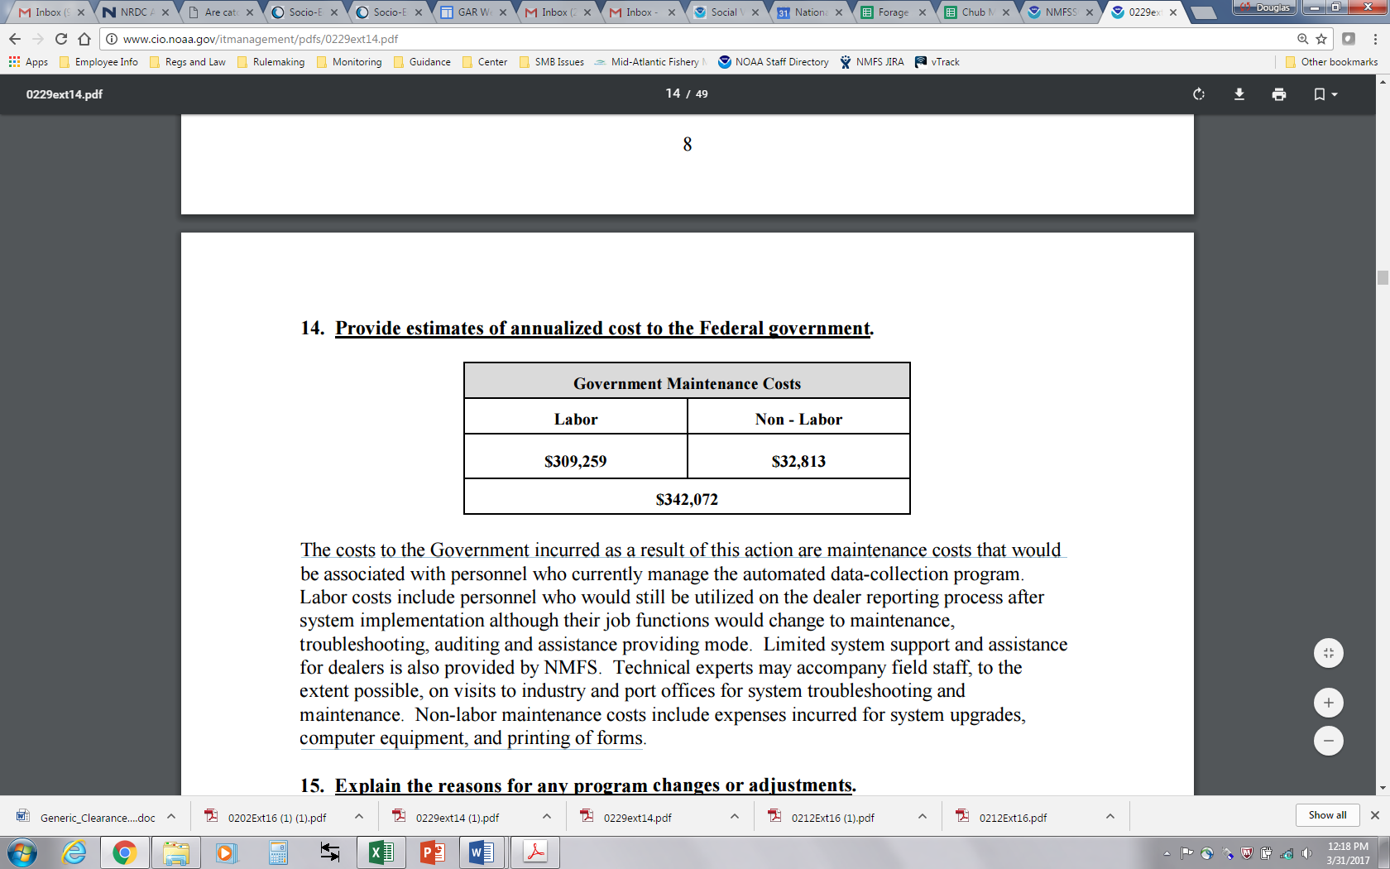

The costs to the Government incurred as a result of this action are maintenance costs that would be associated with personnel who currently manage the automated data-collection program. Labor costs include personnel who would still be utilized on the dealer reporting process after system implementation although their job functions would change to maintenance, troubleshooting, auditing and assistance providing mode. Limited system support and assistance for dealers is also provided by NMFS. Technical experts may accompany field staff, to the extent possible, on visits to industry and port offices for system troubleshooting and maintenance. Non-labor maintenance costs include expenses incurred for system upgrades, computer equipment, and printing of forms.

**15. Explain the reasons for any program changes or adjustments.**

No changes or adjustments to previously estimated burdens or costs associated with the dealer report requirements are made as a result of this action to implement the Interstate Fishery Management Plan for Jonah Crab. While this action would add a new requirement for the Federally-permitted dealers to report purchases of Jonah crabs by species and disposition on dealer reports, it is unlikely that the number of respondents will change as a result. Jonah crabs have historically been caught as an incidental catch in the lobster fishery, but more recently have become a targeted species. Due to the overlap with lobster, a fishery for which there are Federal vessel and dealer reports, it is likely that the vast majority of those dealers purchasing Jonah crab already have a Federal dealer permit and are required to report all purchases from Federal vessels.

**16. For collections whose results will be published, outline the plans for tabulation and publication.**

Results from these collections may be used in scientific, management, technical, or general informational publications such as Fisheries of the United States (FUS) and in Status of the Fishery Resources (SFR) off the Northeastern United States, which follow prescribed statistical tabulations and summary table formats. The time schedule for publication of FUS is June of the year following collection. Publication of SFR has usually been in September. Data are available to the general public on request in summary form only and to NMFS Service employees in detailed form on a need-to-know basis only. Aggregate landings and economic data are available on NMFS web pages as well.

**17. If seeking approval to not display the expiration date for OMB approval of the information collection, explain the reasons why display would be inappropriate.**

Because this collection involves electronic reports, there is no form on which to display an expiration date. However, an expiration date will be displayed in the instructions or cover letter that will be mailed to each permit holder who is required to report purchases through the electronic system.

**18. Explain each exception to the certification statement.**

No exceptions are requested.

**B. COLLECTION OF INFORMATION EMPLOYING STATISTICAL METHODS**

This collection does not employ statistical methods.

1. The Atlantic Coastal Act provides authority for NMFS to support state actions, under the umbrella of the Atlantic States Marine Fisheries Commission, for species without a Federal Fishery Management Plan under the Magnuson-Stevens Act. These Federal regulations are to complement Commission management actions for species harvested mainly from state waters, and for species where interstate coordination can enhance management and enforcement and must be consistent with the MSA’s National Standards.