OMB Approval No. 0648-0240 Expires 01/31/2019

Application to Shuck  Surfclams/Ocean Quahogs  at Sea | 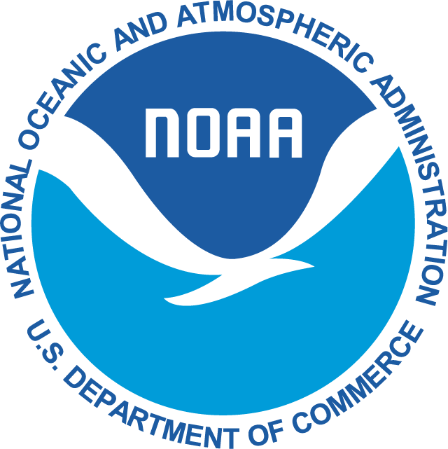  U.S. Department of Commerce  NOAA/National Marine Fisheries Service  55 Great Republic Drive  Gloucester, MA 01930-2298  Tel: (978) 282-8483

In order to receive authorization to shuck surfclams or ocean quahogs at sea, please provide the information requested below and mail to:

Regional Administrator
National Marine Fisheries Service
55 Great Republic Drive
Gloucester, MA 01930

This application is required under 50 CFR 648.75 in order to obtain a shucking-at-sea permit for the Atlantic surfclam and ocean quahog fishery. Information provided on the application will allow the Regional Administrator to determine if a vessel has the capability to calculate the amount of surfclams or ocean quahogs harvested in the shell. This information is needed to execute the individual transferable quota system which uses unshucked bushels as a standard unit of measure.

Name:
(Print legibly)
Vessel Name:
Federal permit #:
Doc/Reg #:
Street:
City/ State/ Zip:
Telephone:
U.S. citizen requirement. By checking this box you are indicating that you are eligible to own a documented vessel under the terms of 46 U.S.C. 12103(b) and are able to provide documentation attesting to such eligibility if requested by the National Marine Fisheries Service.

On an attachment, or the back of this form, please describe the method to be used to calculate the amount of surfclams or ocean quahogs harvested in the shell.

Vessel Dimensions:  (Length and Gross Tonnage) | Observer Accommodations:
Anticipated Trip Length:

Signature: | Date:

Paperwork Reduction Act Statement
Public reporting burden for this collection of information is estimated to average 30 minutes per response, including the time for reviewing instructions, searching existing data sources, gathering and maintaining the data needed, and completing and reviewing the collection of information. Send comments regarding this burden estimate or any other suggestions for reducing this burden to the Assistant Regional Administrator, Sustainable Fisheries Division, NOAA National Marine Fisheries Service, 55 Great Republic Drive, Gloucester, MA 01930.
Permit holder name, address, phone, and permit information will be released via a NOAA Fisheries website. All other data submitted will be handled as confidential in accordance with section 402(b) of the Magnuson-Stevens Act and NOAA Administrative Order 216-100, Protection of Confidential Fisheries Statistics. Notwithstanding any other provisions of the law, no person is required to respond to, nor shall any person be subjected to a penalty for failure to comply with, a collection of information subject to the requirements of the Paperwork Reduction Act, unless that collection of information displays a currently valid OMB Control Number.

Privacy Act Statement
Authority: The collection of this information is authorized under the Magnuson-Stevens Fishery Conservation and Management Act, 16 U.S.C. 1801 et seq.
Purpose: In order to manage U.S. fisheries, the NOAA National Marine Fisheries Service (NMFS) requires the use of permits or registrations by participants in the United States. Information on NMFS permit applicants and renewing holders includes vessel owner contact information, date of birth, and vessel descriptive information. Permit holder information may be used as sampling frames for surveys, as part of Fishery Management Council (FMC) analysis to support FMC decisions.
Routine Uses: The Department will use this information to determine permit eligibility and to identify fishery participants. Disclosure of this information is permitted under the Privacy Act of 1974 (5 U.S.C. Section 552a), to be shared within NMFS offices, in order to coordinate monitoring and management of sustainability of fisheries and protected resources, as well as with the applicable State or Regional Marine Fisheries Commissions and International Organizations. Disclosure of this information is also subject to all of the published routine uses as identified in the Privacy Act System of Records Notice COMMERCE/NOAA-19, Permits and Registrations for the United States Federally Regulated Fisheries.
Disclosure: Furnishing this information is voluntary; however, failure to provide complete and accurate information will prevent the determination of eligibility for a permit.

