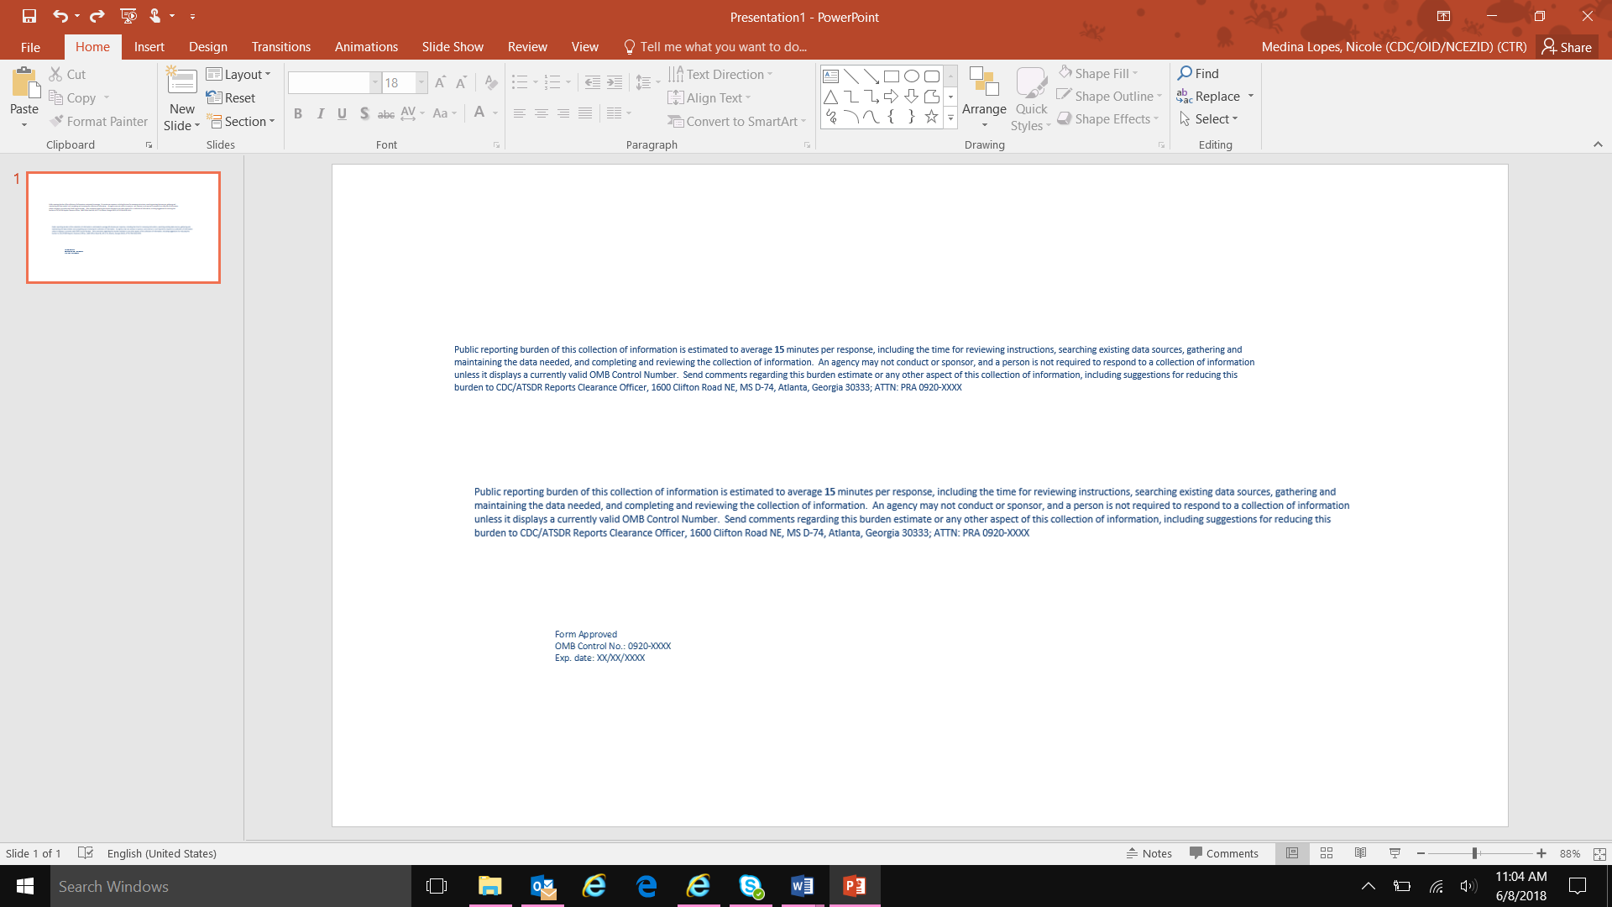  KAP: Younger Children (7-11)  2. In the last 12 months, since this month of the past year, which of the following sources have you used to obtain health information?  Probe if necessary. Select all that apply.  School Brochures Internet Children Newspapers/magazines Official spokespeople Health professionals Radio Social networks (Facebook, Twitter, Instagram) Community meetings TV Neighbors WhatsApp  6. Do you think that diseases transmitted by mosquitos such as dengue, Zika and chikungunya are a problem in your community?  Yes | No  8. In the last 12 months, how often have you used a mosquito net?  Daily  One time per week  One time per month  Rarely  Never  9. Where do mosquitoes bite you most frequently?  Read the options. Select all that apply.  Around the house outside  Inside the house  Work  School  Community sports field  Somewhere else in the community  Somewhere else outside of the community  Mosquitoes do not bite me  A mosquito-breeding site is anything that retains water that enables mosquitoes to reproduce. Mosquitoes can even reproduce in an area as small as a bottle cap.  11. Do you think controlling mosquito-breeding sites is a good strategy to prevent mosquito-borne diseases?  Yes | No  13. Do you think that your community should do more to control mosquitoes?  Yes | No  14b. Do you think you are responsible for controlling mosquitoes?  Yes | No |  | KAP: Younger Children (7-11)  Participant Laboratory Data  Participant ID:  P  ______/______/______  ^{Month Day} ^{Year}  Collection Date:  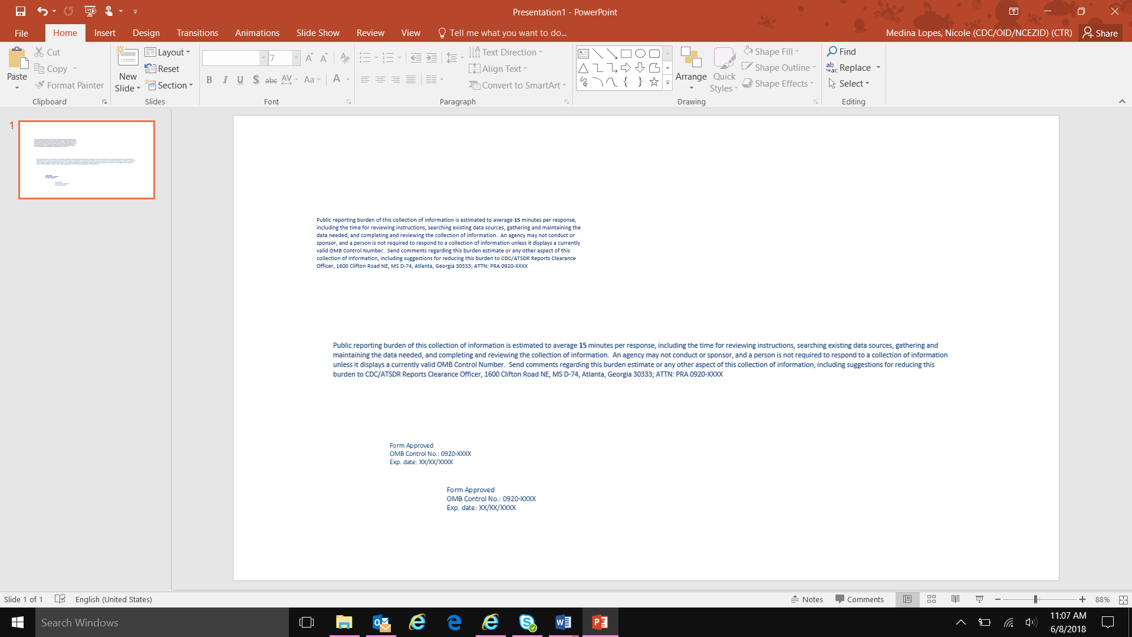  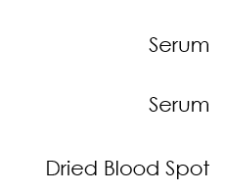  **Project flag:** Fever in last 7 days  No: COPA  Yes: COPA_SYM  PARTICIPANT BARCODE  Yes  No

