CMS-10675 Appendix A.1

Medication Safety and Adverse Drug Event Prevention Survey Screenshots

Introduction
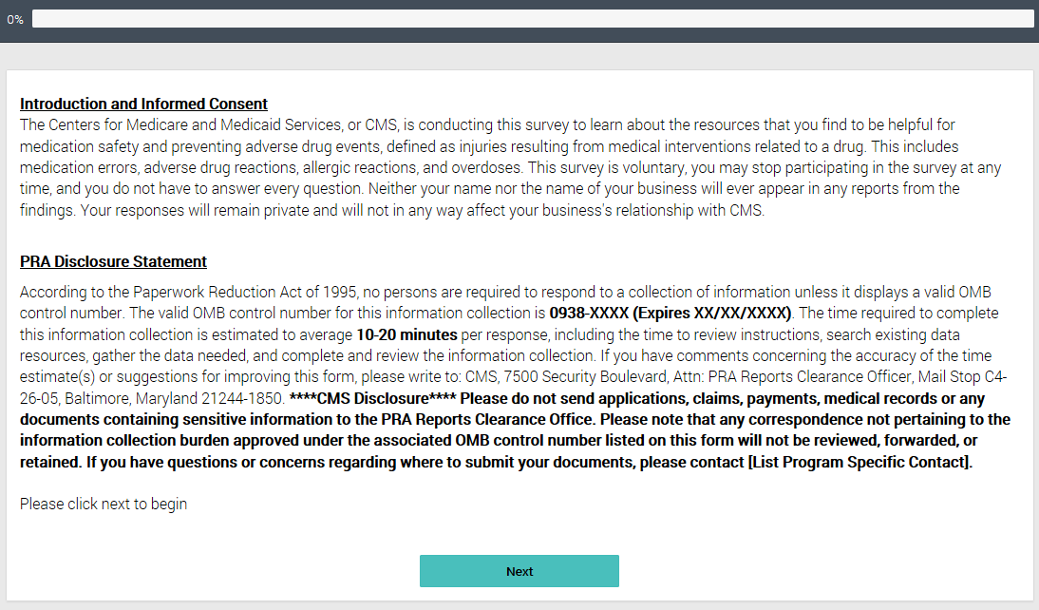

Screener
S1. In what state do you currently work?
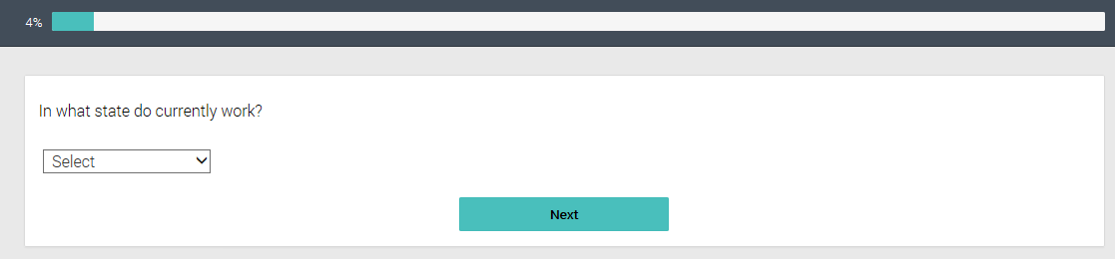
S2. Which of the following best describes your specific occupation within a medical practice/ pharmacy? Please select one.
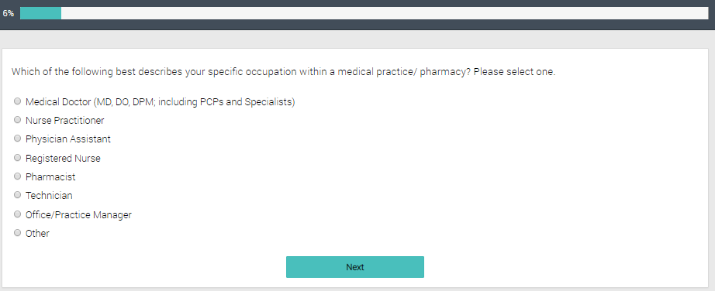
S3. In what setting do you primarily work? Please select one.
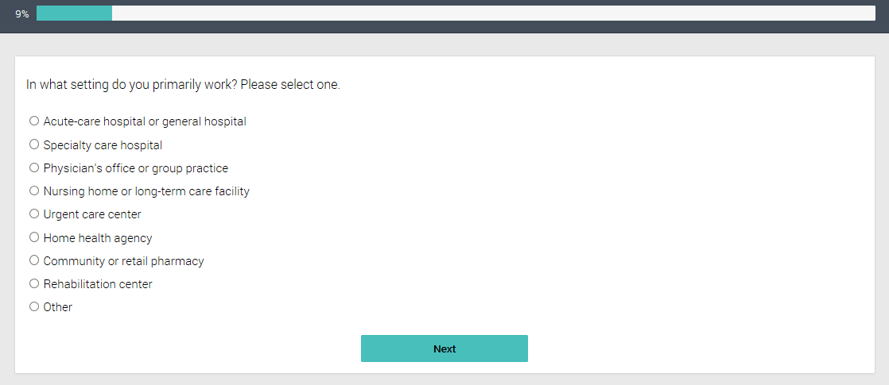
S4. Approximately how many [INSERT “providers” OR “pharmacists”] are employed at your [INSERT “practice” or “community or retail pharmacy”]?
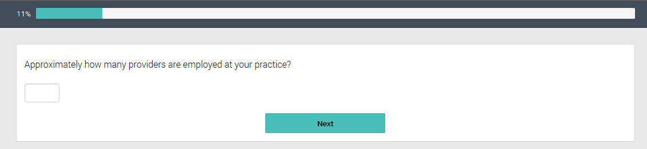
S5. Is the [INSERT “practice” OR “pharmacy” depending on participant’s setting] where you primarily work part of any of the following?
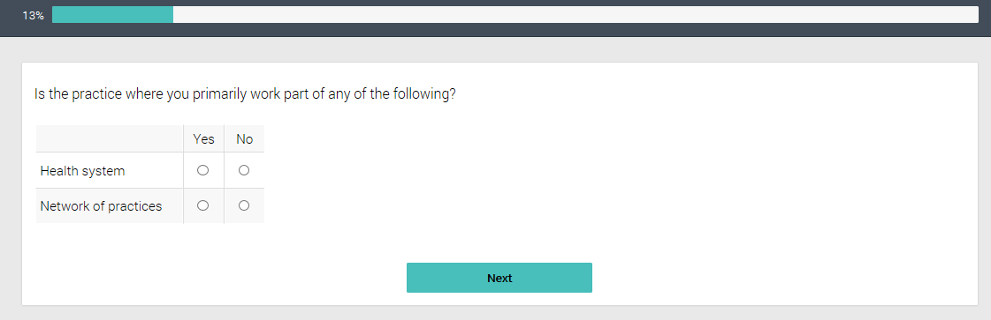
S6. Does your [INSERT “practice” OR “pharmacy” depending on participant’s setting] have any programs or protocols in place to reduce or prevent adverse drug events among your patients/customers?
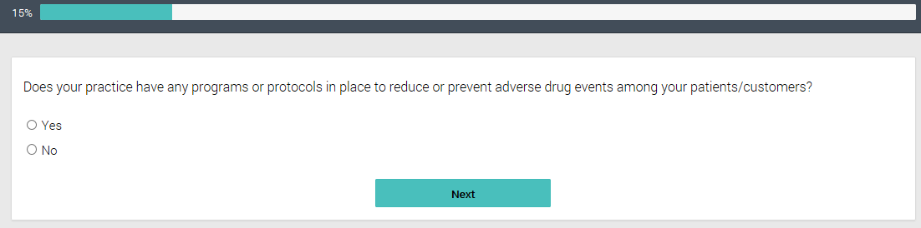
S7. How familiar are you with your [INSERT “practice’s” OR “pharmacy’s”] programs or protocols to reduce or prevent adverse drug events?
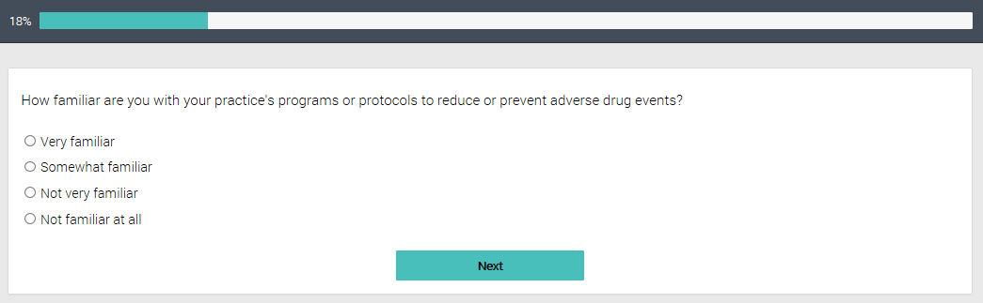
S8. Has your [INSERT “practice” OR “pharmacy”] worked with or received assistance from any of the following organizations to develop programs or protocols to reduce or prevent adverse drug events?
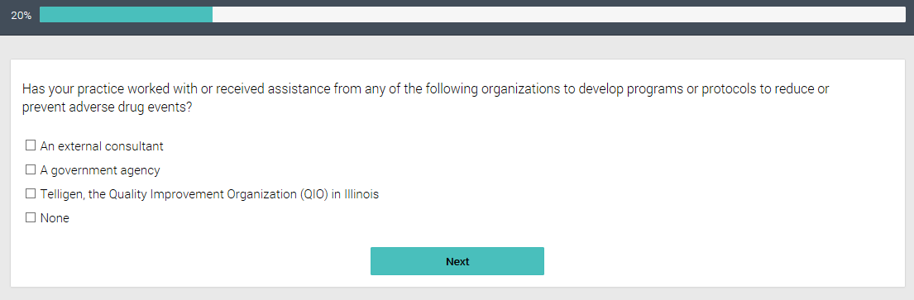
S9. How long have you worked in the field of healthcare?
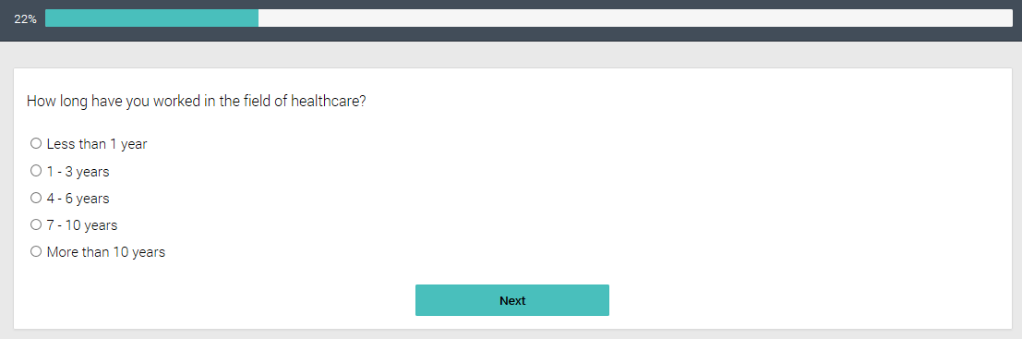
S10. How many years have you been at your current position?
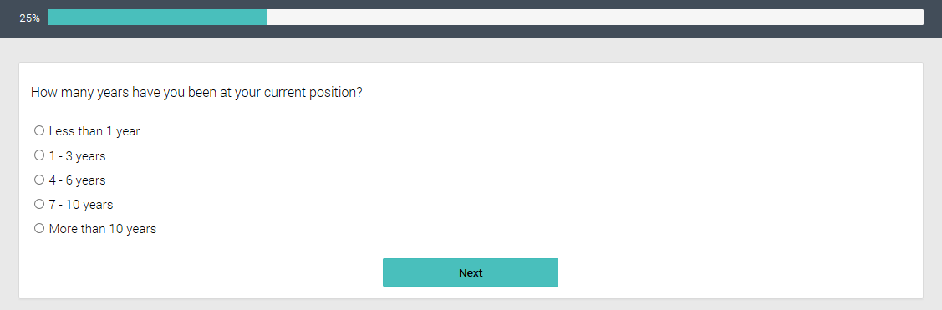

Survey Questions
- Quality Improvement Initiatives
- Since [for practices INSERT ‘January 2015’ OR for pharmacies INSERT ‘September 2016’], has your practice begun or continued working on any quality improvement (QI) activities with the goal of reducing or preventing adverse drug events related to the following medications?
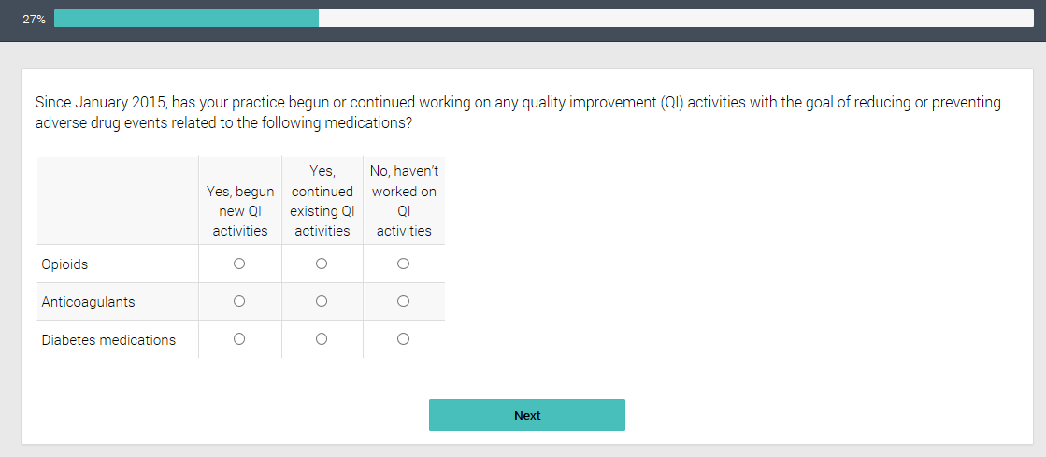
- How effective would you say your organization has been in reducing or preventing adverse drug events related to these medications?
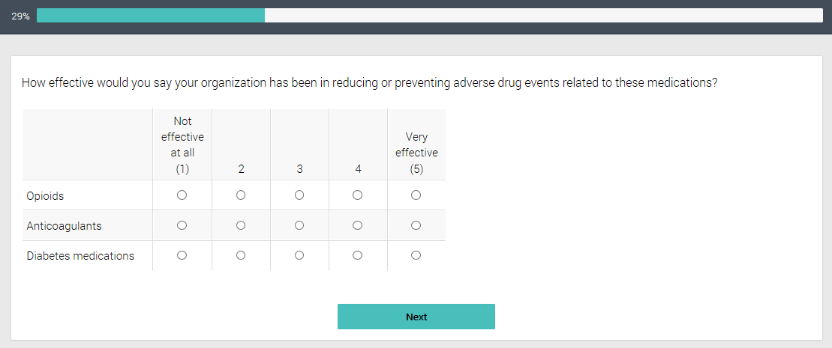
- Does your [INSERT “practice” OR “pharmacy”] use any of these methods or activities for medication safety or prevention of adverse drug events?
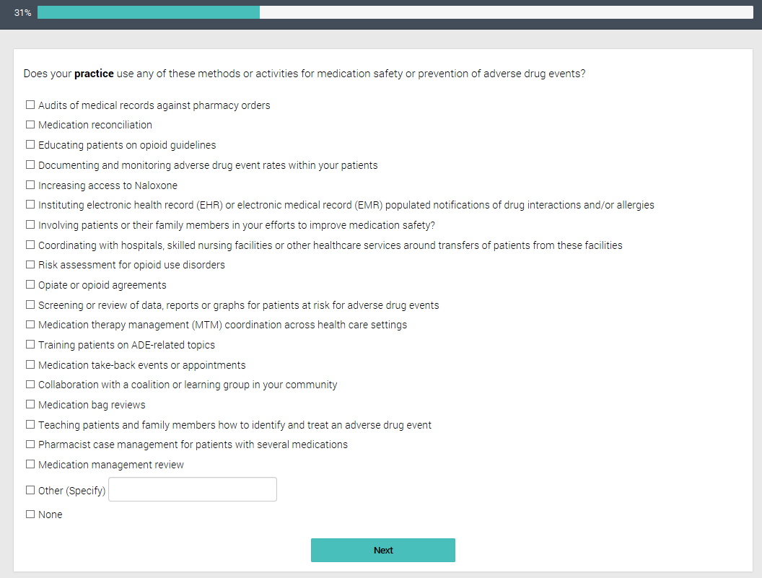
- How would you gauge the extent to which you involve [INSERT “patients” OR “customers”] or their family members in your efforts to improve medication safety?
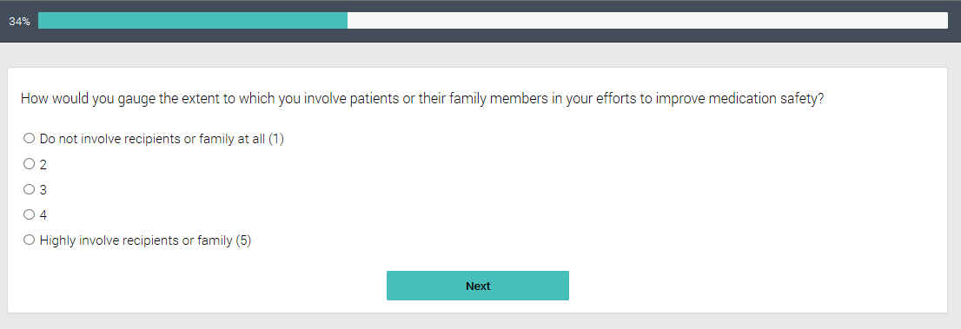
- To the best of your knowledge, was your [INSERT “practice” OR “pharmacy”] working in each of the following methods or activities before [for practices INSERT ‘January 2015’ OR for pharmacies INSERT ‘September 2016’]?
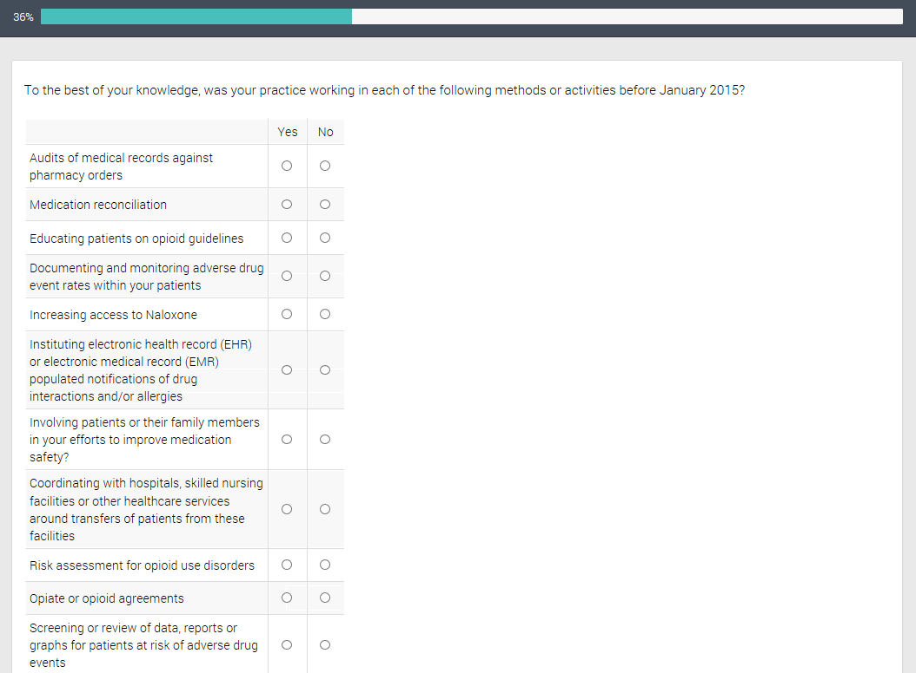
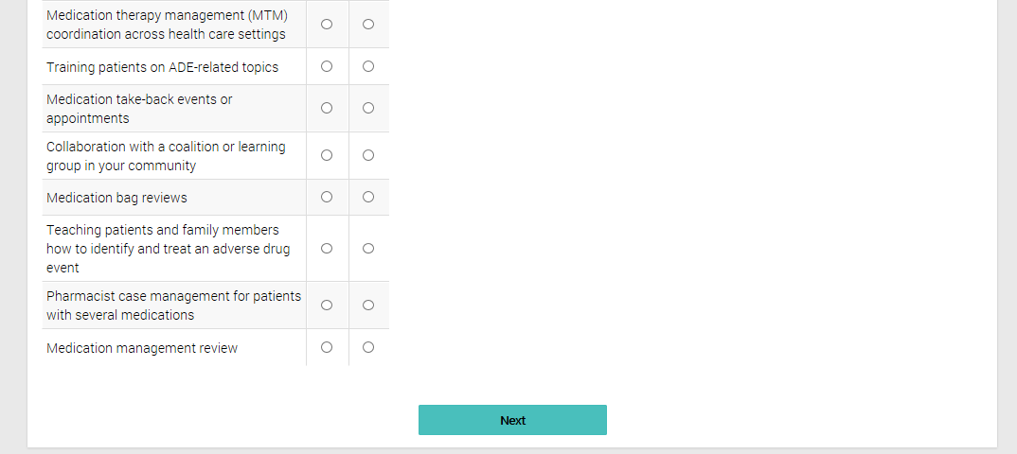
- Outcome Attribution to QIO

Section Introduction
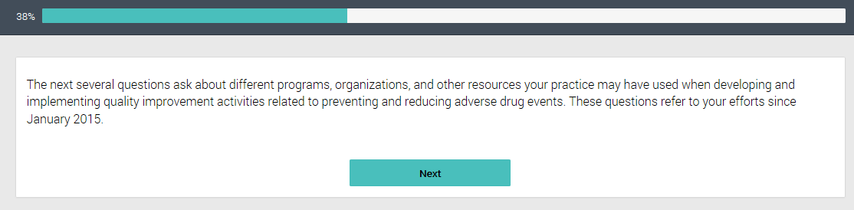
- Please select the programs below that your [INSERT “practice” OR “pharmacy”] has used to promote medication safety or prevent adverse drug events.
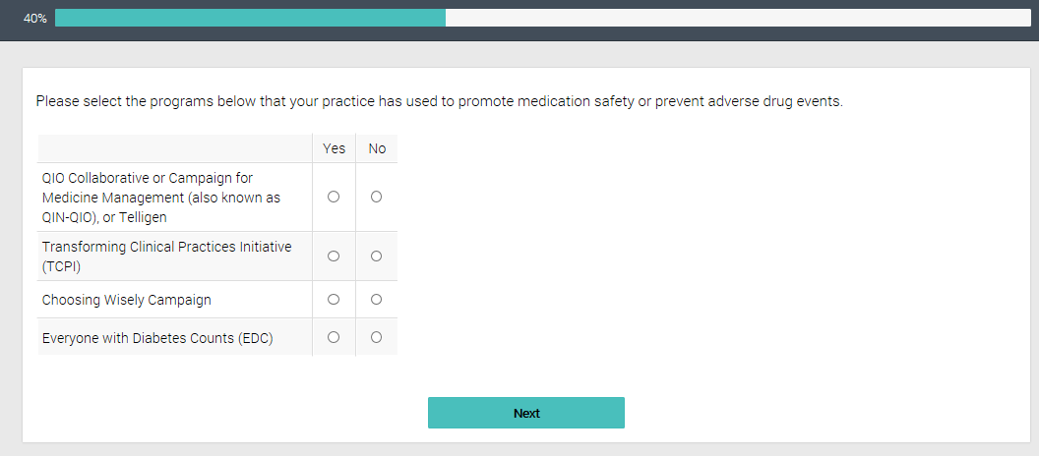

Please select other national or state agencies/organizations that your [practice/pharmacy] use to promote medication safety or prevent adverse drug events.
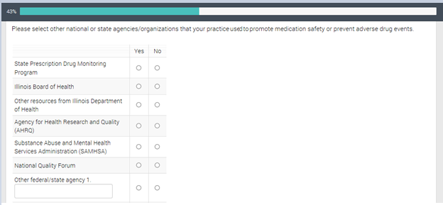

Did your [“practice” OR “pharmacy”] use information and resources from any of these organizations?
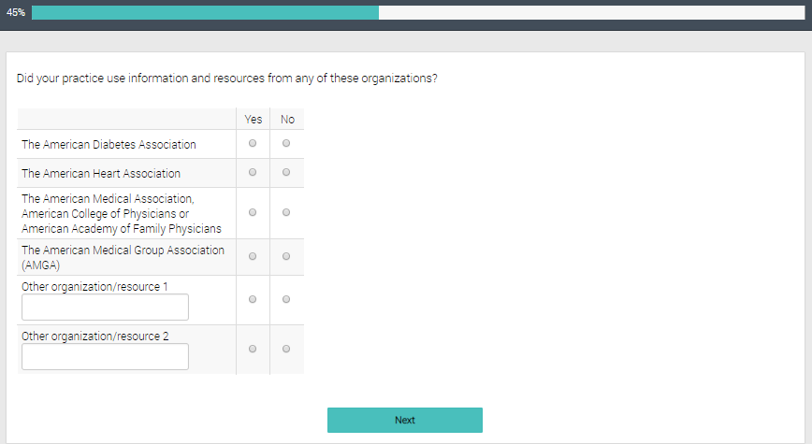

Here are some other resources that may have been used when working or reducing ADEs. Please check if your organization uses any of the following.
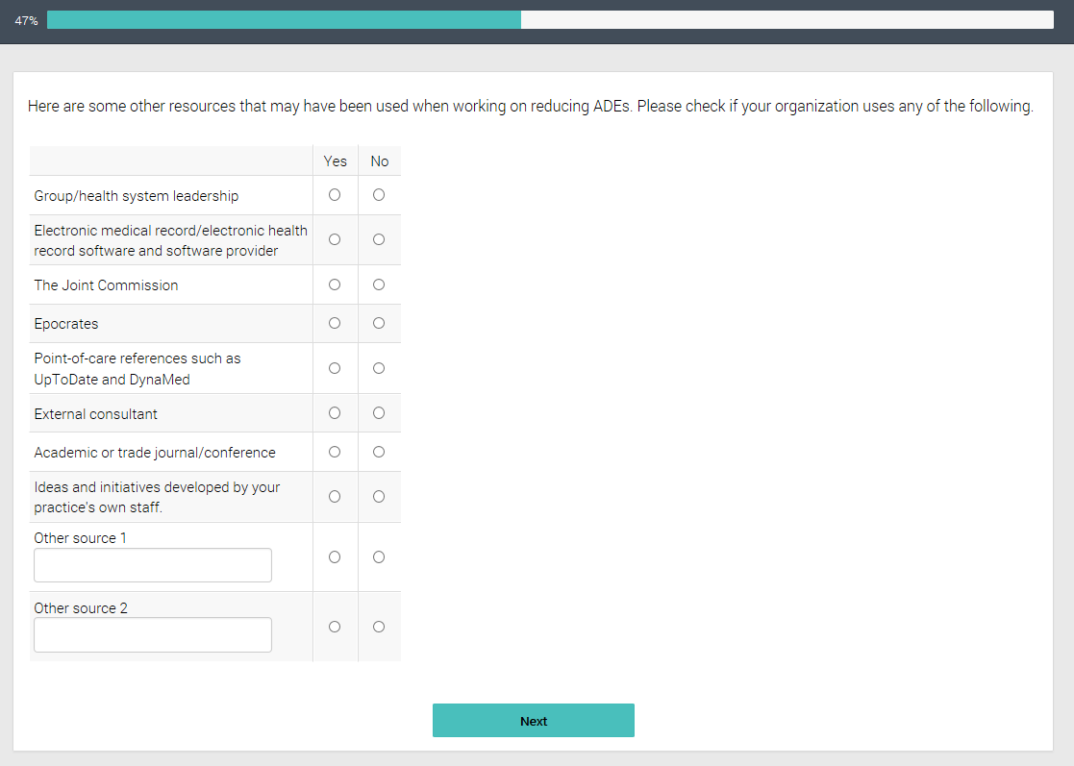
- You indicated that the sources of information below helped with your efforts to reduce adverse drug events. Please indicate how helpful you found each resource in your quality improvement efforts to improve medication safety and reduce adverse drug events.

In other words, how much would you say each program contributed to your organization’s ability to promote medication safety or prevent adverse drug events since [for practices display ‘January 2015’ for pharmacies display ‘September 2016’]?
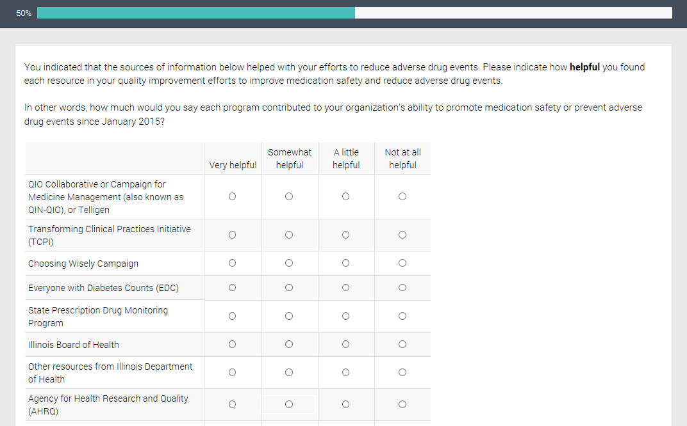
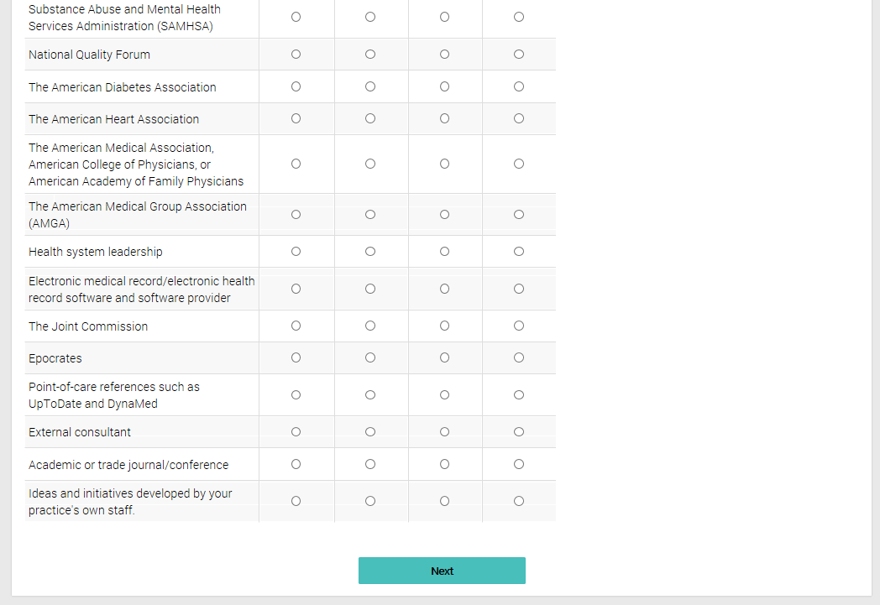

7aa. Which sources of information, design or assistance had the most impact on your [INSERT “practice’s” OR “pharmacy’s”] ability to medication safety or prevent adverse drug events since [for practices display ‘January 2015’for pharmacies display ‘September 2016”]?
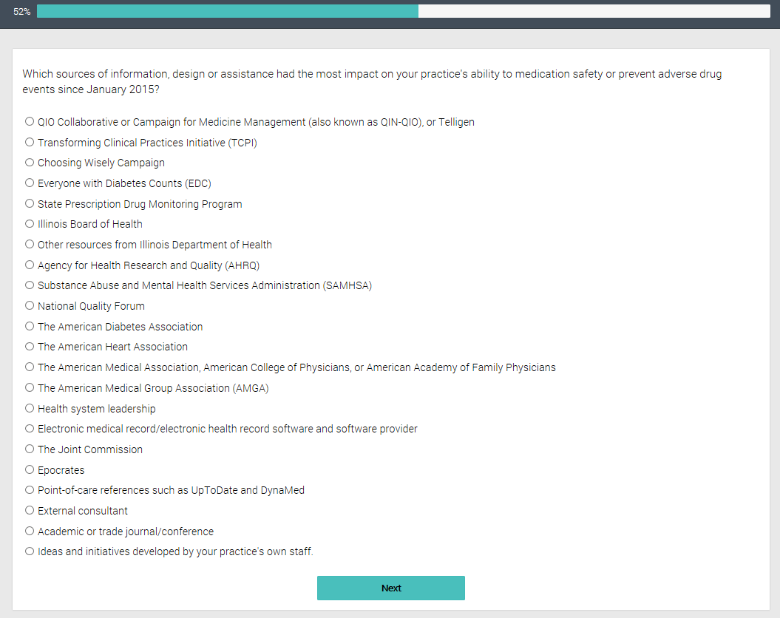

7a. Why was [INSERT TOP SOURCE] the most helpful source of information?”
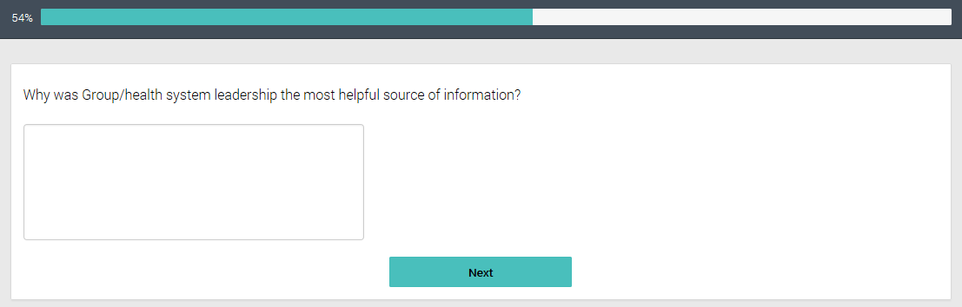
- Participation in QIN-QIO activities for non-QIO Practice/Facilities/Pharmacies
- Before this survey, had you ever heard of Quality Improvement Organizations, otherwise referred to as QIOs?
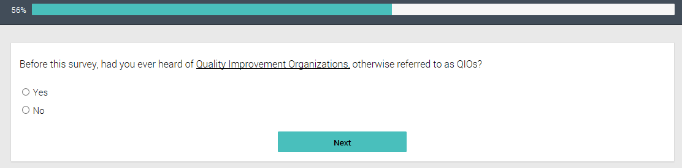
- Before this survey, had you ever heard of [INSERT NAME OF LOCAL QIO]?
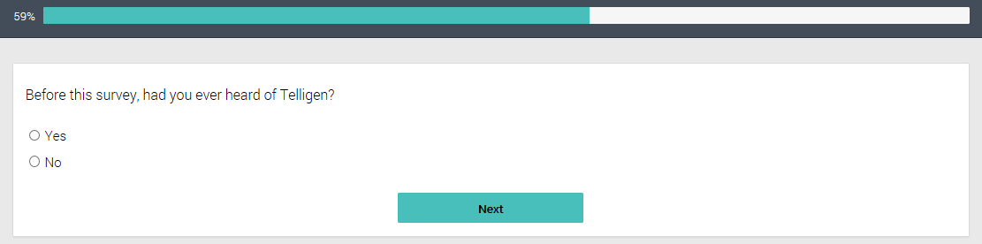
- Has your organization participated in any activities with [INSERT NAME OF LOCAL QIO], the Quality Improvement Organization in [INSERT STATE] (such as technical assistance using data, Learning and Action Networks or webinars)?
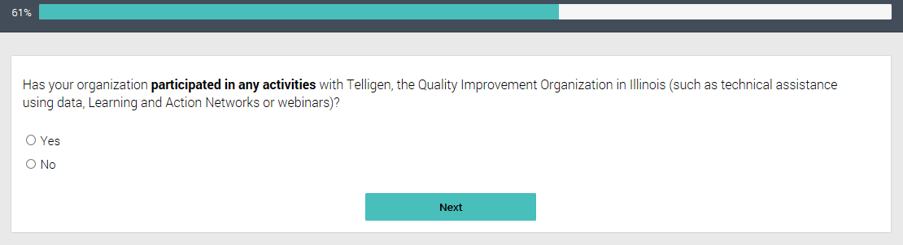
- Interaction with the QIN-QIO

Section Introduction
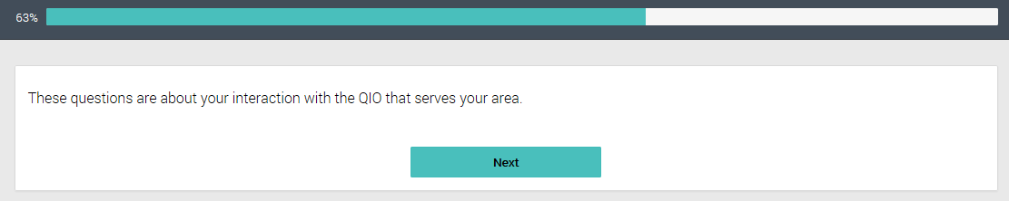
- How long has your [INSERT “practice” OR “pharmacy”] worked with [INSERT NAME OF LOCAL QIO Based on Sample Variable ‘QIO’]?
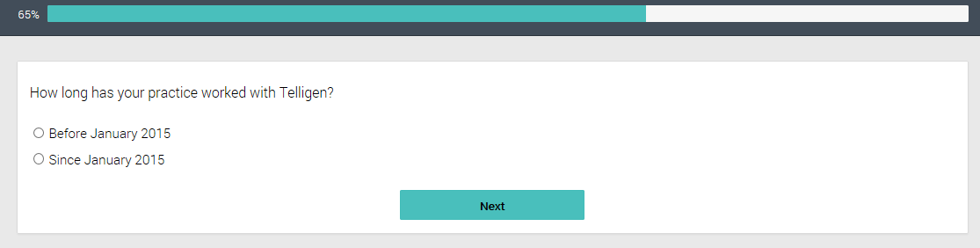
- How much do you agree or disagree with the following statement?

My organization benefits from participating with [INSERT NAME OF LOCAL QIO. Based on Sample Variable ‘QIO’]
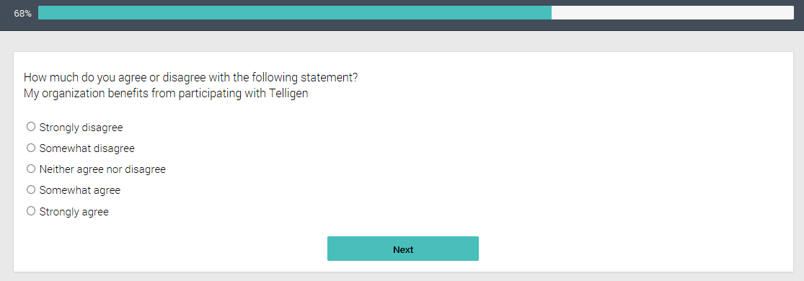

12a. Please explain why you disagree with this statement
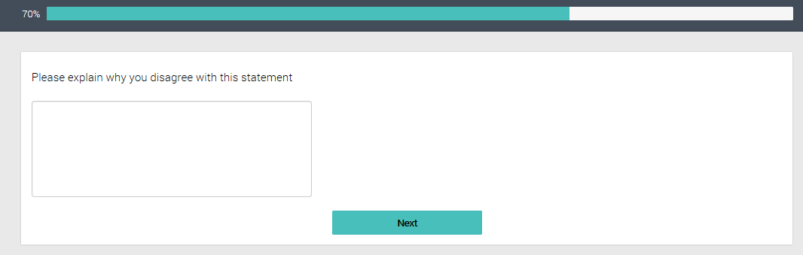
- Do you know whom to contact at [INSERT NAME OF LOCAL QIO Based on Sample Variable ‘QIO’], if you wanted help or advice from them on improving medical safety, or preventing ADEs?
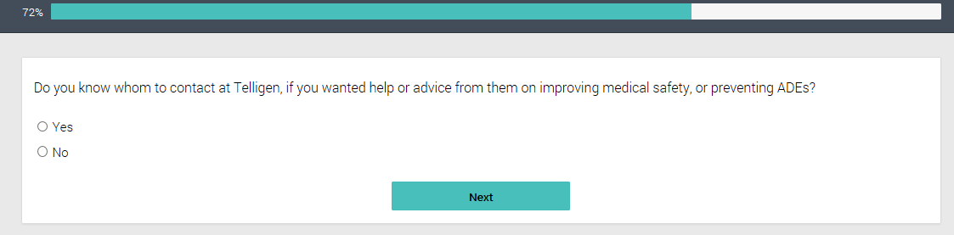
- Approximately how many times did you or someone at your organization participate in one-on-one or small group meetings with someone from [INSERT NAME OF LOCAL QIO Based on Sample Variable ‘QIO’] on the phone, through email exchanges, or in-person in the past twelve months?
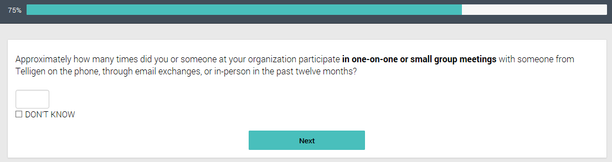
- Apart from one-on-one exchanges, did your organization take part in meetings led by [INSERT NAME OF LOCAL QIO. Based on Sample Variable QIO] with other healthcare providers and pharmacists in the community, such as those working in hospitals, nursing homes, home health agencies or other types of healthcare providers?
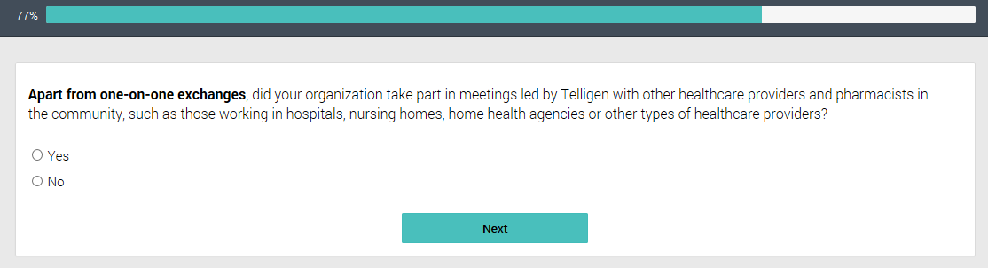
- Approximately how many times did you or someone from your organization participate in meetings with these other healthcare providers or pharmacists in the past twelve months?
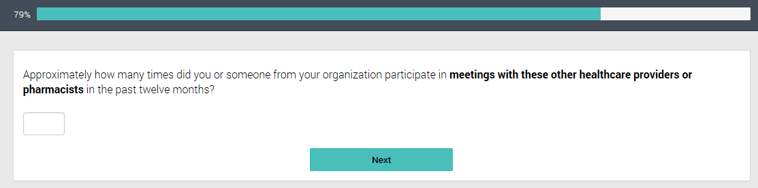
- How much do you agree or disagree with the following statements about these meetings organized by [INSERT NAME OF LOCAL QIO. Based on Sample Variable QIO]?
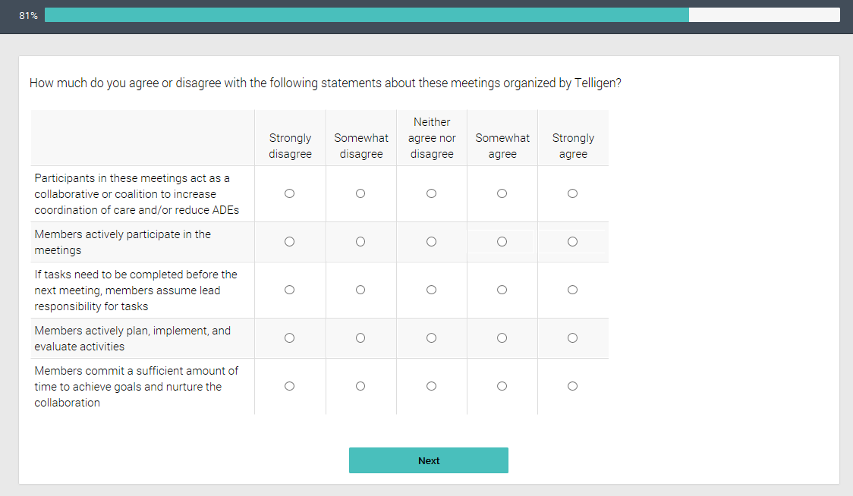
- Activities and Resources Provided By QIN-QIO
- Please indicate to the best of your knowledge whether your [INSERT “practice” OR “pharmacy”] has used any of the following resources that may be provided by your QIO:
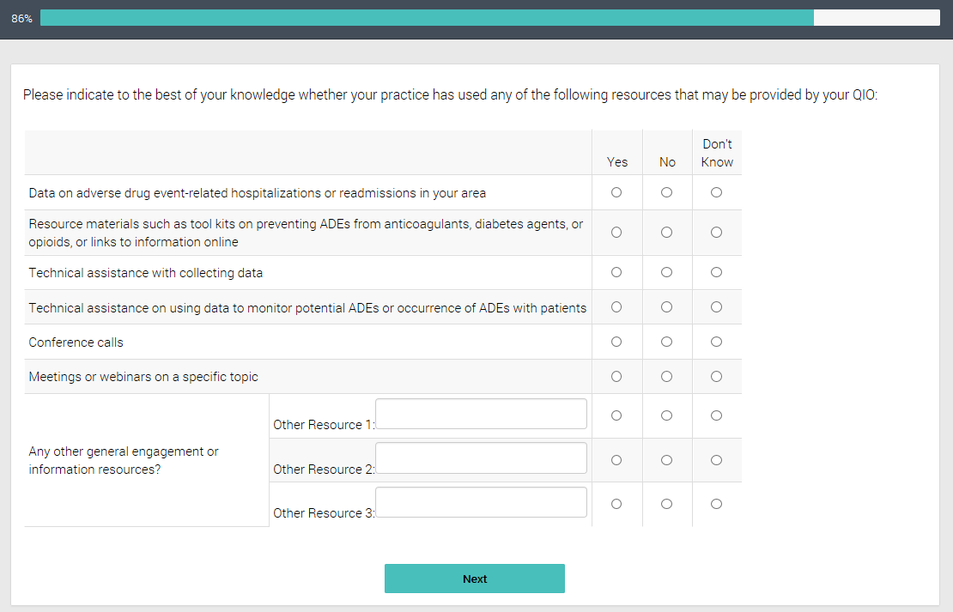
- Overall, please mark the response that best describes your organization’s level of engagement with medication safety technical assistance and resources provided by [INSERT NAME OF LOCAL QIO] since [for practices insert “January 2015” OR for pharmacies insert “September 2016”].
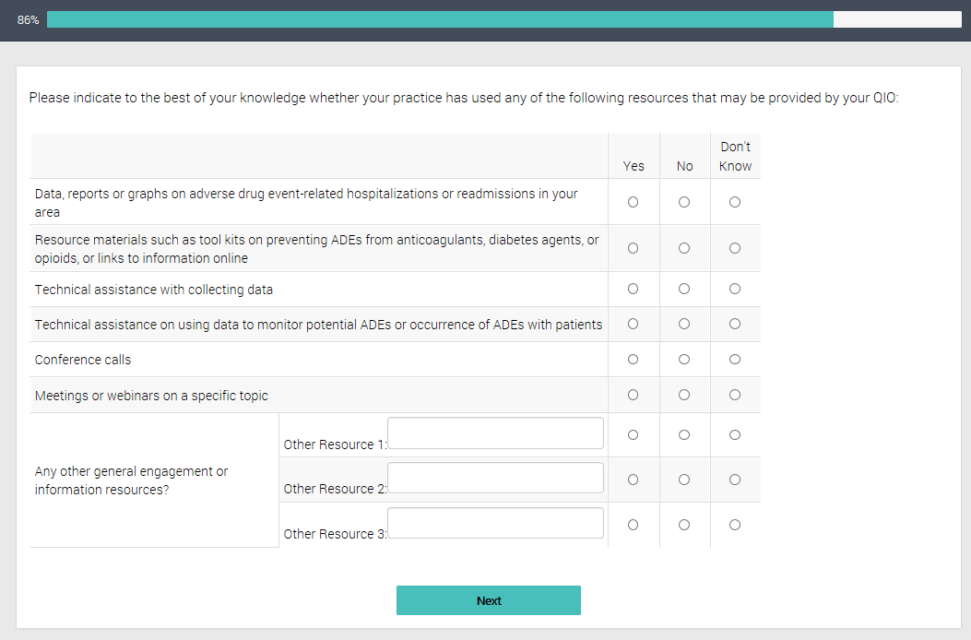
- What quality improvement areas related to medication safety or adverse drug events is your [INSERT “practice” OR “pharmacy”] most in need of for additional assistance?

Please provide enough detail so that CMS can understand what type of assistance you would need for this quality improvement area.
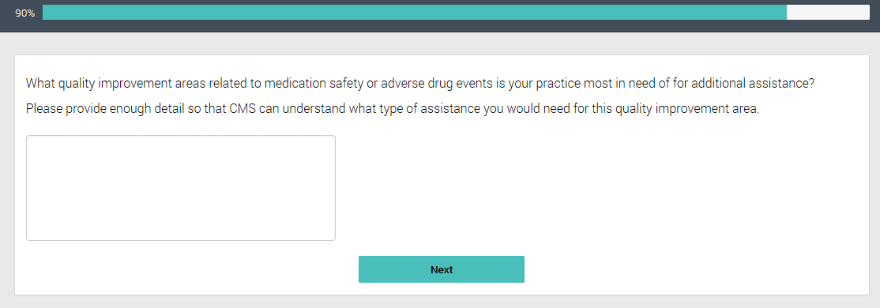
- How useful would it be for your [INSERT “practice” OR “pharmacy”] to adopt each of the following practices? [Only for respondents who chose No for Q6a and Q10]
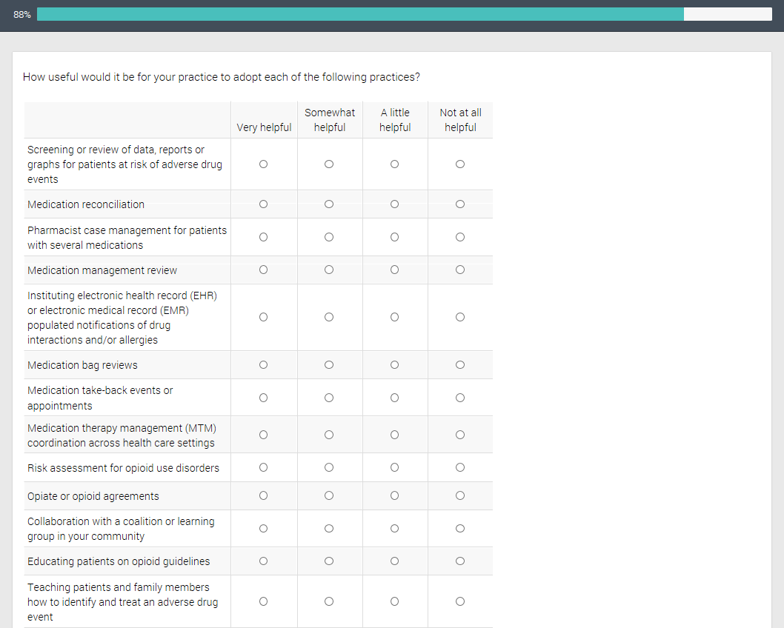
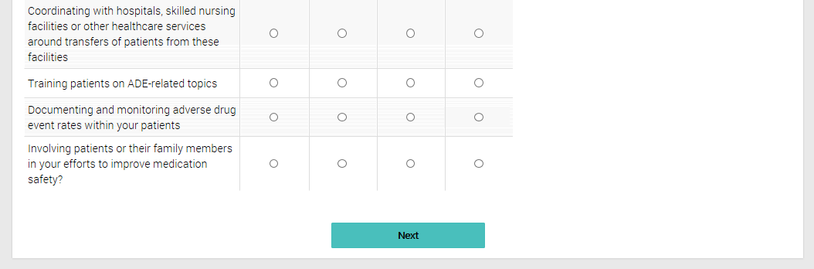

End
