APPOINTED REPRESENTATIVE REGISTRATION via INTRANET

CSA Home – user search
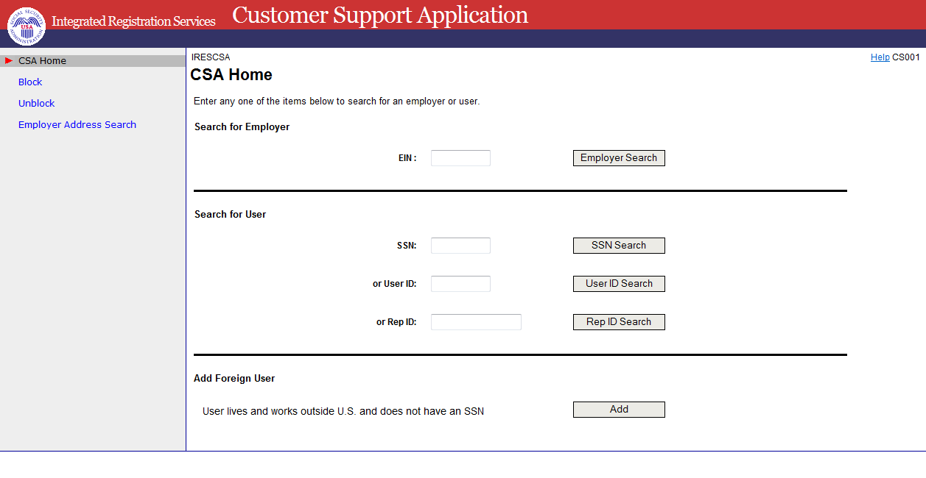
Multiple users found
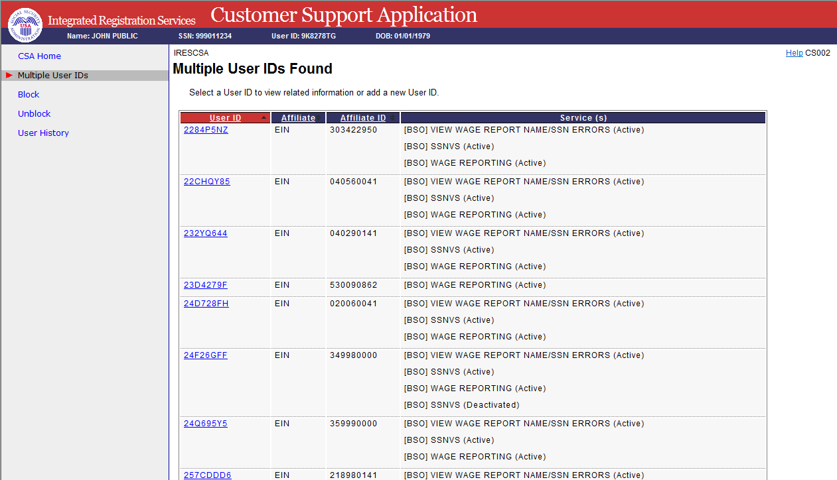

One user found or selecting a user id link above
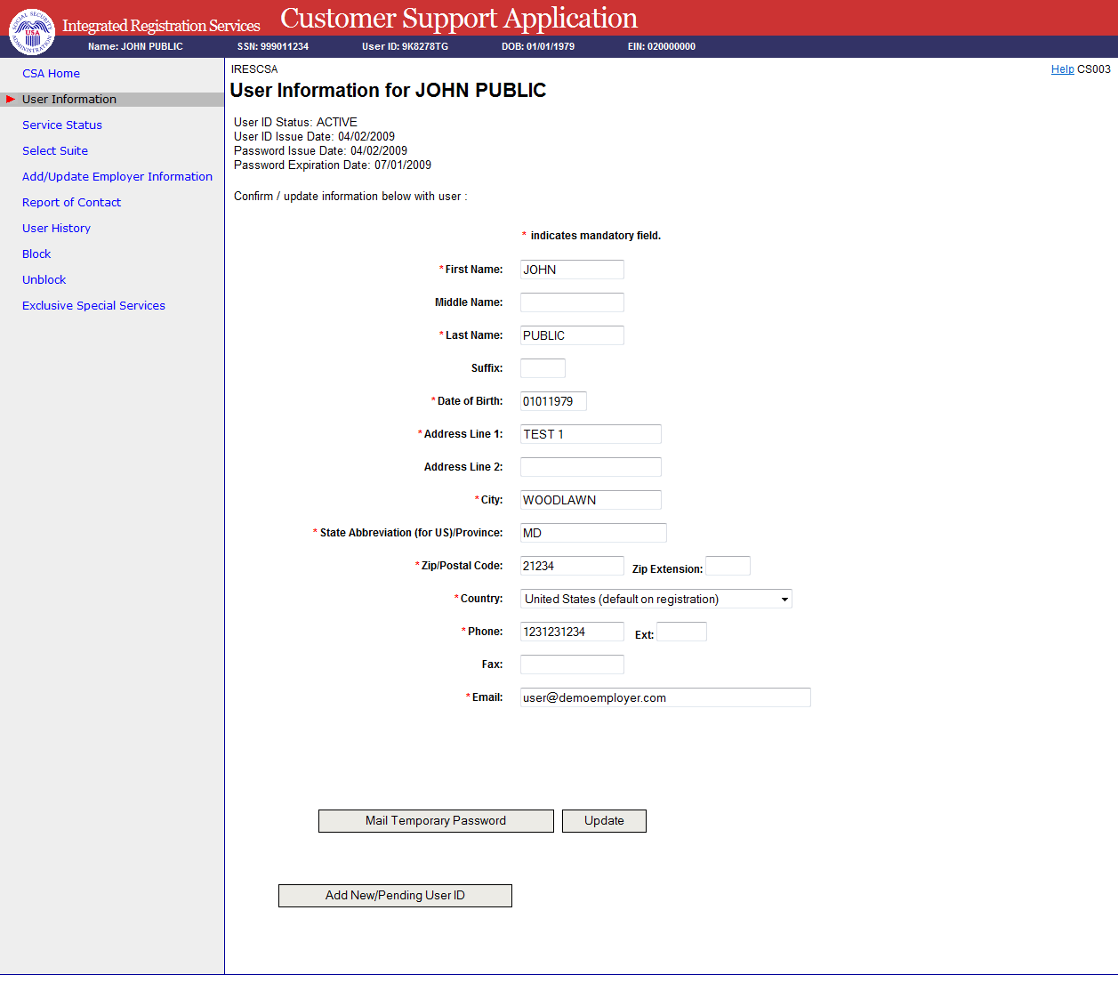

Add new user - phone registration
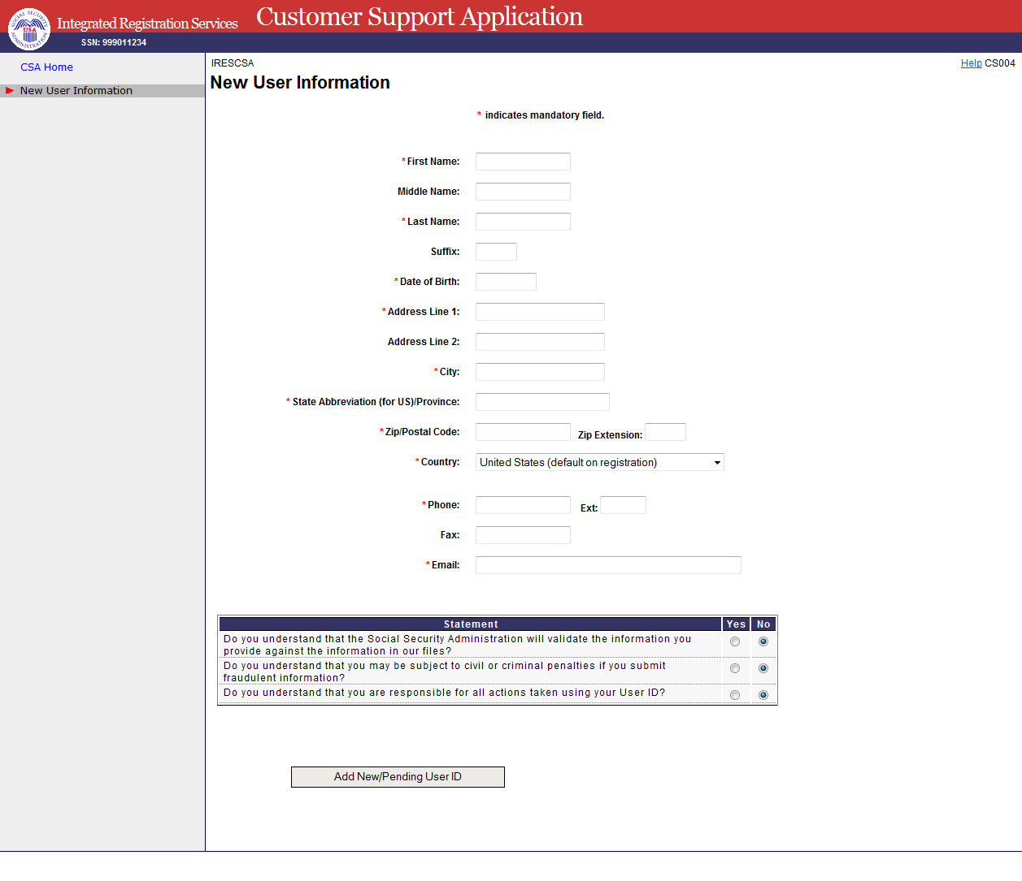

New user NUMI failed
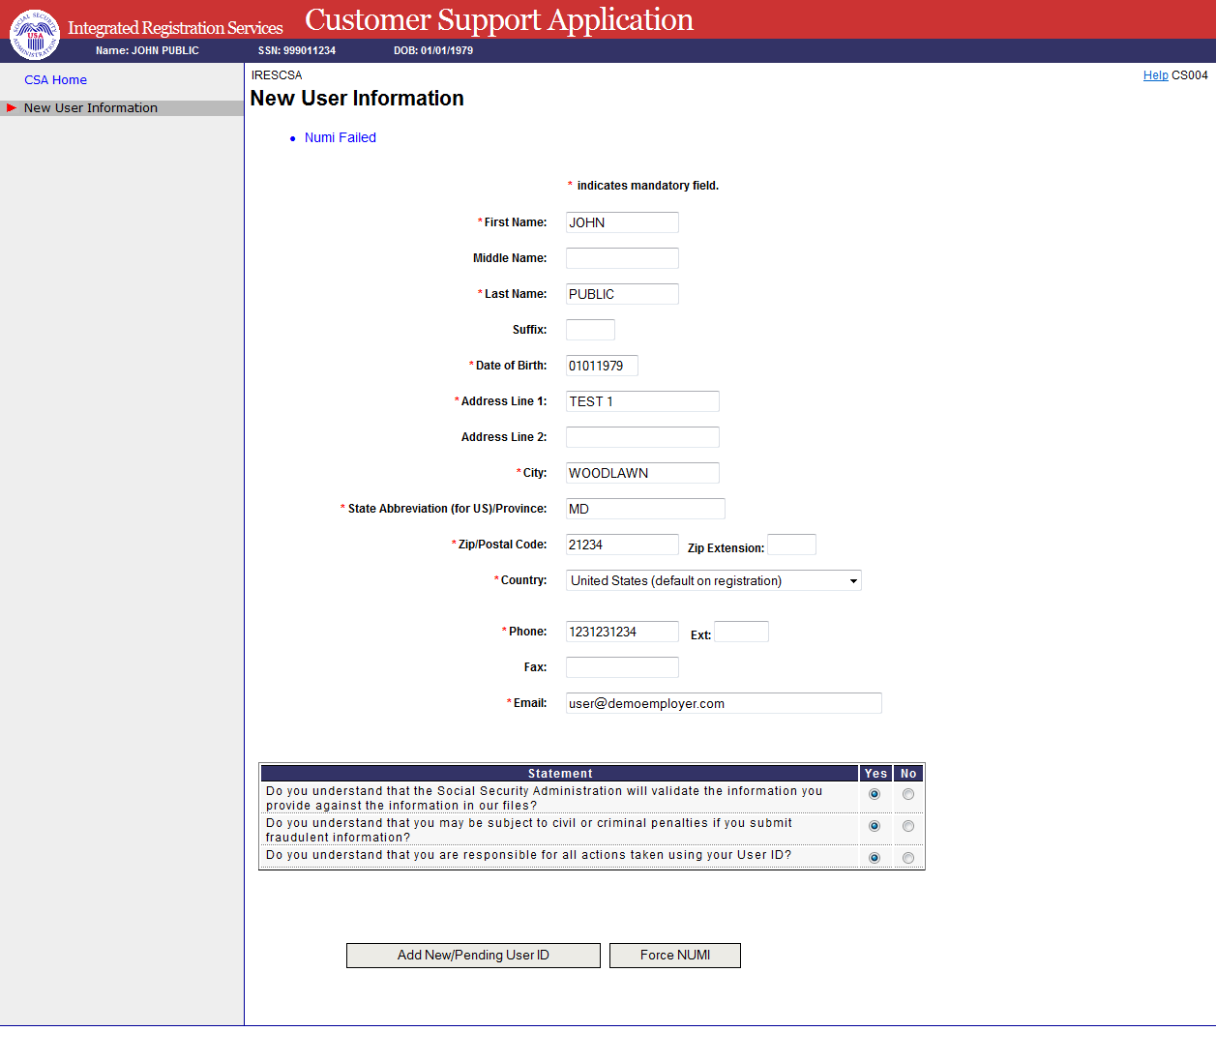

Add employer information
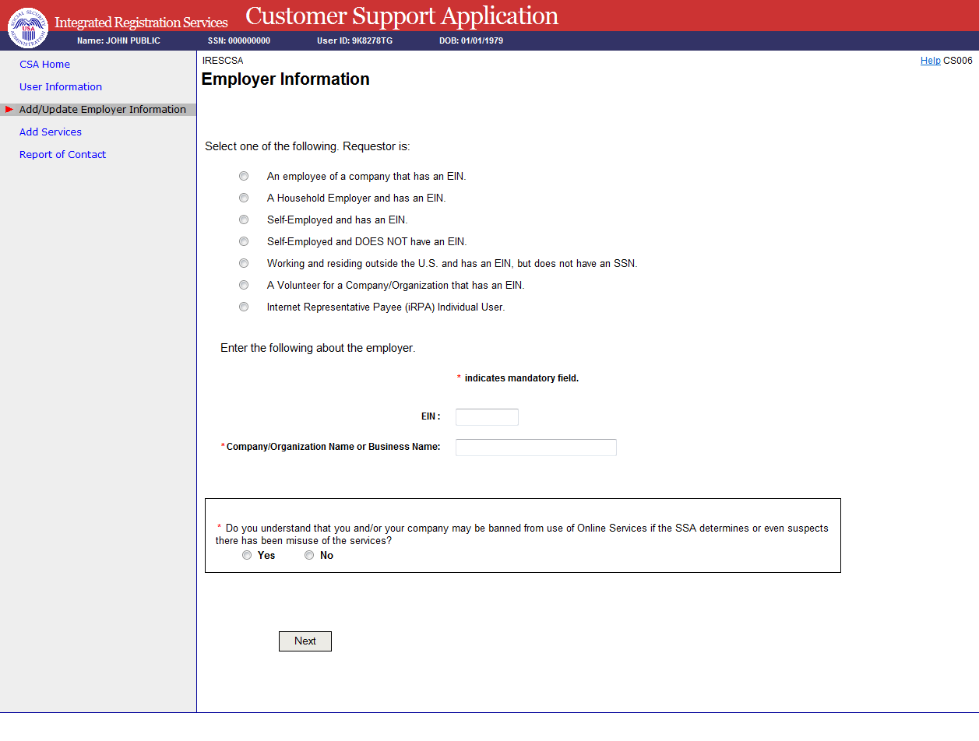

Select Suite
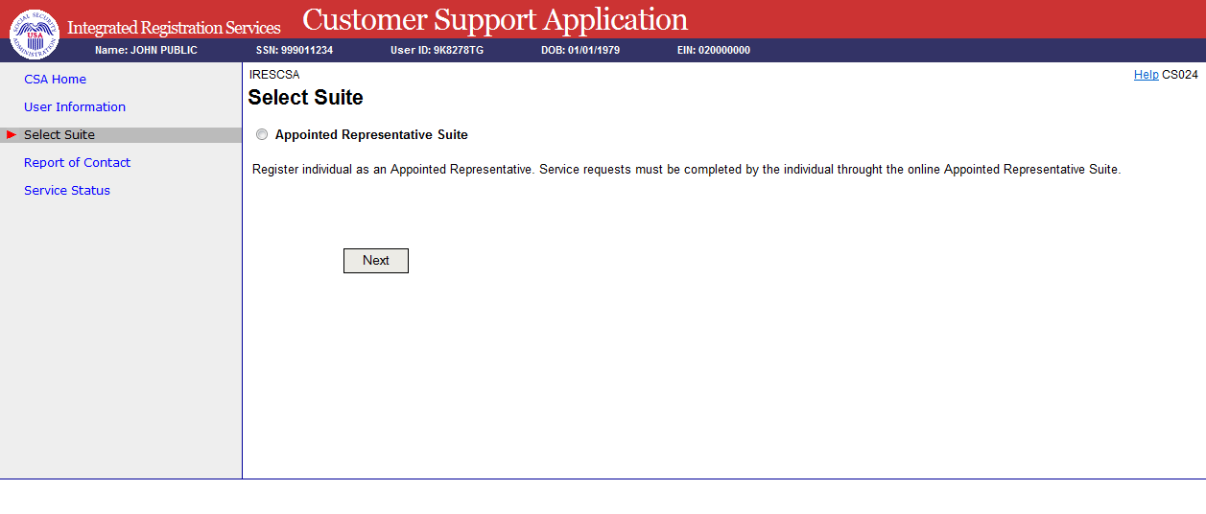

In person proofing – record information
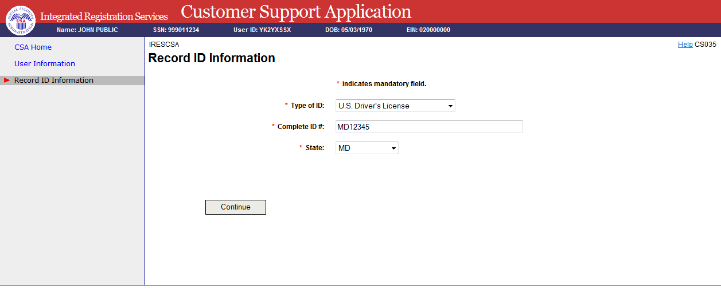

Print activation code for efolder
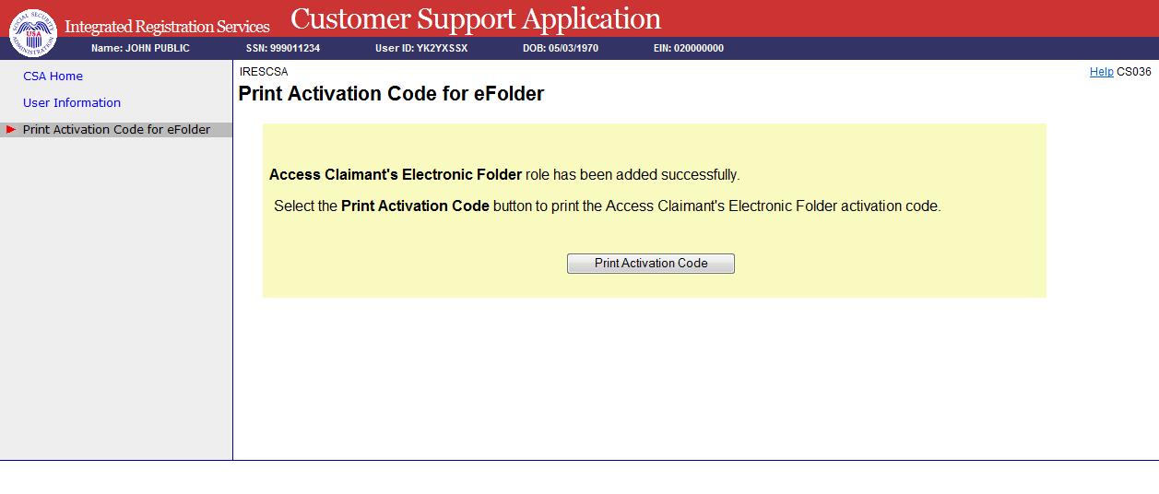
View activation code for efolder
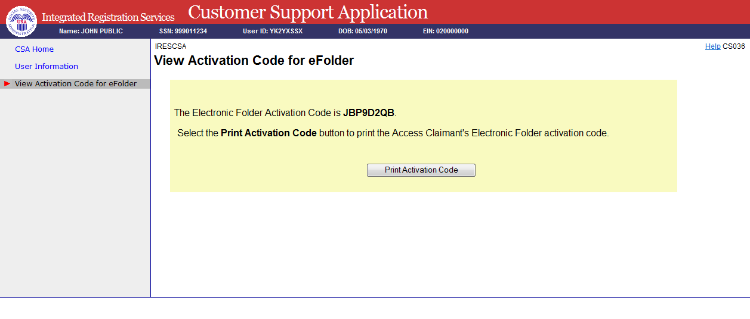

Paperwork Reduction Act Statement

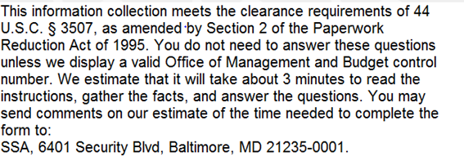

Privacy Act Statement
See revised Privacy Act Statement Attached

Privacy Act Statement

Collection and Use of Personal Information

Sections 205(a) and 1106 of the Social Security Act, as amended, authorize us to collect this information to allow you access to our online applications. We will use the information you provide to verify your identity and to register you, your company, or authorized employee(s) to use our Business Services Online (BSO) suite of services. The Privacy Act (5 U.S.C. § 552a(b)) permits us to disclose the information you provide in accordance with approved routine uses. Providing us this information is voluntary. However, failing to provide us with all or part of the information could prevent us from offering you access to our BSO suite of services. Additional information regarding your use our online applications, routine uses of information, programs, and systems are available on our Internet website, www.socialsecurity.gov, or at your local Social Security office.
SSA will insert the following revised Privacy Act Statement into the form as soon as possible:
Privacy Act Statement
Collection and Use of Personal Information

Sections 205(a) and 1106 of the Social Security Act, as amended, allow us to collect this information. Furnishing us this information is voluntary. However, failing to provide all or part of the information could prevent us from offering you access to our Business Services Online (BSO) suite of services.
We will use the information to verify your identity and register you, your company, or authorized employee(s) to use our BSO suite of services. We may also share your information for the following purposes, called routine uses:

- To Federal, State, and local entities to assist them with administering income maintenance and health maintenance programs, when a Federal statute authorizes them to use the Social Security number; and,

- To contractors and other Federal agencies, as necessary, to assist us in efficiently administering our programs.

In addition, we may share this information in accordance with the Privacy Act and other Federal laws. For example, where authorized, we may use and disclose this information in computer matching programs, in which our records are compared with other records to establish or verify a person’s eligibility for Federal benefit programs and for repayment of incorrect or delinquent debts under these programs.

A list of additional routine uses is available in our Privacy Act System of Records Notice (SORN) 60-0058, Master Files of Social Security Number (SSN) Holders and SSN Applications, as published in the Federal Register (FR) on December 29, 2010, at 75 FR 82121. Additional information and a full listing of all our SORNs are available on our website at www.ssa.gov/privacy.

