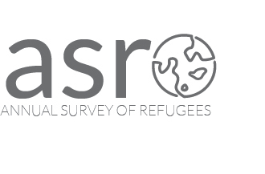

Thank you for your interest in participating in our study about how refugees adapt to life in the United States. Your contact information will be kept private and will only be used to contact you for this study.

- Please provide the best phone number for us to reach you in the boxes below. This could be a landline home phone or a cell phone.

- Is there any other number where we can reach you? If so, please write the number in the box below.

- What is your preferred language for the interview? ______________

