**Attachment 7 (A-I)**

2019 NSECE Center-based Provider Survey Contact Materials

August 2018

Table of Contents

**7A. Center-based Provider Advance Letter** 1

**7B. Center-based Provider Thank You/Reminder Postcard** 2

**7C. Center-based Provider Follow-up Letter** 3

**7D. Center-based Provider Elementary School Conversion Contact** 4

**7E. Center-based Provider Refusal Conversion Contact** 6

**7F. Center-based Provider Last Chance Contact** 8

**7G. Center-based Provider Thank You Letter** 10

**7H. Center-based Provider Frequently Asked Questions (FAQs)** 11

**7I. Center-based Provider Brochure Text** 13

**7A. Center-based Provider Advance Letter:** Initial contact 1 - First contact with sampled providers.

Dear [ADMINISTRATOR],

We are writing to ask for your help with an important study about how we care for children in the United States. In 2012 the National Survey of Early Care and Education (NSECE) conducted interviews with nearly 15,000 providers to create the first national profile of early care and education services in more than 20 years. We are now collecting new information to update this profile and to learn how recent policy and program changes have affected center-based providers like you.

Please participate in the 2019 NSECE. Your response will ultimately inform how public funds are spent to subsidize early care and education and to support related services. To thank you for your participation, we will send you a $25 gift card for completing the survey.

To access the web survey, please type the URL into any computer or mobile device’s web browser and enter the unique PIN and Password:

URL address: [https://XYZ/]

PIN: [WEBPIN] Password: [WEBPWD]

NORC at the University of Chicago is conducting this study on behalf of the U.S. Department of Health and Human Services. Your participation is voluntary. The survey will take about 45 minutes, and your responses will be kept private. You have the option to skip any question or end the survey at any time. If you have questions, please call us toll free at [PHONE] or email [EMAIL].

By participating, you will help government agencies and policy makers better understand the challenges early care and education providers face as they work to offer quality care to children.

We need your help to make this study a success.

Thank you,

cid:image002.jpg@01CCD077.2E3172E0

A. Rupa Datta, Ph.D.

­­2019 NSECE Project Director

NORC at the University of Chicago

An agency may not conduct or sponsor, and a person is not required to respond to, a collection of information unless it displays a currently valid OMB control number. The OMB number for this information collection is 0970-0391and the expiration date is MM/DD/YEAR. Please send comments regarding the time required for this survey or any other aspect of the described information collection to: [Name and address to be added].

**7B. Center-based Provider Thank You/Reminder Postcard:** Initial contact 2 - Sent to sampled providers who have not yet participated approximately two weeks after the mailing of the advance letter.

Dear [ADMINISTRATOR],

We recently sent you a letter asking you to complete a web survey sponsored by the Administration for Children and Families about how we care for children in the United States. Your response will help the government understand the availability of early care and education services in your area.

The survey will take about 45 minutes. To thank you for your participation, we will send you a $25 gift card for completing the survey.

If you have already completed this survey, thank you! If not, **we ask you complete it as soon as possible**. You can access the survey by typing the secure URL into the browser of any computer or mobile device and entering the PIN and Password:

URL address: [https://XYZ/]

PIN: [WEBPIN] Password: [WEBPWD]]

If you have any questions, please contact us at [EMAIL] or [PHONE.]

Thank you!

Participation is voluntary and your responses will be kept private. An agency may not conduct or sponsor, and a person is not required to respond to, a collection of information unless it displays a currently valid OMB control number. The OMB number for this information collection is 0970-0391and the expiration date is MM/DD/YEAR. Please send comments regarding the time required for this survey or any other aspect of the described information collection to: [Name and address to be added].

**7C. Center-based Provider Follow-up Letter:** Initial contact 3 - Sent to sampled providers who have not yet participated approximately two weeks after the mailing of the thank you/reminder postcard.

Dear [ADMINISTRATOR],

We recently contacted you to ask for your participation in the National Survey of Early Care and Education. This survey is sponsored by the federal Administration for Children and Families, one of the largest sources of public support for early and school age care in our country. Your response will help the government better understand the need for and availability of early care and education for children under age 13 in your area. To thank you for your participation, we will send you a $25 gift card for completing the survey.

To begin, please type the secure URL into any computer or mobile device’s web browser and enter the unique PIN and Password:

URL address: [https://XYZ/]

PIN: [WEBPIN] Password: [WEBPWD]

NORC at the University of Chicago is conducting this study on behalf of the U.S. Department of Health and Human Services. The survey will take about 45 minutes. Participation is voluntary, and your responses will be kept private. You have the option to end the survey at any time, or skip any question.

A professional interviewer will be contacting you in the near future to answer any questions and assist you in completing the survey. You can call us toll free at [PHONE] or email us at [EMAIL] if you have questions or need assistance.

You have been selected for participation in this study from a list of providers in your area based on geographic and program criteria. It is important for us to interview every selected provider to get a complete picture of the availability and use of early care in your area. Your responses will help inform how public funds are spent to subsidize early care and education of young children and to support related services.

We need your help to make this study a success. We hope you will decide to take part.

Thank you,



A. Rupa Datta

­­2019 NSECE Project Director

NORC at the University of Chicago

An agency may not conduct or sponsor, and a person is not required to respond to, a collection of information unless it displays a currently valid OMB control number. The OMB number for this information collection is 0970-0391and the expiration date is MM/DD/YEAR. Please send comments regarding the time required for this survey or any other aspect of the described information collection to: [Name and address to be added].

**7D. Center-based Provider Elementary School Conversion Contact:** As needed - Sent to sampled school-based providers who have not responded to the survey.

Dear Early Childhood Educator,

I write to ensure that your school is represented in the 2019 National Survey of Early Care and Education (NSECE), which is in the final stages of data collection. [IF SUPPORT LETTER INCLUDED: The enclosed letter from the XX describes some of the reasons this study is important to educators like you.]

As you know, the last two decades have seen a tremendous expansion in the availability and use of programs for children not yet in kindergarten. That expansion has been based on compelling research evidence that birth to age five is a critical time for children’s development. The 2019 NSECE offers a significant opportunity to continue to build on that knowledge about children’s experiences.

In 2012 the NSECE conducted interviews with nearly 15,000 providers to create the first national profile of early care and education services in more than 20 years. This profile was distinctive because it included all types of non-parental care and education experiences available for children not yet in kindergarten, spanning home-based care, traditional pre-school, school-based pre-kindergarten, and many other options. Legislators deciding state and federal budgets, policy makers determining licensing and subsidy rules, instructional staff seeking employment, and parents enrolling their children must all choose between different types of care, yet there had been virtually no systematic evidence on which to base these choices. The 2012 study collected data and produced analyses that made systematic and rigorous comparisons between the various educational and care programs for young children possible. We are now collecting new information to update this profile in order to learn how recent policy and program changes have affected early care and education providers like you.

We expect that the NSECE data and analyses will be particularly relevant for school-based early childhood educators in the following ways:

- improving children’s readiness to learn in school. Policy makers and researchers know that high-quality early childhood experiences dramatically increase children’s readiness to learn in elementary school, but little is known about how programs vary in terms of their staff quality, access to supportive services, and turnover in instructional staff. NSECE results will help communities invest private and public resources wisely so that children’s access to quality programs and overall quality of care can be improved.

- enhancing the workforce for early care and education classrooms. We know that the teachers and aides who spend hours each day with children are the critical element for high-quality care, yet we also know that wages, benefits, job security, and opportunities for training and advancement can all be limited for early childhood staff. The NSECE asks and answers questions such as, “What job conditions are conducive to maintaining a strong workforce? In what types of communities might expanding school-based early learning opportunities weaken the availability of quality staff for community-based and home-based programs?” Your school was selected through a scientific method to represent school-based early care and education programs in the U.S. Please make sure your school’s early care and education offerings will be counted in these important estimates of the opportunities available in your area. The survey will take about 45 minutes. Participation is voluntary and your responses will be kept private. Our project interviewers are able to schedule an in-person or telephone interview at your convenience (call [PHONE]), or you may complete the web survey by typing the secure URL into any computer or mobile device’s web browser and entering the unique PIN and Password:

URL address: [https://XYZ/]

PIN: [WEBPIN] Password: [WEBPWD]

Thank you for your hard work every day educating our nation’s children. We want to make sure that your contributions are included when the NSECE informs policy makers and parents about the current availability of early care and education in our communities, and how we can best invest public and private resources to serve our communities’ needs.

Thank you,



A. Rupa Datta, Ph.D.

­­2019 NSECE Project Director

NORC at the University of Chicago

An agency may not conduct or sponsor, and a person is not required to respond to, a collection of information unless it displays a currently valid OMB control number. The OMB number for this information collection is 0970-0391and the expiration date is MM/DD/YEAR. Please send comments regarding the time required for this survey or any other aspect of the described information collection to: [Name and address to be added].

**7E. Center-based Provider Refusal Conversion Contact:** As needed - Sent to sampled providers who have refused participation.

Dear [ADMINISTRATOR],

Recently an interviewer from NORC at the University of Chicago talked to you about participating in the 2019 National Survey of Early Care and Education (NSECE). This letter includes some information about the NSECE. We hope it will encourage you to participate in this study.

In 2012 the NSECE collected vital information from center-based providers and other caregivers to create the first national profile of early care and education (ECE) services in more than 20 years. This profile included unique information on center-based providers like you who play a critical role in caring for our nation’s children. This information has helped government agencies and policy makers get a clearer understanding of the challenges child care providers face and how they might better support them. Seven years have passed since we gathered this information, and we are now updating this profile.

***The 2019 NSECE will be used to:***

* Identify the types of center-based care available to families, how many providers there are, and the types of programs offered. This will provide urgently needed information about the supply of early care and education available to families across all income levels.
* Understand how the general structure and operations of center-based provider services has changed since 2012 (i.e., the curriculum they use, how they staff and organize classrooms, and what they charge).
* Learn how effective certain professional development initiatives and programs have been in helping to maintain a stable staff to work with children.

***Why are you so important to the NSECE?***

* You were selected for participation in this study from a list of providers in your area. It is important for us to hear from every selected provider to get a complete picture of the availability of early care and education services in your area.
* Your role in the field of early care and education allows you to answer questions about enrollment and funding for your program. This information will help ECE researchers better understand the complexities of provider financing and inform funding decisions and other initiatives designed to help child care providers offer quality care to children across the country.
* Public policy decisions should be based on accurate information. The most effective way to get accurate information to inform such decisions is by going directly to the people who work in the early care and education field. We need you to answer these questions so public policy will not be based on wrong information and guesswork.

If you have any questions about the study, feel free to call me at <<800 number>>. I will be happy to explain what a valuable contribution you will be making through participation in the 2019 NSECE. The survey takes about 45 minutes. Participation is voluntary and your responses will be kept private.

Thank you for your consideration.

Sincerely,

NORC Field Manager

An agency may not conduct or sponsor, and a person is not required to respond to, a collection of information unless it displays a currently valid OMB control number. The OMB number for this information collection is 0970-0391and the expiration date is MM/DD/YEAR. Please send comments regarding the time required for this survey or any other aspect of the described information collection to: [Name and address to be added].

**7F. Center-based Provider Last Chance Contact:** As needed - Sent to sampled providers who have not participated later in the data collection period.

Dear [ADMINISTRATOR],

You still have a chance to contribute to an important, national study about how we care for children in the United States!

The National Survey of Early Care and Education is your opportunity to represent your program about the challenges that you face and the successes that you have had:

- providing quality care to children

- maintaining a stable staff to work with children

- balancing affordability for parents with financial stability as a program.

We believe that your work is among the most important and difficult to do in our communities, but better decisions can be made only with good information, information that only you have.

To thank you for your participation, we will send you a $25 gift card upon completion of your survey.

The survey will take about 45 minutes to complete. Participation is voluntary and your responses will be kept private. To begin, please type the secure URL into any computer or mobile device’s web browser and enter the unique PIN and Password:

URL address: [https://XYZ/]

PIN: [WEBPIN] Password: [WEBPWD]

The attached worksheet may help you gather information that we will be requesting in the survey. Completing it in advance may save you time responding to the survey questions. If you are unable to answer specific questions, you may leave them blank and continue to the next item.

If you have questions or need help completing your survey, please call your local Field Manager, [FNAME LNAME] at [PHONE]. You can also learn more about the study at [WEBSITE].

Please participate; this is your chance to inform improvements in early care and education!

Sincerely,

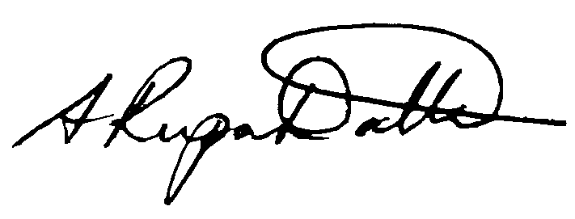

A. Rupa Datta, Ph.D.

2019 NSECE Project Director

NORC at the University of Chicago

An agency may not conduct or sponsor, and a person is not required to respond to, a collection of information unless it displays a currently valid OMB control number. The OMB number for this information collection is 0970-0391and the expiration date is MM/DD/YEAR. Please send comments regarding the time required for this survey or any other aspect of the described information collection to: [Name and address to be added].

**7G. Center-based Provider Thank You Letter:** Post participation - Sent to respondents after completion of the survey to thank them for participation and provide the honorarium.

Dear [ADMINISTRATOR],

Thank you for taking part in the National Survey of Early Care and Education. The survey you completed will help the government better understand the need for and availability of early care and education for children under age 13 in your area.

In appreciation of your time and effort spent answering our questions, we have enclosed a $25 gift card.

If you have any additional questions, you may contact us at [PHONE] or email [EMAIL].

Thank you again for your help with this important research.

Sincerely,



A. Rupa Datta, Ph.D.

Project Director

NORC at the University of Chicago

**7H. Center-based Provider Frequently Asked Questions (FAQs):** To be included on the back of respondent letters.

**Who is NORC at the University of Chicago?**

NORC at the University of Chicago (NORC) is conducting this study. NORC is an independent, non-partisan research institution that helps federal agencies, decision-makers, and nonprofits make better decisions through data and analysis. For more information about us, please visit [www.norc.org](http://www.norc.org).

**How can I learn more about the NSECE and how the 2012 survey data has been used?**

More information about the NSECE 2012 data and findings can be found at: <http://nsece.norc.org>.

**What is the NSECE?**

The National Survey of Early Care and Education is the only study aimed at better understanding the people and programs throughout the country that take care of America’s children and the services that they provide. The study was first conducted in 2012 and we need to collect up-to-date information to properly inform policies and practices to support early care and education providers.

**How was I selected?**

You have been selected for participation in this study from a list of providers in your area based on geographic and program criteria. It is important for us to hear from every selected provider to get a complete picture of the availability of early care and education services in your area.

**How do I know this is legitimate?**

This survey has been approved by the U.S. Office of Management and Budget number 0970-0391. Without this number we could not conduct this survey.

**What kinds of questions will you ask?**

The survey will include various questions related to early care and education (ECE), including

* The type of care your program provides
* How you seek new children to serve
* General information about the structure of your services

**How do I know my information will be kept safe and private?**

All NORC staff, including interviewers, must sign a pledge to protect your information. If this pledge is broken an employee can lose his/her job and face legal action. Answers that could identify you or your program in any way are separated from your other responses. Survey findings are put into summary reports that contain no names or other identifying information. Your name or any identifying information will never be released to the public.

**Who sees my answers?**

Only a few people who work on this survey ever see any personal information. Survey findings are put into summary reports that contain no names or other identifying information. This information will be used solely for the purposes of this study and will be destroyed when the study is over. Information that could identify you or your organization will never be released to the public.

**How do you protect my information?**

All information that you provide will be kept private to the fullest extent provided by the law. If you have questions about your rights as a study participant, you may call the NORC Institutional Review Board Administrator, toll free, at 1-866-309-0542.

**How long does the survey take?**

The survey takes about 45 minutes to complete.

**If you have any other questions, call us toll-free at [PHONE] or by email at [EMAIL].**

Your participation is voluntary. An agency may not conduct or sponsor, and a person is not required to respond to, a collection of information unless it displays a currently valid OMB control number. The OMB number for this information collection is 0970-0391and the expiration date is MM/DD/YEAR. Please send comments regarding the time required for this survey or any other aspect of the described information collection to: [Name and address to be added].

**7I. Center-based Provider Brochure Text:** As needed – Available for any sampled providers to provide a general study overview, explain benefits of participation, answer questions, and serve as a refusal conversion tool.

**BROCHURE INTERIOR**

**LEFT PANEL**

**What is the NSECE?**

The National Survey of Early Care and Education (NSECE) is a study sponsored by the Office of Planning, Research, and Evaluation within the Administration for Children and Families, and conducted by NORC at the University of Chicago.

In 2012 the NSECE collected vital information from center-based providers and other caregivers to create the first national profile of early care and education (ECE) services in more than 20 years. This much-needed information helped inform funding decisions and other initiatives designed to improve early care and education across the country. In January 2019, we will be contacting over 10,000 center-based providers across all 50 states to collect updated information to learn how the ECE landscape has changed since that time.

The NSECE will implement a set of integrated surveys with center- and home-based providers, as well as families with children under age 13 to provide urgently needed information about the supply and demand for early care and education available to families across all income levels.

**What is ACF?**

The Administration for Children and Families (ACF) in the U.S. Department of Health and Human Services (HHS) administers Head Start and the Child Care and Development Fund (child care subsidies) programs, and sponsors research on early care and education (ECE). ACF is helping more children in low-income families access high-quality care and supports coordination efforts across multiple early childhood development programs throughout HHS and across the Federal Government. Through its direct work and in coordination with others, ACF supports efforts to build professional development systems and workforce initiatives to help ECE professionals pursue better training and higher education, moving up career ladders to higher compensation. The NSECE will assist ACF in its overall mission to improve the availability of high-quality ECE programs.

**BROCHURE INTERIOR**

**CENTER PANEL**

**Why is the NSECE so important?**

With responses from more than 8,500 center-based providers, the 2012 NSECE helped administrators, policy makers, and government agencies understand what types of center-based care were available to families, how many providers there were, and what types of programs they offered. The study also gave insight into the challenges providers face in their efforts to provide quality care to the families they serve.

Since 2012 new legislation, funding opportunities, and program standards have been introduced in an effort to better support center-based providers and make quality care more accessible to all families. These changes make it a critical time to collect updated information so we can examine what impact they have had on early care and education services in general and center-based providers in particular.

**Who are you surveying?**

The study focuses on early care and education providers and workforce, as well as the working families they support. We will implement four integrated surveys of:

1. **Centers, schools, and other programs**: The survey samples all types of organizational providers including license-exempt providers, Head Start and providers in school-based settings, and for-profit and non-profit community-based pre-school providers. The survey will take about 45 minutes.
2. **Classroom staff**: Teachers, assistant teachers, or aides working in early care and education classrooms will be selected to provide information about their professional experiences and classroom activities.
3. **Providers of home-based care**: Individuals who provide care for children under age 13 (who are not their own) in a home-based setting will be surveyed.
4. **Families with children**: Parents or guardians of children under age 13 will be interviewed to learn more about their early care and education use and needs.

**BROCHURE INTERIOR**

**RIGHT PANEL**

**Why should I participate?**

Your responses will be combined with others to produce a rich data source that has the potential to benefit federal, state, and local or community-level child care policies. The data collected from this survey will be used to:

* Create a comprehensive description of the range of institutional and individual providers in the U.S., including community-based care, for-profit providers, Head Start programs, school-based settings, and home-based child care providers.
* Provide detailed information on the ways in which early care and education providers operate - like what curriculum they use, how they staff and organize classrooms, and what they charge.
* Help develop initiatives to support caregivers through such things as educational assistance, training, and improved pay and benefits.
* Better understand the experiences of the early care and education workforce and offer opportunities for them to improve their knowledge and skills.

**BROCHURE EXTERIOR**

**LEFT PANEL**

**Why was I chosen?**

You have been chosen for this study from a list of providers in your area. It is important for us to hear from every selected provider to get a complete picture of the availability of early care and education in your area. You represent many other providers across the nation and cannot be replaced.

Your participation will help ensure that the nation’s policy makers, practitioners, and parents have an accurate understanding of our nation’s early care and education landscape.

**Will my responses be private?**

All data provided by you and your staff will be used only for statistical purposes; identities of programs and individuals will not be disclosed except as required by law. All project staff who handle the information collected for the study must sign a privacy agreement that provides for criminal and civil penalties if privacy is breached.

The NSECE has also obtained a federal Certificate of Confidentiality from the Department of Health and Human Services in order to further protect your privacy. With this Certificate, NORC cannot be forced (for example by court order or subpoena) to disclose information that may identify you in any federal, state, local, civil, criminal, legislative, administrative, or other proceedings.

**BROCHURE EXTERIOR**

**CENTER PANEL**

**How can I participate?**

Participating in the NSECE is easy. In an effort to make this as convenient for you as possible, NORC offers multiple ways for you to complete your interview. Contact us at [EMAIL] or at [PHONE] and we’ll find the best option to suit your schedule.

**Questions this study will help to answer**

* Who is caring for and teaching America’s children when they are not with their parents?
* What are the characteristics of care available to families?
* What sources of revenue do providers rely on, and how are those sources related to the care offered?
* How can we better support the early care and education workforce and offer opportunities to help them improve the care they provide children?

ECE researchers have and continue to use public data files (no identifying respondent information) from the 2012 NSECE survey to inform important ECE public policy decisions. The data has been accessed over 9,100 times!

**Questions about NSECE?**

[PHONE] or [EMAIL]

Participation is voluntary. An agency may not conduct or sponsor, and a person is not required to respond to, a collection of information unless it displays a currently valid OMB control number. The OMB number for this information collection is 0970-0391and the expiration date is MM/DD/YEAR. Please send comments regarding the time required for this survey or any other aspect of the described information collection to: [Name and address to be added].

**BROCHURE EXTERIOR**

**RIGHT PANEL**

**[IMAGE]**

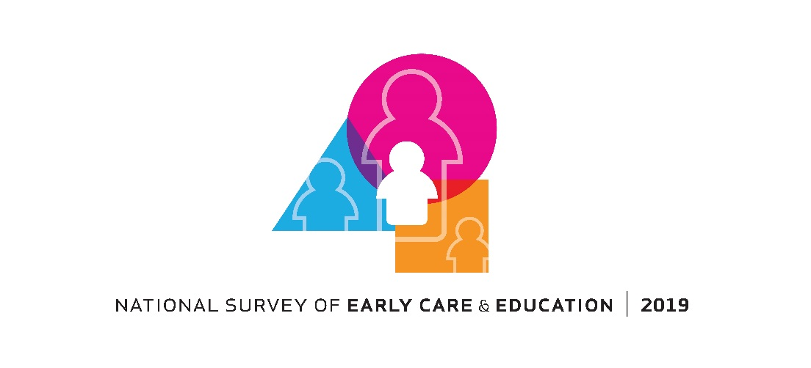

**[Department of Health and Human Services, Administration for Children & Families LOGO]**

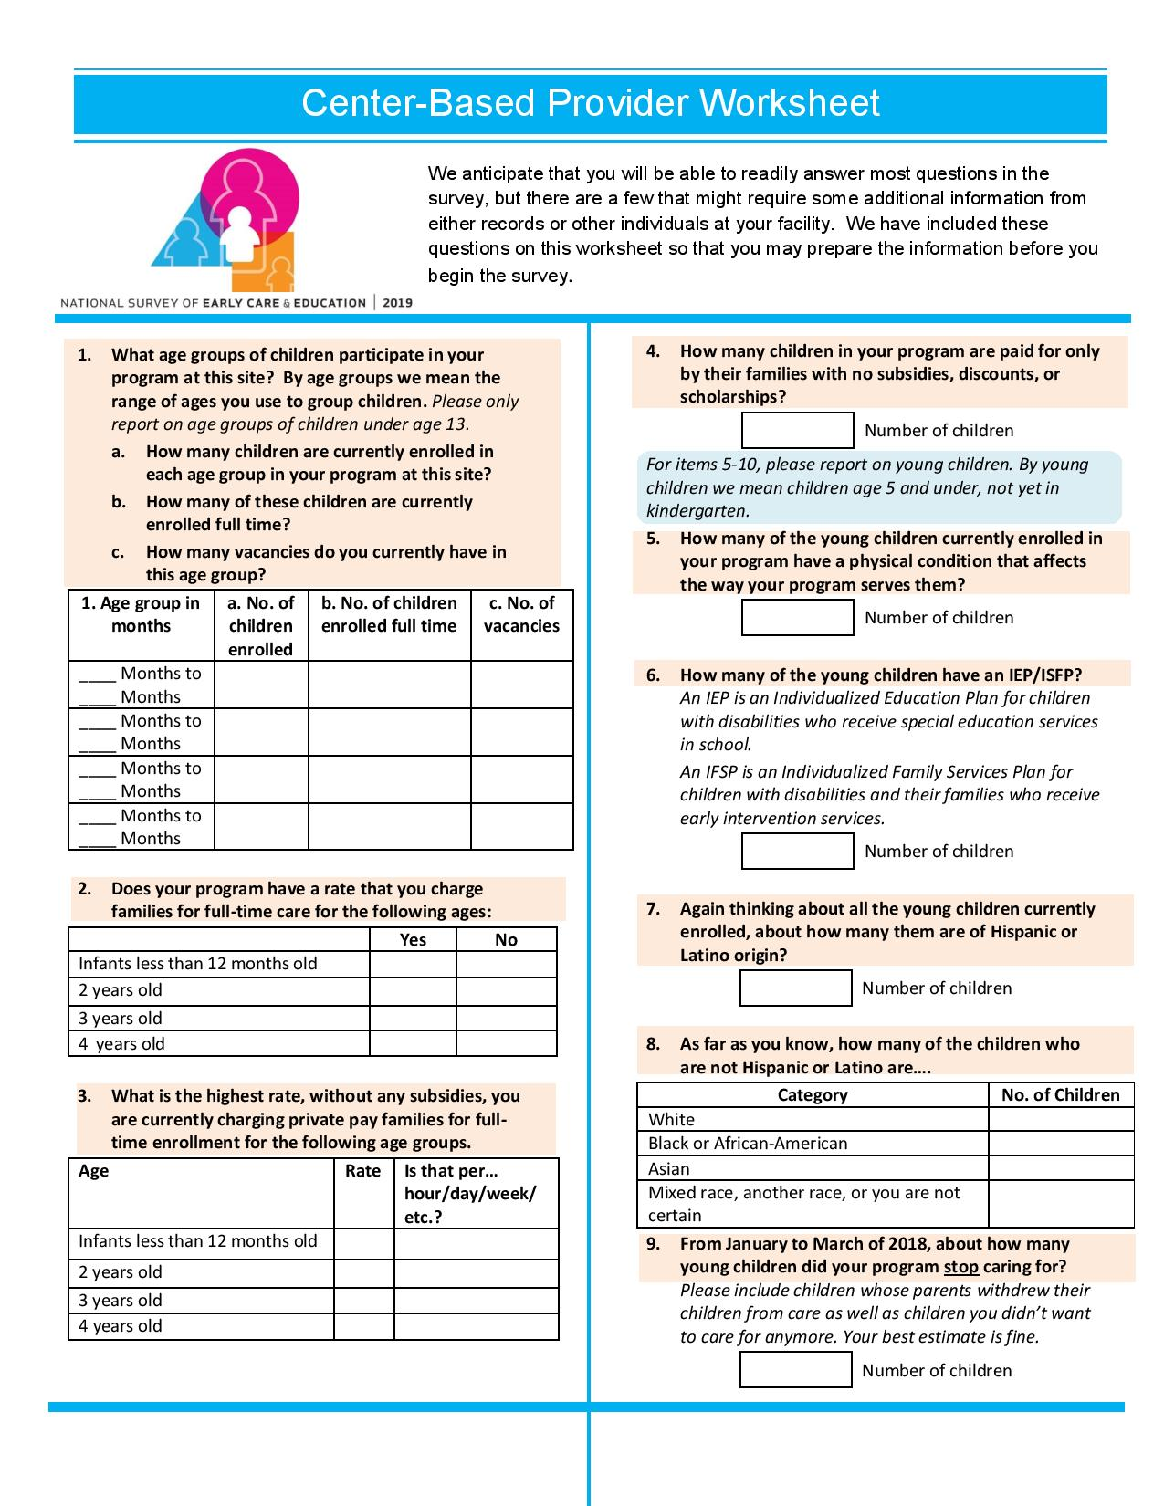

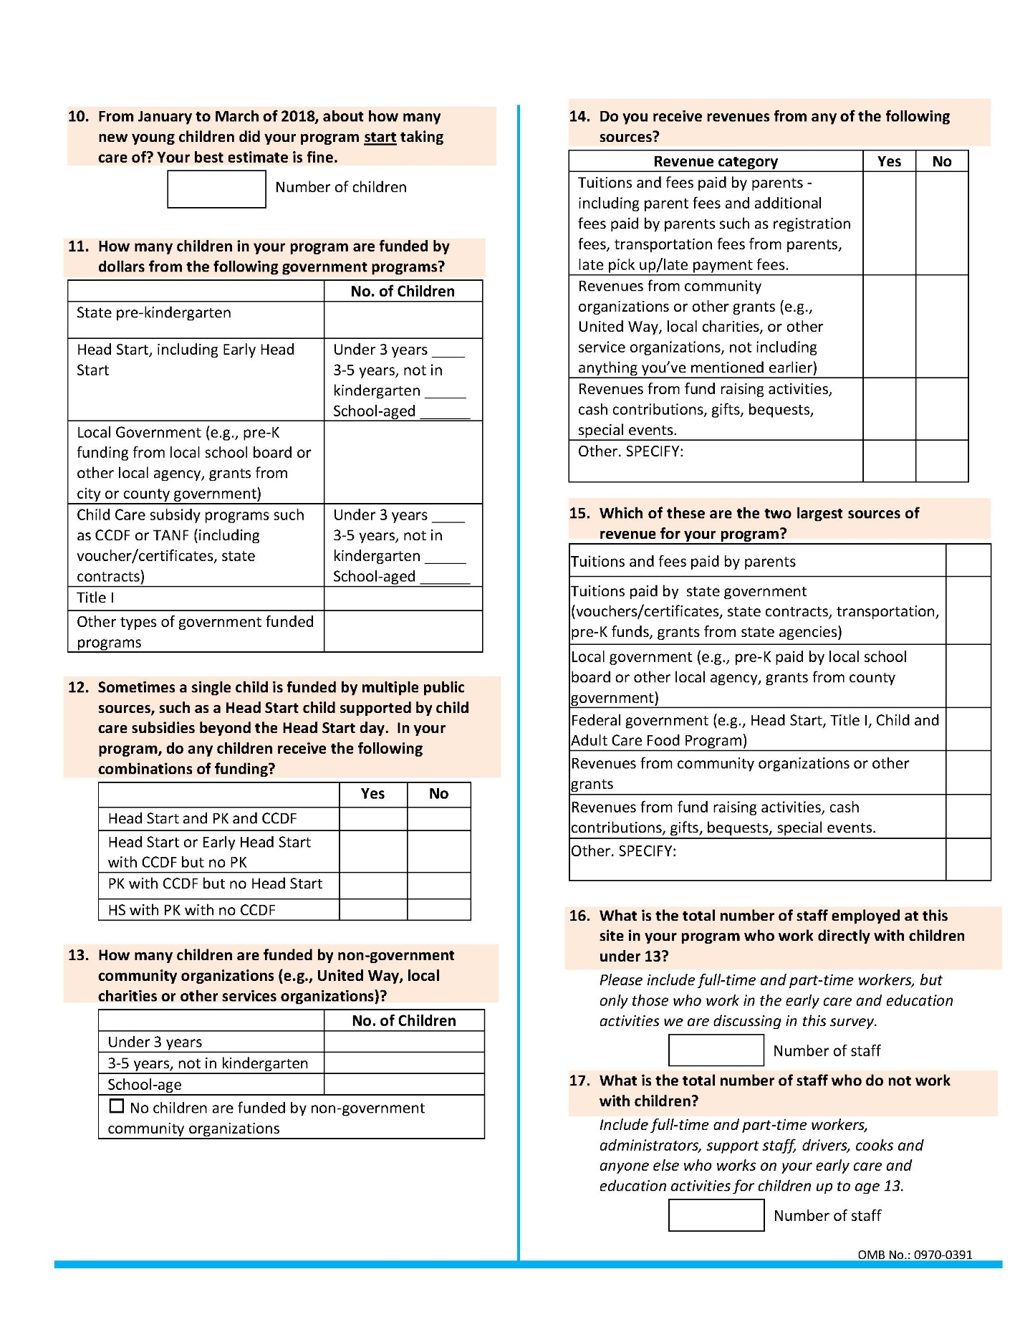

An agency may not conduct or sponsor, and a person is not required to respond to, a collection of information unless it displays a currently valid OMB control number. The OMB number for this information collection is 0970-0391and the expiration date is MM/DD/YEAR. Please send comments regarding the time required for this survey or any other aspect of the described information collection to: [Name and address to be added].