Progress in International Reading Literacy Study

(PIRLS 2021) FIELD TEST RECRUITMENT

REQUEST FOR OMB Clearance

OMB# 1850-0645 v.11

AppendiX A:

**PIRLS 2021 Field Test Consent and Recruitment Materials**

Submitted by:

National Center for Education Statistics

U.S. Department of Education

Institute of Education Sciences

Washington, DC

December 2018

**Appendix A**

**PIRLS 2021 Field Test Consent and Recruitment Materials**

Table of Contents

PIRLS Field Test Sample Notification Letter 2

PIRLS Field Test Sample Implicit Consent Letter 3

PIRLS Implicit Consent Form 4

PIRLS Field Test Sample Explicit Consent Letter 5

PIRLS Explicit Consent Form 6

PIRLS Facts for Parents about the Field Test 7

State Field Test Letter 8

School PIRLS Field Test Letter 10

PIRLS Field Test Letter to School Coordinator 11

PIRLS School Coordinator Responsibilities 12

Administrator Questionnaire PIRLS Field Test Letter 14

Teacher Questionnaire PIRLS Field Test Letter 15

PIRLS 2021 Study Brochure Content: 8 ½ X 11in Tri-fold 16

PIRLS Field Test FAQ 19

Summary of School Activities: PIRLS Field Test (Spring 2020) 21

Email to School Coordinator (SC) for PIRLS Registration and to Provide School Information (PSI) 22

PIRLS Registration and Provide School Information (PSI) Guide 24

Site Home Page 25

Provide School Information (PSI) 26

Automated Email for all PIRLS registrants 28

Automated Email for PIRLS School Coordinator registrant 29

PIRLS Login Page 30

PIRLS Home Page 32

PIRLS Provide School Information (PSI) Page 33

Email to School Coordinator (SC) to Submit Class and Student Lists—Grade 4 34

Instructions for Submitting Class Lists- Grade 4 35

Instructions for Submitting Student Lists- Grade 4 38

Submit Class List Page – Grade 4 42

Submit Student List Page – Grade 4 43

PIRLS Prepare for Assessment Page 44

Student-Teacher Linkage Form (STLF) Email 45

Student Tracking Form (STF) Email 46

Instructions for Student Tracking Form (STF) 47

Student-Teacher Linkage Form (STLF) Template (Grade 4) 48

Student Tracking Form (STF) Template (digitalPIRLS VS Paper Bridge Study) 49

digitalPIRLS STF 49

Paper Bridge Study STF 49

PIRLS Documents Page 50

PIRLS Important Websites and Contact Us Pages 51

School Principal Questionnaire Login Card/Email 52

Teacher Questionnaire Selection Email 53

Teacher Questionnaire Reminder Email 54

Amazon Gift Card Code Email 55

Online Questionnaire Login Screen Text 56

Student Login Card 58

Student Certificate of Completion 59

School Certificate of Appreciation 60

# PIRLS Field Test Sample Notification Letter

SCHOOL LETTERHEAD

Dear Parent or Guardian,

This letter is to inform you about an important international study of student learning being conducted in our school this spring. The Progress in International Reading Literacy Study (PIRLS) provides important information for benchmarking student performance in reading in the United States against countries around the world. Since 2001, PIRLS has measured worldwide trends in student reading skills at grade 4. The next PIRLS assessment will be in the spring of 2021.

Each time the PIRLS is done, new questions need to be developed and tested to ensure that those questions accurately measure the knowledge and skills of students. In spring 2020, new PIRLS questions will be tested in approximately 40 schools in the United States. This field test will allow test developers to modify or delete questions that are not reliable or fair across participating countries.

Our school has accepted an invitation from the National Center for Education Statistics (NCES), part of the U.S. Department of Education, to participate in the PIRLS field test. {Insert number} of our 4th grade classes will take part. {This/One of these} is your child’s class. The enclosed summary sheet provides background information about PIRLS, explains what is involved for each selected student to participate in the study, and gives a contact phone number and email address where you can find answers to any questions you might have.

To have an accurate picture of what U.S. 4th graders can do in reading, it is important for each selected student to take part in the study. In addition to answering reading questions, students will be asked to complete a brief questionnaire about themselves. For the first time, PIRLS will be completely electronic, and administered on a tablet or laptop. I urge you to support this effort by encouraging your child to take part; however, participation in this study is entirely voluntary. Previous experience suggests that students enjoy taking part, and participating students will receive a small gift, which we think they will also like.

All of the information collected is protected as required by law. NCES is authorized to conduct this study under the Education Sciences Reform Act of 2002 (ESRA 2002, 20 U.S.C. §9543). All of the information provided by schools, staff, and students may be used only for statistical purposes and may not be disclosed, or used, in identifiable form for any other purpose except as required by law (20 U.S.C. §9573 and 6 U.S.C. §151). Students and schools are never identified in any reports. All reported statistics refer to the United States as a whole.

Thank you for taking the time to learn about this important study.

Sincerely,

[School Official]

Enclosures: Facts for Parents about the PIRLS Field Test

# PIRLS Field Test Sample Implicit Consent Letter

SCHOOL LETTERHEAD

Dear Parent or Guardian,

This letter is to inform you about an important international study of student learning being conducted in our school this spring. The Progress in International Reading Literacy Study (PIRLS) provides important information for benchmarking student performance in reading in the United States against countries around the world. Since 2001, PIRLS has measured worldwide trends in student reading skills at grade 4. The next PIRLS assessment will be in the spring of 2021.

Each time the PIRLS is done, new questions need to be developed and tested to ensure that those questions accurately measure the knowledge and skills of students. In spring 2020, new PIRLS questions will be tested in approximately 40 schools in the United States. This field test will allow test developers to modify or delete questions that are not reliable or fair across participating countries.

Our school has accepted an invitation from the National Center for Education Statistics (NCES), part of the U.S. Department of Education, to participate in the PIRLS field test. {Insert number} of our 4th grade classes will take part. {This/One of these} is your child’s class. The enclosed summary sheet provides background information about PIRLS, explains what is involved for each selected student to participate in the study, and gives a contact phone number and email address where you can find answers to any questions you might have.

To have an accurate picture of what U.S. 4th graders can do in reading, it is important for each selected student to take part in the study. In addition to answering reading questions, students will be asked to complete a brief questionnaire about themselves. For the first time, PIRLS will be completely electronic, and administered on a tablet or laptop. I urge you to support this effort by encouraging your child to take part; however, participation in this study is entirely voluntary. Previous experience suggests that students enjoy taking part, and participating students will receive a small gift, which we think they will also like.

All of the information collected is protected as required by law. NCES is authorized to conduct this study under the Education Sciences Reform Act of 2002 (ESRA 2002, 20 U.S.C. §9543). All of the information provided by schools, staff, and students may be used only for statistical purposes and may not be disclosed, or used, in identifiable form for any other purpose except as required by law (20 U.S.C. §9573 and 6 U.S.C. §151). Students and schools are never identified in any reports. All reported statistics refer to the United States as a whole.

If you have any objection to your child joining in the PIRLS activities, please let us know by completing the attached consent form and returning it to the school.

Thank you for taking the time to learn about this important study.

Sincerely,

[School Official]

Enclosures:

Facts for Parents about the PIRLS Field Test

Parent/Guardian Consent Form

# PIRLS Implicit Consent Form

**Progress in International Reading Literacy Study (PIRLS)**

**Field Test**

**Parent/Guardian Consent Form**

Your child has been asked to participate in a field test of an international study of student learning called the Progress in International Reading Literacy Study (PIRLS). Each student who participates will receive a small gift.

The student assessment will be administered by a team of researchers from [XXX] on behalf of the National Center for Education Statistics (NCES). In spring 2020, new questions will be tested in approximately 40 schools in the United States in preparation for the 2021 international study. This field test will allow test developers to modify or delete questions that are not reliable or fair.

**If you grant permission for your child to participate in the PIRLS field test, you do not need to return this form.**

**If you do not consent to your child’s participation in the PIRLS field test, please return this form to your child’s school as soon as possible.**

**I do not grant permission** for my child, _______________________________, to participate in the Progress in International Reading Literacy Study Field Test.

**__________________________________________________________________**

(Signature of parent or guardian)

Date of signature: _______/_______/____________

PLEASE PRINT:

**Student name: _____________________________________________**

School name: ______________________________________________

FOR OFFICE USE ONLY:

Student ID: ________________________________________________

# PIRLS Field Test Sample Explicit Consent Letter

SCHOOL LETTERHEAD

Dear Parent or Guardian,

This letter is to inform you about an important international study of student learning being conducted in our school this spring. The Progress in International Reading Literacy Study (PIRLS) provides important information for benchmarking student performance in reading in the United States against countries around the world. Since 2001, PIRLS has measured worldwide trends in student reading skills at grade 4. The next PIRLS assessment will be in the spring of 2021.

Each time the PIRLS is done, new questions need to be developed and tested to ensure that those questions accurately measure the knowledge and skills of students. In spring 2020, new PIRLS questions will be tested in approximately 40 schools in the United States. This field test will allow test developers to modify or delete questions that are not reliable or fair across participating countries.

Our school has accepted an invitation from the National Center for Education Statistics (NCES), part of the U.S. Department of Education, to participate in the PIRLS field test. {Insert number} of our 4th grade classes will take part. {This/One of these} is your child’s class. The enclosed summary sheet provides background information about PIRLS, explains what is involved for each selected student to participate in the study, and gives a contact phone number and email address where you can find answers to any questions you might have.

To have an accurate picture of what U.S. 4th graders can do in reading, it is important for each selected student to take part in the study. In addition to answering reading questions, students will be asked to complete a brief questionnaire about themselves. For the first time, PIRLS will be completely electronic, and administered on a tablet or laptop. I urge you to support this effort by encouraging your child to take part; however, participation in this study is entirely voluntary. Previous experience suggests that students enjoy taking part, and participating students will receive a small gift, which we think they will also like.

All of the information collected is protected as required by law. NCES is authorized to conduct this study under the Education Sciences Reform Act of 2002 (ESRA 2002, 20 U.S.C. §9543). All of the information provided by schools, staff, and students may be used only for statistical purposes and may not be disclosed, or used, in identifiable form for any other purpose except as required by law (20 U.S.C. §9573 and 6 U.S.C. §151). Students and schools are never identified in any reports. All reported statistics refer to the United States as a whole.

Before we can allow your child to join in the PIRLS activities, we must have your written consent. Please let us know by completing the attached form and returning it to the school.

Thank you for taking the time to learn about this important study and to consider your child’s participation in it.

Sincerely,

[School Official]

Enclosures: Facts for Parents about the PIRLS Field Test

Parent/Guardian Consent Form

# PIRLS Explicit Consent Form

**Progress in International Reading Literacy Study (PIRLS)**

**Field Test**

**Parent/Guardian Consent Form**

Your child has been asked to participate in a field test of an international study of student learning called the Progress in International Reading Literacy Study (PIRLS). For the first time, PIRLS be completely electronic and administered on a tablet or laptop. Each student who participates will receive a small gift.

The student assessment will be administered by a team of researchers *[National contractor to be determined]*, on behalf of the National Center for Education Statistics (NCES). In spring 2020, new questions will be tested in approximately 40 schools in the United States in preparation for the 2021 international study. This field test will allow test developers to modify or delete questions that are not reliable or fair.

Yes, I grant permission for my child to participate in the PIRLS field test.

No, I do not grant permission for my child to participate in the PIRLS field test.

**__________________________________________________________________**

(Signature of parent or guardian)

Date of signature: _______/_______/____________

PLEASE PRINT:

**Student name: _____________________________________________**

School name: ______________________________________________

FOR OFFICE USE ONLY:

Student ID: ________________________________________________

# PIRLS Facts for Parents about the Field Test

Between March and April of 2020, your child’s school will be one of about 40 nationwide taking part in the PIRLS Field Test. Within each school, 4th grade classrooms were selected randomly to represent the nation’s 4th graders. All students from selected classrooms are invited to participate, and your child was among those students selected to take part in the PIRLS field test.

**What is PIRLS?**

PIRLS (Progress in International Reading Literacy Study) is an international assessment that measures student learning in reading. Every five years since 2001, PIRLS documents worldwide trends in the reading knowledge of 4th graders. The National Center for Education Statistics (NCES) within the U.S. Department of Education conducts U.S. participation in PIRLS. Along with more than 50 other nations, the U.S. will take part in the 2021 PIRLS cycle as we did in 2001, 2006, 2011, and 2016. For the first time, PIRLS will be completely electronic and administered on a tablet or laptop.

**What is the purpose of the PIRLS Field Test?**

Each time the study is done, new assessment questions need to be developed and tested to ensure that those questions accurately measure the knowledge and skills of students. This field test will allow test developers to modify or delete questions that are not reliable or fair for students in the United States.

**What is involved?**

PIRLS staff will visit the school and administer the study. The main assessment will take approximately 2 hours and will include a paper and pencil questionnaire that asks students about themselves and their educational experience.

**What are the benefits?**

The nation as a whole benefits from PIRLS by having a greater understanding of how the reading knowledge and skills of U.S. 4th graders compare with 4th graders from other countries. The country benefits from the field test by ensuring that the questions used in the main study are fair and appropriate for U.S. students. Schools that participate in PIRLS will receive $200, and each student who participates will receive a small gift.

**Who administers PIRLS?**

The entire assessment is administered by trained staff from *[National contractor to be determined]* a research organization under contract to the U.S. Department of Education’s National Center for Education Statistics.

All of the information collected is protected as required by law. NCES is authorized to conduct this study under the Education Sciences Reform Act of 2002 (ESRA 2002, 20 U.S.C. §9543). All of the information provided by schools, staff, and students may be used only for statistical purposes and may not be disclosed, or used, in identifiable form for any other purpose except as required by law (20 U.S.C. §9573 and 6 U.S.C. §151). Students and schools are never identified in any reports. All reported statistics refer to the United States as a whole.

**Where can I find out more about PIRLS?**

More information about PIRLS is available at the PIRLS website at <http://nces.ed.gov/surveys/pirls/index.asp> or the PIRLS International Study Center website at <http://pirls.org/>. Or if you like to contact a PIRLS staff member directly, please feel free to call the PIRLS hotline at (XXX) XXX-XXXX or email us at XXX.

# State Field Test Letter

[Date]

[Title] [Name First] [Name Last]

[Title/Department]

[State]

[Address 1]

[Address 2]

[City], [State] [Zip code]

Dear [Title] [Name Last]:

The United States is participating in an important international study in 2021: the Progress in International Reading Literacy Study (PIRLS). Since 2001, PIRLS has measured trends in reading achievement at grade 4 in countries around the world, including the United States. Results from PIRLS are used by researchers and policymakers to chart national progress against international standards and other countries around the world, informing national discussions about international competitiveness.

Some schools in your state have been randomly selected to participate in the international field test for PIRLS in the spring of 2020. I am writing to ask your agency to support the participation of those schools in the field test. The purpose of the field test is both to determine whether new questions are valid and fair for U.S. students and to help ensure that PIRLS field operations will be effective for the main study in 2021. For the first time, PIRLS will be completely electronic, and administered on a tablet or laptop.

PIRLS is described in more detail in the enclosed materials. For information on the confidentiality of the data collected, please see the enclosed FAQ. While participation in this study is voluntary, your support of school participation in your state is invaluable so that the United States has a nationally representative sample of schools across the country.

Within the next few weeks, a representative of [contractor to be determined] will contact sampled school districts and schools to discuss participating in the field test. In the meantime, if you have questions about the study, please do not hesitate to call [contractor lead to be determined] or send an email to [to be determined]. You may also get more information about this study by contacting Dr. Sheila Thompson at NCES at (202) 245-8330 or sheila.thompson@ed.gov, or by visiting the PIRLS website at [http://nces.ed.gov/surveys/PIRLS](http://nces.ed.gov/surveys/timss).

Thank you for your time and support of this important international study.

Sincerely,

Peggy Carr

Associate Commissioner, NCES

cc: [State assessment director]

[NAEP State Coordinator]

Enclosures

*NCES is authorized to conduct this study under the Education Sciences Reform Act of 2002 (ESRA 2002, 20 U.S.C. §9543). All of the information provided by schools, staff, and students may be used only for statistical purposes and may not be disclosed, or used, in identifiable form for any other purpose except as required by law (20 U.S.C. §9573 and 6 U.S.C. §151). In the United States, PIRLS is conducted by the National Center for Education Statistics (NCES), part of the U.S. Department of Education, and the data are being collected by [to be determined]. The U.S. Office of Management and Budget has approved the data collection under OMB # 1850-0645.*School District Field Test Letter

[Date]

[Title] [Name First] [Name Last], [Title/Department]

[School District]

[Address 1]

[City], [State] [Zip code]

Dear [Title] [Name Last]:

The United States is participating in an important international study in 2021: the Progress in International Reading Literacy Study (PIRLS). Since 2001, PIRLS has measured trends in reading achievement at grade 4 in countries around the world, including the United States. Results from PIRLS are used by researchers and policymakers to chart national progress against international standards and other countries around the world, informing national discussions about international competitiveness.

One or more schools in your district have been randomly selected to participate in the PIRLS field test in the spring of 2020. I am writing to ask your agency to support the participation of those selected schools. The purpose of the PIRLS field test is both to determine whether new questions are valid and fair for U.S. students and to help ensure that PIRLS field operations will be effective for the main study in 2021. For the first time, PIRLS will be completely electronic, and administered on a tablet or laptop.

Participating schools will receive $200, and each school’s PIRLS school coordinator (the school staff person designated to work with PIRLS staff) will receive $150 as a thank you for his or her time and effort. The school administrator and selected teachers will each be asked to complete a questionnaire. Teachers will receive $20 as a thank you for completing the questionnaire. Each student who participates will receive a small gift as a token of appreciation.

PIRLS is described in more detail in the enclosed materials. For information on the confidentiality of the data collected, please see the enclosed FAQ. While participation in this study is voluntary, your support of school participation in your district is invaluable so that the United States has a nationally representative sample of schools across the country.

Within the next few days, a representative of [national contractor to be determined] will contact the following school or schools in your district that have been selected for the field test: [LIST SAMPLED SCHOOLS HERE…].

If you have any questions, please do not hesitate to call [to be determined] at (XXX) XXX-XXXX or send an email to [to be determined]. You may also get more information about this study by contacting Dr. Sheila Thompson at NCES at (202) 245-8330 or sheila.thompson@ed.gov, or by visiting the PIRLS website at [http://nces.ed.gov/surveys/PIRLS](http://nces.ed.gov/surveys/timss).

Thank you for your time and support of this important international study.

Peggy Carr

Associate Commissioner, NCES

Enclosures

*NCES is authorized to conduct this study under the Education Sciences Reform Act of 2002 (ESRA 2002, 20 U.S.C. §9543). All of the information provided by schools, staff, and students may be used only for statistical purposes and may not be disclosed, or used, in identifiable form for any other purpose except as required by law (20 U.S.C. §9573 and 6 U.S.C. §151). In the United States, PIRLS is conducted by the National Center for Education Statistics (NCES), part of the U.S. Department of Education, and the data are being collected by [to be determined]. The U.S. Office of Management and Budget has approved the data collection under OMB # 1850-0645.*

# School PIRLS Field Test Letter

[Date]

[Title] [Name First] [Name Last], [Title/Department]

[School District]

[Address 1]

[City], [State] [Zip code]

Dear [Title] [Name Last]:

I am writing to inform you that [school name] has been randomly selected to represent schools across the United States by participating in an important international study in 2021: the Progress in International Reading Literacy Study (PIRLS). Since 2001, PIRLS has measured trends in reading achievement at grade 4 in countries around the world, including the United States. Results from PIRLS are used by researchers and policymakers to chart national progress against international standards and other countries around the world, informing national discussions about international competitiveness.

In preparation for the 2021 assessment, the United States is participating in a field test in the spring of 2020. The purpose of the field test is both to try out new questions and to help ensure that operational procedures will be effective in the 2021 assessment. For the first time, PIRLS will be completely electronic, and administered on a tablet or laptop.

NCES recognizes the burden of assessments on schools and works to reduce that burden as much as possible both in terms of time and resources. PIRLS will sample two classes of fourth-graders in your school. A school administrator and teachers of the selected students will be asked to complete a questionnaire. As a token of appreciation for participating in PIRLS, your school will receive $200. Your school’s PIRLS school coordinator (a staff person designated to work with PIRLS staff) will receive $150 for his or her time and effort. Teachers of selected students will receive a $20 Amazon gift card for completing a questionnaire. Students who participate in the test will receive a small token of appreciation.

PIRLS is described in more detail in the enclosed materials. For information on the confidentiality of the data collected, please see the enclosed FAQ. While participation in this study is voluntary, your school’s participation is invaluable so that the United States has a nationally representative sample of schools across the country.

Within the next few days, a representative of [national contractor to be determined] will contact you to discuss your participation. If you have any questions, please do not hesitate to call [contractor lead to be determined] at (XXX) XXX-XXXX or send an email to [to be determined]. You may also get more information about this study by contacting Dr. Sheila Thompson at NCES at (202) 245-8330 or sheila.thompson@ed.gov, or by visiting the PIRLS website at [http://nces.ed.gov/surveys/PIRLS](http://nces.ed.gov/surveys/timss).

Your participation in the field test for PIRLS 2021 is very important to its success. Thank you for your time and for supporting this important international study.

Peggy Carr

Associate Commissioner, NCES

Enclosures

*NCES is authorized to conduct this study under the Education Sciences Reform Act of 2002 (ESRA 2002, 20 U.S.C. §9543). All of the information provided by schools, staff, and students may be used only for statistical purposes and may not be disclosed, or used, in identifiable form for any other purpose except as required by law (20 U.S.C. §9573 and 6 U.S.C. §151). In the United States, PIRLS is conducted by the National Center for Education Statistics (NCES), part of the U.S. Department of Education, and the data are being collected by [to be determined]. The U.S. Office of Management and Budget has approved the data collection under OMB # 1850-0645.*

# PIRLS Field Test Letter to School Coordinator

DATE

«sch_entity_name»

«sch_address»

«sch_citystzip»

Dear «sch_coord_name»,

We are looking forward to working with you and your school this school year on the Progress in International Reading Literacy Study (PIRLS). As the designated school coordinator for PIRLS you play a critical role in assist­ing us with study preparations. We appreciate your assistance, particularly given the many demands on your time.

The attached document, PIRLS School Coordinator Responsibilities, will provide you with an overview of PIRLS, as well as a list of tasks and timeline needed to prepare for PIRLS data collection. The first step is to provide a list of the 4th grade classes in your school, so that we may select the classes and students who will be invited to participate. This step is critically important, and we would appreciate your help in completing this task within three weeks of receipt of this letter.

A PIRLS study representative will contact you shortly to answer questions you may have and to begin discussing data collection logistics. In-school data collection is scheduled to take place during March and April 2020. The student data collection will include a reading assessment and background questionnaire. For the first time, PIRLS will be completely electronic, and administered on a tablet or laptop that we provide.

[National contractor to be determined] will provide a trained test administrator (TA) to conduct the student sessions and to assist with the parental permission form process. A school administrator and the teachers of selected classes will also be asked to complete a questionnaire. They will be contacted separately, and their responses will be collected through a web-based application or hard-copy survey. The data collected during the field test will permit assessment developers to test new questions to ensure fairness for U.S. students and to allow us to fine tune operational procedures for the 2021 assessment.

We sincerely appreciate your help in preparing for the session at your school and in ensuring that PIRLS is a success. Each school’s participation is critical to the success of the study, and reports will not identify participating districts, schools, students, or individual staff.

If you have any questions, please contact us at [to be determined] at (XXX) XXX-XXXX or by email at [to be determined]. Thank you for your support of education through participating in PIRLS.

Sincerely,

[to be determined]

Project Director, Progress in International Reading Literacy Study (PIRLS)

Enclosures

*NCES is authorized to conduct this study under the Education Sciences Reform Act of 2002 (ESRA 2002, 20 U.S.C. §9543). All of the information provided by schools, staff, and students may be used only for statistical purposes and may not be disclosed, or used, in identifiable form for any other purpose except as required by law (20 U.S.C. §9573 and 6 U.S.C. §151). In the United States, PIRLS is conducted by the National Center for Education Statistics (NCES), part of the U.S. Department of Education, and the data are being collected by [to be determined]. The U.S. Office of Management and Budget has approved the data collection under OMB # 1850-0645.*

# PIRLS School Coordinator Responsibilities

As the PIRLS school coordinator (SC), you play an important role in the success of the study. [XXX] will provide a trained test administrator (TA) to conduct the student sessions and to assist you as much as possible. But we will need to rely on you to complete certain tasks so that data collection will be successful.

**Study Details**

The field test phase of PIRLS consists of the following:

**Student Reading Assessment** **and Questionnaire** – Students in selected classrooms will be administered a reading assessment and background questionnaire. For the first time PIRLS will be completely electronic, and administered on a tablet or laptop. This new format for the assessment is called digitalPIRLS*.*

* TA from [XXX] will conduct the student sessions at your school and each participating student will receive a thank you gift.
* **School Administrator Questionnaire -** The school administrator or designee will complete a questionnaire about school characteristics, enrollment, resources, policies, and the learning environment. The questionnaire may be completed online or via hardcopy and will take about 40 minutes to complete. [XXX] will send information to you to distribute to the person who is designated to answer the school administrator questionnaire.
* **School Teacher Questionnaire –** Teachers of selected classrooms will complete a questionnaire regarding their teaching experience, available resources, and instructional practices. The questionnaire may be completed online or via hardcopy and will take about 40 minutes to complete. [XXX] will send information to you to distribute to selected teachers.

For additional information, you may visit our website at: https://xxx.xxx.xxx

**Your Responsibilities**

You have been asked to complete several tasks prior to the student data collection sessions that will take place in the spring of 2020. These include providing student information, working with [XXX] on the session logistics, assisting with parental consent form distribution and receipt, and helping to coordinate school staff surveys.

We will use the PIRLS secure website to exchange information, such as class and student lists. Please visit: <https://xxx.xxx.xxx> and log-in with the following information:

Study ID: ############

Password: #######

Table 1 shows the activities you will be asked to perform and a timeline for these activities.

**Table 1. Activities Timeline**

|  |  |
| --- | --- |
| Provide information on 4th grade classes using the Class Listing Form. | Within 3 weeks of receipt of request |
| Complete Student Listing Form for selected class(es) | Within one week of selection of classes |
| Coordinate session logistics (dates, times, locations, consent type) | Within 3 weeks of receipt of request |
| Notify teachers, selected students, and parents of the study and benefit of participating | At least 3 weeks prior to scheduled session |
| Distribute parental consent forms to all selected students | At least 3 weeks prior to scheduled session |
| Monitor return of consent forms; distribute reminder letters as needed. Collect returned, signed forms and submit to TA. | During the 3 weeks from distribution to data collection day |
| Run a systems check of the digital system | At least 2 weeks prior to scheduled session |
| Notify/remind teachers and students about the data collection sessions | One week prior and one day prior to session |
| Assist the TA with getting the students to the sessions and setting up the room (if necessary) | On the day of the session |
| Coordinate completion of the administrator and teachers’ questionnaires. | Two weeks prior to the student session |

**Providing Student Information**

We will select one or two classes per school, depending on the number of classes available at grade 4. Please submit the Class Listing Form (including all classes that account for each student in 4th grade). The CLF should be uploaded to the secure PIRLS website. The student sample will consist of all students in the selected classes.

We will then ask you to complete the Student Listing Form for selected class(es) to provide information on the students in those classes (e.g., name, district ID, class, date of birth, gender). SLF should be uploaded to the secure PIRLS website.

**Assisting with Student Session Logistics**

In order to minimize disruption at the school on the day of the student data collection, it is crucial that arrangements be made in advance. These arrangements include:

* Determine the dates for student data collection.
* Determine the location and time(s) of the student session(s): will the student sessions take place in the classrooms or will a separate room be reserved? If there are multiple classes sampled, will the administration be conducted together or separately?
* Determine parental permission type (implied/ passive or written/active). Determine best method of distributing consent forms, tracking returned, signed forms, collecting returned forms, and submitting to the PIRLS TA.
* Work with the TA to identify students with special needs.
* Notify teachers and students in selected classrooms about PIRLS, the importance of participating, and explain test day activities.
* Contact parents to encourage them to return the signed consent form (if applicable).

**Parental Permission**

Parental permission materials will be supplied by [XXX] a few weeks before the scheduled session. We can either mail them directly to parents or ask that you distribute the parent permission forms to the sampled students.

* Most schools use implied/passive permission (which means students only return a form if their parent denies permission to participate), as this option lessens the burden on school staff and results in higher participation rates. If you are using this permission type, please record parent refusals onto the student tracking form (STF) which will be provided with the permission forms.
* Some schools require written/active consent. If your school requires active consent, parents are asked to return signed permission forms to the school coordinator. Please keep track of the return of these forms on the STF. Please make sure any returned forms have one “box” checked, a parent/guardian signature (not just a printed name) and the name of the student.

Your TA will be in contact with you to track the return of consent forms, as well as exclusion statuses for students. Reminder forms will be sent home as needed. The TA will check the permission forms on the day of the first session to make sure we do not include anyone whose parents have not granted permission. Please keep the returned parent permission forms in a locked or secure location. Your TA will fax any returned forms from your school at the end of the data collection to a secure fax machine at [XXX]. Please let him/her know if you need to retain copies.

**Assist on Day of Student Sessions**

The PIRLS TA will arrive at the school about an hour before the student session. In order to have valid results from the study, we need as many sampled students to participate as possible. We are depending on you to make certain the students and teachers are aware of the date, time, and location for their participation and to generate enthusiasm. This often makes the difference in high student participation. You may want to advertise PIRLS throughout the school and classroom or make a PA announcement about the study the day before and the day of the session to generate interest and encourage participation.

We would also like for you or a teacher to remain in the room during the session administration to help maintain order and assist as needed.

Again, the TA will need to fax any returned permission forms at the end of the session. Please assist him or her in faxing these forms.

**Token of Appreciation**

As a token of our appreciation for your time and energy with PIRLS, you will receive a total of $150 after the student session has been completed.

**THANK YOU** for your help to make PIRLS a success!! We greatly appreciate your time and assistance!

# Administrator Questionnaire PIRLS Field Test Letter

[Date] Web Address:

[Title] [Name First] [Name Last], [Principal/Administrator] Your Study ID:

[School] Your Password:

[Address 1]

[City], [State] [Zip code]

Dear [Title] [Name Last]:

The United States is participating in an important international study in 2021: the Progress in International Reading Literacy Study (PIRLS). Since 2001, PIRLS has measured trends in reading achievement at grade 4 in countries around the world, including the United States. Results from PIRLS are used by researchers and policymakers to chart national progress against international standards and other countries around the world, informing national discussions about international competitiveness. In preparation for the 2021 assessment, [school name] is participating in a field test in the spring of 2020. The purpose of the field test is both to try out new questions and to help ensure that operational procedures will be effective in the 2021 assessment.

We are asking you to complete a 40-minute questionnaire to provide insight into the practices and resources at your school. The survey is designed to be completed by you or a staff person you designate who can provide information about the characteristics of the school, its enrollment, resources, policies, and learning environment. The questionnaire may be completed by hardcopy or online using a secure website. To access the questionnaire online, please use the web address and unique study ID and password provided on this letter. If completing the questionnaire by hardcopy, please use the enclosed business reply envelope to return the completed questionnaire to us. You may also give the completed hard copy questionnaire to the PIRLS school coordinator at your school.

For information on the confidentiality of the data collected, please see the enclosed FAQ. While participation in this questionnaire is voluntary, your participation is invaluable.

If you have any questions, please do not hesitate to call [XXX] at (XXX) XXX-XXXX or send an email to[XXX@xxxx). You may also get more information about this study by visiting the PIRLS website at [http://nces.ed.gov/surveys/PIRLS](http://nces.ed.gov/surveys/timss). If you have questions about your rights as a study participant, you may call [to be determined].

Your participation in the field test administrator questionnaire for PIRLS 2021 is very important to its success. Thank you for your time and for supporting this important international study.

Peggy Carr

Associate Commissioner, NCES

Enclosures

*NCES is authorized to conduct this study under the Education Sciences Reform Act of 2002 (ESRA 2002, 20 U.S.C. §9543). All of the information provided by schools, staff, and students may be used only for statistical purposes and may not be disclosed, or used, in identifiable form for any other purpose except as required by law (20 U.S.C. §9573 and 6 U.S.C. §151). In the United States, PIRLS is conducted by the National Center for Education Statistics (NCES), part of the U.S. Department of Education, and the data are being collected by [to be determined]. The U.S. Office of Management and Budget has approved the data collection under OMB # 1850-0645.*

# Teacher Questionnaire PIRLS Field Test Letter

[Date] Web Address:

[Title] [Name First] [Name Last], [Teacher] Your Study ID:

[School] Your Password:

[Address 1]

[City], [State] [Zip code]

Dear [Title] [Name Last]:

The United States is participating in an important international study in 2021: the Progress in International Reading Literacy Study (PIRLS). Since 2001, PIRLS has measured trends in reading achievement at grade 4 in countries around the world, including the United States. Results from PIRLS are used by researchers and policymakers to chart national progress against international standards and other countries around the world, informing national discussions about international competitiveness. In preparation for the 2021 assessment, [School Name] is participating in a field test in the spring of 2020. The purpose of the field test is both to try out new questions and to help ensure that operational procedures will be effective in the 2021 assessment.

We are asking you to complete a 40-minute questionnaire to provide insight into your teaching experience and available resources and instructional practices at your school. You may complete the questionnaire by hardcopy or online using a secure website. To access the questionnaire online, please use the web address and unique study ID and password provided on this letter. If completing the questionnaire by hardcopy, please use the enclosed business reply envelope to return the completed questionnaire to us. You may also give the completed hard copy questionnaire to the PIRLS school coordinator at your school.

**You will receive a check for $20 within a few weeks of completing the questionnaire as a token of our appreciation.**

For information on the confidentiality of the data collected, please see the enclosed FAQ. While participation in this questionnaire is voluntary, your participation is invaluable.

If you have any questions, please do not hesitate to call [XXX] at (XXX) XXX-XXXX or send an email to [to be determined]. You may also get more information about this study by visiting the PIRLS website at [http://nces.ed.gov/surveys/PIRLS](http://nces.ed.gov/surveys/timss). If you have questions about your rights as a study participant, you may call [to be determined].

Your participation in the field test teacher questionnaire for PIRLS 2021 is very important to its success. Thank you for your time and for supporting this important international study.

Sincerely,

Peggy Carr

Associate Commissioner, NCES

Enclosures

*NCES is authorized to conduct this study under the Education Sciences Reform Act of 2002 (ESRA 2002, 20 U.S.C. §9543). All of the information provided by schools, staff, and students may be used only for statistical purposes and may not be disclosed, or used, in identifiable form for any other purpose except as required by law (20 U.S.C. §9573 and 6 U.S.C. §151). In the United States, PIRLS is conducted by the National Center for Education Statistics (NCES), part of the U.S. Department of Education, and the data are being collected by [to be determined]. The U.S. Office of Management and Budget has approved the data collection under OMB # 1850-0645.*

# PIRLS 2021 Study Brochure Content: 8 ½ X 11in Tri-fold

***Title page:*** PIRLS USA Logo

Map of world

Progress in International Reading Literacy Study (PIRLS) 2021

***Inside panels:***

**What is PIRLS?**

The Progress in International Reading Literacy Study (PIRLS) is an international assessment and research project designed to measure reading achievement at the fourth grade, as well as school and teacher practices related to instruction. PIRLS was previously assessed in 2001, 2006, 2011, and 2016 with the United State participating in all past assessments. In 2021, PIRLS will involve students from more than 50 countries, including the United States. For the first time, PIRLS will be completely electronic, and administered on a tablet or laptop. This new format for the assessment is called digitalPIRLS.

PIRLS is sponsored by the International Association for the Evaluation of Educational Achievement (IEA) and conducted in the United States by the National Center for Education Statistics (NCES), part of the U.S. Department of Education.

**Why is PIRLS important?**

PIRLS provides a unique opportunity to compare the reading of U.S. fourth-grade students with that of their peers in countries around the world. PIRLS complements what we learn from national assessments by identifying the strengths and weaknesses of student performance relative to students around the world. The results inform national discussions about education as well as international competitiveness.

PIRLS provides valuable benchmark information on how U.S. students compare to students around the world, allows educators and policymakers to examine other educational systems for practices that could have application to the United States, and contributes to ongoing discussions of ways to improve the quality of education of all students.

**What type of assessment is PIRLS?**

PIRLS is developed through an international consensus-building process involving input from U.S. and international experts in reading and measurement. In a final step, the assessment is endorsed as suitable by all participating countries. The assessment contains a mix of questions: some require students to select appropriate responses, while others require that students provide written answers. Examples of released PIRLS items are available at <http://nces.ed.gov/surveys/pirls/released.asp>.

The new version of PIRLS (digitalPIRLS) will be administered in a fully digital format, either on a tablet or laptop computer.

**Key findings from PIRLS 2016**

At grade 4, the U.S. average reading score (549) was higher than the PIRLS international average of 500. The U.S. was among the top 11 education systems (10 education systems had higher averages and 15 were not measurably different) and scored higher, on average, than 30 education systems.

In the new 2016 ePIRLS online assessment the U.S. average score was 557, which was lower that the averages for 3 eduation systems, higher than the average for 10 education systems, and not measurably different from the averages for 2 education systems.

***Back panels:***

**Other information collected by PIRLS**

PIRLS is more than an assessment of student knowledge in reading. PIRLS also considers the context in which learning occurs. Students, teachers, and schools are asked about a variety of aspects of the environments in which content is taught, learned, practiced, and applied. In this way, PIRLS provides each country with a rich source of information on the factors influencing reading achievement.

**Countries that participated in PIRLS and ePIRLS in 2016**

|  |  |  |
| --- | --- | --- |
| **Education system** | **2016** | |
| **PIRLS** | **ePIRLS** |
| Australia | ● |  |
| Austria | ● |  |
| Azerbaijan | ● |  |
| Bahrain | ● |  |
| Belgium (Flemish)-BEL | ● |  |
| Belgium (French)-BEL | ● |  |
| Bulgaria | ● |  |
| Canada | ● | ● |
| Chile | ● |  |
| Chinese Taipei | ● | ● |
| Czech Republic | ● |  |
| Denmark | ● | ● |
| Egypt | ● |  |
| England-GBR | ● |  |
| Finland | ● |  |
| France | ● |  |
| Georgia | ● | ● |
| Germany | ● |  |
| Hong Kong-CHN | ● |  |
| Hungary | ● |  |
| Iran, Islamic Republic of | ● |  |
| Ireland | ● | ● |
| Israel | ● | ● |
| Italy | ● | ● |
| Kazakhstan | ● |  |
| Kuwait | ● |  |
| Latvia | ● |  |
| Lithuania | ● |  |
| Macao-CHN | ● |  |
| Macedonia, Republic of |  |  |
| Malta | ● |  |
| Morocco | ● |  |
| Netherlands | ● |  |
| New Zealand | ● |  |
| Northern Ireland-GBR | ● |  |
| Norway | ● | ● |
| Oman | ● |  |
| Poland | ● |  |
| Portugal | ● | ● |
| Qatar | ● |  |
| Russian Federation | ● |  |
| Saudi Arabia | ● |  |
| Singapore | ● | ● |
| Slovak Republic | ● |  |
| Slovenia | ● | ● |
| Spain | ● |  |
| Sweden | ● | ● |
| Trinidad and Tobago | ● |  |
| United Arab Emirates | ● | ● |
| United States | ● | ● |

**Study Authorization and Confidentiality**

NCES is authorized to conduct this study under the Education Sciences Reform Act of 2002 (ESRA 2002, 20 U.S.C. §9543). Information collected will help the U.S. Department of Education’s ongoing efforts to benchmark student achievement in the United States. Participation is voluntary. All of the information provided by school staff and students may be used only for statistical purposes and may not be disclosed, or used, in identifiable form for any other purpose except as required by law (20 U.S.C. §9573 and 6 U.S.C. §151). The U.S. Office of Management and Budget has approved the data collection under OMB # 1850-0645. Individual responses will be combined with those from other participants to produce summary statistics and reports.

PIRLS USA logo goes here

IES / NCES logo goes here

For questions about PIRLS 2021, contact the PIRLS Information Hotline at (XXX) XXX-XXXX or email [[XXX](mailto:PIRLS@rti.org)].

# PIRLS Field Test FAQ

Progress in International Reading Literacy Study

**Frequently Asked Questions**

PIRLS Field Test (Spring 2020)

<<Insert quote from previous PIRLS participating school>>

**What is PIRLS?**

The Progress in International Reading Literacy Study (PIRLS) is an international assessment and research project designed to measure trends in reading achievement at the fourth-grade level as well as school and teacher practices related to instruction. Since 2001, PIRLS has been administered every 5 years. PIRLS 2021, the fifth study in the series, will involve students from more than 40 countries, including the United States. For the first time, PIRLS will be completely electronic and administered on a tablet or laptop. This new format for the assessment is called digitalPIRLS.

**What is the field test for?**

Field tests are a critical part of the development of test questions for assessments like PIRLS. Field tests (small-scale, trial runs of an assessment) allow assessment developers to try out new questions to determine their performance when administered to students around the world. The results of the U.S. field test will help assessment developers to determine specific wording or content that may put U.S. students at a disadvantage relative to students in other countries. It will also allow the U.S. to fine tune operational procedures for the 2021 assessment.

**Why was my school selected for participation?**

Your school was randomly selected so that the overall U.S. field test sample will be representative of the overall U.S. school population. Field-testing on a diverse sample of students from a variety of schools, locations, and backgrounds ensures that the assessment wording and concepts are not regionally, culturally, or socially biased.

**Why should my school and students participate?**

PIRLS informs national discussions about education policy as well as international competitiveness. By participating, students ensure fairness in the questions that will be used in the main study in 2021. Field-testing the assessment questions will identify specific wording and content that could disadvantage U.S. students in the main study. Students’ efforts in the field test help ensure that the achievement of our students is accurately and fairly reported.

**Is it possible that my school will be selected for the main study as well as the field test?**

No, schools selected for the field test will not be selected for the 2021 main study.

**Will all our fourth-grade students be asked to participate?**

Probably not, unless your school only has two grade 4 classroom. Students with disabilities and English-Language learners may also be excused.

**Who conducts the PIRLS assessment?**

The entire assessment process will be conducted by trained staff from [national contractor to be determined], a research organization under contract with the National Center for Education Statistics in the U.S. Department of Education. NCES is authorized to conduct this study under the Education Sciences Reform Act of 2002 (ESRA 2002, 20 U.S.C. §9543) and approval of the U.S. Office of Management and Budget under OMB # 1850-0645.

**How are the teacher and school questionnaires administered?**

The teacher and school questionnaires are administered either online from a secure website or via a hardcopy form. Teacher questionnaires take about 40 minutes to complete and ask teachers questions about their experience, available resources, and instructional practices. School questionnaires take about 40 minutes to complete and ask about school practices and resources.

**Do teachers need to help administer the assessment?**

No, [national contractor to be determined] field staff will visit the school on the day of the assessment, bringing with them all the materials required. These field staff will administer the assessments to students.

**When will the field test be conducted?**

The field test will be conducted between March 1 and April 30, 2020. [national contractor to be determined] will work with schools to identify an assessment date convenient for the school in that time period.

**Where will the field test be conducted?**

The assessment will be conducted in the schools that are selected to participate.

**How long does the field test take?**

The field test assessment will take approximately 2 hours, including time for directions.

**What will happen with the collected data?**

The field test data will be used to evaluate whether the assessment fairly and accurately measures student’s knowledge and skills in all participating countries. All of the information provided by school staff and students may be used only for statistical purposes and may not be disclosed, or used, in identifiable form for any other purpose except as required by law (20 U.S.C. §9573 and 6 U.S.C. §151). Reports of the findings from the field test will not identify participating districts, schools, students, or individual staff. Individual responses will be combined with those of other participants to produce summary statistics and reports.

**Are schools required by federal law to participate?**

No. School participation is voluntary. However, we hope you will participate in this study so that students like those in your school are accurately and fairly represented.

**What are the benefits?**

The nation as a whole benefits from PIRLS by having a greater understanding of how the reading knowledge and skills of U.S. 4th graders compare with 4th graders from other countries. The country benefits from the field test by ensuring that the questions used in the main study are fair and appropriate for U.S. students. To thank participating schools and individuals for their time and effort we offer tokens of appreciation: schools that participate in PIRLS will receive $200 and the school coordinator (staff person designated to assist with the study) will receive $150. Teachers who complete a survey will receive $20, and each student who participates will receive a small gift.

**Where can I find more information about PIRLS?**

Visit the PIRLS website at <http://nces.ed.gov/surveys/pirls/index.asp> .

For additional information about PIRLS 2021, contact the PIRLS U.S. home office at (XXX) XXX-XXXX or email PIRLS@rti.org.

# Summary of School Activities: PIRLS Field Test (Spring 2020)

|  |  |  |  |  |
| --- | --- | --- | --- | --- |
| **Summary of School Activities: PIRLS Field Test** | | | | |
|  | **November-December 2019** | **January-March 2020**  **Prior to assessment day** | **March-April 2020**  **Assessment day** | **Benefits** |
| **Principal** | * Designate a school coordinator | * Complete a brief School Questionnaire on the characteristics of the school, its enrollment, resources, policies, and learning environment (available online or hardcopy) * Share the importance of participation in the study with school staff | * Support assessment day activities * Encourage students to participate and do their best on the assessment | * Represent other similar U.S. schools * Receive a $200 check for the school |
| **School coordinator** | * Select an assessment date convenient for your school | * Arrange the day and location for the PIRLS sessions * Confirm dates and location with PIRLS assessment staff * Provide class lists, student lists, and contact information for grade 4 students * Notify teachers, selected students, and students’ parents of the study and benefit of participating * Work with assessment staff to identify students with special needs * Coordinate the principal’s completion of the School Questionnaire (online or hardcopy) * Coordinate the teacher’s completion of the Teacher Questionnaire (online or hardcopy) * Collect parental consent forms where required and submit to PIRLS staff * Run a systems check of the digital -system | * Confirm spaces for assessment is problem-free * Collect complete School and Teacher Questionnaires (if not completed online) and give to assessment staff * Ensure all sampled students attend the assessment sessions * Meet with assessment staff and provide feedback about the assessment process | * Receive a $100 check * Receive an additional $50 for running the system check, and assisting with computer setup. These components may be delegated to a school IT coordinator if necessary. |
| **Teachers of eligible courses** |  | * Complete Teacher Questionnaire and return to school coordinator prior to assessment day (if not completed online) |  | * Receive a $20 check * Represent the United States in preparations for the international study |
| **Selected Students** |  |  | * Attend the assessment session, complete the assessment and Student Questionnaire | * Receive a small thank-you gift * Represent the United States in preparations for the international study |
| ***[National contractor’s]* assessment staff** | * Work with the school to set assessment dates * Help school coordinator with assessment details and logistics * Protect school and student confidentiality | * Call the school coordinator to discuss assessment day location(s) and student participation * Select student sample and notify school of selected students * Provide School and Teacher Questionnaires to the school coordinator for distribution | * Conduct assessments from start to finish * Furnish all the assessment materials, pencils, and test booklets * Conduct a brief debriefing interview with the school coordinator at the end of the assessment * Maintain security of all materials | * Ensure quality and uniformity of data collected across the United States |

For additional information, go to [http://nces.ed.gov/PIRLS](http://nces.ed.gov/timss).

# Email to School Coordinator (SC) for PIRLS Registration and to Provide School Information (PSI)

(Yellow highlight for merge data fields; red font for customization)

Dear SC:

We hope that this finds you well and enjoying another terrific school year! We are following up with you to remind you to put the 2020 Progress in International Reading Literacy Study *(PIRLS)* field test assessment date, [date], on your school calendar at [school name]. We appreciate your commitment to PIRLS, and we know your students will be excited and proud to represent U.S. students in this important international assessment. The PIRLS team looks forward to working with you to coordinate PIRLS in your school.

A sample of your grade 4 classes will be taking PIRLS. In most schools, PIRLS will randomly select about two [ ] classes to participate in the assessment.

You will have a number of responsibilities critical to making PIRLS a success. Please review the attached *Summary of School Activities* for an overview of these responsibilities. The PIRLS website -) will assist you with these responsibilities and provide information about the assessment. You can refer to the attached *PIRLS Registration and Provide School Information (PSI) Guide* to assist you through the immediate next steps. Please register on PIRLS using this **registration ID**: [PIRLS school registration ID].

Once you have registered, please make sure to complete the questions on the **Provide School Information** page on the PIRLS website.

The timeline below provides an overview of these activities:

•  **Today** – Register on PIRLS and answer the questions on the PIRLS **Provide School Information** page.

•  **January** – Prepare and submit a list of classes on the Submit Class List. Once classes are submitted, PIRLS staff will inform you of the selected classes and will email you to submit the list of students in selected classes on the Student List page of PIRLS. The PIRLS team will contact you in January with directions for submitting the class and student lists.

• **January through March** –

* Receive a packet of PIRLS materials, including a PIRLS Parent FAQ, and sample parent/guardian notification letters. These materials will also be available on the PIRLS website.
* Review lists of students and teachers.
* An assigned PIRLS representative will contact you to discuss assessment logistics and accommodations for students with disabilities or English language learners.
* Notify parents/guardians that their children have been selected for the assessment. A sample parent/guardian notification letter will be available on the PIRLS website for you to customize and print on your school letterhead.
* **One week before the assessment** – Notify teachers in advance, and remind them to complete an online PIRLS Teacher Questionnaire, which should have been emailed to them by the PIRLS Team. Request that the school principal complete the PIRLS School Questionnaire as well.

Thank you in advance for your cooperation and effort in helping to coordinate this important assessment. If you have any questions, please feel free to contact the PIRLS information hotline at or You may also get more information about this study by visiting the PIRLS website at [https://nces.ed.gov/PIRLS/](https://nces.ed.gov/timss/).

Sincerely,

[NAEP State Coordinator]

Attachment: *Summary of School Activities*

*PIRLS Registration and PSI Guide*

*NCES is authorized to conduct PIRLS under the Education Sciences Reform Act of 2002 (ESRA 2002, 20 U.S.C. §9543). All of the information provided by school staff and students may be used only for statistical purposes and may not be disclosed, or used, in identifiable form for any other purpose except as required by law (20 U.S.C. §9573 and 6 U.S.C. §151). The U.S. Office of Management and Budget has approved the data collection under OMB# 1850-0645. Individual responses will be combined with those from other participants to produce summary statistics and reports.*

**Note: The following content/text is provided as a model, but the specific form and presentation will only be known once a contractor has been selected and the online system to be used is determined.**

# PIRLS Registration and Provide School Information (PSI) Guide

**Registration + Username/Password**

In order to prepare for the 2020 PIRLS field test in grade 4 , you must log in to the PIRLS website (www.PIRLS.com). If you have never logged in to the website for the 2020 PIRLS field test and cannot find the registration ID number provided to you by your state coordinator, please contact your state coordinator or the PIRLS Help desk at XXXX-XXXX

1. Once you have your registration ID number, go to the www.PIRLS.xxxwebsite and click “Please register.”
2. Enter your registration ID and click “Continue.”
3. Make sure to confirm the district and school name shown at the top of the page are correct. Then follow the instructions to enter your name and other contact info. If you will be handling most of the PIRLS tasks at your school, make sure to click “Are you the school coordinator for?”

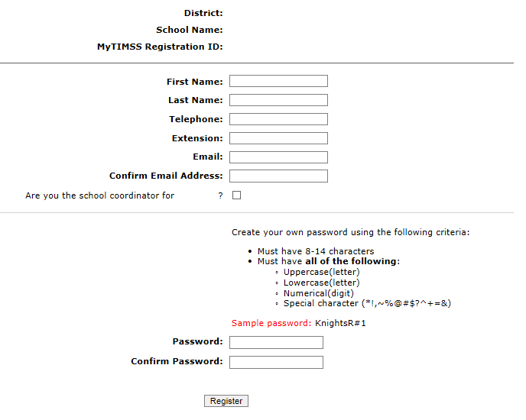

1. Then create a password that meets the password criteria and click **Register.**
2. Once created, your username will be emailed to you. Your username is **not** your email address. Usually the username convention will be LastNameFirstinitialofFirstName, e.g. *JohnsonB*
3. If you check the “Are you the school coordinator for?” box, you will get an additional email with a Summary of upcoming activities.

**Note: The following content/text from TIMSS is provided as a model, but the specific form and presentation will only be known once a contractor has been selected and the online system to be used is determined.**

# Site Home Page

When you first log in, you will see your school name, grade, and assessment date at the top banner. Please make sure those fields are accurate. If not, contact www.PIRLS.xxx.

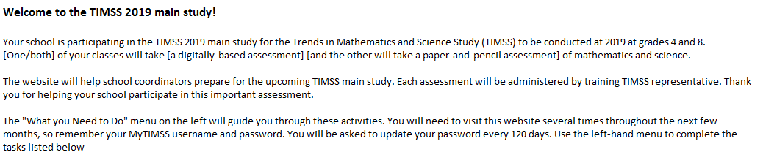

The **“What You Need to Do”** menu on the left will guide you through the upcoming PIRLS activities. You will need to visit this website several times throughout the next few months, so remember your PIRLS username and password. You will also be asked to update your password every 120 days. The change password link is at the top right of the page.

To get started, use the left-hand menu to complete the tasks listed below.

* Provide School Information—Now
* Submit Class List—January
* Submit Student List—January
* Prepare for Assessment—January-March

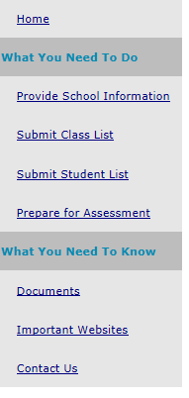

**Note: The following content/text from TIMSS is provided as a model, but the specific form and presentation will only be known once a contractor has been selected and the online system to be used is determined.**

# Provide School Information (PSI)

The first step in PIRLS is to complete the **Provide School Information** page. Click the **Provide School Information** link at the left-hand menu to access this page.

On the PSI page, the information on the left is the current information available for your school. Please make updates in the fields on the right if the current information on the left is blank or incorrect. Make sure to complete both the **“School Contact Information**” and **“School Characteristics”** sections. Then click Save.

Note: You will see this red text banner below until all required fields are filled out completely:



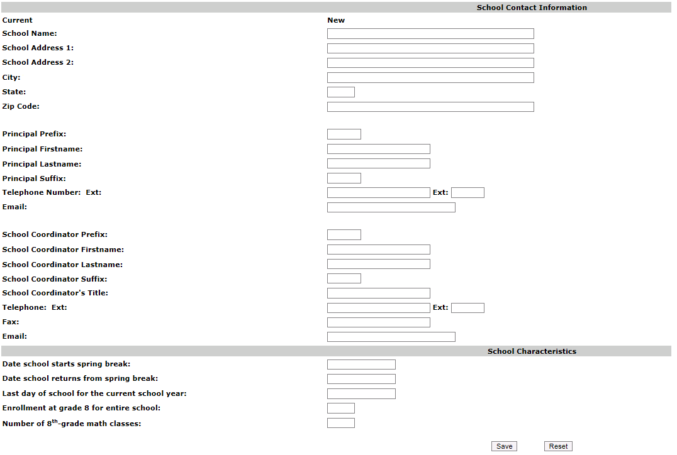

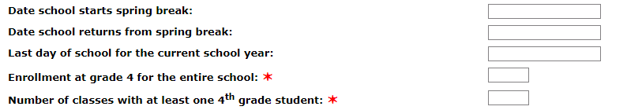

Once complete, you will see this blue text bar shown below at the top of the page.



In January, 2020, we will email to you instructions for submitting class and student lists.

Thank you for you school’s participation in the 2020 PIRLS Field Test!

The PIRLS team

www.PIRLS.xxx

# Automated Email for all PIRLS registrants

(Yellow highlight for merge data fields)

Thank you for creating a PIRLS account for the Progress in International Reading Literacy Study (PIRLS). To access PIRLS, go to www.PIRLS.xxx and enter your username and password.

**Username: [username]**

**Password information:** You created your own password upon registering. Use the **"Forgot Password"** links on PIRLS login page if needed. You will be prompted to change your password after 120 days.

PIRLS is a secure site that contains confidential information, so it is important to remember your username and password. If you choose to write down this information, store it in a secure place.

If you have questions or need help accessing the website, please contact the PIRLS Help Desk at XXXX or at 1-800-XXX-XXXX Monday through Friday between 9 a.m. and 5:00 p.m. ET.

Sincerely,

The PIRLS Team

*NCES is authorized to conduct PIRLS under the Education Sciences Reform Act of 2002 (ESRA 2002, 20 U.S.C. §9543). All of the information provided by school staff and students may be used only for statistical purposes and may not be disclosed, or used, in identifiable form for any other purpose except as required by law (20 U.S.C. §9573 and 6 U.S.C. §151). The U.S. Office of Management and Budget has approved the data collection under OMB# 1850-0645. Individual responses will be combined with those from other participants to produce summary statistics and reports.*

# Automated Email for PIRLS School Coordinator registrant

(Yellow highlight for merge data fields; red font for customization)

Dear [school coordinator],  
  
Thank you for creating a PIRLS account for the Progress in International Reading Literacy Study (PIRLS) on [https://www.PIRLS.com](https://www.MyTIMSS.com). PIRLS is a secure website for sharing information and files related to your school’s participation in the 2020 PIRLS field test. The website’s **"What You Need to Do"** menu will guide you through the upcoming PIRLS activities.  
  
The first step is to complete the **Provide School Information** page. If you have not already done so, please go to [https://www.PIRLS.com/ProvideSchoolInformation.aspx](https://www.MyTIMSS.com/ProvideSchoolInformation.aspx).   
  
In January, you will need to provide a complete and current list of **all of your school’s fourth-grade classes** for the PIRLS team to randomly select two classes to participate in the PIRLS field test. You will then be asked to submit lists of **all students in the selected classes**. We will email you in early January with instructions about how to submit the class list, student list, and teacher list through www.PIRLS.xxx.   
  
Please see the **attached** Summary of School Activities for a complete list of activities associated with your school’s participation in the 2020 PIRLS field test.  
  
Thank you very much for participating in PIRLS, and for playing a key role in making the assessment a success in [school name]!  
  
Sincerely,  
  
The PIRLS Team  
  
*NCES is authorized to conduct PIRLS under the Education Sciences Reform Act of 2002 (ESRA 2002, 20 U.S.C. §9543). All of the information provided by school staff and students may be used only for statistical purposes and may not be disclosed, or used, in identifiable form for any other purpose except as required by law (20 U.S.C. §9573 and 6 U.S.C. §151). The U.S. Office of Management and Budget has approved the data collection under OMB# 1850-0645. Individual responses will be combined with those from other participants to produce summary statistics and reports.*

**Note: The following content/text is provided as a model, but the specific form and presentation will only be known once a contractor has been selected and the online system to be used is determined.**

# PIRLS Login Page

PIRLS USA LOGO

PIRLS

**Login**

PIRLS is a restricted-use website that contains information on the Progress in International Reading Literacy Study (PIRLS).

**Existing User Login** First time visiting the PIRLS site?

Schools can register now!

User Name: Please register

Password:

Forgot Password | Having trouble logging in?

Log In

The National Center for Education Statistics (NCES), within the U.S. Department of Education, conducts PIRLS in the United States as authorized by the Education Sciences Reform Act of 2002 (ESRA 2002, 20 U.S.C. §9543). All of the information you provide may be used only for statistical purposes and may not be disclosed, or used, in identifiable form for any other purpose except as required by law (20 U.S.C. §9573 and 6 U.S.C. §151).

According to the Paperwork Reduction Act of 1995, no persons are required to respond to a collection of information unless such collection displays a valid OMB control number. The valid OMB control number for this voluntary information collection is 1850-0645. The time required to complete this information collection and participate in study activities is estimated to average 240 minutes per school coordinator, including the time to review instructions, search existing data resources, gather the data needed, and complete and review the information collection. If you have any comments or concerns regarding the accuracy of the time estimate(s), suggestions for improving the form, or questions about the status of your individual submission of this form, write directly to: Progress in International Reading Literacy Study (PIRLS), National Center for Education Statistics, Potomac Center Plaza (PCP), 550 12th St., SW, 4th floor, Washington, DC 20202.

OMB No. 1850-0645, Approval Expires XX/XX/2022.

**Notice: You are accessing a U.S. Government information system.**

This warning banner provides privacy and security notices consistent with applicable federal laws, directives, and other federal guidance for accessing this Government system, which includes all devices/storage media attached to this system. This system is provided for Government-authorized use only. Unauthorized or improper use of this system is prohibited and may result in disciplinary action and/or civil and criminal penalties.

**Note: The following content/text from TIMSS is provided as a model, but the specific form and presentation will only be known once a contractor has been selected and the online system to be used is determined.**

(Login Page screenshot from TIMSS. The PIRLS field test page will replace this one once available)

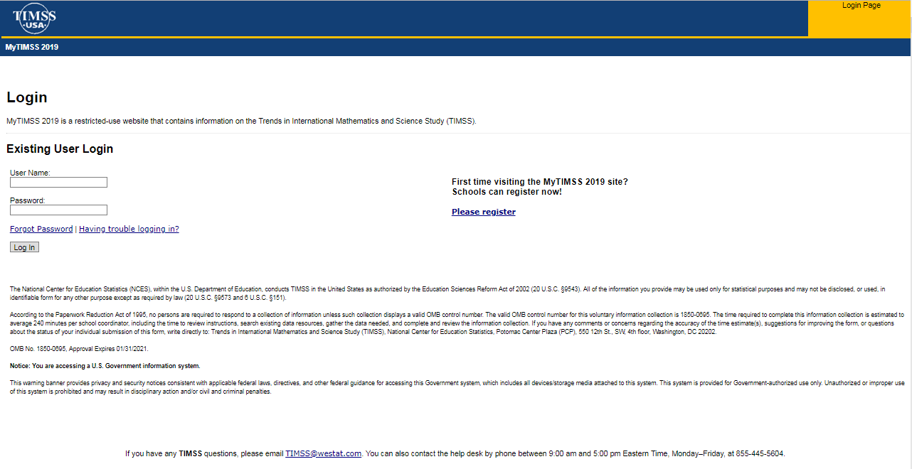

**Note: The following content/text from TIMSS is provided as a model, but the specific form and presentation will only be known once a contractor has been selected and the online system to be used is determined.**

# PIRLS Home Page

Welcome to the 2020 PIRLS field test!

Your school is participating in the field test for the Progress in International Reading Literacy Study (PIRLS) to be conducted in 2020 in grade 4. Students in schools selected for grade 4 will take a digitally-based assessment of reading.

This website will help school coordinators prepare for the upcoming PIRLS field test. Each assessment will be administered by trained PIRLS representatives. Thank you for helping your school participate in this important assessment.

The "What You Need to Do" menu on the left will guide you through these activities. You will need to visit this website several times throughout the next few months, so remember your PIRLS username and password. You will be asked to update your password every 120 days. Use the left-hand menu to complete the tasks listed below.

* Provide School Information—Late Fall, 2019
* Submit Class List—January, 2020
* Submit Student List—January, 2020
* Prepare for Assessment—January-February, 2020

(Model for PIRLS Home Page screenshot from TIMSS)

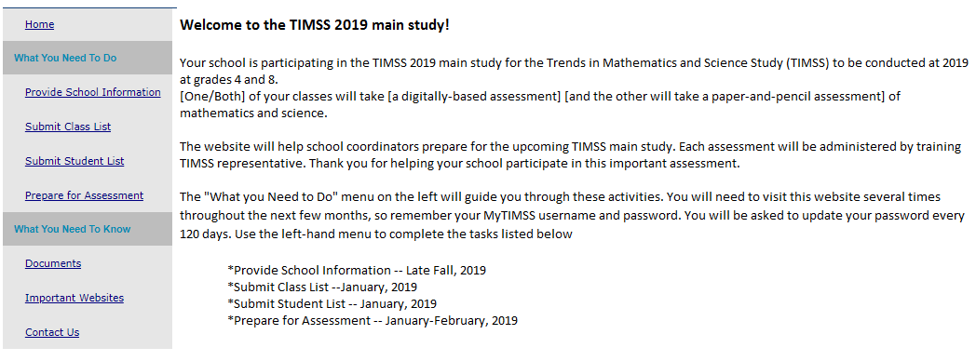

# PIRLS Provide School Information (PSI) Page

(Model for PIRLS Provide School Information (PSI) Page screenshot from TIMSS)

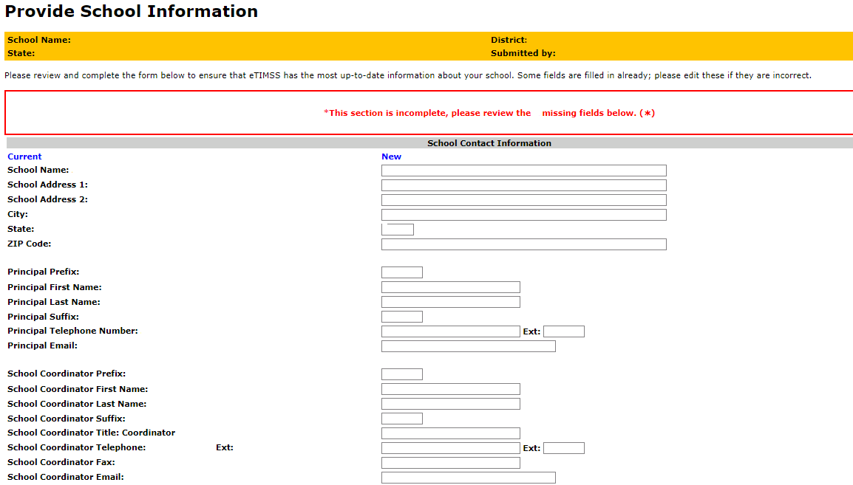

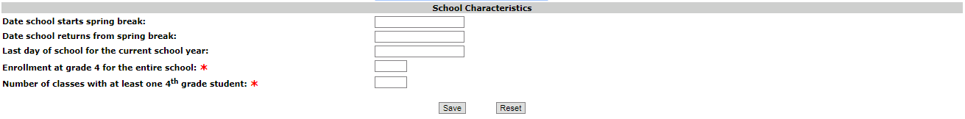

# Email to School Coordinator (SC) to Submit Class and Student Lists—Grade 4

Dear [School Coordinator],

PIRLS needs a complete and current list of **all of your school’s fourth-grade classes** and **all the fourth-grade students in those classes** in order to randomly select classes to participate in the 2020 PIRLS field test.

Please go to [https://www.PIRLS.com](http://www.mytimss.com) to submit your class and student lists. If you have forgotten your login ID please contact the PIRLS hotline at XXXX or 1-800-XXX-XXXX. If you have forgotten your password, you can request a new password on the PIRLS login page.

After logging in, select **Submit Class List** from the left hand panel to provide information about your fourth-grade classes. Once you have provided information about all fourth-grade classes, select **Submit Student List** to provide an electronic list of currently enrolled fourth-grade students in your school.

Instructions for **Submit Class List** and **Submit Student List** are attached. These tip sheets and Excel templates can also be found in the **Documents** section of this website.

If you have any questions about submitting your list, please email or call the PIRLS Help Desk at 1-800-XXX-XXXX or www.PIRLS.xxx.

Please submit your student E-File by **xx/xx/xx.** PIRLS will process your submission and select the sample of fourth-grade classes to be assessed. You will be informed of the classes selected within a few weeks of submitting your lists.

Thank you very much for participating in PIRLS, and for submitting your school's class and student lists!

Sincerely,

The PIRLS team

Attachments: Grade 4 Submit Class List Tip Sheet; Grade 4 Submit Student List Tip Sheet

*NCES is authorized to conduct this study under the Education Sciences Reform Act of 2002 (ESRA 2002, 20 U.S.C. §9543). All of the information you provide may be used only for statistical purposes and may not be disclosed, or used, in identifiable form for any other purpose except as required by law (20 U.S.C. §9573 and 6 U.S.C. §151).*

# Instructions for Submitting Class Lists- Grade 4

**Submit Class List**

PIRLS needs a complete and current list of all of your school’s fourth-grade classes in order to randomly select classes to be assessed. Typically, two classes are sampled in each school, and all students in the selected classes are assessed. Submit your class list first, and then the PIRLS Team will email you the list of selected classes. After you receive the list of selected classes, you will be given instructions to submit student lists for the selected classes only.

Go to [www.PIRLS.com](http://www.mytimss.com) and log in. Your PIRLS username is usually in the format of **last name + first initial of first name**. *For example, Britney Johnson’s username would be johnsonb.*

**Enter information about all fourth-grade classes at your school**

On [www.PIRLS.com](http://www.mytimss.com/), select **Submit Class List** from the navigation menu on the left. The table on the page provides a description of all information that is needed. Enter information for each fourth-grade class in the web form. After you have entered information for each class, click on the *Save* button, and another row will appear for you to enter information about another class. If you have not completely filled out a row, you may get a warning message at the top of the screen that the data must be fixed and resaved. Continue until you have entered information for all classes that contain fourth-grade students. Note: Do not click the Finished button until all classes have been entered. Make sure to click “Save” one last time **prior** to clicking “Finished.”

Include the following information for each class:

1. *Class Name (each class name must be unique and descriptive, e.g. “Mrs. Johnson’s 4th grade class;” each row must have a unique new name)*
2. *Class Group or Track (Select “average” track if there are no tracks or group levels)*
3. *Number of 4thgrade students in the class (Do not include 3rd or 5th graders)*
4. *Class Exclusion Status (If applicable; Only use this field if EVERY student in that class cannot take PIRLS)*
5. *Name of Teacher*
6. *Email address of Teacher*

**Additional tips for submitting information about your fourth-grade classes:**

* Record the Class Name that is typically used by your school to refer to the class, but we recommend it be as descriptive as possible so you can later on identify it easily.
* For classes with students from more than one grade level, include in *Number of Students* only those students in Grade 4. For example, if the class has 5 third-graders, 6 fourth-graders, and 4 fifth-graders, enter “6” as the *Number of Students* in this class.
* Use the most current enrollment information.
* Include all classes, even if they typically are excluded from your state testing program, or all students take alternate assessments. You can indicate information about the class in ***Class Exclusion Status****, but only if all students should be excluded*.
* Print a list of the classes you included for your future reference using the *Print* button.

Once you have entered information for all the fourth-grade classes in your school, click *Save* and then the *Finished* button. Only click *Finished* AFTER clicking *Save*.

When you click “Submit Class List” for Grade 4, you will see this description table at the top and an empty form to enter information at the bottom of the page.

Below is a detailed description of what will be needed.

**Table of Fields to enter for Grade 4 Class List Submission**

|  |  |
| --- | --- |
| **✶**Class Name (each class name must be unique) | Record the class name that is typically used by your school to refer to the class. For example, it may be that your school uses the grade plus a letter for the class name (4a, 4b, etc.), the grade plus a number (4.1, 4.2, etc.), the teacher name, the class period (Period 1, Period 2, etc.), the class location (Room 7, Room 8, etc.), or some other combination of these items. **It is important that unique class names are entered because these names will be used to indicate to the Test Administrator which classes will be tested.** |
| **✶**Class Group or Track (use Average if none) | If your school assigns students to specific classes based on their ability, please indicate the relevant level: Low ability, Average ability, or High ability. Use average if no group or track level. |
| **✶**Number of 4th-grade students in each class | Enter the number of fourth-grade students in each class. In the case of *multi-grade classes* (e.g., students from more than one grade level in the same class), only the fourth-grade students should be counted as a class in the list. For example, if three Grade 3 students, five Grade 4 students, and ten Grade 5 students form a multi-grade class, then you should record five students for the number of students in this multi-grade class. |
| Class Exclusion Status (if applicable; if at least one 4th-grade student in this class is able to be assessed, do not use this field) | **1** = Students with functional disabilities; i.e., students who have physical disabilities in such a way that they cannot perform in the PIRLS testing situation. Students with functional disabilities who are able to perform should be accommodated in the test situation, within reason, rather than excluded.   **2** = Students with intellectual disabilities; i.e., students who are considered, in the professional opinion of the school principal or by other qualified staff members, to have severe intellectual disabilities or who have been tested as such. This category includes students who are emotionally or mentally unable to follow even the general instructions of the test. Students should not be excluded solely because of poor academic performance or normal disciplinary problems. It should be noted that students with dyslexia, or other such learning disabilities, should be accommodated in the test situation, within reason, rather than excluded.   **3** = Non-native language speakers; i.e., students who are unable to read or speak the language(s) of the test and would be unable to overcome the language barrier in the test situation.   **If all students in the excluded class do not belong to the same exclusion category, please identify the category corresponding to the majority of students.** |
| **✶**Name of Teacher | Name of Teacher of class. |
| **✶**Email address of Teacher | Email address of Teacher of class. |

**Note: The following content/text from TIMSS is provided as a model, but the specific form and presentation will only be known once a contractor has been selected and the online system to be used is determined.**

**Enter classes in this table:**

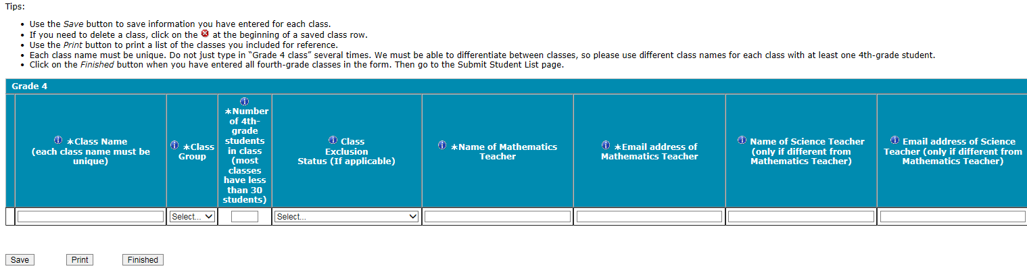

You can hover your mouse cursor over the Information symbol to get more information about each field and its requirements.

The white asterisks indicates the field is required.  Enter class details and then click **Save** after each row. The row will not save if an error occurs. If you see an error message, please correct the text in that row and re-save to activate a new row to enter.

Continue to click “save” and make sure to click “save” after you enter the last class. Do Not click “Finished” until **after** you click “save” one last time and there are no error messages.

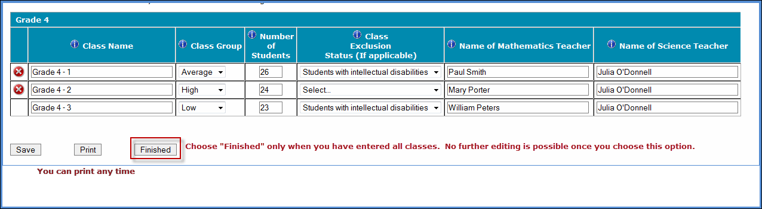

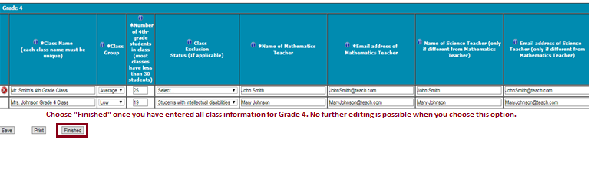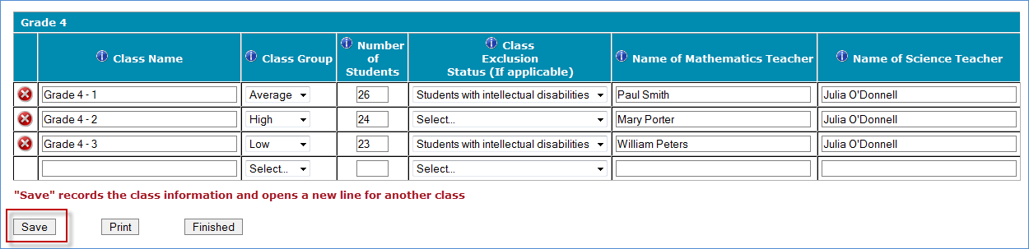Once finished, the PIRLS team will email you within 5-7 business days which grade 4 classes were selected. Then you can submit student lists for the selected classes only.

**If you need assistance, email** PIRLS@xxx

**or call 1-(855)-XXX-XXXX.**

# Instructions for Submitting Student Lists- Grade 4

**Submit Student List – Part 1 - Upload**

Along with the list of classes, PIRLS needs a complete and current list of **all students** in grade 4 in order to draw a random sample of classes (and therefore students) to participate in the assessment. If you prefer just to submit a list of students for selected classes only, please email XXX after you have submitted you class lists. We will then randomly select 2 (sometimes more) classes and you only need to provide student lists for the selected classes.

Your student data electronic file (E-File) must be submitted as a Microsoft Excel file. Click the “Submit Student List” link to get started. You can only do this AFTER you have completed the Submit Class List Page. The class names you entered on that page will need to be reentered exactly when completing student lists.

You may use the - E-File Excel Template we provide in the **Documents** section or you may provide an Excel file with the same information. Include the following information for each student:

* Class: The fourth-grade class the student is enrolled in. Please use **the same unique class names** you used in the Submit Class List screen.
* Teacher Name: Teacher of the above named class.
* Student Name: The preferred format is First Name, Middle Name (or Initial), and Last Name in separate columns. However, PIRLS will accept student names in one column.
* Sex: Codes for Male/Female.
* Date of Birth: The preferred format is Month of Birth and Year of Birth in separate columns. However, PIRLS will accept Date of Birth in one column.

It is preferred that you include column headers as the first row in your E-File (see templates for examples in [Documents](http://mytimssdev.westat.com/documents.aspx)). However, E-Files without column headers will be accepted. If you cannot submit your student data with this information in an Excel file, please call or email the PIRLS Help Desk at XXXXXXXX. Please save this file with your school name and district in the file name.

Once finished, click “Yes” or “No” if you do have column headers (first row in file says, “class, teacher name, student name”, etc.). Then click Upload.

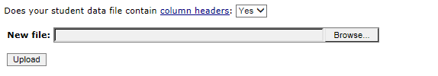  
  
Then click Browse to look for the excel file and then Upload.

Proceed to the next page of this guide.

**Note: The following content/text from TIMSS is provided as a model, but the specific form and presentation will only be known once a contractor has been selected and the online system to be used is determined.**

**Submit Student List – Part 2 – Identifying Columns**

**Identify Your Columns**   
  
We need to know what information is in each column of your student data file (E-File). If you provided column headers in your E-File (preferred), they are displayed in **Column Heading Is** in the table below. If you did not provide column headers, **Column Heading Is** will contain numbers for each column in your submitted E-File. Click on the down arrows in **Your Column Contains** to select descriptions for each column header. If there is no appropriate description in the drop-down list, please select N/A.

Once finished, click Next.

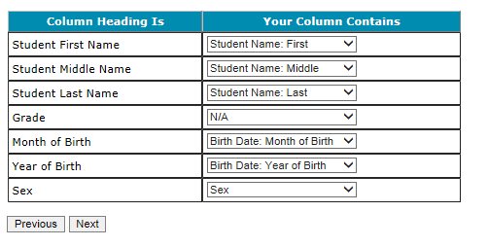

You can always come back to this **Identify Columns** page by clicking on the link circled in red on the **Submit Student List** page:

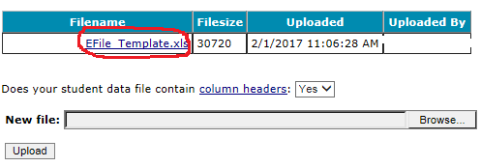

**Note: The following content/text from TIMSS is provided as a model, but the specific form and presentation will only be known once a contractor has been selected and the online system to be used is determined.**

**Submit Student List – Part 3 – Matching Values and Verifying E-file Percentages**

Match Your Values to PIRLS Codes

Follow the instructions below to verify codes you entered in your excel file, e.g. M means male and F means female student.

PIRLS needs to know the values for each of the columns in your E-File. The tables on the next few web pages contain the following information for each column:

* Your Values: The values in your E-File
* PIRLS Codes: Click on the down arrow and select the PIRLS Code that best matches Your Values
* Number: The number of students in your E-File with that value
* Percentage: The percentage in your E-File with that value

Use the Previous and Next buttons to navigate from column header to column header.

If there is an error in your data file, exit E-File, correct the problem in your Excel file, and upload the file again.

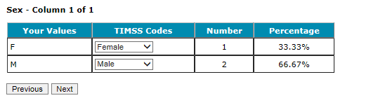

Submit Student List – Part 4 – Data verification

Possible warnings:

You have entered that there # of students in the PSI page for your selected grade; however, there are # of students in your excel file. Please confirm your excel file has the correct number of students.

There are several students with a possibly ineligible birth year. The potentially ineligible birth year(s) are:

Please confirm this is correct before moving on. If the data are incorrect, please re-upload a new file by going to the Submit Student List Page.

**Verify Your E-File**

Once complete with matching your codes, you can review the percentages to ensure your file looks correct. For example, most schools would have around 50% female and 50% male students.

The table below summarizes the information you have provided on your student list (E-File). Please review this summary and verify that the information is correct. Total Enrollment at the bottom of the table should match the number of students in your E-File and the total number of students currently enrolled in grade 4.

Record whether the information is correct or incorrect by selecting the appropriate button at the bottom of the page. Then click the Submit button. If you select incorrect, you will need to correct your E-File and resubmit it.

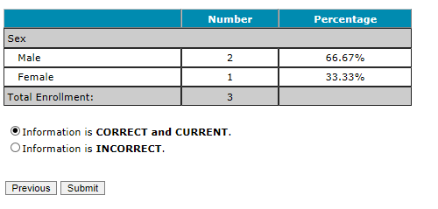Record Edited

**Once you click submit, you will see this message below.**

Thank you for submitting your E-File!

PIRLS will process your submission and select the sample of fourth-grade classes to be assessed. Soon you will receive an email explaining which classes were selected.

A PIRLS representative will contact you to make arrangements for the assessment.

**Note: The following content/text from TIMSS is provided as a model, but the specific form and presentation will only be known once a contractor has been selected and the online system to be used is determined.**

Submit Class List Page – Grade 4

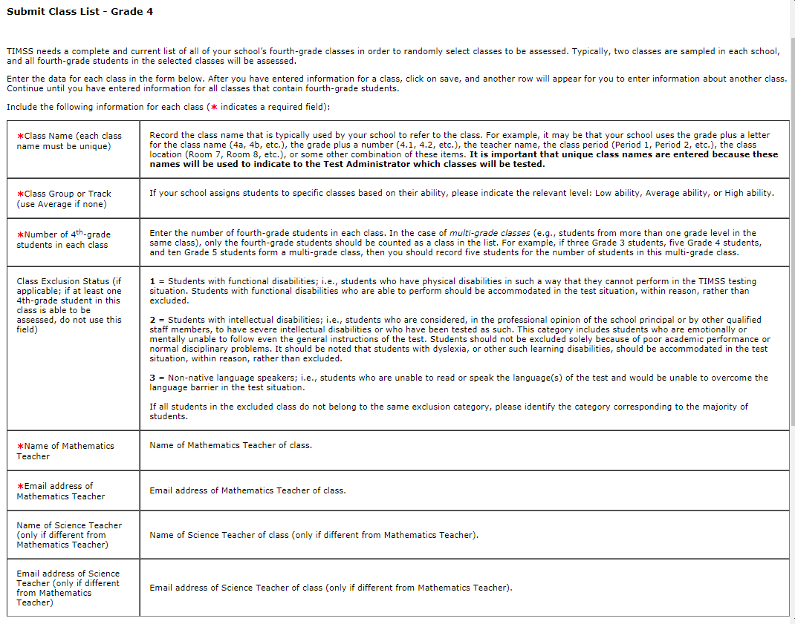

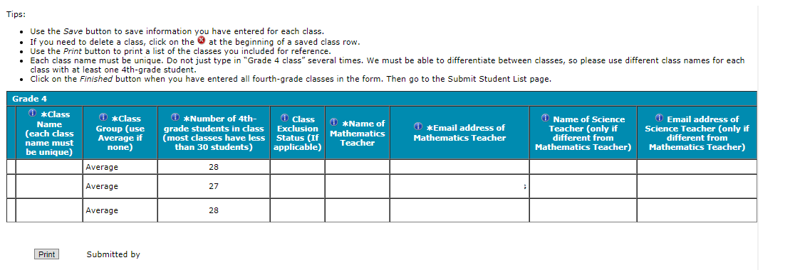

**Note: The following content/text from TIMSS is provided as a model, but the specific form and presentation will only be known once a contractor has been selected and the online system to be used is determined.**

Submit Student List Page – Grade 4

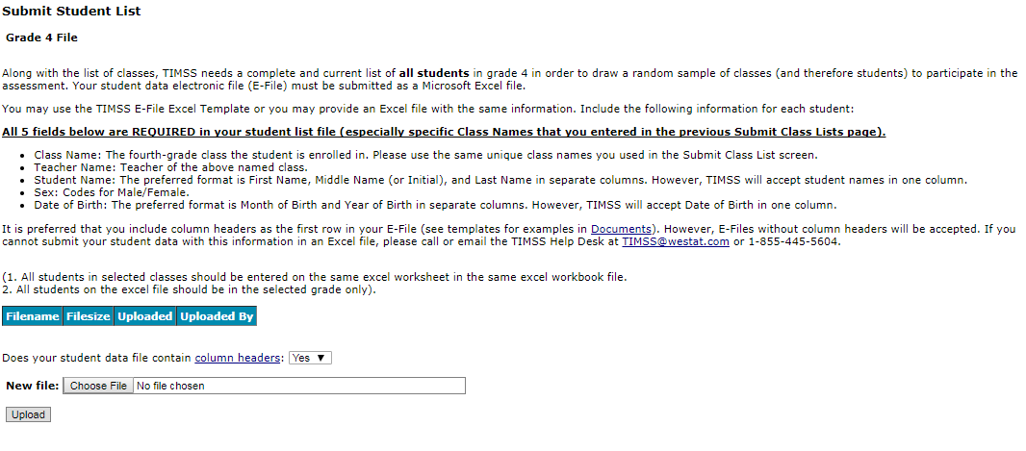

# PIRLS Prepare for Assessment Page

(red font is customized depending on grade the school was selected for)

**Prepare For Assessment**

Thank you for providing information about all the fourth-grade classes in your school! In a few days you will receive an email informing you that your sample of classes has been selected. Return to this webpage when you receive the email from [PIRLS@](mailto:PIRLS@)xxx.xxx: “The list of students selected to participate in PIRLS is available in the Student-Teacher Linkage Form (STLF)”

**Please note the following:**

**Student-Teacher Linkage Form (STLF)** –The forms list the students who have been selected to participate in the assessment at your school. You will get an email when this form is ready.

**Student Tracking Form (STF)–**The form lists the students who have been selected to participate in the assessment at your school.

**Teacher Tracking Form (TTF)–**The form lists the teachers who have been selected to participate in teacher questionnaire at your school.

Instructions on how to access and review the forms are in the Documents section on this website. The STF and TTF will become available about a week after the STLF has been posted.

**Sample Parent Notification Letter and Facts for Parents about PIRLS**. Starting *[mid-February]* and after you submit student lists, your school will receive a FedEx packet of PIRLS materials including a PIRLS Parent FAQ, and a sample hardy copy parent/guardian notification letter.

A sample parent/guardian notification letter is in the Documents section for you to customize and print on your school letterhead. Please distribute the parent notification letter and the Parent FAQ (from our FedEx mailing to you) to the parents of the selected students prior to the assessment. Additionally, a Spanish version of the letter is available in the Documents page. You can also share the Parent FAQ link available here: https://nces.ed.gov/PIRLS/parents/.

As your assessment date approaches, your Test Administrator will be contacting you to finalize the assessment day activities.

**Prepare for Assessment page** (screenshot)

(the TIMSS model below will be updated with the text above)

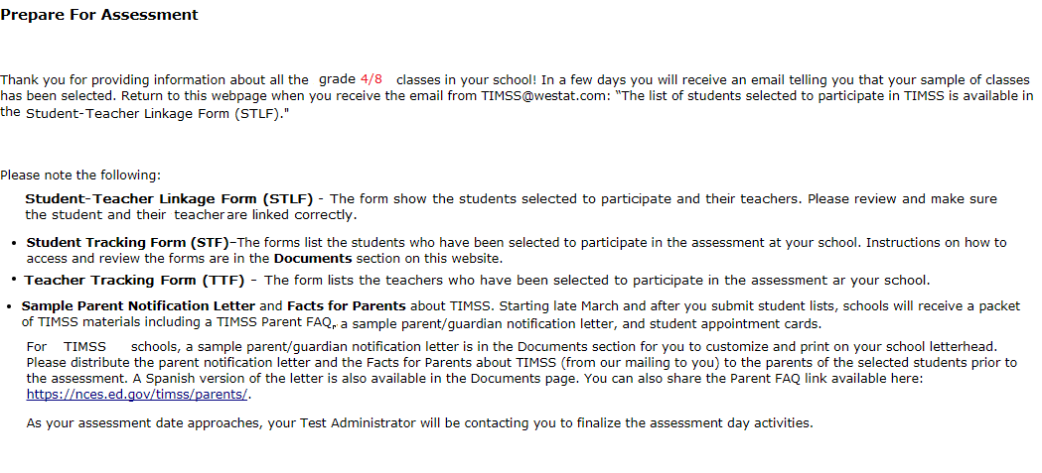

**Note: The following content/text from TIMSS is provided as a model, but the specific form and presentation will only be known once a contractor has been selected and the online system to be used is determined.**

# Student-Teacher Linkage Form (STLF) Email

(yellow highlight for mail merge)

Dear [school coordinator],

The list of students selected to participate in PIRLS is available in the Student-Teacher Linkage Form (STLF)!

The **Student-Teacher Linkage Form (**STLF) lists the students who have been selected to participate in the assessment at your school. This list is based on the class and student information you submitted. To access the STLF, please login at www.PIRLS.com, then go to **Prepare for Assessment** and select **“Click here to download the STLF.”** In the STLF excel file, there is a worksheet for each set of selected classes or students, so please make sure to review each worksheet in the STLF excel file. Most schools will have two worksheets, one for each class.



For the Student-Teacher Linkage Form (STLF), you will only need to make sure the students on that list match the teachers to the selected students in the header of Column 6. If you see any errors, please contact the PIRLS Hotline at[PIRLS@](mailto:PIRLS@)xxx.xxx or 1-800-XXX-XXXX. Please do not email the list back to us.

In a week of the STLF posting, you will receive an email informing you that the final list of selected students and teachers are available. These lists, called the Student Tracking Form (STF) and Teacher Tracking Form (TTF) will be posted on this same **Prepare for Assessment** page.

Thank you very much for participating in PIRLS, and for submitting your school's class and student lists!

Sincerely,

The PIRLS Team

*NCES is authorized to conduct this study under the Education Sciences Reform Act of 2002 (ESRA 2002, 20 U.S.C. §9543). All of the information you provide may be used only for statistical purposes and may not be disclosed, or used, in identifiable form for any other purpose except as required by law (20 U.S.C. §9573 and 6 U.S.C. §151).*

# Student Tracking Form (STF) Email

(yellow highlight for mail merge; red for customization)

Dear [School Coordinator],

Thank you for providing information about all the fourth-grade classes in your school! The list of students and teachers selected to participate in PIRLS is now available in the Student Tracking Form (STF) and Teacher Tracking Form (TTF) available on the PIRLS website. Please see below for more details about the forms and parent notification.

* Student Tracking Form (STF) –The forms list the students who have been selected to participate in the assessment at your school. Instructions on how to access and review the forms are attached.
* Sample Parent Notification Letter and Facts for Parents about PIRLS (Parent FAQ) – A sample parent/guardian notification letter is attached for you to customize and print on your school letterhead. Please distribute the parent notification letter and the *Facts for Parents about PIRLS* to the parents of the selected students prior to the assessment. A Spanish version of the letter is available on the PIRLS site in **Documents.**
* FedEx Shipment
  + Within a week, a FedEx shipment of hard-copies of the *Facts for Parents* *about PIRLS (Parent FAQ)* will be delivered to you. You can also distribute them electronically or share the Parent FAQ link available here: [https://nces.ed.gov/PIRLS/parents/](https://nces.ed.gov/timss/parents/)

As your assessment date approaches, your Test Administrator will be contacting you to finalize the assessment day activities and discuss accommodations, if necessary.

If you have any questions, please do not hesitate to call xxx-xxx-xxxx or send an email to [PIRLS@](mailto:PIRLS@)xxx.xxx. You may also get more information about this study by visiting the PIRLS website at [http://nces.ed.gov/PIRLS](http://nces.ed.gov/timss).

Thank you for your assistance with this study!

Sincerely,

The PIRLS Team

Attachments:

Sample Parent Notification Letter

Facts for Parents about PIRLS (Parent FAQ)

STF and TTF Instructions

*NCES is authorized to conduct this study under the Education Sciences Reform Act of 2002 (ESRA 2002, 20 U.S.C. §9543). All of the information you provide may be used only for statistical purposes and may not be disclosed, or used, in identifiable form for any other purpose except as required by law (20 U.S.C. §9573 and 6 U.S.C. §151).*

# Instructions for Student Tracking Form (STF)

**Reviewing the Student Tracking Form (STF)**

The two **Student Tracking Form** (STF) lists the students who have been selected to participate in the assessment at your school. This list is based on the student information you submitted. You can take notes on this form in preparation for the pre-assessment call in which the Test Administrator will ask you about any updates to this form over the phone. To access the STF, please login at www.PIRLS.com, then go to **Prepare for Assessment** and select **“Click here to download the STF.”**

As the first step in reviewing the Student Tracking Form, please verify the student information for accuracy after you open the excel file you just downloaded. See below for what should be reviewed. Please also make sure the school name and students match what you expect.

* Student’s name is listed in **Column 1**.
* Date of birth is listed in **Column 4.**
* Gender (using codes—1 for female and 2 for male) is listed in **Column 5**.
* Exclusion status in **Column 6.**
* Participation status in **Column 7.**

**Student Exclusions and Accommodations**

If a student is to be excluded from the assessment because he or she requires an accommodation, please make a note in column 6 using the codes at the bottom of the STF.

**Participation Status + Newly-enrolled or no-longer-enrolled students**

If many of the students listed in the STF are not enrolled in the school, please contact [PIRLS@](mailto:PIRLS@)xxx.xxx ASAP, but you do not need to contact [PIRLS@](mailto:PIRLS@)xxx.xxx if only 1 to 3 students are no longer enrolled or are newly enrolled. These new or no-longer-enrolled students can be discussed with your Test Administrator when they call you for the pre-assessment call (usually 1-2 weeks before assessment date). You can make a note on the form regarding these students in the first column in column 7 using the status codes shown at the bottom of the STF. You can also use status codes 1 through 4 to provide more information about a student.

**Updates and Questions**

If you have updates to the STF, please have the form ready for the pre-assessment call. You can also provide the hardcopy to the Test Administrator when they come to your school on assessment day. If you have any questions about completing this form, please address them with your Test Administrator when they contact you. For urgent questions on the STF, you can also contact the PIRLS Help Desk ([PIRLS@](mailto:PIRLS@)xxx.xxx or 1-800-XXX-XXXX). The STF is just for you to take notes on in preparation for the pre-assessment call so you know parents of which students should be notified. Please do not send the STF or TTF back to us. You can however give it to the Test Administrator in person, if you would like, when they come on the assessment day. Instructions for reviewing the Teacher Tracking Form (TTF) are on the next page.

**Note: The following content/text from TIMSS is provided as a model, but the specific form and presentation will only be known once a contractor has been selected and the online system to be used is determined.**

# Student-Teacher Linkage Form (STLF) Template (Grade 4)

Grade 4 STLF

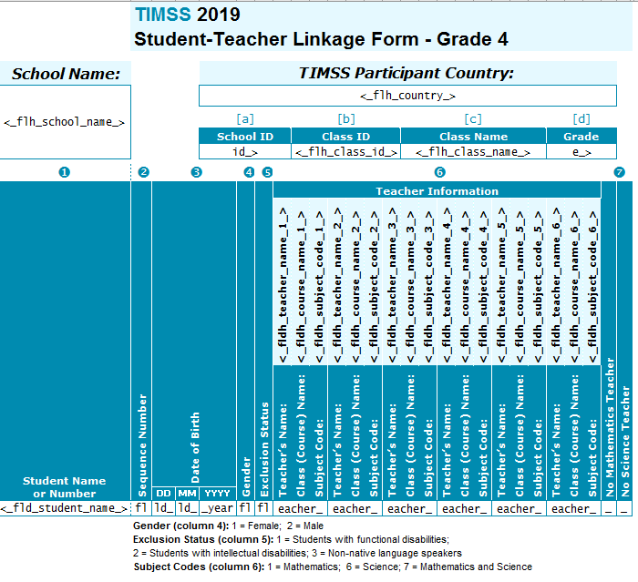

**Note: The following content/text from TIMSS is provided as a model, but the specific form and presentation will only be known once a contractor has been selected and the online system to be used is determined.**

# Student Tracking Form (STF) Template (digitalPIRLS VS Paper Bridge Study)

### digitalPIRLS STF

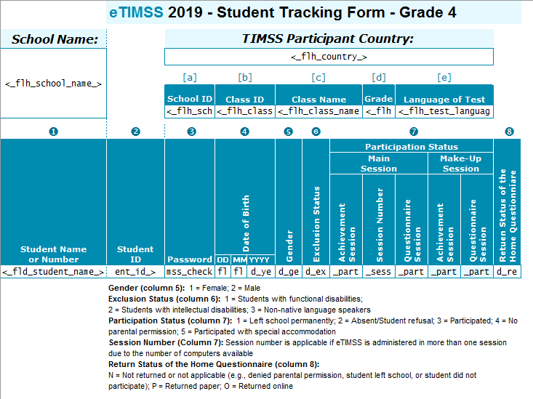

### Paper Bridge Study STF

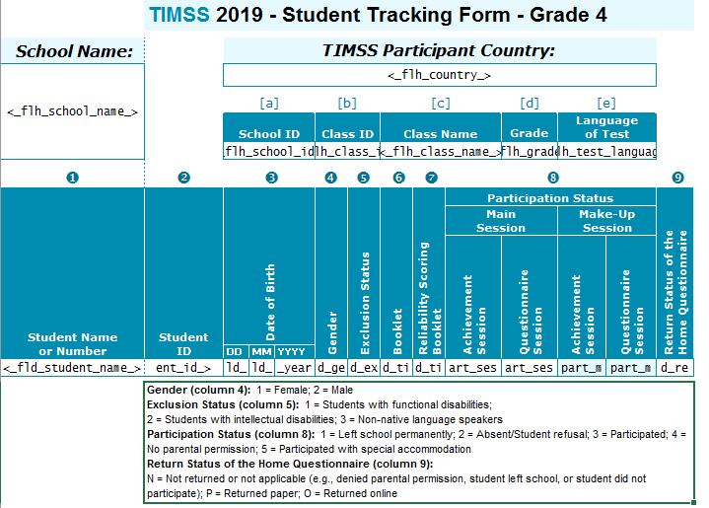

**Note: The following content/text from TIMSS is provided as a model, but the specific form and presentation will only be known once a contractor has been selected and the online system to be used is determined.**

# Documents Page

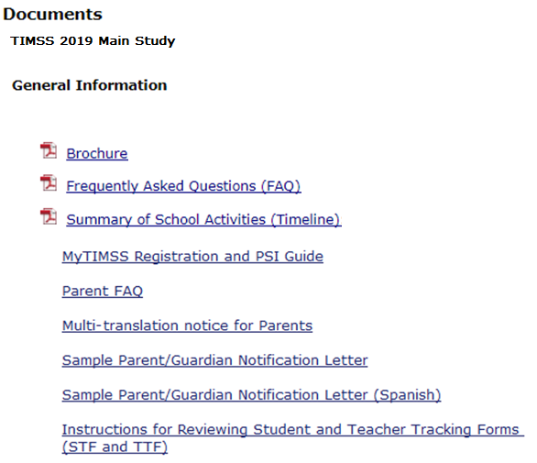

**Note: The following content/text from TIMSS is provided as a model, but the specific form and presentation will only be known once a contractor has been selected and the online system to be used is determined.**

# PIRLS Important Websites and Contact Us Pages

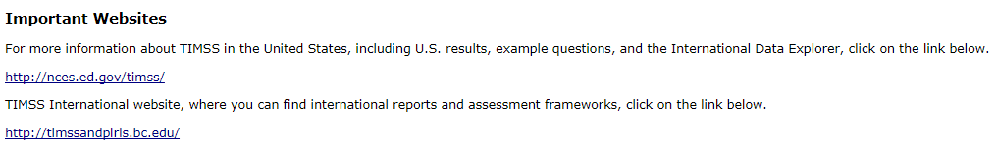

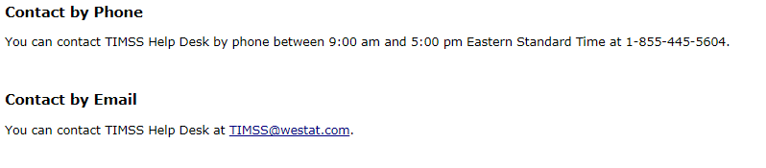

# School Principal Questionnaire Login Card/Email

**Front of Card:**

Welcome to PIRLS!

Your school is participating in the 2020 Progress in International Reading Literacy Study (PIRLS) field test. This online questionnaire seeks information about schools and provides important context to understanding the achievement of students taking the assessment.

Please go to the web address (URL) given below and log in to the online questionnaire with your “School ID” and “Password”, which are printed on the label attached below. Please contact the PIRLS Help Desk ([PIRLS@](mailto:PIRLS@)xxx.xxx) if you have problems logging on.

The website link is: [PIRLS@](mailto:PIRLS@)xxx

[Insert Label]

The online questionnaire does NOT require JavaScript or cookies to work. Responses are saved automatically as you go from question to question. The “Table of Contents” link on the bottom of each page provides an overview of all questions and whether you have completed them. You may leave the questionnaire at any time and log in again later. See notes on the back of this card.

OMB# 1850-0645 (expires xx/xx/xx).

**Back of Card:**

NOTES

* Please use the Previous and Next buttons to navigate backward and forward
* You may exit the questionnaire at any time and log in again later— all of your responses will be saved automatically.
* The Table of Contents provides an overview of all questions and shows whether you have completed all questions.
* To exit the Table of Contents, click on any question link or section header.
* If you would like a printed copy of the online questionnaire, click on the “Prepare Printer Version” link on the Table of Contents page.
* It is estimated that it will take approximately 30 minutes to complete the questionnaire.
* If you have problems accessing the online questionnaire or need assistance, please contact the PIRLS help desk at [PIRLS@](mailto:PIRLS@)xxx.xxx or 1-800-XXX-XXXX.
* If you would prefer to complete a paper questionnaire, please contact your PIRLS School Coordinator.

Thank you for the thought, time, and effort you have put into completing the questionnaire!

*NCES is authorized to conduct PIRLS under the Education Sciences Reform Act of 2002 (ESRA 2002, 20 U.S.C. §9543). All of the information provided by school staff and students may be used only for statistical purposes and may not be disclosed, or used, in identifiable form for any other purpose except as required by law (20 U.S.C. §9573 and 6 U.S.C. §151). The U.S. Office of Management and Budget has approved the data collection under OMB# 1850-0645. Individual responses will be combined with those from other participants to produce summary statistics and reports.*

# Teacher Questionnaire Selection Email

Welcome to PIRLS!

Your school is participating in the 2020 Progress in International Reading Literacy Study (PIRLS) field test.  This online questionnaire seeks information about teachers’ academic and professional backgrounds, classroom resources, instructional practices, and attitudes toward teaching.

Please go to the web address (URL) given below and log in to the online questionnaire with your “User ID” and “Password”, which are below. Please contact the PIRLS Help Desk ([PIRLS@](mailto:PIRLS@)xxx.xxx) if you have problems logging on.  The website link is: [hyperlink]

**User ID:                [User ID]**

**Password:           [Password]**

**Subject code:     [Subject code]**

Responses are saved automatically as you go from question to question. The “Table of Contents” link on the bottom of each page provides an overview of all questions and whether you have completed them. You may leave the questionnaire at any time and log in again later. You must click “Finish” at the last page for us to receive your submission. See notes below.

NOTES

•        Please use the Previous and Next buttons to navigate backward and forward

•        You may exit the questionnaire at any time and log in again later— all of your responses will be saved automatically.

•        The Table of Contents provides an overview of all questions and shows whether you have completed all questions.

•        To exit the Table of Contents, click on any question link.

•        If you would like a printed copy of the online questionnaire, click on the “Prepare Printer Version” link on the Table of Contents page.

•        It is estimated that it will take approximately 30 minutes to complete the questionnaire.

•        You must click “Finish” at the last page for us to receive your submission.

•        If you have problems accessing the online questionnaire or need assistance, please contact the PIRLS help desk at [PIRLS@](mailto:PIRLS@)xxx.xxx or 1-800-XXX-XXXX.

•        If you would prefer to complete a paper questionnaire, please contact your PIRLS School Coordinator.

•        After you have completed the questionnaire and within a few days, you will receive a $20 Amazon gift card code from this email address as a token of appreciation for your participation.

Thank you for the thought, time, and effort you have put into completing the questionnaire!

Sincerely,

The U.S. PIRLS team

*NCES is authorized to conduct PIRLS under the Education Sciences Reform Act of 2002 (ESRA 2002, 20 U.S.C. §9543). All of the information provided by school staff and students may be used only for statistical purposes and may not be disclosed, or used, in identifiable form for any other purpose except as required by law (20 U.S.C. §9573 and 6 U.S.C. §151). The U.S. Office of Management and Budget has approved the data collection under OMB# 1850-0645. Individual responses will be combined with those from other participants to produce summary statistics and reports.*

# Teacher Questionnaire Reminder Email

Hello,

This is a gentle reminder to please complete the Progress in Reading Literacy Study (PIRLS) online teacher questionnaire. This online questionnaire seeks information about teachers’ academic and professional backgrounds, classroom resources, instructional practices, and attitudes toward teaching.

Please go to the web address (URL) given below and log in to the online questionnaire with your “User ID” and “Password”, which are below. Please contact the PIRLS Help Desk ([PIRLS@xxx.xxx](mailto:PIRLS@xxx.xxx)) if you have problems logging on.  The website link is: [hyperlink]

**User ID:                [User ID]**

**Password:           [Password]**

**Subject code:     [Subject code]**

Responses are saved automatically as you go from question to question. The “Table of Contents” link on the bottom of each page provides an overview of all questions and whether you have completed them. You may leave the questionnaire at any time and log in again later. You must click “Finish” at the last page for us to receive your submission. See notes below.

NOTES

•        Please use the Previous and Next buttons to navigate backward and forward

•        You may exit the questionnaire at any time and log in again later— all of your responses will be saved automatically.

•        The Table of Contents provides an overview of all questions and shows whether you have completed all questions.

•        To exit the Table of Contents, click on any question link.

•        If you would like a printed copy of the online questionnaire, click on the “Prepare Printer Version” link on the Table of Contents page.

•        It is estimated that it will take approximately 30 minutes to complete the questionnaire.

•        You must click “Finish” at the last page for us to receive your submission.

•        If you have problems accessing the online questionnaire or need assistance, please contact the PIRLS help desk at [PIRLS@](mailto:PIRLS@)xxx.xxx or 1-800-XXX-XXXX.

•        If you would prefer to complete a paper questionnaire, please contact your PIRLS School Coordinator.

•        After you have completed the questionnaire and within a few days, you will receive a $20 Amazon gift card code from this email address as a token of appreciation for your participation.

Thank you for the thought, time, and effort you have put into completing the questionnaire!

Sincerely,

The U.S. PIRLS team

*NCES is authorized to conduct PIRLS under the Education Sciences Reform Act of 2002 (ESRA 2002, 20 U.S.C. §9543). All of the information provided by school staff and students may be used only for statistical purposes and may not be disclosed, or used, in identifiable form for any other purpose except as required by law (20 U.S.C. §9573 and 6 U.S.C. §151). The U.S. Office of Management and Budget has approved the data collection under OMB# 1850-0645. Individual responses will be combined with those from other participants to produce summary statistics and reports.*

# Amazon Gift Card Code Email

Thank you for completing the PIRLS Teacher Questionnaire! We appreciate your time and effort to complete the survey. Your participation in PIRLS is very important to its success.

Here is your **$20 Amazon gift card code: [code]**. To redeem this gift card, go to www.Amazon.com/redeem.

If you have any questions about the research study, please email or call the PIRLS Help Desk at [PIRLS@](mailto:PIRLS@)xxx.xxx or 1-800-XXX-XXXX.

Thank you again for participating in PIRLS!

Sincerely,

The U.S. PIRLS team

# Online Questionnaire Login Screen Text

(for the Principal, Teachers, and Students)

PIRLS - English (United States)

You are not logged in.

Welcome to the IEA - DPC SurveySystem

Online Questionnaires

Please enter your user ID and password (Checksum).

User ID:

Password:

The National Center for Education Statistics (NCES), within the U.S. Department of Education, conducts PIRLS in the United States as authorized by the Education Sciences Reform Act of 2002 (ESRA 2002, 20 U.S.C. §9543). All of the information you provide may be used only for statistical purposes and may not be disclosed, or used, in identifiable form for any other purpose except as required by law (20 U.S.C. §9573 and 6 U.S.C. §151).

According to the Paperwork Reduction Act of 1995, no persons are required to respond to a collection of information unless such collection displays a valid OMB control number. The valid OMB control number for this voluntary information collection is 1850-0645. The time required to complete this information collection is estimated to average 30 minutes per principal, 30 minutes per teacher, and 30 minutes per student, including the time to review instructions, search existing data resources, gather the data needed, and complete and review the information collection. If you have any comments or concerns regarding the accuracy of the time estimate(s), suggestions for improving the form, or questions about the status of your individual submission of this form, write directly to: the Progress in International Reading Literacy Study (PIRLS), National Center for Education Statistics, Potomac Center Plaza (PCP), 550 12th St., SW, 4th floor, Washington, DC 20202.

OMB No. 1850-0645, Approval Expires xx/xx/xxxx.

© IEA Online SurveySystem - Help

**Note: The following content/text from TIMSS is provided as a model, but the specific form and presentation will only be known once a contractor has been selected and the online system to be used is determined.**

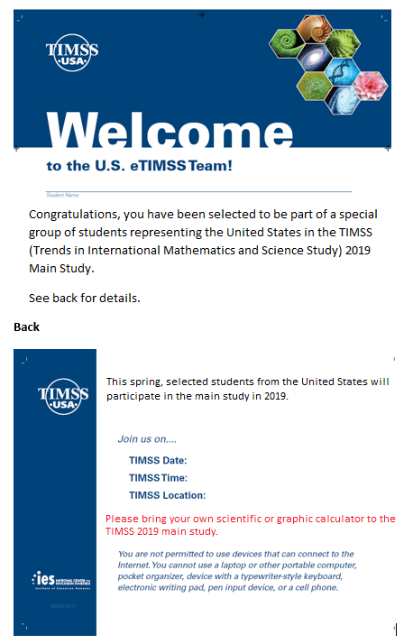

**Note: The following content/text from TIMSS is provided as a model, but the specific form and presentation will only be known once a contractor has been selected and the online system to be used is determined.**

Student Login Card (label with login information will be affixed to the card)

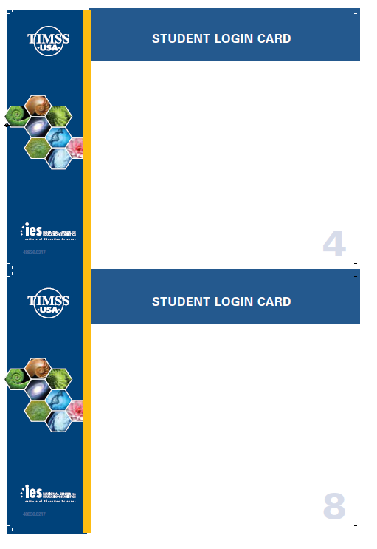

**Note: The following content/text from TIMSS is provided as a model, but the specific form and presentation will only be known once a contractor has been selected and the online system to be used is determined.**

# Student Certificate of Completion

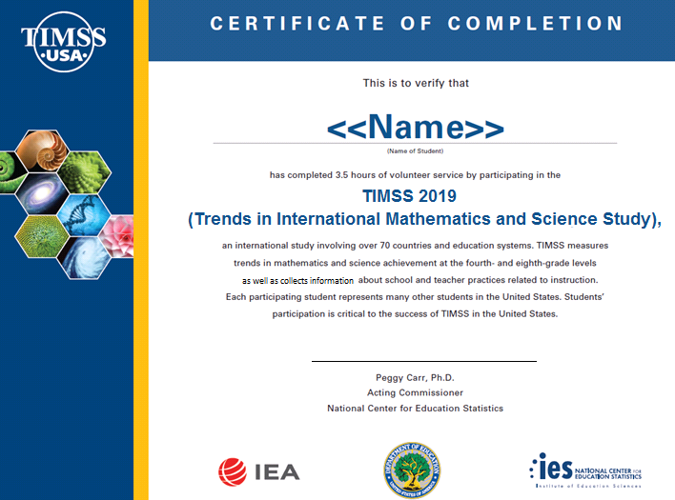

# School Certificate of Appreciation

