Certification Statements for Investing and Government Segments
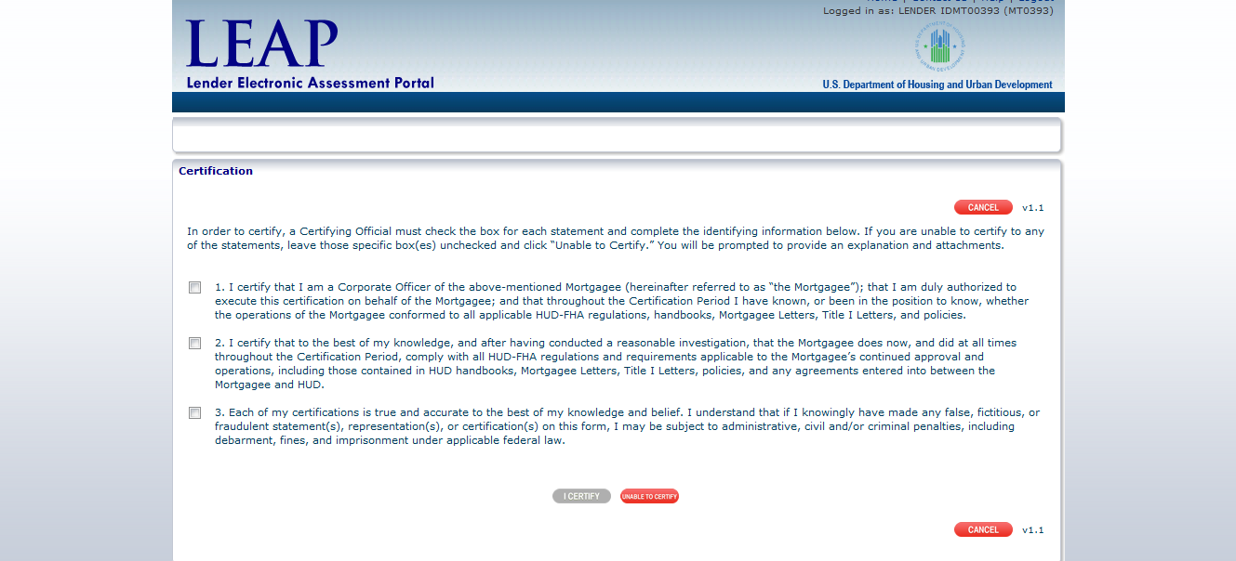
Certification Statements for Supervised Large, Supervised Small, Non-Supervised and Other Segments
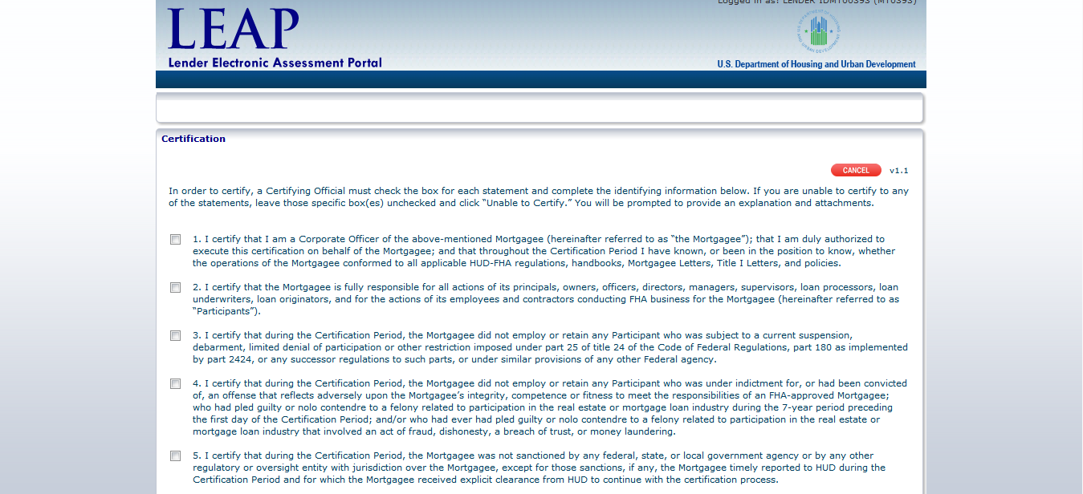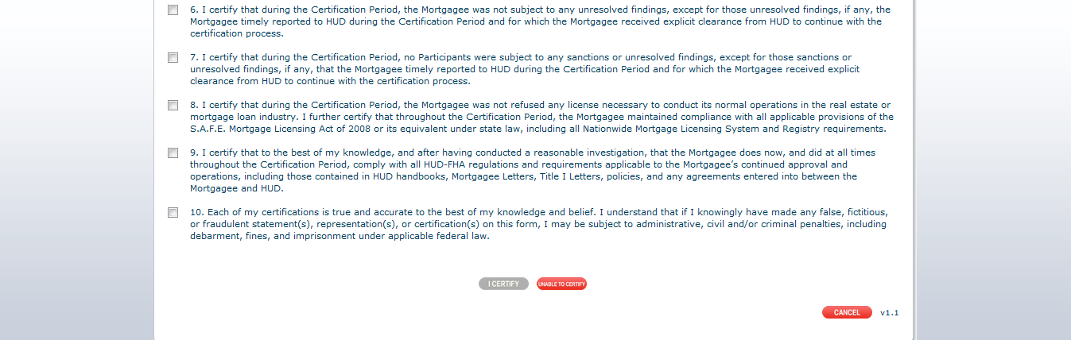
Unable to Certify Pop-Up
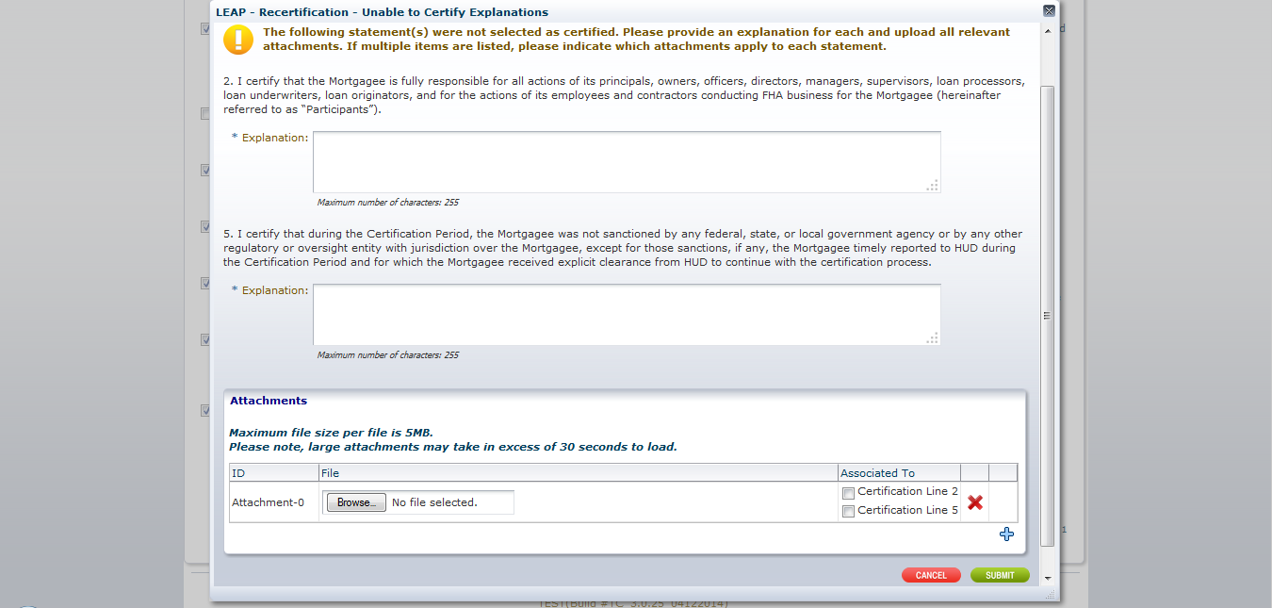
Explanation is required for each statement to which the lender is unable to certify. Attachments are optional.

