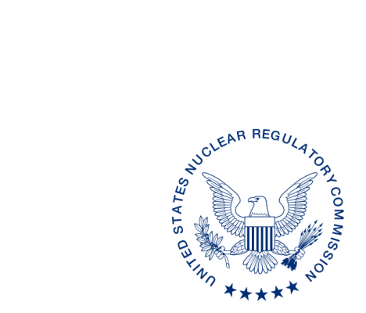
UNITED STATES
NUCLEAR REGULATORY COMMISSION
WASHINGTON, D.C. 20555-0001

ALL AGREEMENT STATES, VERMONT

OPPORTUNITY TO COMMENT ON DRAFT REVISION TO INSPECTION MANUAL CHAPTER (IMC) 2800, “MATERIALS INSPECTION PROGRAM” (STC-19-XXX)

Purpose: To provide Agreement States, as well as any States with pending Agreement State applications, the opportunity to comment on the draft latest revision of the Office of Nuclear Material Safety and Safeguards Inspection Manual Chapter (IMC) 2800, “Materials Inspection Program.”

Background: On April 13, 2016, the U.S. Nuclear Regulatory Commission (NRC) issued Staff Requirements Memorandum (SRM) to SECY-16-0009, “Recommendations Resulting from the Integrated Prioritization and Re-Baselining of Agency Activities.” Item 110 in this SRM directed the NRC staff to revise IMC 2800 to allow for the addition of more flexibility and logical extensions to the inspection interval of materials licensees.

To more efficiently and effectively address the Commission direction for Item 110, the NRC management and staff divided action on this item into two phases: 1) to specifically address the items listed in the Commission paper; and 2) to conduct a more comprehensive evaluation of the entire NRC materials inspection program.

Phase 1 was completed with the issuance of a revision to IMC 2800, dated September 12, 2017. An electronic copy of the September 12, 2017, revision to IMC 2800 can be found in the NRC’s Agencywide Document Access and Management System under Accession No. ML17186A204.

During a senior management counterpart meeting in April 2018, management from the Division of Materials Safety, Security, State, and Tribal Programs (MSST) and the Division of Nuclear Materials and Safety (DNMS) for Regions I, III, and IV met and finalized the Phase Two Project Plan.

Discussion: In August 2018, a Working Group (WG) composed of NRC and Agreement State inspection management and staff was formed and tasked with completing the Phase 2 Project Plan. This activity resulted in substantial proposed changes to IMC 2800. The proposed changes are intended to improve the effectiveness and efficiency of the materials inspection program while not diminishing the protection of public health and safety or security of licensed radioactive material. Changes in the following areas were especially noteworthy during this revision: (1) clearer guidance and expectations on inspections of locations of use; (2) expansion of remote inspection options; (3) consolidation of reciprocity inspection guidance and relaxation of the reciprocity metric in favor of a more risk-informed selection process; (4) streamlining of inspection documentation; and (5) increased emphasis on coordination and collaboration among the NRC and Agreement inspection efforts to help strengthen the National Materials Program.

Enclosed for your review and comment is a copy of the WG’s proposed revision to IMC 2800.

The comment period for this document, which was developed following consultation with the Organization of Agreement States, ends on September 30, 2019. Please provide comments to the individuals named below:

POINTS OF CONTACT: Aaron McCraw INTERNET: aaron.mccraw@nrc.gov

TELEPHONE: (630) 829-9650

Anthony McMurtray INTERNET: anthony.mcmurtray@nrc.gov

TELEPHONE: (301) 415-2746

Paul Michalak, Chief
State Agreement and Liaison Programs Branch
Division of Materials Safety, Security, State,
and Tribal Programs
Office of Nuclear Material Safety
and Safeguards

Distribution:
MSTR r/f

This information request has been approved by OMB 3150-0029 expiration February 28, 2022. The estimated burden per response to comply with this voluntary collection is approximately 16 hours. Send comments regarding the burden estimate to the Information Services Branch, U.S. Nuclear Regulatory Commission, Washington, DC 20555-0001, or by e-mail to infocollects.resource@nrc.gov, and to OMB Office of Information and Regulatory Affairs (3150-0029), Attn: Desk Officer for the Nuclear Regulatory Commission, 725 17th Street, NW Washington, DC 20503; e-mail: oira_submission@omb.eop.gov. An agency may not conduct or sponsor, and that a person is not required to respond to, a collection of information unless it displays a currently valid OMB control number.

