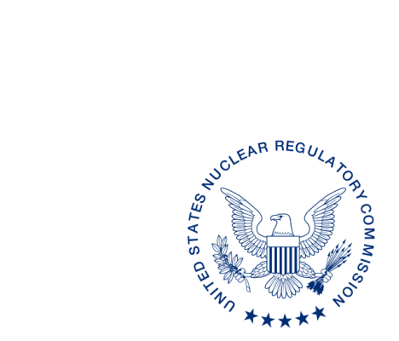**UNITED STATES**

**NUCLEAR REGULATORY COMMISSION**

**WASHINGTON, D.C. 20555-0001**

October XX, 2019

ALL AGREEMENT STATES, NRC NMSS, NRC REGIONS I, III and IV

NOTIFICATION OF THE ISSUANCE, AND OPPORTUNITY TO COMMENT ON THE FOLLOWING INTERIM PROCEDURES RELATED TO THE INTEGRATED MATERIALS PERFORMANCE EVALUATION PROGRAM (IMPEP):

SA-107, REVIEWING THE NON-COMMON PERFORMANCE INDICATOR: LEGISLATION, REGULATIONS, AND OTHER PROGRAM ELEMENTS;

SA-200, COMPATIBILITY CATEGORIES AND HEALTH AND SAFETY IDENTIFICATION FOR NRC REGULATIONS AND OTHER PROGRAM ELEMENTS; AND

SA-201, REVIEW OF STATE REGULATORY REQUIREMENTS

**Purpose**: This communication serves two purposes: 1) To inform the National Materials, Program (NMP) community (Agreement States and U.S. Nuclear Regulatory Commission, (NRC)) that the above indicated Office Of Nuclear Material Safety And Safeguards (NMSS) State Agreements (SA) procedures have been approved for use as interim procedures; and 2) To provide the NMP community an opportunity to comment on the three interim procedures.

**Background**: On July 24, 2019, the NRC approved and issued the revised Management Directive (MD) 5.6 “Integrated Materials Performance Evaluation Program (IMPEP).” In September 2019, 11 working groups consisting of Agreement State and NRC representatives with IMPEP experience were formed to revise NMSS SA procedures used to implement the MD and IMPEP. To fully implement the revised MD 5.6 in a timely manner, the revision of these procedures is being completed simultaneously. These 11 working groups will ultimately revise 14 NMSS SA procedures. The charter for the working groups can be found in the Agencywide Document Access and Management System at Accession number ML19274C608. A list of all procedures included in this effort and co-chairs can be found in the charter.

**Discussion**: This letter notifies the NMP community that NMSS SA procedures SA-107, SA-200, and SA-201 have been revised and issued for use on an interim basis until July 31, 2020, to allow NRC and Agreement State staff in the NMP community to provide comments[1] based on their review of the procedure, or implementation during IMPEP reviews or periodic meetings.

The comment period which was developed following consultation with the Organization of Agreement States, ends on April 1, 2020. If there are no comments for a procedure by the NMP community, then the procedure will automatically become final on July 31, 2020, without any further action. Please provide comments to the Working Group Co-Chairs who are listed below.

These procedures have been uploaded to the state communications portal (SCP) website for use, and to provide for your review and comment: <https://scp.nrc.gov/procedures.html>.

If you have any questions regarding this correspondence, please contact me at (301) 415-9956, or the individuals listed below:

POINTS OF CONTACT:

Michelle Beardsley E-MAIL: michelle.beardsley@nrc.gov

TELEPHONE: (301) 415-0275

Jenny Goodman E-MAIL: jenny.goodman@dep.nj.gov

TELEPHONE: (609) 984-5498

Michael Layton, Director

Division of Material Safety, Security, State,

and Tribal Programs

Office of Nuclear Material Safety

and Safeguards

1. This information request has been approved by OMB 3150-0029 expiration February 28, 2022. The estimated burden per response to comply with this voluntary collection is approximately 16 hours. Send comments regarding the burden estimate to the Information Services Branch, U.S. Nuclear Regulatory Commission, Washington, DC 20555-0001, or by e-mail to [infocollects.resource@nrc.gov](mailto:infocollects.resource@nrc.gov), and to OMB Office of Information and Regulatory Affairs (3150-0029), Attn: Desk Officer for the Nuclear Regulatory Commission, 725 17th Street, NW Washington, DC 20503; e-mail: [oira_submission@omb.eop.gov](mailto:oira_submission@omb.eop.gov). An agency may not conduct or sponsor, and that a person is not required to respond to, a collection of information unless it displays a currently valid OMB control number.