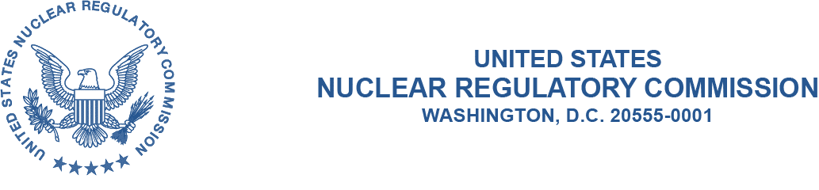
March XX, 2020

ALL AGREEMENT STATES, NRC NMSS, NRC REGIONS I, III and IV

NOTIFICATION OF THE OPPORTUNITY TO COMMENT ON SA-112 EMERGENCY SUSPENSION(STC-20-XXX):

Purpose: This communication serves two purposes: (1) to inform the National Materials, Program (NMP) community (Agreement States and U.S. Nuclear Regulatory Commission, (NRC)) that the above indicated Office of Nuclear Material Safety and Safeguards (NMSS) State Agreements (SA) procedure have been revised; and (2) to provide the NMP community an opportunity to comment on this procedure prior to the procedure being issued.

Background: SA-112, Emergency Suspension of a 274b. Agreement, is subject to routine update and revision every five years. The last revision to this procedure was issued in March 2014. Although not part of the Integrated Materials Performance Evaluation Program (IMPEP) process, the revision is taking place at the same time other IMPEP procedures have been issued in an interim status.

Discussion: This letter notifies the NMP community that NMSS SA procedure SA-112 has been revised and issued for comment. Comments are due by May 1, 2020 but will be considered at anytime. Once the comments have been resolved, the procedure will be finalized and issued. This time period will allow NRC and Agreement State staff in the NMP community to provide comments1 based on their review of the procedure.

1 This information request has been approved by OMB 3150-0029 expiration February 28, 2022. The estimated burden per response to comply with this voluntary collection is approximately 4 hours. Send comments regarding the burden estimate to the Information Services Branch, U.S. Nuclear Regulatory Commission, Washington, DC 20555-0001, or by e-mail to infocollects.resource@nrc.gov, and to OMB Office of Information and Regulatory Affairs (3150-0029), Attn: Desk Officer for the Nuclear Regulatory Commission, 725 17th Street, NW Washington, DC 20503; e-mail: oira_submission@omb.eop.gov. An agency may not conduct or sponsor, and that a person is not required to respond to, a collection of information unless it displays a currently valid OMB control number.

Please provide comments to Joe O’Hara at (301) 415-6854 (Joe.OHara@nrc.gov).

This procedure has been uploaded to the state communications portal (SCP) website for use, and to provide for your review and comment: https://scp.nrc.gov/procedures.html.

If you have any questions regarding this correspondence, please contact me at (301) 415-9956, or Joe O’Hara at (301) 415-6854 or (Joe.OHara@nrc.gov).

Michael C. Layton, Director
Division of Materials Safety, Security, State, and Tribal Programs
Office of Nuclear Material Safety and Safeguards

