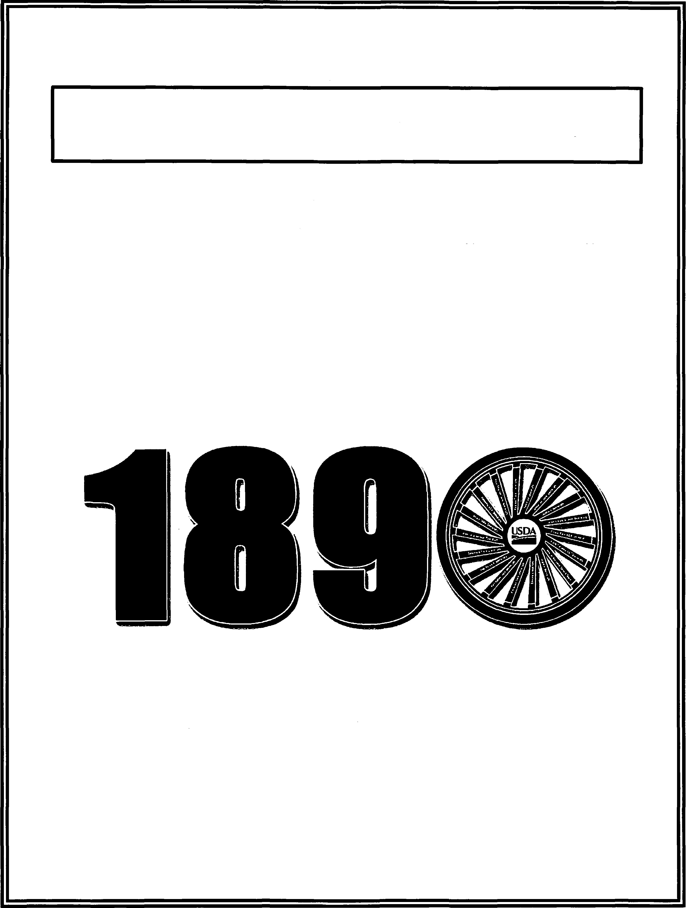
United States Department of Agriculture
USDA/1890 National Scholars Program
2019
HIGH SCHOOL APPLICATION
XXX
201
8

INTRODUCTION

0MB No.: 0503-0015
Thank you for your interest in the U.S. Department of Agriculture's 1890 National Scholars Program. The USDA/1890 National Scholars Program was established in 1992 as part of the partnership between the U.S. Department of Agriculture and the 1890 Land-Grant Universities.
The goal of the USDA/1890 National Scholars Program is to increase the number of students studying agriculture, food sciences, natural resource sciences, and other related disciplines. The program is open to high school seniors, rising college sophomores, and juniors who exhibit exemplary leadership traits and demonstrated community service. The Scholarship is highly competitive and provides for full tuition payment, among other benefits, for up to 4-years to selected students enrolled or accepted for enrollment at an 1890 Land-Grant University. The 1890 National Scholars Program partners with USDA agencies and staff offices to provide scholars with professional and educational opportunities. A sponsoring Agency Coordinator will be assigned to the scholar. The program Agency Coordinator will be the primary point of contact of scholar. The Sponsoring Agency will work closely with scholars to provide ongoing support and ensure the Scholar is on track with degree requirements.
The USDA/1890 National Scholars Program is implemented under the USDA Fellows Experience Program (FEP). Scholars accepted into the program will be appointed using the Schedule A(r) authority (5 CFR 213.3202) and are not eligible for noncompetitive conversion to full time employment upon graduation. However, all USDA/1890 National Scholars are required to compete for appropriate employment immediately after graduation. If selected, commit to at least one year of service to USDA for each year of financial assistance provided. ¹
The USDA/1890 National Scholar is required to:
./ Compete for appropriate employment immediately after graduation. If selected, commit to at least one year of service to USDA for each year of financial assistance provided .
./ Reimburse the USDA Sponsoring Agency for costs of education (excluding the employee's pay and allowances) incurred by the USDA Sponsoring Agency, if the Scholar voluntarily separates from the service of the USDA Sponsoring Agency before the end of the period for which the Scholar has agreed to continue in the service of USDA .
./ Consult with and obtain the approval of the Sponsoring Agency prior to making any changes to their academic program. Unapproved changes may affect the Scholar's continued participation in the program, such as scholar's participation in study abroad programs, third party internships and leave of absence. The Scholar is expected to meet with Agency Coordinator to go over degree classes and ongoing academic status.
./ The Scholar must coordinate summer work experience through their work site manager. The Scholar must report to work site and have a record oftheir individual development plan.
Again, thank you for your interest in the USDA/1890 National Scholars Program and best wishes in your pursuit of academic excellence!
!Specific details of this "seivice requirement" will be outlined in the agreement entered into by the selected Scholar, the University at which the scholar is matriculated, and the USDA sponsoring agency. The "service requirement" is subject to change. XXX 2018
USDA is an equal opporutnity provider and employer

0MB No.: 0503-0015
USDA/1890 NATIONAL SCHOLARS PROGRAM
OVERVIEW
The USDA/1890 National Program is a partnership between the U.S. Department of Agriculture (USDA) and the 1890 Historically Black Land-Grant Universities. The program awards scholarships to students accepted to or attending one of the 1890 Land-Grant Universities in pursuit of a bachelor's degree in agriculture, food sciences, natural resource sciences, or related academic discipline(s).
The Land-Grant Universities are as follows:
AlabamaA&M University | North CarolinaA&T State University
Alcorn State University (Mississippi) | Prairie View A&M University (Texas)
Central State University (Ohio) | South Carolina State University
Delaware State University | Southern A&M University (Louisiana)
Florida A&M University | Tennessee State University
Fort Valley State University (Georgia) | Tuskegee University (Alabama)
Kentucky State University | University ofA rkansas Pine Bluff
Langston University (Oklahoma) | University of Maryland Eastern Shore
Lincoln University (Missouri) | Virginia State University West Virginia State University
AUTHORITIES
- Legislative authority of the Second Morrill Act of August 30, 1890 (7 U.S.C. 321-326 and 328);
- National Agricultural Research, Extension and Teaching Act of 1977 (Public Law 95-113, 1402, et seq 7 U.S.C. § 3101);
- Office of Personnel Management, Training (5 C.F.R part 410);
- Schedule A (r) federal Experience Authority (5 C.F.R. 213.312 ((r));
- Federal Agriculture Improvement and Reform Act of 1996 (FAIR ACT), Title IX, Section 922 (7 U.S.C § 2279c);
- Executive Order 13779, White House Initiative on historically Black Colleges and Universities, signed February 18, 2017 continued by Executive Order 13811, signed September 29 September 2017.
XXX 2018

0MB No.: 0503-0015

PURPOSE
The purposes of the USDA/1890 National Scholars Program are:
- To strengthen the long-term partnership between USDA and the 1890 Land-Grant Universities.
- To promote increase cooperation among the parties in all areas of mutual interest.
- To improve USDA’s outreach efforts within the communities served by 1890 Land-Grant Universities and USDA.
- To increase the number of students studying and pursuing careers in agriculture, food sciences, and natural resource science or other related disciplines.

OBJECTIVE
The USDA/1890 National Scholars Program offers scholarships to U.S. citizens who are seeking a bachelor's degree at one of the 1890 Land-Grant Universities pursuing a bachelor's degree in any of the fields of study within agriculture, food sciences, natural resource sciences, or other related disciplines. Examples of required fields of study or related disciplines are:
Water Resource Management  Business Management  Agricultural Production and  Technology Agronomy or Crop Agricultural Economics  Agricultural Engineering/Mechanics Science  Animal Sciences/ Botany Business Management  Farm and Range Management  Financial Management | Forestry and Related Sciences Food Sciences/Technology  Home Economics/Nutrition  Horticulture  Natural Resources Management  Soil Conservation/Soil Science  Other related disciplines, (e .g., non-medical biological sciences, pre-veterinary medicine, computer sciences)

AWARD
Scholarships are awarded . annually and must be used at one of the 1890 Land-Grant Universities. Each award provides full tuition, as well as fees, books, and room and board, renewable each year for the term of the scholarship. The scholarship renewal is contingent upon satisfactory academic performance, summer work performance and academic progress toward the bachelor's degree.
XXX 2018

0MB No.: 0503-0015

GENERAL ELIGIBILITY
Applicant must:
./ • Be a U.S. citizen
- Intend to study agriculture, food sciences, natural resource sciences, or other related academic disciplines
- Have a high school cumulative GPA of3.0 or better(on a 4.0 scale)
- Have been accepted for admission to an 1890 Land-Grant University
- Have a combined verbal/math/written score of 1,080 or more on the SAT (note: 1,000 or more combined for those universities that only accept verbal/math score) or a composite score of21 or more on the ACT
- Demonstrate leadership and community service
- Submit the most recent official transcript with the school seal and/or the signature of an authorized school official
- Submit a 500-800 word essay describing one of the following topics. 1) My interest in working for USDA. 2) How I envision the scholarship will impact me personally and my future as a public servant. 3) My experiences and perceptions about agriculture, food sciences and natural resource sciences.
- Submit a signed and dated application (original signature only)

APPLICATION DEADLINE
All application materials must be postmarked no later than Tuesday, January 31 2019 and sent to the USDA/1890 Program Liaison at the university or universities selected by the applicant.
SELECTION PROCESS
If selected, the student will be contact by the sponsoring Agency Coordinator coordinator. The applicant will be given an opportunity to ask questions related to the agency, the job and Program expectations. Selected applicants should contact their Agency Coordinator with any unanswered questions or concerns related to agency, summer experience or academic requirements.
Applications Must Be Postmarked by Tuesday, January 31 2019.
USDA is an equal opportunity provider and employer. ^{XXX 2018}
5

INSTRUCTIONS
Only complete application packages submitted by Tuesday, January 31, 2019 will be considered. All application materials must be submitted in one application package. Complete application packages must include the following:
. Signed and dates application including signature of parent of guardian, if the applicant is under the age of 18.
. Completed Privacy Act Advisory Statement and Release Form
. Completed Biographical Questionnaire
. Current resume
. 500-800 word essay on one of the designated topics
. High School Counselor's Assessment Report (see page 18) in a sealed envelope
. High School Teacher's Assessment Report (see pages 20-24) in a sealed envelope
Applicants are responsible for obtaining the Assessment Reports of the High School Counselor (pages
18-19) and the High School Teacher (pages 20-24). These Assessment Reports should be in a sealed envelope and included with the application package. All application materials must have original signatures and seals/stamps.
Application materials containing photocopied signatures and transcripts will not be considered for the USDA/1890 National Scholars Program scholarship.
Applications Must Be Postmarked by Tuesday, January 31, 2019.
Note: The application may also be printed and filled in by hand in black or blue ink only.
USDA is an equal opportunity provider and employer. ⁶ ^{XXX 2018}

0MB No.: 0503-0015
PRIVACY ACT ADVISORY STATEMENT

The Privacy Act of1 974 (P.L. 93-579) requires that you be given certain infonnation in connection with this request for information. Accordingly, pursuant to the requirements for this Act, please be advised:
I • Furnishing the information requested is voluntary.
- The data will be used for selection of1890 National Program, printing certificates, and related activities.
- The data is maintained in a privacy act system as defined by National Archives and Records Administration under 0MB.
- Failure to complete the form will mean that you cannot be included among those candidates being considered for designation as USDA/1890 National Scholar.
Affirmation of Candidacy and Authorization for Release of Information
I understand that I am a candidate for the honor ofUSDA/1890 National
Program, have read the Privacy Act Advisory Statement, and affirm my wish to be considered. In the event I am named a Scholar, permission is hereby given for the release of materials submitted by me for the use of the U.S. Department of Agriculture and the 1890 Land-Grant Universities as deemed appropriate for purposes of the 1890 National Program.
I further consent to the release of photographs that may be taken ofme, by or for the U.S. Department of Agriculture in connection with the Program. I am (check one) willingnunwillingnto appear on radio and/or television if such arrangements are made by the U.S. Departmcrti'rof Agriculhni in connection with the USDA/1890 National Scholars Program.
Printed Name:----------------------
Signature:-----------------------Date ...- · --------------------------
7 XXX 2018

OS03-0015
Candidate's Biographical Questionnaire
The questions that follow are designed to collect information about your background, your interests, and your plans. Your answers to these questions will be used only in connection with your application for this scholarship program and wiJJ be divulged only to qualified persons who must see them in the course of their duties.
(Please Print)
- Biographical Information
Full Legal Name:
First D D Middle D Last
Gender: Female Male Other Age:
Street City/Town State Zip Code
Telephone:
(Home) _____________ cell)_ ____________ _
Are you a U.S. Citizen? (select one) Yes D No D Email Address:
- Education
1.
Na
me ofH igh
School currentlya ttending:
Street Address: City/Town State Zip Code Telephone: --------
GPA (on a 4.0 unweighted scale)
ACT: Composite Score __ _

SAT:Math Verbal __
Combined SAT:
Note: Grade point averages and standardized test scores should match supporting documentation submitted by counselor. Only applicants meeting minimum GPA criteria and standardized test scores will be considered for the USDA/1890 National Scholars Program scholarship. Please do not submit an application if you do not meet these criteria.
XXX 2018

0MB No.: 0503-0015
- List any other schools you attended in the last 4 years, starting with the one you attended most recently.
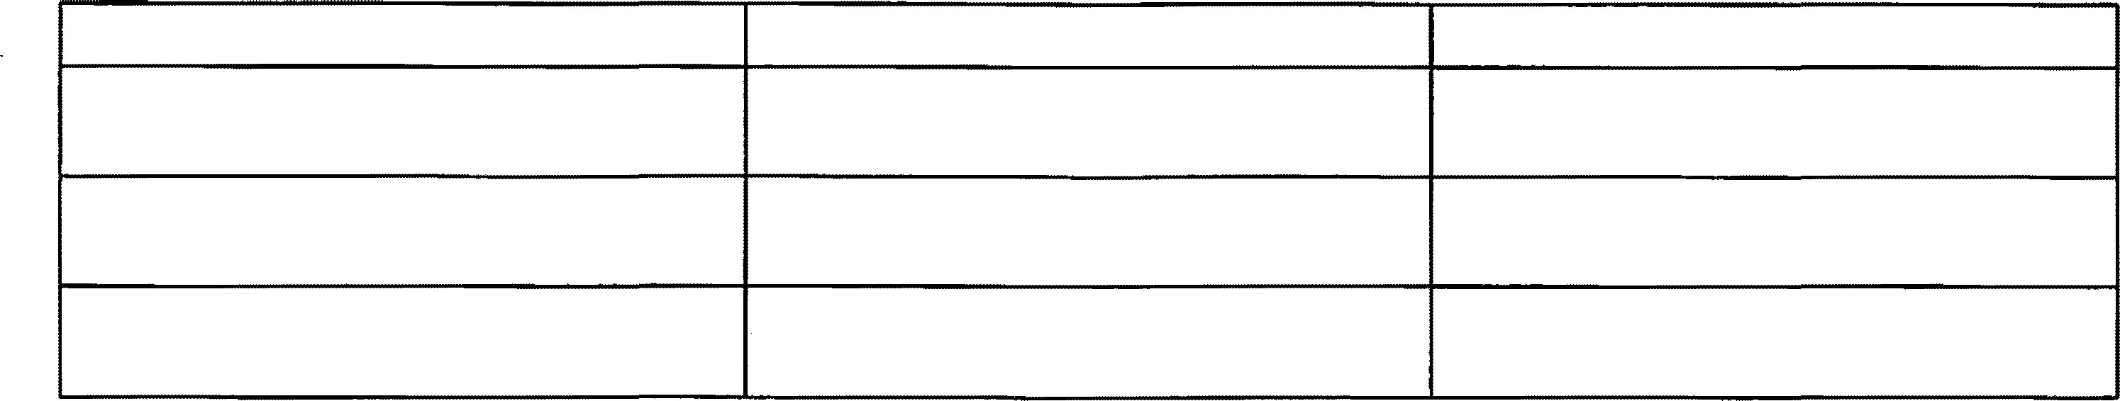
Name of School
Address
Dates of Attendance
- List any advanced or special program, courses, or summer courses you have taken. List the most recent course or program first.
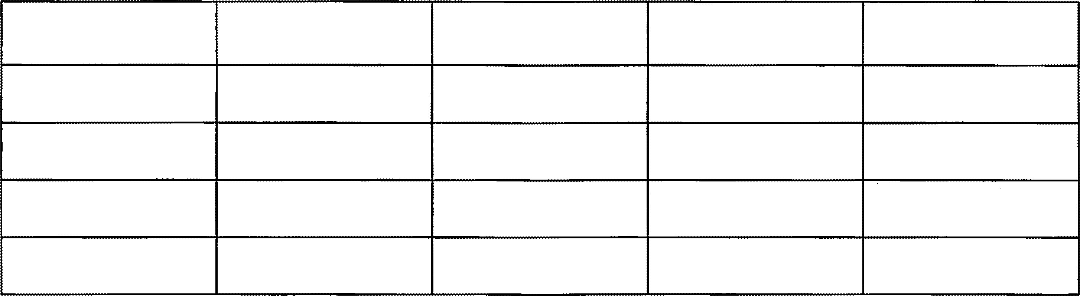
Course or
Program
Name ofS chool
Address
Dates of
Hours Per Week
Attendance
- Name(s) ofthe 1890 University (or Universities)to which you are applying:

a. -----------------
b. _..... ................................................................. ..... c.
XXX 2018

0503-00lS
- If accepte_{d} at multiple 1890 Lan_{d}-Grant U_{n}iversities, please list in or_{d}er of preference (i.e. 1 =Most Preferre_{d}, 3=Least Preferred)
  - -----------------
  - ------------------------------
  - _______________________________
Note: Applica_{n}ts applying to more than o_{n}e 1890 La_{nd}-Gra_{n}t U_{n}iversity must submit separate 1890 Natio_{n}al Program applicatio_{n}s foreach u_{n}iversity.
- What course of stu_{d}y (major) will you pursue?
I ⁵¹Choice:
2nd Choice:
Other Related Discipline/Unlisted Major (Please Identify):
Note: All academic disciplines may not be available al every I 890 Historically B/ackl.and-Grrm1 Unil'ersity. Check the Uni,,ersity 's academic offerings before applying.
- Have you ma_{d}e career _{d}ecisio_{n}s relate_{d} to agriculture, food sciences, natural resource scie_{n}ces or related disciplines?
Yes ___ No ___ If yes, please explain in the space
below:

XXX 2018

0MB No.: 0503-00JS

C. Activities
I. List extra curricular activities in which you have participated in school or in the community i.e. academic activities such as 4-H, FFA, debate, sports, music, art, etc).
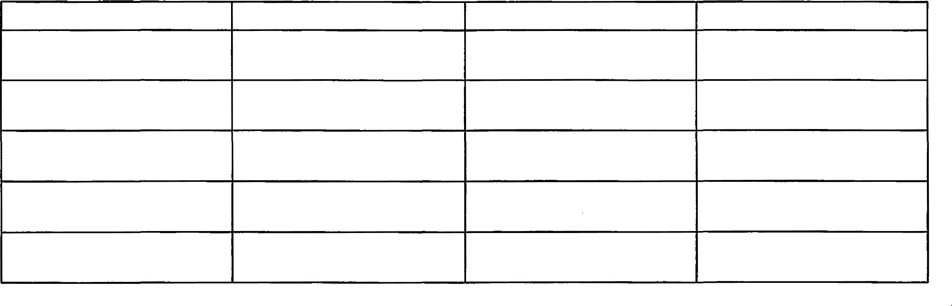
Activity
Participation Dates
Office(s) Held
Special Award(s)
2. List volunteer and paid positions you have held in the past 4 years (including summer employment).
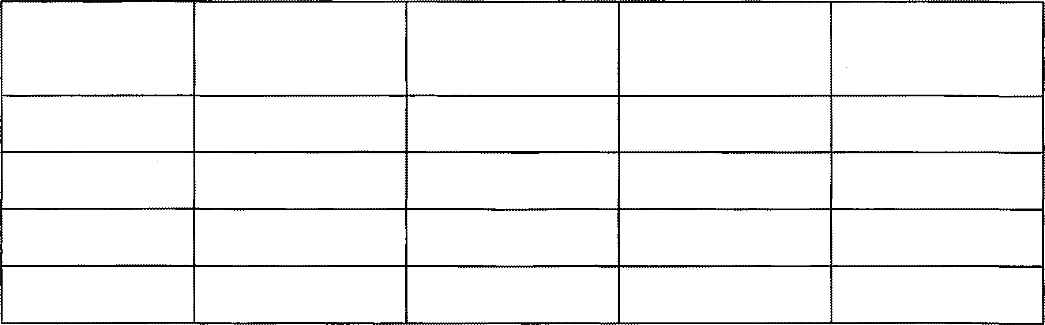
Volunteer or paid
Organization/
Dates of service or
Hours per week
Special award(s)
positions
Employer
employment
II XXX 2018

0503-00tS
- Candidates Self-Assessment
- Please list your hobbies and how each plays a role in your personal development.
D2.Describe activities in which you had a leadership role in your school or in your community.
12 XXX 2018

0MB No.: 0503-0015
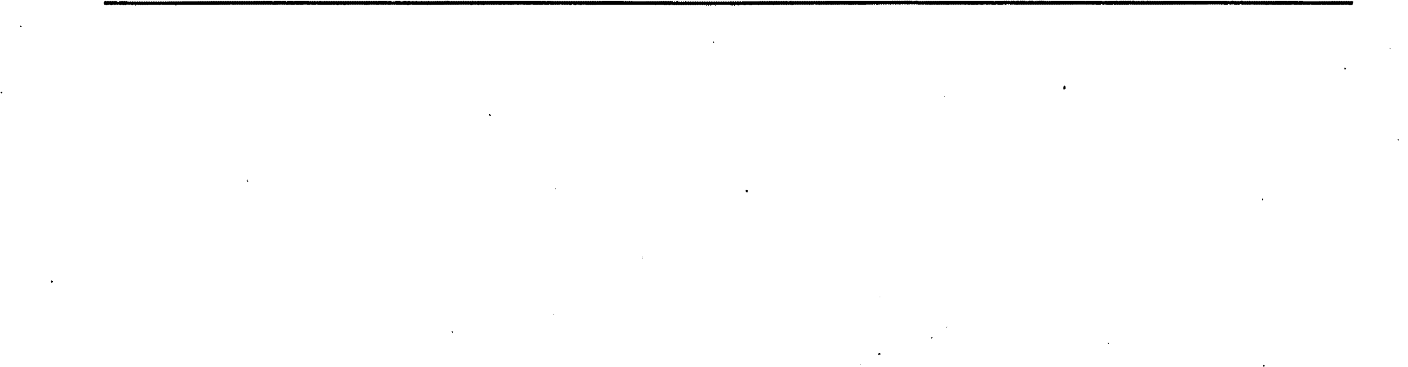
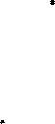
D4. Briefly discuss why have you chosen to study agricultural, or a related discipline.
D
3
. Describe a recent experience that has given you a sense of satisfaction or pride.
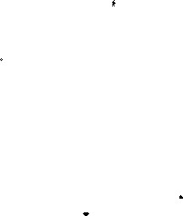
XXX 20 I8

0MB No.: 0503-0015
Review this form to make sure you have answered all questions completely. Proofread your responses.
I certify that I completed this application and that all statements are true and accurate to the best of my knowledge. I understand that a false statement could eliminate me from consideration for this scholarship.
Print Name (Applicant)
Applicant's Signature
Date
Print name (Parent or Legal Guardian)
Note: If the applicant is a minor child, under the age of 18; parental or legal guardian signature is required
Parent or Legal Guardian Signature
Date
This form and all other application materials must be postmarked by Tuesday, January 31, 2019.

XXX 2018

0MB No.: 0503-0015
How did you hear about the 1890 National Program Scholarship? (Select all that apply.)
College fair(s )
Name of event(s)
Informational Session Location
Public Service Announcement Stations
Direct Mail/e -mail
Source of communication
USDA Employee
Name of employee(s)
Church or place of worship
Name of Facility
Website(s)
Name of website(s)
Other
201

0MB No.:
INSTRUCTIONS AUTHORIZATION TO RELEASE ACADEMIC INFORMATION
The above-named student is a candidate for the honor of USDA/1890 National Program. To process this application, the U.S. Department o f Agriculture and the University will need:
An official secondary school transcript, the SAT, a d/or ACT scores. The transcripts from the student's secondary school record must contain a seal and signature of an authorized school official. Please note that only students with a GPA of 3.0 on a 4.0 scale and a combined SAT score of at least 1080 or 1000 (math and verbal) or ACT score of at least 21 are eligible for the USDA/1890 National Program.
Thorough responses will greatly enhance your student's candidacy. This information will be used only-in connection with the selection of Scholars and will be seen only by qualified persons involved in the selection process.
Please delete all personally identifiable information, such as social security numbers and dates of birth from any supporting documentations.
For questions or more information about the 1890 National Program, please contact us at 1890init@usda.gov or (202) 720-6350.
16 201

0MB No.: 0503-0015

USDA/1890 NATIONAL SCHOLARS PROGRAM SCHOLARSHIP
Applicant's Authorization to Release Academic Information.
Applicant's Full Name
Last First Middle Suffix
To comply with the provisions of the Family Educational Rights and Privacy Act of 1974, a school must obtain signed authorization before it can release student information for use in this scholarship program. Permission is hereby given to school officials to release record and other requested information for consideration in the scholarship program named above. Note: If the applicant is a minor child, under the age of 17; parental or legal guardian signature is required.
Student's Signature ___________
Date __________
Parent's or Legal Guardian's Signature____________ Date____________
Applicant: If you have attended this school less than 2 years, you must copy this form and have your previous school also complete this form for you.
School Name
Address
City State Zip Code Phone Number
17 20 I

USDA/1890 National Program ^{0MB No.:}
Secondary School Report
High School Guidance Counselor Assessment
Report
- Please type or print using black ink
Name of Counselor
Last First MI Suffix
Address:
Phone:
- Are you confidentthat the student will receive a high school diploma during the current academic year?
Yes D No D
If your answer is no, please explain your reason using a separate page
- Student's class rank
How many students are in the class?
- Student's cumulative grade point average (u nweighted on 4.0 scale) __ Do not enter GPA on a scale of 0-100.
- ACT Composite Score ____
SAT Score (combined) ___
SAT Score (math and verbal) ___
18
XXX 2018

0MB No.: 0503-0015
F.SecondarySchoolRecord
The applicant's SAT and/or ACT scores, along with an official secondary school transcript (with seal and signature by an authorized official), including grades 9 through 12 must be attached to this section of the application. If the official transcript and SAT and/or ACT scores are not provided, the applicant will not be considered for the scholarship.
Counselor's Signature
Date
This fonn and the candidate's transcript and SAT and/or ACT scores must be included in the student's application package. Applicants applying to more than one the designated schools must submit separate USDA/1890 National Scholars application packages for each school. The complete application packages must be postmarked by Tuesday, January 31, 2019.
19

XXX 2018

0MB No.:
USDA/1890 National Program
Secondary School Report
School Teacher Assessment Report
The application for the USDA/1890 National program scholarship requires a carefully considered character and ability assessment by a teacher who knows the student well, including a summary of other teachers' judgments of the student.
A. Please type or print using black ink
Last First MI Suffix
Name of Teacher
Address ___________________________ _

Phone ----------
- Length of Relationship-----
- Considering this student's interests, work habits, and life goals, what is your assessment as to whether the student will be motivated to take advantage of the opportunities available in college? Please give reasons for your assessment.
20 XXX 2018

0MB No.: 0503-0015
D.What special features is a part of your school's curriculum ( e.g., AP and honors courses, college study, and independent study)? Has the student taken advantage of the most challenging opportunities your school has to offer?
- Has the student shown exceptional talent or originality in agriculture, food sciences, natural
resource sciences, and/ or other related disciplines?
Yes D No D
Please explain your selection:
- Describe this student's strengths and weaknesses.
Strengths:
Weaknesses:

21 XXX 2018

- Sometimes, special circumstances should be considered when evaluating a student'sachievement records and test scores. If in your opinion, this student may have been disadvantaged by any such circumstances, please specify. *Additional pages may be attached if needed, please reference page 22 sub tangent G.
- Indicate comments made by teachers about the student relative to the following: 1. Participation in discussion:
D D always involved, often initiates discussion _{occasionally participates}
D seldom participates D not applicable 2. Involvement in classroom activities:
D active, usually shows genuine interest
D mild, politely attentive
D languid, attention often wanders
D vacillates gently
D poor understanding 3. Pursuit of independent study:
0
MB No.:
0503-0015

D considerable study and majorproject(s) D some study and minor projects( s)
D no evidenceofindependentstudy D not applicable 4. Evenness of performance:
D even, varies no more than one mark
D slightlyuneven
D D uneven, often varies two marks erratic, fluctuates greatly
D inadequate opportunity to observe
5. Critical and questioning attitude:
    - D occasionallyprobes often challenges
D rarely questions
D not applicable
XXX 2018

0MB No.: 0503-0015
6. Depth of understanding: D excellent insight D good understanding
D some insight
D little understanding D not applicable 7. Personal responsibility: D al ways accepts fully
D usuallyaccepts fully
D sometimes refuses D often refuses
  - Consideration for others:
    - alw ays considerate of other:-s' rights and feelings D usuallyconsiderate
D sometimes inconsiderate D often inconsiderate
  - Population of the community in which your school is located: D less than 500
D
D
D
soo-1,500 1,soo -5,ooo 5,ooo - 2s,ooo D 25,000-100,000
    - over 100,000
  - What economic or social conditions characterize the commu nity and most of the parents of the children in your school? D Rural farming area
    - Industrial
D Smalltown
D Large city, Metropolitan area
D Other
Teacher's Signature ________________________ Date ----------
This form and the candidate's transcript and SAT and/or ACT scores must be included in the student's application package. Applicants applying to more than one 1890 Historically Black Land-Grant University must submit separate USDA/1890 National Scholars application packages for each university. The complete application packages must be postmarked by Tuesday, January 31, 2019.
23 XXX 2018

0MB No.: 0503-0015
USDA/1890 National Application Checklist
- I have read the eligibility requirements and meet all eligibility criteria.
- I am submitting an original application and transcript to each USDA/1890 University of interest (see addresses on page 26 of this application).
- I have applied for admission to each 1890 Historically Black Land- Grant
Institution of interest.
- I completed the Candidate's Biographical Information section.
- I have included and signed the Secondary School Report from my high school counselor and explained the need to have all official transcripts with a seal.
- Signature and SAT and/o r ACT scores are enclosed with this response.
- I have included and signed the School Teacher Assessment completed .
- I have signed and dated the application (o riginal signature only). If under the age of 18 years old, parents or guardians have signed my application.
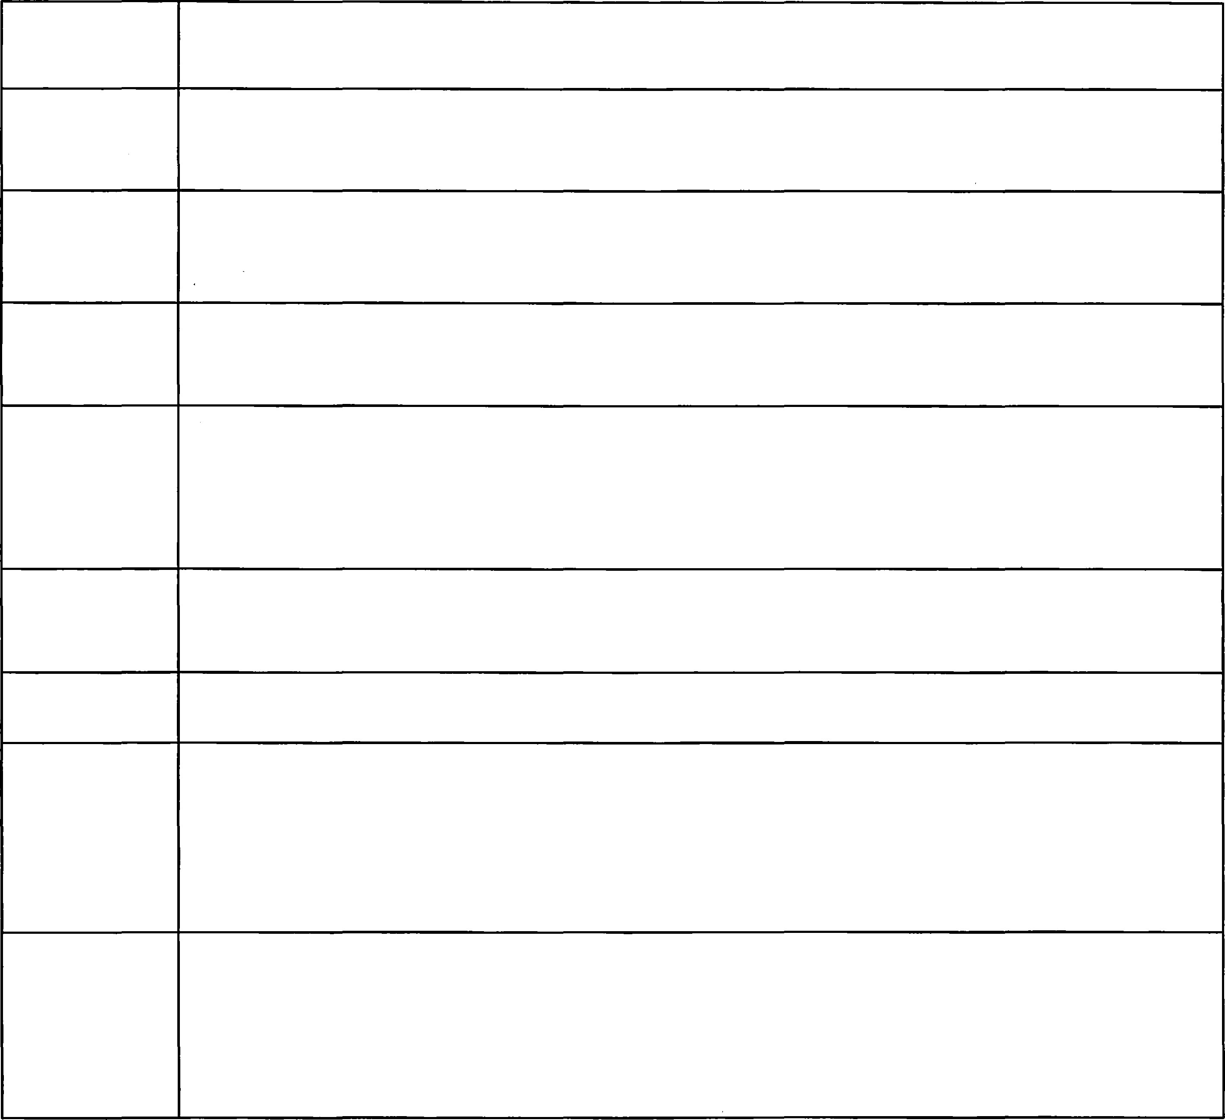
- I have enclosed a 500-800 word essay in one of the designated topics as outlined in page 5. 1) My interest in USDA 2) How I envision the scholarship will impact me and my future as a public servant, and 3) my experiences and perceptions about agriculture, food sciences and natural resource sciences.
10. | I understand that the full application package must be postmarked no later than Tuesday, January 31, 2019 for consideration for the USDA/1890 Programs Scholarship.
XXX 2018

0MB No.: 0503-0015
1890 Land-Grant Universities Liaison Directory

Attn: USDA/1890 Program Liaison Alabama A&M University
P_ ost Office Box 1087
Normal, AL 35762
(202) 570- 3926
Attn: USDA/1890 Program Liaison
Alcorn State University
1000 ASU Drive, Room 1139
104 Agriculture ScienceBuilding.
Lorman, MS 39096
(202) 596-0478
Attn: USDA/1890 Program Liaison
Central State University
1400 Brush Row Road
McLin Building, Room 2 I 0
Wilberforce, OH 45384
(202) 596-0140
Attn: USDA/I 890 Program Liaison
Delaware State University
CARS Ag Annex, Room I 08F
Dover, DE 1991 (202) 308-7687
Attn: USDA/1890 Program Liaison
Florida A&M University
1740 South Martin L. King Jr.,
Boulevard Room 217 , S. Perry-Paige Building
Tallahassee, FL 32307-4100
(202) 510-6301
Attn: USDA/1890 Program Liaison
Fort Valley State University
2
S
1 005 State University Drive Pettigrew Center, Room 244
Fort Valley, GA 31030
(202) 253-4218
Attn: USDA/1890 Program Liaison Kentucky State University
Cooperative Extension Facility,
400 East Main Street, Room 221
Frankfort, KY 40601
(202) 570-5202
Attn: USDA/1890 Program Liaison
Langston University
School of Agriculture and Applied Sciences 100 Success Drive, Room V1 15
Langston, OK 73050 ( 202) 263-9209
Attn: USDA/1890 Program Liaison
Lincoln University
818 Lee Drive
I 08 Bennett Hall
Jefferson City, MO 65101
(202) 264-0736
Attn: USDA/1890 Program Liaison North Carolina A&T University 160 I East Market Street 107 B.C.
Webb Hall
Greensboro, NC 27411
(202) 281-8214
XXX 2018

0MB No.: 0503-0015 .

Attn: USDA/1890 Program Liaison Prairie View A&M University
Agriculture and Business Building,
Room 402 P. 0. Box 2736
Prairie View, TX 77446 (202) 302-4712
Attn: USDA/1890 Program Liaison South Carolina State University 300 College Av enue, N. E.
P.O. Box 7246
Orangeburg, SC 29117 (202) 596-4442
Attn: USDA/1890 Program Liaison
Southern University and A&M College Fisher Hall, Room l 02
Baton Rouge, LA 70813 (202) 302-7255
Attn: USDA/1890 Program Liaison
Tennessee State University
3500 John Merritt Boulevard
Ag Science Dept., Room 20 P.O. Box 9629
Nashville, TN 37 209-1561
(202) 596-0226
Attn: USDA/1890 Program Liaison Tuskegee University College of Agriculture, Environmental and Nutritional Sciences Campbell Hall, Room I 03
Tuskegee, AL 36088 (202) 306-9884
Attn: USDA/1890 Program Liaison University of Arkansas Pine Bluff
1200 North University Drive
Mail Slot: 4806
Pine Bluff, AR 71611-2799
(202) 306-9810
Attn: USDA/1890 Program Liaison University of Maryland Eastern Shore
30665 Student Services Center Lane
Trigg Hall, Room I 13 7
Princess Anne, MD 21853
(202) 306-7368
Attn: USDA/1890 Program Liaison Virginia State University
P.O. Box 9081
1 Hayden Drive
L. Douglas Wilder Building, Room 202C Petersburg, VA 23806 (202) 596-0301
Attn: USDA/1890 Program Liaison
West Virginia State University I 00 Curtis House
P .0. Box I 000
Institute, WV 25112-1 000
(202) 596-4605
XXX 2018

0MB No.: 0503-0015
For questions related to this application, please contact:
The Office of Partnership and Public Engagement
USDA/1890 Programs
1400 Independence Ave. SW., Stop 0601
Washington, D.C. 20250
Telephone Number: (202) 720-6350
Fax Number: (202) 720-7136
Email: I 890init@usda.gov
According to the Paperwork Reduction Act of 1995, an agency may not conduct or sponsor, and a person is not required to respond to, a collection of information unless it displays a· valid 0MB control number. The valid 0MB control number for this information collection is 0503-0015. The time required to complete this information collection is estimated to average 2.6 to 3 hours per response, including the time for reviewing instructions, searching existing data sources, gathering and maintaining the data needed, and completing and reviewing the collection of information.
The U.S. Department of Agriculture (USDA) prohibits discrimination in all its programs and activities on the basis of race, color, national origin, gender, religion, age, disability, political beliefs, sexual orientation, and martial or family status (not all prohibited bases apply to all programs). Persons with disabilities who require alternative means for communication of program information (Braille, large print, audiotape, etc.) should contact the USDA 's TARGET Center at (202) 720-2600 (voice and TDD). To file a complaint of discrimination, contact the USDA Assistant Secretary for Civil Rights, 300 7th Street S.W., Suite 521, Washington, D.C. 20024 or call (202) 401-0005 or (800) 795-3272.
27

USDA is an equal opportunity provider and employer XXX 2018

